[Date]

Muhamad kamran

[company name]

BOOK My SHOW

Group Members:

Muhammad Kamran Group Leader

Reg # 18-NTU-1130

Abdul Qadoos Reg# 18-NTU-1112

Ghulam Mujtbah Reg# 18-NTU-1122

Welcome Page

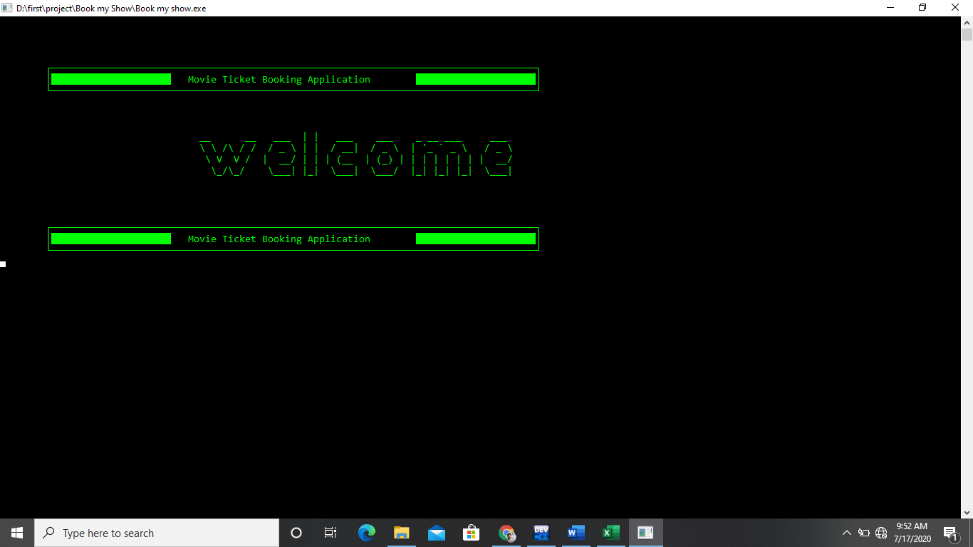

Login page

