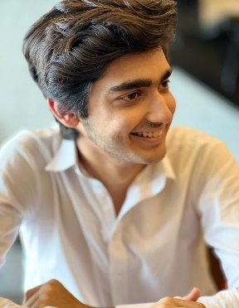
- UDEMY
Oct 2024,
The Complete 2024 Web Development Bootcamp
https://www.udemy.com/certificate/UC-22ef8862-8b42-4dd3-89b9-69e70583bc57/
PROJECTS
- https://supermarket-rose.vercel.app/
CERTIFICATES

HEADSTART, Islamabad, Pakistan
May 2022,
High school
NUCES-FAST, Islamabad, Pakistan
May 2026
Bachelor of Computer Science

EDUCATION

I am doing Bachelors of Computer Science (BSCS) from NUCES-FAST Batch 2022. I am a passionate student pursuing my dream of learning Computer Science and make a name for myself in the industry. I am a Hard-working student and cooperative person, and work hard to meet my deadlines helping my group members as well.
EXPERIENCE
SUMMARY
- Sports
- Video Games
- Travelling
HOBBIES
- English
- Urdu
- Saraiki
- Pashto
LANGUAGES
- UI/UX DESIGNER
- Web-Developer
- App-Developer
- Full-Stack Web-Developer
SKILLS
🕻 +92 330 3355115
✉ sayyidmuhammadomer@gmail.com
 Islamabad-Pakistan
Muhammad Omer

