FOP Home Tasks (Lab Manual 4)

Task 1:

#include <iostream>

int main() {

for (int s = 1; s <= 150; s++) {

if (s % 10 == 0) {

continue;

}

std::cout << s << " ";

}

return 0;

}

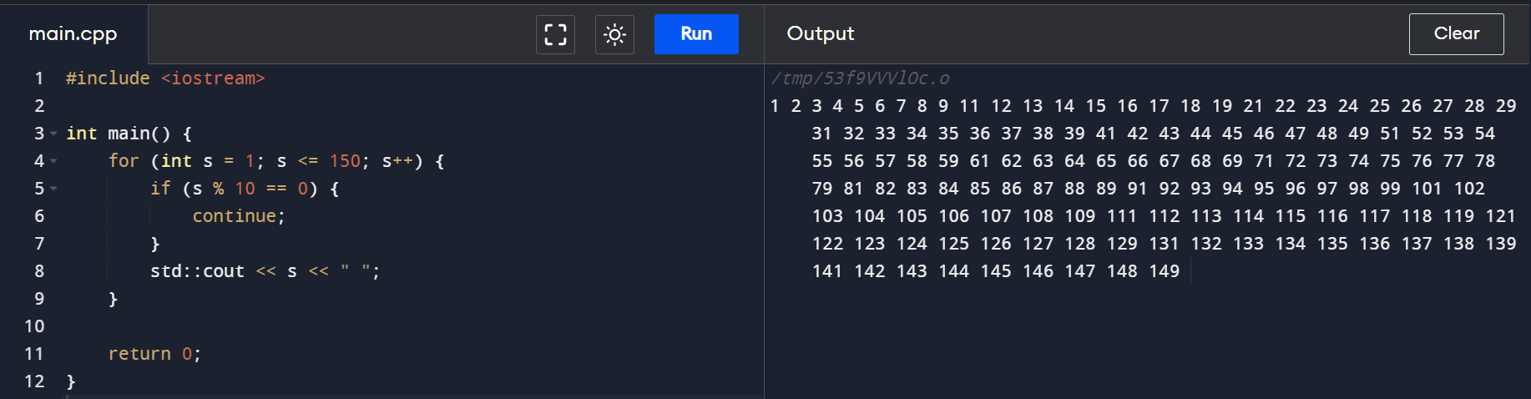

Task 2:

#include <iostream>

int main() {

int number, sum = 0;

std::cout << "Enter the number you want to use ";

std::cin >> number;

while (number != 0) {

sum += number % 10;

number /= 10;

}

std::cout << "The sum of the digits of this number is " << sum << std::endl;

return 0;

}

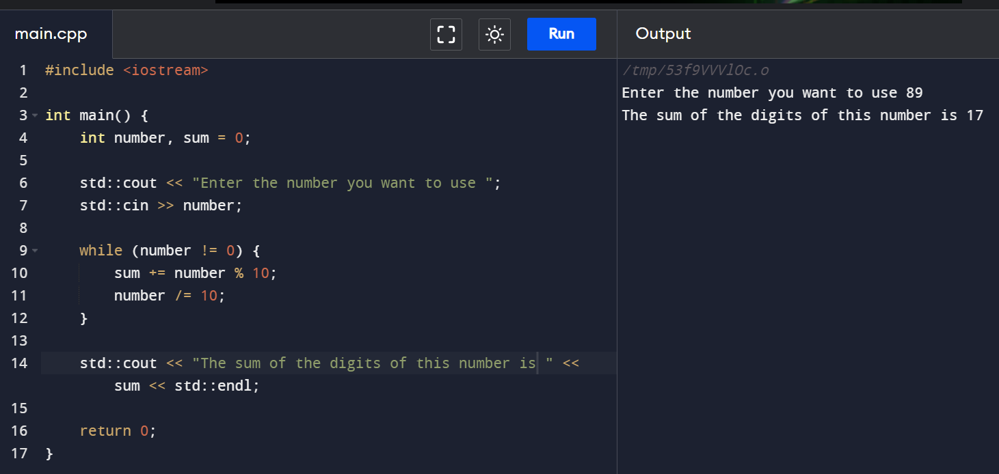

Task 3:

#include <iostream>

int main() {

int number;

bool isPrime = true;

std::cout << "Enter the number you want to use: ";

std::cin >> number;

if (number <= 1) {

isPrime = false;

}

else {

for (int s = 2; s <= number / 2; s++) {

if (number % s == 0) {

isPrime = false;

break;

}

}

}

if (isPrime) {

std::cout << "This is a prime number" << std::endl;

}

else {

std::cout << "This is not a prime number." << std::endl;

}

return 0;

}

