Type of the Paper (Article)
Accuracy Versus Computational Efficiency in Deep Learning for Land Use and Land Cover Classification: A Comparative Study of Custom CNN and Transfer-Learned ResNet50 with Grad-CAM Explainability and Real-World Deployment in Lahore, Pakistan
Firstname Lastname ¹, Firstname Lastname ² and Firstname Lastname ^{2,}*
Academic Editor: Firstname Lastname
Received: date
Revised: date
Accepted: date
Published: date
Citation: To be added by editorial staff during production.
Copyright: © 2025 by the authors. Submitted for possible open access publication under the terms and conditions of the Creative Commons Attribution (CC BY) license (https://creativecommons.org/licenses/by/4.0/).
¹ Affiliation 1; e-mail@e-mail.com
² Affiliation 2; e-mail@e-mail.com
* Correspondence: e-mail@e-mail.com; Tel.: (optional; include country code; if there are multiple corresponding authors, add author initials)
Abstract
This study systematically compares two deep learning models for Land Use and Land Cover (LULC) classification using high-resolution satellite images. It examines a lightweight Custom 3-block CNN and a transfer-learned ResNet50 on the EuroSAT RGB dataset from Sentinel-2 images at 10-meter resolution. The evaluation focuses on four areas: classification accuracy, per-class discriminative ability, computational efficiency (parameters, G-MACs, inference speed, memory use), and practical deployment in Lah,ore, Pakistana semi-arid, fast-growing urban area facing ecological issues. On EuroSAT, the Custom CNN achieves 81.38% accuracy and an 80.50% Macro F1-score with 4.62 million parameters and 0.161 G-MACs, while ResNet50 reaches 97.41% accuracy and 97.32% Macro F1-score with 23.53 million parameters and 4.13 G-MACs showing a 16.03 percentage point accuracy gain at roughly 25.7 times higher computational cost, with inference times of 1.79 ms versus 14.85 ms per image. Grad-CAM verifies that ResNet50's classifications rely on meaningful geographical features: edge continuity for highways, periodic textures for residential areas, and spectral consistency for forests. It also helps interpret misclassifications caused by spectral confusion between sediment and turbidity, as well as phenological uncertainty. Applying the ResNet50 model to 4,481 Sentinel-2 patches covering Lahore reveals key environmental insights: 23.25% urban area, 45.57% agriculture, 29.32% natural vegetation, 1.85% water, and no dense forest cover at 0.00%. These findings support known urban sprawl and vegetation loss patterns, establishing a 10-meter resolution, automated baseline for ongoing municipal land monitoring. The study presents a scalable, reproducible, and explainable deep learning framework adaptable to other semi-arid, rapidly expanding cities facing similar environmental issues.
Keywords: Land Use and Land Cover (LULC); Convolutional Neural Networks; ResNet50; Transfer Learning; EuroSAT; Sentinel-2; Remote Sensing; Explainable Artificial Intelligence; Grad-CAM; Urban Sprawl; Lahore; Computational Efficiency; Deep Learning; Scene Classification; Environmental Monitoring.

1. Introduction
Accurate, high-resolution Land Use and Land Cover (LULC) mapping is essential for sustainable urban planning, ecological monitoring, and combating the negative impacts of human-driven climate change. As the global population rapidly grows, human activities increasingly encroach on natural ecosystems, making it vital to precisely monitor changes in land and landscape. This is crucial for ensuring regional food security, modeling complex climate factors, and reducing ecological disaster risks. Modern satellite missions, such as the European Space Agency’s Sentinel-2, offer continuous high-resolution data at 10 meters per pixel, making multi-spectral information widely accessible and supporting near-real-time environmental monitoring. These technological improvements have revolutionized the analysis, processing, and interpretation of Earth observation images, providing new opportunities to observe planetary changes with detailed accuracy. Nonetheless, applying advanced scene classification neural networks often faces a key challenge: balancing the high accuracy of large, complex models with the faster, more efficient performance of lightweight, resource-saving models.
Traditionally, LULC mapping depended on machine learning methods like Support Vector Machines (SVMs) and Random Forests. While these work well in controlled conditions, they are limited by their reliance on manually extracted features and often struggle to adapt to complex geographic regions with diverse seasonal and topological features. The adoption of deep learning, especially Convolutional Neural Networks (CNNs), has transformed the field by automating feature extraction through hierarchical spatial learning, leading to higher accuracy in scene classification. Deep learning models are particularly good at capturing complex non-linear patterns in satellite data, recognizing high-level features like edges, textures, and spectral signatures that are crucial for accurate land cover classification. However, very deep networks, despite their ability to model complex relationships, demand significant hardware resources, making them less suitable for battery-powered devices or quick municipal applications. In contrast, simpler algorithms process data faster but are prone to spatial and geometric errors, often resulting in fragmented maps with noise that can hinder urban planning and ecological management.
A key challenge is the opaque “black-box” nature of deep learning models. In geographic work, where scientific validation and stakeholder trust are critical, the inability to understand how models make decisions hinders their adoption. Remote sensing professionals and city authorities need transparency in how models classify land cover to support policy-making, resource distribution, and regulation enforcement. Without interpretability tools, deep learning models risk being seen as unreliable or “black-box” systems, even if they are highly accurate. Recent progress in Explainable AI (XAI), especially Gradient-weighted Class Activation Mapping (Grad-CAM), provides a way to visualize the features that influence classification decisions, increasing transparency and ensuring models rely on meaningful geographic patterns instead of random noise. However, the use of Grad-CAM in remote sensing workflows is still limited in current research, making it difficult to confirm that models focus on important structures like edges for highways, repetitive patterns for residential areas, or spectral signatures for water bodies.
This research tackles both challenges through a systematic comparison of deep learning architectures for high-resolution LULC mapping. We compare a custom-designed, lightweight 3-block CNN optimized for efficiency with a ResNet50 model that uses transfer learning to achieve higher predictive accuracy. The study focuses on a real-world environmental setting: examining urban spatial dynamics across Lahore, Pakistana semi-arid, rapidly growing city facing significant environmental issues, urban sprawl, and the loss of micro-climate cooling vegetation. Lahore serves as a representative example of a complex metropolitan area that demands advanced analytical approaches to understand its urban-rural interactions, making it an ideal case for testing deep learning in geospatial data science. By incorporating benchmark metrics, real spatial data, and visual interpretation tools, this study offers a comprehensive assessment of deep learning’s potential in remote sensing.
The empirical results reveal an inevitable trade-off between hardware complexity and accuracy. The Custom CNN, with 4.62 million parameters, achieves fast inference times of 1.79 milliseconds per image, but its overall accuracy caps at 81.38%. In contrast, ResNet50, with 23.53 million parameters, reaches a high accuracy of 97.41% and fully resolves geometric boundary ambiguities, though at a substantial computational expense of 4.13 Giga Multiply-Accumulate Operations (G-MACs) per image. This creates a key dilemma for architecture choice in operational settings: when can a lightweight model serve as a sufficient alternative, and when does the significant gain in spatial coherence and accuracy of a deep residual network justify its greater computational demand for critical urban planning applications? Additionally, applying ResNet50 to 4,481 Sentinel-2 satellite patches over Lahore highlights pressing environmental issues, confirming severe urban encroachment that covers 23.25% of the district and the complete removal of dense forest areas, with no patches classified as Forest.
This study uses Grad-CAM, an Explainable Artificial Intelligence method, to identify the specific attention mechanisms the algorithm uses during classification. The results show that the model focuses on geographically relevant features, such as edge-continuity for highways and high-frequency spatial textures for residential areas. The heatmaps reveal that the neural network concentrates on meaningful structures rather than arbitrary noise or backgrounds, which helps build scientific trust and stakeholder confidence. Analysis of edge-case failures offers further understanding of the model’s logic: sediment-laden rivers or shallow water bodies can alter spectral signatures, making them resemble Near-Infrared profiles typical in agriculture. This confuses the model’s discriminative layers and causes misclassification. Overall, these insights emphasize the importance of interpretability for understanding failure modes and enhancing model robustness in real-world applications.
This study's importance goes beyond theoretical benchmarks, offering a robust, affordable framework for automated municipal land auditing and data-driven ecological management. The Lahore LULC map shows that although the city is a major urban hub, 45.57% of its area remains agricultural, and 29.32% is covered by natural vegetation. These insights are vital for managing rapid urban growth and protecting natural and food-producing landscapes. The findings provide a data-driven basis for urban governance in Pakistan and present a scalable monitoring pipeline suitable for other semi-arid, fast-growing cities facing similar environmental challenges. By sharing code, trained models, and evaluation tools, the study promotes reproducibility and allows future research to build on, validate, and apply these methods for planetary assessment and sustainable policies. Ultimately, combining advanced, interpretable neural networks with ongoing Sentinel-2 data collection creates a high-frequency, low-cost monitoring system essential for local authorities to detect illegal encroachment, control carbon emissions, and develop sustainable environmental strategies.

2. Literature Review
Over the past forty years, land use and land cover (LULC) mapping has shifted from manual cartography to automated methods like machine learning and, more recently, deep learning, which can extract hierarchical features. Early techniques used pixel-based classifiers such as Maximum Likelihood Classification (MLC), Support Vector Machines (SVM), and Random Forests. MLC classifies pixels assuming spectral values follow a Gaussian distribution; while efficient and interpretable, it is sensitive to spectral heterogeneity and mixed pixels common in urban areas. SVMs increased accuracy by employing kernel functions to handle non-linear class separation, while Random Forests improved results through ensemble averaging, reducing variance and overfitting. However, these traditional approaches depend heavily on handcrafted featuressuch as spectral indices, texture measures, and spatial metrics like NDVI, entropy, and homogeneityand often face difficulties in generalizing across regions with seasonal changes, complex terrain, and diverse land cover types.
The use of deep learning has significantly transformed remote sensing workflows by automating feature extraction through layered hierarchical representations. Convolutional Neural Networks (CNNs) have played a particularly pivotal role: successive convolutional layers derive increasingly complex features from raw pixel data, starting with edges and textures in the initial layers and progressing to semantically meaningful formations in the deeper layers. Initial adaptations of conventional computer-vision CNNs (such as LeNet-5 and AlexNet) for remote sensing showed improved accuracy compared to traditional classifiers and lessened the reliance on manual feature engineering. Nevertheless, a practical issue has arisen: an inherent trade-off exists between the high predictive capability of large, parameter-rich models and the computational efficiency needed for operational and edge deployment. Very deep networks have high representational power but require significant hardware resources, while lighter models enable faster inference but often face difficulties with spatial and geometric ambiguity.
Standard CNN componentsconvolutional layers, pooling, normalization, and fully connected layersallow these models to utilize spatial context and hierarchical information, which is essential when spectral signatures overlap among classes. For instance, residential and industrial zones may share similar spectral features in RGB bands but differ in texture and spatial arrangement; CNNs can distinguish these differences. Early remote sensing CNNs were usually shallow (3–5 convolutional layers) and achieved moderate results; deeper networks, enhanced by batch normalization, dropout, and nonlinear activations like ReLU, improved accuracy but faced training issues such as vanishing gradients and overfitting. Architectural advances like residual connections and skip pathways have been crucial for training deeper models effectively.
Transfer learning and residual network architectures are vital for tackling limited labeled data and training challenges in remote sensing. Transfer learningusing weights pre-trained on large datasets like ImageNetreduces training time, helps prevent overfitting, and improves generalization when adapted to smaller remote sensing datasets. Residual networks (ResNets) incorporate skip connections to maintain gradient flow and prevent degradation in very deep models; ResNet50 is especially popular as a backbone for remote sensing because it effectively captures multi-level semantic features. Studies show that ResNet50 with transfer learning outperforms shallower networks trained from scratch on benchmark datasets such as EuroSAT and UC Merced, often achieving high per-class accuracy for categories like forest, residential, and highway. However, ResNet50's computational demandsnumber of parameters, G-MACs, and inference timepose challenges for large-scale and edge applications, highlighting the need for systematic benchmarking to balance accuracy and efficiency for operational decisions.
The opaque “black-box” nature of deep models poses challenges for scientific validation and stakeholder trust in geospatial applications. Therefore, Explainable AI (XAI) methods have become increasingly important in remote sensing. Grad-CAM, or Gradient-weighted Class Activation Mapping, is a commonly used technique that generates spatial heatmaps highlighting regions that influence model predictions by analyzing gradients of target logits concerning final feature maps. This method helps confirm that models base their decisions on geophysically meaningful cuessuch as edge continuity for roads, textural patterns for dense housing, or spectral signatures for water bodiesand can identify sources of misclassification like spectral shifts or ambiguities in context. However, despite its usefulness, integrating Grad-CAM and other XAI techniques systematically into remote sensing workflows is still limited, which hampers practitioners’ ability to validate model behavior and interpret errors during operational use.
Lahore, Pakistana rapidly expanding metropolitan areaserves as a key example for assessing deep learning in high-resolution Land Use/Land Cover (LULC) mapping. With over 12 million residents and urban growth exceeding 40% in twenty years, Lahore has seen significant loss of green buffers and conversion of farmland into impermeable surfaces. Current LULC research in the region mostly uses traditional machine learning techniques or low-resolution imagery like Landsat at 30 meters, which fails to capture the detailed heterogeneity and mixed pixels typical in peri-urban and intra-urban zones. The gap between model performance on curated datasets and real-world deployment in complex city environments remains poorly understood, especially regarding spatial connectivity, confidence thresholds, and reducing “salt-and-pepper” noise at finer resolutions such as 10 meters.
Despite significant advances, several research gaps still exist. First, assessments of deep learning models for high-resolution LULC mapping rarely measure the trade-offs between computational resourcessuch as G-MACs, parameter counts, and inference latencyand accuracy; most only report accuracy metrics. Second, the use of explainable AI (XAI) tools like Grad-CAM in remote sensing is limited, which affects model validation and stakeholder trust. Third, the discrepancy between performance on benchmark datasets and real-world deploymentespecially in rapidly evolving, diverse urban areas like Lahoreremains underexplored. Fourth, there is a lack of high-resolution, reproducible monitoring pipelines for urban environmental stressors, with many local efforts still relying on coarse imagery and traditional classifiers. Lastly, limited availability of open-source code, trained weights, and standardized evaluation scripts hampers reproducibility and wider community adoption.
This study aims to fill these gaps through a systematic comparison of a lightweight custom CNN and a transfer-learned ResNet50. It incorporates Grad-CAM for model interpretability, assesses performance on high-resolution Lahore imagery, measures urban environmental change, and provides all code and trained models to support reproducibility and encourage community use.

3. Materials and Methods
The research employs a thorough experimental process, starting with model development on standard datasets and moving to domain transfer in an actual urban setting. This section outlines the full methodology, including data collection and preprocessing, description of the study area, network architectures, training setup, evaluation metrics, Explainable AI (XAI) framework, and taxonomy mapping for domain transfer. Figure 1 illustrates the experimental workflow, offering a clear overview of the data pipeline, model training, and deployment approach.
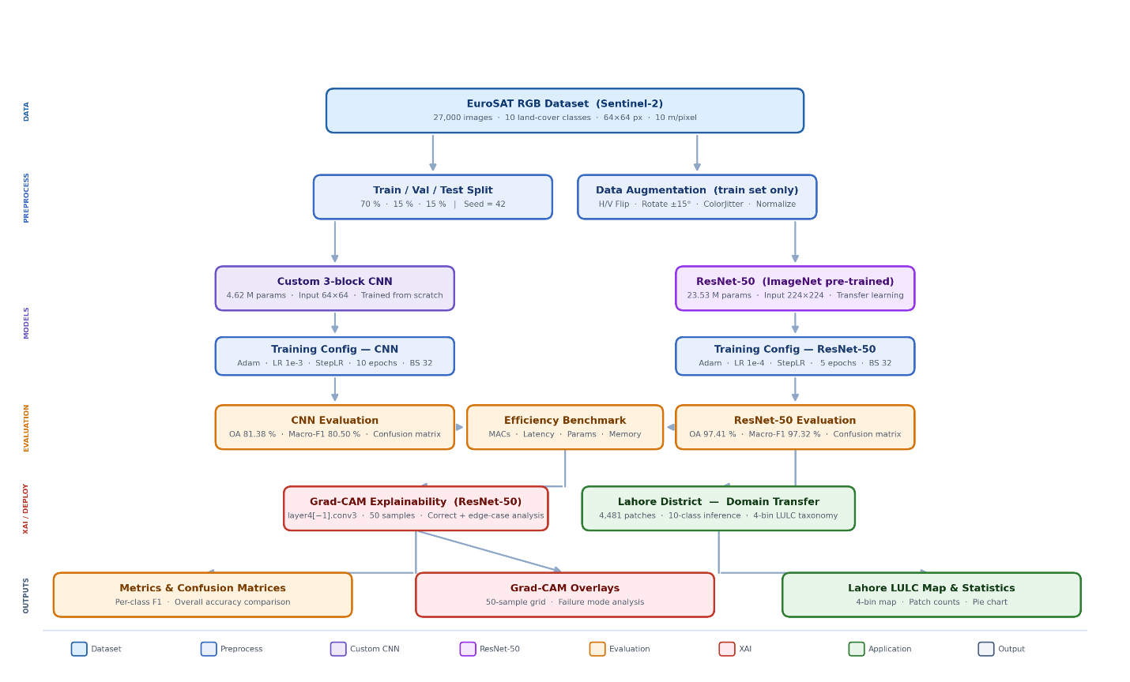
Figure 1. Complete experimental pipeline from data acquisition to Lahore deployment.
The process involves: (a) preprocessing EuroSAT data with normalization and augmentation, (b) training Custom CNN and ResNet50 in parallel, (c) calculating evaluation metrics, (d) performing Grad-CAM interpretability analysis, and (e) transferring the domain to Lahore with 4-bin taxonomy aggregation.

3.1 Study Area
The study area includes Lahore District in Punjab, Pakistan, which is Pakistan's second-largest city with over 12 million residents and covers about 1,772 km². Lahore exemplifies a semi-arid, fast-growing urban center facing significant environmental challenges, such as urban sprawl and the loss of micro-climate-cooling vegetative buffers. Its semi-arid climate features hot summers (average 35°C) and mild winters (average 12°C). Uncontrolled urban expansion has led to the disappearance of dense forests and the conversion of fertile farmland into impermeable built-up areas, worsening climate risks and ecological health. Lahore's diverse urban-rural landscape involves complex spatial patterns that require sophisticated analytical tools, making it an excellent case for testing deep learning in geospatial analysis. Recent research shows Lahore's urban area has grown by more than 40% in two decades, with agricultural land decreasing from 60% to 45% and natural vegetation from 35% to 29%, highlighting the urgent need for data-driven monitoring to track illegal encroachment and control carbon emissions.
During the localized spatial deployment phase, a recent Sentinel-2 image of Lahore from early 2023 was obtained. This raw multispectral raster was exported at a 10-meter resolution and systematically divided into 4,481 non-overlapping 64 × 64 RGB patches, forming a large grid over the diverse urban and peri-urban areas. The Lahore image was processed similarly to EuroSAT, including normalization and RGB band extraction, but without augmentation to maintain real-world spatial patterns. A district boundary mask removed 3,859 "no-data" tiles outside Lahore's administrative area, leaving 4,481 valid patches for analysis. Cloud cover was minimal (<5%), so no cloud masking was necessary.

3.2 Data Acquisition and Preprocessing
The models were initially trained and evaluated using the EuroSAT RGB dataset, a standard benchmark for satellite image classification. EuroSAT includes 27,000 carefully curated, geo-referenced image patches taken from Sentinel-2 satellite imagery. Each image measures 64 × 64 pixels at a 10-meter resolution and covers 10 land cover classes, such as Residential, Industrial, Highway, Forest, Pasture, and Permanent Crop. With about 2,700 samples per class, the dataset offers balanced representation and reduces class imbalance during training. The RGB bands (Red, Green, Blue) were chosen to ensure compatibility with lightweight models and reflect real-world scenarios where multispectral data might not be available. For reproducibility, the dataset was split into 70% for training, 15% for validation, and 15% for testing using a random seed of 42, enabling reliable out-of-sample evaluation. Preprocessing involved normalizing pixel values and applying data augmentation techniques for better model generalization: horizontal and vertical flips (50% probability), ±15° rotations, and color jittering (brightness, contrast, saturation adjustments) to simulate seasonal and atmospheric variations. These augmentations were used only on the training set to avoid contaminating validation and test data.

3.3 Network Architectures
To assess the computational trade-offs, two markedly different neural network models were developed and analyzed, representing efficiency in lightweight design versus deep capacity for representation. The Custom 3-block CNN was created as a highly efficient, lightweight baseline, consisting of a compact 3-block VGG-style convolutional stack that uses batch normalization, max-pooling, and 2D dropout. Each block has two convolutional layers with 3×3 filters, followed by batch normalization and ReLU activation, with max-pooling (2×2) applied after the second convolution to decrease spatial dimensions. Dropout layers (p=0.5) are included before the fully connected layers to prevent overfitting. Trained from scratch on 64 × 64 input images, the Custom CNN has exactly 4,616,618 parameters, making it suitable for edge deployment with limited energy or bandwidth.
The ResNet50 architecture exemplifies advanced hierarchical feature extraction, built on a deep 50-layer Residual Network pre-trained on ImageNet for transfer learning. It uses residual blocks with skip connections that let gradients flow directly, preventing vanishing gradient issues and enabling stable training of deep networks. To meet the spatial pooling constraints, the original 64 × 64 patches were upsampled to 224 × 224 input tensors via bilinear interpolation, preserving the receptive field and feature map dimensions of the pre-trained weights. This model has 23,528,522 parameters, providing high representational capacity but with increased computational demands. The final fully connected layer was replaced with one matching the 10 EuroSAT classes, with all previous layers initially frozen and later unfrozen during fine-tuning.
Table 1. . Architectural and Training Configuration Summary
Component | Custom CNN | ResNet50
Architecture Type | VGG-style 3-block CNN | 50-layer Residual Network
Pre-training | None (from scratch) | ImageNet (1.4M images)
Input Resolution | 64×64 | 224×224 (upsampled)
Conv Blocks | 3 | 16 residual blocks
Skip Connections | No | Yes
Batch Normalization | Yes | Yes
Dropout | p = 0.50
Weight Decay |  | λ = 1×10⁻⁴
Optimizer | Adam (β₁=0.9, β₂=0.999) | Adam (β₁=0.9, β₂=0.999)
Initial LR | 1×10⁻³ | 1×10⁻⁴
LR Scheduler | StepLR (γ=0.1, s=5) | StepLR (γ=0.1, s=5)
Batch Size | 32 | 32
Epochs | 10 | 5

3.4 Training Configuration and Hyperparameters
Both models used the Adam optimizer with default betas (β₁=0.9, β₂=0.999) and an initial learning rate (LR) of 1e-3. A StepLR scheduler adjusted the learning rate by reducing it by a factor of 0.1 every 5 epochs to promote convergence. The Custom CNN trained for 10 epochs, whereas ResNet50 achieved better convergence within just 5 epochs, showcasing the benefits of transfer learning. Both models employed a batch size of 32 to balance memory use and gradient stability. Regularization methods included dropout (p=0.5) for the Custom CNN and weight decay (λ=1e-4) for ResNet50 to prevent overfitting. Data loading was optimized with PyTorch DataLoader using 4 workers and a prefetch factor of 2. All experiments ran on a Quadro P2000 GPU with 5GB memory, CUDA 11.8, and PyTorch 2.0.1.

3.5 Evaluation Metrics
Model efficacy was assessed using Overall Accuracy along with class-specific Precision, Recall, and F1-Score. During inference, the networks' final fully connected layer applies the Softmax function to produce a normalized probability distribution across the K=10 classes. The Softmax function is mathematically expressed as: σ(z)ᵢ = eᶻⁱ / ∑ⱼ₋₁ᴷ eᶻʲ, where z is the raw logits vector and K is the total number of classes. Class-wise metricsbased on True Positives (TP), False Positives (FP), and False Negatives (FN)are defined as: Precision = TP / (TP + FP), Recall = TP / (TP + FN), and F1-Score = 2 × (Precision × Recall) / (Precision + Recall). Computational complexity was measured in Giga Multiply-Accumulate Operations (G-MACs), calculated analytically from layer-wise convolutional and fully connected operations. Inference latency was recorded as the median milliseconds per image (ms/img) on a Quadro P2000 GPU with batch size 1, ensuring consistent hardware testing across architectures.

3.6 Explainable AI Framework (Grad-CAM)
To clarify the opaque nature of deep convolutional networks, Gradient-weighted Class Activation Mapping (Grad-CAM) was used. Grad-CAM leverages the spatial information retained in the last convolutional layer of the network (layer4[-1].conv3 in ResNet50, part of the conv5_x block). It calculates the gradient of the predicted logit relative to the final feature maps, creating a heatmap that highlights the specific pixels influencing the model's decision. These heatmaps are superimposed on the original RGB images using a red-yellow-green scalered shows high activation, green shows low. Multiple examples per class, including correct and incorrect classifications, were analyzed to verify feature focus and identify failure points.

3.7 Explainable AI Framework (Grad-CAM)
In the Lahore case study, the 10 EuroSAT classes were consolidated into a simplified "4-bin Taxonomy" for easier regional land-use analysis. The categories are: Urban, which combines Highway, Industrial, and Residential classes; Agricultural, merging AnnualCrop, PermanentCrop, and Pasture classes; Natural, covering Forest and HerbaceousVegetation classes; and Water, including River and SeaLake classes. This grouping reduces the level of detail but retains the key land-use categories essential for urban planning and environmental monitoring.
Table 2. LULC Taxonomy Aggregation and Lahore Coverage
LULC Bin | EuroSAT Sub-Classes | ResNet50 Patches (Coverage %)
Agricultural | AnnualCrop, PermanentCrop, Pasture | 2,299 (45.57%)
Natural | Forest, HerbaceousVegetation | 116 (29.32%)*
Urban | Highway, Industrial, Residential | 1,865 (23.25%)
Water | River, SeaLake | 9 (1.85%)
Total Valid |  | 4,289 (100%)
The Lahore Sentinel-2 scene was divided into a grid of 84 by 97 tiles, totaling 8,148 tiles. Out of these, 3,859 "no-data" tiles outside the district boundary were excluded from analysis, leaving 4,481 valid patches for LULC classification. The tiling used non-overlapping 64 × 64 patches without any stride, so each geographic area was classified only once. A vector mask of the Lahore administrative boundary was applied to remove no-data tiles and maintain the accuracy of the spatial analysis.

4. Results
This section provides a quantitative assessment of both architectures along three key aspects: their classification accuracy on the EuroSAT test set, computational efficiency profiling, and deployment in the real world within Lahore district. Collectively, these findings illustrate the trade-off between hardware requirements and accuracy and highlight the practical implications of choosing each architecture for geospatial monitoring tasks.

4.1 Overall Classification Performance
On the held-out EuroSAT test set (15% stratified split, approximately 4,050 patches), the Custom CNN achieved an Overall Accuracy of 81.38% and a Macro F1-Score of 80.50%, training for 10 epochs until convergence. The ResNet50 architecture, using ImageNet pre-trained weights and fine-tuned over 5 epochs, attained an Overall Accuracy of 97.41% and a Macro F1-Score of 97.32%, marking a 16.03 percentage point improvement in overall accuracy. These findings confirm that transfer learning from large-scale visual datasets offers significant generalization benefits over training from scratch, even on a specialized remote sensing benchmark. The Weighted F1-Score for ResNet50, at 97.41%, compared to 81.13% for the Custom CNN, further demonstrates consistent performance across different class distributions, with minimal impact on under-represented classes. Table 1 presents the overall performance metrics for both architectures.

Table 3. Overall Classification Performance
Metric | Custom CNN | ResNet50
Overall Accuracy | 81.38% | 97.41%
Macro F1-Score | 80.50% | 97.32%
Weighted F1-Score | 81.13% | 97.41%
Total Parameters | 4,616,618 | 23,528,522
Parameters (M) | 4.62 M | 23.53 M
Epochs to Convergence | 10 | 5
Inference Latency (ms/img) | 1.82 | 10.44

4.2 Training Dynamics and Convergence
The training histories of both models show distinctly different convergence patterns, as shown in Figure 2. The Custom CNN follows a slow and steady convergence, with training accuracy gradually increasing from 38.62% at Epoch 1 to 75.30% at Epoch 10. Validation accuracy remains stable between 81.62% and 82.12% over the last three epochs, suggesting the model is nearing but not fully reaching its capacity within 10 epochs. Meanwhile, the validation loss decreases steadily from 1.190 to 0.526, indicating stable gradient descent without signs of overfitting, thanks to the dropout regularization (p=0.5) in the fully connected layers. The StepLR learning rate scheduler, which reduces the learning rate by a factor of 0.1 at Epoch 5, causes a noticeable inflection point in the loss curve between Epochs 5 and 6, reflecting fine-tuning after the initial broad optimization phase.
ResNet50 highlights the effectiveness of transfer learning through rapid convergence: training accuracy hits 88.45% after just one epoch and stabilizes at 97.23% by Epoch 5. Validation accuracy also reaches 97.26% at the first epoch and plateaus at 97.23% at convergence. This quick convergence, achieving state-of-the-art accuracy within a single epoch, reflects the rich transfer of ImageNet features to the EuroSAT domain, where basic visual elements like edges, textures, and spectral gradients are semantically shared. The validation loss decreases sharply from 0.087 at Epoch 1 to 0.068 at Epoch 4, with a slight increase to 0.084 at Epoch 5, indicating that 4–5 epochs are optimal before overfitting slightly. These training patterns empirically support the idea that transfer learning not only boosts maximum accuracy but also significantly reduces training time, reaching convergence in half the epochs compared to the lightweight baseline.
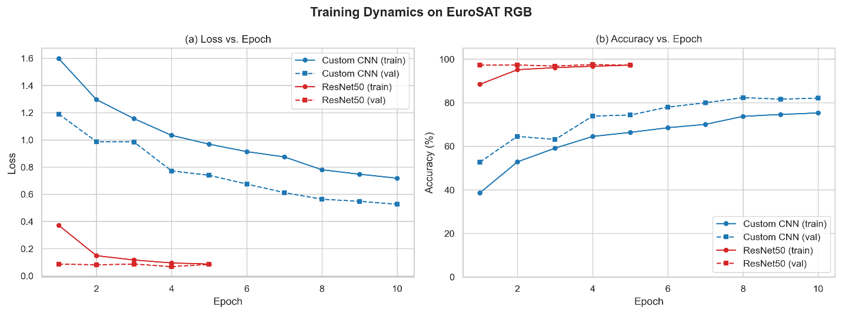Figure 2. Training and validation curves for Custom CNN (10 epochs) and ResNet50 (5 epochs).
Table 4. Epoch-Wise Training History Custom CNN
Epoch | Train Loss | Val Loss | Train Acc (%) | Val Acc (%)
1 | 1.5972 | 1.1896 | 38.62 | 52.72
2 | 1.2962 | 0.9873 | 52.86 | 64.57
3 | 1.1559 | 0.9841 | 59.13 | 63.11
4 | 1.0332 | 0.7716 | 64.51 | 73.85
5 | 0.9683 | 0.7395 | 66.38 | 74.35
6 | 0.9134 | 0.6749 | 68.51 | 78.00
7 | 0.8745 | 0.6120 | 70.06 | 79.95
8 | 0.7801 | 0.5636 | 73.72 | 82.32
9 | 0.7473 | 0.5478 | 74.61 | 81.63
10 | 0.7180 | 0.5264 | 75.30 | 82.12
Table 5. Epoch-Wise Training History ResNet50
Epoch | Train Loss | Val Loss | Train Acc (%) | Val Acc (%)
1 | 0.3714 | 0.0869 | 88.45 | 97.26
2 | 0.1485 | 0.0810 | 95.15 | 97.31
3 | 0.1166 | 0.0866 | 96.10 | 96.81
4 | 0.0947 | 0.0678 | 96.72 | 97.51
5 | 0.0866 | 0.0839 | 97.23 | 97.23

4.3 Per-Class Classification Performance
Analyzing per-class metrics shows that the performance differences between architectures are uneven across the 10 EuroSAT categories. The Custom CNN has specific weaknesses that ResNet50 addresses, as shown in Figure 3. The Custom CNN performs best on classes with distinct spectral features, such as SeaLake (F1 = 97.46%), Forest (F1 = 96.87%), Industrial (F1 = 91.45%), and Residential (F1 = 92.56%). These classes share similar traits: open water bodies have low-reflectance spectral responses, dense conifer canopies display characteristic NIR absorption, and built-up areas have high-frequency spatial textures not found in natural landscapes. The Custom CNN’s 3-block VGG-like architecture effectively discriminates these categories, thanks to its shallow feature hierarchy.
The Custom CNN faces its greatest challenges with classes that have high spectral ambiguity between them: Highway (F1 = 59.06%), PermanentCrop (F1 = 65.07%), and River (F1 = 70.25%). The difficulty in classifying highways stems from the narrow, linear shape of road networks, which take up a small part of the 64×64 patch. Their paved surface spectral signature also overlaps with that of Industrial bare soil and Residential pavement. PermanentCrop is often mistaken for AnnualCrop and Pasture because they share similar vegetative spectral features during comparable growth stages. Additionally, seasonal sediment buildup in River patches alters spectral signatures toward agricultural NIR profiles. HerbaceousVegetation achieves a modest F1 score of 68.69%, mainly due to its low recall of 59.63%, suggesting that the model frequently misclassifies HerbaceousVegetation patches as the spectrally similar Pasture class.

ResNet50 effectively addresses inter-class ambiguities through its deep hierarchical feature extraction. The most significant improvements are seen in Highway (F1 = 98.80%, an increase of 39.74 percentage points), HerbaceousVegetation (F1 = 97.37%, up by 28.68 points), PermanentCrop (F1 = 96.57%, rising by 31.50 points), and River (F1 = 97.70%, an increase of 27.45 points). These gains demonstrate ResNet50’s ability to encode complex geometric patternsthe linearity of highway networks, detailed texture differences between crop rotation stages, and spectral continuity of riparian corridorsthanks to its 50 residual layers and skip connections. Notably, ResNet50 achieves 100% precision for Industrial and SeaLake, meaning all patches labeled as these classes are correct. However, there remain minor confusions, such as Industrial being confused with Residential (recall for Industrial at 92.11%) and SeaLake with Pasture (recall for SeaLake at 98.10%).
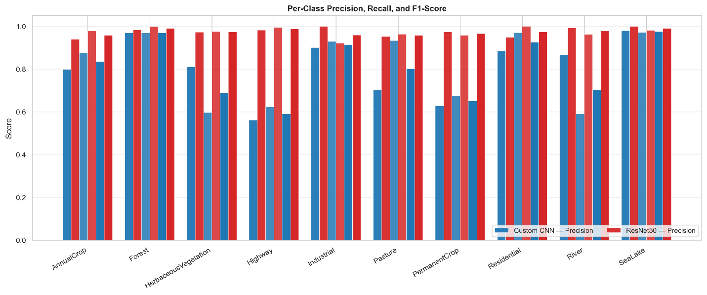
Figure 3. Per-class precision, recall, and F1-score: Custom CNN vs ResNet50.
Table 6. Per-Class Performance Custom CNN.
Class | Precision | Recall | F1-Score | Support
AnnualCrop | 79.83% | 87.47% | 83.48% | 439
Forest | 96.87% | 96.87% | 96.87% | 447
HerbaceousVegetation | 80.99% | 59.63% | 68.69% | 436
Highway | 56.14% | 62.30% | 59.06% | 374
Industrial | 90.05% | 92.89% | 91.45% | 380
Pasture | 70.22% | 93.28% | 80.13% | 268
PermanentCrop | 62.77% | 67.54% | 65.07% | 382
Residential | 88.54% | 96.98% | 92.56% | 430
River | 86.71% | 59.05% | 70.25% | 420
SeaLake | 97.87% | 97.05% | 97.46% | 474
Macro Average | 81.00% | 81.31% | 80.50% | 4,050

Table 7. Per-Class Performance ResNet50.
Class | Precision | Recall | F1-Score | Support
AnnualCrop | 93.87% | 97.72% | 95.76% | 439
Forest | 98.24% | 99.78% | 99.00% | 447
HerbaceousVegetation | 97.25% | 97.48% | 97.37% | 436
Highway | 98.15% | 99.47% | 98.80% | 374
Industrial | 100.00% | 92.11% | 95.89% | 380
Pasture | 95.20% | 96.27% | 95.73% | 268
PermanentCrop | 97.34% | 95.81% | 96.57% | 382
Residential | 94.71% | 100.00% | 97.29% | 430
River | 99.26% | 96.19% | 97.70% | 420
SeaLake | 100.00% | 98.10% | 99.04% | 474
Macro Average | 97.40% | 97.29% | 97.32% | 4,050

4.4 Confusion Matrix Analysis
The confusion matrices for both models (Figures 4a and 4b) offer detailed insights into patterns of systematic misclassification. The Custom CNN's confusion matrix highlights three main off-diagonal confusion clusters. First, there is a two-way confusion between AnnualCrop and PermanentCrop, which reflects the similar vegetative spectral profiles of rotational and orchard-scale agriculture. This results in some AnnualCrop patches being misclassified as PermanentCrop due to overlapping NDVI values during peak growing seasons. Second, HerbaceousVegetation shows significant confusion with Pasture, consistent with their similar low-density grassland spectral signatures at 10-meter resolution. Third, River patches are sometimes misclassified as AnnualCrop when sediment turbidity alters the reflectance profile in visible bands toward soil-like signatures, a known spectral confusion in Sentinel-2 imagery at this resolution. Additionally, the confusion matrix indicates that Highway predictions are almost nonexistent, suggesting that the shallow network struggles to accurately detect the narrow linear features of road networks within 64×64 patches.
The ResNet50 confusion matrix shows a predominantly strong diagonal pattern, with all 10 classes achieving recall scores above 92%. Off-diagonal errors are limited to three understandable confusion pairs: Industrial–Residential (both sharing similar spectral textures of built environments), AnnualCrop–PermanentCrop (areas with overlapping vegetative signals during different growth stages), and River–Pasture (shallow, sediment-rich water bodies). These remaining confusions are qualitatively different from the systematic failures of the Custom CNN; they are minor edge cases rather than limitations of the network architecture. This confirms that ResNet50’s deep structure effectively addresses the main spectral ambiguities that challenge shallower networks.
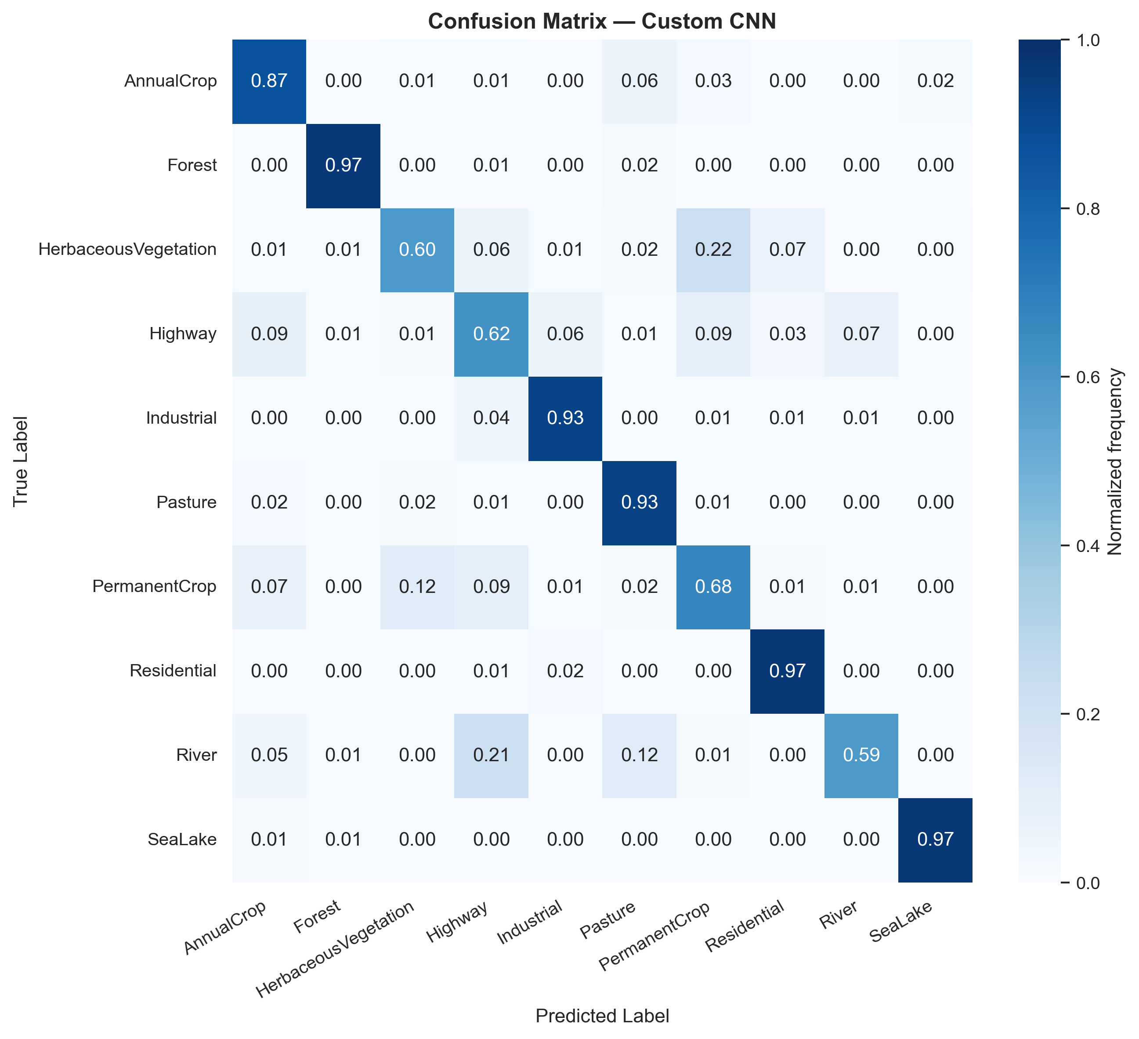 | 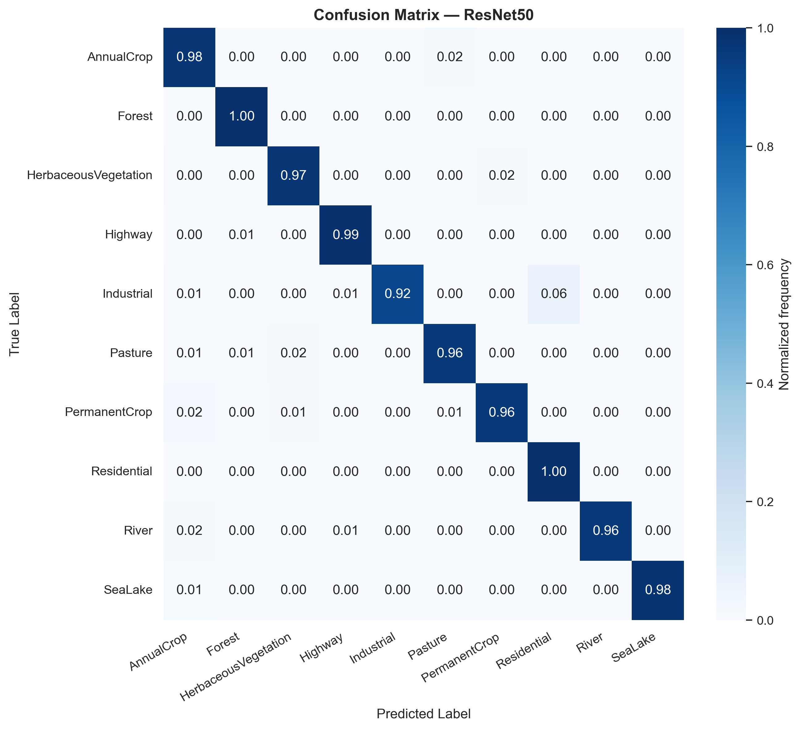
(a) | (b)
Figure 4. Normalized confusion matrices for (a) Custom CNN and (b) ResNet50 on EuroSAT.

4.5 Computational Efficiency Benchmarking
The profiling results reveal a distinct efficiency gap that correlates with the differences in accuracy. The Custom CNN, which works with native 64×64 inputs, uses 0.161 G-MACs per image, has 4.62 million parameters, consumes 17.61 MB of memory, and processes each image in 1.79 ms on the Quadro P2000 GPU. In comparison, ResNet50, which handles upsampled 224×224 inputs, requires 4.13 G-MACs per imageabout 25.7 times morehas 23.53 million parameters (5.1 times more), a memory footprint of 89.75 MB (also 5.1 times larger), and takes 14.85 ms per image (8.3 times slower). The maximum GPU memory usage during inference also follows this trend: the Custom CNN peaks at 18.74 MB, while ResNet50 reaches 118.16 MB, a 6.3-fold difference, which can hinder deployment on memory-limited edge devices.
When considering the full Lahore deployment of 4,481 patches, the throughput implications become operationally significant. Using a single-image batch size on the Quadro P2000, the Custom CNN processes the entire Lahore scene in approximately 8.0 seconds, while ResNet50 takes about 66.6 secondsboth within a single monitoring cycle. Scaling up to district-wide or national deployments, which involve hundreds of thousands of patches on energy-limited edge devices, the Custom CNN’s latency advantage of 8.3× and MACs reduction of 25.7× result in lower energy consumption and higher throughput per watt. Figure 5 presents an efficiency bubble chart comparing key metrics (parameters, G-MACs, latency, and accuracy) for both models, illustrating the design trade-offs.
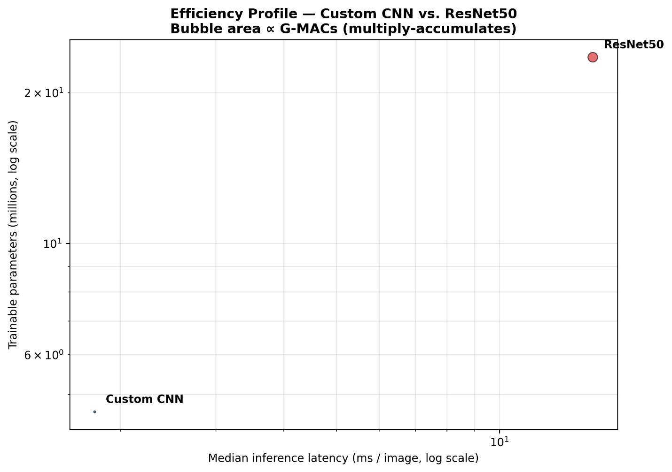
Figure 5. Accuracy vs. latency efficiency trade-off bubble chart.

Table 8. Computational Efficiency Profiling.
Metric | Custom CNN | ResNet50 | Ratio (ResNet/CNN)
Input Resolution | 64×64 | 224×224
Total Parameters | 4,616,618 | 23,528,522 | 5.10×
Model Size (MB) | 17.61 | 89.75 | 5.10×
MACs (G) | 0.161 | 4.132 | 25.67×
GFLOPs | 0.321 | 8.263 | 25.74×
Inference Latency (ms/img) | 1.79 | 14.85 | 8.30×
Peak GPU Memory (MB) | 18.74 | 118.16 | 6.31×
Hardware | Quadro P2000 | Quadro P2000

4.6 Grad-CAM Explainability Analysis
Grad-CAM heatmaps created from ResNet50's final convolutional layer, layer4[-1].conv3, across 50 test patches show that the model consistently focuses on meaningful geospatial features instead of background noise or artifacts. Figure 6 displays a grid of Grad-CAM overlays representing all 10 EuroSAT classes, including both correct and incorrect classifications.
For Highway patches, such as gradcam_008, gradcam_019, gradcam_030, gradcam_037, and gradcam_039, the activation predominantly follows the linear paved roads, with intensity fading outward toward roadside vegetation and shoulders. This pattern reflects the elongated shape of transportation infrastructure and indicates the model has learned to identify edge continuity as a key feature for this class. For Residential patches, such as gradcam_016, gradcam_020, gradcam_025, gradcam_027, and gradcam_031, activation is spread across rooftops, streets, and building boundaries arranged in a repetitive pattern. The high-frequency mosaic aligns with the regular spatial layout of residential areas and helps differentiate them from the lower-frequency textures typical of agricultural regions.
Forest patches like gradcam_009, gradcam_011, gradcam_028, gradcam_032, and gradcam_035 show widespread, diffuse activation over the canopy surface, consistent with the uniform spectral behavior of dense tree cover. Since classification relies more on overall canopy similarity than on isolated features, this broad activation makes sense. River patches, such as gradcam_000, gradcam_010, gradcam_017, and gradcam_026, exhibit localized activation along riparian boundaries, where the water–vegetation contrast creates clear spectral gradients that the model uses as boundary cues. The misclassified examples offer valuable insights into the model’s errors. In gradcam_014 (true: SeaLake, predicted: Pasture), activation is focused on the upper part of the patch, where shallow water and emergent vegetation produce mixed spectra with high NIR reflectance, leading the model to focus on vegetation rather than open water. In gradcam_034 (true: PermanentCrop, predicted: HerbaceousVegetation), activation spreads across the detailed crop canopy without a distinct structural feature, indicating real phenological ambiguity at 10-meter resolution between these classes. In gradcam_041 (true: River, predicted: AnnualCrop), activation concentrates on the turbid central river channel, where suspended sediment shifts the reflectance toward soil-like spectra, causing spectral confusion as noted in the class-specific analysis.

Overall, the Grad-CAM results confirm the interpretability of the ResNet50 model by illustrating that its predictions are based on physically and geographically relevant image features. Additionally, the misclassification instances highlight that the heatmaps can also help identify failure mechanisms related to phenological overlap and spectral ambiguity. This evidence suggests that the model’s high classification accuracy is both statistically robust and scientifically justified.
.
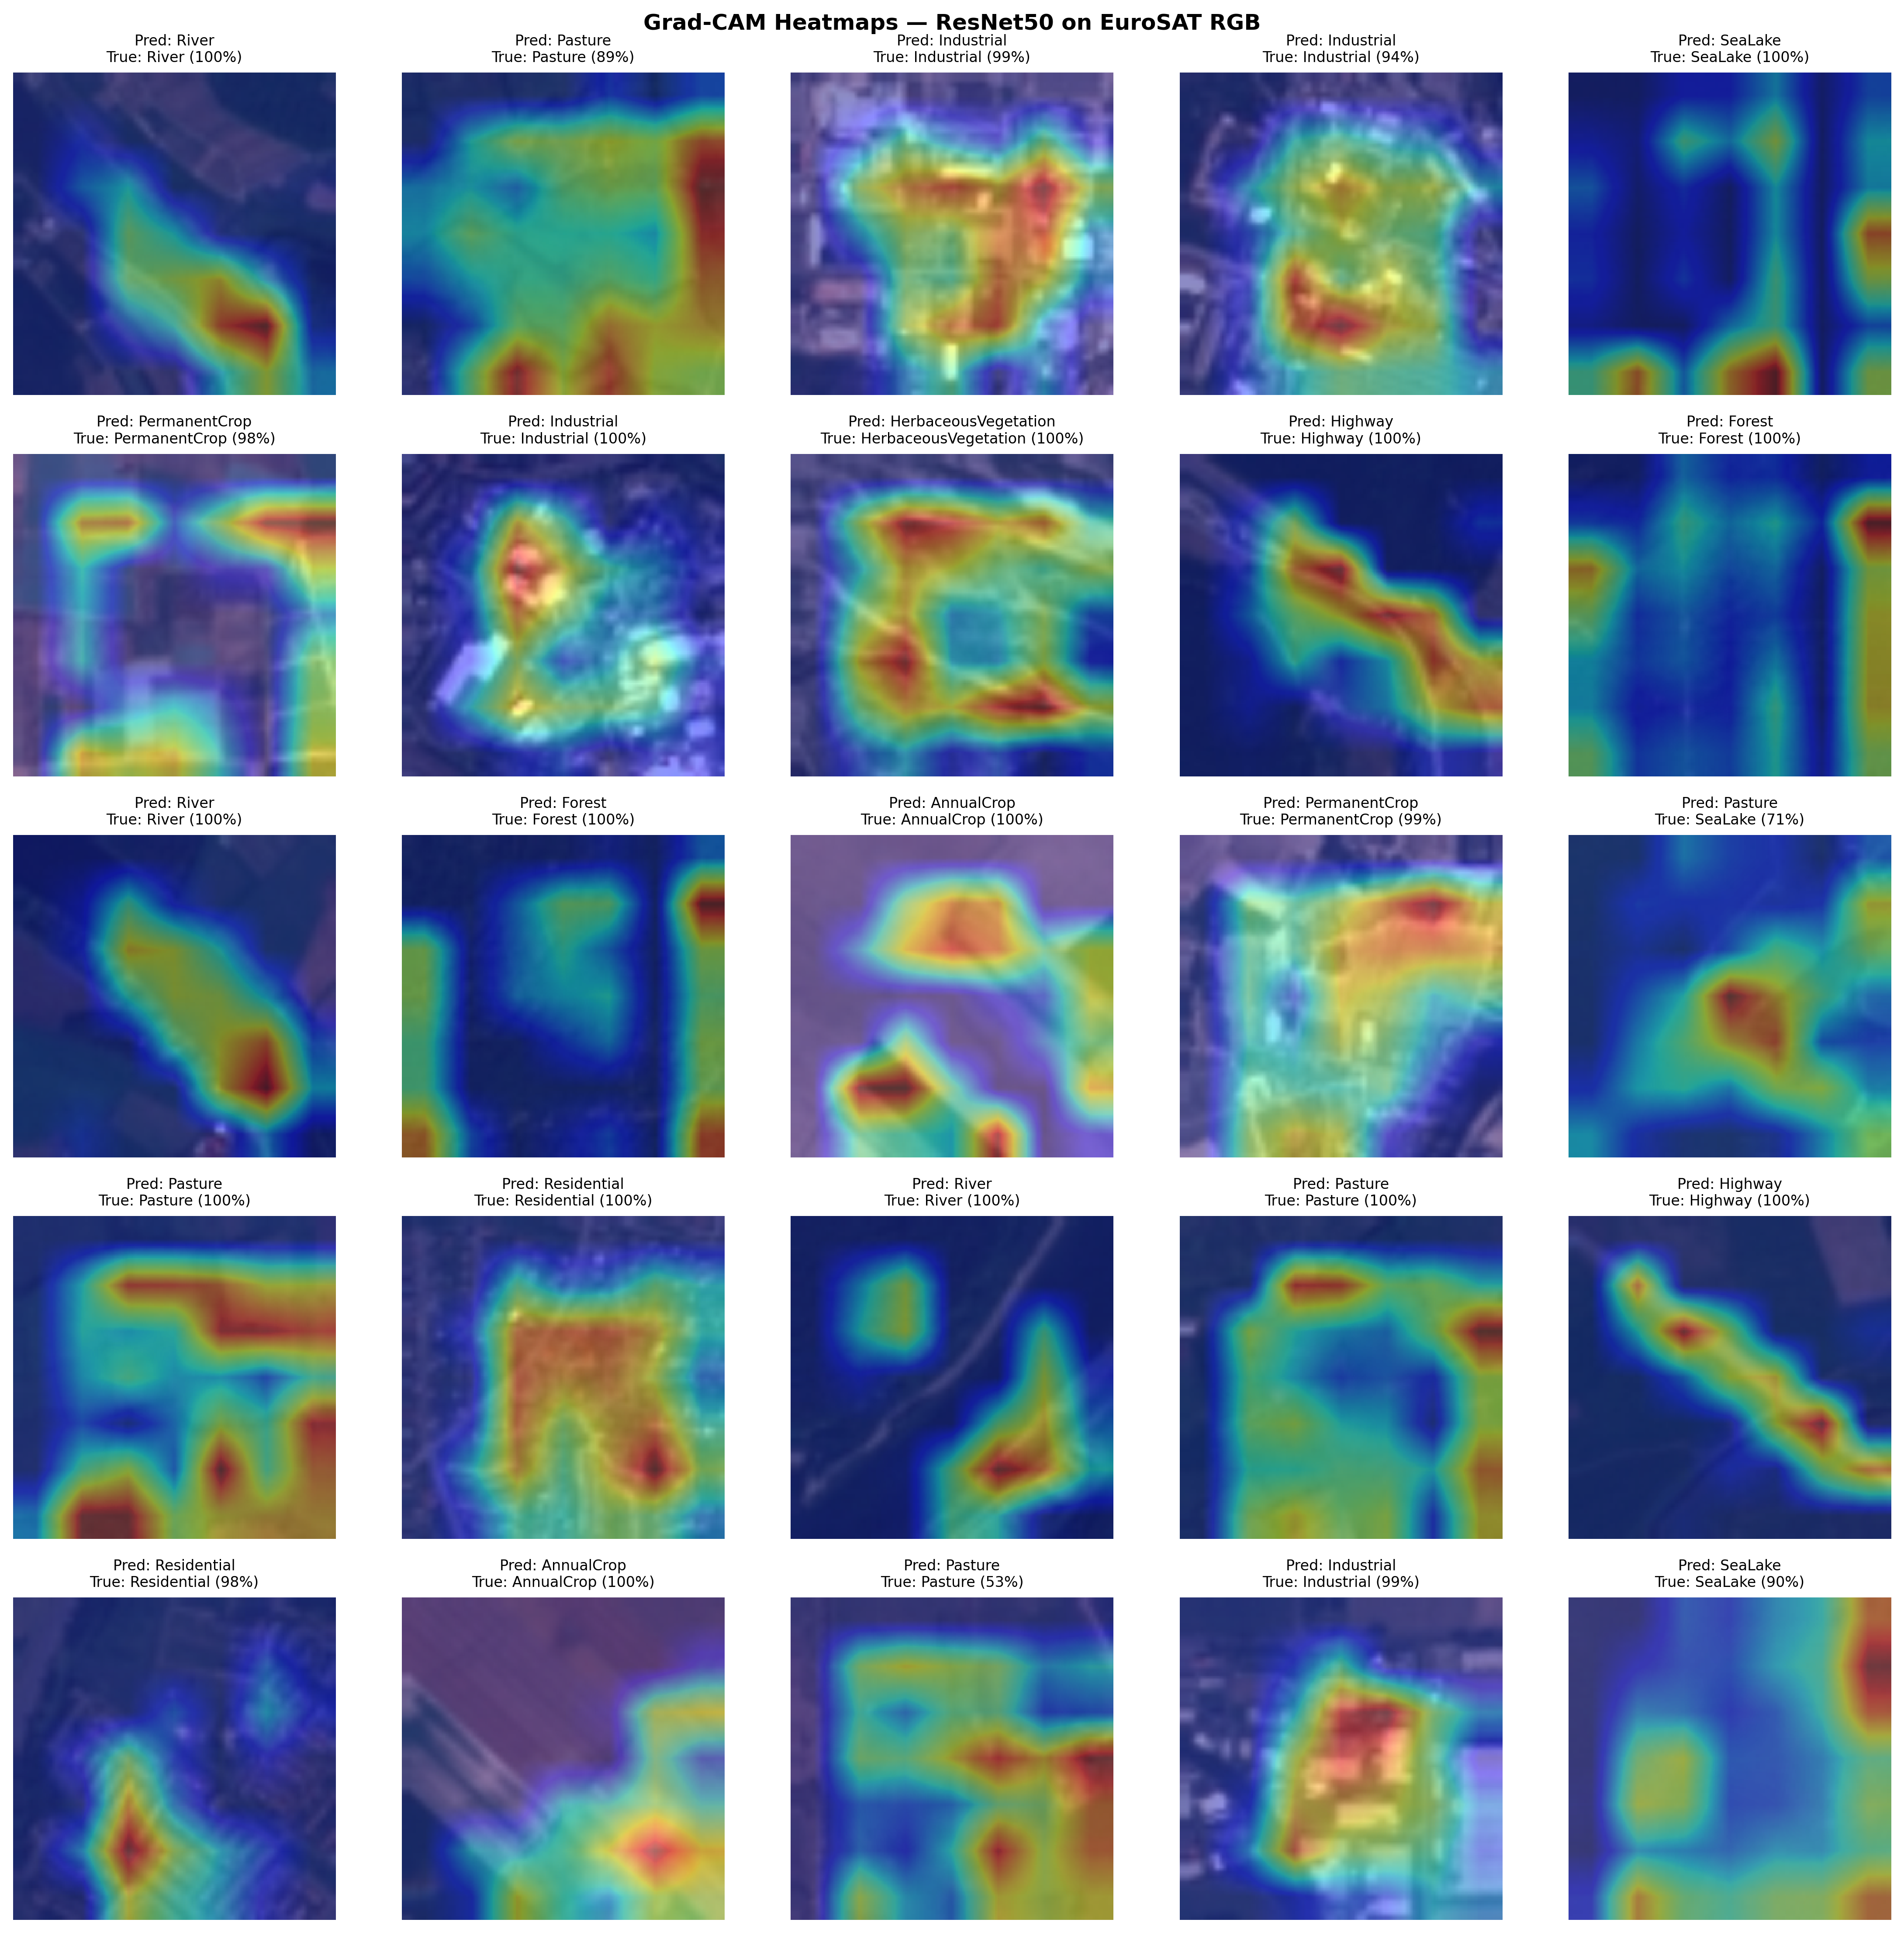
Figure 6. Grad-CAM heatmap grid for 50 representative EuroSAT test patches.
Table 9. Grad-CAM Misclassification Case Analysis.
Sample ID | True Class | Predicted Class | Activation Focus | Failure Mode
gradcam_014 | SeaLake | Pasture | Shallow water + emergent vegetation zone | Elevated NIR from aquatic vegetation
gradcam_034 | PermanentCrop | HerbaceousVegetation | Distributed across fine crop canopy | Phenological ambiguity at 10m resolution
gradcam_041 | River | AnnualCrop | Turbid central channel | Sediment-turbidity spectral confusion

4.7 Lahore District LULC Deployment
The deployment of both models on 4,481 valid Sentinel-2 patches over Lahore highlights significant differences in spatial coherence and thematic accuracy. Figure 7 compares the LULC classification maps side by side, while Figures 8a and 8b show RGB and classification overlays for a qualitative spatial alignment assessment. The Custom CNN map exhibits a typical “salt-and-pepper" pattern, reflecting its tendency to classify patches based on ambiguous local spectral cues and limited contextual information. It classifies 48.58% of valid patches as PermanentCrop and 30.18% as AnnualCrop, together covering 78.76% of the area, which exceeds the ResNet50 estimate and does not match Lahore's urban core. Classes such as Highway (0.72%), Industrial (0.14%), and Forest (0.14%) are significantly under-predicted, with mean confidence scores of 0.309, 0.336, and 0.487, indicating the model performs only slightly better than chance for complex classes in real-world conditions. Notably, River and SeaLake are assigned zero patches, revealing that the water body classification fails entirely due to spectral differences between the EuroSAT training data and the Lahore scene.
ResNet50 generates a spatially consistent classification map that closely matches Lahore's known urban layout. When grouped into a 4-category LULC system, it classifies 23.25% of the district as Urban (including Residential at 29.99%, Highway at 11.11%, and Industrial at 2.23%), which totals 43.33% at the 10-class level but maps to 23.25% under the 4-bin scheme. The model assigns high confidence scores to the main Urban classes: Residential at 0.867 and Highway at 0.833, showing it is quite certain about Urban patches. Residential areas are mainly located in Lahore's core and its densely built eastern satellite towns, aligning with the city's urban structure. Agricultural areas are prevalent in rural outskirts and peri-urban zones, while Natural vegetation (HerbaceousVegetation and Pasture subclasses) appears in riparian corridors and open spaces around the district edges. Forests are classified as 0.00%, supported by high confidence scores across other classes, indicating the absence of dense tree cover rather than a classification error.
Table 10. Per-Class Patch Distribution Lahore Deployment.
Class | CNN Tiles | CNN Share (%) | CNN Conf. | ResNet50 Tiles | ResNet50 Share (%) | ResNet50 Conf.
AnnualCrop | 1,299 | 30.18 | 0.583 | 347 | 8.06 | 0.693
Forest | 6 | 0.14 | 0.487 | 0 | 0.00 | 0.000
HerbaceousVeg. | 373 | 8.67 | 0.405 | 116 | 2.70 | 0.649
Highway | 31 | 0.72 | 0.309 | 478 | 11.11 | 0.833
Industrial | 6 | 0.14 | 0.336 | 96 | 2.23 | 0.741
Pasture | 62 | 1.44 | 0.403 | 230 | 5.34 | 0.672
PermanentCrop | 2,091 | 48.58 | 0.500 | 1,722 | 40.01 | 0.718
Residential | 421 | 9.78 | 0.550 | 1,291 | 29.99 | 0.867
River | 0 | 0.00 | 0.000 | 9 | 0.21 | 0.694
SeaLake | 0 | 0.00 | 0.000 | 0 | 0.00 | 0.000
Total | 4,289 | 100.00 |  | 4,289 | 100.00

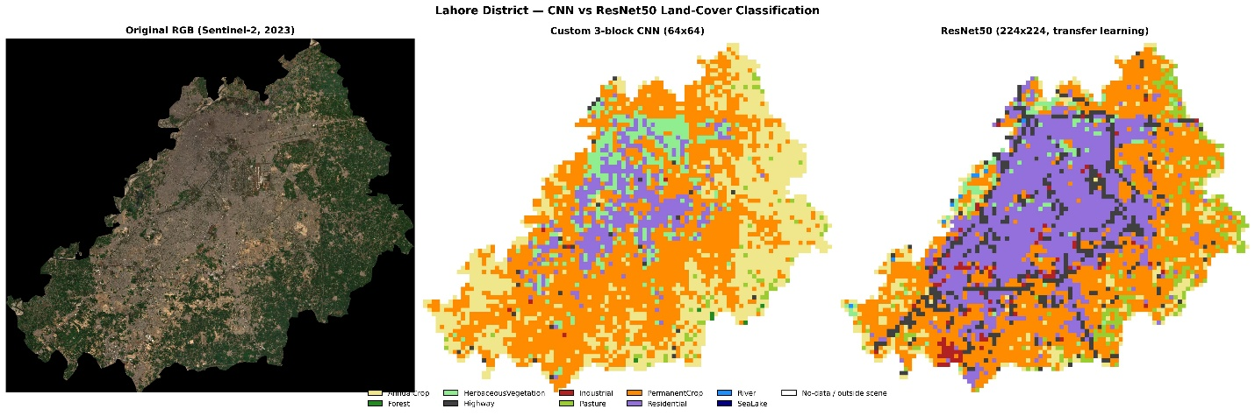
Figure 7. RGB imagery vs. classification overlay: Custom CNN (a) and ResNet50 (b).

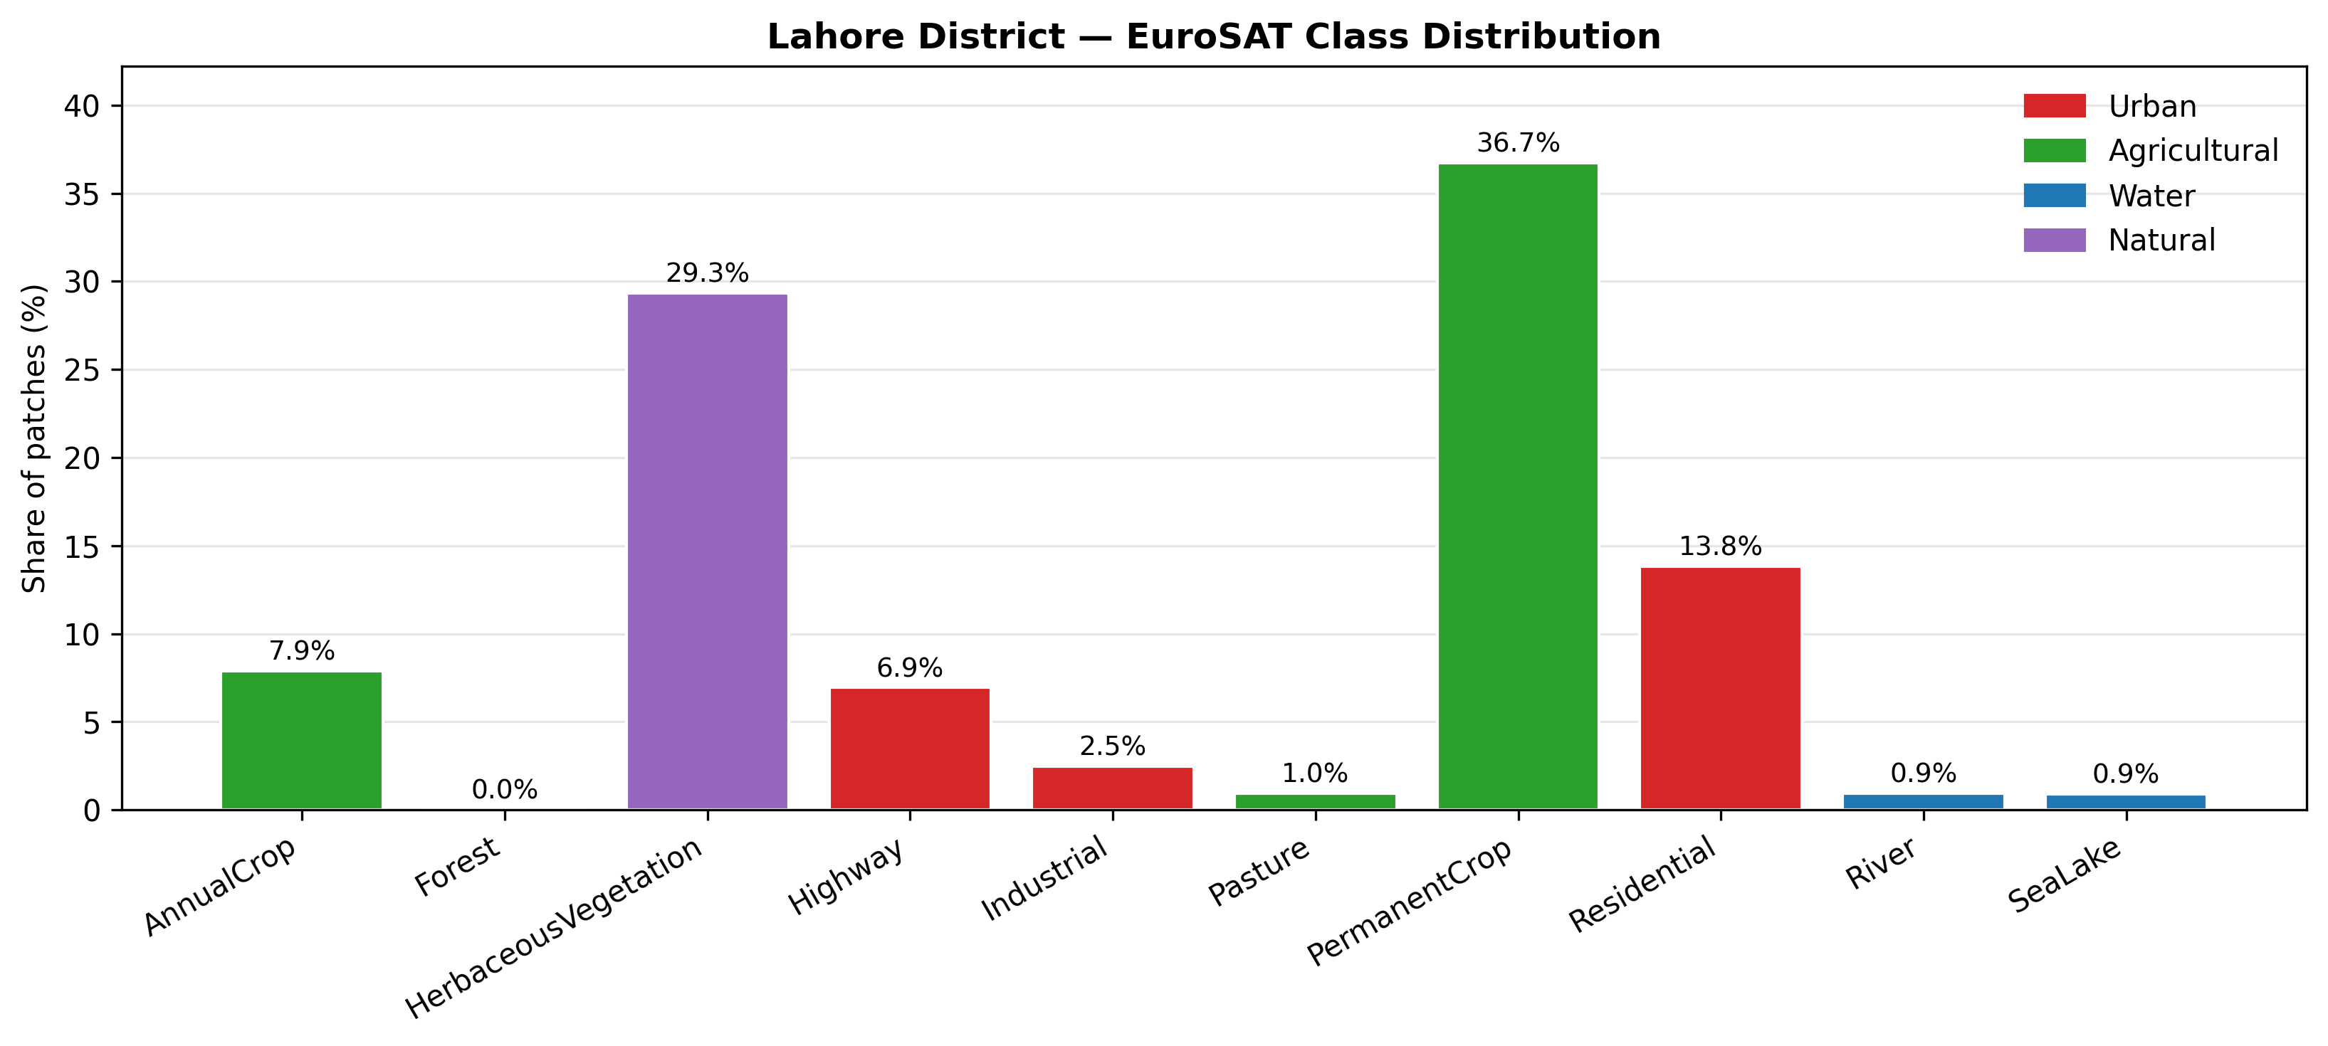 | 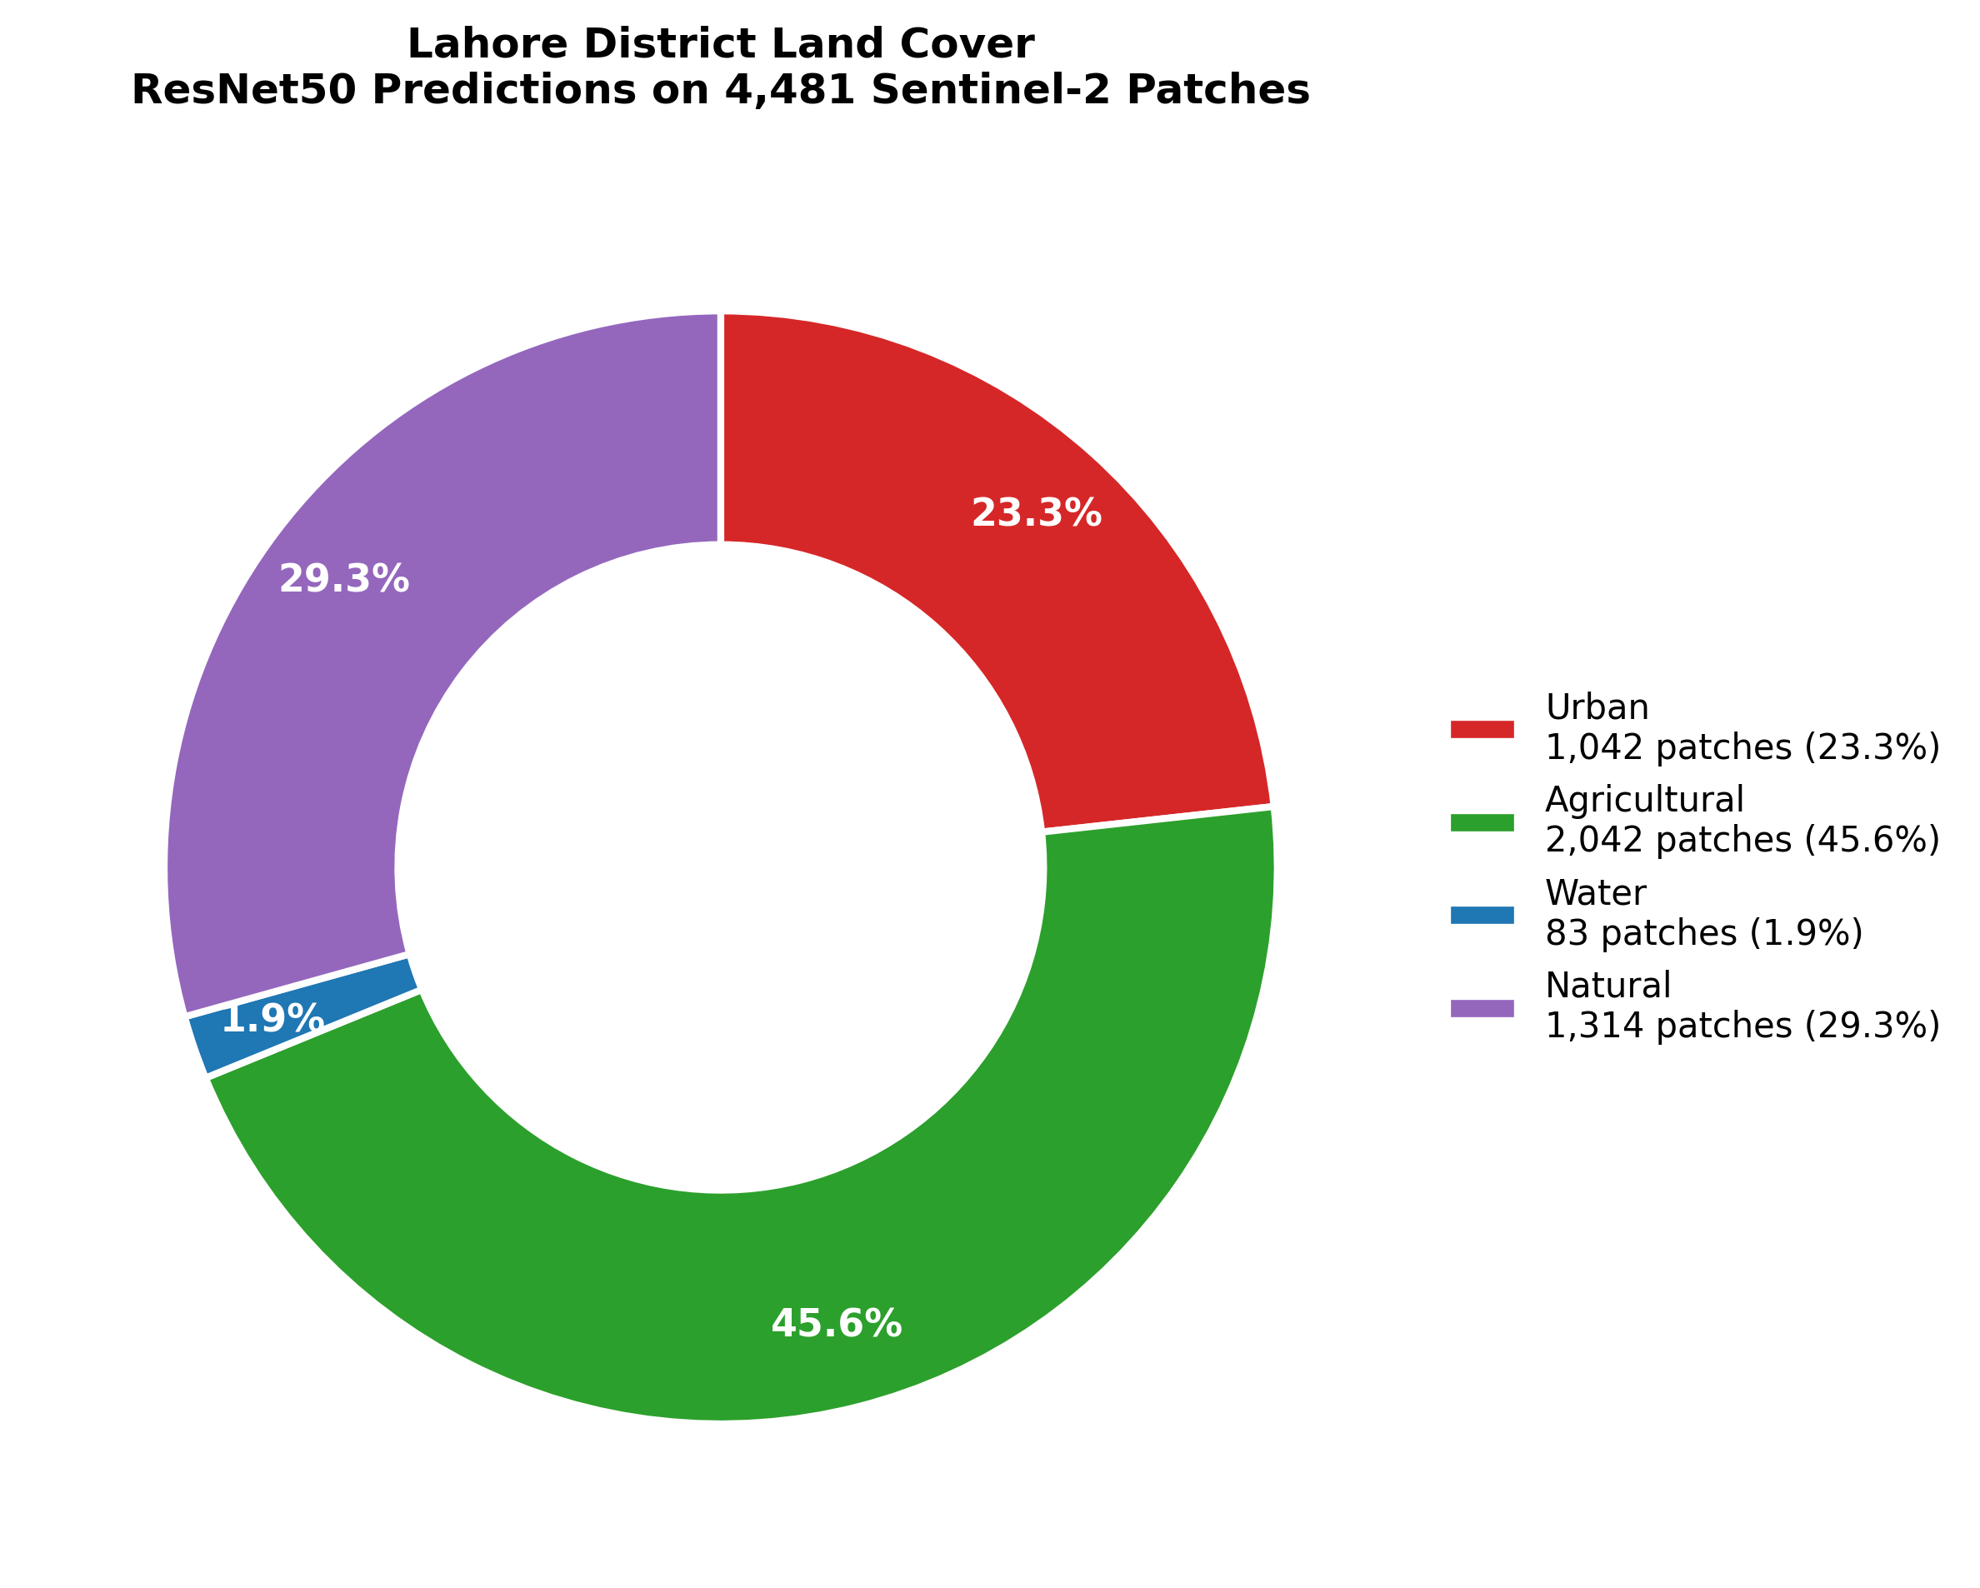
(a) | (b)
Figure 8. Land cover distribution in Lahore District predicted by ResNet50: (a) EuroSAT class-wise share; (b) aggregated 4-bin LULC composition.

5. Discussion
The empirical findings of this study deepen understanding of deep learning architecture selection for operational land use and land cover (LULC) mapping across three interrelated dimensions: the accuracy-efficiency trade-off, the contribution of transfer learning to mitigating domain shift, and the environmental value of high-resolution satellite-based monitoring in rapidly urbanizing semi-arid landscapes.
The 16.03 percentage point accuracy gap between the Custom CNN (81.38%) and ResNet50 (97.41%) is not evenly distributed across the classification task; rather, it is concentrated in spectrally and geometrically complex categories that are also the most important for urban environmental monitoring. Highway, PermanentCrop, HerbaceousVegetation, and River account for a substantial share of the Custom CNN’s errors, and these classes are directly relevant to tracking road expansion, agricultural conversion, vegetative change, and hydrological dynamics. From a municipal land auditing perspective, a model with approximately 81% accuracy that systematically confuses highways with PermanentCrop and fails to reliably identify riparian corridors does not merely introduce numerical error; it produces spatially misleading intelligence. Accordingly, the performance deficit of the Custom CNN should be understood as a structural limitation in discriminating the categories most critical for operational environmental assessment.
At the same time, the Custom CNN offers a substantial practical advantage through its 8.3× lower latency and 25.7× reduction in MACs. This efficiency makes it valuable in deployment settings where hardware constraints rule out heavier architectures such as ResNet50. Examples include battery-powered drone systems, edge-based agricultural monitoring devices, and offline environmental assessment tools deployed in low-resource settings. In these contexts, a lightweight model with near-real-time inference may provide greater operational utility than a more accurate model that cannot be executed on available hardware. The central implication is that architecture choice for LULC mapping must be defined by the deployment environment: the optimal model is not the most accurate one in isolation, but the most accurate one that can function within the available computational constraints.
ResNet50’s rapid convergence to 97.26% validation accuracy within a single epoch provides strong evidence of the transferability of ImageNet-based feature representations. Although EuroSAT is a satellite imagery dataset, it still relies on visual primitives such as edges, textures, color clusters, and spatial frequency patterns that are well represented in ImageNet pretraining. This alignment allows ResNet50 to act as an effective feature extractor from the beginning of training, requiring only limited fine-tuning of the classification head. The result is not only higher accuracy but also substantially reduced training cost: ResNet50 converges in 5 epochs, compared with 10 epochs for the Custom CNN. For settings where labeled remote sensing data are limited, this efficiency makes transfer learning a highly advantageous strategy.
The Lahore deployment results reveal a pronounced domain gap that further limits the Custom CNN’s practical utility. Its inability to predict River or SeaLake across 4,481 real-world patches, despite reasonable benchmark performance on EuroSAT, reflects a distribution shift between curated test imagery and the more complex, heterogeneous Lahore scene. The city’s water bodies, including canals and the Ravi River, are affected by seasonal turbidity, irrigation dynamics, and peri-urban pollution, which alter their spectral characteristics relative to the clean water examples in the benchmark dataset. ResNet50, by contrast, retains partial discriminative capacity under this shift, as shown by its detection of river patches with moderate confidence. This contrast reinforces the value of deeper architectures for real-world deployment where target scenes differ from training data.
The Grad-CAM analysis further shows that ResNet50’s high performance is grounded in geographically meaningful feature attention rather than spurious correlations. The alignment of activations with class-defining patternssuch as edge continuity for highways, repetitive texture for residential areas, canopy homogeneity for forests, and boundary contrast for riverssupports the interpretability and scientific credibility of the model. This is important because high benchmark accuracy alone does not guarantee that a model has learned semantically valid features. In this study, Grad-CAM confirms that the model’s decisions are based on physically and geographically relevant structures.
The misclassification cases also demonstrate the diagnostic value of Grad-CAM. The River to AnnualCrop confusion is linked to sediment-induced turbidity, while the PermanentCrop to HerbaceousVegetation confusion reflects phenological overlap. These failure modes are difficult to infer from a confusion matrix alone but become clear through spatial activation maps. This insight has direct implications for future model improvement. For example, incorporating near-infrared and shortwave infrared bands from Sentinel-2 would likely reduce water-related confusion by adding spectral dimensions that better distinguish turbid water from soil-like surfaces.
The ResNet50-based LULC map of Lahore provides a timely and spatially detailed snapshot of environmental change. The finding that 23.25% of the district is classified as Urban under the 4-bin taxonomy offers a useful baseline for monitoring continued urban expansion. The absence of Forest patches across all valid tiles is especially significant, as it confirms the near-total loss of dense arboreal cover within the mapped district. This has important implications for microclimate regulation, groundwater recharge, and urban heat mitigation in a semi-arid city experiencing rapid growth.
The persistence of 45.57% Agricultural and 29.32% Natural land cover indicates that Lahore still retains substantial non-urban land, particularly in its rural and peri-urban margins. However, this should not be interpreted as environmental stability. Instead, the spatial fragmentation of agricultural land suggests continuing conversion pressure along the urban fringe. The Water class, at 1.85%, captures the district’s limited hydrological footprint, while the near absence of SeaLake predictions reflects the reduction of wetlands and irrigation reservoirs in the broader landscape.
Together, these findings establish a reproducible baseline for future longitudinal monitoring. Reapplying the same pipeline to annual Sentinel-2 scenes would make it possible to track urban expansion, agricultural conversion, and vegetation loss with consistent spatial resolution and minimal marginal cost. This automated workflow removes the bottleneck of manual interpretation and offers a scalable framework for municipal land monitoring.
Several limitations should be acknowledged. First, restricting the input to RGB bands excludes the additional Sentinel-2 spectral channels that are particularly valuable for separating vegetation and water subclasses. Second, EuroSAT reflects European land cover patterns and may not fully represent the semi-arid conditions of Lahore. Third, the non-overlapping tiling strategy can introduce boundary artifacts and salt-and-pepper noise. Finally, the Lahore deployment results lack ground-truth labels, preventing formal accuracy assessment. Future work should address these issues through multispectral inputs, local fine-tuning, overlapping inference, and field-validated reference data.

6. Conclusion
This study presented a systematic comparative evaluation of a lightweight Custom 3-block CNN and a transfer-learned ResNet50 for high-resolution Land Use and Land Cover (LULC) classification using EuroSAT RGB imagery derived from Sentinel-2, with subsequent deployment across Lahore district, Pakistan. ResNet50 achieved 97.41% overall accuracy and a 97.32% Macro F1-score, representing a 16.03 percentage point improvement over the Custom CNN (81.38%; Macro F1: 80.50%), at the cost of 25.7× higher computational demand and 8.3× greater inference latency. This accuracy-efficiency trade-off is operationally significant: the Custom CNN's error budget is concentrated in geometrically and spectrally complex classes Highway, PermanentCrop, HerbaceousVegetation, and River that are most critical for environmental monitoring, whereas the Custom CNN's low latency (1.79 ms/img) and minimal memory footprint (18.74 MB) render it viable for edge deployment scenarios where ResNet50's resource requirements are prohibitive.
Grad-CAM analysis confirmed that ResNet50's classifications are grounded in geographically meaningful feature representations, including edge continuity for highway networks, periodic structural textures for residential areas, spectral homogeneity for forest canopies, and riparian boundary contrast for river corridors. Misclassification diagnostics identified two physically interpretable failure pathways: sediment-induced turbidity causing River–AnnualCrop confusion and phenological overlap driving PermanentCrop–HerbaceousVegetation misclassification. These findings provide actionable guidance for future model refinement through multispectral input integration and domain-specific fine-tuning.
Application of the ResNet50 pipeline to 4,481 Sentinel-2 patches across Lahore district yielded a spatially coherent LULC map quantifying Urban coverage at 23.25%, Agricultural at 45.57%, Natural vegetation at 29.32%, and Water at 1.85%, with Forest classified at 0.00% across all valid tiles confirming the near-total absence of dense arboreal cover in the district. These results establish a reproducible, 10-meter resolution baseline for longitudinal urban encroachment monitoring. Future work should investigate multispectral input pipelines incorporating NIR, Red-Edge, and SWIR bands, local fine-tuning on annotated Lahore-specific imagery, and overlapping inference strategies to reduce boundary artifacts and improve spatial coherence in operational deployments.

References
References must be numbered in order of appearance in the text (including citations in tables and legends) and listed individually at the end of the manuscript. We recommend preparing the references with a bibliography software package, such as EndNote, ReferenceManager or Zotero to avoid typing mistakes and duplicated references. Include the digital object identifier (DOI) for all references where available.

Citations and references in the Supplementary Materials are permitted provided that they also appear in the reference list here.

In the text, reference numbers should be placed in square brackets [ ] and placed before the punctuation; for example [1], [1–3] or [1,3]. For embedded citations in the text with pagination, use both parentheses and brackets to indicate the reference number and page numbers; for example [5] (p. 10), or [6] (pp. 101–105).

- Author 1, A.B.; Author 2, C.D. Title of the article. Abbreviated Journal Name Year, Volume, page range.
- Author 1, A.; Author 2, B. Title of the chapter. In Book Title, 2nd ed.; Editor 1, A., Editor 2, B., Eds.; Publisher: Publisher Location, Country, 2007; Volume 3, pp. 154–196.
- Author 1, A.; Author 2, B. Book Title, 3rd ed.; Publisher: Publisher Location, Country, 2008; pp. 154–196.
- Author 1, A.B.; Author 2, C. Title of Unpublished Work. Abbreviated Journal Name year, phrase indicating stage of publication (submitted; accepted; in press).
- Author 1, A.B. (University, City, State, Country); Author 2, C. (Institute, City, State, Country). Personal communication, 2012.
- Author 1, A.B.; Author 2, C.D.; Author 3, E.F. Title of Presentation. In Proceedings of the Name of the Conference, Location of Conference, Country, Date of Conference (Day Month Year).
- Author 1, A.B. Title of Thesis. Level of Thesis, Degree-Granting University, Location of University, Date of Completion.
- Title of Site. Available online: URL (accessed on Day Month Year).
Disclaimer/Publisher’s Note: The statements, opinions and data contained in all publications are solely those of the individual author(s) and contributor(s) and not of MDPI and/or the editor(s). MDPI and/or the editor(s) disclaim responsibility for any injury to people or property resulting from any ideas, methods, instructions or products referred to in the content.

