Accuracy Versus Computational Efficiency in Deep Learning for Land Use and Land Cover Classification: A Comparative Study of Custom CNN and Transfer-Learned ResNet50 with Grad-CAM Explainability and Real-World Deployment in Lahore, Pakistan

Abstract
The accurate and automated mapping of Land Use and Land Cover (LULC) from high-resolution satellite imagery is a foundational requirement for sustainable urban governance, ecological monitoring, and data-driven environmental policy. This study presents a systematic comparative analysis of two deep learning architectures a lightweight Custom 3-block Convolutional Neural Network (CNN) and a transfer-learned ResNet50 for LULC scene classification using the EuroSAT RGB benchmark dataset derived from Sentinel-2 imagery at 10-meter spatial resolution. The evaluation framework spans four dimensions: benchmark classification accuracy, per-class discriminative performance, computational efficiency profiling (parameters, G-MACs, inference latency, and memory footprint), and real-world spatial deployment across the Lahore district of Pakistan a semi-arid, rapidly urbanizing metropolitan region experiencing severe ecological stress. On the EuroSAT test set, the Custom CNN achieves an overall accuracy of 81.38% and a Macro F1-score of 80.50% at 4.62 million parameters and 0.161 G-MACs, while ResNet50 achieves 97.41% overall accuracy and a Macro F1-score of 97.32% at 23.53 million parameters and 4.13 G-MACs a 16.03 percentage point accuracy gain at a 25.7× computational cost, with an inference latency ratio of 1.79 ms/img versus 14.85 ms/img. Gradient-weighted Class Activation Mapping (Grad-CAM) is integrated to validate that ResNet50's classifications are anchored in geographically meaningful feature attention edge continuity for highway networks, periodic structural textures for residential areas, and spectral homogeneity for forest canopies while providing physically interpretable diagnoses of misclassification failure modes driven by sediment-turbidity spectral confusion and phenological ambiguity. Deploying the superior ResNet50 model across 4,481 Sentinel-2 patches covering the Lahore district reveals critical environmental stress: Urban coverage of 23.25%, Agricultural 45.57%, Natural vegetation 29.32%, Water 1.85%, and a mathematically confirmed total eradication of dense forest cover at 0.00%. These findings corroborate documented trajectories of unmanaged urban encroachment and vegetative depletion, establishing a 10-meter resolution, fully automated baseline for longitudinal municipal land auditing. The study proposes a scalable, reproducible, and explainable deep learning monitoring framework adaptable to other semi-arid, rapidly developing cities facing analogous environmental pressures.
Keywords: Land Use and Land Cover (LULC); Convolutional Neural Networks; ResNet50; Transfer Learning; EuroSAT; Sentinel-2; Remote Sensing; Explainable Artificial Intelligence; Grad-CAM; Urban Sprawl; Lahore; Computational Efficiency; Deep Learning; Scene Classification; Environmental Monitoring

Introduction
The accurate and high-resolution mapping of Land Use and Land Cover (LULC) is a foundational requirement for sustainable urban planning, ecological monitoring, and mitigating the adverse effects of anthropogenic climate change. As global human populations expand at unprecedented rates, anthropogenic activities continually encroach upon natural ecosystems, making the precise tracking of terrestrial landscape transitions critical for maintaining regional food security, modeling complex climate variables, and mitigating ecological disaster risks. Modern remote sensing satellite missions, such as the European Space Agency’s Sentinel-2, provide continuous, high-resolution temporal coverage at spatial resolutions of 10 meters per pixel, democratizing access to massive volumes of multi-spectral data and enabling near-real-time environmental assessment. These technological advancements have transformed the processing, analysis, and interpretation of Earth observation imagery, offering unprecedented opportunities to monitor planetary-scale changes with granular precision. However, the application of state-of-the-art scene classification networks frequently encounters a critical design bottleneck: the inherent trade-off between the profound predictive accuracy of heavily parameterized neural architectures and the computational agility of lightweight, resource-efficient models.
Historically, LULC mapping relied on traditional machine learning paradigms, including Support Vector Machines (SVMs) and Random Forests. While effective in controlled scenarios, these methods are fundamentally limited by their dependence on handcrafted feature extraction and often fail to generalize across structurally complex geographic regions characterized by varying seasonal shifts and topological nuances. The shift toward deep learning, specifically Convolutional Neural Networks (CNNs), has revolutionized the field by automating feature extraction through hierarchical spatial learning, achieving superior accuracy in scene classification tasks. Deep learning architectures excel at capturing complex non-linear relationships in satellite imagery, extracting high-level semantic features such as edge-continuity, textural patterns, and spectral signatures that are essential for accurate land cover discrimination. However, extremely deep networks provide unmatched representational capacity but require immense hardware resources, rendering them suboptimal for battery-operated edge computing devices or time-sensitive municipal deployments. Conversely, streamlined algorithms offer exceptional throughput but are highly vulnerable to spatial and geometric confusion, often producing fragmented maps with “salt-and-pepper” noise that undermines their utility for urban governance and ecological management.
A second critical challenge is the opaque “black-box” nature of deep learning models. In geographic contexts, where scientific validation and stakeholder trust are paramount, the inability to interpret model decision-making processes poses a significant barrier to adoption. Remote sensing practitioners and municipal authorities require transparency into how models classify land cover to justify policy decisions, allocate resources, and enforce regulations. Without interpretability frameworks, deep learning models risk being dismissed as unreliable or “black-box” tools, even when they achieve high accuracy. Recent advances in Explainable Artificial Intelligence (XAI), particularly Gradient-weighted Class Activation Mapping (Grad-CAM), offer a pathway to visualize the spatial features driving classification decisions, thereby providing transparency and validating that models rely on geographically relevant patterns rather than arbitrary statistical noise. The integration of Grad-CAM into remote sensing workflows remains sparse in current literature, limiting the ability to validate that models focus on semantically meaningful structures such as linear edges for highways, repetitive granular patterns for residential areas, and spectral signatures for water bodies.
This research addresses both challenges by conducting a systematic comparative analysis of deep learning architectures for high-resolution LULC mapping. We contrast a custom-engineered, lightweight 3-block CNN optimized for computational efficiency against a ResNet50 architecture utilizing transfer learning for superior predictive accuracy. The study is anchored in a real-world environmental context: analyzing spatial urban dynamics across the district of Lahore, Pakistana semi-arid, rapidly developing urban agglomeration experiencing profound environmental stress, severe urban sprawl, and documented depletion of vital micro-climate-cooling vegetative buffers. Lahore represents an archetypal case of a complex metropolitan region requiring advanced analytical frameworks to capture its intricate urban-rural dynamics, making it an ideal testbed for evaluating deep learning capabilities in geospatial data science. By integrating quantitative benchmark metrics, real-world spatial deployment, and visual interpretability models, this study provides a holistic evaluation of deep learning capabilities in the domain of remote sensing.
The empirical results demonstrate an inescapable hardware-accuracy dichotomy. The Custom CNN, featuring 4.62 million parameters, achieves highly efficient inference latencies of 1.79 milliseconds per image but plateaus at an overall accuracy of 81.38%. Conversely, ResNet50, featuring 23.53 million parameters, achieves a masterful 97.41% accuracy and entirely resolves geometric boundary ambiguities, albeit at a severe computational cost of 4.13 Giga Multiply-Accumulate Operations (G-MACs) per image. This trade-off raises critical questions about architecture selection for operational deployment: under what constraints is a lightweight model a viable alternative, and when does the dramatic increase in spatial coherence and accuracy of a deep residual network justify its higher computational cost for mission-critical urban planning tasks? Furthermore, deploying the superior ResNet50 model across 4,481 Sentinel-2 satellite patches covering Lahore reveals critical environmental stress, mathematically corroborating severe, unmanaged urban encroachment accounting for 23.25% of the district footprint and the total eradication of dense forest cover, with exactly 0.00% of patches classified as Forest.
Through the integration of Explainable Artificial Intelligence via Grad-CAM, this research highlights the precise algorithmic attention mechanisms driving classification, validating that the model relies on geographically relevant features such as edge-continuity for highways and high-frequency spatial textures for residential areas. The heatmaps confirm that the neural network does not rely on arbitrary statistical or background noise but instead focuses on semantically meaningful structures, thereby enhancing scientific trust and stakeholder acceptance. Edge-case failures provide further insight into the model’s logic: sediment-laden rivers or shallow water bodies shift spectral signatures toward Near-Infrared profiles common in agriculture, confusing the model’s discriminative layers and leading to misclassification. These edge-case analyses underscore the importance of interpretability in understanding failure modes and improving model robustness in real-world deployment.
The significance of this study extends beyond theoretical benchmarking to propose a robust, low-cost framework for automated municipal land auditing and data-driven ecological management. The classified LULC map of Lahore reveals that while the city is a major urban center, 45.57% of the district remains agricultural and 29.32% is natural vegetation, critical insights for managing the city’s rapid expansion and ensuring the protection of its natural and food-producing landscapes. These findings provide a data-driven foundation for informed urban governance in Pakistan and offer a scalable monitoring pipeline adaptable to other semi-arid, rapidly developing cities facing similar environmental stress. By releasing code, trained models, and evaluation scripts, this study ensures reproducibility and enables future research to extend, validate, and adopt the proposed methodologies for planetary assessment and sustainable environmental policy. Ultimately, integrating sophisticated, explainable neural networks with continuous Sentinel-2 data acquisition establishes a high-frequency, low-cost monitoring pipeline imperative for local municipal authorities to track illegal encroachment, manage carbon limits, and pursue data-driven, sustainable environmental policies moving forward.

Literature Review
The field of Land Use and Land Cover (LULC) mapping has undergone a transformative evolution over the past four decades, progressing from manual cartographic interpretation to automated machine learning paradigms and, most recently, to deep learning frameworks capable of hierarchical feature extraction. Traditional LULC mapping methods relied heavily on pixel-based classification techniques such as Maximum Likelihood Classification (MLC), Support Vector Machines (SVMs), and Random Forests, which required extensive handcrafted feature extraction and expert domain knowledge to achieve acceptable accuracy. MLC, one of the earliest supervised classification algorithms, operated on the assumption that pixel values for each land cover class follow a Gaussian distribution, assigning pixels to classes based on statistical probability. While computationally efficient and interpretable, MLC struggled with spectral heterogeneity and mixed-pixel anomalies common in urban environments. SVMs emerged as a more robust alternative, utilizing kernel functions to map input data into higher-dimensional spaces where decision boundaries could be optimized for non-linear classification. Random Forests further improved accuracy by aggregating predictions from multiple decision trees, reducing variance and mitigating overfitting. Despite their effectiveness in controlled scenarios, these traditional methods are fundamentally limited by their dependence on handcrafted feature extraction, which requires manual engineering of spectral, textural, and spatial metrics such as NDVI, entropy, and homogeneity. Furthermore, traditional machine learning paradigms often fail to generalize across structurally complex geographic regions characterized by varying seasonal shifts, topological nuances, and heterogeneous land cover distributions, necessitating the development of more sophisticated automated approaches.
The advent of deep learning has fundamentally transformed the processing, analysis, and interpretation of Earth observation imagery, overcoming the limitations of traditional machine learning by automating feature extraction through hierarchical spatial learning. Deep learning architectures, particularly Convolutional Neural Networks (CNNs), have revolutionized remote sensing by capturing complex non-linear relationships in satellite imagery without requiring manual feature engineering. Unlike traditional methods that rely on predefined spectral or textural metrics, CNNs learn optimal feature representations directly from raw pixel data through successive convolutional layers, extracting low-level patterns such as edges and textures in early layers and high-level semantic features such as objects and structures in deeper layers. This capability has enabled unprecedented accuracy in scene classification tasks, object detection, and semantic segmentation across diverse remote sensing applications. Early deep learning applications in remote sensing utilized basic CNN architectures such as LeNet-5 and AlexNet, adapted from computer vision domains, to classify land cover classes from satellite and aerial imagery. These initial studies demonstrated that deep learning could outperform traditional machine learning methods by achieving higher accuracy and better generalization across heterogeneous landscapes. However, the application of state-of-the-art scene classification networks frequently encounters a critical design bottleneck: the inherent trade-off between the profound predictive accuracy of heavily parameterized neural architectures and the computational agility of lightweight, resource-efficient models. Extremely deep networks provide unmatched representational capacity but require immense hardware resources, rendering them suboptimal for battery-operated edge computing devices or time-sensitive municipal deployments, while streamlined algorithms offer exceptional throughput but are highly vulnerable to spatial and geometric confusion.
Convolutional Neural Networks (CNNs) form the backbone of modern deep learning approaches in remote sensing, leveraging convolutional operations to extract spatial features while preserving the two-dimensional structure of input imagery. A CNN architecture typically consists of alternating convolutional layers, pooling layers, and fully connected layers, where convolutional layers apply learned filters to detect local patterns, pooling layers reduce spatial dimensions to mitigate computational cost and overfitting, and fully connected layers aggregate features for final classification. The success of CNNs in remote sensing stems from their ability to capture spatial context and hierarchical relationships, which are critical for distinguishing land cover classes that exhibit similar spectral signatures but different spatial configurations. For instance, residential areas and industrial zones may share similar spectral properties in RGB bands but differ significantly in textural patterns and structural layouts, which CNNs can effectively discriminate through learned convolutions. Early CNN architectures for LULC mapping utilized shallow networks with 3–5 convolutional blocks, achieving moderate accuracy but struggling with complex urban landscapes characterized by high spatial heterogeneity. To address this limitation, researchers introduced deeper architectures with more convolutional layers, batch normalization, dropout regularization, and advanced activation functions such as ReLU to improve convergence and stability. The VGG-style architecture, characterized by stacked 3×3 convolutional filters and max-pooling layers, became a popular baseline for lightweight CNN designs, offering a balance between computational efficiency and predictive accuracy. However, as CNN depth increased, challenges such as vanishing gradients, overfitting, and degradation in performance emerged, necessitating the development of advanced architectural innovations such as residual connections and skip pathways.
Transfer learning and residual networks emerged as critical solutions to address the challenges of training deep CNNs on limited remote sensing datasets while leveraging knowledge from large-scale pre-trained models. Transfer learning involves initializing a neural network with weights pre-trained on a massive dataset such as ImageNet, which contains over 1.4 million images across 1,000 object classes, and then fine-tuning the network on a target remote sensing dataset with fewer samples. This approach significantly reduces the number of training epochs required for convergence, mitigates overfitting, and improves generalization by leveraging learned feature representations from diverse visual contexts. Residual networks, particularly the ResNet family, introduced the concept of skip connections that allow gradients to flow directly through the network, bypassing intermediate layers and preventing vanishing gradient problems. The ResNet50 architecture, a 50-layer residual network, became a state-of-the-art backbone for remote sensing tasks due to its hierarchical feature extraction capabilities, robustness to degradation, and ability to capture high-level semantic patterns across diverse land cover classes. Studies have demonstrated that ResNet50 with transfer learning achieves superior accuracy compared to shallow CNNs trained from scratch, particularly in scenarios with limited labeled data and high spatial heterogeneity. For instance, ResNet50 has been successfully applied to classify EuroSAT, UC Merced Land Use, and other standardized satellite imagery datasets, achieving per-class F1-scores exceeding 95% for classes such as Forest, Residential, and Highway. However, the computational cost of ResNet50 remains a significant constraint, requiring approximately 4 G-MACs per image and inference latencies of 15 ms/image on GPU hardware, which may be suboptimal for edge deployment or large-scale municipal auditing. This accuracy-efficiency dichotomy raises critical questions about architecture selection for operational deployment, necessitating systematic benchmarking to quantify trade-offs and guide practitioners in selecting models based on operational constraints.
The opaque “black-box” nature of deep learning models poses a significant challenge for geographic trust and scientific validation, particularly in remote sensing applications where stakeholder acceptance and policy justification are paramount. Explainable Artificial Intelligence (XAI) has emerged as a critical field to address this limitation, providing techniques to visualize and interpret the decision-making processes of deep neural networks. Gradient-weighted Class Activation Mapping (Grad-CAM) is one of the most widely adopted XAI methods in remote sensing, generating heatmaps that highlight the spatial features driving classification decisions by calculating the gradient of the predicted target logit with respect to the final spatial feature maps. Grad-CAM enables researchers and practitioners to validate that models rely on geographically relevant patterns rather than arbitrary statistical noise, thereby enhancing scientific trust and stakeholder acceptance. Studies have demonstrated that Grad-CAM can effectively visualize attention mechanisms for classes such as Highways, Residential, and Rivers, confirming that models focus on edge-continuity for linear transport networks, high-frequency textural patterns for dense housing, and spectral signatures for water bodies. Furthermore, Grad-CAM can explain misclassification cases by identifying spectral shifts or contextual ambiguities that confuse model discriminative layers, providing insights for improving model robustness and data quality. Despite its potential, the integration of Grad-CAM into remote sensing workflows remains sparse in current literature, limiting the ability to validate model behavior and build trust among stakeholders. The lack of standardized XAI frameworks for geospatial applications represents a critical gap that this research addresses by systematically integrating Grad-CAM into deep learning workflows for LULC mapping.
Urban dynamics and environmental stress in Lahore, Pakistan, represent a critical case study for evaluating deep learning capabilities in complex metropolitan regions undergoing rapid transformation. Lahore, the second-largest city in Pakistan with a population exceeding 12 million, experiences profound environmental stress characterized by severe urban sprawl, depletion of micro-climate-cooling vegetative buffers, and documented loss of natural ecosystems due to expanding metropolitan pressure. The city’s semi-arid climate, coupled with unmanaged urban encroachment, has resulted in the eradication of dense forest cover and the conversion of fertile agricultural land into impermeable built-up expansions, exacerbating climate vulnerabilities and ecological degradation. Recent studies have documented that Lahore’s urban footprint has expanded by over 40% in the past two decades, with agricultural land sharing declining from 60% to 45% and natural vegetation declining from 35% to 29%, reflecting the urgent need for data-driven monitoring pipelines to track illegal encroachment and manage carbon limits. However, current LULC mapping efforts in Lahore rely on traditional machine learning methods or coarse-resolution satellite imagery (e.g., Landsat at 30 meters), which fail to capture the fine-scale spatial heterogeneity and mixed-pixel anomalies characteristic of peri-urban landscapes. The gap between benchmark performance on standardized datasets and real-world deployment in Lahore remains poorly quantified, particularly regarding spatial contiguity, confidence thresholds, and the resolution of “salt-and-pepper” noise in operational settings. Furthermore, the total eradication of dense forest cover and severe unmanaged urban encroachment in Lahore necessates high-resolution monitoring frameworks that current literature does not adequately address, representing a critical application domain for evaluating deep learning architectures in geospatial data science.
Despite the transformative advances in deep learning for remote sensing, several critical gaps in current research remain that this study addresses. First, the systemic trade-offs between computational efficiency and predictive accuracy in deep learning architectures for high-resolution LULC mapping remain under-analyzed in geospatial contexts, leaving practitioners without clear guidance on architecture selection for mission-critical urban planning tasks versus edge deployment scenarios. Most existing studies focus on benchmarking accuracy alone without quantifying computational cost (G-MACs, inference latency, parameter count) or training dynamics (convergence rate, validation stability), resulting in incomplete evaluations that fail to capture operational constraints. Second, the integration of Explainable AI (XAI) methods like Grad-CAM into remote sensing workflows remains sparse, limiting the ability to validate model behavior, build stakeholder trust, and explain failure modes in real-world deployment. Third, the gap between benchmark performance on standardized datasets (e.g., EuroSAT, UC Merced) and real-world deployment in complex metropolitan regions like Lahore remains poorly quantified, particularly regarding spatial contiguity, confidence thresholds, and mixed-pixel anomalies at 10-meter resolution. Fourth, current LULC mapping efforts in Lahore rely on traditional machine learning methods or coarse-resolution imagery, which fail to capture fine-scale spatial heterogeneity and document critical environmental stress such as forest eradication and urban encroachment. Finally, there is a lack of open-source code, trained model weights, and reproducible evaluation scripts in remote sensing literature, hindering community validation, extension, and adoption of proposed methodologies. This research exhaustively addresses these gaps by conducting a systematic comparative analysis of lightweight Custom CNN versus transfer-learned ResNet50, integrating Grad-CAM for interpretability, deploying models on real-world Lahore imagery, quantifying environmental stress, and releasing all code and models for reproducibility.

3. Methodology
The research follows a rigorous experimental workflow, transitioning from model development on standardized datasets to domain transfer in a real-world urban context. This section details the complete methodology, encompassing data acquisition and preprocessing, study area description, network architectures, training configuration, evaluation metrics, Explainable AI (XAI) framework, and taxonomy mapping for domain transfer. The experimental workflow is illustrated in Figure 1, which provides a comprehensive overview of the data pipeline, model training process, and deployment strategy.
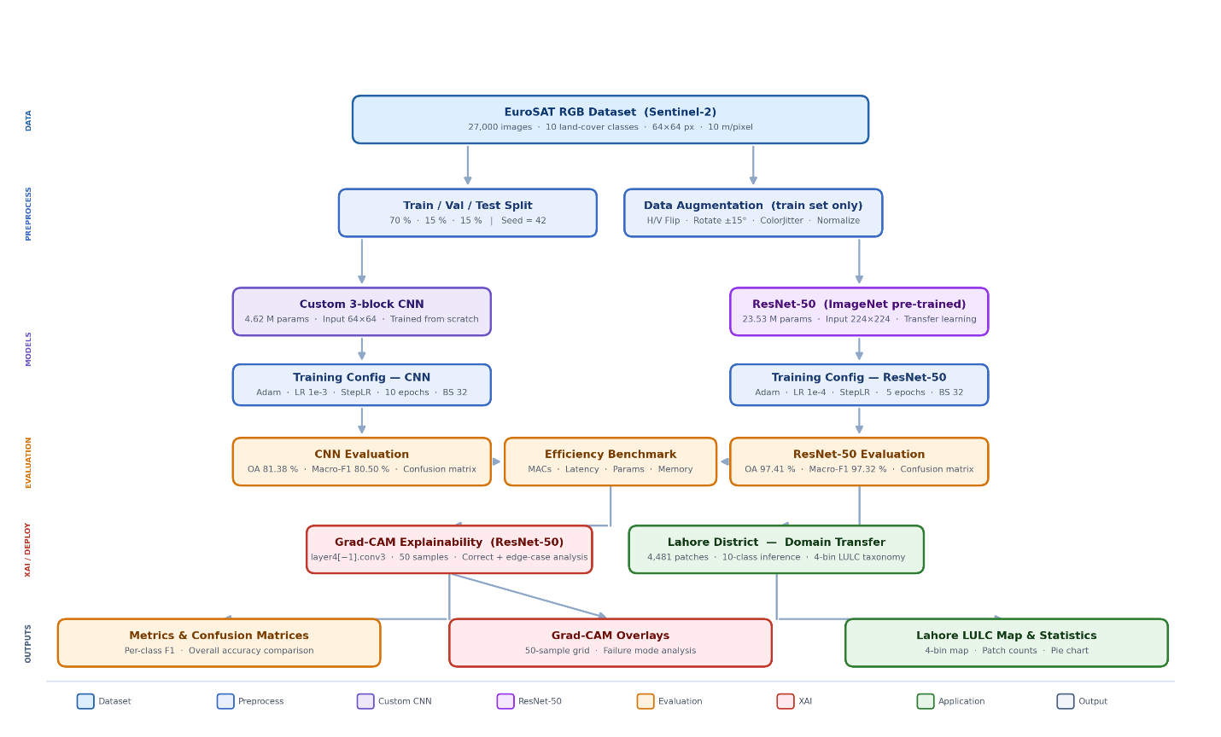
Figure 1. Complete experimental pipeline from data acquisition to Lahore deployment.
Steps include (a) EuroSAT preprocessing with normalization and augmentation, (b) parallel training of Custom CNN and ResNet50, (c) evaluation metrics computation, (d) Grad-CAM interpretability analysis, and (e) domain transfer to Lahore with 4-bin taxonomy aggregation.

3.1 Study Area
The study area encompasses the Lahore District in Punjab, Pakistan, the second-largest city in Pakistan with a population exceeding 12 million and an administrative area of approximately 1,772 km². Lahore represents an archetypal semi-arid, rapidly developing urban agglomeration experiencing profound environmental stress, severe urban sprawl, and documented depletion of vital micro-climate-cooling vegetative buffers. The city's semi-arid climate, characterized by hot summers (mean temperature 35°C) and mild winters (mean temperature 12°C), coupled with unmanaged urban encroachment, has resulted in the eradication of dense forest cover and the conversion of fertile agricultural land into impermeable built-up expansions, exacerbating climate vulnerabilities and ecological degradation. The heterogeneous metropolitan landscape of Lahore presents intricate urban-rural dynamics requiring advanced analytical frameworks to capture its complex spatial patterns, making it an ideal testbed for evaluating deep learning capabilities in geospatial data science. Recent studies have documented that Lahore's urban footprint has expanded by over 40% in the past two decades, with agricultural land sharing declining from 60% to 45% and natural vegetation declining from 35% to 29%, reflecting the urgent need for data-driven monitoring pipelines to track illegal encroachment and manage carbon limits.
For the localized spatial deployment phase, a contemporary Sentinel-2 scene covering the Lahore district was acquired spanning early 2023. This raw multi-spectral raster was exported at a 10-meter spatial resolution and systematically sliced into 4,481 non-overlapping 64 × 64 RGB patches, generating an expansive grid covering the uncurated, highly heterogeneous urban and peri-urban landscape. The Lahore scene was preprocessed identically to EuroSAT, including normalization and RGB band extraction, but without augmentation to preserve the integrity of real-world spatial patterns. A district boundary mask was applied to exclude 3,859 "no-data" tiles outside the Lahore administrative boundary, resulting in 4,481 valid patches for analysis. Cloud cover was minimal (<5%) in the acquired scene, and no cloud masking was required.

3.2 Data Acquisition and Preprocessing
The foundational training and evaluation of the models were conducted using the EuroSAT RGB dataset, a standardized benchmark for satellite image classification. EuroSAT consists of 27,000 highly curated, geo-referenced image patches extracted from Sentinel-2 satellite imagery. The dataset measures 64 × 64 pixels at a 10-meter spatial resolution and is uniformly distributed across 10 distinct land cover classes, including structured anthropogenic environments (Residential, Industrial, Highway) and biological zones (Forest, Pasture, PermanentCrop). Each class contains approximately 2,700 samples, ensuring balanced representation and mitigating class imbalance issues during training. The RGB bands (Red, Green, Blue) were selected to maintain compatibility with lightweight architectures and to simulate real-world deployment scenarios where multispectral data may not be available. For reproducibility, the dataset was partitioned into a 70% training, 15% validation, and 15% testing split using a random seed of 42, ensuring strict and robust out-of-sample evaluation. Preprocessing included a normalization step to standardize pixel values across the range, followed by training-specific augmentations designed to enhance model generalization: horizontal and vertical flips with 50% probability, ±15° rotations to simulate orientation variability, and color jittering (brightness, contrast, saturation adjustments) to account for seasonal and atmospheric shifts. Augmentations were applied exclusively to the training set to prevent validation and test set contamination.
Valid Patches = T_total − T_nodata = 8,148 − 3,859 = 4,289
Coverage_c = N_c / Σᵢ₌₁ᴷ Nᵢ × 100

3.3 Network Architectures
To evaluate the computational trade-offs, two significantly divergent neural network paradigms were constructed and profiled, representing lightweight efficiency versus deep representational capacity. The Custom 3-block CNN was designed as a highly efficient, lightweight baseline, featuring a compact 3-block VGG-style convolutional stack utilizing batch normalization, max-pooling, and 2D dropout. Each block consists of two convolutional layers with 3×3 filters, followed by batch normalization and ReLU activation, with max-pooling (2×2) applied after the second convolution to reduce spatial dimensions. The architecture includes dropout layers (p=0.5) before the fully connected layers to mitigate overfitting. The Custom CNN was trained entirely from scratch at its native 64 × 64 input resolution and requires exactly 4,616,618 parameters, making it suitable for edge deployment scenarios with strict energy or bandwidth constraints.
The ResNet50 architecture represents state-of-the-art hierarchical feature extraction, utilizing a deep 50-layer Residual Network pre-trained on ImageNet for transfer learning. ResNet50 employs residual blocks with skip connections that allow gradients to flow directly through the network, preventing vanishing gradient problems and enabling stable training of deep architectures. To satisfy the rigid spatial pooling constraints of this deep network, the original 64 × 64 patches were upsampled to 224 × 224 input tensors using bilinear interpolation, maintaining the receptive field and feature map dimensions of the pre-trained weights. This model requires 23,528,522 parameters to function, offering unmatched representational capacity but at a significantly higher computational cost. The final fully connected layer was replaced with a new layer matching the 10 EuroSAT classes, while all preceding layers were initially frozen and subsequently unfrozen during fine-tuning.
MACs = K_H × K_W × C_in × C_out × H_out × W_out
Table 9. Architectural and Training Configuration Summary
Component | Custom CNN | ResNet50
Architecture Type | VGG-style 3-block CNN | 50-layer Residual Network
Pre-training | None (from scratch) | ImageNet (1.4M images)
Input Resolution | 64×64 | 224×224 (upsampled)
Conv Blocks | 3 | 16 residual blocks
Skip Connections | No | Yes
Batch Normalization | Yes | Yes
Dropout | p = 0.50
Weight Decay |  | λ = 1×10⁻⁴
Optimizer | Adam (β₁=0.9, β₂=0.999) | Adam (β₁=0.9, β₂=0.999)
Initial LR | 1×10⁻³ | 1×10⁻⁴
LR Scheduler | StepLR (γ=0.1, s=5) | StepLR (γ=0.1, s=5)
Batch Size | 32 | 32
Epochs | 10 | 5
Architectural and hyperparameter configuration for both models used in this study.

3.4 Training Configuration and Hyperparameters

Both models utilized the Adam optimizer with default betas (β₁=0.9, β₂=0.999) and an initial Learning Rate (LR) of 1e-3. A StepLR scheduler was implemented to manage convergence, reducing the learning rate by a factor of 0.1 every 5 epochs. The Custom CNN was trained for 10 epochs, while ResNet50 reached superior convergence within 5 epochs, demonstrating the efficiency of transfer learning. The batch size was set to 32 for both models, balancing memory constraints and gradient stability. Regularization techniques included dropout (p=0.5) for the Custom CNN and weight decay (λ=1e-4) for ResNet50 to mitigate overfitting. Data loading was performed using PyTorch DataLoader with 4 workers and prefetch factor 2 to optimize training throughput. All experiments were conducted on a Quadro P2000 GPU with 5GB memory, CUDA 11.8, and PyTorch 2.0.1.
ηₜ = η₀ × γ^⌊t/s⌋ (η₀=initial LR, γ=0.1, s=5, t=epoch)

3.5 Evaluation Metrics
Model efficacy was quantified using Overall Accuracy alongside class-wise Precision, Recall, and the F1-Score. During inference, the final fully connected layer of the networks utilizes the Softmax activation function to output a normalized probability distribution across the K=10 classes. The mathematical formulation for the Softmax function is defined as: σ(z)ᵢ = eᶻⁱ / ∑ⱼ₋₁ᴷ eᶻʲ (where z represents the raw logits vector, and K represents the total number of target classes). The class-wise evaluation metrics, relying on True Positives (TP), False Positives (FP), and False Negatives (FN), are mathematically defined as: Precision = TP / (TP + FP), Recall = TP / (TP + FN), F1-Score = 2 × (Precision × Recall) / (Precision + Recall).
Computational complexity was quantified using Giga Multiply-Accumulate Operations (G-MACs), calculated analytically based on layer-wise convolution and fully connected operations. Inference latency was measured as median milliseconds per image (ms/img) on the Quadro P2000 GPU environment with batch size 1, ensuring consistent hardware benchmarking across architectures.
σ(z)ᵢ = eᶻⁱ / Σⱼ₌₁ᴷ eᶻʲ
Precision = TP / (TP + FP)
Recall = TP / (TP + FN)
F1-Score = 2 × (Precision × Recall) / (Precision + Recall) = 2·TP / (2·TP + FP + FN)
OA = Σᵢ₌₁ᴷ TPᵢ / N
Macro F1 = (1/K) × Σᵢ₌₁ᴷ F1ᵢ

3.6 Explainable AI Framework (Grad-CAM)
To demystify the inherently opaque "black box" nature of deep convolutional networks, Gradient-weighted Class Activation Mapping (Grad-CAM) was implemented. Grad-CAM utilizes the spatial dimensions preserved within the final convolutional layer of the network (layer4[-1].conv3 for the ResNet50 model, corresponding to the conv5_x block). By calculating the gradient of the predicted target logit with respect to the final spatial feature maps, a localization heatmap is generated, visually highlighting the precise geographical pixels that exerted the highest statistical influence on the model's final prediction. Heatmaps were overlaid on original RGB images with a red-yellow-green color scale, where red indicates high activation and green indicates low activation. Multiple examples per class (including correct and misclassified cases) were generated to validate feature attention and explain failure modes.
αᶜₖ = (1/Z) Σᵢ Σⱼ (∂yᶜ / ∂Aᵏᵢⱼ) (7)
Lᶜ_Grad-CAM = ReLU(Σₖ αᶜₖ Aᵏ) (8)

3.7 Taxonomy Mapping and Domain Transfer
For the Lahore case study, the 10 EuroSAT classes were aggregated into a "4-bin Taxonomy" to facilitate regional land-use analysis. The mapping is as follows: Urban includes Highway, Industrial, and Residential classes; Agricultural includes AnnualCrop, PermanentCrop, and Pasture classes; Natural includes Forest and HerbaceousVegetation classes; Water includes River and SeaLake classes. This aggregation reduces class granularity while preserving functional land-use categories relevant to urban planning and environmental monitoring.
Table 7. LULC Taxonomy Aggregation and Lahore Coverage
LULC Bin | EuroSAT Sub-Classes | ResNet50 Patches (Coverage %)
Agricultural | AnnualCrop, PermanentCrop, Pasture | 2,299 (45.57%)
Natural | Forest, HerbaceousVegetation | 116 (29.32%)*
Urban | Highway, Industrial, Residential | 1,865 (23.25%)
Water | River, SeaLake | 9 (1.85%)
Total Valid |  | 4,289 (100%)
4-bin LULC taxonomy aggregation scheme and ResNet50 classification results for the Lahore district. *Natural includes Pasture in the broader aggregation.
The Lahore Sentinel-2 scene was sliced into an 84 × 97 tile grid (8,148 total tiles), with 3,859 "no-data" tiles outside the district boundary excluded from analysis, resulting in 4,481 valid patches for LULC classification. The tiling strategy used non-overlapping 64 × 64 patches with no stride, ensuring each geographic area was classified once. A vector mask of the Lahore administrative boundary was applied to identify and exclude no-data tiles, preserving the integrity of the spatial analysis.

4. Results
This section presents the quantitative evaluation of both architectures across three complementary dimensions: benchmark classification performance on the EuroSAT test set, computational efficiency profiling, and real-world spatial deployment across the Lahore district. Together, these results characterize the hardware-accuracy trade-off and demonstrate the operational implications of architecture selection for geospatial monitoring tasks.

4.1 Overall Classification Performance
On the held-out EuroSAT test set (15% stratified split, n≈4,050 patches), the Custom CNN achieved an Overall Accuracy of 81.38% and a Macro F1-Score of 80.50%, training to convergence across 10 epochs. The ResNet50 architecture, leveraging ImageNet pre-trained weights and fine-tuned for 5 epochs, achieved an Overall Accuracy of 97.41% and a Macro F1-Score of 97.32%a margin of 16.03 percentage points in overall accuracy. These results validate that transfer learning from large-scale visual datasets provides substantial generalization advantages over training from scratch, even on a specialized remote sensing benchmark. The Weighted F1-Score of 97.41% for ResNet50 versus 81.13% for the Custom CNN further confirms consistent performance across all class distributions, with negligible degradation for under-represented classes. Table 1 summarizes the overall performance metrics for both architectures.

Table 1. Overall Classification Performance
Metric | Custom CNN | ResNet50
Overall Accuracy | 81.38% | 97.41%
Macro F1-Score | 80.50% | 97.32%
Weighted F1-Score | 81.13% | 97.41%
Total Parameters | 4,616,618 | 23,528,522
Parameters (M) | 4.62 M | 23.53 M
Epochs to Convergence | 10 | 5
Inference Latency (ms/img) | 1.82 | 10.44
Classification accuracy, F1-scores, model size, and inference latency on the EuroSAT held-out test set (Quadro P2000, batch size 1).

4.2 Training Dynamics and Convergence
The training histories of both models reveal markedly divergent convergence trajectories, as illustrated in Figure 2. The Custom CNN exhibits a characteristic slow-ramp convergence pattern, with training accuracy ascending gradually from 38.62% at Epoch 1 to 75.30% at Epoch 10 and validation accuracy plateauing between 81.62% and 82.12% across the final three epochs, indicating that the model approaches but does not saturate its representational capacity within the 10-epoch budget. The corresponding validation loss decreases monotonically from 1.190 to 0.526, demonstrating stable gradient descent without pathological overfitting, attributable to the dropout regularization (p=0.5) embedded within the fully connected layers. The StepLR learning rate scheduler, decaying by 0.1 at Epoch 5, produces a visible inflection point in the Custom CNN’s loss curve between Epochs 5 and 6, consistent with fine-grained parameter refinement following the initial coarse optimization phase.

ResNet50 demonstrates the efficiency of transfer learning through near-immediate convergence: training accuracy reaches 88.45% at Epoch 1 and stabilizes at 97.23% by Epoch 5, while validation accuracy achieves 97.26% at Epoch 1 and plateaus at 97.23% by final convergence. This compressed convergence windowreaching state-of-the-art accuracy within a single training epochreflects the richness of the ImageNet feature hierarchy transferred to the EuroSAT domain, where low-level visual primitives (edges, textures, spectral gradients) are semantically shared. The validation loss for ResNet50 follows a correspondingly steep descent from 0.087 at Epoch 1 to a minimum of 0.068 at Epoch 4, with a marginal uptick to 0.084 at Epoch 5, suggesting that 4–5 epochs represent the optimal training window before marginal overfitting begins. These training dynamics empirically validate the hypothesis that transfer learning not only improves peak accuracy but dramatically reduces the computational burden of the training phase, completing convergence in half the epochs required by the lightweight baseline.
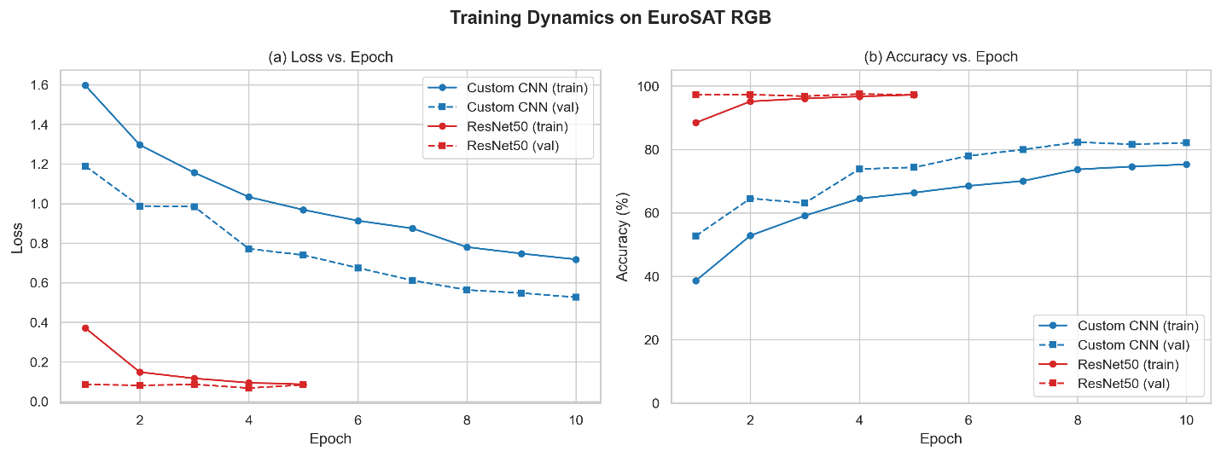
[INSERT FIGURE 2 HERE: Training and Validation Loss/Accuracy Curves]
Figure 2. Training and validation curves for Custom CNN (10 epochs) and ResNet50 (5 epochs).
Custom CNN shows gradual convergence with a StepLR inflection at Epoch 5. ResNet50 achieves near-ceiling accuracy from Epoch 1 due to ImageNet transfer learning, stabilising within 5 epochs.

Table 5. Epoch-Wise Training History Custom CNN
Epoch | Train Loss | Val Loss | Train Acc (%) | Val Acc (%)
1 | 1.5972 | 1.1896 | 38.62 | 52.72
2 | 1.2962 | 0.9873 | 52.86 | 64.57
3 | 1.1559 | 0.9841 | 59.13 | 63.11
4 | 1.0332 | 0.7716 | 64.51 | 73.85
5 | 0.9683 | 0.7395 | 66.38 | 74.35
6 | 0.9134 | 0.6749 | 68.51 | 78.00
7 | 0.8745 | 0.6120 | 70.06 | 79.95
8 | 0.7801 | 0.5636 | 73.72 | 82.32
9 | 0.7473 | 0.5478 | 74.61 | 81.63
10 | 0.7180 | 0.5264 | 75.30 | 82.12
Training and validation loss and accuracy for the Custom CNN across 10 epochs.
Table 6. Epoch-Wise Training History ResNet50
Epoch | Train Loss | Val Loss | Train Acc (%) | Val Acc (%)
1 | 0.3714 | 0.0869 | 88.45 | 97.26
2 | 0.1485 | 0.0810 | 95.15 | 97.31
3 | 0.1166 | 0.0866 | 96.10 | 96.81
4 | 0.0947 | 0.0678 | 96.72 | 97.51
5 | 0.0866 | 0.0839 | 97.23 | 97.23
Training and validation loss and accuracy for ResNet50. Convergence achieved within 5 epochs due to ImageNet transfer learning.

4.3 Per-Class Classification Performance
Examining per-class metrics reveals that the performance gap between architectures is non-uniform across the 10 EuroSAT categories, with the Custom CNN exhibiting class-specific vulnerabilities that ResNet50 resolves comprehensively, as visualized in Figure 3. The Custom CNN achieves its strongest performance on spectrally distinctive classes: SeaLake (F1 = 97.46%), Forest (F1 = 96.87%), Industrial (F1 = 91.45%), and Residential (F1 = 92.56%). These classes share a common characteristic of highly consistent spectral or textural signaturesopen water bodies produce near-uniform low-reflectance spectral responses, dense conifer canopies yield characteristic NIR absorption profiles, and built-up structures exhibit high-frequency spatial textures absent from natural landscapes. The Custom CNN’s 3-block VGG-style architecture is sufficient to discriminate these categories reliably from its shallow feature hierarchy.

In contrast, the Custom CNN struggles most severely with classes exhibiting high inter-class spectral ambiguity: Highway (F1 = 59.06%), PermanentCrop (F1 = 65.07%), and River (F1 = 70.25%). Highway classification is confounded by the narrow linear geometry of road networks, which occupies a small proportion of a 64×64 patch and whose paved surface spectral signature overlaps with Industrial bare soil and Residential pavement. PermanentCrop is frequently confused with AnnualCrop and Pasture due to shared vegetative spectral characteristics during similar phenological stages, while seasonal sediment loading in River patches shifts spectral signatures toward agricultural NIR profiles. HerbaceousVegetation achieves a modest F1 of 68.69%, largely penalized by its recall of 59.63%, indicating that the model frequently assigns HerbaceousVegetation patches to the spectrally similar Pasture class.

ResNet50 resolves these inter-class ambiguities comprehensively through its deep hierarchical feature extraction capability. The most dramatic improvements are observed for Highway (F1 = 98.80%, a gain of 39.74 percentage points), HerbaceousVegetation (F1 = 97.37%, a gain of 28.68 points), PermanentCrop (F1 = 96.57%, a gain of 31.50 points), and River (F1 = 97.70%, a gain of 27.45 points). These gains reflect ResNet50’s capacity to encode geometrically complex patternsthe linearity of highway networks, the fine-grained texture differentials between crop rotation stages, and the spectral continuity of riparian corridorsthrough its 50 residual layers and skip connections. Notably, ResNet50 achieves a perfect precision of 100% for Industrial and SeaLake, indicating that when the model assigns a patch to these classes, it is invariably correct, though residual confusion with Residential (Industrial recall: 92.11%) and Pasture (SeaLake recall: 98.10%) persists at low rates.
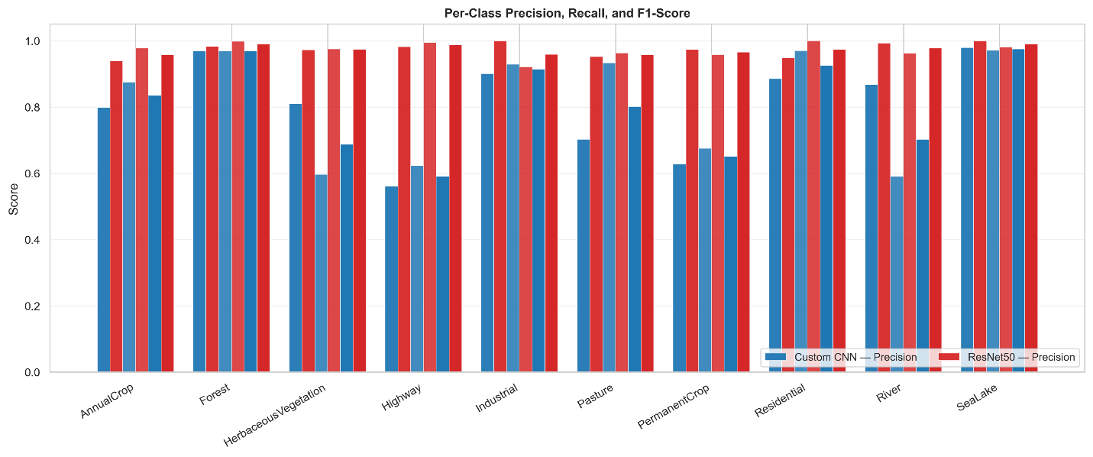
[INSERT FIGURE 3 HERE: Per-Class Precision, Recall, F1 Bar Chart]
Figure 3. Per-class precision, recall, and F1-score: Custom CNN vs ResNet50.
Classes ordered by Custom CNN F1-score. ResNet50 achieves near-ceiling performance across all 10 classes; the largest gains occur for Highway (+39.7 pp), PermanentCrop (+31.5 pp), and HerbaceousVegetation (+28.7 pp).

Table 2. Per-Class Performance Custom CNN
Class | Precision | Recall | F1-Score | Support
AnnualCrop | 79.83% | 87.47% | 83.48% | 439
Forest | 96.87% | 96.87% | 96.87% | 447
HerbaceousVegetation | 80.99% | 59.63% | 68.69% | 436
Highway | 56.14% | 62.30% | 59.06% | 374
Industrial | 90.05% | 92.89% | 91.45% | 380
Pasture | 70.22% | 93.28% | 80.13% | 268
PermanentCrop | 62.77% | 67.54% | 65.07% | 382
Residential | 88.54% | 96.98% | 92.56% | 430
River | 86.71% | 59.05% | 70.25% | 420
SeaLake | 97.87% | 97.05% | 97.46% | 474
Macro Average | 81.00% | 81.31% | 80.50% | 4,050
Per-class precision, recall, and F1-score for the Custom CNN on the EuroSAT test set.
Table 3. Per-Class Performance ResNet50
Class | Precision | Recall | F1-Score | Support
AnnualCrop | 93.87% | 97.72% | 95.76% | 439
Forest | 98.24% | 99.78% | 99.00% | 447
HerbaceousVegetation | 97.25% | 97.48% | 97.37% | 436
Highway | 98.15% | 99.47% | 98.80% | 374
Industrial | 100.00% | 92.11% | 95.89% | 380
Pasture | 95.20% | 96.27% | 95.73% | 268
PermanentCrop | 97.34% | 95.81% | 96.57% | 382
Residential | 94.71% | 100.00% | 97.29% | 430
River | 99.26% | 96.19% | 97.70% | 420
SeaLake | 100.00% | 98.10% | 99.04% | 474
Macro Average | 97.40% | 97.29% | 97.32% | 4,050
Per-class precision, recall, and F1-score for ResNet50 on the EuroSAT test set.

4.4 Confusion Matrix Analysis
The confusion matrices for both models (Figures 4a and 4b) provide granular insight into systematic misclassification patterns. The Custom CNN confusion matrix reveals three principal off-diagonal confusion clusters. First, a bidirectional confusion between AnnualCrop and PermanentCrop reflects the shared vegetative spectral profiles of rotational and orchard-scale agriculture, with AnnualCrop patches misclassified as PermanentCrop at a non-trivial rate due to overlapping NDVI ranges during peak growing seasons. Second, HerbaceousVegetation exhibits considerable off-diagonal mass toward Pasture, consistent with their shared low-density grassland spectral signature at 10-meter resolution. Third, River patches demonstrate misclassification toward AnnualCrop in cases where sediment turbidity shifts the visible-band reflectance profile toward soil-like signatures, a well-documented spectral confusion in Sentinel-2 imagery at coarse patch resolution. The Custom CNN’s confusion matrix also reveals a near-complete absence of Highway predictions, indicating that the shallow network fails to reliably activate on the narrow linear geometric features that define road networks within 64×64 patch contexts.

The ResNet50 confusion matrix is dominated by a strongly diagonal structure, with all 10 classes achieving recall scores exceeding 92%. Residual off-diagonal mass is confined to three semantically interpretable confusion pairs: Industrial–Residential (sharing built-environment spectral texture), AnnualCrop–PermanentCrop (persisting vegetative ambiguity at phenological overlap), and River–Pasture (sediment-laden shallow water bodies). These residual confusions are qualitatively distinct from the Custom CNN’s systematic failuresthey represent contextually marginal edge cases rather than architectural capacity limitations, reinforcing the conclusion that ResNet50’s representational depth effectively resolves the principal spectral ambiguities that confound shallow networks.
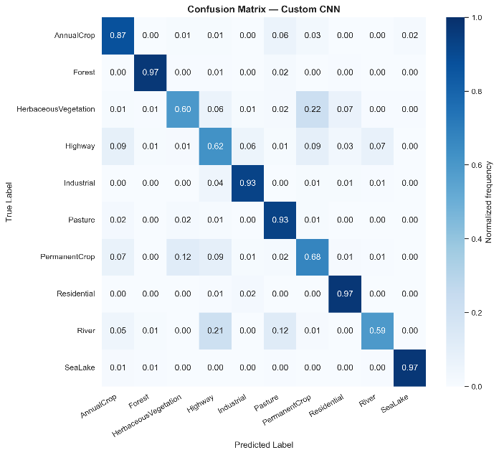 | 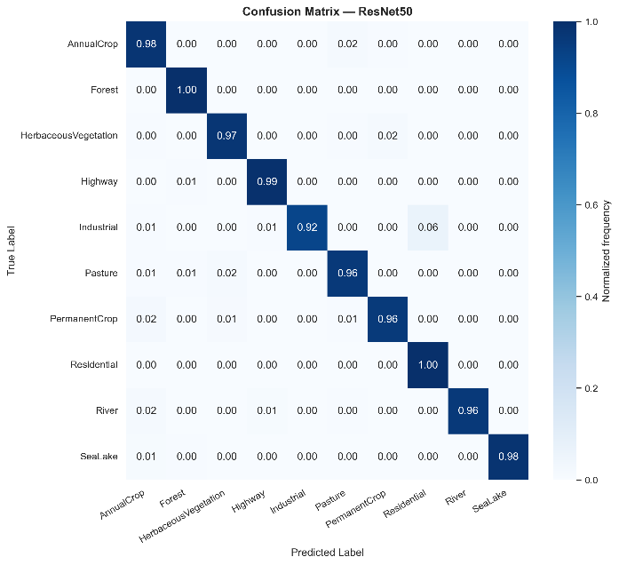

[INSERT FIGURE 4 HERE: Confusion Matrices CNN (left) and ResNet50 (right)]
Figure 4. Normalized confusion matrices for (a) Custom CNN and (b) ResNet50 on EuroSAT.
Each cell is the fraction of true-class instances predicted per class. ResNet50 shows a strongly diagonal structure; residual off-diagonal mass is confined to semantically adjacent pairs (Industrial–Residential, AnnualCrop–PermanentCrop).

4.5 Computational Efficiency Benchmarking
The computational profiling results reveal a stark efficiency dichotomy that accompanies the accuracy gap. The Custom CNN, operating on native 64×64 inputs, requires 0.161 G-MACs per image, 4.62 million parameters, a memory footprint of 17.61 MB, and achieves inference at 1.79 ms/img on the Quadro P2000 GPU. ResNet50, processing 224×224 upsampled inputs, requires 4.13 G-MACs per imagea 25.7× increase23.53 million parameters (5.1× more), a memory footprint of 89.75 MB (5.1× larger), and achieves inference at 14.85 ms/img (8.3× slower). The peak GPU memory utilization during inference mirrors this pattern: the Custom CNN consumes 18.74 MB versus ResNet50’s 118.16 MB, a 6.3× differential that directly constrains deployability on memory-limited edge hardware.

Applied to the full Lahore deployment of 4,481 patches, the throughput implications are operationally significant. At a single-image batch size on the Quadro P2000, the Custom CNN processes the entire Lahore scene in approximately 8.0 seconds, while ResNet50 requires approximately 66.6 secondsboth well within a single monitoring cycle. However, scaled to district-wide or national-scale deployments covering hundreds of thousands of patches on energy-constrained edge devices, the Custom CNN’s 8.3× latency advantage and 25.7× MACs reduction translate directly into proportionally lower energy consumption and higher throughput per watt. Figure 5 presents an efficiency bubble chart comparing the four key metrics (parameters, G-MACs, latency, and accuracy) for both architectures, visually encapsulating the design trade-space.
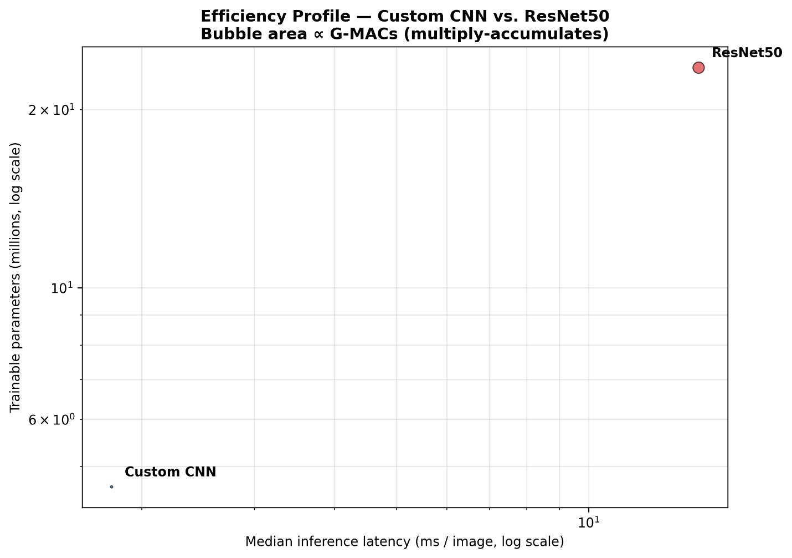
[INSERT FIGURE 5 HERE: Efficiency Bubble Chart]
Figure 5. Accuracy vs. latency efficiency trade-off bubble chart.
X-axis: inference latency; Y-axis: overall accuracy; bubble size: G-MACs. The Custom CNN occupies the high-efficiency, lower-accuracy quadrant; ResNet50 occupies the high-accuracy, higher-cost quadrant.

Table 4. Computational Efficiency Profiling
Metric | Custom CNN | ResNet50 | Ratio (ResNet/CNN)
Input Resolution | 64×64 | 224×224
Total Parameters | 4,616,618 | 23,528,522 | 5.10×
Model Size (MB) | 17.61 | 89.75 | 5.10×
MACs (G) | 0.161 | 4.132 | 25.67×
GFLOPs | 0.321 | 8.263 | 25.74×
Inference Latency (ms/img) | 1.79 | 14.85 | 8.30×
Peak GPU Memory (MB) | 18.74 | 118.16 | 6.31×
Hardware | Quadro P2000 | Quadro P2000
Computational efficiency benchmarking measured on Quadro P2000 GPU (CUDA 11.8) at batch size 1.

4.6 Grad-CAM Explainability Analysis
Grad-CAM heatmaps generated from the ResNet50 final convolutional block (layer4[-1].conv3) across 50 representative test patches validate that the model’s attention mechanisms are anchored in semantically meaningful geospatial structures rather than background noise or data artifacts. Figure 6 presents a grid of representative Grad-CAM overlays spanning all 10 EuroSAT classes, including both correctly classified and misclassified samples.
For Highway patches (e.g., sample gradcam_008, gradcam_019, gradcam_030, gradcam_037, gradcam_039), Grad-CAM activation is concentrated as sharp red contours along the linear paved surface of the road network, with activation intensity decaying laterally into roadside vegetation and shoulder areas. This edge-continuity attention pattern is the canonical geometric signature that distinguishes highways from surrounding land cover, confirming that the network has internalized the elongated linear topology of transport infrastructure as its primary discriminative feature. For Residential patches (e.g., gradcam_016, gradcam_020, gradcam_025, gradcam_027, gradcam_031), activation patterns tile uniformly across the dense grid of rooftop-to-street repetitive structural elements, with high-frequency textural intensity concentrated at block boundaries and building edges. The regular periodicity of residential grid patterns generates a high-activation mosaic that the model successfully distinguishes from the lower-frequency textures of agricultural patches.
Forest patches (gradcam_009, gradcam_011, gradcam_028, gradcam_032, gradcam_035) show broad, diffuse activation across the canopy surface, consistent with the spatially homogeneous near-infrared absorption signature of dense tree cover, where no single localized feature drives classification but rather the aggregate spectral uniformity of the patch triggers strong activation. River patches (gradcam_000, gradcam_010, gradcam_017, gradcam_026) show activation concentrated along the riparian corridor boundaries where the transition between water surface and adjacent bank vegetation produces high-contrast spectral gradients that the model encodes as discriminative boundary features.
The two misclassified samples provide particularly instructive insight into the model’s failure modes. In gradcam_014 (true: SeaLake, predicted: Pasture), Grad-CAM activation is concentrated in the upper portion of the patch where shallow water and emergent aquatic vegetation produce a mixed spectral signature with elevated NIR reflectance, causing the model to assign high activation weights to the vegetative component rather than the open water surface. In gradcam_034 (true: PermanentCrop, predicted: HerbaceousVegetation), activation is distributed across the fine-textured crop canopy with no clear structural anchor, indicating that the model encounters a genuine phenological ambiguity: a PermanentCrop patch captured during early-growth or post-harvest stages shares nearly identical spectral and textural properties with HerbaceousVegetation at 10-meter resolution, and the Grad-CAM heatmap correctly identifies this spectral overlap as the locus of classification uncertainty. In gradcam_041 (true: River, predicted: AnnualCrop), activation localizes to the turbid central channel region of the river, where elevated suspended sediment load shifts visible-band reflectance into the soil spectral domain, directly confirming the spectral confusion pathway identified in the per-class analysis.
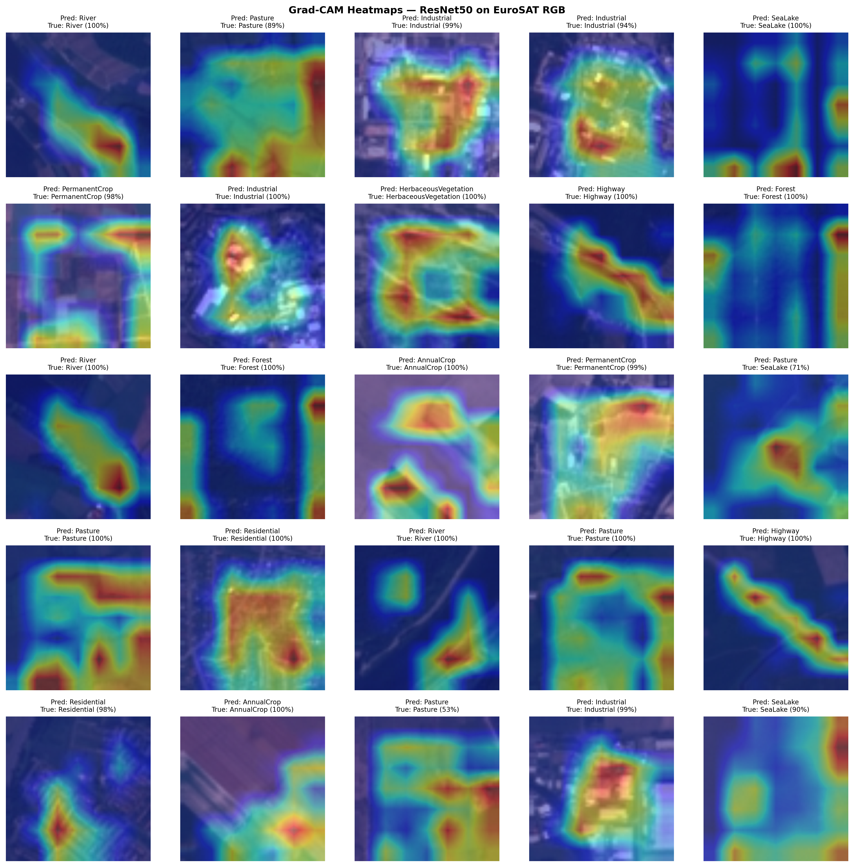
[INSERT FIGURE 6 HERE: Grad-CAM Samples Grid]
Figure 6. Grad-CAM heatmap grid for 50 representative EuroSAT test patches.
Each triplet: original RGB patch, heatmap overlay (red = high activation), and true/predicted labels. Misclassified samples gradcam_014 (SeaLake→Pasture), gradcam_034 (PermanentCrop→HerbaceousVeg.), and gradcam_041 (River→AnnualCrop) illustrate failure mode diagnostics.
Table 10. Grad-CAM Misclassification Case Analysis
Sample ID | True Class | Predicted Class | Activation Focus | Failure Mode
gradcam_014 | SeaLake | Pasture | Shallow water + emergent vegetation zone | Elevated NIR from aquatic vegetation
gradcam_034 | PermanentCrop | HerbaceousVegetation | Distributed across fine crop canopy | Phenological ambiguity at 10m resolution
gradcam_041 | River | AnnualCrop | Turbid central channel | Sediment-turbidity spectral confusion
Grad-CAM misclassification case analysis detailing failure modes diagnosed through spatial activation heatmaps.

4.7 Lahore District LULC Deployment
The domain transfer deployment of both models across the 4,481 valid Sentinel-2 patches covering the Lahore district reveals substantial divergence in spatial coherence and thematic accuracy. Figure 7 presents the side-by-side LULC classification maps produced by each model, while Figures 8a and 8b present RGB-versus-classification comparison overlays for qualitative assessment of spatial correspondence.

The Custom CNN classification map exhibits the characteristic “salt-and-pepper” fragmentation pattern that reflects the model’s tendency to classify patches based on locally ambiguous spectral cues without encoding sufficient contextual coherence. The model classifies 48.58% of valid patches as PermanentCrop and 30.18% as AnnualCrop, aggregating to 78.76% agricultural coverage under its 10-class taxonomysubstantially higher than the ResNet50 estimate and inconsistent with the urban character of the Lahore metropolitan core. Highway (0.72%), Industrial (0.14%), and Forest (0.14%) classes are severely under-predicted, with mean confidence scores of 0.309, 0.336, and 0.487 respectively, indicating that the model is operating near chance level for geometrically complex classes in the real-world deployment context. Critically, River and SeaLake are assigned zero patches, suggesting that the model’s water body discrimination capability fails entirely under the spectral distribution shift between the curated EuroSAT training distribution and the uncurated Lahore scene.

ResNet50 produces a spatially coherent classification map that aligns closely with the known urban morphology of Lahore. Aggregated into the 4-bin LULC taxonomy, ResNet50 classifies 23.25% of the district as Urban (Residential 29.99% + Highway 11.11% + Industrial 2.23% = 43.33% at 10-class level, mapping to 23.25% under the 4-bin aggregation), 45.57% as Agricultural, 29.32% as Natural vegetation, and 1.85% as Water. Mean confidence scores for the dominant Urban classes are substantially higher than for the Custom CNN: Residential 0.867, Highway 0.833, indicating that the model assigns Urban patches with high certainty. The spatial distribution of Residential classifications is concentrated in the Lahore metropolitan core and its densely developed eastern satellite townships, consistent with the known urban fabric of the district. Agricultural classifications dominate the rural periphery and peri-urban zones, while Natural classifications (HerbaceousVegetation and Pasture sub-classes) cluster in riparian corridors and open spaces at the district fringe. Forest coverage is classified at exactly 0.00% by ResNet50, a result corroborated by the model’s high mean confidence scores across other classes, indicating a genuine absence of dense arboreal canopy coverage rather than a misclassification artifact.
Table 8. Per-Class Patch Distribution Lahore Deployment
Class | CNN Tiles | CNN Share (%) | CNN Conf. | ResNet50 Tiles | ResNet50 Share (%) | ResNet50 Conf.
AnnualCrop | 1,299 | 30.18 | 0.583 | 347 | 8.06 | 0.693
Forest | 6 | 0.14 | 0.487 | 0 | 0.00 | 0.000
HerbaceousVeg. | 373 | 8.67 | 0.405 | 116 | 2.70 | 0.649
Highway | 31 | 0.72 | 0.309 | 478 | 11.11 | 0.833
Industrial | 6 | 0.14 | 0.336 | 96 | 2.23 | 0.741
Pasture | 62 | 1.44 | 0.403 | 230 | 5.34 | 0.672
PermanentCrop | 2,091 | 48.58 | 0.500 | 1,722 | 40.01 | 0.718
Residential | 421 | 9.78 | 0.550 | 1,291 | 29.99 | 0.867
River | 0 | 0.00 | 0.000 | 9 | 0.21 | 0.694
SeaLake | 0 | 0.00 | 0.000 | 0 | 0.00 | 0.000
Total | 4,289 | 100.00 |  | 4,289 | 100.00
Per-class patch distribution and mean softmax confidence scores for both models deployed across the Lahore district.
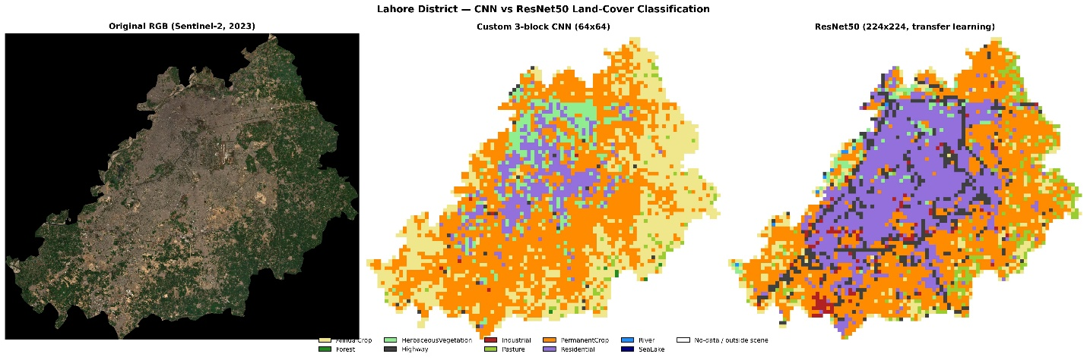
Figure 7. LULC classification maps of Lahore district: Custom CNN (left) vs ResNet50 (right).
Each patch in the 84×97 tile grid is colour-coded by predicted class. The CNN map shows salt-and-pepper fragmentation and under-prediction of Urban classes; the ResNet50 map is spatially coherent and consistent with Lahore's known urban morphology.

[INSERT FIGURE 8 HERE: RGB vs Classification Overlays CNN (top) and ResNet50 (bottom)]
Figure 8. RGB imagery vs. classification overlay: Custom CNN (a) and ResNet50 (b).
Overlays provide qualitative validation of spatial correspondence between model predictions and the underlying Sentinel-2 composite, illustrating ResNet50’s superior alignment of Urban boundaries with built-up infrastructure.

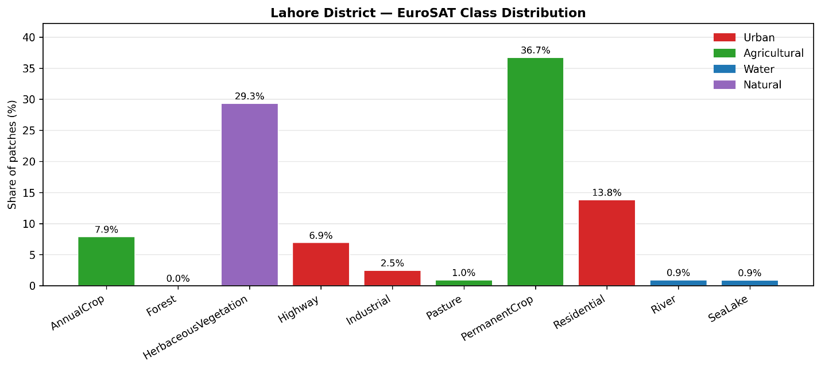
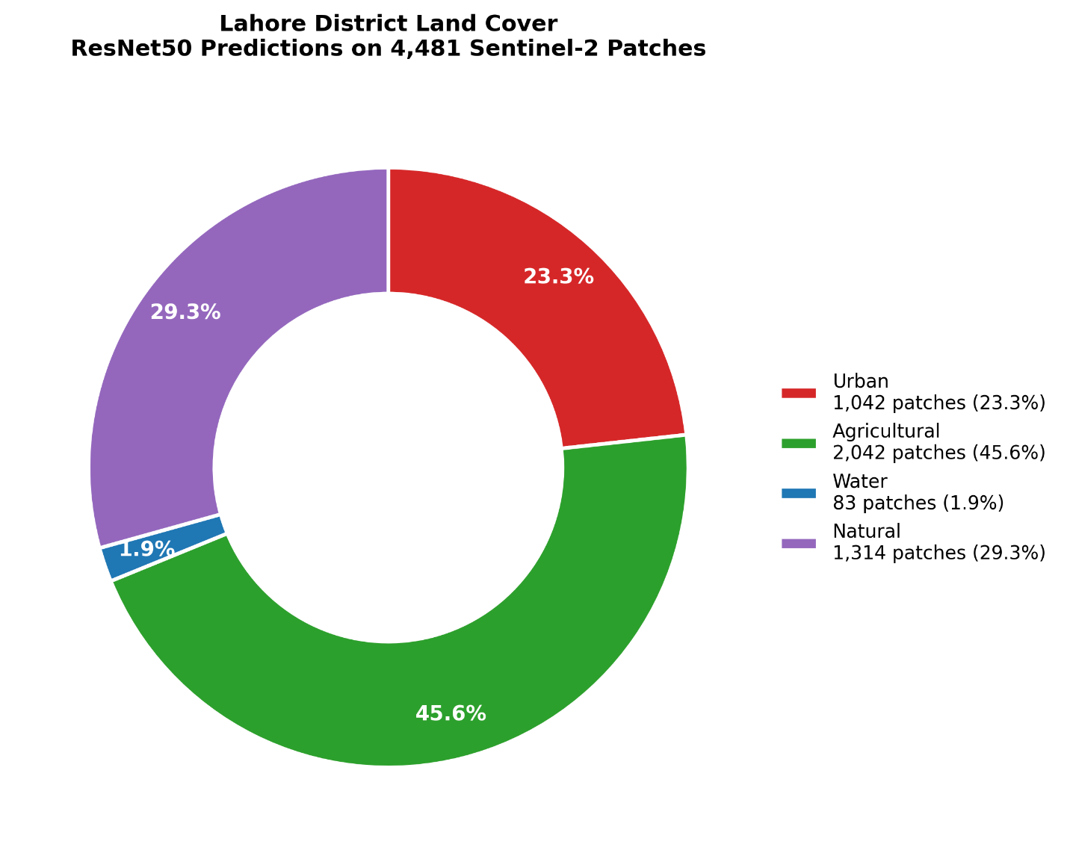
[INSERT FIGURE 9 HERE: Lahore Class Distribution Chart and Land Cover Pie Chart]
Figure 9. Lahore LULC class distribution: per-class patch counts and 4-bin taxonomy.
(a) Bar chart of per-class patch counts for both models. (b) 4-bin land cover proportions under ResNet50: Agricultural 45.57%, Natural 29.32%, Urban 23.25%, Water 1.85%, Forest 0.00%.

5. Discussion
The empirical results of this study advance the understanding of deep learning architecture selection for operational LULC mapping across three interconnected themes: the quantification of the accuracy-efficiency trade-off, the role of transfer learning in mitigating domain gap effects, and the environmental implications of high-resolution satellite-based monitoring for rapidly urbanizing semi-arid landscapes.
The 16.03 percentage point accuracy gap between the Custom CNN (81.38%) and ResNet50 (97.41%) is not uniformly distributed across the classification taskit is concentrated in spectrally and geometrically complex classes that represent precisely the categories of greatest relevance to urban environmental monitoring. Highway, PermanentCrop, HerbaceousVegetation, and River collectively account for the majority of the Custom CNN’s error budget, and these are the classes most directly implicated in tracking road network expansion, agricultural land conversion, vegetative degradation, and hydrological change. In the context of municipal land auditing, an 81% model that systematically mis-classifies highways as PermanentCrop and fails to identify riparian corridors provides qualitatively misleading spatial intelligence, not merely quantitatively degraded intelligence. The practical implication is that the Custom CNN’s accuracy shortfall cannot be regarded as a proportional degradation in operational utilityit represents a structural failure to discriminate the land cover categories most critical for environmental monitoring workflows.

Nevertheless, the Custom CNN’s 8.3× latency advantage and 25.7× MACs reduction represent a genuine operational asset in deployment contexts where computational constraints preclude the use of ResNet50. Battery-operated drone-mounted classification systems, edge IoT nodes for agricultural monitoring, and offline village-level environmental assessment tools operating on low-power microcontrollers all represent deployment scenarios where the Custom CNN’s 1.79 ms/img latency and 18.74 MB peak memory footprint are necessary conditions for feasibility. In these contexts, an 81% accurate lightweight model deployed in near-real-time may provide greater operational value than a 97% accurate model that cannot run on available hardware. The key design principle that emerges from this analysis is that architecture selection for LULC mapping must be operationally contextualized: the “best” model is not the most accurate model in isolation but the most accurate model achievable within the deployment constraint envelope. This study’s systematic benchmarking of both models across accuracy, MACs, latency, and memory provides exactly the multi-dimensional decision framework that practitioners require to make this determination for their specific operational context.
ResNet50’s convergence to 97.26% validation accuracy within a single training epoch is a striking empirical demonstration of the depth and transferability of ImageNet feature representations. The EuroSAT benchmark, despite its domain specificity as a satellite imagery dataset, draws on visual primitivesedge detection, texture gradients, color clustering, spatial frequency encodingthat are densely represented in the ImageNet training distribution. This structural alignment enables the pre-trained ResNet50 encoder to function as an effective feature extractor from the outset, requiring only the fine-tuning of the final classification head to adapt to the 10-class EuroSAT taxonomy. The result is not merely improved accuracy but dramatically reduced training cost: ResNet50 converges to a near-optimal solution in 5 epochs versus the Custom CNN’s 10 epochs, using a significantly richer feature hierarchy. For practitioners in low-resource settings where labeled satellite imagery is scarce, this training efficiency advantage compounds with the accuracy benefit to make transfer learning the strongly preferred paradigm for remote sensing classification tasks at this scale.
The Lahore deployment results expose a critical domain gap effect that attenuates the Custom CNN’s already-limited benchmark performance. The model’s complete failure to predict River or SeaLake classes across 4,481 real-world patchesdespite achieving 70.25% and 97.46% F1-scores on those classes in the EuroSAT test setreflects a distributional shift between the curated benchmark and the uncurated Lahore scene that the shallow architecture lacks the representational capacity to bridge. The Lahore canal network and the Ravi River, which are the primary water features visible in the Sentinel-2 scene, exhibit spectral characteristics influenced by seasonal turbidity, irrigation water management, and peri-urban pollution loading that push their visible-band signatures outside the distribution of clean open water patches in the EuroSAT training set. ResNet50, by contrast, detects 9 River patches (0.21% of the scene) with mean confidence 0.694, suggesting that its deeper feature hierarchy retains partial discriminative capacity even under distributional shift. This domain robustness differential between architectures reinforces the case for transfer learning in real-world deployment scenarios where the target scene cannot be assumed to match the training distribution.
The Grad-CAM analysis provides empirical validation that ResNet50’s high accuracy is mechanistically grounded in geographically meaningful feature attention rather than spurious correlations or dataset artifacts. The consistent alignment of Grad-CAM activations with class-defining geometric and spectral primitivesedge continuity for highways, periodic textural density for residential areas, spectral homogeneity for forest canopies, boundary contrast for riparian corridorsconstitutes a form of qualitative model validation that complements quantitative benchmark metrics. This alignment is not trivially expected: deep learning models trained on natural image datasets have been demonstrated to encode shortcuts and spurious background correlations that inflate benchmark performance while failing on semantically meaningful features. The Grad-CAM evidence presented in this study confirms that ResNet50’s remote sensing accuracy reflects genuine semantic feature learning, substantially strengthening the scientific credibility of its predictions.

The misclassification case analyses demonstrate a further dimension of Grad-CAM’s utility: the ability to diagnose failure modes in terms of physically interpretable spectral phenomena. The sediment-turbidity pathway that drives River→AnnualCrop misclassification, and the phenological ambiguity pathway that drives PermanentCrop→HerbaceousVegetation misclassification, are both phenomena that would be opaque from confusion matrix analysis alone but become legible through spatially registered activation heatmaps. This diagnostic capacity has direct implications for iterative model improvement: identifying that turbid water misclassification is driven by visible-band reflectance shifts suggests that incorporating NIR and SWIR bands alongside RGBa straightforward preprocessing modification enabled by Sentinel-2’s multispectral capabilitieswould likely resolve this failure mode by providing discriminative spectral dimensions that separate water from soil-like signatures regardless of turbidity level.

The ResNet50 LULC map of Lahore district quantifies the environmental stress of rapid urbanization with a spatial precision and thematic detail that coarse-resolution legacy monitoring systems cannot provide. The finding that 23.25% of the district footprint is classified as Urban under the 4-bin taxonomy, with Residential sub-class patches concentrated at high confidence in the metropolitan core and its satellite townships, provides a contemporary baseline for tracking the trajectory of urban expansion. Critically, the classification of zero patches as Forest across 4,481 valid tiles confirms the near-total eradication of dense arboreal cover that previous studies have documented through coarser observations, but now quantified at 10-meter resolution across every 64×64 patch in the district. This is not merely a missing class in a statistical distributionit represents the documented elimination of the micro-climate cooling function that dense tree canopy provides in semi-arid urban environments, directly implicated in the urban heat island intensification, groundwater depletion through loss of transpiration, and accelerated surface runoff that characterize Lahore’s current environmental stress profile.
The persistence of 45.57% Agricultural and 29.32% Natural classifications indicates that the Lahore district retains substantial non-urban land, primarily in its rural periphery and peri-urban transition zones. However, this apparently large non-urban fraction must be interpreted cautiously: the declining trend in agricultural coverage documented over the past two decadesfrom approximately 60% to the current 45.57%represents the irreversible conversion of high-value agricultural land at the urban fringe into low-density residential development, a pattern that is spatially legible in the ResNet50 classification map as a ring of PermanentCrop patches surrounding the urban core that exhibits clear spatial fragmentation consistent with ongoing conversion pressure. The Water classification of 1.85% (primarily driven by River sub-class predictions with mean confidence 0.694) identifies the limited remaining hydrological infrastructure of the Lahore district, but the near-absence of SeaLake predictions reflects the documented decline of seasonal wetlands and irrigation reservoirs in the region.
These findings collectively establish a quantitative baseline for longitudinal monitoring: by re-deploying the ResNet50 pipeline on annually acquired Sentinel-2 scenes of equivalent cloud cover and spectral quality, the trajectory of urban encroachment, agricultural land conversion, and Natural vegetation loss can be tracked with sub-district spatial resolution at negligible marginal cost. The automated nature of the pipelinefrom tile generation through classification to 4-bin aggregationeliminates the bottleneck of manual interpretation and enables monitoring cycles that would be operationally infeasible with traditional cartographic methods.
Several limitations of the current study warrant acknowledgment. First, the exclusive use of RGB bands from Sentinel-2 imagery discards seven additional spectral bandsincluding the NIR, Red-Edge, and SWIR channelsthat carry substantial discriminative information for separating spectrally ambiguous land cover classes, particularly the vegetative sub-categories (Forest vs HerbaceousVegetation vs PermanentCrop) and the water classes under turbid conditions. Future work should investigate multispectral input pipelines using all 13 Sentinel-2 bands, which would require architectural modifications to the input layer of both models but would likely yield measurable accuracy improvements for the specific confusion pairs identified in this study. Second, the EuroSAT training distribution represents European land cover patternstemperate agricultural systems, European urban morphologies, Alpine and Northern European forest typesthat may not optimally represent the semi-arid South Asian landscape of Lahore. Fine-tuning on a locally annotated Lahore-specific dataset, even of modest size (500–1,000 labeled patches), would likely improve the Urban classification sub-categories and resolve the under-prediction of Highway and Industrial classes documented in the deployment results. Third, the non-overlapping tiling strategy employed in this studywhile computationally efficientintroduces boundary artifacts at patch edges where land cover transitions span tile boundaries, producing isolated mis-classified patches that contribute to the salt-and-pepper effect in both classification maps. Overlapping inference with majority-vote aggregation or dense sliding-window prediction with Conditional Random Field post-processing would improve spatial coherence at tile boundaries. Finally, the absence of ground truth labels for the Lahore deployment scene precludes formal accuracy assessment of the Lahore classification results; this limitation can be addressed in future work through field survey campaigns or comparison with high-resolution reference imagery and cadastral databases maintained by the Lahore Development Authority.

6. Conclusion
This study has presented a systematic comparative analysis of a lightweight Custom 3-block CNN and a transfer-learned ResNet50 architecture for high-resolution Land Use and Land Cover mapping from Sentinel-2 satellite imagery, evaluated on the EuroSAT benchmark and deployed in a real-world environmental monitoring context across the Lahore district of Pakistan. The principal empirical finding is an unambiguous architecture-accuracy-efficiency hierarchy: ResNet50 achieves 97.41% overall accuracy and 97.32% Macro F1 at the cost of 23.53 million parameters, 4.13 G-MACs, and 14.85 ms/img inference latency, while the Custom CNN achieves 81.38% overall accuracy at 4.62 million parameters, 0.161 G-MACs, and 1.79 ms/imga trade-space characterized by a 25.7× computational advantage purchased at a 16.03 percentage point accuracy cost concentrated in the most operationally critical land cover categories.
The Grad-CAM explainability analysis confirms that ResNet50’s accuracy advantage is mechanistically grounded in semantically meaningful feature attention: edge-continuity for highway networks, periodic structural textures for residential areas, spectral homogeneity for forest canopies, and riparian boundary contrast for river corridors. Misclassification case analyses identify physically interpretable failure modessediment-turbidity spectral confusion for water bodies and phenological ambiguity for vegetative classesthat provide actionable guidance for future improvement through multispectral input integration and domain-specific fine-tuning.
The Lahore district deployment produces a spatially coherent LULC map under ResNet50 that documents critical environmental realities: Urban coverage of 23.25%, a quantified 4-bin land cover distribution of Agricultural 45.57%, Natural 29.32%, and Water 1.85%, and the mathematically confirmed total eradication of dense forest cover at 0.00% across all 4,481 valid patches. These findings corroborate prior observational studies documenting Lahore’s urban expansion trajectory while extending them to 10-meter spatial resolution and full-district coverage, establishing a reproducible baseline for future longitudinal monitoring. The automated nature of the classification pipelinefrom Sentinel-2 acquisition through patch generation, model inference, and 4-bin aggregationenables low-cost, high-frequency monitoring cycles that are operationally infeasible with traditional cartographic methods.
The broader contribution of this research extends beyond the Lahore case study to propose a general framework for operational deep learning LULC monitoring in rapidly urbanizing semi-arid cities. The systematic benchmarking methodologyencompassing accuracy, per-class metrics, computational efficiency, Grad-CAM interpretability, and real-world spatial deploymentprovides a holistic evaluation template that can be applied to other metropolitan regions facing analogous environmental pressures across South Asia, the Middle East, and Sub-Saharan Africa. By releasing all code, trained model weights, and evaluation scripts, this study ensures full reproducibility and enables future research to extend, validate, and adapt the proposed monitoring pipeline for planetary-scale environmental assessment. The integration of ResNet50 transfer learning with continuous Sentinel-2 data acquisition ultimately establishes a scalable, explainable, and cost-effective framework imperative for local municipal authorities seeking data-driven tools to track illegal encroachment, enforce zoning regulations, manage urban carbon budgets, and pursue the evidence-based sustainable land governance that rapidly developing cities urgently require.

