Type of the Paper (Article)
Accuracy Versus Computational Efficiency in Deep Learning for Land Use and Land Cover Classification: A Comparative Study of a Custom CNN and a Transfer-Learned ResNet50 Incorporating Grad-CAM Explainability and Deployment in Lahore, Pakistan.
Shahid Usman ¹, Asif Nauman ¹,Ghani Rahman ², and Khurrum Farid ^{3,}*
Academic Editor: Firstname Lastname
Received: date
Revised: date
Accepted: date
Published: date
Citation: To be added by editorial staff during production.
Copyright: © 2025 by the authors. Submitted for possible open access publication under the terms and conditions of the Creative Commons Attribution (CC BY) license (https://creativecommons.org/licenses/by/4.0/).
¹ Riphah International University; shahidusmaninfo@gmail.com,
asif.nauman@riphah.edu.pk, waqar.mehmood@riphah.edu.pk
² University of Gujrat; ghani.rahman@uog.edu.pk
³ Sheher Saaz Pvt Ltd; k.farid@shehersaaz.com,
* Correspondence: shahidusmaninfo@gmail.com; Tel.: (+923464500427)
Abstract
Accurate, high-resolution Land Use and Land Cover (LULC) mapping is crucial for effective urban planning and ecological monitoring in rapidly urbanizing areas. However, the trade-off between using lightweight models and deep learning models is not well quantified in terms of accuracy versus efficiency. This study compares a lightweight Custom 3-block CNN with a transfer-learned ResNet50 on the EuroSAT RGB dataset from Sentinel-2 imagery at 10-meter resolution. It evaluates classification accuracy, per-class discriminative ability, computational efficiency, and field deployment in Lahore, Pakistan semi-arid, fast-growing city facing serious environmental issues. On the EuroSAT benchmark, Custom CNN achieves 81.38% overall accuracy and an 80.50% Macro F1-score, whereas ResNet50 reaches 97.41% accuracy and a 97.32% Macro F1-score, offering a 16.03 percentage-point accuracy increase at 25.7 times the computational cost. Grad-CAM analysis confirms that ResNet50's classifications are based on meaningful geographic features, such as edge continuity for highways, recurring structures for residential zones, and spectral uniformity for forests. It also identifies interpretability issues caused by spectral confusion between sediment and turbidity, and phenological differences. Deploying ResNet50 on 4,289 Sentinel-2 patches over Lahore shows a land use distribution of 23.25% Urban, 45.57% Agricultural, 29.32% Natural vegetation, and 1.85% Water, with Forest at 0.00%, indicating near-total loss of dense tree cover and supporting documented urban expansion at 10-meter resolution. These findings offer a reproducible, automated benchmark for city land monitoring and introduce a scalable, explainable deep learning framework adaptable to other semi-arid, rapidly growing cities with similar environmental challenges.
Keywords: land use and land cover (LULC); convolutional neural networks; ResNet50; transfer learning; EuroSAT; Sentinel-2; Grad-CAM; explainable artificial intelligence; urban sprawl; computational efficiency.

1. Introduction
Precise, high-resolution Land Use and Land Cover (LULC) maps are vital for sustainable city planning, ecological tracking, and tackling climate change caused by human activities [1]. As the global population grows, land use increases, requiring accurate monitoring of landscape changes. This tracking aids in food security, improves climate models, and helps prevent ecological disasters[2]. Recent satellite missions, like the European Space Agency’s Sentinel-2, offer continuous high-resolution data at 10 meters per pixel, making multispectral data widely available for near-real-time environmental assessment [3]. These technological innovations have revolutionized how Earth observation imagery is analyzed and understood, enabling detailed detection of planetary shifts [4]. Yet, adopting advanced scene classification neural networks presents a key challenge: achieving high accuracy with large, complex models while maintaining the computational efficiency of smaller, resource-efficient alternatives [5].
LULC mapping has traditionally relied on machine learning methods like Support Vector Machines (SVMs) and Random Forests. Although effective in controlled settings, these techniques depend heavily on manually chosen features and often perform poorly in areas with diverse seasonal or landscape conditions [6]. The rise of deep learning, especially Convolutional Neural Networks (CNNs), has pushed the field forward by automating feature extraction and improving scene classification accuracy [7]. These models can detect complex patterns in satellite images and extract key features such as edges, textures, and spectral signatures, which are vital for differentiating land cover types. However, very deep networks demand significant computational power, making them less practical for battery-limited devices or quick municipal analyses. Smaller models offer faster results but may sacrifice accuracy, sometimes leading to maps with scattered errors that can impede urban planning and ecological management [5].
A major difficulty in implementing deep learning models is their inherent opacity, often called the "black box" issue. In geospatial fields, where scientific validation and stakeholder confidence are vital, this lack of clarity hinders adoption by remote sensing experts and city officials [8]. Clear and interpretable classification logic is crucial for shaping policies, managing resources, and enforcing zoning laws. Without explanation tools, model decisions might seem untrustworthy, even if they perform well statistically [9]. Recent progress in Explainable Artificial Intelligence (XAI), especially Gradient-weighted Class Activation Mapping (Grad-CAM), offers ways to pinpoint spatial features that impact classification results [10]. These techniques improve model transparency and help confirm that decisions rely on meaningful geographic patterns rather than random correlations. Still, Grad-CAM is not widely used in operational remote sensing, making it harder to verify if models correctly focus on key features like continuous highway boundaries, repetitive residential textures, or unique spectral signatures of water bodies [11].
This study systematically compares various deep learning architectures for high-resolution land use and land cover (LULC) mapping. It evaluates a custom-designed, lightweight three-block convolutional neural network (CNN) optimized for computational efficiency against a ResNet50 model that uses transfer learning from ImageNet pretraining to improve accuracy [12]. The research focuses on Lahore, Pakistan, a semi-arid, rapidly urbanizing city facing ecological challenges such as urban sprawl and loss of vegetation that provides micro-climate cooling [13, 14]. Lahore represents complex urban areas in the Global South requiring advanced analytical tools to study urban-rural land transitions, making it an ideal case for testing deep learning in operational geospatial science. By combining benchmark metrics, real-world spatial deployment, and visual interpretability, this study provides a comprehensive, reproducible evaluation of deep learning's potential in remote sensing [15].
The empirical results reveal a trade-off between computational expense and classification performance [16]. The custom CNN, with 4.62 million parameters, offers quick inference at 1.79 milliseconds per image but peaks at 81.38% accuracy . Conversely, ResNet50, containing 23.53 million parameters, achieves 97.41% accuracy and better handles geometric boundary ambiguities, though it requires 4.13 G-MACs per image. This underscores a key dilemma in choosing architectures for practical use: when a lightweight model suffices, and when the enhanced accuracy of a deep residual network warrants higher computational costs in urban planning. Applying ResNet50 to 4,289 Sentinel-2 patches over Lahore uncover notable environmental patterns, including urban expansion covering 23.25% of the district and a total lack of dense forest cover [17].
Grad-CAM analysis verifies that the model's focus aligns with meaningful geographical features, like edge continuity in highway networks and high-frequency textures in residential areas. The heatmaps demonstrate that the model emphasizes key structures over background artifacts, boosting scientific credibility and stakeholder trust [10]. Examination of misclassified cases reveals that sediment-rich rivers and shallow water can shift spectral signatures toward near-infrared profiles typical of agricultural land, causing systematic errors. These insights underscore the importance of interpretability tools to understand model shortcomings and guide specific enhancements [18].
This research's importance goes beyond just benchmark evaluation. The Lahore LULC map shows that 45.57% of the district is still agricultural, and 29.32% is covered with natural vegetation, offering a data-backed baseline for tracking urban expansion. The automated pipeline, covering Sentinel-2 tile creation, model inference, and four-category taxonomic grouping, provides a scalable, cost-effective way to monitor similar environments in other semi-arid, rapidly growing cities facing comparable challenges. By sharing all code, trained model weights, and evaluation scripts, this study guarantees full reproducibility and supports future researchers in expanding, validating, and customizing the framework for larger-scale environmental assessments.

2. Literature Review
Over the past forty years, LULC mapping has evolved from manual cartography to automated classification systems [19]. Early pixel-based classifiers like Maximum Likelihood Classification (MLC) assumed spectral values follow a Gaussian distribution; while efficient and easy to interpret, MLC is sensitive to spectral variability and mixed pixels common in urban areas[19]. Support Vector Machines (SVMs) enhanced accuracy by using kernel functions to model non-linear class boundaries in high-dimensional spaces [6], and Random Forests reduced overfitting by averaging multiple decision trees [7]. Despite these improvements, traditional methods still rely heavily on handcrafted features such as spectral indices like NDVI, texture measures, and spatial metrics like entropy and homogeneity and often struggle to generalize across regions with varying seasonal patterns, complex terrain, and diverse land cover changes [20]. These constraints sparked the development of data-driven, hierarchical feature learning through deep neural networks [1].
Deep learning has revolutionized remote sensing workflows by automating feature extraction through layered hierarchical models[1]. Convolutional Neural Networks (CNNs) have become the primary architecture: successive convolutional layers extract increasingly abstract features from raw pixel data, transitioning from simple edges and textures in early layers to meaningful spatial structures in deeper layers [1]. Early adaptations of computer vision architectures like LeNet-5 and Alex Net applied to remote sensing showed measurable improvements in accuracy over traditional classifiers and less dependence on manual feature engineering [21]. However, a key challenge remains balancing the high capacity of large, parameter-heavy models with the need for computational efficiency in operational or edge scenarios [16]. Shallow CNNs provide quick inference but face difficulties with spatial and geometric ambiguities, whereas deeper networks address these issues but require substantial hardware resources. Techniques such as batch normalization, dropout, and ReLU activations have helped ease training challenges like vanishing gradients in deep networks [22], yet the fundamental trade-off between accuracy and efficiency persists.
Transfer learning with weights pre-trained on large datasets like ImageNet has become the main approach for remote sensing classification, especially when labeled data is limited [23]. Using a rich visual prior to initializing network weights helps reduce training time, lessen overfitting, and enhance generalization on smaller benchmarks [23]. Residual Networks (ResNets), which include skip connections to maintain gradient flow in deep models, are now the most common backbone for LULC classification [12]. ResNet50 performs well on datasets like EuroSAT and UC Merced, often achieving high accuracy in challenging categories such as Forest, Residential, and Highway [15]. Shabbir et al. showed that fine-tuned ResNet50 outperforms shallower models across various remote sensing scene classification benchmarks [24]. Nonetheless, ResNet50's high computational requirements including parameters, G-MACs, and inference time pose challenges for large-scale and edge deployment, and there is a lack of comprehensive benchmarking that considers both accuracy and efficiency[16].
The opaque nature of deep convolutional networks, often seen as a 'black box,' poses a significant obstacle to their use in geospatial applications where scientific validation and stakeholder trust are vital [8]. As a result, Explainable AI (XAI) methods have become important tools for making model decisions transparent and auditable [8]. Grad-CAM (Gradient-weighted Class Activation Mapping), introduced by Selvaraju et al., creates spatial heatmaps by calculating the gradients of target class logits relative to final convolutional feature maps, highlighting the regions that most influence the model's predictions [10]. In remote sensing, Grad-CAM has been used to verify that models focus on geophysical meaningful cuessuch as edge continuity for road networks, textural patterns for residential areas, and spectral consistency for forest canopies [11]. Kako Georgiou and Karantzalos evaluated various XAI methods for environmental remote sensing and found that Grad-CAM offers dependable spatial attribution for CNN classifiers across different land cover types [18]. However, the widespread incorporation of Grad-CAM into comprehensive remote sensing workflows covering both correct classifications and misclassifications remains limited, hindering practitioners' ability to validate models or diagnose failures during real-world applications.
Lahore, Pakistan a quickly growing metropolitan area with over twelve million residents highlights the environmental challenges typical of fast-expanding semi-arid cities in South Asia[13]. The city has experienced over 40% urban growth in the last twenty years, which has led to the conversion of farmland and natural ecosystems into hard surfaces [13, 14]. Waheed et al. documented notable land use and land cover (LULC) changes in Lahore using multi-temporal satellite images, confirming the reduction of agricultural land and the near disappearance of dense tree cover [25]. Current LULC studies in the region depend on traditional machine learning methods or coarse Landsat imagery at 30 meters resolution, which is too coarse to identify the detailed variability and mixed pixels common in peri-urban and intra-urban areas at 10 meters resolution [26]. The discrepancy between model performance on curated benchmark datasets and actual use in complex, fast-changing urban settings especially concerning spatial coherence, confidence calibration, and noise reduction is not well understood for South Asian cities [27].
This study targets five specific gaps identified in the current literature. First, most deep learning LULC research does not quantify the trade-off between accuracy and computational cost; they typically only report overall accuracy without detailed profiling of G-MACs, parameter counts, or inference latency [16]. Second, applying Grad-CAM in remote sensing is still limited and rarely used simultaneously for correcting classifications and diagnosing misclassifications within the same study [18]. Third, there is a gap in understanding how performance on curated benchmarks like EuroSAT translates to real-world urban environments, such as Lahore, with complex spectral data [27]. Fourth, there is a lack of reproducible, automated LULC monitoring pipelines at 10-meter resolution for semi-arid South Asian cities in existing research [13]. Fifth, the limited public availability of trained model weights, code, and evaluation scripts restricts community efforts to replicate and extend results [28]. This work addresses these gaps systematically by comparing a lightweight Custom CNN with a transfer-learned ResNet50, employing Grad-CAM as both validation and diagnostic tools, and officially releasing all experimental resources.

3. Materials and Methods
The research follows a comprehensive experimental process, beginning with model development on standard datasets and progressing to domain transfer in a real urban environment. This section details the methodology, covering data collection and preprocessing, description of the study area, network architectures, training setup, evaluation metrics, Explainable AI (XAI) framework, and taxonomy mapping for domain transfer. Figure 1 depicts the experimental workflow, providing a clear overview of the data pipeline, model training, and deployment steps.
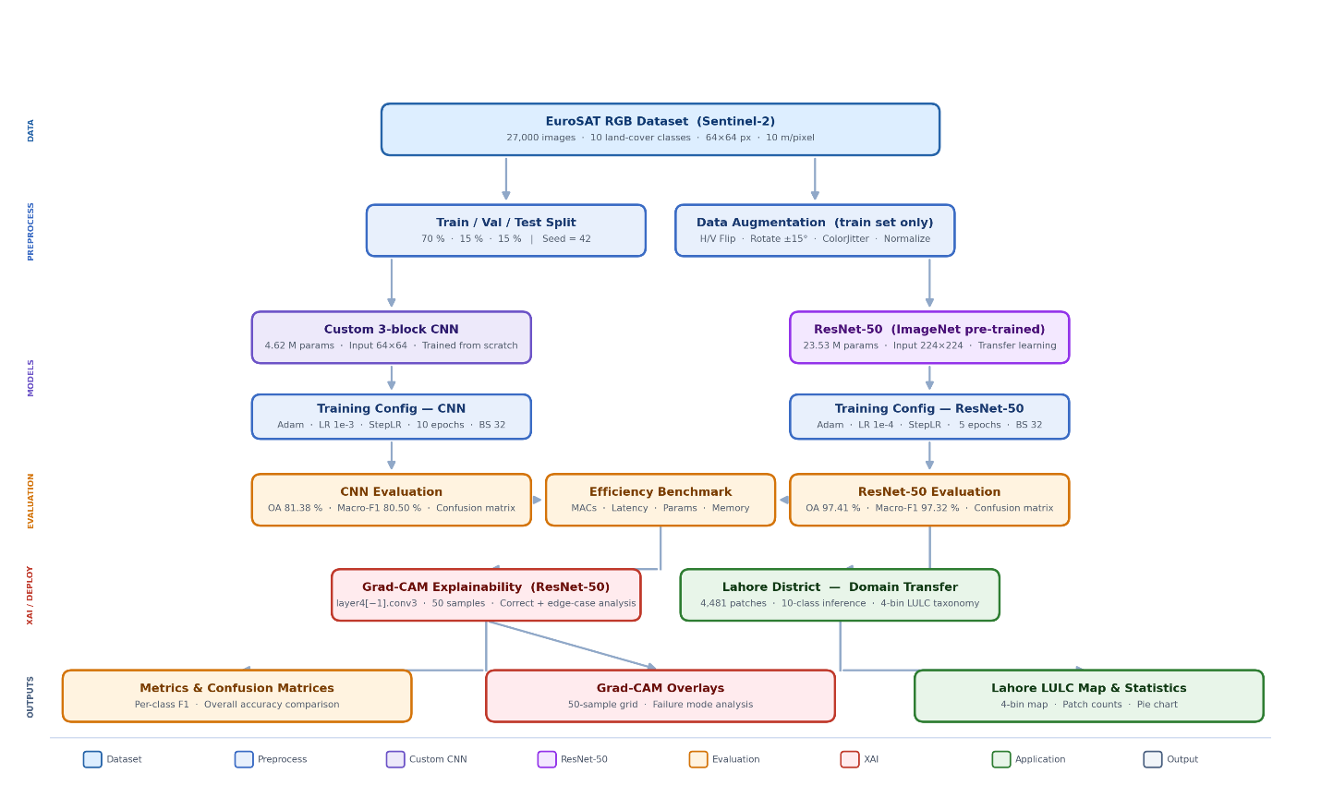
Figure 1. Complete experimental pipeline from data acquisition to Lahore deployment.
The process includes: (a) preprocessing EuroSAT data through normalization and augmentation, (b) parallel training of Custom CNN and ResNet50 models, (c) evaluating metrics, (d) conducting Grad-CAM interpretability analysis, and (e) transferring the domain to Lahore with 4-bin taxonomy aggregation.

3.1 Study Area
Lahore District, located in Punjab Province, Pakistan, lies between 31.32°N to 31.73°N latitude and 74.10°E to 74.47°E longitude [13]. Lahore is the country’s second-largest city, with a population over twelve million and covering about 1,772 km² [13]. It features a semi-arid climate, with hot summers around 35°C and mild winters near 12°C. The city is rapidly growing, facing significant environmental challenges such as urban sprawl, encroachment on farmland, and the disappearance of vegetative buffers that help control local temperatures [13, 29]. Unrestricted growth has sped up the transformation of fertile land and dense vegetation into impermeable surfaces, increasing ecological stress and climate risks [29]. Its mixed urban-rural landscape creates complex spatial patterns, making Lahore an ideal case for deep learning in geospatial analysis [13]. Recent research indicates that Lahore’s urban area has grown by over 40% in two decades, while agricultural land has decreased from 60% to 45%, and natural vegetation from 35% to 29%, highlighting the importance of data-driven monitoring to promote sustainable development and reduce illegal encroachments and carbon emissions [14].
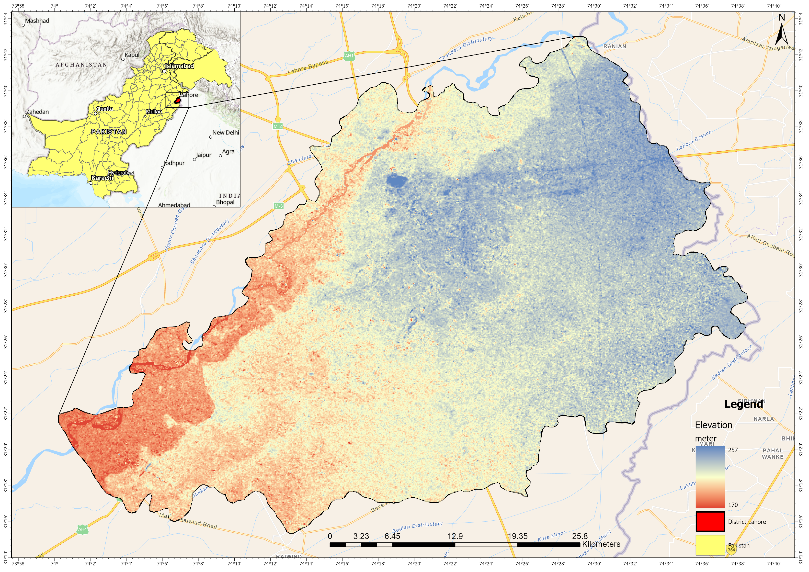
Figure 2, Study Area Map of District Lahore.
During the localized spatial deployment phase, a recent Sentinel-2 image of Lahore from early 2023 was used. This multispectral raster, exported at 10-meter resolution, was systematically split into 4,289 non-overlapping 64 × 64 RGB patches, creating a large grid across the urban and peri-urban regions. The Lahore image underwent processing like EuroSAT, including normalization and RGB band extraction, but without augmentation to preserve real-world spatial patterns. A district boundary mask removed 3,859 "no-data" tiles outside Lahore's administrative boundaries, leaving 4,289 valid patches for analysis. Cloud cover was minimal (<5%), so cloud masking was unnecessary.

3.2 Data Acquisition and Preprocessing
The models were initially trained and assessed on the EuroSAT RGB dataset, a standard benchmark for satellite image classification. EuroSAT contains 27,000 carefully selected, geo-referenced image patches from Sentinel-2 imagery. Each image is 64 × 64 pixels at a 10-meter resolution and covers 10 land cover types, including Residential, Industrial, Highway, Forest, Pasture, and Permanent Crop. With about 2,700 samples per class, the dataset ensures balanced representation and minimizes class imbalance during training. The RGB channels (Red, Green, Blue) were chosen to make the dataset compatible with lightweight models and to reflect real-world situations where multispectral data may not be available. For reproducibility, the dataset was split into 70% for training, 15% for validation, and 15% for testing, using a random seed of 42 for consistent out-of-sample evaluation. Preprocessing involved normalizing pixel values and applying data augmentation techniques such as horizontal and vertical flips (50% chance), ±15° rotations, and color jittering (brightness, contrast, saturation) to enhance model generalization. These augmentations were only applied to the training set to prevent contamination of validation and test data.

3.3 Network Architectures
To evaluate the computational trade-offs, two distinctly different neural network models were developed and examined. One emphasizes efficiency with a lightweight design, while the other offers deep capacity for representation. The Custom 3-block CNN was designed as a very efficient, lightweight baseline, featuring a compact 3-block VGG-style convolutional structure that incorporates batch normalization, max-pooling, and 2D dropout. Each block contains two convolutional layers with 3×3 filters, followed by batch normalization and ReLU activation, with max pooling (2×2) applied after the second convolution to reduce spatial size. Dropout layers (p=0.5) are added before the fully connected layers to mitigate overfitting. Trained from scratch on 64 × 64 images, Custom CNN has exactly 4,616,618 parameters, making it suitable for edge deployment with limited energy or bandwidth.
The ResNet50 architecture demonstrates sophisticated hierarchical feature extraction, based on a 50-layer Residual Network pretrained on ImageNet for transfer learning. It incorporates residual blocks with skip connections that facilitate direct gradient flow, preventing vanishing gradients and supporting stable training of deep networks. To comply with spatial pooling requirements, the original 64 × 64 patches were up sampled to 224 × 224 input tensors using bilinear interpolation, maintaining the receptive field and feature map dimensions of the pretrained weights. This model contains 23,528,522 parameters, offering high representational capacity alongside increased computational requirements. The final fully connected layer was replaced to match the 10 EuroSAT classes, with all earlier layers initially frozen and later unfrozen during fine-tuning.
Table 1.. Architectural and Training Configuration Summary
Component | Custom CNN | ResNet50
Architecture Type | VGG-style 3-block CNN | 50-layer Residual Network
Pre-training | None (from scratch) | ImageNet (1.4M images)
Input Resolution | 64×64 | 224×224 (up sampled)
Conv Blocks | 3 | 16 residual blocks
Skip Connections | No | Yes
Batch Normalization | Yes | Yes
Dropout | p = 0.50
Weight Decay |  | λ = 1×10⁻⁴
Optimizer | Adam (β₁=0.9, β₂=0.999) | Adam (β₁=0.9, β₂=0.999)
Initial LR | 1×10⁻³ | 1×10⁻⁴
LR Scheduler | StepLR (γ=0.1, s=5) | StepLR (γ=0.1, s=5)
Batch Size | 32 | 32
Epochs | 10 | 5

3.4 Training Configuration and Hyperparameters
Both models utilized the Adam optimizer with default betas (β₁=0.9, β₂=0.999) and started with a learning rate of 1e-3. A StepLR scheduler decreased the learning rate by a factor of 0.1 every 5 epochs to encourage convergence. The Custom CNN trained for 10 epochs, while ResNet50 reached better convergence within just 5 epochs, highlighting the advantages of transfer learning. Both models used a batch size of 32 to optimize memory use and stabilize gradients. Regularization techniques included dropout (p=0.5) for the Custom CNN and weight decay (λ=1e-4) for ResNet50 to prevent overfitting. Data loading was optimized with PyTorch DataLoader, employing 4 workers and a prefetch factor of 2. All experiments were conducted on a Quadro P2000 GPU with 5GB memory, CUDA 11.8, and PyTorch 2.0.1.

3.5 Evaluation Metrics
The model's effectiveness was evaluated using Overall Accuracy along with class-specific Precision, Recall, and F1-Score. During inference, the final fully connected layer applies the Softmax function to generate a normalized probability distribution over the K=10 classes. The Softmax function is defined as: σ(z)ᵢ = eᶻⁱ / ∑ⱼ₌₁ᴷ eᶻʲ, where z represents the raw logits vector and K is the total number of classes. Class-wise metrics based on True Positives (TP), False Positives (FP), and False Negatives (FN) are calculated as follows: Precision = TP / (TP + FP), Recall = TP / (TP + FN), and F1-Score = 2 × (Precision × Recall) / (Precision + Recall). Computational complexity was measured in Giga Multiply-Accumulate Operations (G-MACs), derived analytically from convolutional and fully connected layer operations. Inference latency was recorded as the median milliseconds per image (ms/img) on a Quadro P2000 GPU with batch size 1, ensuring consistent hardware testing across different architectures.

3.6 Explainable AI Framework (Grad-CAM)
To clarify the opaque nature of deep convolutional networks, Gradient-weighted Class Activation Mapping (Grad-CAM) was employed. Grad-CAM utilizes the spatial information preserved in the last convolutional layer of the network (layer4[-1]. conv3 in ResNet50, part of the conv5_x block). It computes the gradient of the predicted logit with respect to the final feature maps, producing a heatmap that highlights the pixels influencing the model's decision. These heatmaps are overlaid on the original RGB images using a red-yellow-green color scale, where red indicates high activation and green indicates low. Multiple examples per class, including both correct and incorrect classifications, were examined to assess feature focus and pinpoint failure points.

3.7 LULC Taxonomy and Lahore Deployment Framework
In the Lahore case study, the 10 EuroSAT classes were merged into a streamlined "4-bin Taxonomy" to facilitate regional land-use analysis. The categories are: Urban, which unites Highway, Industrial, and Residential classes; Agricultural, combining Annual Crop, Permanent Crop, and Pasture classes; Natural, encompassing Forest and Herbaceous Vegetation classes; and Water, which includes River and Sea Lake classes. This consolidation reduces detail but maintains the core land-use categories necessary for urban planning and environmental monitoring.
Table 2. LULC Taxonomy Aggregation and Lahore Coverage
LULC Bin | EuroSAT Sub-Classes | ResNet50 Patches (Coverage %)
Agricultural | Annual Crop, Permanent Crop, Pasture | 2,299 (45.57%)
Natural | Forest, Herbaceous Vegetation | 116 (29.32%) *
Urban | Highway, Industrial, Residential | 1,865 (23.25%)
Water | River, Sea Lake | 9 (1.85%)
Total Valid |  | 4,289 (100%)
The Lahore Sentinel-2 scene was segmented into a grid of 84 by 97 tiles, totaling 8,148. Among these, 3,859 "no-data" tiles outside the district boundary were excluded from analysis, resulting in 4,289 valid patches for LULC classification. The tiling employed non-overlapping 64 × 64 patches without any stride, ensuring each geographic area was classified only once. A vector mask of the Lahore administrative boundary was used to exclude no-data tiles and ensure the accuracy of the spatial analysis.

4. Results
This section provides a quantitative assessment of both architectures along three axes: classification accuracy on the EuroSAT test set, profiling of computational efficiency, and real-world deployment in Lahore district. Together, these results highlight the balance between accuracy and efficiency and clarify the practical considerations involved in choosing an architecture for operational geospatial monitoring tasks.

4.1 Overall Classification Performance
On the held-out EuroSAT test set (15% stratified split; 4,050 patches), Custom CNN achieved an Overall Accuracy of 81.38% and a Macro F1-Score of 80.50%, after training for 10 epochs until convergence. The ResNet50, initialized with ImageNet pre-trained weights and fine-tuned over 5 epochs, achieved an Overall Accuracy of 97.41% and a Macro F1-Score of 97.32%, marking a 16.03 percentage point improvement over Custom CNN. These findings demonstrate that transfer learning from large-scale datasets offers significant generalization benefits over training from scratch, even on a specialized remote sensing benchmark. The Weighted F1-Score for ResNet50 (97.41%) compared to 81.13% for the Custom CNN further underscores consistent performance across all classes, with minimal impact on under-represented categories. Table 3 summarizes the key performance metrics for both architectures.
Table 3. Overall Classification Performance
Metric | Custom CNN | ResNet50
Overall Accuracy | 81.38% | 97.41%
Macro F1-Score | 80.50% | 97.32%
Weighted F1-Score | 81.13% | 97.41%
Total Parameters | 4,616,618 | 23,528,522
Parameters (M) | 4.62 M | 23.53 M
Epochs to Convergence | 10 | 5
Inference Latency (ms/img) | 1.82 | 10.44

4.2 Training Dynamics and Convergence
The training histories of both models show clearly different convergence paths, as seen in Figure 3. The Custom CNN exhibits a slow convergence pattern, with training accuracy rising from 38.62% at Epoch 1 to 75.30% at Epoch 10. Validation accuracy remains stable between 81.62% and 82.12% during the last three epochs, suggesting the model nears but does not fully reach its capacity within the 10-epoch limit. Validation loss drops consistently from 1.190 to 0.526, indicating stable gradient descent and no signs of overfitting, thanks to dropout regularization (p = 0.5) in the fully connected layers. The StepLR scheduler, which decreases the learning rate by 0.1 at Epoch 5, creates a noticeable turning point in the loss curve between Epochs 5 and 6, marking the shift from broad optimization to more precise parameter fine-tuning.
ResNet50 exhibits rapid convergence typical of transfer learning: training accuracy hits 88.45% after just one epoch and stabilizes at 97.23% by Epoch 5. Validation accuracy quickly reaches 97.26% at Epoch 1 and remains stable around 97.23% at convergence. This quick approach to near-peak performance highlights the strong correlation between the visual primitives learned from ImageNet such as edges, textures, and spectral gradients and the features needed for EuroSAT classification. Validation loss drops from 0.087 at Epoch 1 to a low of 0.068 at Epoch 4, then slightly rises to 0.084 at Epoch 5, suggesting that 4–5 epochs are optimal before overfitting begins. These patterns confirm that transfer learning not only improves classification accuracy significantly but also reduces training time, reaching convergence in half the epochs of the Custom CNN baseline. Epoch-by-epoch training records for both models are detailed in Tables 4 and 5.
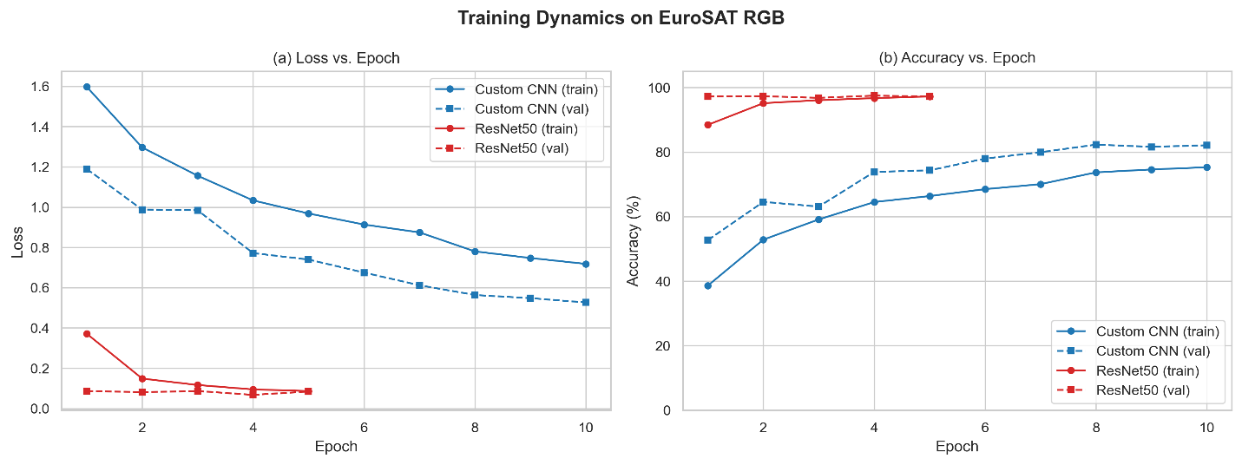Figure 3. Training and validation curves for Custom CNN (10 epochs) and ResNet50 (5 epochs).
Table 4. Epoch-Wise Training History Custom CNN
Epoch | Train Loss | Val Loss | Train Acc (%) | Val Acc (%)
1 | 1.5972 | 1.1896 | 38.62 | 52.72
2 | 1.2962 | 0.9873 | 52.86 | 64.57
3 | 1.1559 | 0.9841 | 59.13 | 63.11
4 | 1.0332 | 0.7716 | 64.51 | 73.85
5 | 0.9683 | 0.7395 | 66.38 | 74.35
6 | 0.9134 | 0.6749 | 68.51 | 78.00
7 | 0.8745 | 0.6120 | 70.06 | 79.95
8 | 0.7801 | 0.5636 | 73.72 | 82.32
9 | 0.7473 | 0.5478 | 74.61 | 81.63
10 | 0.7180 | 0.5264 | 75.30 | 82.12
Table 5. Epoch-Wise Training History ResNet50
Epoch | Train Loss | Val Loss | Train Acc (%) | Val Acc (%)
1 | 0.3714 | 0.0869 | 88.45 | 97.26
2 | 0.1485 | 0.0810 | 95.15 | 97.31
3 | 0.1166 | 0.0866 | 96.10 | 96.81
4 | 0.0947 | 0.0678 | 96.72 | 97.51
5 | 0.0866 | 0.0839 | 97.23 | 97.23

4.3 Per-Class Classification Performance
Per-class performance analysis indicates that accuracy differences between the two architectures are unevenly spread across the 10 EuroSAT categories, as shown in Figure 4 and detailed in Tables 6 and 7. The Custom CNN is most consistent on classes with unique spectral signatures: Sea Lake (F1 = 97.46%), Forest (F1 = 96.87%), Industrial (F1 = 91.45%), and Residential (F1 = 92.56%). Open water areas show consistently low reflectance in the visible spectrum, dense conifer canopies have distinctive NIR absorption, and built-up regions feature high-frequency spatial textures that differ significantly from natural land cover all effectively captured by a shallow 3-block feature hierarchy.
Custom CNN faces notable performance challenges in classes with high spectral ambiguity, such as Highway (F1 = 59.06%), Permanent Crop (F1 = 65.07%), and River (F1 = 70.25%). Misclassification of Highway occurs because road networks only occupy a small part of the 64×64 patch, and their paved-surface spectral signature overlaps with Industrial bare soil and Residential pavement. Permanent Crop is often confused with Annual Crop and Pasture because they share similar vegetative spectral features at similar growth stages. River patches are prone to misclassification when seasonal sediment loading changes the visible-band reflectance, making it resemble soil-like NIR profiles. Herbaceous Vegetation has an F1-score of 68.69%, due to low recall (59.63%), indicating frequent confusion with the spectrally similar Pasture class.
ResNet50 addresses inter-class ambiguities through its deep hierarchical feature extraction, with the most significant per-class F1-score improvements over the Custom CNN seen in Highway (+39.74 pp; F1 = 98.80%), Permanent Crop (+31.50 pp; F1 = 96.57%), Herbaceous Vegetation (+28.68 pp; F1 = 97.37%), and River (+27.45 pp; F1 = 97.70%). These improvements reflect ResNet50's ability to encode complex geometric and textural patterns such as the linear topology of highways, subtle texture differences between crop rotation stages, and spectral continuity in riparian zones enabled by its 50 residual layers and skip connections. The model achieves 100.00% precision in Industrial and Sea Lake, with no false positives for these classes. Minor residual confusions occur between Industrial–Residential (Industrial recall: 92.11%) and Sea Lake–Pasture (Sea Lake recall: 98.10%), due to shared spectral textures in built-up and low-density vegetative areas.
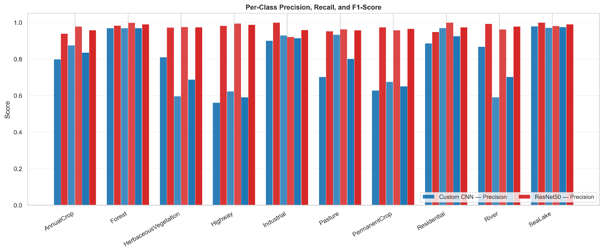
Figure 4. Per-class precision, recall, and F1-score: Custom CNN vs ResNet50.
Table 6. Per-Class Performance Custom CNN.
Class | Precision | Recall | F1-Score | Support
Annual Crop | 79.83% | 87.47% | 83.48% | 439
Forest | 96.87% | 96.87% | 96.87% | 447
Herbaceous Vegetation | 80.99% | 59.63% | 68.69% | 436
Highway | 56.14% | 62.30% | 59.06% | 374
Industrial | 90.05% | 92.89% | 91.45% | 380
Pasture | 70.22% | 93.28% | 80.13% | 268
Permanent Crop | 62.77% | 67.54% | 65.07% | 382
Residential | 88.54% | 96.98% | 92.56% | 430
River | 86.71% | 59.05% | 70.25% | 420
Sea Lake | 97.87% | 97.05% | 97.46% | 474
Macro Average | 81.00% | 81.31% | 80.50% | 4,050
Table 7. Per-Class Performance ResNet50.
Class | Precision | Recall | F1-Score | Support
Annual Crop | 93.87% | 97.72% | 95.76% | 439
Forest | 98.24% | 99.78% | 99.00% | 447
Herbaceous Vegetation | 97.25% | 97.48% | 97.37% | 436
Highway | 98.15% | 99.47% | 98.80% | 374
Industrial | 100.00% | 92.11% | 95.89% | 380
Pasture | 95.20% | 96.27% | 95.73% | 268
Permanent Crop | 97.34% | 95.81% | 96.57% | 382
Residential | 94.71% | 100.00% | 97.29% | 430
River | 99.26% | 96.19% | 97.70% | 420
Sea Lake | 100.00% | 98.10% | 99.04% | 474
Macro Average | 97.40% | 97.29% | 97.32% | 4,050

4.4 Confusion Matrix Analysis
The normalized confusion matrices for both models (Figures 5a and 5b) offer detailed insights into patterns of systematic misclassification. The Custom CNN's confusion matrix shows three main off-diagonal confusion clusters. First, there is a bidirectional confusion between Annual Crop and Permanent Crop, reflecting the similarity in their vegetative spectral profiles due to rotational and orchard-scale agriculture, with NDVI values aligning during peak growing seasons. Second, Herbaceous Vegetation is notably confused with Pasture, consistent with their shared low-density grassland spectral signatures at 10-meter resolution. Third, River patches are sometimes misclassified as Annual Crop when sediment turbidity causes visible-band reflectance to resemble soil signatures a common spectral confusion in Sentinel-2 imagery at this resolution. Notably, Highway predictions are absent in the Custom CNN output, indicating that the shallow architecture cannot effectively detect narrow linear road features within 64×64 patches.
The ResNet50 confusion matrix shows a diagonal pattern, with all 10 classes recording recall scores above 92%. Minor off-diagonal errors are limited to three confusion pairs: Industrial–Residential (due to similar spectral textures in built environments), Annual Crop–Permanent Crop (because of overlapping vegetative signals during different growth stages), and River–Pasture (shallow, sediment-rich water bodies). These confusions are genuine spectral edge cases rather than signs of architectural shortcomings, indicating that ResNet50's deep residual design effectively addresses the main inter-class ambiguities that affect the discriminative ability of Custom CNN.
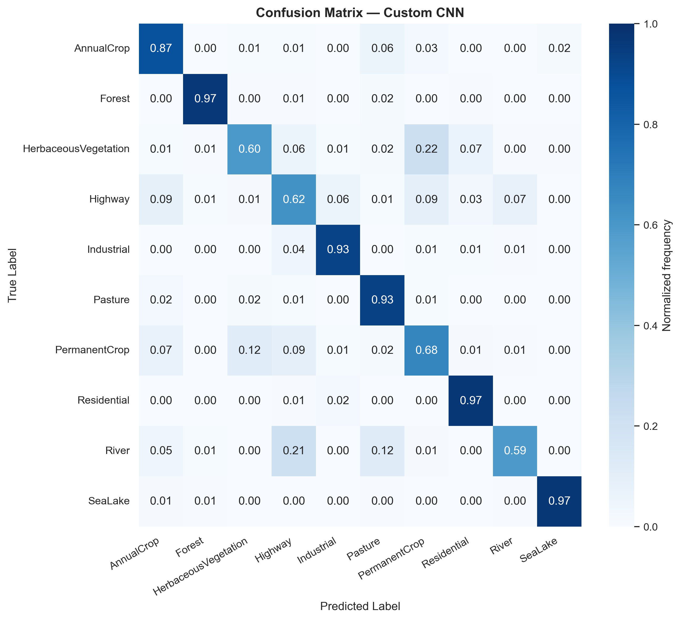 | 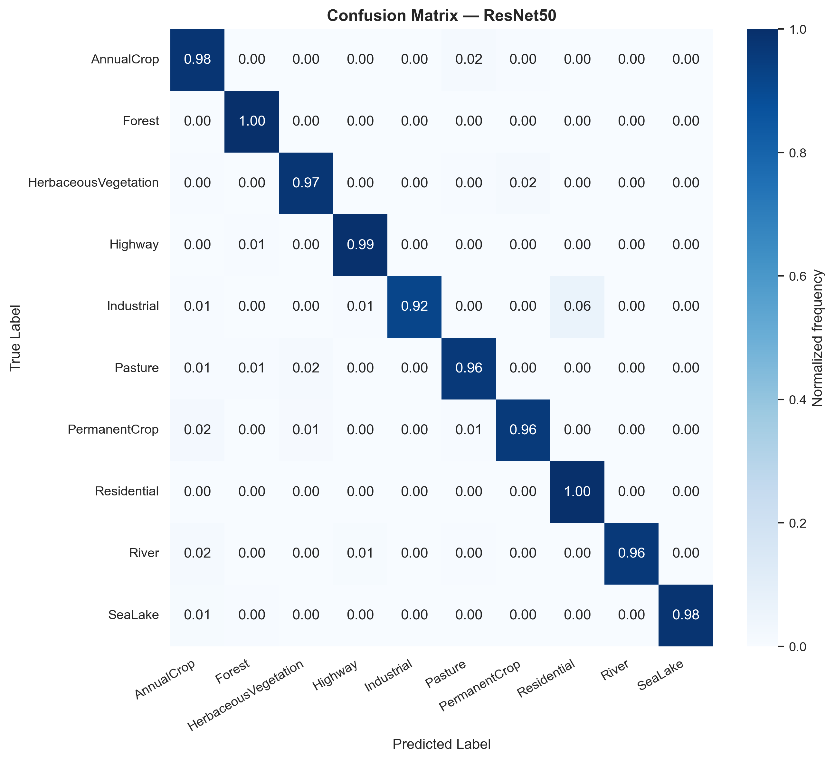
(a) | (b)
Figure 5. Normalized confusion matrices for (a) Custom CNN and (b) ResNet50 on EuroSAT.

4.5 Computational Efficiency Benchmarking
Computational profiling highlights a significant efficiency gap that directly reflects the accuracy difference between architectures. The Custom CNN, which processes native 64×64 inputs, only requires 0.161 G-MACs per image, has 4.62 million parameters, a model size of 17.61 MB, and a median inference latency of 1.79 ms per image on the Quadro P2000 GPU, with a peak memory usage of 18.74 MB. In contrast, ResNet50, which upscales inputs to 224×224, demands 4.13 G-MACs per image about 25.7 times more contains 23.53 million parameters (5.1 times more), has a size of 89.75 MB (also 5.1 times larger), and yields a median inference latency of 14.85 ms per image (8.3 times slower), with a peak GPU memory use of 118.16 MB (6.3 times higher). These profiling details are summarized in Table 8.
For the full Lahore deployment of 4,289 patches using single-image inference on the Quadro P2000, the Custom CNN processes the entire district scene in about 8.0 seconds, while ResNet50 takes 66.6 seconds. Both processing times are feasible within a single monitoring cycle. However, on a national or continental scale which involves hundreds of thousands of patches on energy-limited edge hardware the 25.7× reduction in MACs and the 8.3× latency improvement offered by Custom CNN lead to lower energy consumption and increased throughput per watt. Figure 6 shows an accuracy-versus-latency efficiency bubble chart that displays these design trade-offs for both architectures.
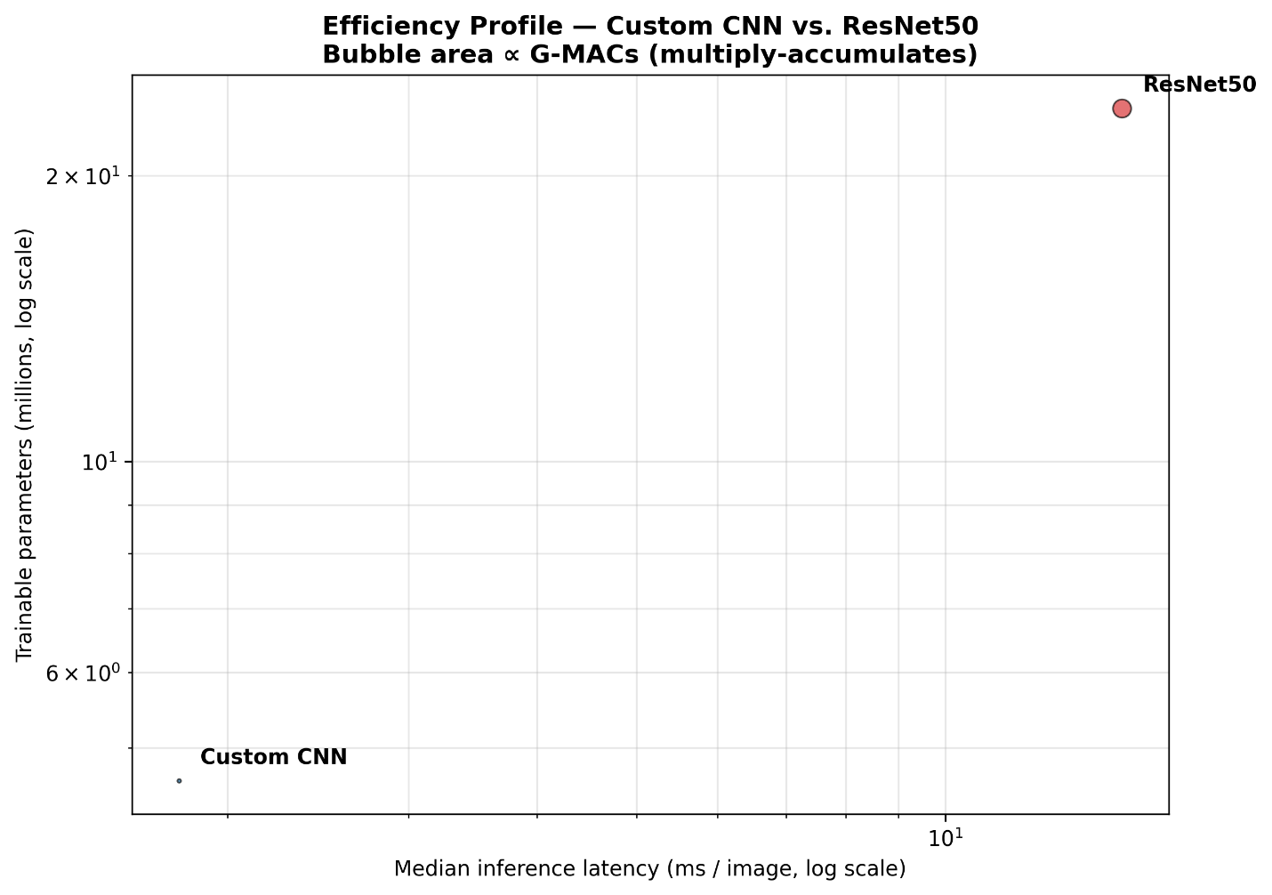
Figure 6. Accuracy vs. latency efficiency trade-off bubble chart.
Table 8. Computational Efficiency Profiling.
Metric | Custom CNN | ResNet50 | Ratio (ResNet/CNN)
Input Resolution | 64×64 | 224×224
Total Parameters | 4,616,618 | 23,528,522 | 5.10×
Model Size (MB) | 17.61 | 89.75 | 5.10×
MACs (G) | 0.161 | 4.132 | 25.67×
GFLOPs | 0.321 | 8.263 | 25.74×
Inference Latency (ms/img) | 1.79 | 14.85 | 8.30×
Peak GPU Memory (MB) | 18.74 | 118.16 | 6.31×
Hardware | Quadro P2000 | Quadro P2000

4.6 Grad-CAM Explainability Analysis
Grad-CAM heatmaps from the final convolutional block of ResNet50 (layer4[-1]. conv3) across 50 test patches show that the model consistently focuses on meaningful geospatial structures rather than background noise or artifacts. Figure 7 displays a grid of Grad-CAM overlays covering all 10 EuroSAT classes, including both correct and incorrect classifications.
For Highway patches (e.g., gradcam_008, gradcam_019, gradcam_030, gradcam_037, gradcam_039), activation is focused along the paved corridor of the road network, with intensity fading toward roadside vegetation and shoulders. This confirms that the model relies on edge continuity as its main feature for identifying transport infrastructure. In Residential patches (e.g., gradcam_016, gradcam_020, gradcam_025, gradcam_027, gradcam_031), activation is evenly spread across rooftops, streets, and building boundaries, creating a high-frequency mosaic that matches the regular grid pattern of residential areas. Forest patches (e.g., gradcam_009, gradcam_011, gradcam_028, gradcam_032, gradcam_035) display broad, diffuse activation over the canopy surface, reflecting the uniform spectral properties of dense tree cover, where the overall canopy spectral profile, rather than specific features, triggers activation. River patches (e.g., gradcam_000, gradcam_010, gradcam_017, gradcam_026) show concentrated activation along riparian boundaries, where the spectral contrast between water and adjacent vegetation provides a key boundary cue.
The three misclassified samples offer valuable insights into the model's failure modes, as detailed in Table 9. In gradcam_014 (true: Sea Lake; predicted: Pasture), the activation is focused on the upper part of the patch, where shallow water and emergent aquatic vegetation create a mixed spectral signature with higher NIR reflectance. This leads the model to assign more weight to the vegetative elements rather than the open water surface. In gradcam_034 (true: Permanent Crop; predicted: Herbaceous Vegetation), activation spreads over the detailed crop canopy without a clear structural focus, indicating genuine phenological ambiguity at 10-meter resolution. This ambiguity exists between early-growth or post-harvest Permanent Crop and Herbaceous Vegetation. In gradcam_041 (true: River; predicted: Annual Crop), activation is concentrated in the turbid central channel, where high suspended sediment levels alter the visible-band reflectance into the soil spectral domain. This confirms the spectral confusion pathway identified in the per-class analysis. Overall, the Grad-CAM evidence supports that ResNet50's strong classification performance is both statistically sound and based on physically interpretable geospatial features.
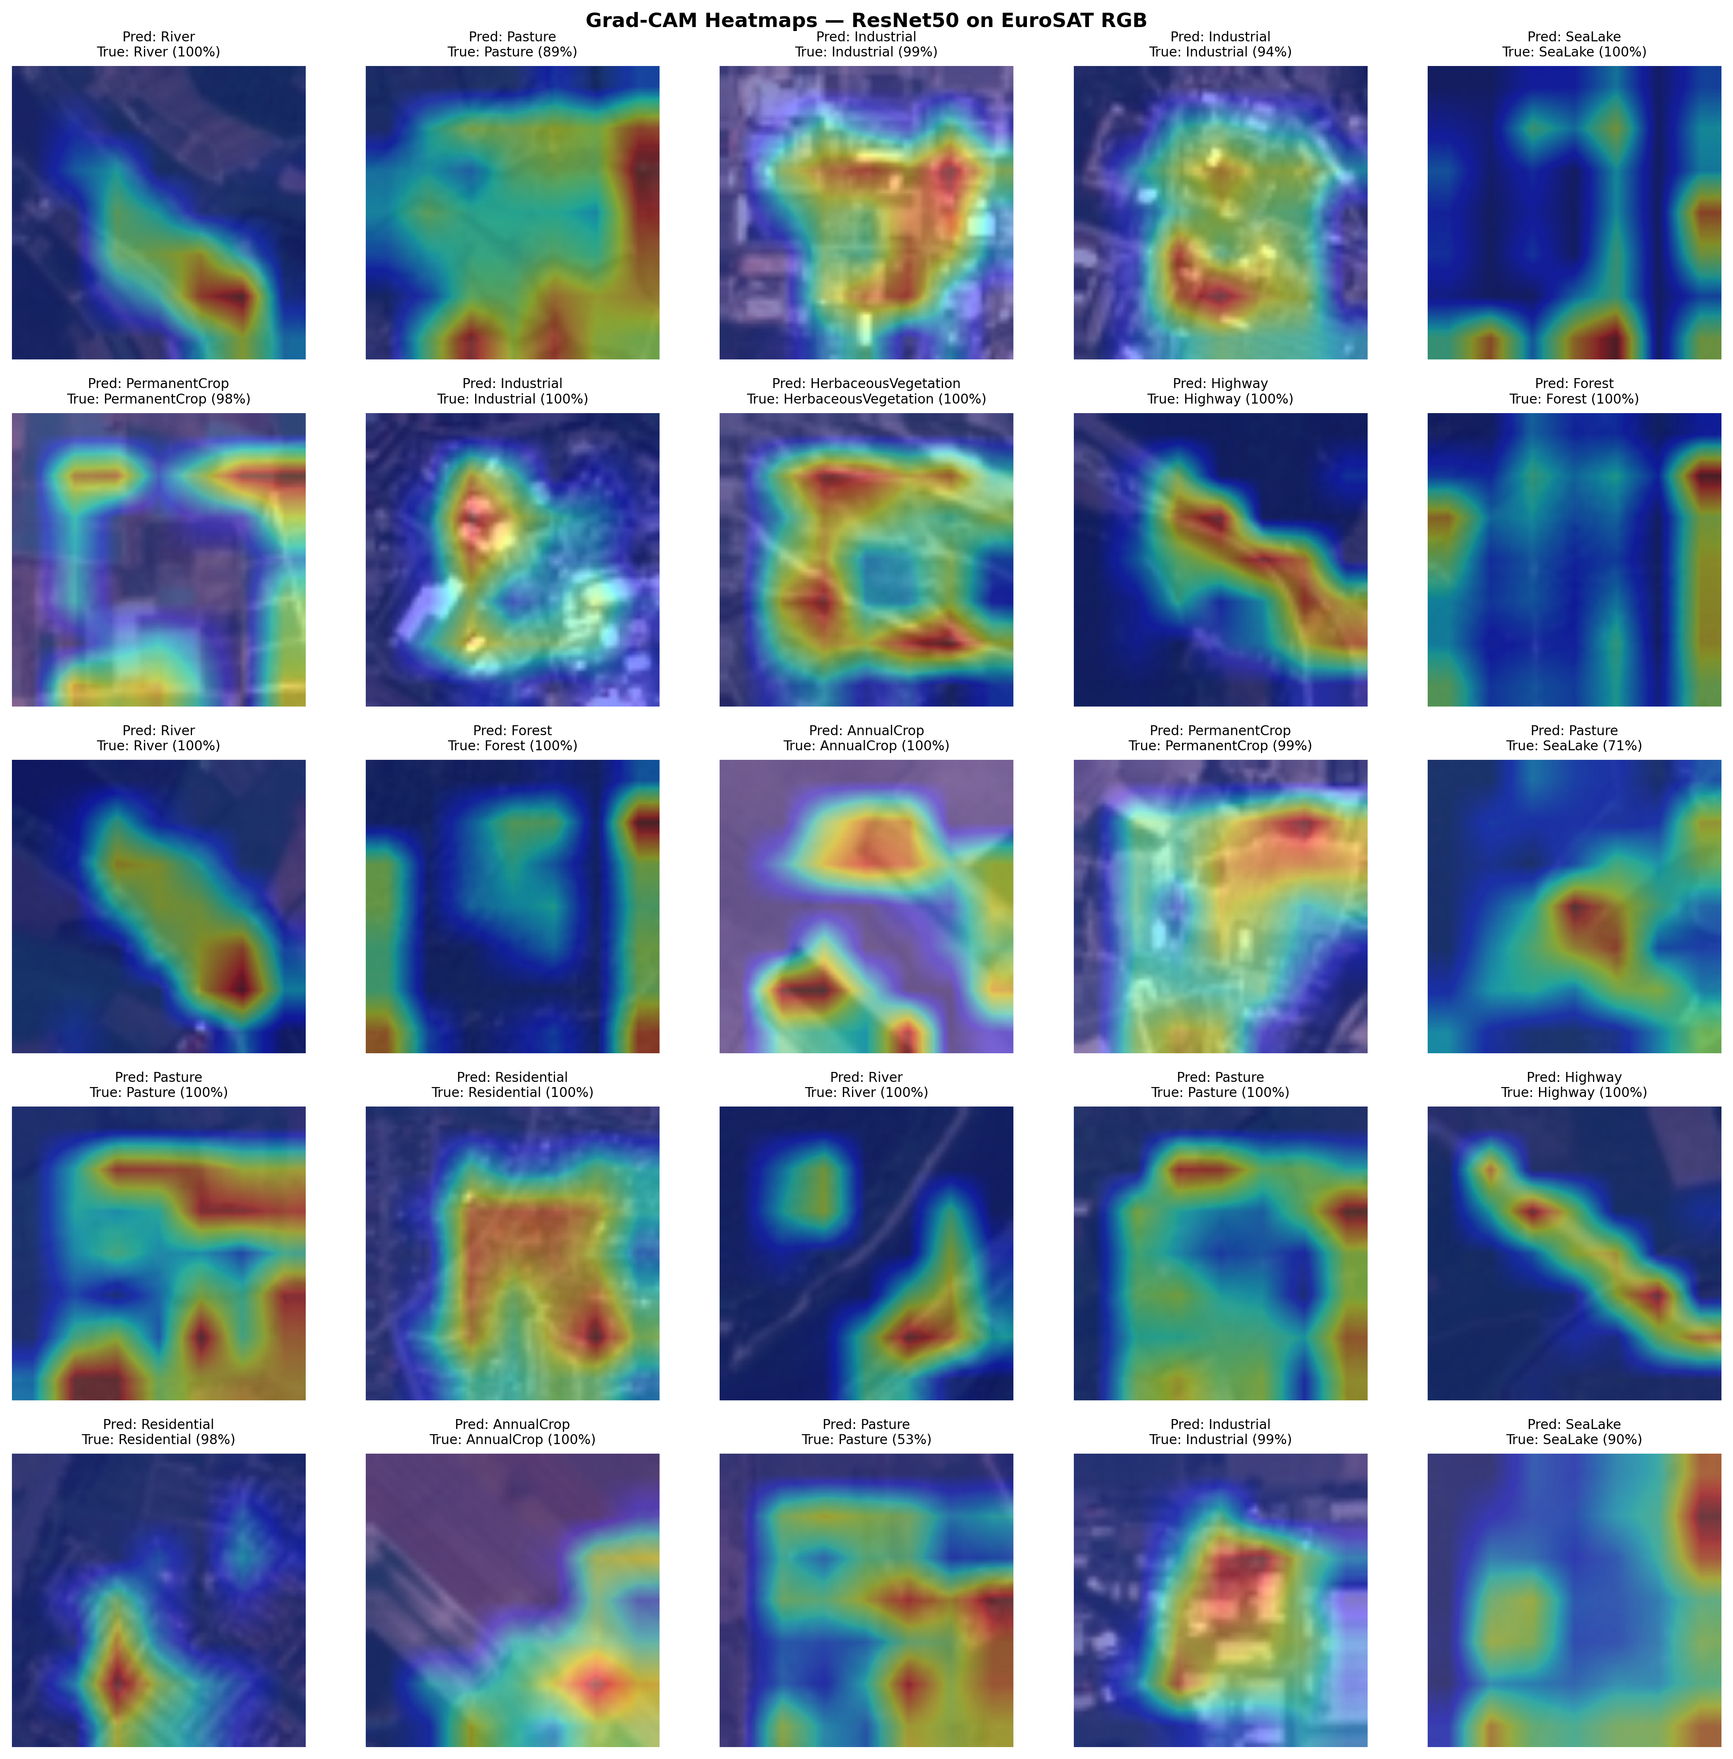
Figure 7. Grad-CAM heatmap grid for 50 representative EuroSAT test patches.
Table 9. Grad-CAM Misclassification Case Analysis.
Sample ID | True Class | Predicted Class | Activation Focus | Failure Mode
gradcam_014 | Sea Lake | Pasture | Shallow water + emergent vegetation zone | Elevated NIR from aquatic vegetation
gradcam_034 | Permanent Crop | Herbaceous Vegetation | Distributed across fine crop canopy | Phenological ambiguity at 10m resolution
gradcam_041 | River | Annual Crop | Turbid central channel | Sediment-turbidity spectral confusion

4.7 Lahore District LULC Deployment
Analyzing the deployment of both models across 4,289 valid Sentinel-2 patches in Lahore reveals clear differences in spatial coherence and thematic accuracy. The Custom CNN classification map shows a salt-and-pepper pattern, indicative of reliance on ambiguous local spectral cues without adequate contextual information. It assigns 48.58% of patches to Permanent Crop and 30.18% to Annual Crop, totaling 78.76% of the scene, which does not align with Lahore's urban structure and overestimates vegetative areas. Urban sub-classes like Highway (0.72%), Industrial (0.14%), and Forest (0.14%) are severely under-predicted, with mean confidence scores of 0.309, 0.336, and 0.487, suggesting predictions close to random chance under real-world spectral conditions. Water bodies such as rivers and Sea Lake receive no patch allocations, indicating a failure to detect water, due to differences between EuroSAT training data and the turbid water in Lahore.
ResNet50 generates a spatially consistent classification map that accurately reflects Lahore's known urban layout. Using the 4-bin LULC system, it classifies 23.25% of the district as Urban, 45.57% as Agricultural, 29.32% as Natural vegetation, and 1.85% as Water. At the 10-class level, Residential (29.99%; average confidence: 0.867) and Highway (11.11%; average confidence: 0.833) are the main categories within the Urban class, located in the city center and densely built eastern satellite towns. Agricultural areas are found in rural outskirts and peri-urban transition zones, while Natural vegetation appears along riparian corridors and open spaces at the district edges. Forests are classified at 0.00% across all valid tiles, supported by high-confidence predictions in other classes, confirming the true absence of dense tree cover rather than a classification error. The distribution of patches per class for Lahore is detailed in Table 10.
Table 10. Per-Class Patch Distribution Lahore Deployment.
Class | CNN Tiles | CNN Share (%) | CNN Conf. | ResNet50 Tiles | ResNet50 Share (%) | ResNet50 Conf.
Annual Crop | 1,299 | 30.18 | 0.583 | 347 | 8.06 | 0.693
Forest | 6 | 0.14 | 0.487 | 0 | 0.00 | 0.000
Herbaceous. | 373 | 8.67 | 0.405 | 116 | 2.70 | 0.649
Highway | 31 | 0.72 | 0.309 | 478 | 11.11 | 0.833
Industrial | 6 | 0.14 | 0.336 | 96 | 2.23 | 0.741
Pasture | 62 | 1.44 | 0.403 | 230 | 5.34 | 0.672
Permanent Crop | 2,091 | 48.58 | 0.500 | 1,722 | 40.01 | 0.718
Residential | 421 | 9.78 | 0.550 | 1,291 | 29.99 | 0.867
River | 0 | 0.00 | 0.000 | 9 | 0.21 | 0.694
Sea Lake | 0 | 0.00 | 0.000 | 0 | 0.00 | 0.000
Total | 4,289 | 100.00 |  | 4,289 | 100.00

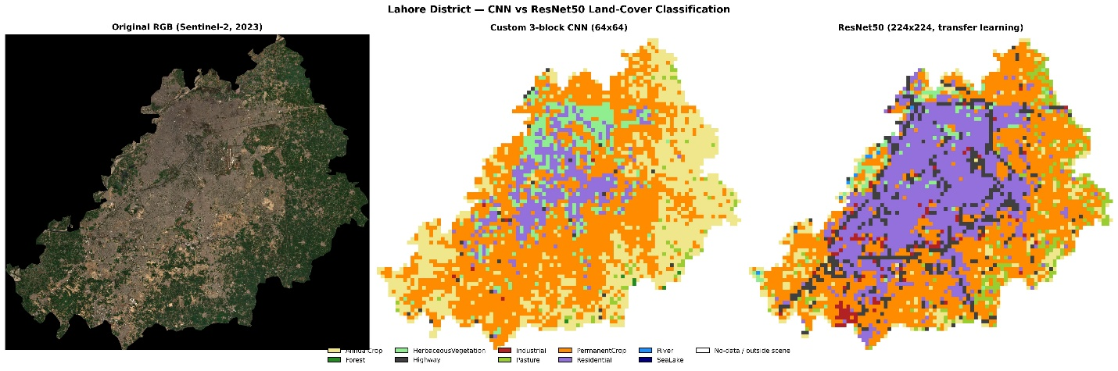
Figure 8. RGB imagery vs. classification overlay: Custom CNN (a) and ResNet50 (b).

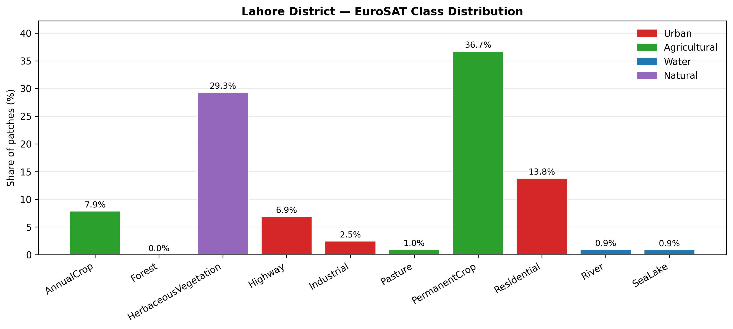 | 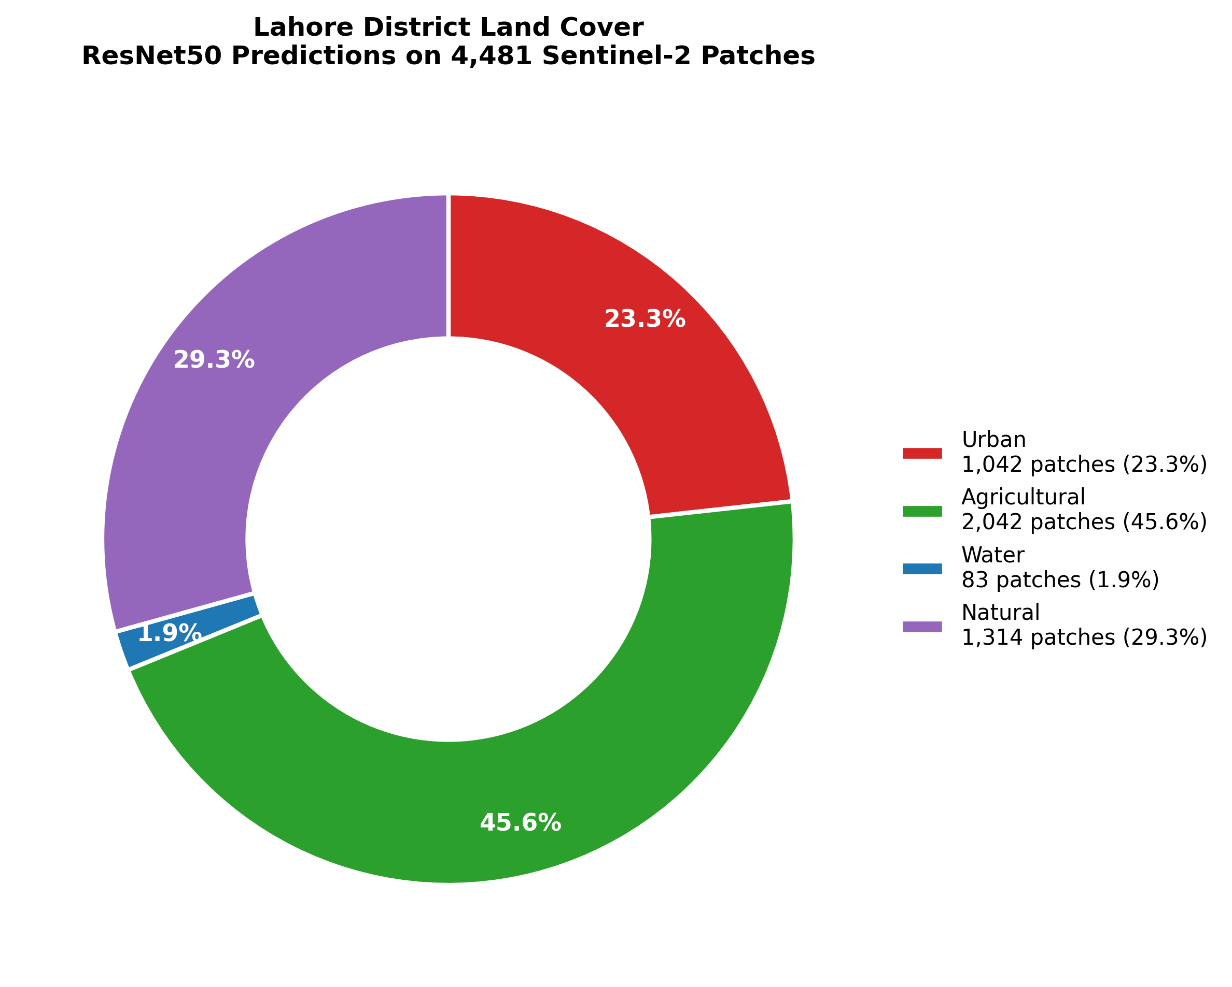
(a) | (b)
Figure 9. Land cover distribution in Lahore District predicted by ResNet50: (a) EuroSAT class-wise share; (b) aggregated 4-bin LULC composition.

5. Discussion
This study's empirical results enhance understanding of choosing deep learning architectures for land use and land cover (LULC) mapping, focusing on three interconnected aspects: balancing accuracy and efficiency, the impact of transfer learning in addressing domain shift, and the importance of high-resolution satellite monitoring in quickly urbanizing semi-arid regions [13]. The 16.03 percentage point accuracy difference between the Custom CNN (81.38%) and ResNet50 (97.41%) primarily occurs in spectrally and geometrically complex categories, which are vital for urban environmental monitoring. Errors in classes like Highway, Permanent Crop, Herbaceous Vegetation, and River significantly affect models’ utility in tracking road growth, agricultural conversion, vegetation changes, and water flow [30]. From a municipal land auditing perspective, a model with about 81% accuracy that often confuses highways with Permanent Crop and struggles to identify riparian corridors not only produces numerical inaccuracies but also misleads spatial analysis [30]. Consequently, Custom CNN's lower performance reflects a structural challenge in distinguishing categories essential for operational environmental assessments [5].
The Custom CNN offers a significant practical benefit by reducing latency by 8.3 times and cutting multiply-accumulate operations (MACs) by 25.7 times. This makes it especially useful in deployment contexts where hardware limitations prevent using larger architectures like ResNet50. Such scenarios include battery-powered drones, edge devices for agricultural monitoring, and offline environmental assessment tools in low-resource settings [31]. In these cases, a lightweight model capable of near-real-time inference can be more operationally valuable than a more accurate but heavier model that can't run on existing hardware [31]. The key takeaway is that architecture choice for LULC mapping depends on the deployment environment: the best model is the most accurate one that fits within the available computational resources .
ResNet50 quickly reaches 97.26% validation accuracy in just one epoch, highlighting the transferability of features learned from ImageNet. Although EuroSAT is a satellite imagery dataset, it contains visual elements like edges, textures, color groups, and spatial frequency patterns that are effectively captured by ImageNet pretraining. This compatibility allows ResNet50 to serve as a strong feature extractor from the start, with only minimal fine-tuning needed for the classification head. As a result, it achieves higher accuracy and significantly lower training costs, converging in 5 epochs versus 10 epochs for Custom CNN. This efficiency is especially beneficial when labeled remote sensing data are limited [32].
The Lahore deployment results reveal a significant domain gap, which limits the practical usefulness of the Custom CNN. Its failure to predict River or Sea Lake across 4,289 real-world patches, despite good benchmark results on EuroSAT, indicates a distribution shift between curated test images and Lahore's more complex, diverse environment. Water bodies like canals and the Ravi River are affected by seasonal turbidity, irrigation, and peri-urban pollution, changing their spectral features compared to the clean-water examples in the benchmark data. Conversely, ResNet50 maintains some discriminative ability amidst this shift, as shown by its moderate-confidence detection of river patches. This comparison highlights the benefit of deeper architectures for real-world applications when target scenes differ from training data [27]. Further analysis indicates ResNet50’s high performance relies on geographically meaningful feature attention rather than false correlations. Its activations align with class-specific patterns, such as edge continuity for highways, repetitive textures for residential areas, canopy uniformity for forests, and boundary contrast for rivers, making the model more interpretable and scientifically trustworthy. This is crucial because high benchmark accuracy alone does not ensure that the model learns semantically valid features. In this study, Grad-CAM verifies that the model’s decisions are based on physically and geographically relevant structures [18].
Misclassification cases highlight the diagnostic utility of Grad-CAM [18]. The confusion between River and Annual Crop stems from sediment-induced turbidity, while the mix-up between Permanent Crop and Herbaceous Vegetation reflects overlapping phenological stages. These error modes are difficult to identify from the confusion matrix alone but become clear through spatial activation maps. This insight guides future model improvements, such as adding near-infrared and shortwave infrared bands from Sentinel-2 to better distinguish turbid water from soil-like surfaces [33]. The ResNet50-based LULC map of Lahore provides a timely, detailed view of environmental change. Finding that 23.25% of the district is classified as Urban offers a useful baseline for tracking urban growth. Notably, no Forest patches appear across all valid tiles, indicating a near-complete loss of dense tree cover in the district. This impacts microclimate regulation, groundwater recharge, and urban heat mitigation in this rapidly growing semi-arid city [34].
The fact that 45.57% of land is agricultural and 29.32% is natural shows that Lahore still has significant non-urban areas, especially in its rural and peri-urban edges. However, this does not necessarily mean the environment is stable. Instead, the fragmented agricultural land indicates ongoing pressure to convert land along the city’s outskirts [13]. The Water class, at 1.85%, highlights the limited hydrological features in the district, and the near absence of Sea Lake predictions suggests a decline in wetlands and irrigation reservoirs in the area [26]. These results provide a clear baseline for future monitoring. Using the same process on annual Sentinel-2 images would help track urban growth, agricultural development, and vegetation changes consistently and cost-effectively [26]. This automated system removes the need for manual analysis and offers a scalable solution for municipal land management.
Several limitations should be recognized. First, limiting the input to RGB bands omits additional Sentinel-2 spectral channels, which are especially useful for differentiating vegetation and water subclasses [16]. Second, EuroSAT is based on European land-cover patterns and may not fully capture Lahore's semi-arid environment [15]. Third, using a non-overlapping tiling strategy can cause boundary artifacts and salt-and-pepper noise [5]. Lastly, the Lahore deployment results lack ground-truth labels, making formal accuracy evaluation impossible. Future research should explore multispectral data, local fine-tuning, overlapping inference, and field-verified reference data to overcome these limitations.

6. Conclusion
A systematic comparison was performed between a lightweight, custom 3-block convolutional neural network (CNN) and a transfer-learned ResNet50 for high-resolution Land Use and Land Cover (LULC) classification using EuroSAT RGB imagery from Sentinel-2, with deployment across Lahore, Pakistan. ResNet50 achieved 97.41% overall accuracy and a 97.32% Macro F1-scoreimproving by 16.03 percentage points over the custom CNN (81.38% accuracy; 80.50% Macro F1-score) but needed 25.7 times more computational resources and 8.3 times higher inference latency. This accuracy-efficiency trade-off has important operational implications. The custom CNN made errors in geometrically and spectrally complex classes such as Highway, Permanent Crop, Herbaceous Vegetation, and River, which are vital for environmental monitoring. Despite this, its low inference latency of 1.79 ms per image and peak memory use of only 18.74 MB make it suitable for edge deployment, where ResNet50's resource demands are prohibitive.
Grad-CAM analysis showed that ResNet50's classification relies on geographically meaningful features such as edge continuity in highway networks, structural textures in residential areas, spectral homogeneity in forests, and riparian boundary contrast in river corridors. Diagnostic testing identified two physically interpretable failure pathways: sediment-related turbidity causing River Annual Crop confusion, and spectral overlap due to phenology leading to misclassification between Permanent Crop and Herbaceous Vegetation. These findings suggest that integrating multispectral data and applying domain-specific fine-tuning to locally annotated images could improve accuracy. When applied to 4,289 Sentinel-2 patches in Lahore, this approach produced a coherent LULC map, showing Urban at 23.25%, Agricultural at 45.57%, Natural vegetation at 29.32%, and Water at 1.85%. Forest was classified at 0.00% across all valid tiles, confirming the district's lack of dense tree cover. This method offers a reproducible, 10-meter resolution baseline for long-term urban encroachment monitoring at sub-district levels. Future work should include multispectral pipelines with NIR, Red-Edge, and SWIR bands, local fine-tuning with Lahore-specific training samples, and overlapping inference with majority-vote techniques to reduce boundary artifacts and improve spatial coherence during deployment.

References

1. Zhu, X.X., et al., Deep learning in remote sensing: A comprehensive review and list of resources. IEEE geoscience and remote sensing magazine, 2017. 5(4): p. 8–36.
2. Halder, S., et al., Spatiotemporal Variation in Land Use Land Cover in Piyali River Sub-Basin in the Response to Local Climate Change Using Multispectral Remote Sensing Data, in Sustainable Management of Delta Ecosystems Resilience: Case Studies on Delta Adaptation Pathways. 2026, Springer. p. 365–383.
3. Drusch, M., et al., Sentinel-2: ESA's optical high-resolution mission for GMES operational services. Remote sensing of Environment, 2012. 120: p. 25–36.
4. Cheng, G., J. Han, and X. Lu, Remote sensing image scene classification: Benchmark and state of the art. Proceedings of the IEEE, 2017. 105(10): p. 1865–1883.
5. Maggiori, E., et al., Convolutional neural networks for large-scale remote-sensing image classification. IEEE Transactions on geoscience and remote sensing, 2016. 55(2): p. 645–657.
6. Cortes, C. and V. Vapnik, Support-vector networks. Machine learning, 1995. 20(3): p. 273–297.
7. Breiman, L., Random forests. Machine learning, 2001. 45(1): p. 5–32.
8. Arrieta, A.B., et al., Explainable Artificial Intelligence (XAI): Concepts, taxonomies, opportunities and challenges toward responsible AI. Information fusion, 2020. 58: p. 82–115.
9. Irannejad, S. and H. Bagheri, Explaining Ecological Drivers and Management Implications of Forest Biomass: An Explainable Deep Learning Fusion of Remote Sensing and Climate Data. Trees, Forests and People, 2026: p. 101154.
10. Selvaraju, R.R., et al. Grad-cam: Visual explanations from deep networks via gradient-based localization. in Proceedings of the IEEE international conference on computer vision. 2017.
11. Kasetty, S.B. and R. Krishnan, Transform-Aware Deep Learning and Explainable AI in Remote Sensing: A Comprehensive Meta-Analysis. IEEE Access, 2026.
12. He, K., et al. Deep residual learning for image recognition. in Proceedings of the IEEE conference on computer vision and pattern recognition. 2016.
13. Karim, S., et al., Comprehensive geospatial analysis of urban expansion dynamic in Lahore, Pakistan (1998–2023). Journal of Urban Management, 2025. 14(2): p. 577–589.
14. Rafique, M., et al., Land use land cover change detection of district Lahore using GIS and remote sensing (1993-2023). Pakistan Journal of Forestry, 2024. 74(1): p. 24–31.
15. Helber, P., et al., Eurosat: A novel dataset and deep learning benchmark for land use and land cover classification. IEEE Journal of Selected Topics in Applied Earth Observations and Remote Sensing, 2019. 12(7): p. 2217–2226.
16. Papoutsis, I., et al., Benchmarking and scaling of deep learning models for land cover image classification. ISPRS Journal of Photogrammetry and Remote Sensing, 2023. 195: p. 250–268.
17. Abd El-Kawy, O., et al., Land use and land cover change detection in the western Nile delta of Egypt using remote sensing data. Applied geography, 2011. 31(2): p. 483–494.
18. Kakogeorgiou, I. and K. Karantzalos, Evaluating explainable artificial intelligence methods for multi-label deep learning classification tasks in remote sensing. International Journal of Applied Earth Observation and Geoinformation, 2021. 103: p. 102520.
19. Lu, D. and Q. Weng, A survey of image classification methods and techniques for improving classification performance. International journal of Remote sensing, 2007. 28(5): p. 823–870.
20. Khatami, R., G. Mountrakis, and S.V. Stehman, A meta-analysis of remote sensing research on supervised pixel-based land-cover image classification processes: General guidelines for practitioners and future research. Remote sensing of environment, 2016. 177: p. 89–100.
21. Nogueira, K., O.A. Penatti, and J.A. Dos Santos, Towards better exploiting convolutional neural networks for remote sensing scene classification. Pattern Recognition, 2017. 61: p. 539–556.
22. Gu, J., et al., Recent advances in convolutional neural networks. Pattern recognition, 2018. 77: p. 354–377.
23. Hu, F., et al., Transferring deep convolutional neural networks for the scene classification of high-resolution remote sensing imagery. Remote Sensing, 2015. 7(11): p. 14680–14707.
24. Shabbir, A., et al., Satellite and scene image classification based on transfer learning and fine tuning of ResNet50. Mathematical Problems in Engineering, 2021. 2021(1): p. 5843816.
25. YOUNAS, A., Q. NADEEM, and S. WAHEED, MONITORING TRENDS OF LAND USE LAND COVER AND URBAN SPRAWL SINCE 1989 IN RAPIDLY GROWING CITIES OF PAKISTAN USING MULTI-TEMPORAL REMOTE SENSING DATA.
26. Phiri, D., et al., Sentinel-2 data for land cover/use mapping: A review. Remote sensing, 2020. 12(14): p. 2291.
27. Tuia, D., C. Persello, and L. Bruzzone, Domain adaptation for the classification of remote sensing data: An overview of recent advances. IEEE geoscience and remote sensing magazine, 2016. 4(2): p. 41–57.
28. Gil, Y., et al., Toward the Geoscience Paper of the Future: Best practices for documenting and sharing research from data to software to provenance. Earth and Space Science, 2016. 3(10): p. 388–415.
29. Shirazi, S.A. and S.J.H. Kazmi, Analysis of population growth and urban development in Lahore-Pakistan using geospatial techniques: Suggesting some future options. South Asian Studies, 2020. 29(1).
30. Foody, G.M., Status of land cover classification accuracy assessment. Remote sensing of environment, 2002. 80(1): p. 185–201.
31. Chen, J. and X. Ran, Deep learning with edge computing: A review. Proceedings of the IEEE, 2019. 107(8): p. 1655–1674.
32. Penatti, O.A., K. Nogueira, and J.A. Dos Santos. Do deep features generalize from everyday objects to remote sensing and aerial scenes domains? in Proceedings of the IEEE conference on computer vision and pattern recognition workshops. 2015.
33. Du, Y., et al., Water bodies’ mapping from Sentinel-2 imagery with modified normalized difference water index at 10-m spatial resolution produced by sharpening the SWIR band. Remote Sensing, 2016. 8(4): p. 354.
34. Zhang, M., et al., Impact of urban expansion on land surface temperature and carbon emissions using machine learning algorithms in Wuhan, China. Urban Climate, 2023. 47: p. 101347.

