**Software Design Specification**

Smart Car using Raspberry Pi 3B

**Team members:**

*U1510422* Mukhammadsher Shermamatov

*U1510419* A’zamjon Rakhimjonov

*U1510401* Umida Khaydarova

*U1510421* Gulshad Yuldasheva

Inha University in Tashkent

Spring Semester, 2019

Contents

Introduction 3

Purpose 3

System Overview 3

Design Considerations 3

Goals 4

Detailed System Design 5

Raspberry Pi 3 5

IR Sensor 5

IR Line Tracker 6

Ultrasonic Sensor 7

Camera Board Module 8

Specific Color detection 9

Traffic control 9

Stop signal recognition 10

Slow sign recognition 10

Parking sign recognition 11

Parking direction recognition 11

DC Motor 11

Setting the components of car 13

Software Design 15

References 16

# Introduction

## Purpose

This document is designed to describe the detailed information about the building of smart car and step by step implementation. It describes the whole architecture and sub-architecture of the associated interfaces, schemas, hardware and software details.

In the modern society there are a great deal of robotic machines that are capable of carrying out some complex series of actions automatically. These projects can be done with the help of raspberry pi computers that are one of the essential parts of building the machine.

Autonomous vehicle is a small car with 4 relative DC motors that help the machine to go and move, it is environmentally responsible and easy to park in small spaces. The car is built with raspberry pi computer that has several functions as

* front / rear / left / right orientations are provided by DC motor and L298N motor control
* Distance detection & obstacle detection using ultrasonic sensor
* Line tracking
* Object recognition based on image processing
* Sign recognition based on image processing

# System Overview

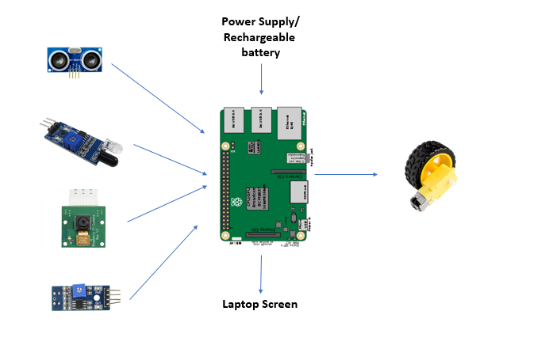

*Smart Car System Overview*

# Design Considerations

Given a map with traffic signs and obstacles. Smart car should start its movement from a start zone and finish its movement in a parking zone. In this project obstacles and a sudden pedestrian are detected by ultrasonic sensor. To follow a given path an IR tracer is used. On a straight road car will move with a high speed however when it detects something depending on a situation it will stop its movement or will slow down. To detect a traffic signs and traffic signal a camera module is used. Starting from the beginning camera will record a video and send it as a frame. So, from obtained frame program will search signs depending on color and shape. After recognition, with help of cascade it will notify which sign was detected and perform further tasks accordingly. For example, if it will detect a STOP sign it will stop and timer is used to start a movement again, because otherwise car will not move. These are all design considerations from which software was developed.

|  |
| --- |
|  |

# Goals

Provided project is mainly developed for dynamic scenario, which means it should detect sign or other things at any time. To achieve a desired goal proper software was developed and detailed explanation will be provided in coming chapters.

The first major goal is, the system is dynamic. In a real world everything changes very fast and a smart car based on conditions can handle tough situations such as changing places of obstacles or traffic signs.

The second major goal is that, whenever the system detects any traffic sign it shows and notifies a user about which sign was detected. For example, if it detects a STOP sign, it will show where it detected a sign and which sign it detected. So, such methods could be used in a real world and accidents rate could be reduced.

The last goal is that, to achieve a simultaneous working environment thread are used. Therefore, whenever two sensors need the same data, program will automatically decide to which sensor to give a turn and no errors will occur.

# Detailed System Design

Autonomous vehicle components include main MCU (raspberry pi 3, model B), Frame (Base Frame where raspberry pi board, shield board, body frame, connecting motor are located), Ultrasonic Frame (Ultrasonic sensor holder frame), Camera frame (Raspberry Pi camera holder frame).

Sensors and modules include 4 DC geared motors ,2 IR sensors, 1 camera module, 2 line tracers, 1 voltmeter, 1 ultrasonic sensor. Other accessories are micro 5-Pin power supply cable, battery holder,4 tires, assembly bolt and screws set,3.7V battery, SD card, SD card readers, female cable and screwdriver.

## Raspberry Pi 3

Raspberry pi is considered to be one of the essential part to build any hardware machine. It is a small and affordable computer that runs on Linux and provides a set of general purpose input and output pins that allow to control the electronic components for physical computing.

Building the development environment for raspberry pi 3 is regarded as important part of configuration that include connecting, checking the booting on the screen and localization. A program is updated and all files installed on the Raspbian OS that is downloaded. To get a remote access to raspberry pi connection via PuTTY is needed where it has default username and password. One of the needed software is VNC viewer that is convenient to connect to OS and show it on the monitor via connecting the same IP address. After all this software is installed, there is some code needed to control the smart car.

## IR Sensor

Sensors are basically electronic devices which are used to sense the changes that occur in their surroundings. The change may be in color, temperature, moisture, sound, heat. They sense the change and work accordingly. In IR sensor the there is emitter and detector. Emitter emits the IR rays and detector detects it.

An IR sensor is basically a device which consists of a pair of an IR LED and a photodiode which are collectively called a photo-coupler or an opto-coupler. The IR LED emits IR radiation, reception and/or intensity of reception of which by the photodiode dictates the output of the sensor. Now, there are so many ways by which the radiation may or may not be able to reach the photodiode.

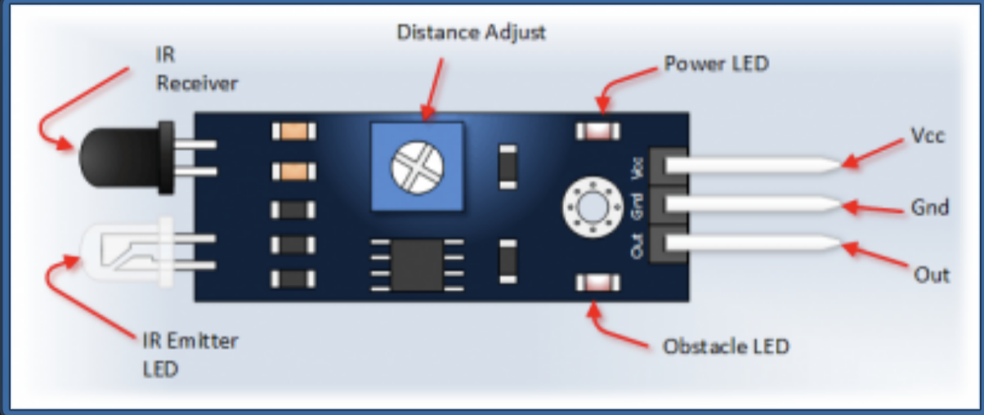The IR sensor basically consists of three components:

* IR LED (emitter)
* Photodiode (detector)
* Op-Amp

|  |  |
| --- | --- |
| Sensor | PIN |
| RIGHT | 26 |
| LEFT | 27 |

In setUp() function RIGHT and LEFT sensors are defined as INPUT.

If some obstacles are detected with the help of sensors, the car moves to the right or left and motorControl function is called. As 1 means no obstacles, car goes in its own direction.

It senses obstacles in the distance of 25 sm. In the case of sudden pedestrian, the car stops until pedestrian is disappeared.

## IR Line Tracker

The sensor works by detecting reflected light coming from its own infrared LED. By measuring the amount of reflected infrared light, it can detect transitions from light to dark (lines) or even objects directly in front of it.

Whenever the is object blocking the infrared source or reflective surface such as a black surface, it reflects the infrared, the receiver gets it and the signal goes through a circuit on board and depending on the threshold that being adjusted, it will output logic LOW at the output pin and the green led will light up to indicate the detection.

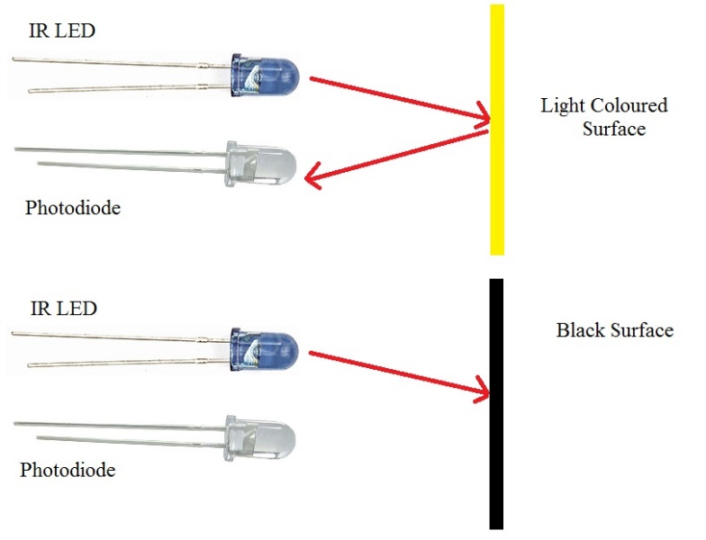

Image 3. IR Line Tracker working mechanism

|  |  |
| --- | --- |
| **IR line tracker** | **Pin** |
| TrackSensorPinRight | 11 |
| TrackSensorPinLeft | 10 |

IR line tracker sensors are used in order to follow the line on the map. As the car moves between the 2 yellow lines and if yellow line is detected from the right side, car goes slightly to the left. If sensor detects the yellow line from the left, car moves to the right so that to follow the proper road on the map accordingly.

|  |
| --- |
|  |

Functions rightIrTracer() and leftIrTracer() are used for reading input from IR sensors. It returns o or 1. If car detects yellow line it returns 0, otherwise 1.

## Ultrasonic Sensor

An ultrasonic sensor is an instrument that measures the distance to an object using ultrasonic sound waves. An ultrasonic sensor uses a transducer to send and receive ultrasonic pulses that relay back information about an object’s proximity.  High-frequency sound waves reflect from boundaries to produce distinct echo patterns.

Ultrasonic sound vibrates at a frequency above the range of human hearing. Transducers are the microphones used to receive and send the ultrasonic sound. The sensor determines the distance to a target by measuring time lapses between the sending and receiving of the ultrasonic pulse.

|  |  |  |
| --- | --- | --- |
|  | Pin name | # |
| OTPUT | TRIG_PIN | 28 |
| INPUT | ECHO_PIN | 29 |

After a wiringPi setup Ultrasonic sensor also will setup and starts working. As it was mentioned before in a table the input will be taken from pin 29(ECHO_PIN) and output will be sent to pin 28(TRIG_PIN).

Every time when an Ultrasonic sensor detects an obstacle it will send a notification to main function. After a system setup every second ECHO_PIN receives data. If ECHO_PIN’s data is equal to zero it means no object was detected, if it detects an objects it calculates the distance.

In this project order to detect a sudden pedestrian ultrasonic sensor was used, because of its high accuracy. Whenever a new object is detected it calculates a distance and if it is close then Smart car automatically stops.

|  |
| --- |
|  |

|  |
| --- |
|  |

|  |
| --- |
|  |

In this project there are many processes should work at the same time and to achieve a desired goal thread was used. Only when an obstacle is noticed then it stops a DC motor.

## Camera Board Module

A camera module is an image sensor integrated with a lens, control electronics and an interface like CSI, Ethernet or plain raw low-voltage differential signaling. An image sensor or imager is a sensor that detects and conveys information used to make an image. It does so by converting the variable attenuation of light waves into signals, small bursts of current that convey the information.

### Specific Color detection

In this project to detect colors of signs and traffic light OpenCV was used. Every second camera takes an image. Then to recognize a color a color detection algorithm is used.

When a new image arrives, it is RGB (RED, GREEN, BLUE) image. However, because RGB images are highly sensitive to illumination, it cannot be used. So, it is converted to HSV (HUE, SATURATION, VALUE) color space. HUE values mainly encodes, color information. Saturation intensity or purity of an image. Value encodes brightness of color.

So, for each color different range of HSV values are used. Moreover, each color has two different types. For example, if traffic lights red color is one type then the STOP sign is different type.

|  |
| --- |
|  |

### 

### Traffic control

If detected objects color is red and shape is circle, then car will stop otherwise it will continue its movement.

|  |
| --- |
|  |

### Stop signal recognition

To detect a STOP, sign special algorithm is used. First of all, from a taken frame only objects with red color is cropped and then from obtained result it is compared with shape. If the shape is octal then it probably STOP sign. However, to prove that it is exactly a STOP sign it is compared with help of cascade.

|  |
| --- |
|  |

### Slow sign recognition

As soon as red colored objects are detected, the shape is checked. If both conditions are satisfied, then with help of cascade the sign is detected and message sent to main function to slow down the speed of a car.

|  |
| --- |
|  |

To slow down a speed withPwm is set to 1. Then after sign detection car will slow down automatically.

|  |
| --- |
|  |

### 

### Parking sign recognition

To detect a parking sign all blue color objects are detected and only rectangular shaped objects are kept. Then with help of cascade sign is detected.

|  |
| --- |
|  |

### Parking direction recognition

Algorithm of parking direction recognition is quite different compared to others. Therefore, to detect it, special approach is used.

First of all, condition checked weather sign is blue and shape is circle. If both conditions satisfied, then the next condition is to detect the direction of sign. To do so, sign is divided into half and white pixels’ quantity is calculated for each part separately. Then quantity of the left side and right side compared and the side where white pixels’ quantity greater is found. So after calculations direction is detected depending on pixels’ quantity.

|  |
| --- |
|  |

## DC Motor

The DC motor is a machine that transforms electric energy into mechanical energy in form of rotation. Its movement is produced by the physical behavior of electromagnetism. DC motors have inductors inside, which produce the magnetic field used to generate movement.

DC motors have only two terminals. If you apply a voltage to these terminals the motor will run, if you invert the terminals position the motor will change its direction. If the motor is running and you suddenly disconnect both terminals the motor will keep rotating but slowing down until stopping. Finally, if the motor is running and you suddenly short-circuit both terminals the motor will stop. We set default values of maximum and minimum speed of the motor. The MAX_SPEED is 40 and MIN_SPEED is 5. The definitions of the pins are as following:

|  |  |
| --- | --- |
| Motor | Pin |
| IN1_PIN | 1 |
| IN2_PIN | 4 |
| IN3_PIN | 5 |
| IN4_PIN | 6 |

|  |
| --- |
|  |

First, the Pwm of the motor is initialized in the initDCMotorPwm() function :

The main and important function of the controlling the motor is the controlPwm function() with parameters int p1, int p4, int p5, int p6, int withPwm. When withPwm is equal to 0, the speed of the motor will be maximum, otherwise the speed will take the minimum value.

The speed and direction of the motor is calculated via formula

*softPwmWrite(IN1_PIN, (p1 + (sMp * p1)) * speed)*

*int sMp = speed * withPwm;*

(0+(0*0)) *40) =0 LOW

(1+(0*1)) *40) =40 HIGH

(1+(0*1)) *40) =40 HIGH

(0+(0*0)) *40) =0 LOW

When p1 is equal to 0 means no obstacle and the speed is 40, in this case the car will move to the left as sensor detect yellow line on the map.

The default working principle of the motor is as following:

motor.controlPwm(controlRight, (controlLeft & ~controlRight), controlLeft, (controlRight & ~controlLeft), withPwm);

Illustration in logical circuit:

|  |
| --- |
|  |

# Setting the components of car

Assembling the car needs an extremely caution and deliberation. To connect and fix the DC motor to the body frame, the DC motor needs to be fixed to the frame portion. The DC engine contains either changeless magnets (PMDC) or electromagnetic windings (SWDC) on the stator, which is outwardly of the engine. Within, the rotor or "armature" is found. The rotor contains the loop windings that are fueled by DC current. At the point when controlled by DC current an magnetic field is made around the rotor. Rotation is brought about by the way that one side of the rotor is pulled in by the magnetic field in the stator and the opposite side is repulsed. Fixed frame is geared below the lead wire of the DC motor. Screwdriver is used to fasten it. The fixed frame is used to connect the body frame and DC motor. Two DC motors are fixed on the right side of the lower body frame and two DC motors on the left side. The position to be connected to the stationary frame part of the frame. The DC motor is placed on fixing frame on the next frame as shown below. Then, it is connected the DC motor and fixed frame connection part to the next frame. Body frame and sensor shield board connection procedure is divided into 3 parts. They are regarded as top of base frame with connected wheels, sensor board connection 4 -hole positions and sensor shield board & off -spacers and bolts. There are four holes for mounting the sensor control board on the upper part of the body frame, and the off spacer and sensor board are connected to the holes. As for sensor shield board & L298N motor driver connection, there are four DC motor connection wires are placed on the top plate. And the corresponding pin is connected to the DC motor related pin of the sensor shield board. The upper (A) and lower (B) lines will be plugged into the DC motor pins on the sensor shield board. In order to connect sub base frame and sensor shield board connection, it is needed mounting the sensor shield board to the chassis base frame and make sure that the hexagonal space is installed in advance to make it easier to connect the raspberry chip board. There are parts for connecting the raspberry pi in the camera support part. Four DC motor connection wires are placed on the top plate. The corresponding pin is connected to the DC motor related pin of the sensor shield board. The following instructions describe the L298N motor driver and Raspberry Pi wiring connection:

1. Pinning mapping of the L298N motor driver and sensor shield is shown below
2. Connecting IN1 to 4 pins of the L298N DC motor driver to the raspberry Pi.

The 1,4,5,6 pins are used in the project for raspberry pi wiring connection to the motors:

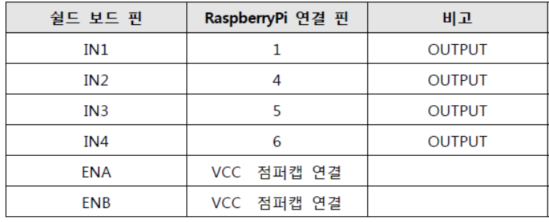

As for connection of ultrasonic sensor, the name itself indicates, ultrasonic sensors measure distance by using ultrasonic waves. The sensor head emits an ultrasonic wave and receives the wave reflected back from the target. Ultrasonic Sensors measure the distance to the target by measuring the time between the emission and reception. To connect the sensor to the board, it is needed to attach the circle in front of the upper part of the body frame of the car. To create the obstacle detection code, the EX_06_01_DCM is changed, and code should operate as initial state. Then it should be forwarded in one second and start ultrasonic sensor measurement at the same time as forward operation starts. After backward, it is waited for a while and then turn right. To run the created program automatically after booting, the following operations are required. After running the terminal, it is typed sudo nano /.etc/rc.local.

Sensors are basically electronic devices which are used to sense the changes that occur in their surroundings. The change may be in color, temperature, moisture, sound, heat etc. They sense the change and work accordingly. In IR sensor, there is emitter and detector. Emitter emits the IR rays and detector detects it. Attaching the IR sensors is occurring by fixing the bolt to the frame and connecting the infrared sensor. Infrared sensor connected to both sides of infrared connection position and pin function on a shield board. GND, VCC to + are connected, - of the sensor shield board, and the other OUT pin to Raspberry Pi is connected as well. To write the obstacle detection code, it is moved to initial state forwarded after 1 second. After turning back, it is waited for a while to check whether the left or right obstacle is reversed. Pi camera is placed behind the ultrasonic sensor. At the top of the frame, it is placed the column with a bolt and nut on the back of the ultrasonic sensor and fixed the mount with the camera attached. There is a port to connect Raspberry Pi and Camera with 15 pins by Camera Serial Interface. The CSI connector is connected to a camera module in the form of a ribbon cable to transmit and receive data via I2C communication.

# Software Design

Software design code is written on C++ language that is regarded as high-level and strong language for implementing the robotic machines. Smart car has some features, that are implemented using some classes and function on C++. The car should stop whenever the footer or any other obstacle is seen. Moreover, it stops when the red color of the traffic light is on. As for motor controlling, several functions are used to control the movement of the car.

*Classification*

Function

*Definition*

Going to the forward

*Responsibilities*

This function helps to go on forward direction on the straight line of road

*Contraints*

None.

*Uses/Interactions*

Will be called by user

# References

1. <https://www.zdnet.com/article/what-is-the-raspberry-pi-3-everything-you-need-to-know-about-the-tiny-low-cost-computer/>
2. <https://www.quora.com/How-does-an-IR-sensor-work>
3. <https://www.cytron.io/p-ir-line-tracking-module>
4. <https://www.maxbotix.com/articles/how-ultrasonic-sensors-work.htm>
5. <https://en.wikipedia.org/wiki/Image_sensor>