**DAY 1: LAYING THE FOUNDATION FOR YOUR MARKETPLACE JOURNEY**

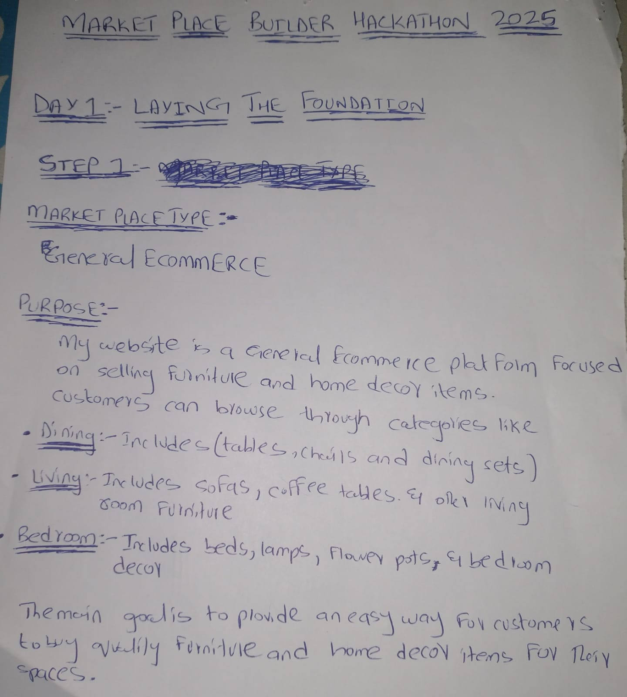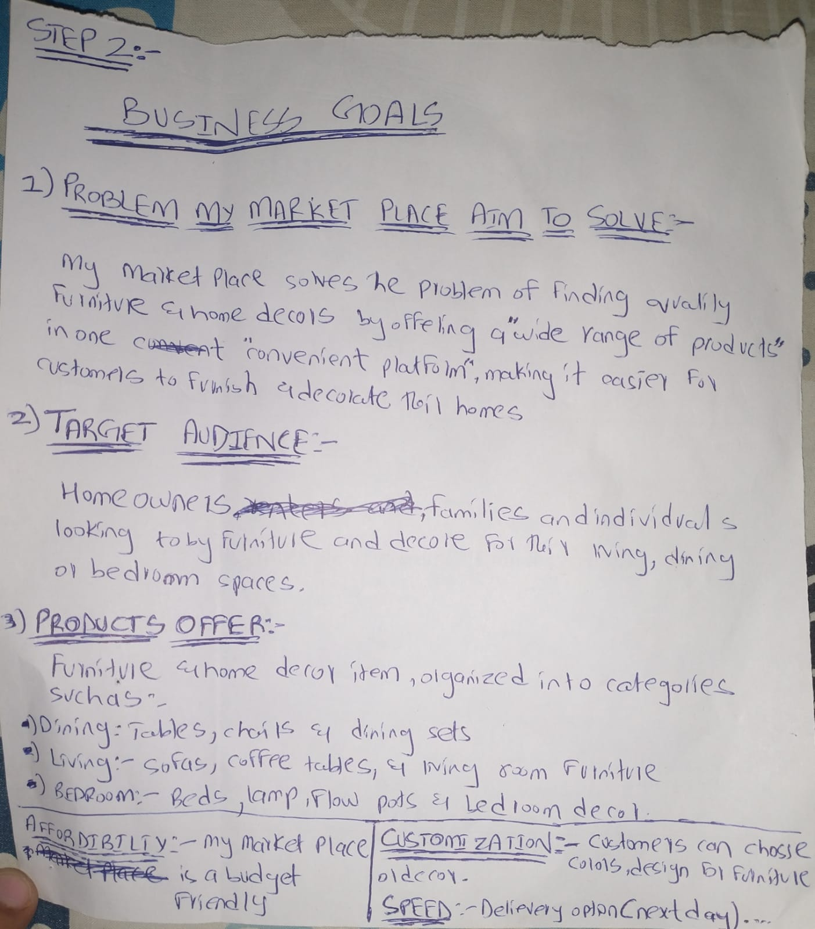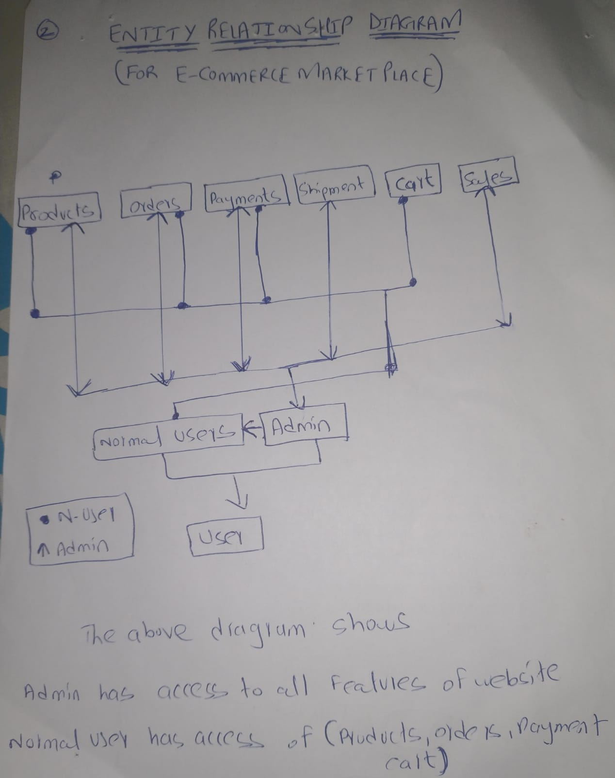

**Key Fields for Each Entity (Schema):**

**User Schema:**

* **UserID: Unique identifier for each user**
* **Name: Full name of the user.**
* **Email: User's email address.**
* **Role: User and Admin.**
* **Phone Number: Contact number of the user.**
* **Address: Primary address for deliveries.**
* **Orders:** 
  + **OrderID: Unique identifier for each order.**
  + **ProductID: Reference to the product schema for items in the order.**
  + **Quantity: Number of each product ordered**
* **Created_at: Date Time**
* **Updated_at: Date Time**

**Products Schema:**

* **Product ID: A unique identifier for the product (id: "1").**
* **Name: The title of the product (title: "Rustic Vase Set").**
* **Description: A detailed explanation of the product and its features**
* **Price: Regular Price ($280)**
* **Discount Price: Discount Price ($280)**
* **Category: Include (ID & Name)**
* **Tags: Keywords for search (eg: rustic, vase, home decor, vintage.)**
* **Colors Available: [Blue, Red, Black]**
* **Sizes Available: [Small (S), Large (L), Extra Large (XL) etc]**
* **Stock: 12 units available.**
* **Minimum Order Quantity: 10 units.**
* **SKU (Stock Keeping Unit): BED-RVD-001.**
* **Rating: 4.5 stars based on customer feedback.**
* **Images: Contain multiple Images of product to show in detail**
* **Thumbnail: URL pointing to the main image of the product**
* **Dimensions:**
  + **Width: 15 cm**
  + **Height: 30 cm**
  + **Depth: 15 cm**
  + **Weight: 1.5 k**
* **General Information**
  + **Sales Package: Includes one Rustic Vase Set.**
  + **Model Number: RVD-123.**
  + **Brand: Vintage Elegance.**
  + **Secondary Material: Ceramic.**
  + **Configuration: Single Piece.**
* **Product-Specific Details**
  + **Filling Material: Foam.**
  + **Finish Colors: Rustic Beige and Glossy White.**
  + **Adjustable Headrest: No.**
  + **Maximum Load Capacity: 50 kg**
  + **Country of Manufacture: India.**
* **Warranty Information**
  + **Warranty: 1 year of manufacturing warranty.**
  + **Domestic Warranty: 3 months.**
  + **Service Contact:** [**support@vintageelegance.com**](mailto:support@vintageelegance.com)**.**
  + **Maximum Load Capacity: 50 kg**
  + **Covered in Warranty: Manufacturing defects.**
  + **Not Covered in Warranty: Physical damage, mishandling, or water exposure.**
* **Created_at: Date Time**
* **Updated_at: Date Time**

**ORDER SCHEMA:**

* **OrderID:** Unique identifier for each order(use sanity id)
* **UserID:** Identifier linking the order to a user
* **ProductID:**
  + **ProductID**(reference to product schema)
  + **ProductName**(product name)
  + **ProductPrice**(product Price if discount else original price)
  + **QuantitySold** (number of items ordered)
* **SalesPrice:** The Total Price of the order
* **PaymentStatus:** (“Paid”,”Pending”,”Failed”)
* **TrackOrder:** Shippo Tracking number
* **DeliveryDetails:** (Name,Address,city=Karachi,country=Pakistan)
* **Created_at:** Date Time (Sanity)
* **Updated_at:** Date Time (Sanity)

**SHIPMENT SCHEMA:**

* **ShipmentID:** Unique identifier for each shipment.
* **OrderID:** Reference to the order schema, linking the shipment to a specific order.
* **UserID:** Reference to the user schema, identifying the user associated with the shipment.
* **ShippingAddress:** Text field for the shipping address.
* **Carrier:** The shipping carrier used (e.g., DHL, FedEx).
* **TrackingNumber:** Tracking number for the shipment.
* **Status:** Current status of the shipment (e.g., Pending, Shipped, Delivered).
* **ShipmentDate:** Date and time the shipment was dispatched.
* **DeliveryDate:** Date and time the shipment was delivered.
* **CreatedAt:** Date and time the shipment record was created.
* **UpdatedAt:** Date and time the shipment record was last updated.