***5 Nexum compitator in Bannu***

# Somezol Cap 20mg

### Product Description

Product Name: Somezol Cap 20mg 2x7's  
  
Product Form: Capsules  
  
Pack Size: 2x7's  
  
Marketed By: BOSCH PHARMACEUTICALS (PVT) LTD  
  
Generic Category: ANTI-ULCERANT  
  
Ingredients: Esomeprazole

**Rs. 123.00**

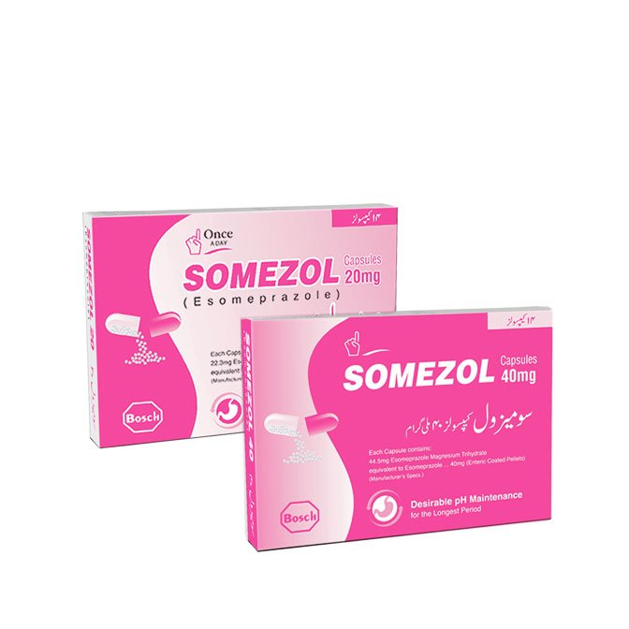

# Eskem Cap 20mg

**Product Description**

Product Name: Eskem Cap 20mg 14's  
  
Product Form: Capsules  
  
Pack Size: 14's  
  
Marketed By: High Q PHARMACEUTICALS  
  
Generic Category: Anti-Ulcerant  
  
Ingredients: Esomeprazol

**Rs. 170.00**

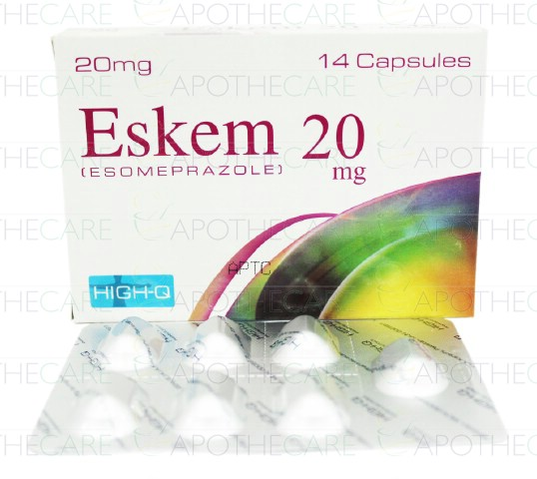

# Esso Cap 20mg

### Product Description

Product Name: Esso Cap 20mg 14’s  
  
Product Form: Capsules  
  
Pack Size: 14’s  
  
Marketed By: Shaigan Pharmaceuticals  
  
Generic Category: ANTI-ULCERANT  
  
Ingredients: ESOMEPRAZOLE

**Rs. 161.00**

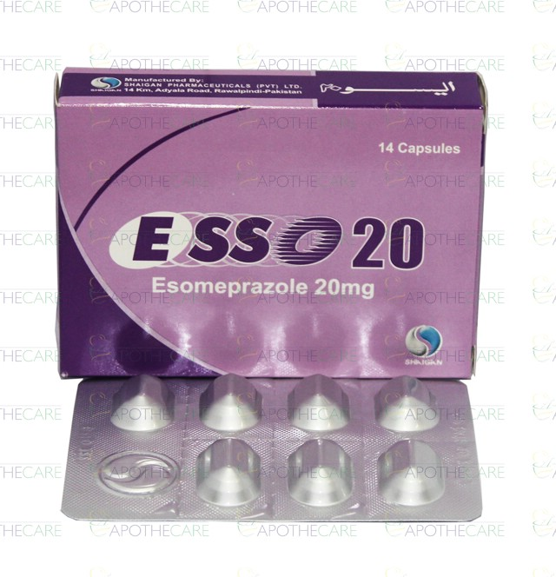

# Esvin Cap 20mg

### Product Description

Product Name: Esvin Cap 20mg 2X7's  
  
Product Form: Capsules  
  
Pack Size: 2X7's  
  
Marketed By: Merck (Pvt) Ltd  
  
Generic Category: Anti-Ulcerant   
  
Ingredients: Esomeprazole

**Rs. 123.70**

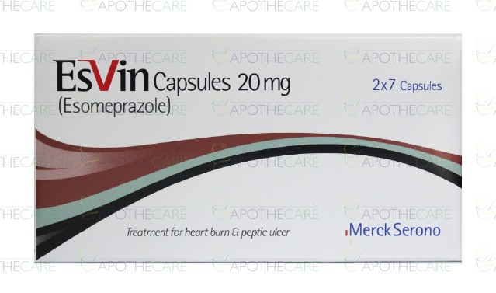

# Esocue Cap 20mg

Pack Of Size= 2x7  
Sandoz Pharmaceutical

**Rs. 162.00**

