Task # 3
Name: Muhammad Zeeshan
Roll Number: SU92-BSSEM-S25-041
Section: 4A

Task 1: BFS and DFS Trace
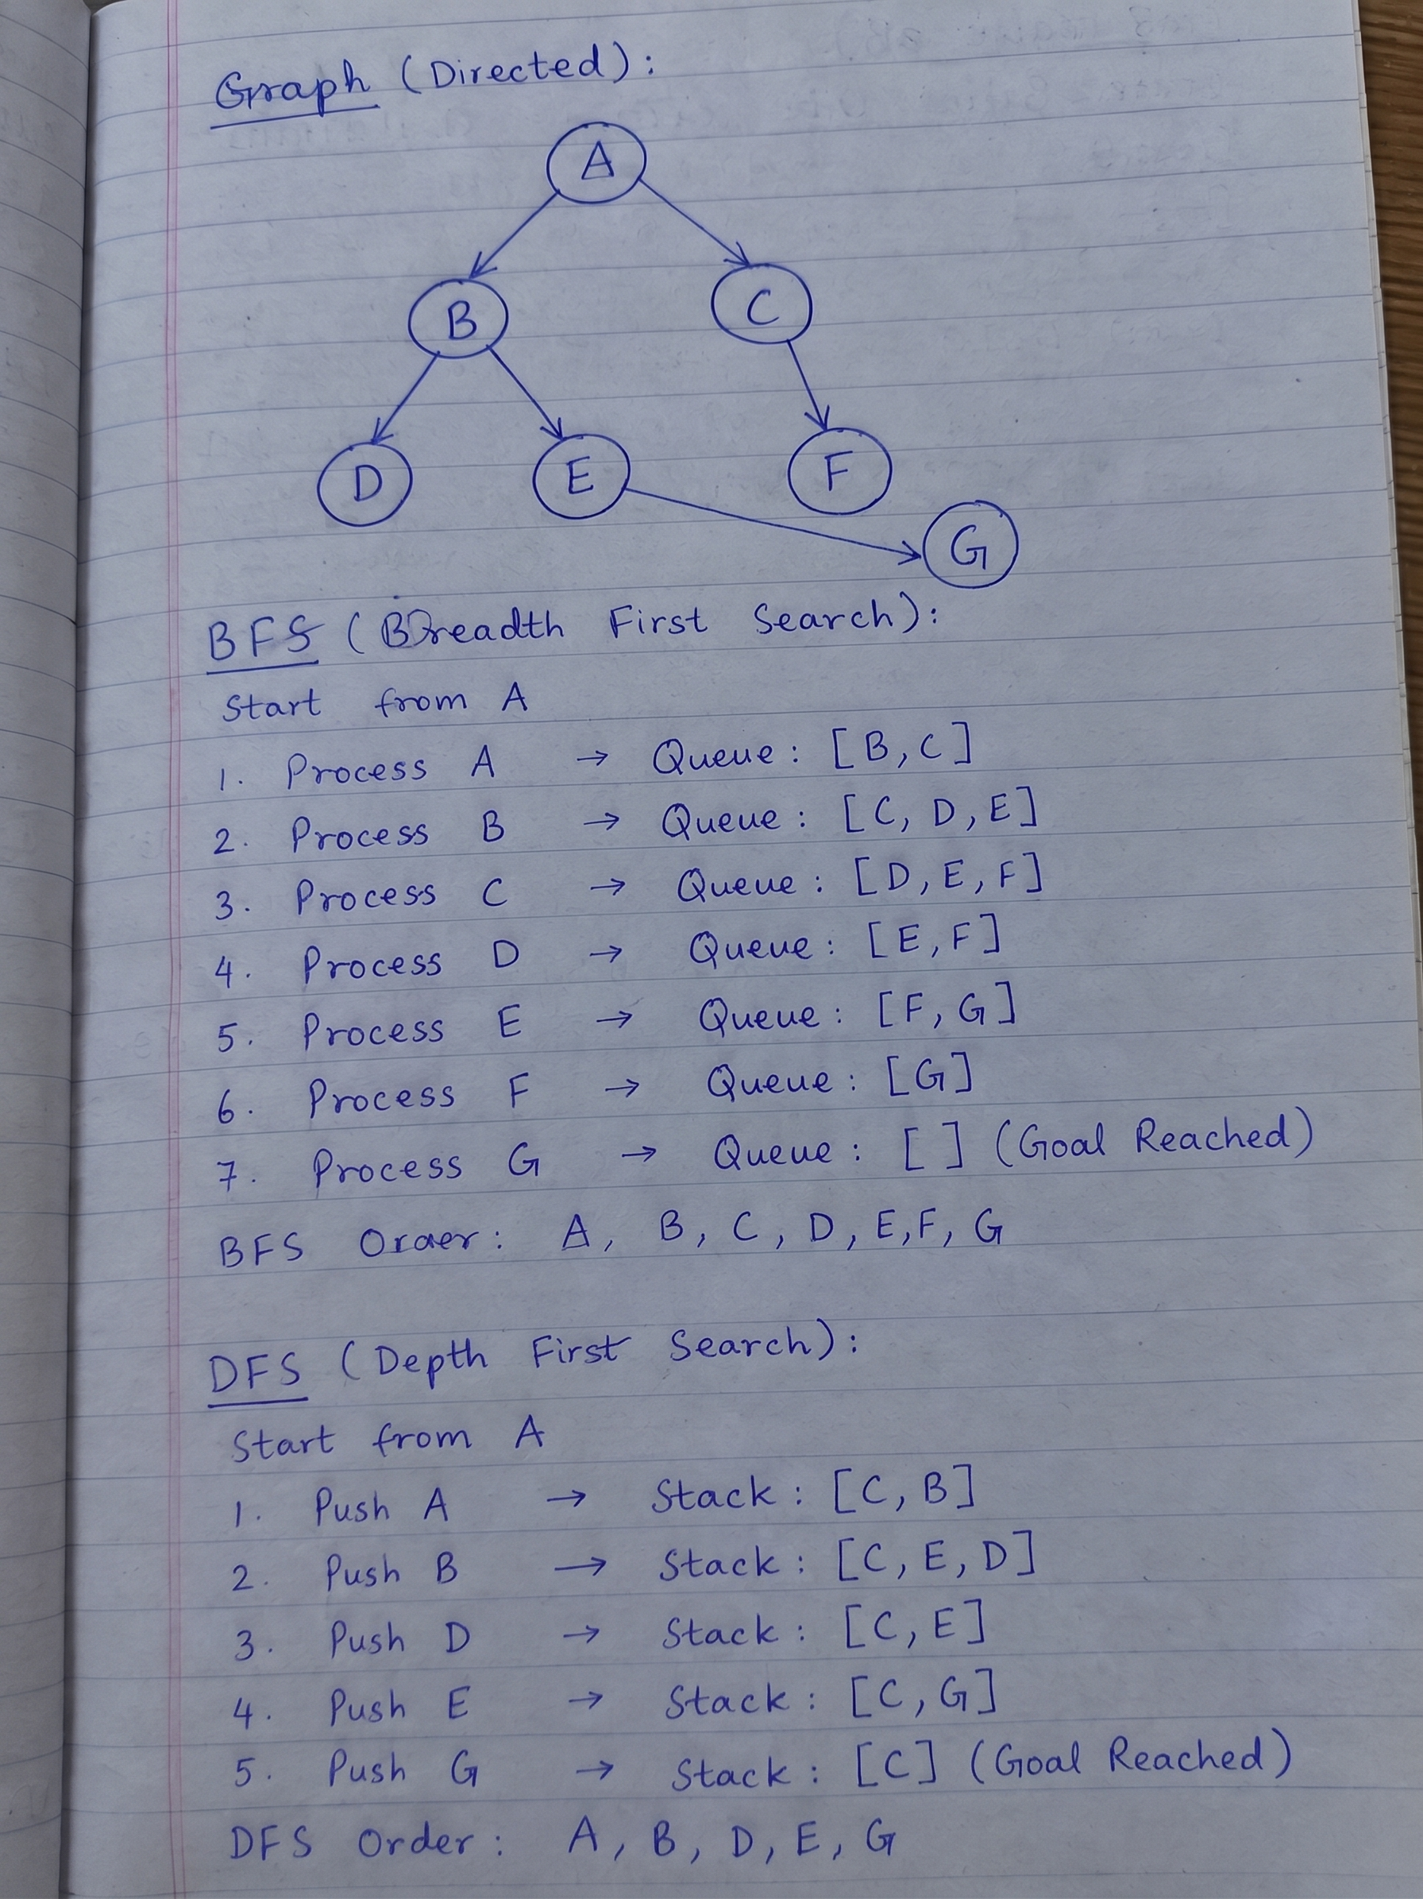
- BFS Visit Order: A, B, C, D, E, F, G
- BFS Final Path: A, B, E, G
- DFS Visit Order: A, B, D, E, G
- DFS Final Path: A, B, E, G

Task 2: DLS Results
I tested DLS with limits 1, 2, 3, and 4.
- Limit 1: CUTOFF.
- Limit 2: CUTOFF.
- Limit 3: FOUND with path A, B, E, G.
- Limit 4: FOUND with path A, B, E, G.
Edge Case Analysis
- Case: Using Limit 2 in DLS.
- Observed Behavior: It returns CUTOFF and stops.
- Reason: Goal 'G' is 3 steps away, so limit 2 fails to reach it.
- Improvement: We must have limits of 3 or more.

Reflection
- Learn: I learned that BFS uses a Queue and DFS uses a Stack.
- Apply: I will use BFS for simple maps.
- Surprise: I was surprised that limit 2 cannot find a 3-step goal.

