Lab 3: Uninformed Search Strategies (BFS, DFS, DLS, IDDFS & UCS)
Student Name: Muhammad Zeeshan
Roll Number: SU92-BSSEM-S25-041
Course: Artificial Intelligence Lab
Instructor: Sir Rasikh Ali

Task 1: Manual Trace of BFS and DFS
For this task, the manual trace of the given graph using Breadth-First Search (queue) and Depth-First Search (stack) has been performed on paper.
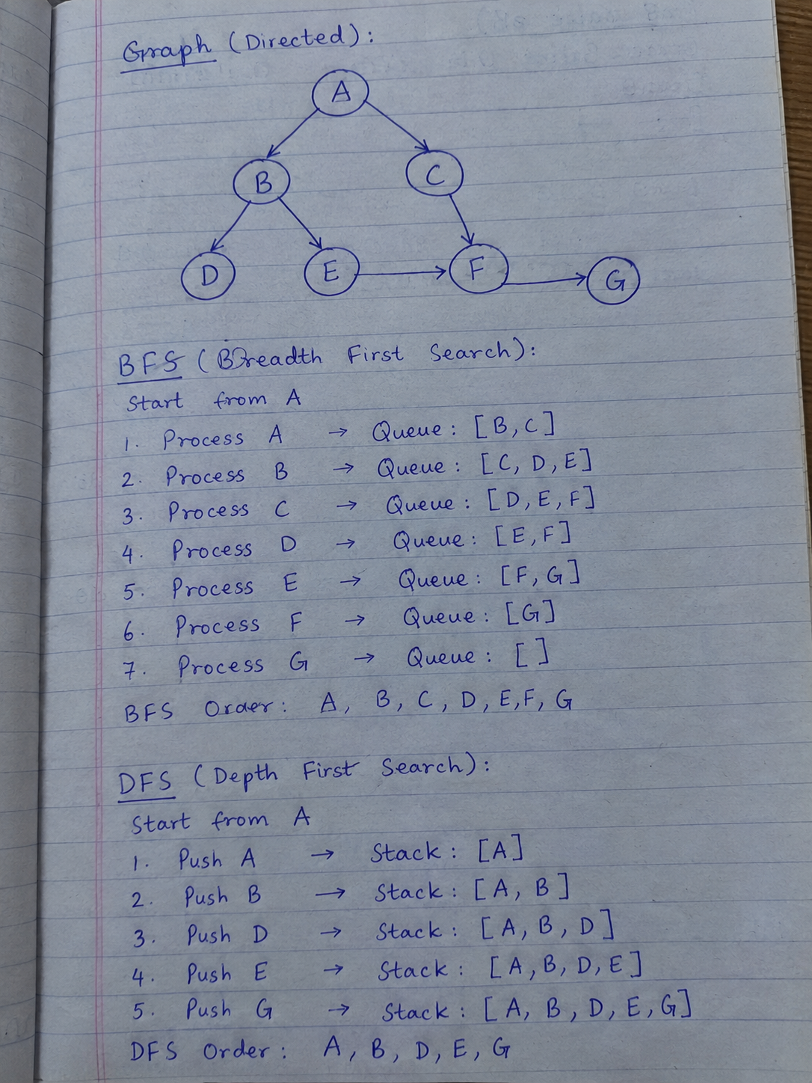
Results from Trace:
- BFS Final Path: A -> B -> E -> G
- DFS Final Path: A -> B -> E -> G
Task 2: DLS and IDDFS Testing
In this task, we implemented Depth-Limited Search (DLS) and Iterative Deepening DFS (IDDFS). We tested the IDDFS algorithm with depth limits from 1 to 4.
Testing Observations:
- Limits 1 & 2: The search returns CUTOFF or FAILURE because the goal node 'G' is too deep to be reached within these small limits.
- Limits 3 & 4: The search successfully finds the goal and returns FOUND.
- Final IDDFS Path: A -> B -> E -> G
Task 3: UCS and Weighted Graph Comparison
For the final task, Uniform Cost Search (UCS) was implemented on a weighted version of the graph.
Modifications and Results:
- Graph Modification: A new corridor was added from node 'C' to 'G' with an edge cost of 2. The other edge costs were kept at minimal values (1 and 10).
- Comparison (BFS vs. UCS):
  - If we use standard BFS, it looks for the fewest edges (hops). It prefers path A -> C -> G (only 2 edges), but its total cost is 12 (10 + 2).
  - When we use UCS, it looks for the lowest total path cost. It correctly ignores the A -> C -> G path and finds the optimal path A -> B -> E - > G (3 edges), which has a much lower total cost of 3 (1 + 1 + 1).
Conclusion: UCS successfully finds the cheapest path based on edge weights, while BFS only finds the shallowest path.

