SOUND
DOCUMENTATION
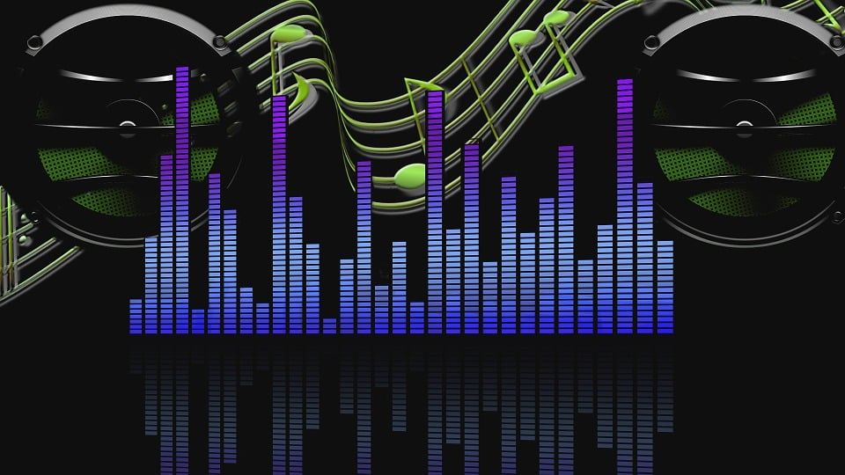

APTECH LEARNING N.K CAMPUS
FACULTY : HOOR-UL-AIN
BATCH : 2312F1
SEMESTER :DISM
TEAM MATES:
1. TEAM LEADER : MUHAMMAD ZIA UDEEN
2. TEAM MEMBER : ASMA SHEIKH
3. TEAM MEMBER : MUHAMMAD AFFAN
4. TEAM MEMBER : ALINA RIAZ
5. TEAM MEMBER : MUNEEB

TABLE OF CONTENT
ACKNOWLEDGEMENT…………………………………………………………………………………!!
INTRODUCTION……………………………………………………………………………………………!!
SYNOPSIS………………………………………………………………………………………………………!!
PROBLEM STATEMENT…………………………………………………………………………………!!
PROJECT DESIGN…………………………………………………………………………………………!!
DATA FLOW DIAGRAM…………………………………………………………………………………!!
FLOW CHART……………………………………………………………………………………………….!!
PROGRESS DIAGRAM……………………………………………………………………………….….!!
MODULE DISCRIPTION FOR SOUND WEBSITE……………………………………………..!!
NAVBAR…………………………………………………………………………………………………….!!
HOME PAGE……………………………………………………………………………………………….!!
INDEX PAGE…………………………………………………………………………………………..…..!!
HISTORY PAGE……………………………………………………………………………………………….!!
SIGNUP & LOGIN PAGE…………………………………………………………………………………..!!
PHP FILES………………………………………………………………………………………………………..!!
DATABASE……………………………………………………………………………………………………….!!
FOOTER………………………………………………………………………………………………………!!
SCREENSHOTS…………………………………………………………………………………………….!!

INTRODUCTION:
A sound website is an online platform designed to provide access to various forms of audio-related content, services, or tools. These websites cater to different audiences, including musicians, audio engineers, sound designers, podcasters, music lovers, and general users who enjoy audio content. Depending on the site, they may focus on the distribution, creation, editing, or exploration of sound.
1. Music Streaming W
Platforms like Spotify, Apple Music, and SoundCloud allow users to stream and discover music. These websites often provide personalized recommendations, playlists, and access to millions of tracks across genres.
2. Sound Effects Libraries
Websites such as FreeSound, Soundsnap, and AudioJungle host collections of sound effects for filmmakers, game developers, and other creators. Users can search for and download sound effects for use in various multimedia projects.
3. Podcasts & Audio Content
Websites like Podbean, Anchor, or even personal blogs serve as hosting platforms for podcasts. These sites allow creators to upload their audio content and offer listeners access to a variety of topics, from storytelling to education, news, and entertainment.
4. Audio Editing Tools
Some websites offer online audio editing and production tools, such as Audacity (open-source software) or cloud-based platforms like Soundtrap. These tools allow users to manipulate sound, create podcasts, or produce music tracks from a browser.
• Sound Design and Production
For sound designers and audio engineers, websites like Splice and Loopmasters provide access to royalty-free music samples, loops, and sound effects. These sites may also offer software tutorials, forums, and community-driven resources.
Key Features of Sound Websites:
1. Search and Discovery Tools: Easy-to-use search functions to find specific sounds, music, or audio effects.
2. Streaming and Download Options: Allow users to stream, download, or purchase audio content directly from the website.
3. Community Engagement: Many sound websites feature community-driven content, allowing users to upload, share, and comment on audio files.
4. User-Friendly Interface: A clean, intuitive design that makes navigation and content consumption easier, whether it's for music discovery, sound editing, or education.
5. Interactive Audio Players: For sites focused on music or podcasts, a customizable audio player to listen to content directly on the platform

ACKNOWLEGEMENT
If you're looking for an acknowledgment specifically for a sound website (whether you used it for sound effects, music, resources, or tools), here’s how you can phrase it. The acknowledgment can be tailored depending on how you used the site and its role in your project.
1. Freesound: “Special thanks to Freesound for their extensive collection of free sound effects, which were used throughout this project."
2. Soundsnap: "Many thanks to Soundsnap for their premium sound effects library, which was instrumental in creating the auditory experience for this project."
3. ZapSplat: "This project benefited from the free sound effects available on ZapSplat, whose wide variety of audio resources were crucial for sound design."
4. Splice: "Thanks to Splice for providing a wealth of music samples and loops that shaped the musical elements of this project."
5. BBC Sound Effects: "Grateful to BBC Sound Effects for granting access to their vast archive of sound effects, which helped to create an authentic and immersive atmosphere

SYNOPSIS
Free sound is an online platform dedicated to providing high-quality audio resources for creators, sound designers, musicians, and filmmakers. The website offers a diverse range of sound effects, music tracks, loops, and other audio content that can be used in various creative projects, including films, games, podcasts, advertisements, and more.
The platform features an easy-to-use search interface, allowing users to quickly find and download sound assets based on category, mood, or specific keywords. Whether you're looking for ambient sounds, foley effects, or cinematic music, [Website Name] provides both free and premium content that suits professional production needs.
Additionally, free sound may offer specialized tools for sound editing, mixing, and music production, making it a go-to resource for those looking to enhance their projects with high-quality, royalty-free sound assets. With its vast library, user-friendly interface, and flexible licensing options, [Website Name] serves as a one-stop shop for all things related to sound design and audio production.
PROBLEM STATEMENT
Problem:
Sound designers, filmmakers, game developers, and content creators often struggle to find high-quality, royalty-free audio assets that meet the specific needs of their projects. Many existing sound libraries are either too expensive, difficult to navigate, or lack the variety and quality required for professional production. As a result, creators spend significant time sourcing sound effects, music, and other audio elements from multiple sources, hindering their productivity and creativity
"Many content creators and sound designers face the challenge of finding high-quality, free-to-use sound effects for their projects. Traditional sound libraries often come with expensive licensing fees, limited selections, or restrictive terms of use. Freesound addresses this problem by providing a collaborative platform where users can access thousands of sound effects and recordings, all available under Creative Commons licenses, making it easy for creators to find and use sounds legally and affordably."

1. The Target Users: Identify who is affected by the problem (e.g., sound designers, filmmakers, game developers).
2. The Specific Problem: Define the challenges or limitations (e.g., difficulty finding high-quality, affordable, and diverse sound assets).
3. The Solution Provided: Outline how the website addresses these issues (e.g., offering a searchable database of sound resources with royalty-free licensing)
4. Difficulty Finding High-Quality Audio Resources:
Users often struggle to find high-quality sound effects, music tracks, and loops that meet the specific needs of their projects, whether for film, games, podcasts, or other media.
Existing sound libraries may be limited in variety or difficult to navigate, leading to frustration for users looking for specific sounds or high-quality assets

MODULE DISCRIPTION FOR SOUND WEBSITE
This module allows users to listen to, upload, and interact with high-quality audio content on the website. It serves as a platform for streaming various types of audio, including music, podcasts, sound effects, and other audio resources. It provides a seamless audio experience for users, whether they are listening on desktop or mobile devices.
Sound Module Description for Website

Sound Player & Audio Streaming
This module allows users to listen to, upload, and interact with high-quality audio content on the website. It serves as a platform for streaming various types of audio, including music, podcasts, sound effects, and other audio resources. It provides a seamless audio experience for users, whether they are listening on desktop or mobile devices.

1.Audio Playback:
- Supports various audio formats, including MP3, WAV, and OGG.
- High-quality audio playback with customizable settings (volume control, playback speed, etc.).
- Responsive player design that adapts to different screen sizes and devices.

2. Playlist Management:
- Users can create and manage personalized playlists.
- Option to add, remove, and reorder audio tracks in a playlist.
- Supports shuffle, repeat, and skip track features.

3.Audio Upload:
- Allows users to upload their own audio files directly to the platform (subject to file size and format restrictions).
- Simple drag-and-drop interface for easy uploads.
- Support for metadata input, including track title, artist name, and genre.

4.Audio Search & Discovery:
- Advanced search functionality that lets users filter audio content by title, artist, genre, or mood.
- Recommendations engine based on user listening preferences.
- Tagging system for easy categorization and discovery of new content.

5. Audio Streaming
- Real-time streaming of audio content without requiring the user to download files.
- Supports streaming from both local server storage and external services (e.g., Spotify, SoundCloud, etc.).

6. Interactive Features:
- Users can leave comments, rate tracks, and share audio content on social media.
- Option to follow favorite artists or creators for updates on new releases.
- Integrated with social media platforms for easy sharing of tracks and playlists.

7.User Profiles & Community:
- Users can create and customize personal profiles.
- Option to showcase uploaded tracks, playlists, and listening history.
- Community-driven features such as follower lists, friend requests, and notifications for new content.

8.Accessibility Features:
- Supports screen readers and keyboard navigation for visually impaired users.
- Customizable font sizes and color schemes for better visibility.

9.Analytics and Insights:
- Real-time data on audio streams, plays, and user engagement.
- Track statistics for uploaded content, including play count, geographic location of listeners, and user interaction me.
DFD’S

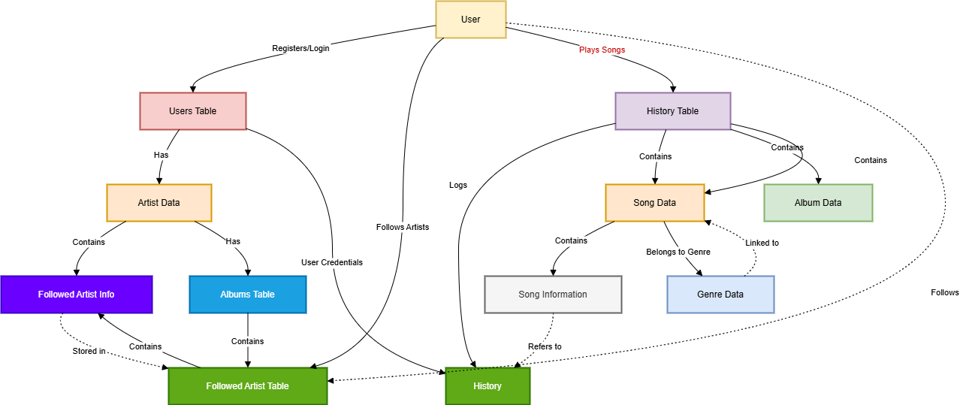

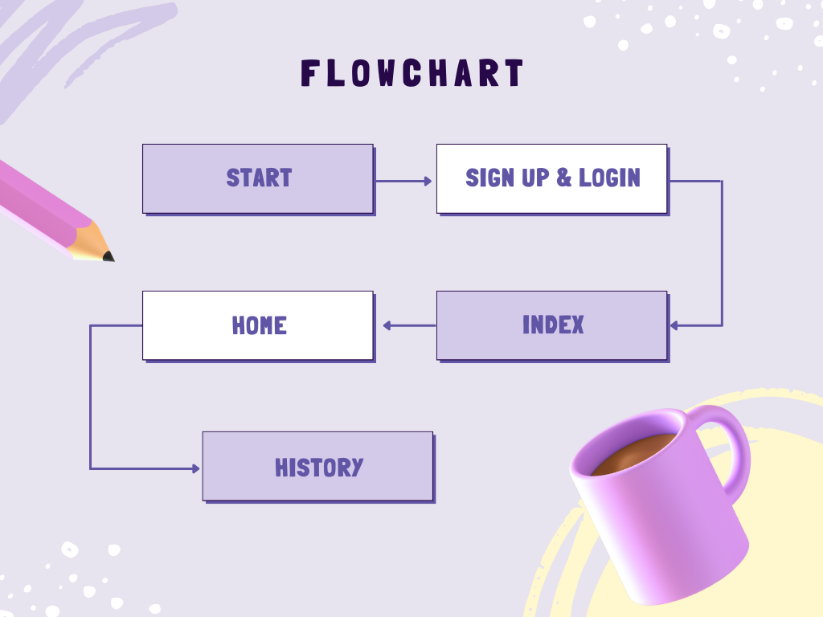

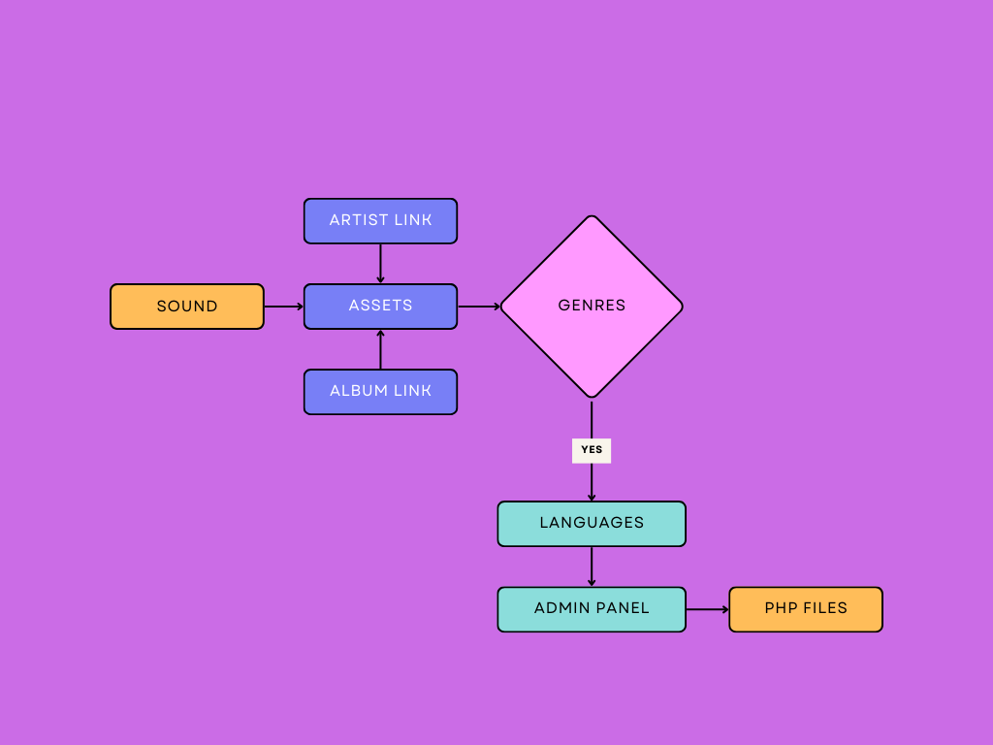

DATABASE DIAGRAM

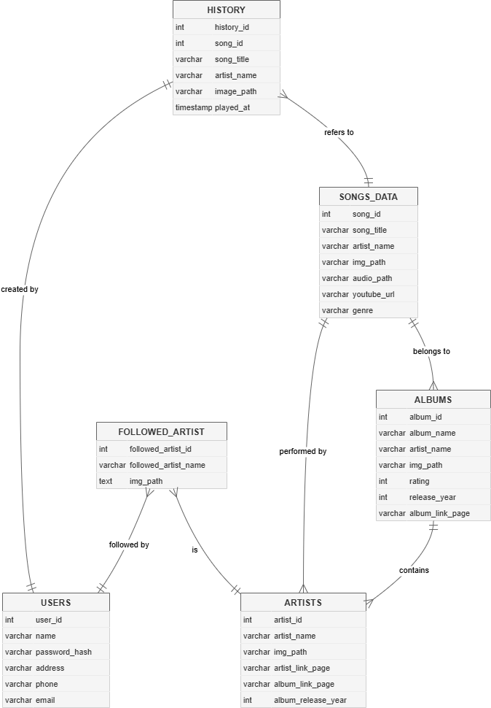

SCREENSHOTS
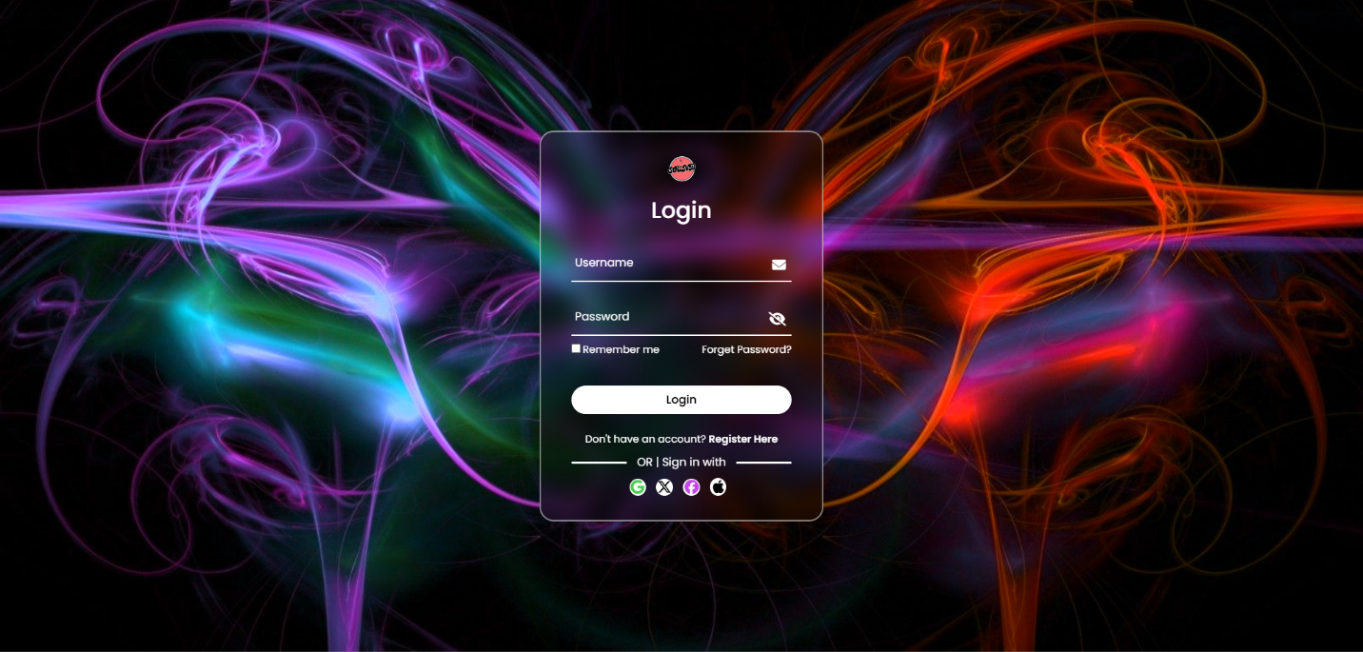

NAVBAR

MUSIC BAR

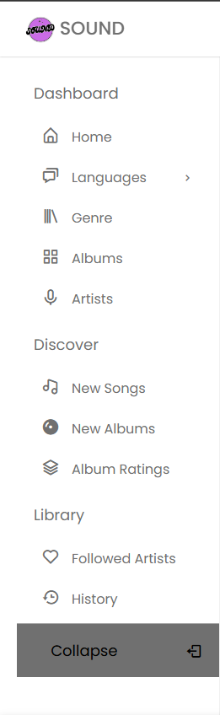

SEARCH BAR
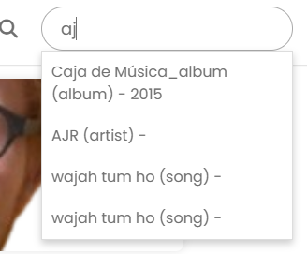
ALBUM
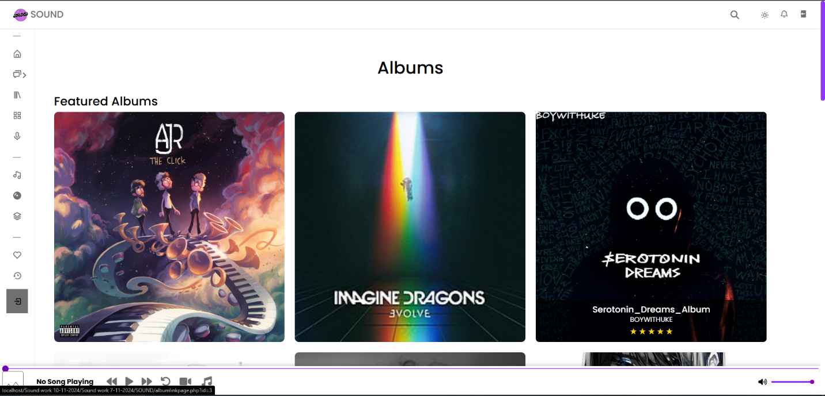

ARTIST
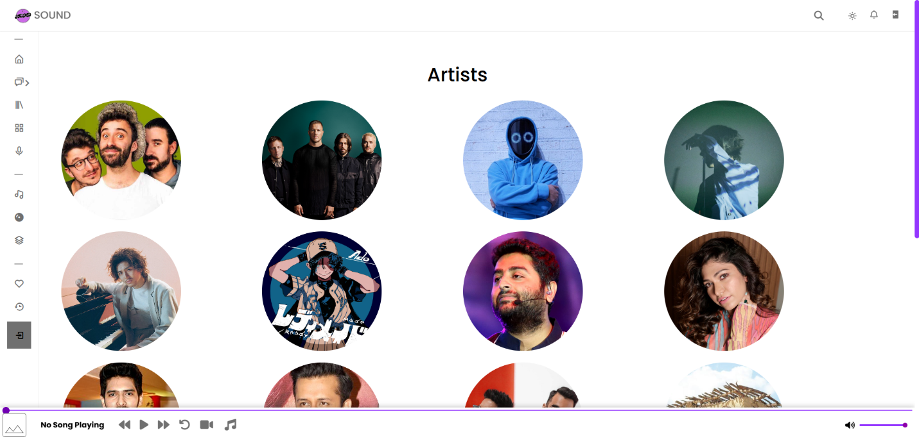
DARK HOME PAGE
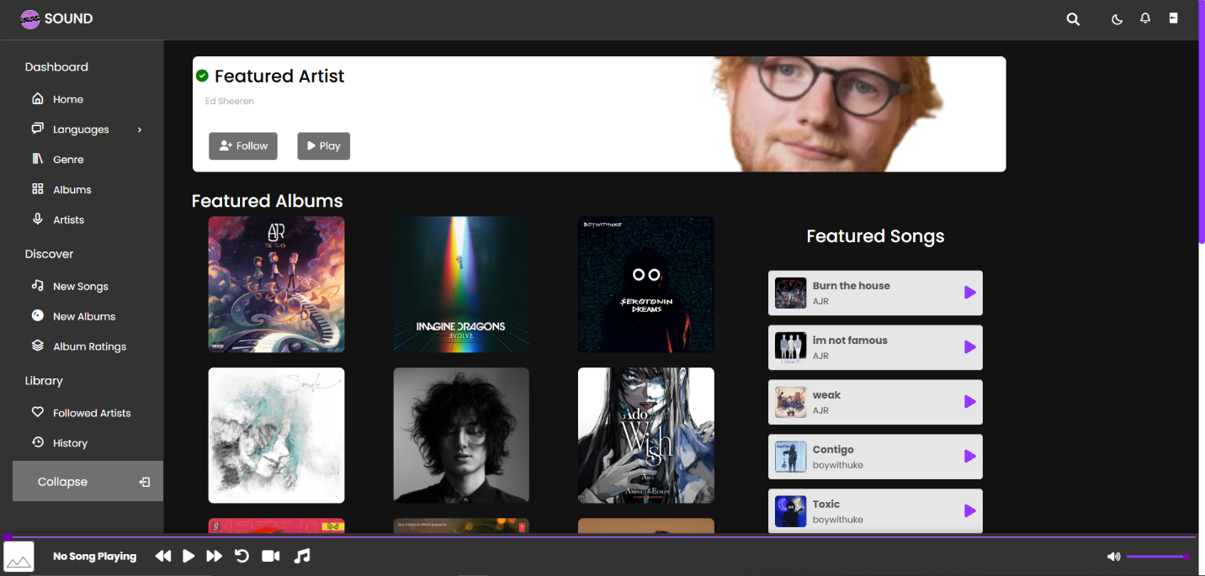

FOLLOW ARTIST
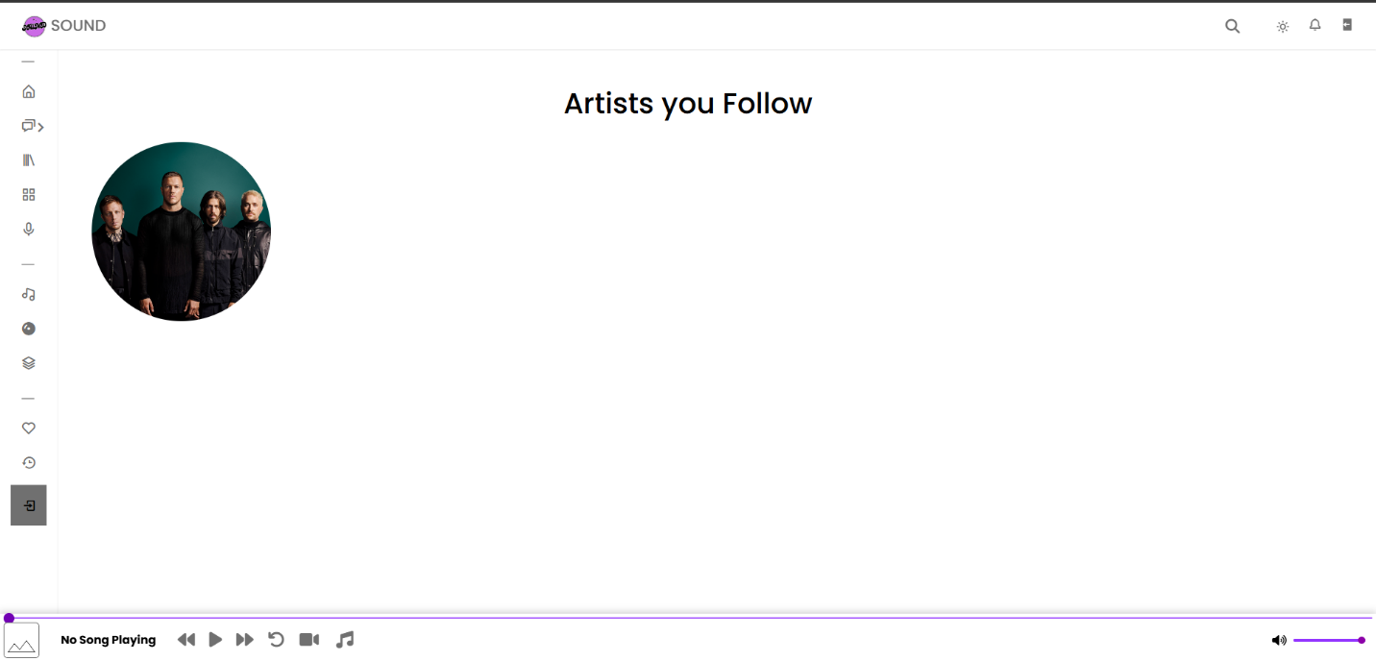
GENRES
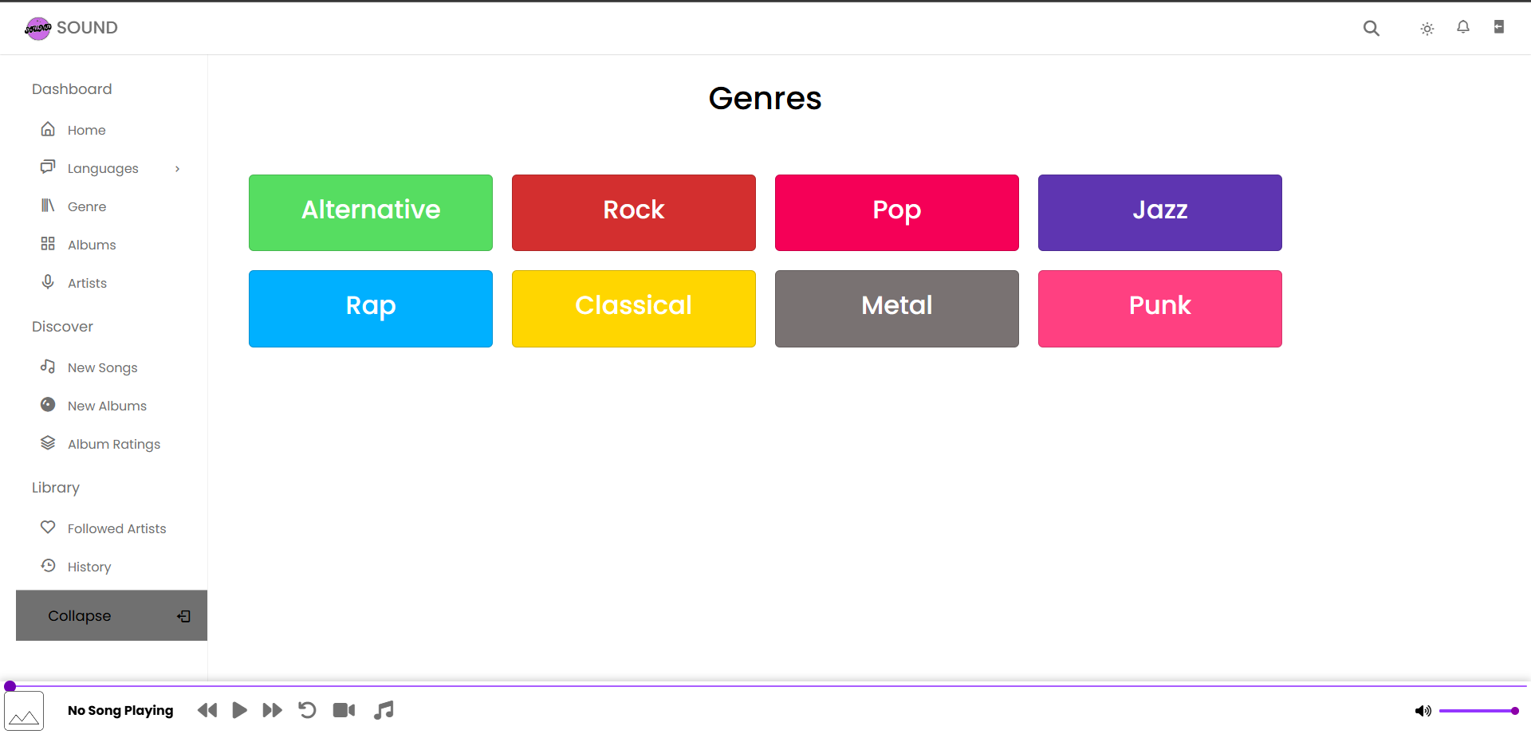

GENRES PAGE
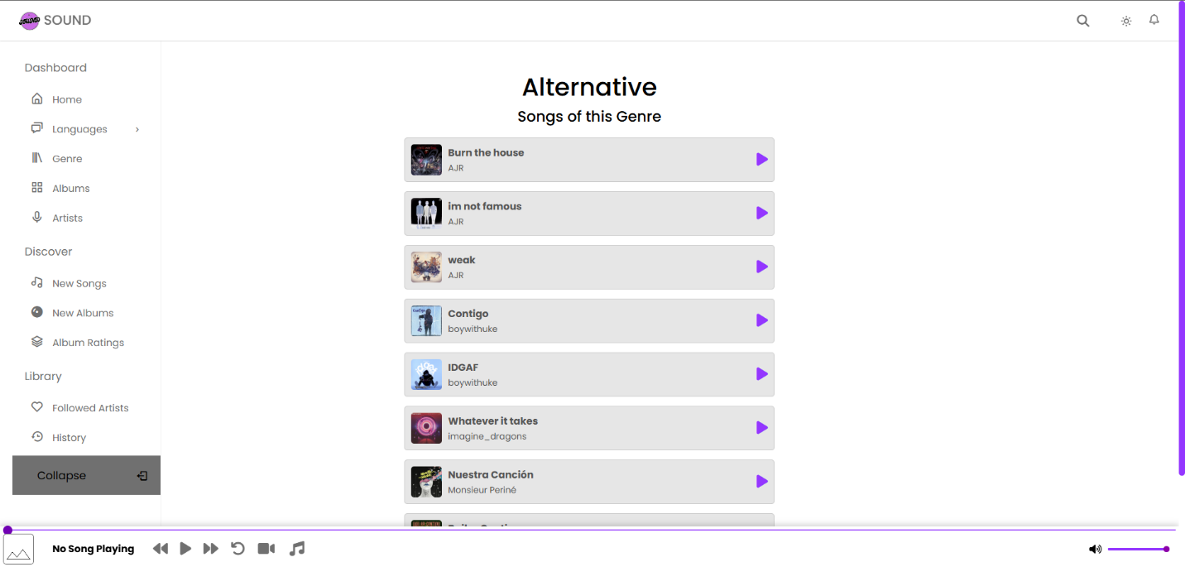
HOME PAGE
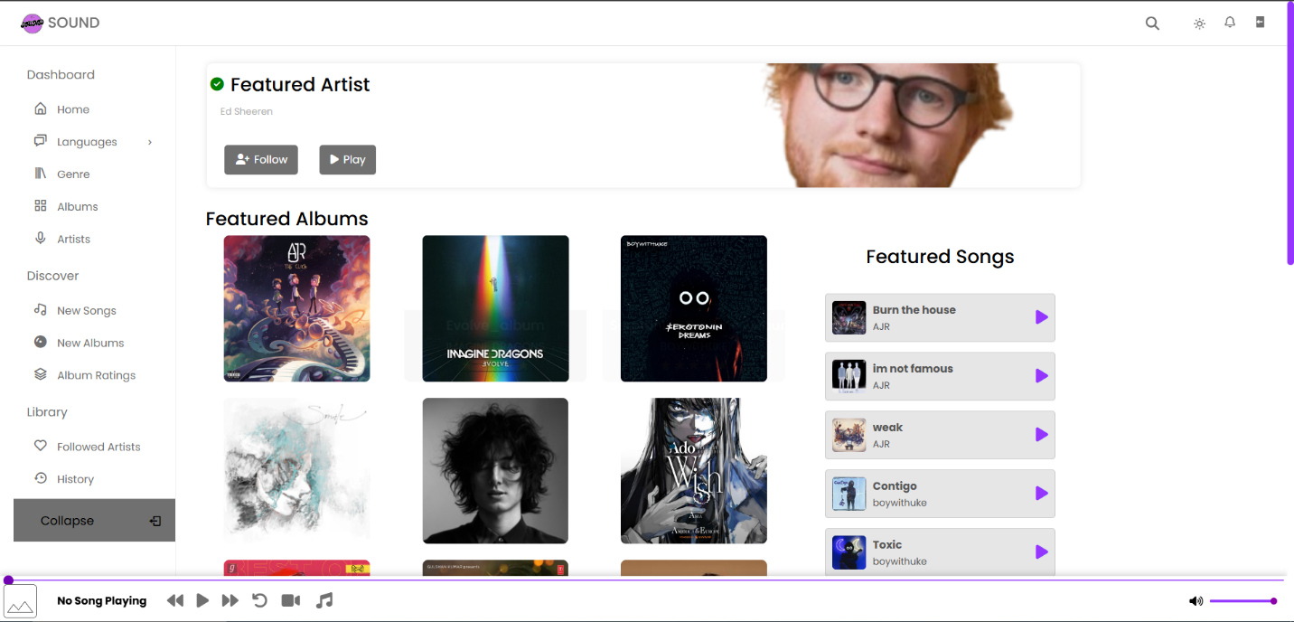

NEW ALBUM
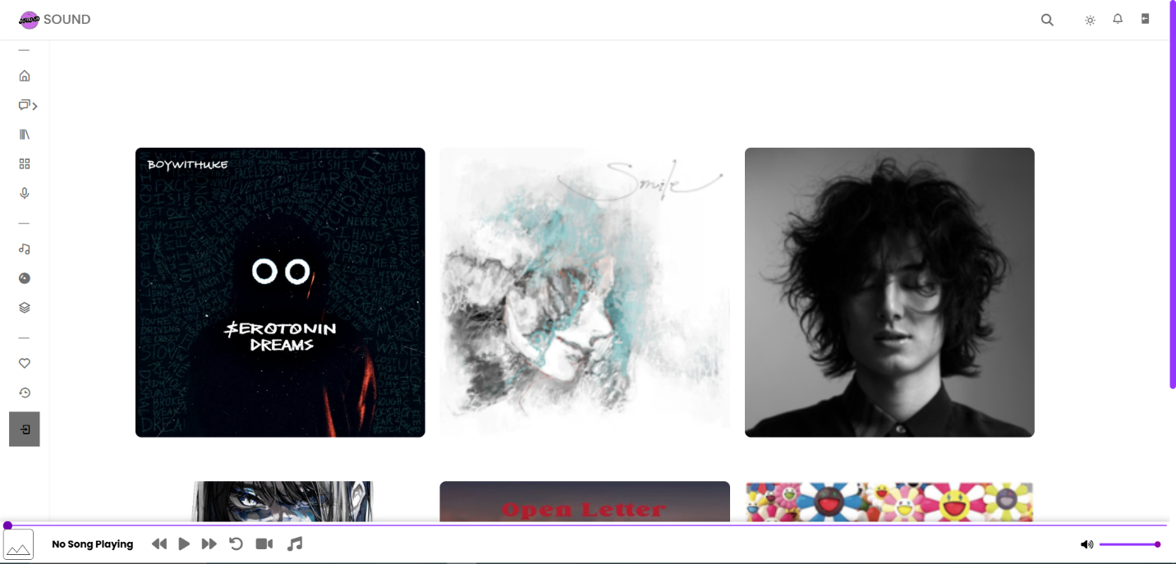
PLAYED SONGS
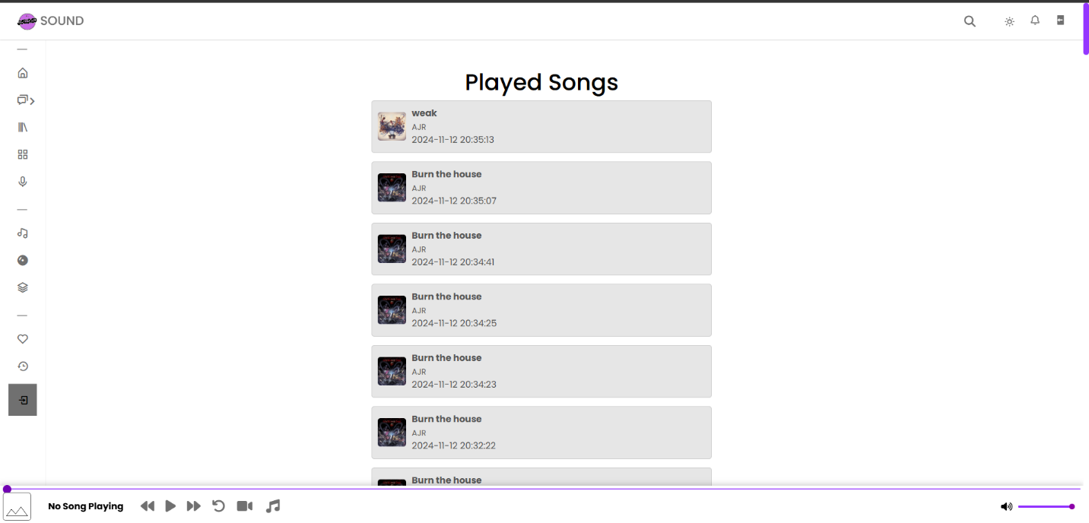

RATE ALBUM
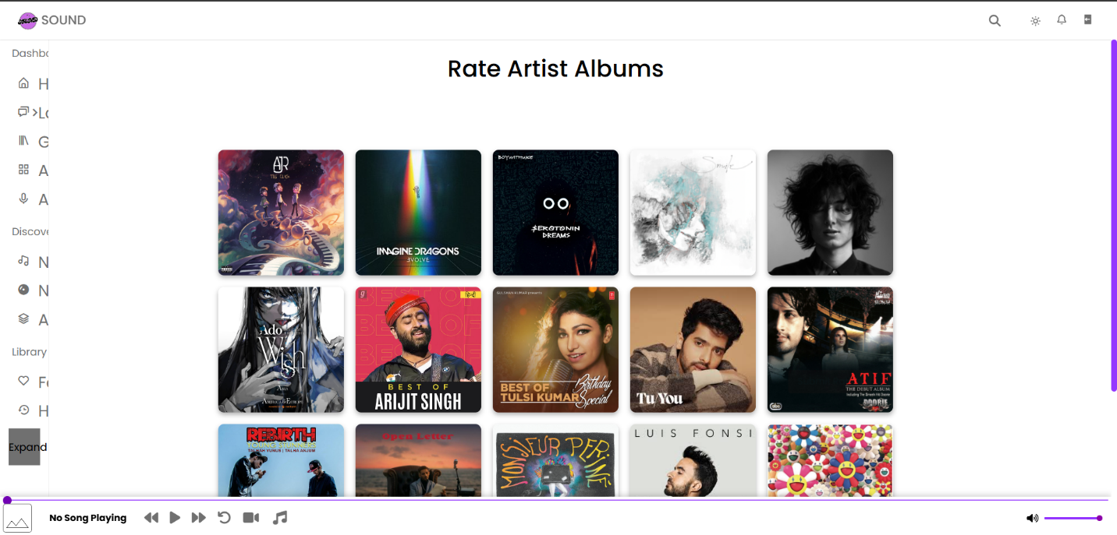
RECENT SONG
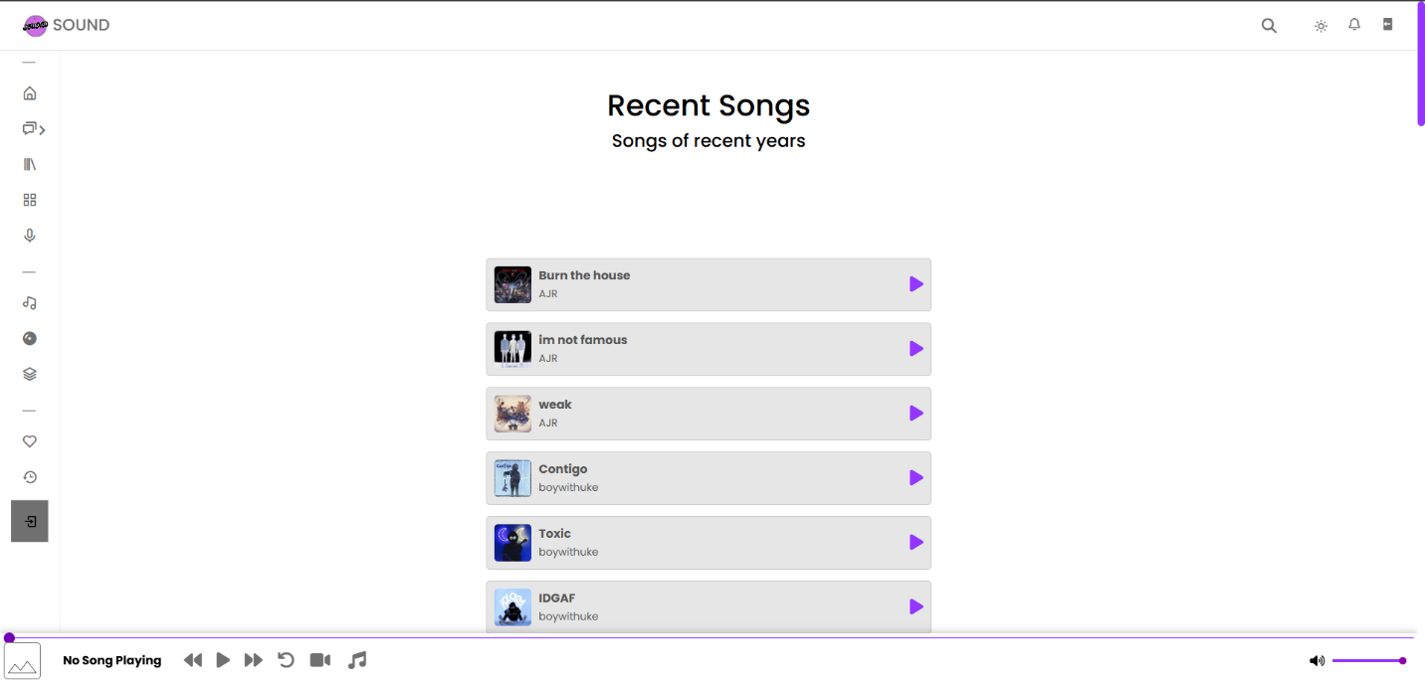

THANKYOU !!

