
Watch hub
Documentation

Branch: APTECH NORTH KARACHI
Batch: 2401F1
Faculty: Miss Noor
Semester: 4th Semester

TEAM MEMBERS:

- Student1538849 MUHAMMAD ZIA UDDIN

- Student1529403 ZOHA SIDDIQUI

- Student1538838 ASMA.

- Student1531232 ALINA RIAZ

- Student1538845 MAIMOONA SHAHID

- Student1511528 SAWERA MUMTAZ

- Student1547167 SYEDA FAZEELAT AYAZ

- Student1546825 SYED MUHAMMAD SAQIB ALI

TABLE OF CONTENT:
ACKNOWLEDGEMENT………………………………………………………………………………!!
INTRODUCTION………………………………………………………………………………………!!
SYNOPSIS………………………………………………………………………………………………………!!
PROBLEM STATEMENT…………………………………………………………………………………!!
PROJECT DESIGN…………………………………………………………………………………………!!
DATA FLOW DIAGRAM…………………………………………………………………………………!!
FLOW CHART……………………………………………………………………………………………….!!
PROGRESS DIAGRAM……………………………………………………………………………….….!!
MODULE DESCRIPTION FOR WATCHHUB APP………………………………………….…!!
APPBAR………………………………………………………………………………………………………!!
HOME PAGE………………………………………………………………………………………………!!
INDEX PAGE………………………………………………………………………………………………!!
ORDER HISTORY PAGE………………………………………………………………………………!!
SIGNUP & LOGIN PAGE………………………………………………………………………………!!
WISHLIST PAGE…………………………………………………………………………………………!!
CART PAGE………………………………………………………………………………………………!!
PRODUCT DETAILS PAGE…………………………………………………………………………!!
SEARCH & FILTER PAGE…………………………………………………………………………!!
PROFILE PAGE……………………………………………………………………………………………!!
CUSTOMER SUPPORT / FAQ PAGE…………………………………………………………!!
ADMIN PANEL PAGE…………………………………………………………………………………!!
DATABASE STRUCTURE (FIRESTORE)……………………………………………………!!
Dart FILES……………………………………………….…………………………………………...!! DATABASE………………………………………………………………………………………….!!
SCREENSHOTS……………………………………………………………………………………….!!
ACKNOWLEDGEMENT
We express our sincere gratitude to all those who supported and guided us throughout the development of the WatchHub App.
Special thanks to our mentors, developers, and the open-source community whose resources and documentation greatly assisted in building this project using Flutter and Firebase technologies.

INTRODUCTION
WatchHub is a cross-platform e-commerce mobile application built with Flutter.
It allows users to browse, search, and purchase watches from various brands with secure authentication, wishlist management, and order history tracking.
The app provides an elegant and responsive user interface suitable for both Android and iOS devices.

SYNOPSIS
The WatchHub App was developed to create a modern, fast, and user-friendly platform for watch enthusiasts to explore and shop.
The project integrates Firebase Authentication, Cloud Firestore, and Cloud Storage to handle real-time data, ensuring a seamless and secure shopping experience.

PROBLEM STATEMENT
Traditional online shopping platforms are often cluttered, slow, or web-based only.
WatchHub aims to provide:
- A mobile-first experience for watch buyers.
- Real-time product updates and inventory tracking.
- Easy wishlist and order management.
- A lightweight app that requires no heavy backend management.

PROJECT DESIGN
The WatchHub app follows the MVVM (Model–View–ViewModel) architecture to maintain separation between UI, logic, and data layers.
The UI components are built with Flutter widgets, while Firebase handles backend services such as data storage, authentication, and media hosting.
Tools & Technologies:
Component | Technology
Framework | Flutter (Dart)
Backend | Firebase
Database | Firestore
Authentication | Firebase Auth
Storage | Firebase Storage
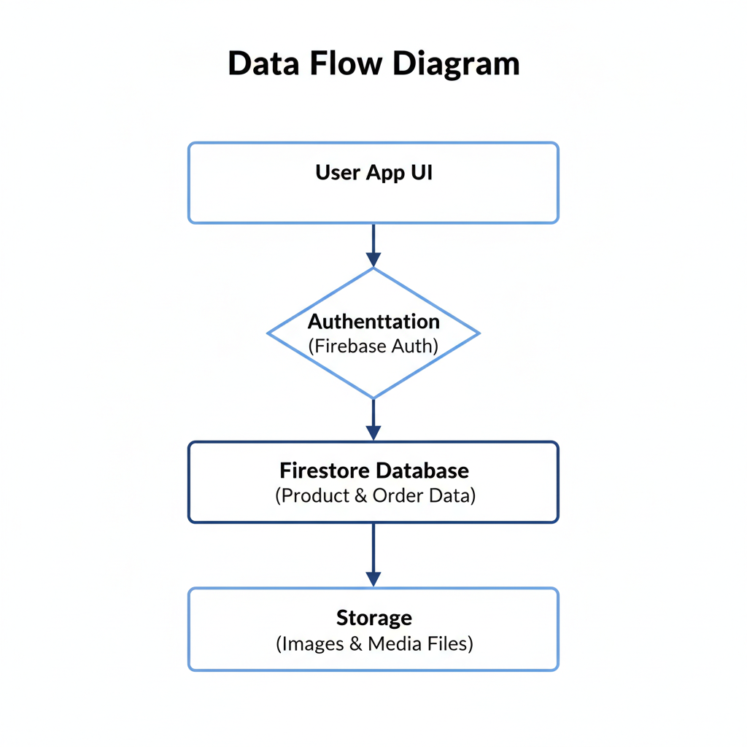
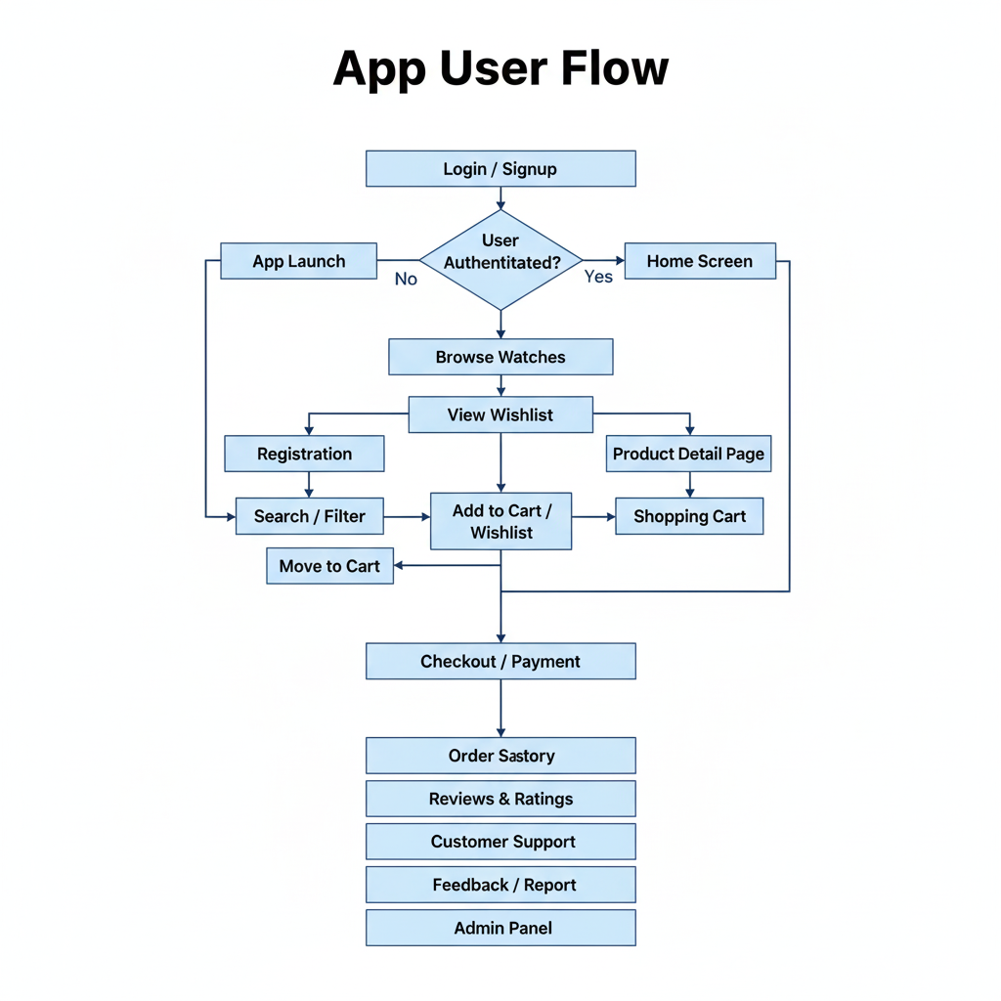
PROGRESS DIAGRAM
Phase | Description | Status
Phase 1 | UI Design & Layout | ✅ Completed
Phase 2 | Firebase Integration | ✅ Completed
Phase 3 | Authentication Setup | ✅ Completed
Phase 4 | Product Module | ✅ Completed
Phase 5 | Wishlist & Orders | ✅ Completed
Phase 6 | Testing & Debugging | ✅ Completed
Phase 7 | Deployment | 🚀 Ready

MODULE DESCRIPTION FOR WATCHHUB APP

APPBAR
The AppBar serves as the main navigation and identity bar of the WatchHub app. It includes the application logo, search icon, and quick access buttons such as the wishlist, shopping cart, and user profile. The AppBar remains consistent across major screens for easy navigation and brand consistency.

HOME PAGE
The Home Page is the main entry screen after login. It showcases featured watches, new arrivals, and trending collections. Users can browse by category, brand, or style directly from this screen. The design emphasizes an elegant layout to attract users and enhance the shopping experience.

SEARCH PAGE (WITH FILTERS)
The Search Page enables users to quickly find watches based on keywords, brands, styles, or price ranges. Integrated filtering options allow users to refine results by brand, type, price, or popularity. Sorting options help users view products based on preferences like “Newest,” “Lowest Price,” or “Top Rated.” This module enhances product discovery and ease of navigation.

ORDER HISTORY PAGE
The Order History Page allows users to view their past purchases and track the status of current orders. Each order entry includes details like order ID, date, total amount, and delivery status. Users can also reorder or view detailed receipts for reference.

SIGNUP & LOGIN PAGE
This module handles user authentication. The Signup screen allows new users to create an account using email and password. The Login screen enables existing users to securely access their accounts. Password recovery and validation features ensure secure and user-friendly authentication.

WISHLIST PAGE
The Wishlist Page enables users to save watches for future purchase. Users can view, remove, or move items from the wishlist to the shopping cart. This module helps users keep track of their favorite products conveniently.

CART PAGE
The Cart Page displays all the selected watches before checkout. It allows users to update quantities, remove items, and view total pricing, including discounts and taxes. The checkout button directs users to the payment process and order confirmation.

PRODUCT DETAILS PAGE
This module displays detailed information about each selected watch. It includes high-quality images, specifications, brand details, and pricing. Users can also view reviews, check availability, and add the item to their cart or wishlist.

SEARCH & FILTER PAGE
This module provides robust search and filtering capabilities. Users can search for specific watches by brand, type, or price range. Filters help refine results based on preferences, popularity, or discounts, ensuring a smoother product discovery experience.

PROFILE PAGE
The Profile Page allows users to manage their personal information, shipping addresses, and contact details. It also displays user preferences and account settings. Users can access order history and manage saved addresses from this page.

CUSTOMER SUPPORT / FAQ PAGE
This module offers users access to customer support and commonly asked questions. Users can contact support through a chat system or form submission and view helpful FAQs related to orders, payments, and delivery policies.

ADMIN PANEL PAGE
The Admin Panel is designed for application administrators. It provides tools to manage product listings, view user data, handle reviews, and process orders. Admins can also monitor feedback and update inventory directly from this module.

DATABASE STRUCTURE (FIRESTORE)
This module uses Google Firestore for real-time data management. It maintains structured collections such as Users, Products, Orders, Wishlist, and Reviews. Firestore ensures instant synchronization across devices, secure data handling, and scalable cloud storage.

DART FILES
File | Purpose
main.dart | App entry point
home_screen.dart | Main UI for home page
product_detail_screen.dart | Displays product details
wishlist_screen.dart | Shows user wishlist
cart_screen.dart | Displays items ready for checkout
auth_service.dart | Handles Firebase authentication
firebase_service.dart | Handles Firestore operations

DATABASE
Uses Firebase Firestore for storing user data, reviews & ratings , products, wishlist, and orders.
Collection | Description
users | Stores user profiles
products | Stores product data
orders | Tracks user orders
wishlist | Saves user wishlist items
Reviews | Track user reviews
Ratings | Track user ratings

SCREENSHOTS

• Splash Screen:
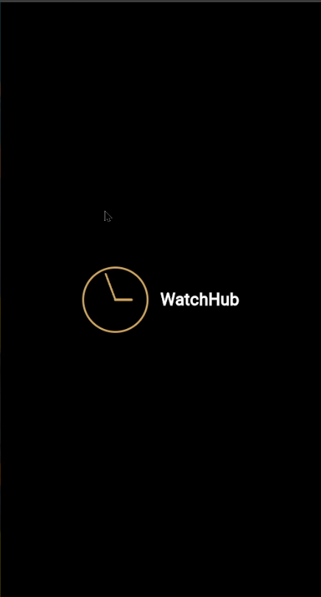
• Login / Signup Page:
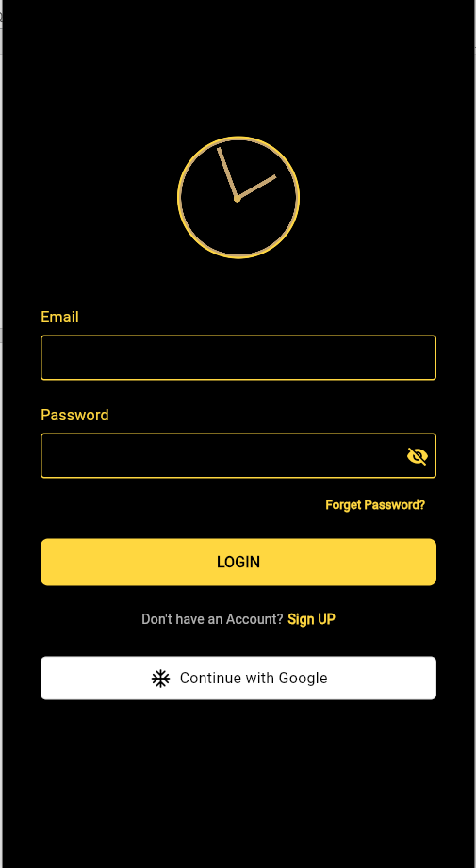
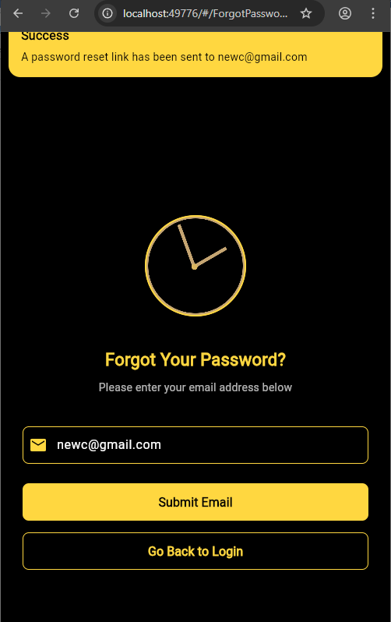
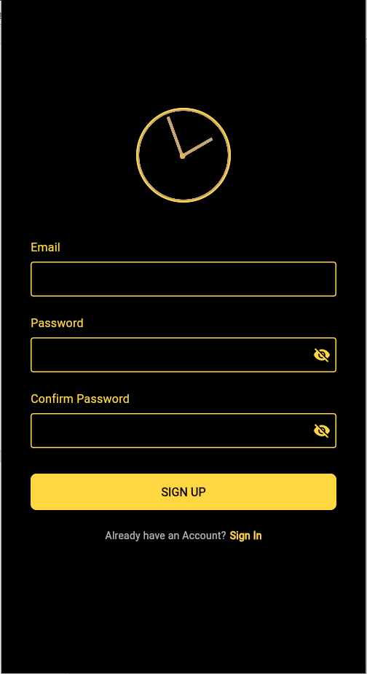
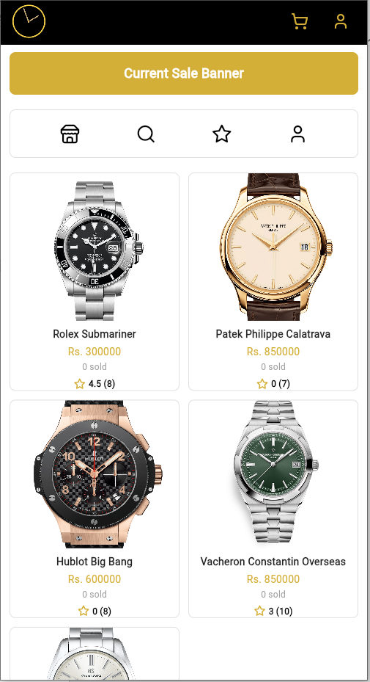
• Home Page with Watch Listings:
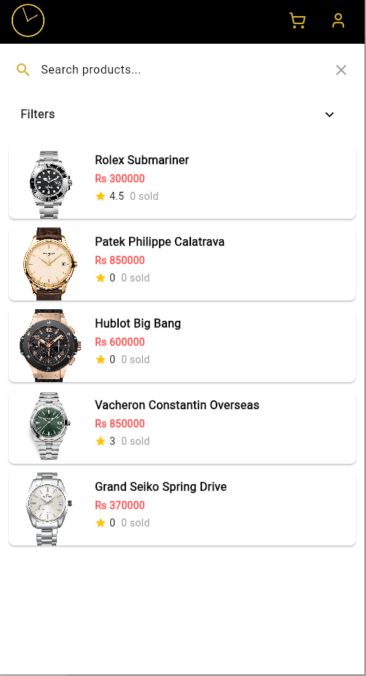
• Search Page:
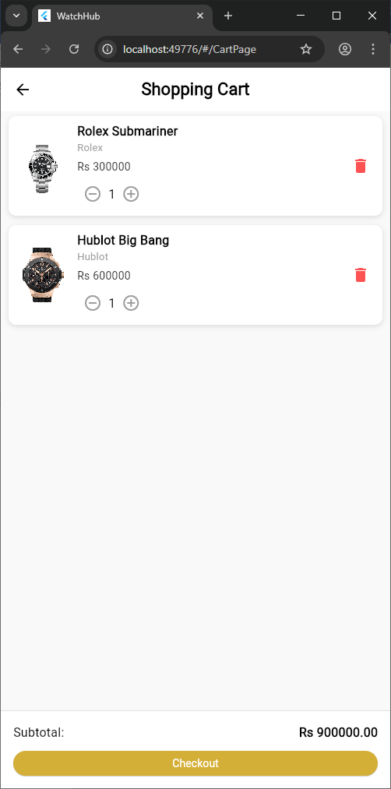
• Cart and Checkout Page:
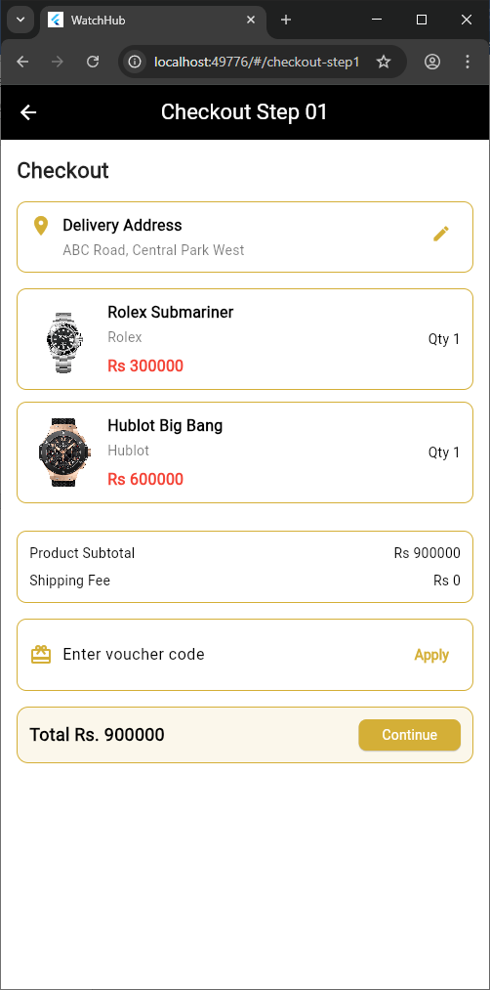
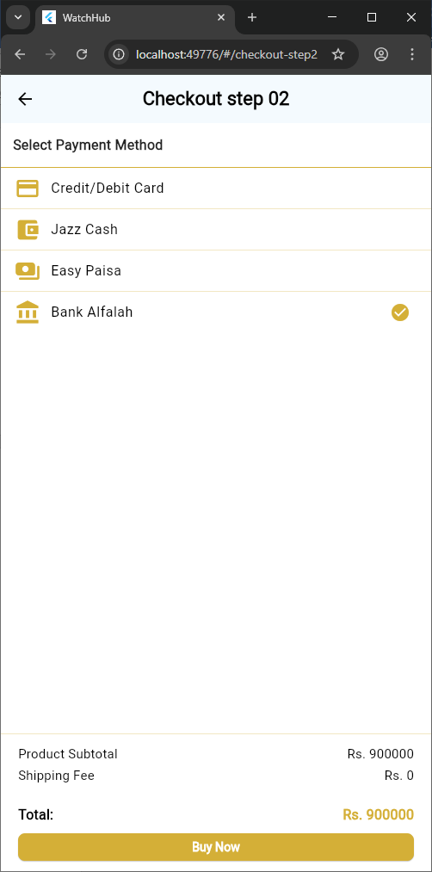
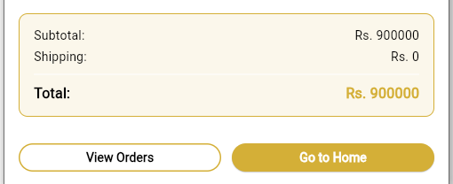
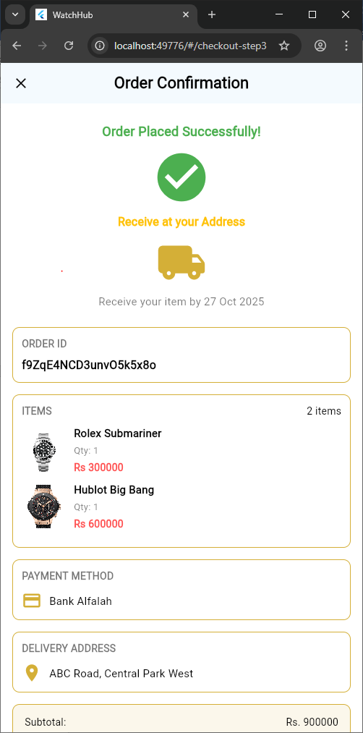
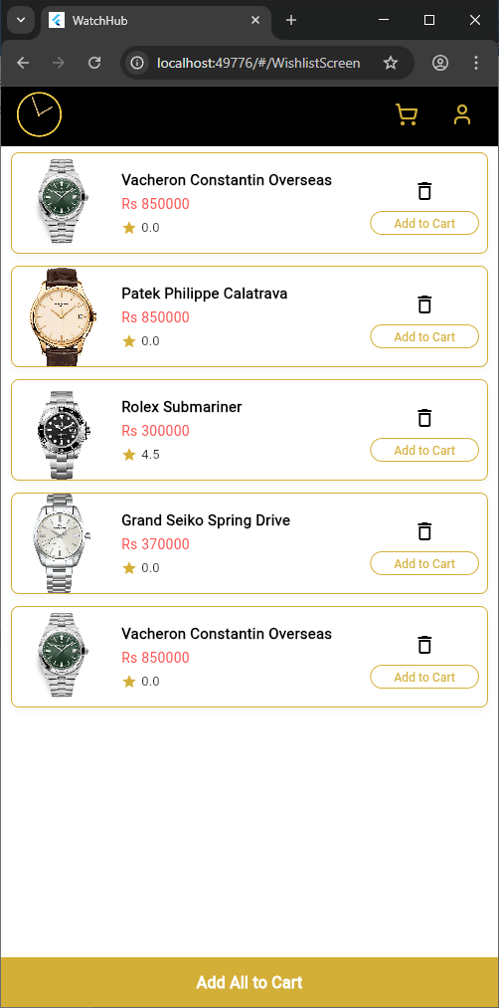
• Wishlist Page:
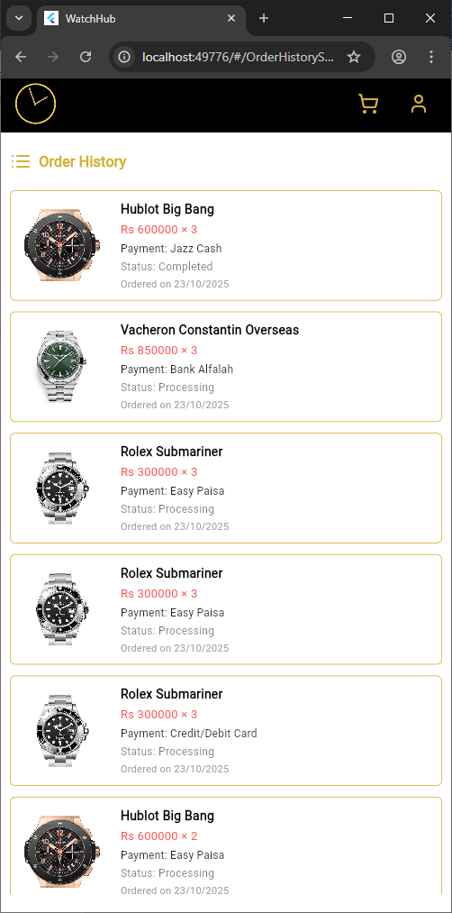
• Order History Page:
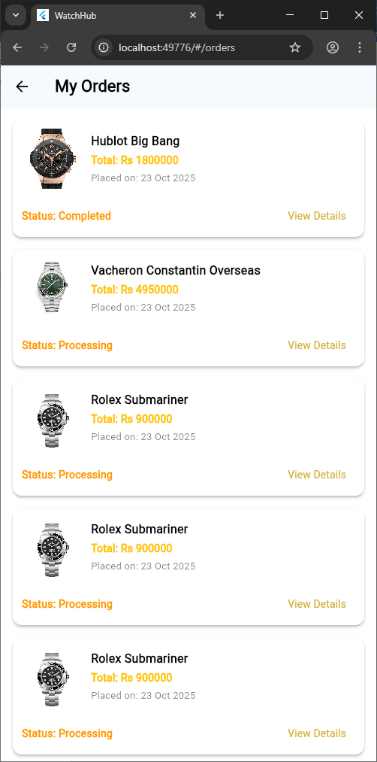
- Orders Page:
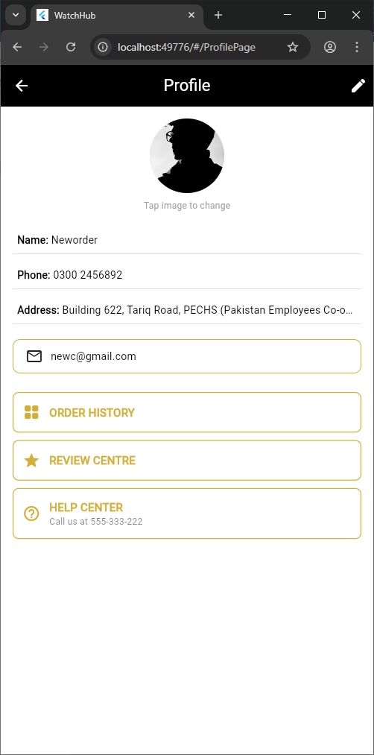
- Profile page
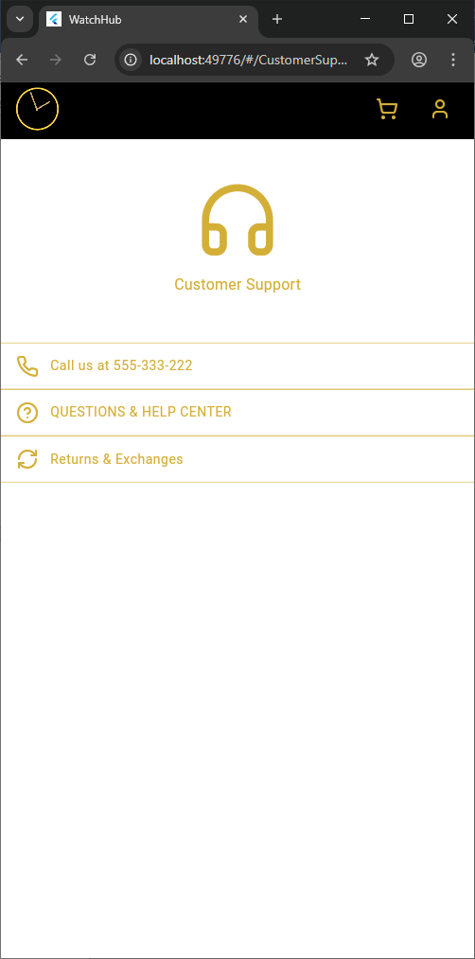
- Customer support page
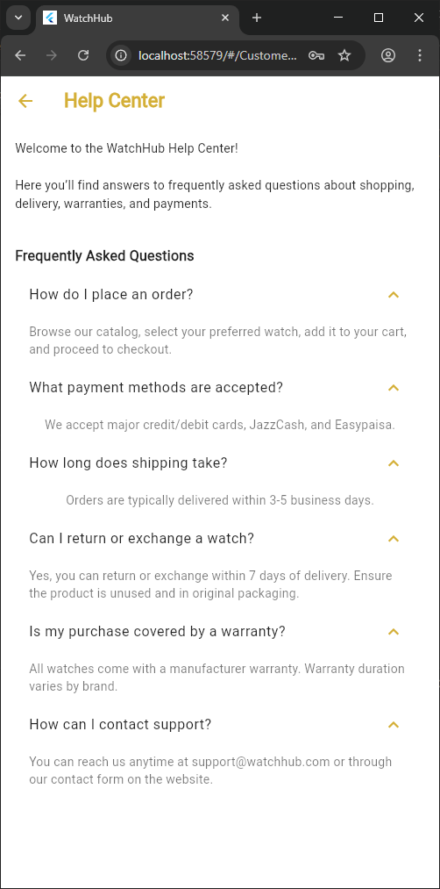
- Questions and help center :
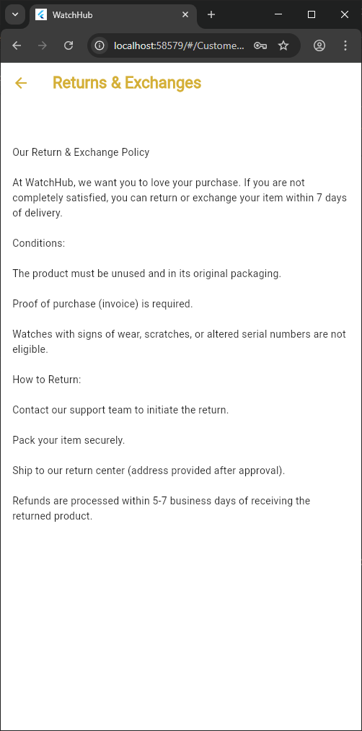
- Return & exchanges

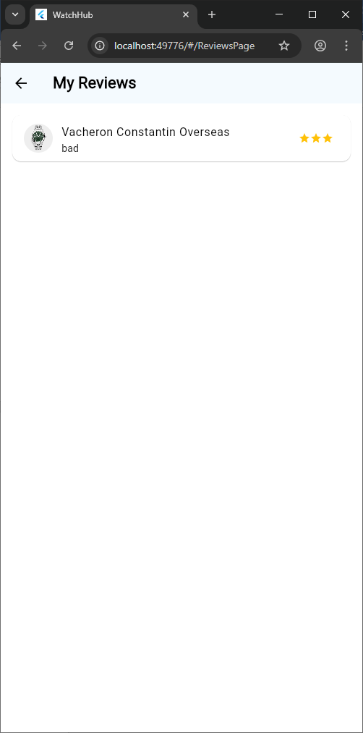
- Reviews page

- Product details page
