Inventory Management System (IMS) Database Design

Author: Muhammad Bilal
bilalmubeen99@gmail.com

Abstract
This project presents the comprehensive design and implementation of a robust Inventory Management System (IMS) database aimed at optimizing stock control, supplier relations, and transaction tracking. To ensure maximum data integrity and minimize redundancy, the relational schema was rigorously normalized to Boyce-Codd Normal Form (BCNF). The system architecture encompasses seven core entities, including Products, Categories, Suppliers, Customers, Stock Transactions, Returns, and Purchase Orders, organized through strategically defined one-to-many and one-to-one relationships.
Implementation was carried out using SQL, featuring advanced database objects such as multi-table joins for complex data retrieval, nested sub-queries for analytical insights, and specialized Views for real-time monitoring of stock levels and return summaries. Furthermore, the system incorporates Stored Procedures with built-in transaction management and rollback capabilities to guarantee atomicity during critical operations like stock updates and price adjustments. The resulting database provides a scalable and efficient foundation for enterprise-level resource planning and data-driven decision-making.

Keywords
Database Management Systems (DBMS), Relational Database Design, Boyce-Codd Normal Form (BCNF), Data Normalization, Inventory Control, SQL, Stored Procedures, Data Integrity, Entity-Relationship Diagram (ERD), Transaction Management.

Table of Contents
1. Introduction 3
2. Objectives of the IMS Database 3
2.1. Efficient Stock Management: 3
2.2. Supplier Management: 3
2.3. Customer Tracking: 3
2.4. Data Integrity: 3
2.5. Scalability: 3
3. Deliverables 3
4. Entities and Their Attributes 3
4.1. Products 3
Attributes: 3
4.2. Categories 4
Attributes: 4
4.3. Suppliers 4
Attributes: 4
4.4. Stock Transactions 4
Attributes: 4
4.5. Returns 4
Attributes: 4
4.6. Customers 5
Attributes: 5
4.7. Purchase Orders 5
Attributes: 5
5. Database Normalization and BCNF 5
Example of BCNF Compliance 6
6. Relationships Between Tables 6
7. ERD Diagram 7
8. Analysis 7
9. Results 7
10. Discussion on Results 7
11. Conclusion 8
12. Reference 8
13. Screen Shots 8
13.1. Creating Database 8
13.2. Categories Table 9
13.3. Products Table 9
13.4. Suppliers Table 10
13.5. Stock Transactions Table 10
13.6. Returns Table 11
13.7. Customers Table 11
13.8. Purchase Order Table 12
13.9. Categories Data 12
13.10. Products Data 13
13.11. Suppliers Data 13
13.12. Stock Transaction Data 14
13.13. Returns Data 14
13.14. Customer Data 15
13.15. Purchase Order Data 15
13.16. Total Sales 16
13.17. Average Price 16
13.18. Total Stocks 17
13.19. Total Returns 17
13.20. Max Quantity Sold 18
13.21. Total Amount for Purchase Orders 18
13.22. Number of Products Sold by Category 19
13.23. Inner Join: Get product details along with their category information 19
13.24. Left Join: Get all products along with their category details 20
13.25. Right Join: Get all categories and their products 20
13.26. Full Join: Get all products and categories, whether they are related or not 21
13.27. Sub Query: Total Sales for a Product 21
13.28. Sub Query: Average Price for a Category 22
13.29. Sub Query: Total Stock for a Product 22
13.30. Nested Query: Find Products with Price Greater than the Average Price 23
13.31. Nested Query: Find Products in a Specific Category 23
13.32. View: Stock Levels with Product Details 24
13.33. View: Product Returns Summary 24
13.34. Stored Procedure with Transaction and Rollback: Add Stock to a Product 25
Before Updating Dinning Table Stock: 25
After Updating Dinnig Table Stock: 26
Updated Stock: 26
13.35. Stored Procedure with Transaction and Rollback: Update Product Price 27
Before Updating Price Smartphone Price: 27
After Updating Smartphone Price: 28
Updated Price: 28
14. Backup: 28

1. Introduction
An Inventory Management System (IMS) is a crucial tool for businesses to efficiently track, manage, and control their inventory. It ensures proper stock levels, reduces waste, streamlines operations, and enhances decision-making. This document outlines the design of a database for an IMS, adhering to the principles of normalization, particularly Boyce-Codd Normal Form (BCNF).

2. Objectives of the IMS Database
2.1. Efficient Stock Management: Track inventory levels, sales, purchases, and returns.
2.2. Supplier Management: Maintain detailed records of suppliers and streamline purchase orders.
2.3. Customer Tracking: Manage customer information and order history.
2.4. Data Integrity: Ensure accurate, consistent, and normalized data.
2.5. Scalability: Support future business growth and additional features.

3. Deliverables
- A relational database schema designed in BCNF.
- Detailed attributes for each entity.
- Logical relationships between tables.
- Description of normalization applied.

4. Entities and Their Attributes
The database will consist of the following entities:

4.1. Products

Attributes:
- Product_ID (Primary Key)
- Product_Name
- Category_ID (Foreign Key)
- SKU (Stock Keeping Unit)
- Price
- Stock_Level
- Description

4.2. Categories

Attributes:
- Category_ID (Primary Key)
- Category_Name
- Description

4.3. Suppliers

Attributes:
- Supplier_ID (Primary Key)
- Supplier_Name
- Contact_Name
- Phone_Number
- Email
- Address

4.4. Stock Transactions

Attributes:
- Transaction_ID (Primary Key)
- Product_ID (Foreign Key)
- Transaction_Type (e.g., Sale, Purchase, Adjustment)
- Quantity
- Transaction_Date
- Remarks

4.5. Returns

Attributes:
- Return_ID (Primary Key)
- Sale_Transaction_ID (Foreign Key)
- Product_ID (Foreign Key)
- Quantity
- Reason
- Return_Date

4.6. Customers

Attributes:
- Customer_ID (Primary Key)
- Customer_Name
- Phone_Number
- Email
- Address

4.7. Purchase Orders

Attributes:
- Order_ID (Primary Key)
- Supplier_ID (Foreign Key)
- Order_Date
- Expected_Delivery_Date
- Status (e.g., Pending, Completed)
- Total_Amount

5. Database Normalization and BCNF
The following normalization steps ensure the database is in BCNF:
- Eliminate Repeating Groups: Each attribute contains atomic values.
- Eliminate Partial Dependencies: All non-prime attributes depend only on the primary key.
- Eliminate Transitive Dependencies: Non-prime attributes depend directly on the primary key.
- BCNF Compliance: Every determinant is a candidate key.

Example of BCNF Compliance
For the Products table:
- Primary Key: Product_ID
- Non-prime attributes (Product_Name, Category_ID, SKU, Price, Stock_Level, Description) depend solely on Product_ID.
- No transitive or partial dependencies exist.

6. Relationships Between Tables
- Products → Categories: One-to-Many (Each product belongs to a single category).
- Products → Stock Transactions: One-to-Many (A product can have multiple stock transactions).
- Suppliers → Purchase Orders: One-to-Many (A supplier can have multiple purchase orders).
- Customers → Returns: One-to-Many (A customer can make multiple returns).
- Stock Transactions → Returns: One-to-One (Each return is tied to a specific transaction).

7. ERD Diagram
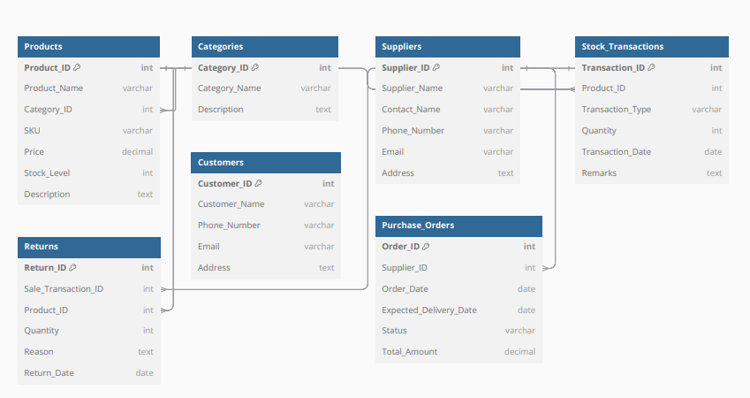

8. Analysis
The database has been normalized to BCNF by ensuring:
- No repeating groups (atomic attributes).
- Non-prime attributes depend only on the primary key.
- All determinants are candidate keys.
- The relationships between entities (e.g., Products, Categories, Suppliers) follow one-to-many and one-to-one associations as necessary.

9. Results
The IMS database design adheres to BCNF principles, ensuring accurate data storage, minimized redundancy, and efficient relationships between tables.

10. Discussion on Results
By normalizing the database to BCNF, data consistency and integrity are enhanced. Redundant information is minimized, and all entities are directly related to the primary key without transitive dependencies.

11. Conclusion
This database design ensures data integrity, scalability, and efficient inventory management. The structure adheres to BCNF principles, reducing redundancy and improving data consistency. The IMS database provides a robust foundation for tracking inventory, managing suppliers and customers, and handling transactions and returns effectively.

12. Reference
- Database Normalization Concepts and Principles.
- BCNF and Database Design Documentation.

13. Screen Shots

13.1. Creating Database
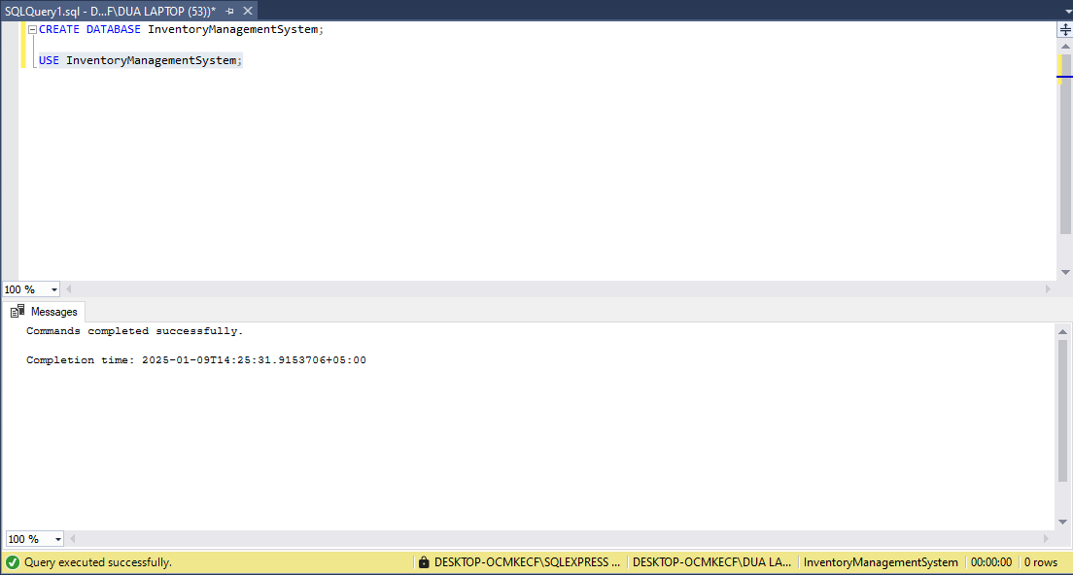

13.2. Categories Table
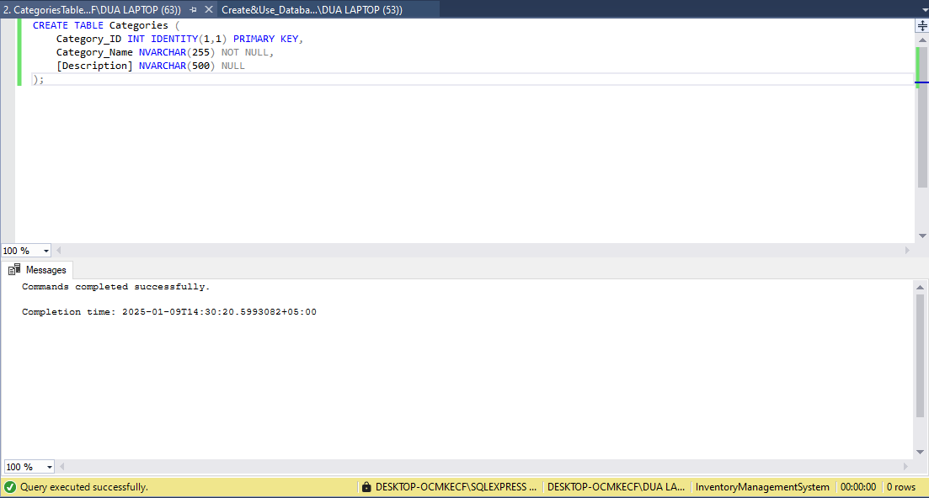

13.3. Products Table
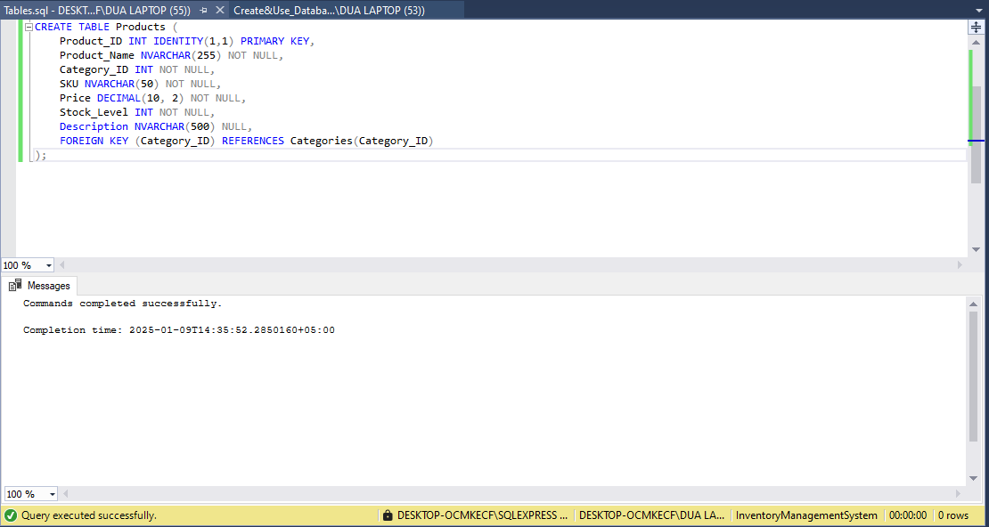

13.4. Suppliers Table
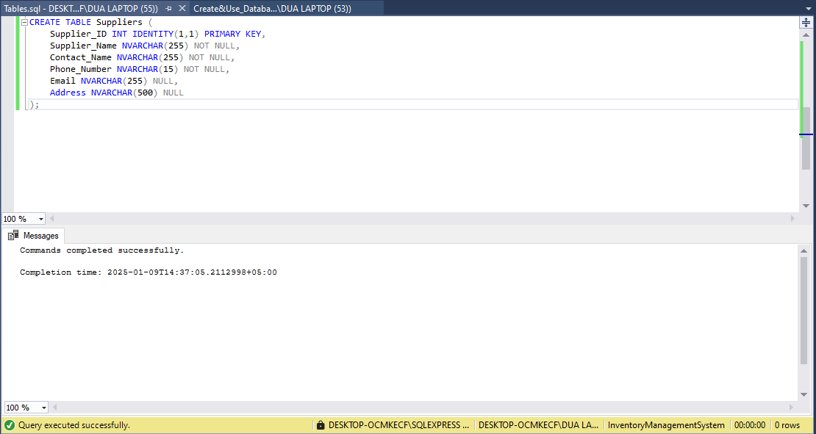

13.5. Stock Transactions Table
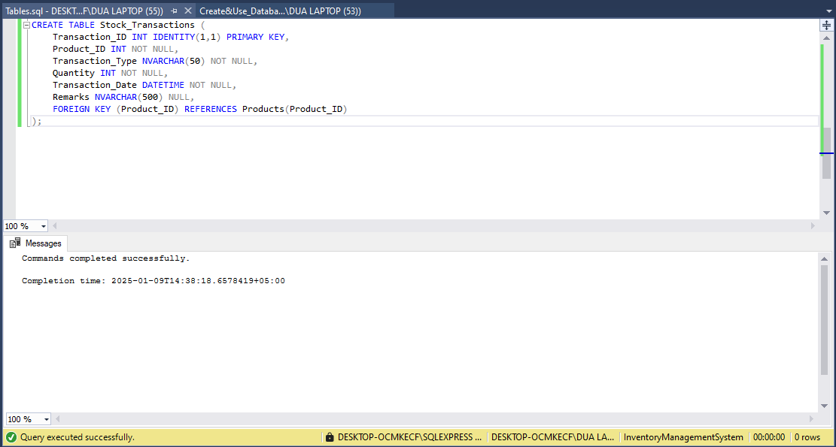

13.6. Returns Table
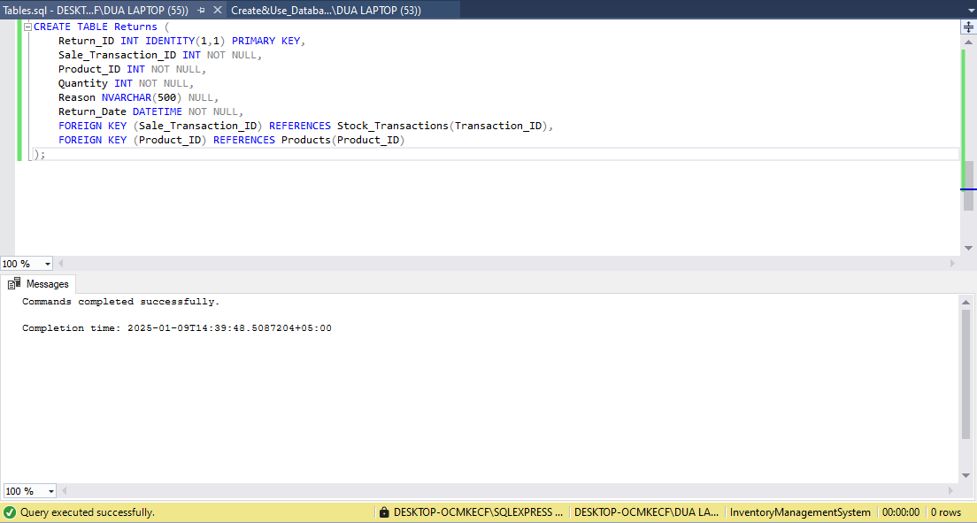

13.7. Customers Table
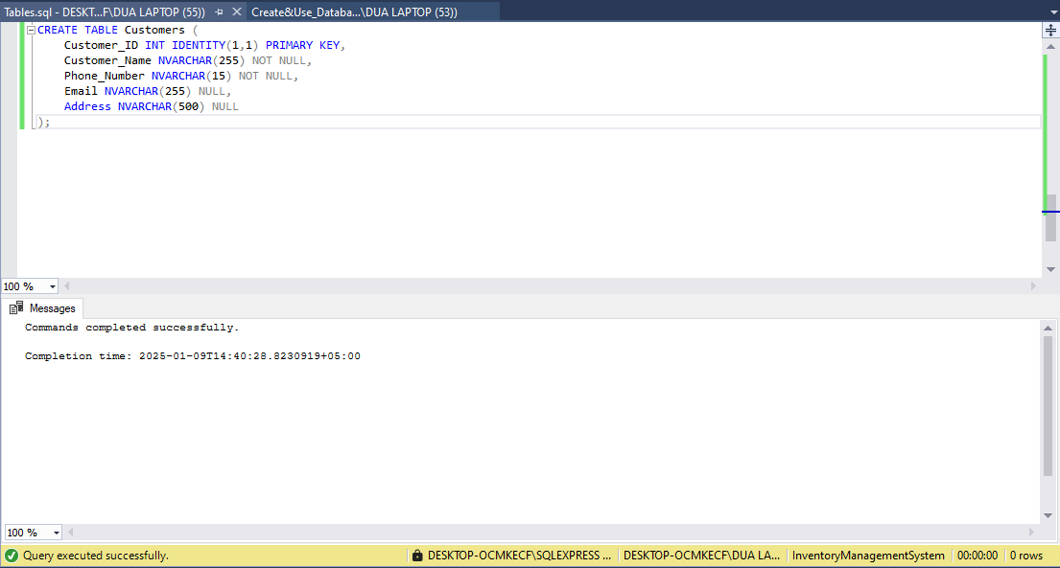

13.8. Purchase Order Table
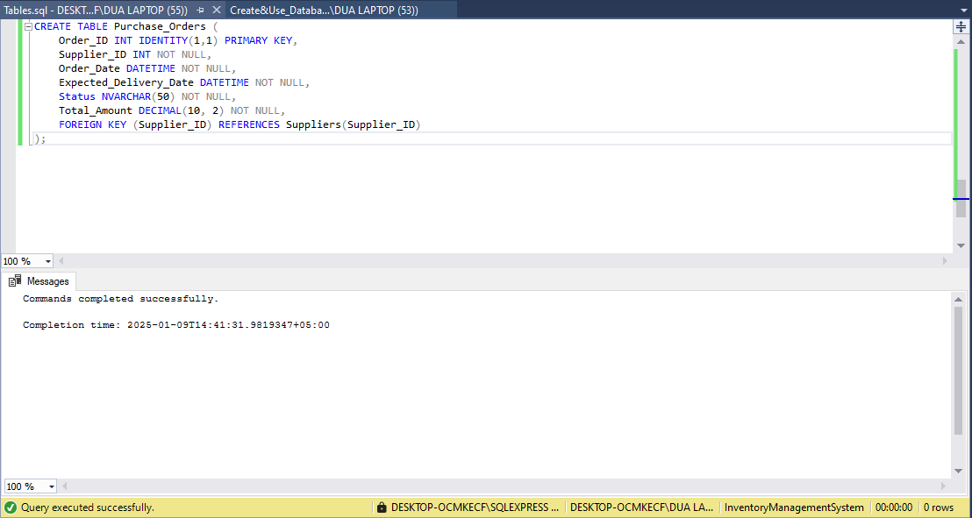

13.9. Categories Data
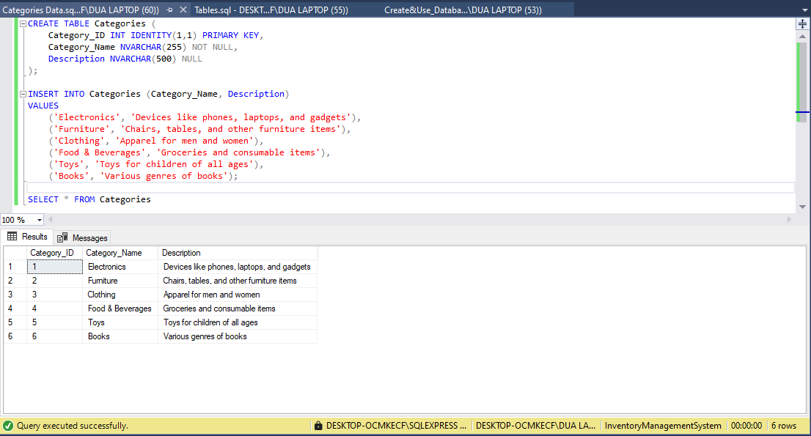

13.10. Products Data
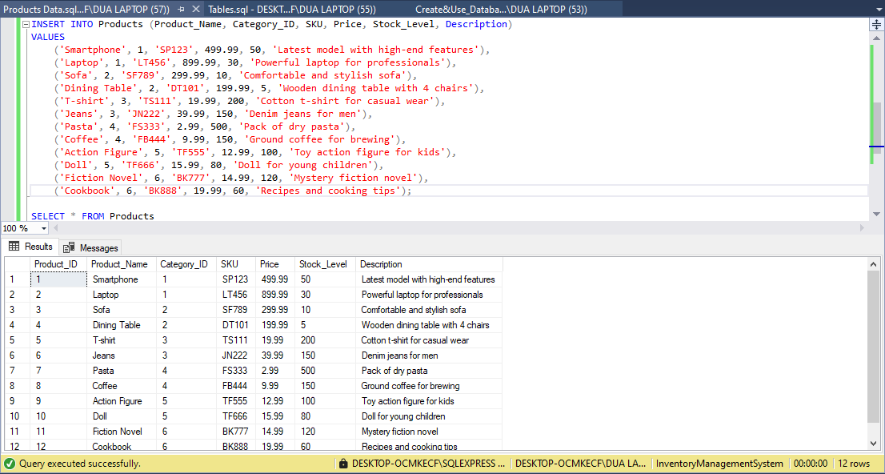

13.11. Suppliers Data
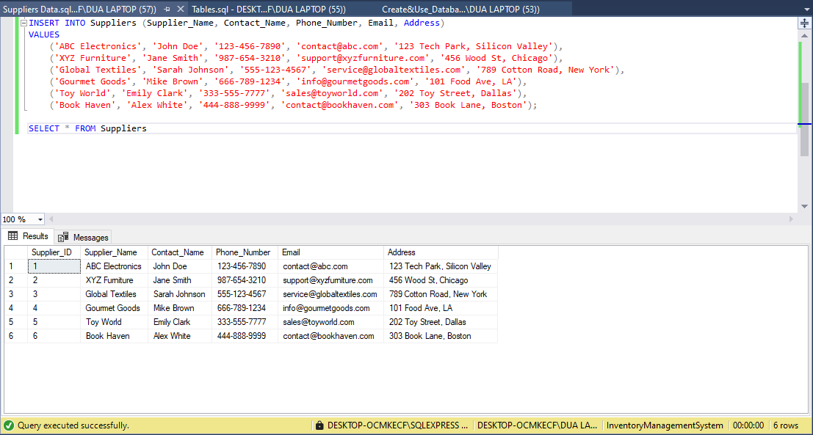

13.12. Stock Transaction Data
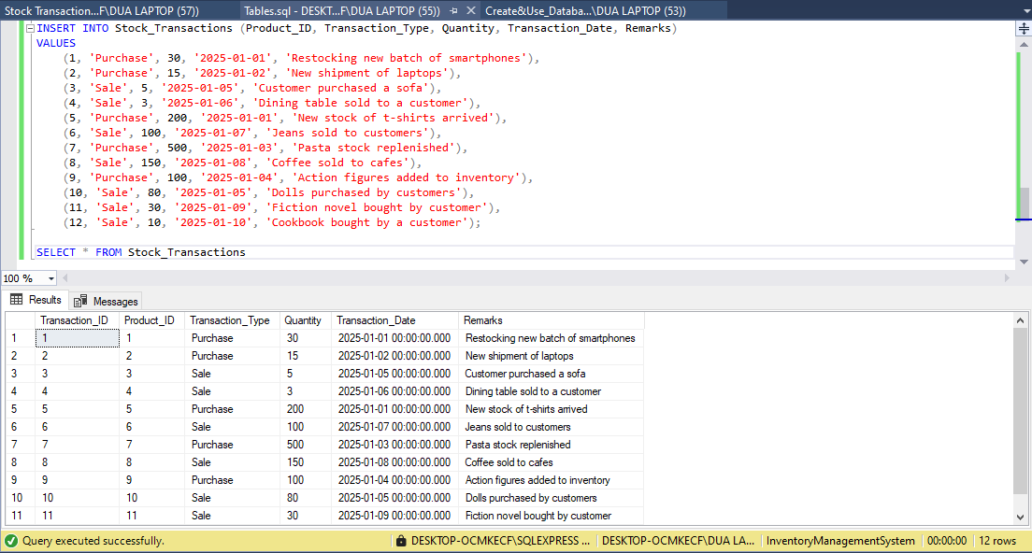

13.13. Returns Data
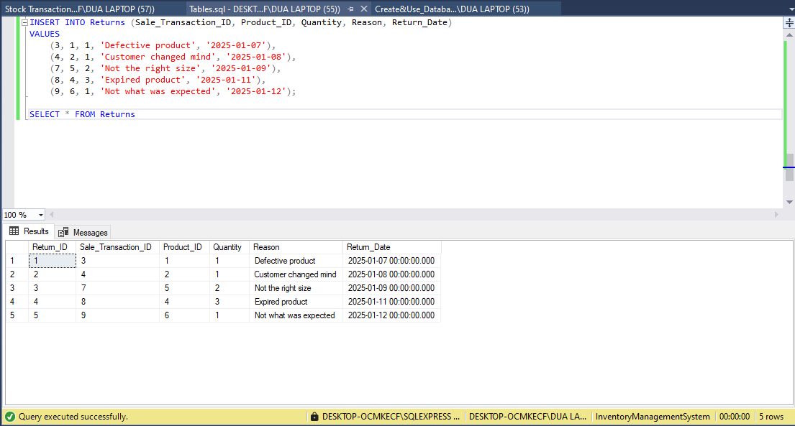

13.14. Customer Data
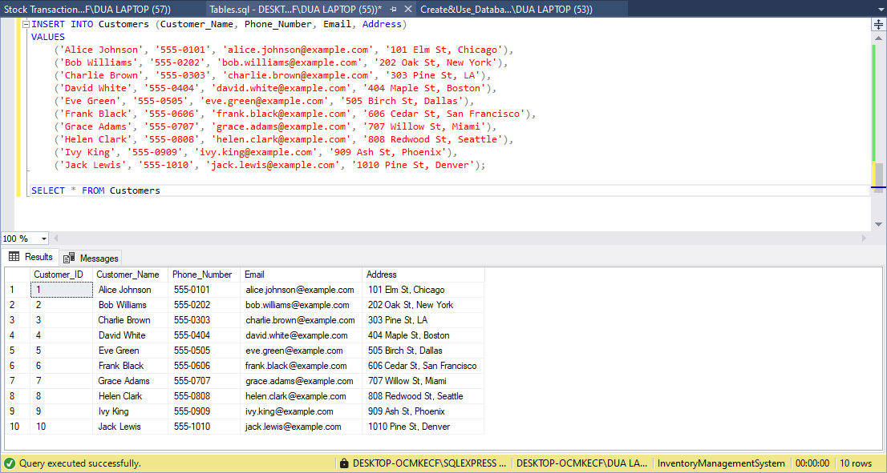

13.15. Purchase Order Data
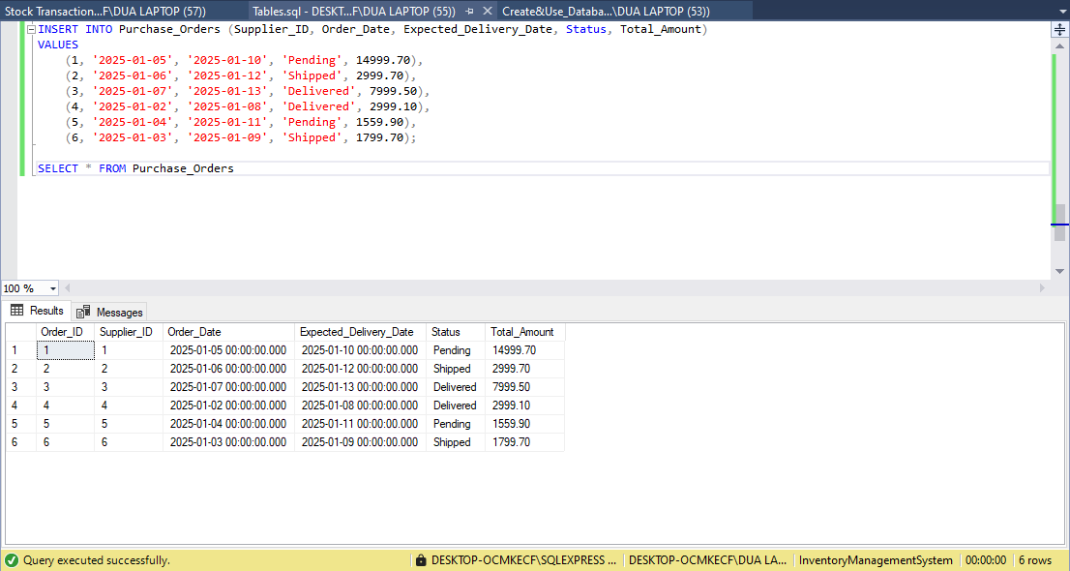

13.16. Total Sales
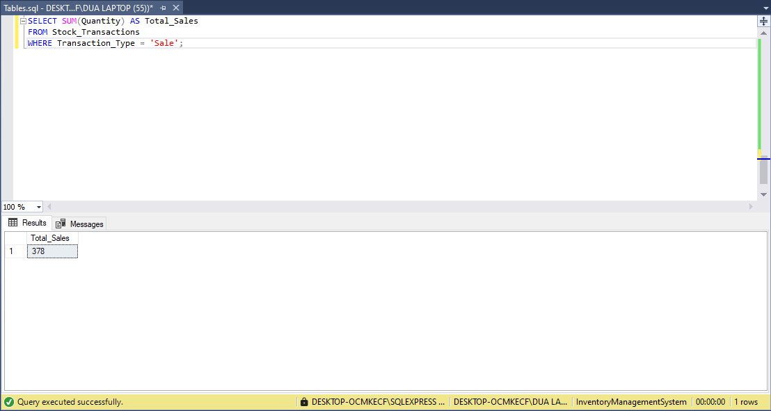

13.17. Average Price
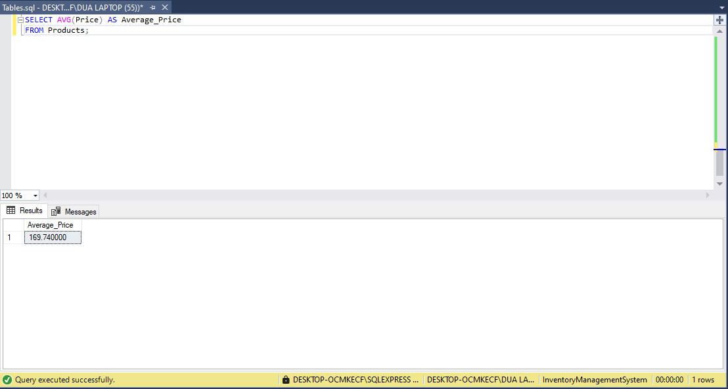

13.18. Total Stocks
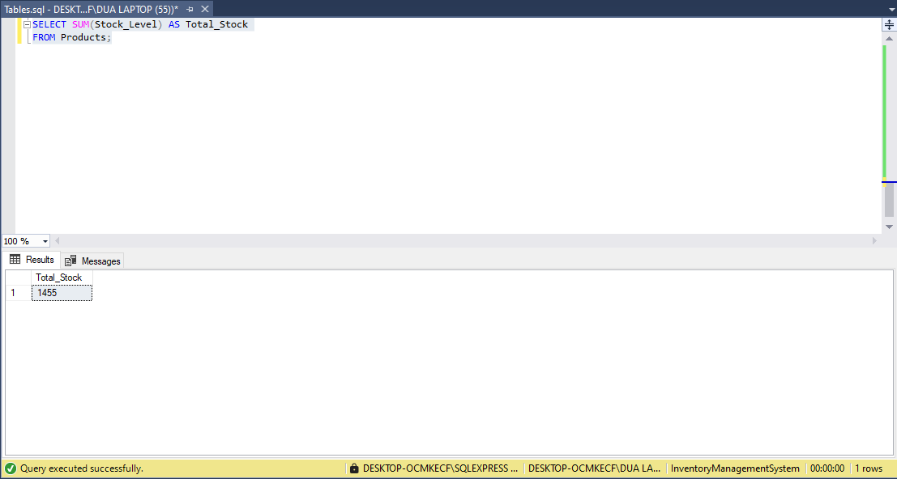

13.19. Total Returns
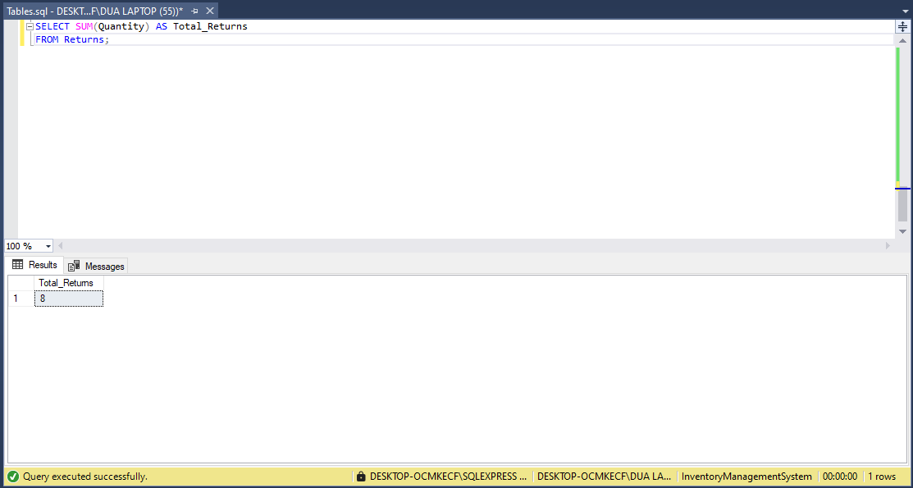

13.20. Max Quantity Sold
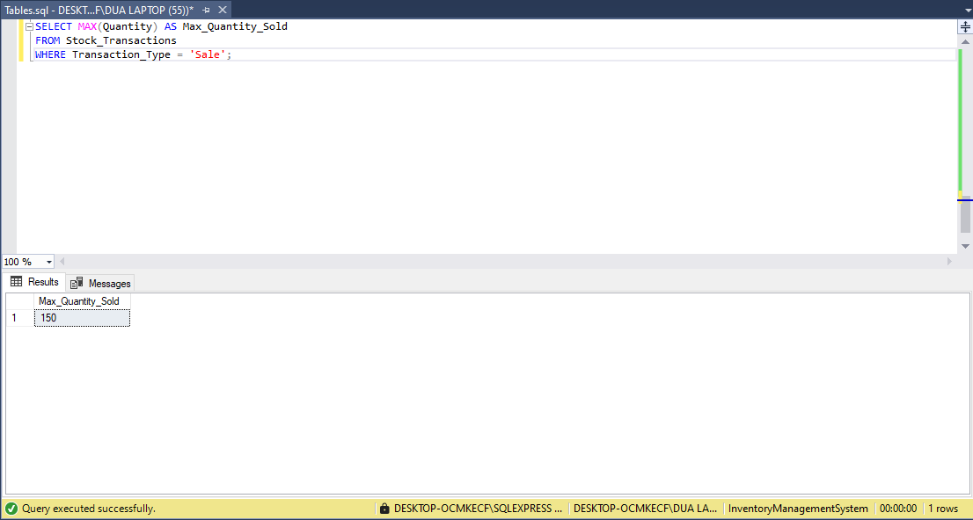

13.21. Total Amount for Purchase Orders
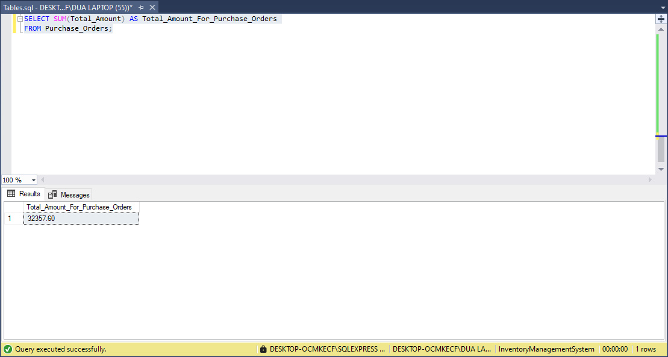

13.22. Number of Products Sold by Category
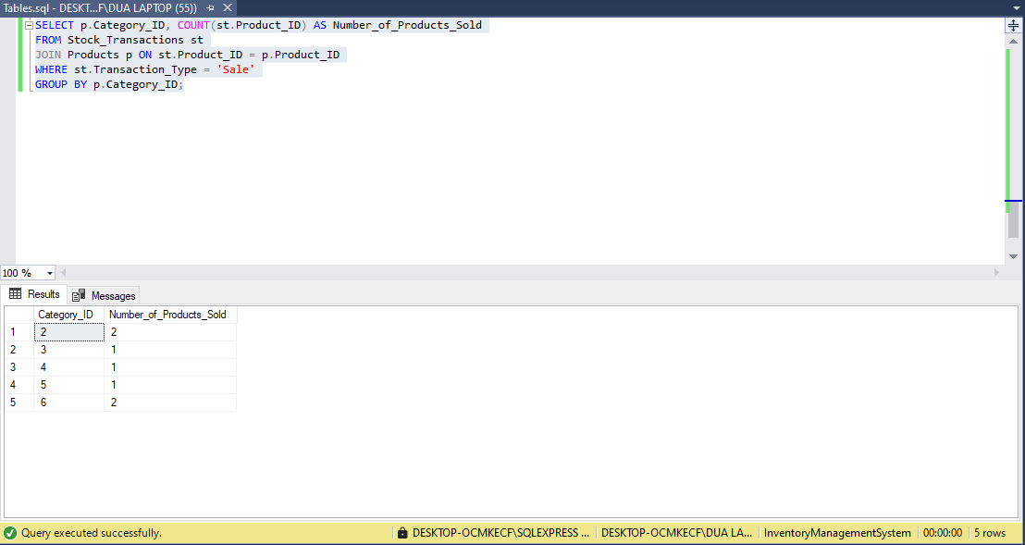

13.23. Inner Join: Get product details along with their category information
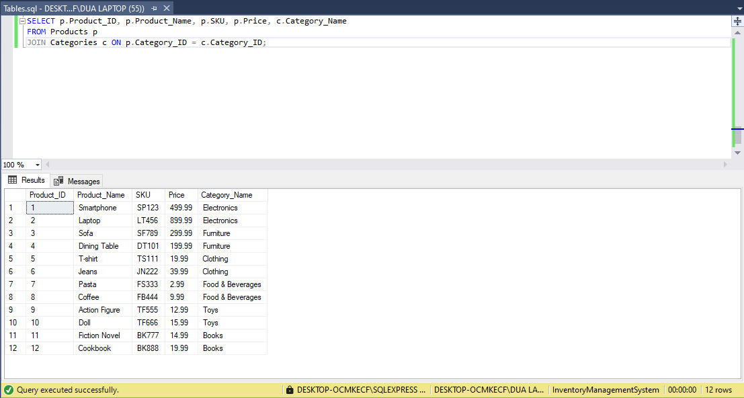

13.24. Left Join: Get all products along with their category details
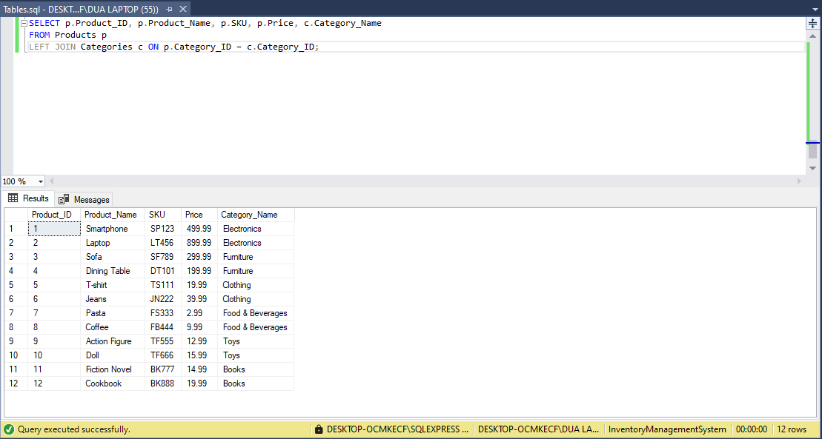

13.25. Right Join: Get all categories and their products
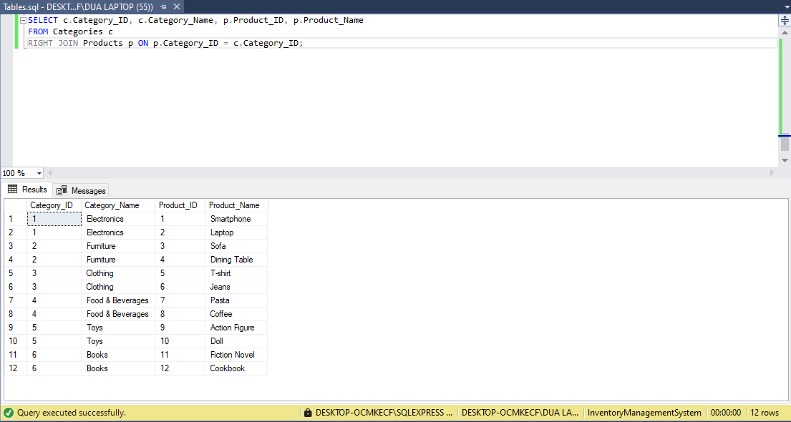

13.26. Full Join: Get all products and categories, whether they are related or not
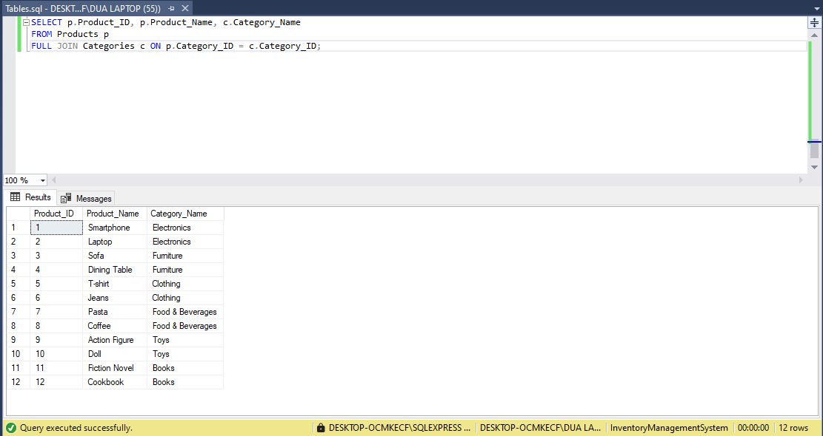

13.27. Sub Query: Total Sales for a Product
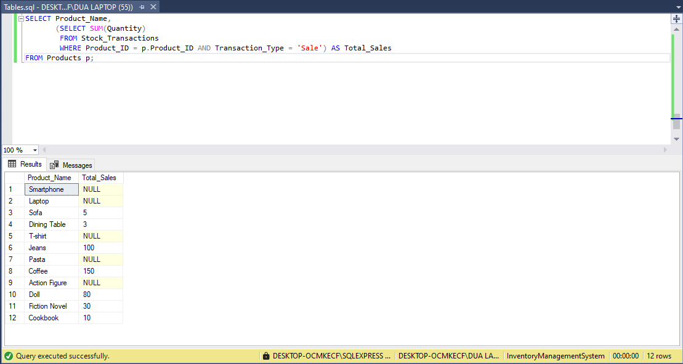

13.28. Sub Query: Average Price for a Category
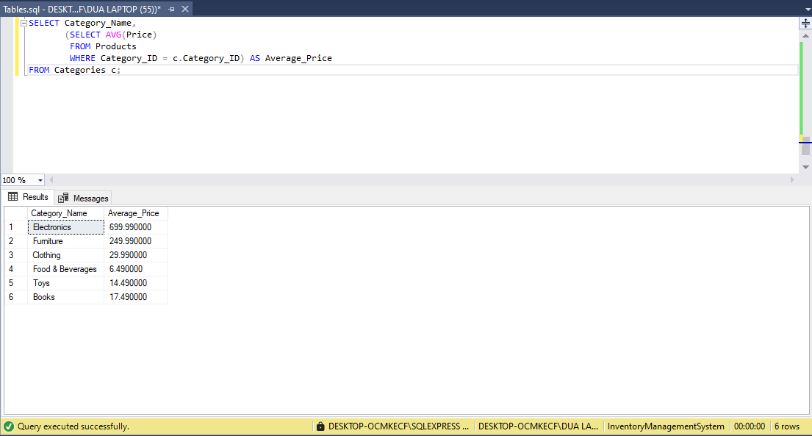

13.29. Sub Query: Total Stock for a Product
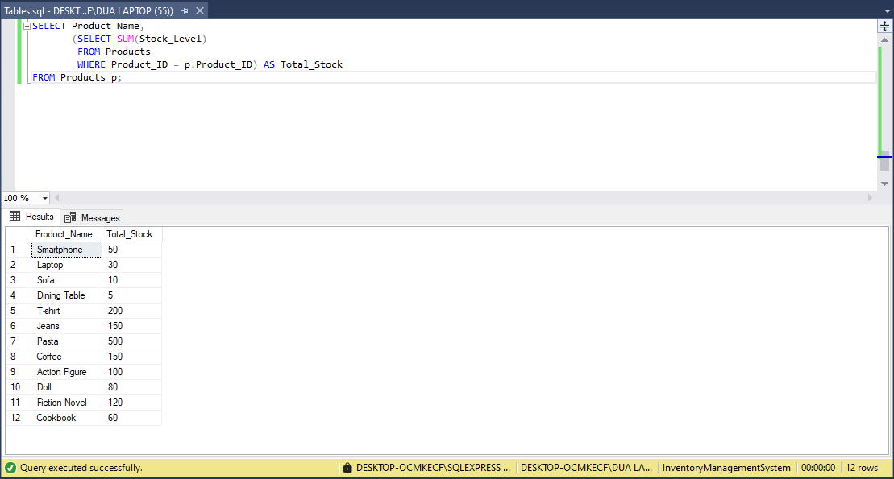

13.30. Nested Query: Find Products with Price Greater than the Average Price
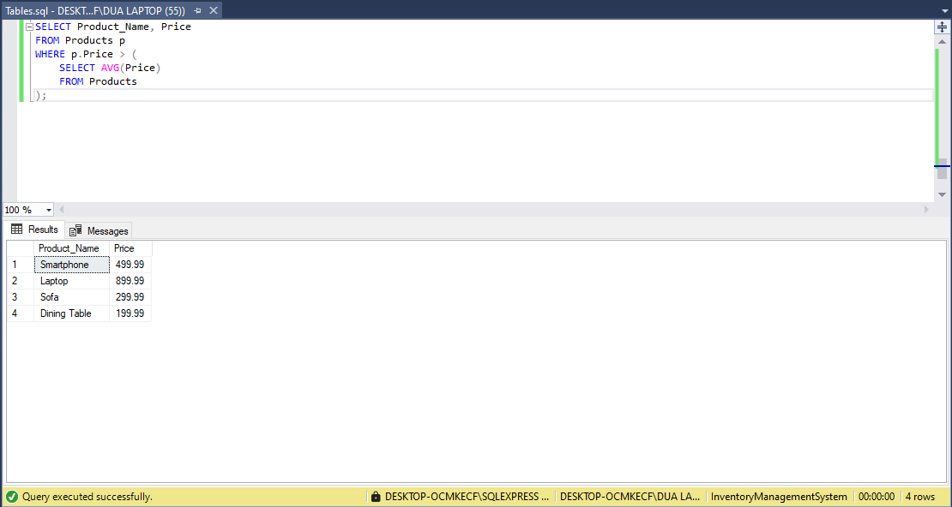

13.31. Nested Query: Find Products in a Specific Category
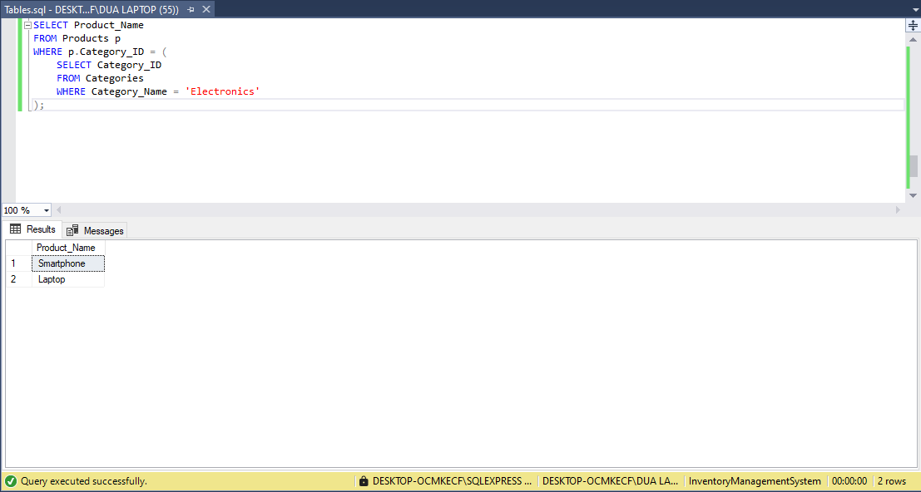

13.32. View: Stock Levels with Product Details
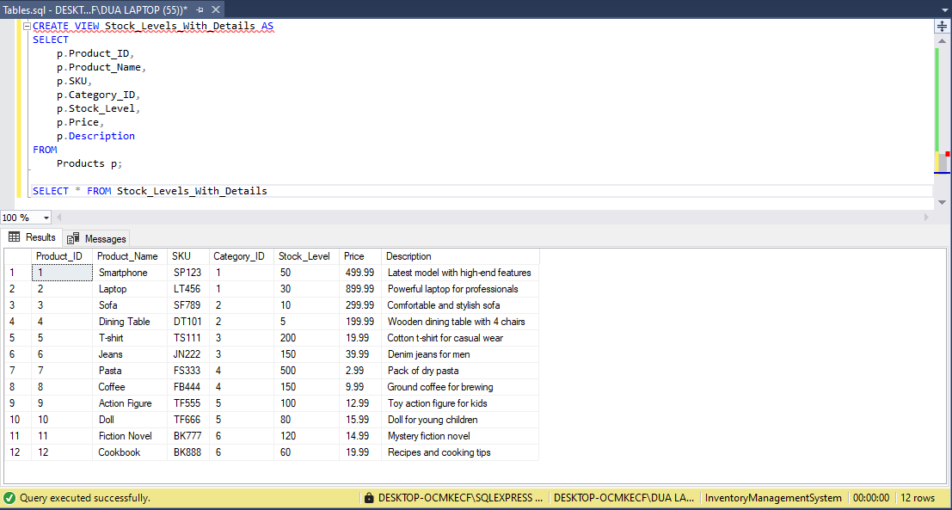

13.33. View: Product Returns Summary
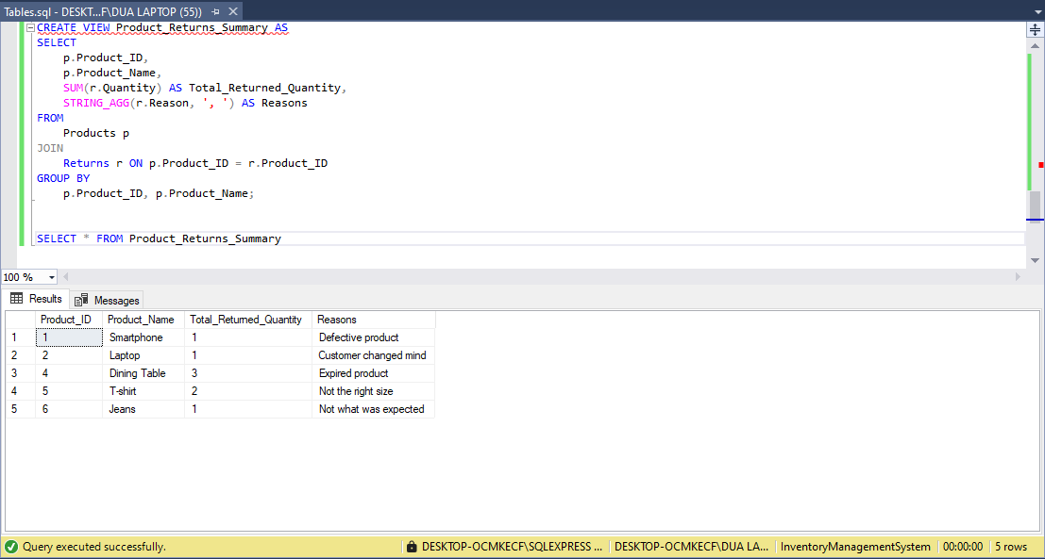

13.34. Stored Procedure with Transaction and Rollback: Add Stock to a Product
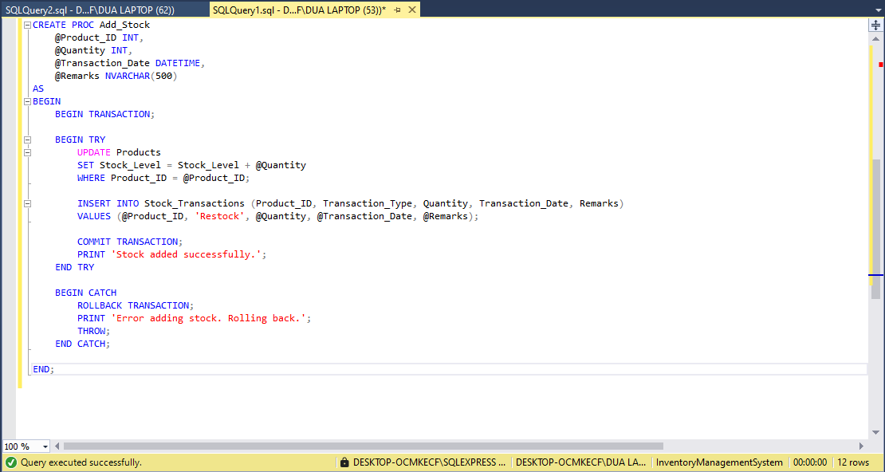

Before Updating Dinning Table Stock:
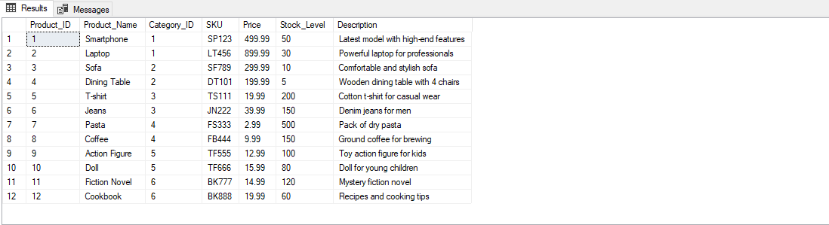

After Updating Dinnig Table Stock:
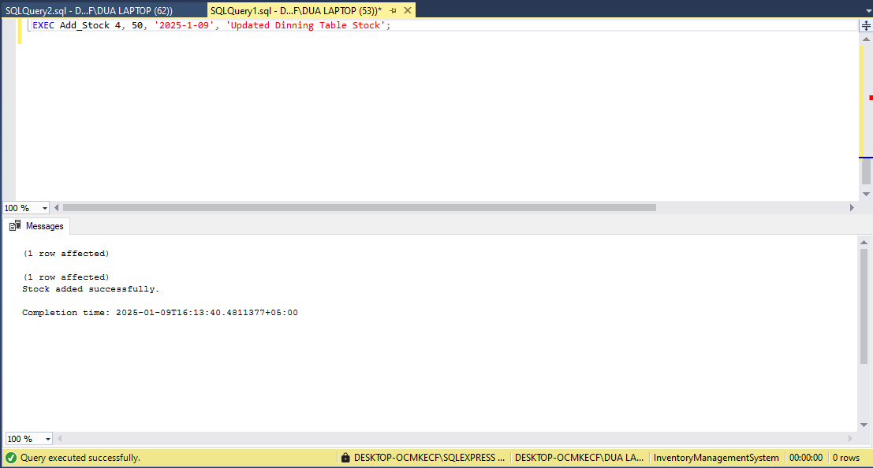

Updated Stock:
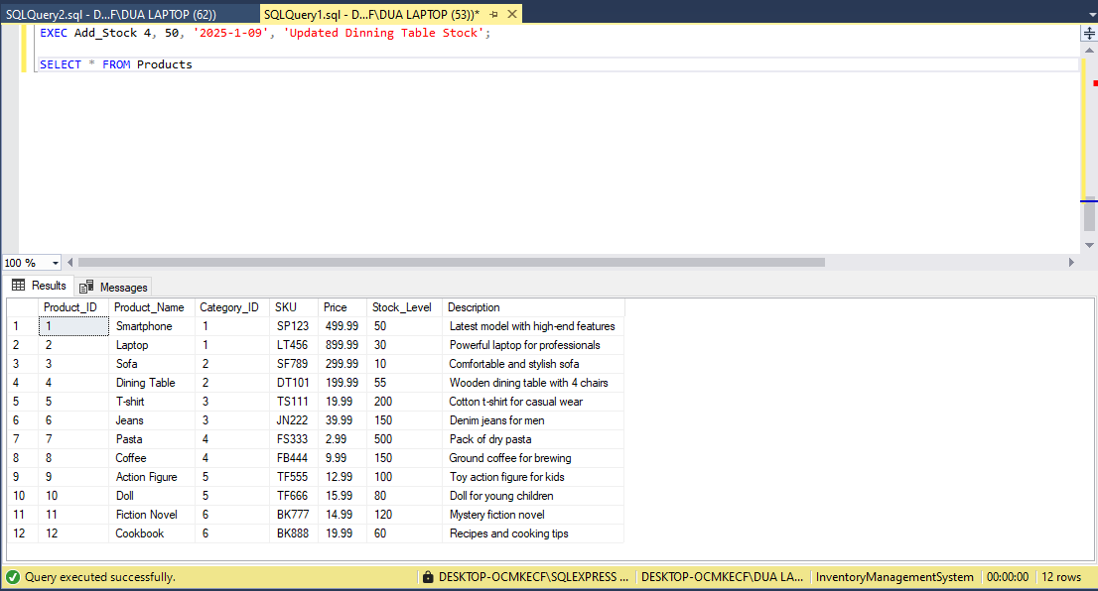

13.35. Stored Procedure with Transaction and Rollback: Update Product Price
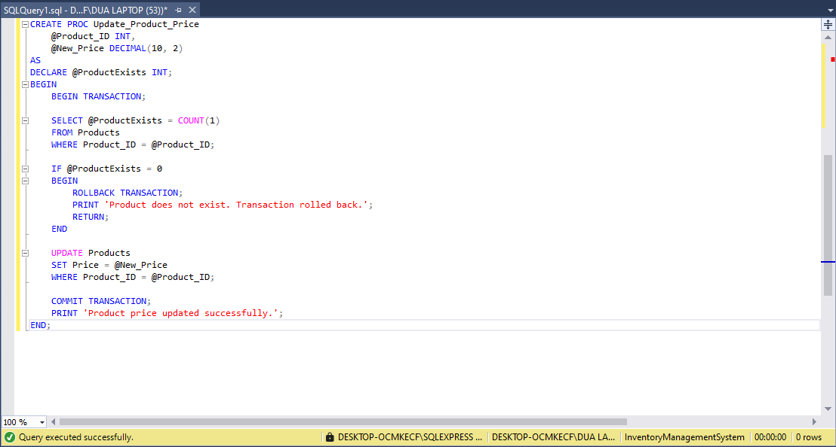

Before Updating Price Smartphone Price:
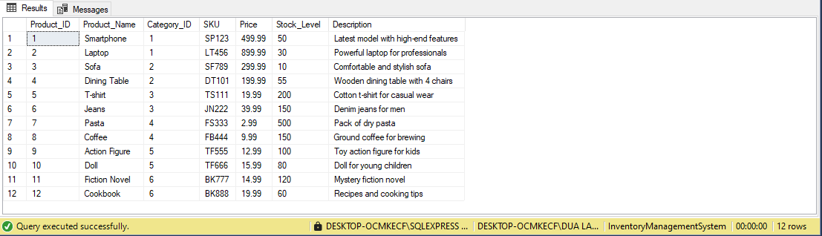

After Updating Smartphone Price:
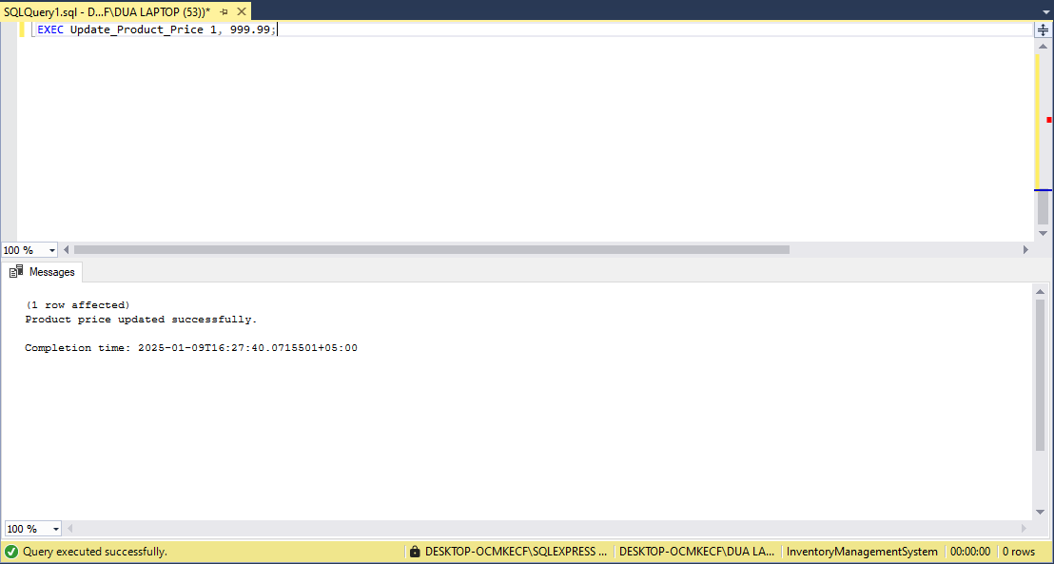

Updated Price:
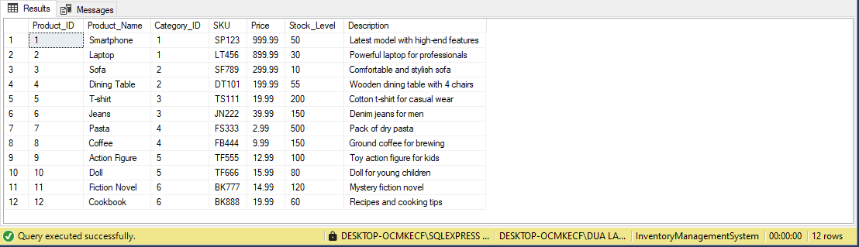

14. Backup:
- InventoryManagementSystem

