|  |
| --- |
|  |

Cairo University

Faculty of Computers and Information

**CS251**

**Software Engineering I**

I Lost It

Software Design

Team Names

|  |  |  |  |
| --- | --- | --- | --- |
| **ID** | **Name** | **Email** | **Mobile** |
| **20160172** | **Amr Mahmoud Hamouda** | **amr.elshakankery@stud.fci-cu.edu.eg** | **01111331075** |
| **20160195** | **Mohamed Anwar Saad** | **m.anwar@stud.fci-cu.edu.eg** | **01122632563** |
| **20160196** | **Muhammed Ayman** | **meldeeb1998@stud.fci-cu.edu.eg** | **01144560665** |
| **20160197** | **Mohamed Gamal Ali** | **mohamad.dapsha@stud.fci-cu.edu.eg** | **01120704784** |

# 

# 

# 

**Document Purpose and Audience**

* This document specifies the Software design specification document for “I lost it “project. It describes scope of the system, both class diagram and sequence diagram for the software, design constraints and system interfaces.

Audience:

* Development Team
* The project manager

# 

# 

# 

# 

# 

# 

# 

# 

# **Class Diagram**

## 

|  |  |  |
| --- | --- | --- |
| **Class ID** | **Class Name** | **Description & Responsibility** |
| 1 | Item | This class is used to identify each item  And insert or delete the item. |
| 2 | User | This class holds The Information of the user of the website. |
| 3 | Post | This class is holds the information of the post of the lost item. |
| 4 | Item_Database | This class is used to identify each item  And responsible for the crud operations in the Database of the Item class |
| 5 | User_Database | This class is used to identify each user  And responsible for the crud operations in the Database of the User class |
| 6 | Post_Database | This class is used to identify each post  And responsible for the crud operations in the Database of the Post class |
| 7 | Validate | This class is used to validate the ownership of the item after any user claiming |
| 8 | Claim | This class is used to claiming the ownership of an item |
| 9 | Notification | This class is used to notify the finder that a user is claiming |
| 10 | Sign up | This class is used to sign up an new user |
| 11 | Sign in | This class is used to sign in a current user |
| 12 | authentication | This class is used to check if user in database or not |

## **II. Sequence diagrams**

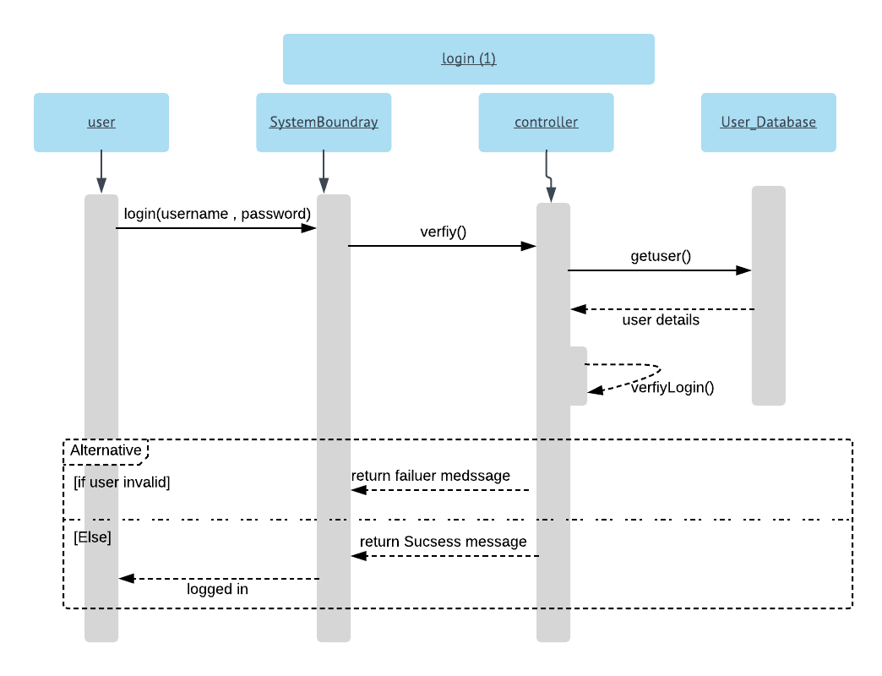

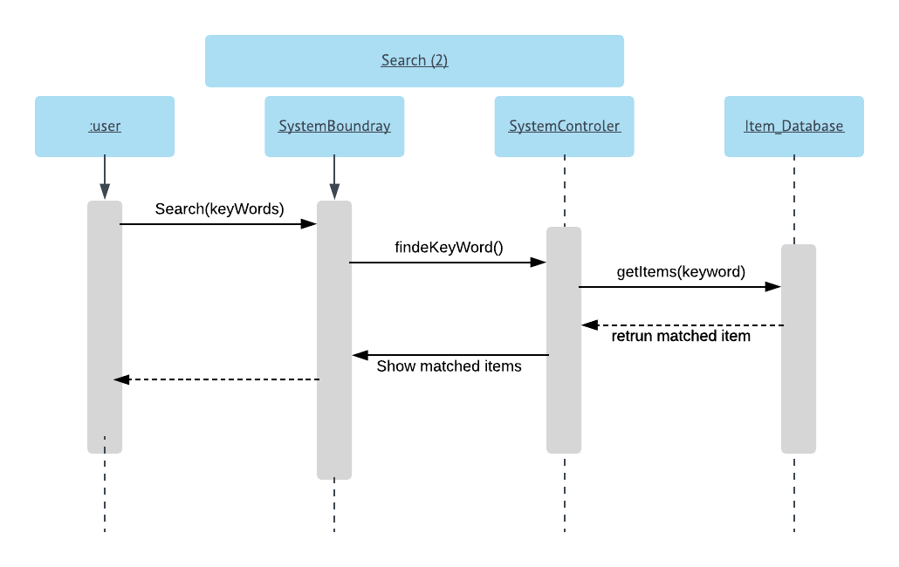

### 

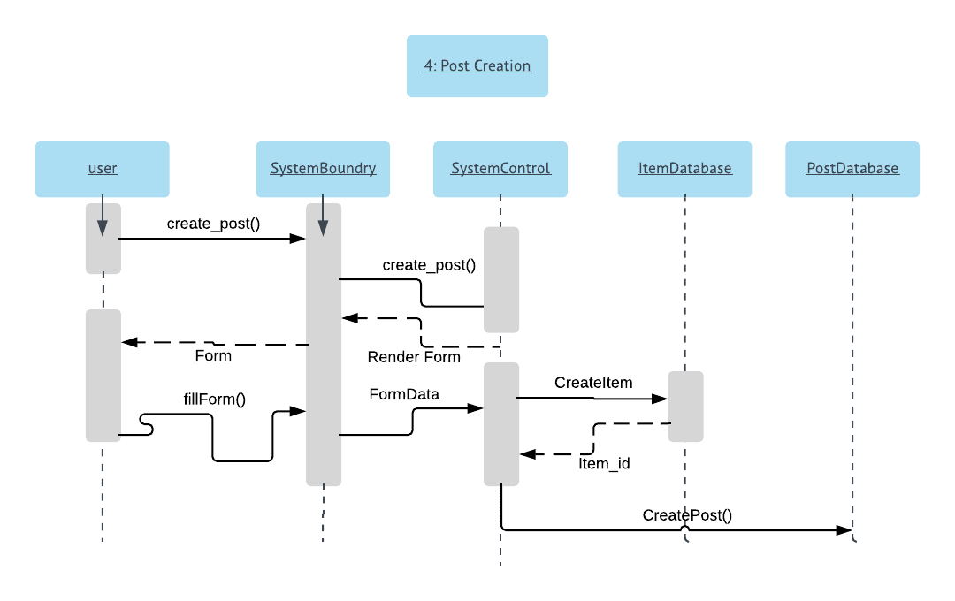

### 

### 

### **Class - Sequence Usage Table**

|  |  |  |
| --- | --- | --- |
| **Class Name** | **Sequence Diagrams** | **Overall used methods** |
| User | 1,2,3,4,5 | Login,logout,post,claim,delete_post,search |
| Item | 2,3,4,5 | create,delete,update |
| Post | 3,4,5 | create,delete,update |

## Link of repo

https://github.com/MuhammdEldeeb/ILostIt