Company X Data Department Report

Executive Summery
Performance and Sales Overview:
- The Consumer segment is the most successful, generating the highest sales and profits .
- Technology stands out as the best-selling and most profitable product category.
- Copiers are the most profitable sub-category, driven by an exceptionally high average profit margin of 31.72%.
- The West region leads to generating the highest profits and the most apparent sales across the evaluated period.

Operational Challenges and Issues:
- The overall ratio of returned orders compared to total orders is 5.9%.
- Office Supplies category is responsible for the majority of returns, accounting for 60.10% of the total returned quantity.
- The returns issue is heavily concentrated in the Binders and Paper sub-categories within the West region, indicating a root problem tied to both the specific products and regional operations.
- A disproportionate 61.25% of all returned orders are linked to a single salesperson,
Anna Andreadi.
- Profitability completely drops into a financial loss whenever the applied discount ratio exceeds 20%.

Introduction & Scope

Analysis Goal
Our goal was to conduct a comprehensive evaluation of sales performance and return dynamics, delivering both macro-level strategic insights for executive decision-making and micro-level diagnostic intelligence for operational optimization.

Analysis Scope
- Salespersons and Returns
- Region & State
- Shipment
- Customers and Segments
- Products and Categories

Data Specification
Data Tables used to conduct our analysis are the following :
- Business Data Set Workbook
  - Returns Table
  - People Table
  - Orders Table
- Shipping Cost Workbook

Descriptive Analysis
Salespersons and Returns
- Who is Salesperson with best sales performance ?
Anna Andreadi has the best Apparent sales performance which performs in the West region.
While Chuck Magee has the Actual best sales when considering returned order’s value which performs in the East region.

- What is the most returned product ?
Ki Adjustable-Height Table from Furniture Category with 156 returned units and Staple Envelope from Office Supplies with 51 returned units are the most returned products.

- What is the ratio of returned orders to total orders?
Ratio of Retuned Orders to all Orders is 5.9% .

- What is the ratio of returned products from each category?
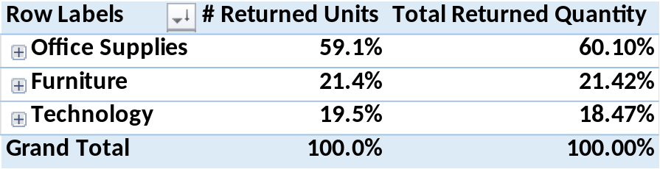
Office Supplies Category have the most returned orders.

- Show ratio distribution of retuned orders across Salespersons
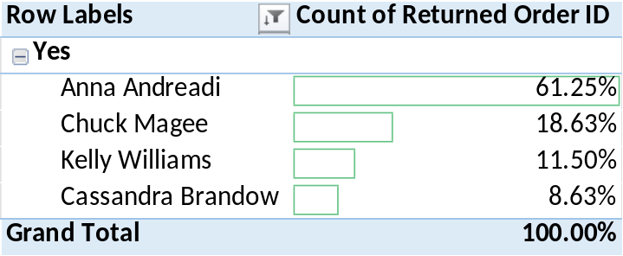
Anna Andreadi is salesperson with most returned orders .

Region & State
- Show sales expansion in each region across time
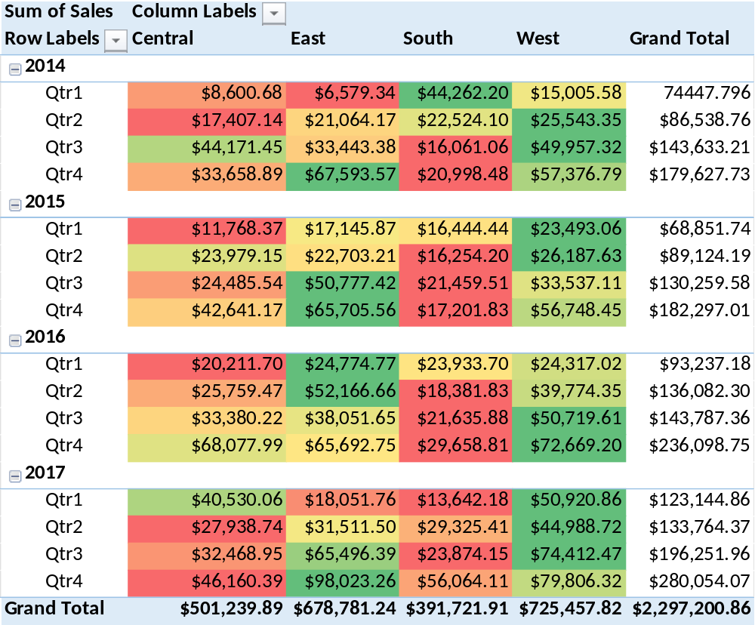

West Region is having most sales across time period of 2014 – 2017 without considering the retuned orders value.

- What region has most sales and makes most profits
East Region has the best sales with considering the retuned orders value.
While West Region is the most profitable Region.

- What are the most selling cities and states
California state has the best sales, while New York is the most profitable State.
New York City has the best sales, and also is the most profitable.

Shipment
- which shipment mode is mostly used ?
Slandered Class is the most used Shipping mode .
Same Day Class is the least used Shipping mode .

- What is the average shipping period ?
Average Shipping Period is 4 Days.

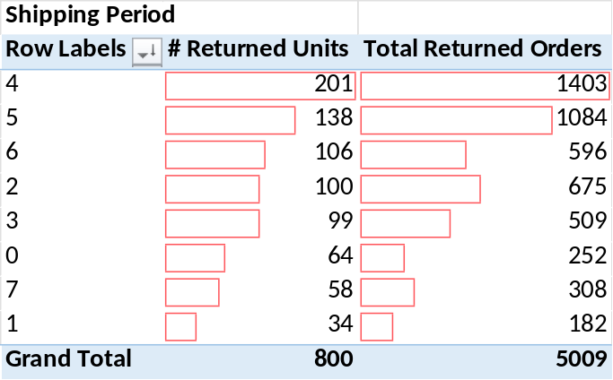
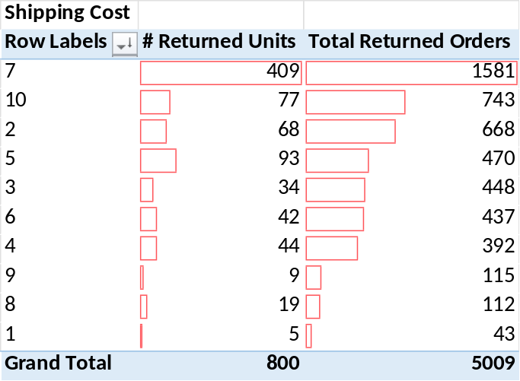
- Is there a relation between shipping period/Shipping cost and number of returned items ?

Most Retuned orders have a 7-dollar shipping cost per unit and shipping period between 4-5 days.

Customers and Segments
- who are the best customers ?
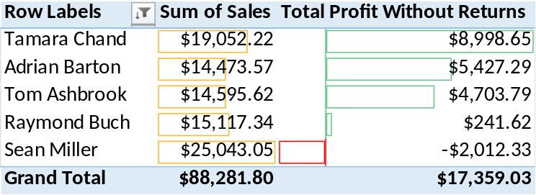

Although Sean Miller is creating best sales, he is creating a loss margin .
While Tamara Chand is the 2nd position in making best sales, She is creating the best profits .

- What is sales distribution across customer segments ?
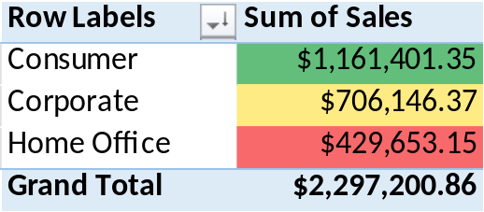
Consumers Segment is making best sales and best profits .

- Which customer segments get more discounts
Consumers segment gets the highest discount rates.

Products and Categories
- Which Category and Sub- Category are best-selling ?
Technology is the best-selling category with $763,445.86 Net Sales and also, it’s the most Profitable Category with total profit of $131,457.60 .
Phones are the best-selling sub-category, while Copiers are the most profitable Sub-Category .

- What is the impact of discounts on Profit Margin

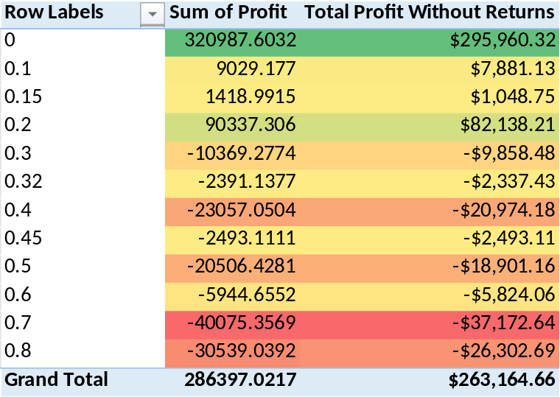
Profitability turns into a loss when discount ratio is higher than 20%.

- Show most profitable products
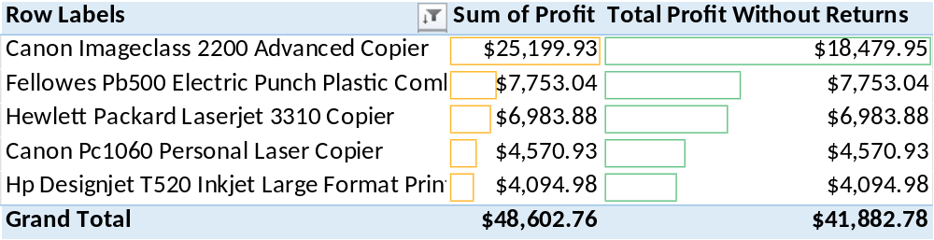
Canon Image class 2200 Advanced Copier from Electronics Category and Copiers Sub-Category is the most profitable product.

- Show products with most quantity ordered
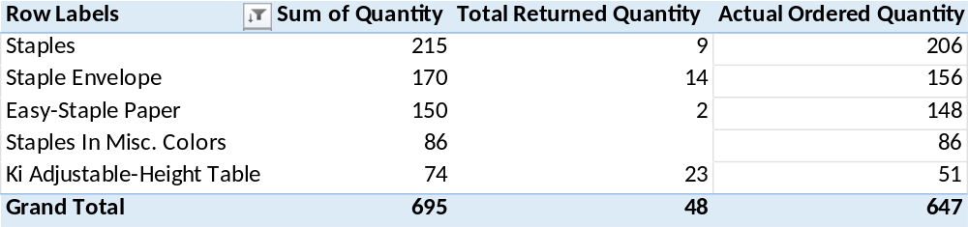

Staples is the product with the most quantity sold.

- Which category does each segment usually orders ?
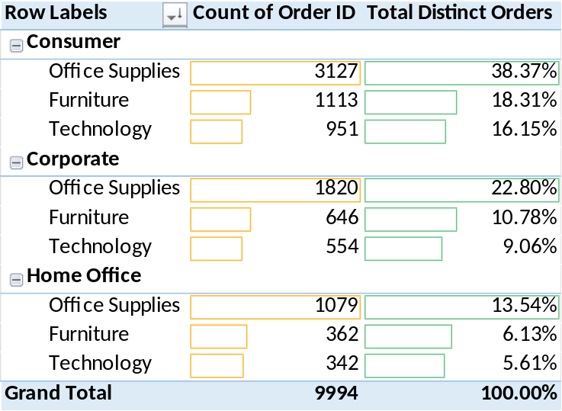

Office Supplies is the most ordered category for all customer segments .
Technology is the least ordered category for all customer segments .

Diagnostic Analysis
- Why the most profitable sub-category is not one having best sales ?
we found out the following:
- Discount difference between these 2 sub-categories is about the same, so it is not what creates that difference .
- Average COGS per unit sold for phones is 86 dollars and for copiers is 387 dollars, so COGS for copiers is much higher, so it is not what creates that difference .
- The true reason behind making copiers the most profitable is the high profit margin for copiers compared to phones; with average profit margin of 31.72% for copiers and 11.92% for phones .

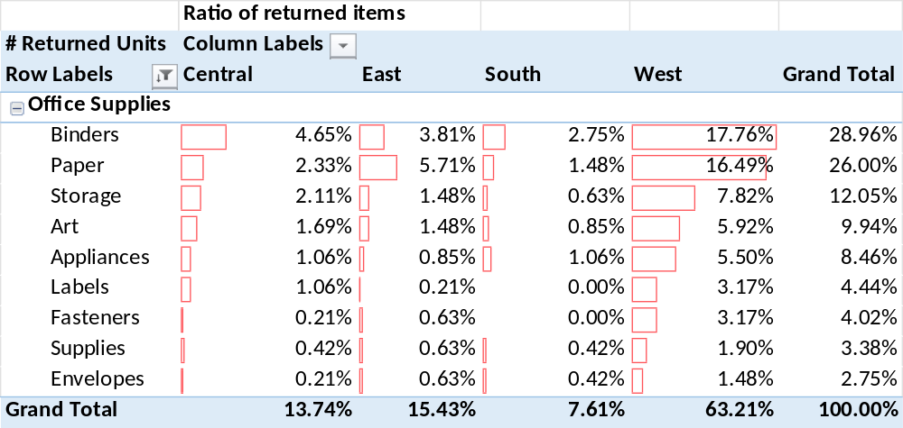
- What is the problem with the most returned products ?

we found out the following:
- Binders and Papers are the sub-categories with most return rates.
- West is Region having highest return rate and returned quantity from both sub-categories.
- By dividing the ratio of returned items on the high quantity sold in the west, we still get an unusual return rate compared to other regions .
- So, the true reason behind the problem is related to both the region tightly and the product itself as the binders and paper are still the highest returned products in all other regions

- What is the Reason Behind Low Sales in the South Region ?
we found out the following :
- Shipping Cost and Shipping Period are not the Reason .
- Profit Margin and number of Returns are also not the Reason .
- From the available date, we can only say that the reason behind low sales in the southern region is the low orders number and low ordered quantity .

- What is common between best Costumers in terms of profit ?
we found out the following :
- Most of them are of consumers segment .
- Most of profits came from ordered shipped to central and east regions .
- Average shipping period is between 4 and 6 days.
- Mostly used shipping mode is first class and slandered class shipping.
- Mostly ordered product categories are office supplies and technology products.
- Average quantity ordered is 4 units .
- Discount rate is not a common factor

- What is the reason behind the rising of sales on the seasonal trend ?
we found out the following :
- Sales, Profit, Quantity, and Number of orders are directly related .
- Profit margin doesn’t have a straight relation to the trend .
- Discount, Average order price and Average number of products in order don’t have a straight relation to the trend
- From the available date, we can only say that the rising in sales on the seasonal trend is due to the increase in overall sales .

Actionable Recommendations
Discount Threshold : Sales team should be prevented from offering discount rates above 20 % .

Reassessing salespersons behavior and performance : Specially Anna Anderadi behavior due to the very unusual orders return rate for her sales .

Quality investigation : Quality investigation should be established to find out the defect on Binders and Papers products , as well as investigating West region logistics and storage conditions

External Analysis : create further investigation into external factors like environmental factors or customers behavior to clarify the reason behind the seasonal rise of sales .

Directed Marketing :
- Marketing Should focus on consumer segments in east and central regions as they are the stable customer base .
- loyalty program can be created to encourage further customers in these regions .
- Increase Marketing of Copiers and Phones as they beings up highest profits .
- Focus on customer persona with the common characteristics between best customers.

