Global Super Store Data Analytics Report

Executive Summery
Performance and Sales Overview:
- The Consumer segment is the most successful, generating the highest sales and profits .
- Technology stands out as the best-selling and most profitable product category.
- Copiers are the most profitable sub-category, driven by an exceptionally high average profit margin of 31.72%.
- The West region leads to generating the highest profits and the most apparent sales across the evaluated period.

Operational Challenges and Issues:
- The overall ratio of returned orders compared to total orders is 5.9%.
- Office Supplies category is responsible for the majority of returns, accounting for 60.10% of the total returned quantity.
- The returns issue is heavily concentrated in the Binders and Paper sub-categories within the West region, indicating a root problem tied to both the specific products and regional operations.
- A disproportionate 61.25% of all returned orders are linked to a single salesperson,
Anna Andreadi.
- Profitability completely drops into a financial loss whenever the applied discount ratio exceeds 20%.

Introduction & Scope
This report provides an end-to-end evaluation of the Global Super Store’s commercial, logistical, and financial operations. By isolating gross positive profits from direct transactional losses, this analysis looks beyond surface-level revenue to understand where value is genuinely created and where capital is leaking.

Analysis Goal
The primary objective of this analysis is to evaluate global revenue and profit generation, isolate the root causes of the $921K direct loss, and examine how discounting behaviors, product mixes, customer purchasing patterns, and shipping logistics interact to impact the final $1.47M net bottom line. Ultimately, these insights aim to guide leadership toward margin recovery and sustainable growth.

Analysis Scope
The investigation spans four years of historical transaction data (2011–2014) covering
25,000 orders, structured across the following dimensions:
- Financial KPIs: Total Sales, Gross Positive Profit, Total Direct Loss, Net Profit, Loss Rate, and Order Averages.
- Customer & Segment Dynamics: Performance across Consumer, Corporate, and Home Office segments, down to individual high-impact customer profiles.
- Product Hierarchy: Revenue and margin breakdowns across Categories, Subcategories, and individual SKUs.
- Geographical Footprint: Market, Region, and City-level commercial evaluations.
- Time-Series & Logistics: Multi-year growth trajectories, quarterly seasonality, shipping modes, delivery durations, and freight costs.

Data Specification
Data Table used to conduct our analysis is Global Super Store which is turned into a star schema as following :
- Orders Table ( Fact )
- Customers Table ( Dimensions )
- Products Table ( Dimensions )
- Locations Table ( Dimensions )

Descriptive Analysis
Customers and Segments
The customer base consists of 1,600 unique customers generating an average profit per order of $58.50 at an average discount rate of 14%.
Segment Uniformity & Volume Dominance:
Across all customer segments, unit economics are remarkably identical, average profit per order hovers tightly between $57 and $59, and the average discount rate sits at 14%.
Because per-order metrics are equal, total financial impact is driven purely by order volume. Consequently, the Consumer segment—being the largest by order count—generates 51% of total profits, while simultaneously accounting for 51% of all direct losses.
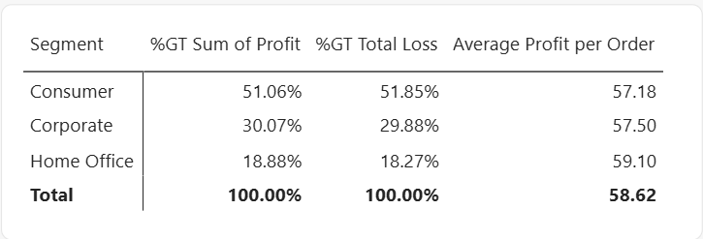
Table 1 Profit and loss rate of customer segments from total profit

Individual Customer Outliers:
- Top Revenue vs. Top Profit: Tom Ashbrook (Home Office) is the highest-spending customer by total sales, whereas Tamara Chand stands as the most profitable individual customer.
- High-Sales, Negative-Margin Profiles: High revenue does not guarantee positive returns. Sean Miller (Home Office) ranks as the 5th best-selling customer overall, yet generates a direct loss of $410, associated with an average discount rate of 19%.
- Deepest Individual Loss: Cindy Stewart (Consumer) is the most loss-generating customer, resulting in $6,150 in direct losses. Her purchasing profile includes 7 units acquired at extreme discount rates ranging between 60% and 85%.
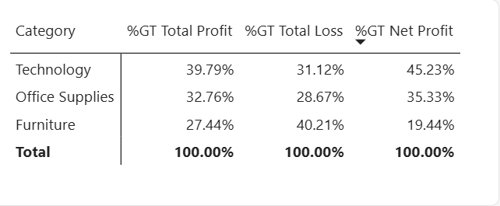
Table 2 Profit and Loss distribution across product Categories

Locations
Markets & Regions:
APAC ranks as the #1 best-selling Market globally.
At the regional level, Central EU leads in total sales, while the Central region stands out as the strongest all-around performer—ranking highest in both sales and total profits.
At the opposite end of the spectrum, Canada is the lowest-selling entity at both the Market and Region levels.

Regional Profit Disparities:
While no single region operates at an overall net loss, Southern Asia exhibits severe margin compression—ranking 5th in total sales but second-to-last in net profits.

City-Level Extremes:
New York City is the most profitable city, whereas Lagos is the single largest loss-causing city.
Shipment and Time Trends
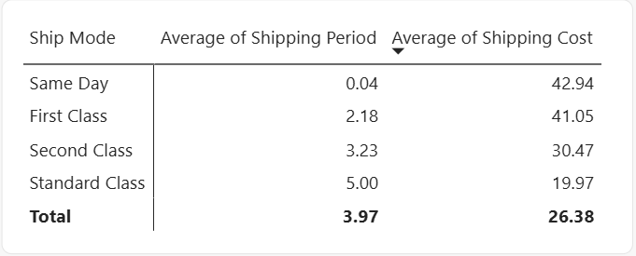
Delivery Operations:
The global average shipping period is 4 days.
Across all available shipping tiers, Standard Class is the most frequently utilized delivery mode. As expected, shipping costs scale inversely with delivery time
(shorter shipping periods incur higher costs).
Notably, the shipping cost difference between Same Day and First Class delivery is negligible, yet First Class is utilized roughly twice as much as Same Day.
Table 3 Average shipping period and shipping cost across shipping modes

Seasonality & Growth:
Sales follow a predictable seasonal cycle every year: Quarter 1 consistently records the lowest sales, followed by, gradual increase through Q2 and Q3, culminating in peak sales during Q4.
Year-over-year expansion is also accelerating, with annual sales growing by 17% from 2011 to 2012 and accelerating to 21% annual growth from 2012 to 2013 and 21% from 2013 to 2014.

Diagnostic Analysis

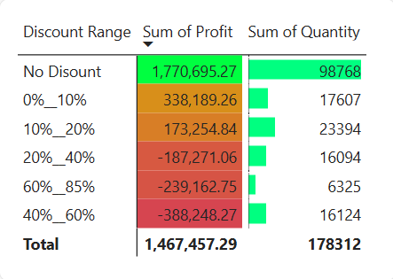
The 20% Discount Tipping Point (Root Cause of the 38.55% Loss Rate):
Cross-referencing discount tiers against margins reveals a clear threshold: whenever the discount rate exceeds 20%, transactions systematically flip from profitable to loss-making.
More importantly, volume analysis shows that the highest quantity of units sold occurs
at a 0% discount, and the accelerating YoY seasonal sales growth (17% to 21%) shows no correlation with discount increases. This confirms that demand is organic and that aggressive discounting is actively destroying $921K in gross profits without being necessary to drive volume.
Table 4 Total profit from each discount range

Why Copiers Outperform Phones in Profit:
Although Phones generate higher top-line revenue than Copiers, Copiers achieve a significantly higher average profit per order ($122 vs. $70 for Phones).
This gap is directly explained by discounting discipline: Copiers maintain a noticeably lower average discount rate than Phones, preserving their unit margins.

Explaining the $144K Tables Deficit & Southern Asia's Margin Collapse:
Both major pockets of underperformance trace directly back to the 20% discount threshold:
- The Tables subcategory suffers $144,000 in direct losses despite high sales volume because its average discount rate sits at 29%—well past the profitability tipping point.
- Southern Asia ranks 5th in sales but near the bottom in profit because the region operates at an average discount rate of 27%, systematically eroding the revenue it generates.

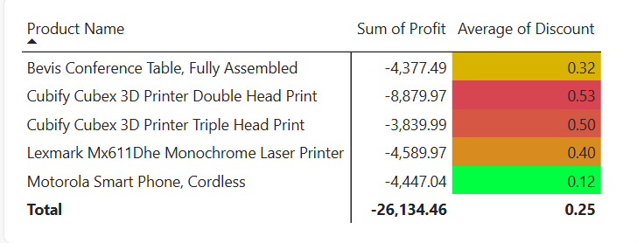
Anatomy of the Top 5 Losing Products & The Motorola Outlier:
Four of the top five loss-making products suffer from average discount rates exceeding 30%.
The sole exception is the Motorola Smart Phone, Cordless (Technology / Phones), which records a severe average loss of -$194 per order.
Diagnostic breakdown shows that while its overall average discount appears lower, 20% of its sales were executed at extreme discount brackets between 40% and 60%.
The massive losses generated by that 20% slice completely wiped out the profits earned on its remaining orders.
Table 5 Most loosing products

Customer-Level Margin Erosion:
The contrast between top customers highlights how unmonitored promotional tiers distort account value.
Cindy Stewart’s $6,150 loss was directly triggered by allowing 60% to 85% discounts on 7 units, while Sean Miller turned from a top 5 revenue generator into a net-loss account (-$410) as his average discount crept up to 19% (bordering the 20% cliff).

Actionable Recommendations
- Enforce a Hard 20% Discount Ceiling & Restructure Promotional Tiers:
- Action: Implement an immediate system-wide pricing rule capping standard promotional discounts at 15%–18%, requiring executive approval for anything reaching 20%.
Eliminate extreme markdown brackets (40%–85%) that drove the Cindy Stewart (-$6,150) and Motorola Smart Phone (-$194/order) losses.
- Expected Impact: Directly curbs the $921K loss pool without harming unit sales, since historical data proves peak volume occurs at 0% discount.
- Turnaround Strategy for the Furniture Category (Tables Subcategory):
- Action: Reduce the average discount rate on Tables from 29% down to the company average of 14% or below.
if specific table SKUs cannot move without 29% markdowns, phase them out of the catalog or bundle them with high-margin Technology or Office Supplies items rather than discounting them standalone.
- Expected Impact: Recovers a major portion of the $144,000 direct loss in Tables and addresses the 40% loss concentration in Furniture.
- Regional Pricing Audit in Southern Asia & Lagos:
- Action: Conduct an immediate commercial audit of sales teams and pricing policies in Southern Asia (currently at a 27% average discount) and Lagos (top loss-causing city). Realign discount permissions with the successful model used in the Central region.
- Expected Impact: Converts Southern Asia’s high sales volume (#5 globally) into actual bottom-line net profit.
- Rebalance Product Marketing Toward High-Margin Tech (Copiers):
- Action: Capitalize on Q2–Q4 seasonal momentum by shifting marketing spend and
cross-selling efforts toward Copiers ($122 profit/order) alongside best-selling
Phones ($70 profit/order).
Audit Phone discounting to bring its margin profile closer to Copiers.
- Optimize Express Shipping Tiers (Same Day vs. First Class):
- Action: Since the shipping cost difference between Same Day and First Class is negligible—yet First Class is used twice as often—reposition Same Day delivery as a premium value-add or loyalty perk for high-margin orders
(such as Copiers or 0%-discount orders) to boost customer conversion without sacrificing product margin via price discounts.

