**Car Price Prediction with Machine Learning**

One of the main areas of research in machine learning is the prediction of the price of cars. It is based on finance and the marketing domain. It is a major research topic in machine learning because the price of a car depends on many factors. Some of the factors that contribute a lot to the price of a car are:

* Brand
* Model
* Horsepower
* Mileage
* Safety Features
* GPS and many more.

If one ignores the brand of the car, a car manufacturer primarily fixes the price of a car based on the features it can offer a customer. Later, the brand may raise the price depending on its goodwill, but the most important factors are what features a car gives you to add value to your life. So, in the section below, I will walk you through the task of training a car price prediction model with machine learning using the Python programming language.

**Car Price Prediction Model using Python**

1. The dataset I’m using here to train a car price prediction model was downloaded from Kaggle. It contains data about all the main features that contribute to the price of a car. So let’s start this task by importing the necessary Python libraries and the dataset:

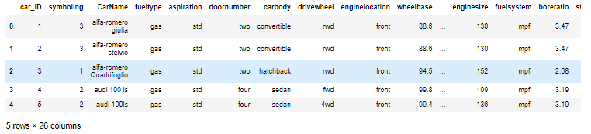

1. There are 26 columns in this dataset, so it is very important to check whether or not this dataset contains null values before going any further:
2. So this dataset doesn’t have any null values, now let’s look at some of the other important insights to get an idea of what kind of data we’re dealing with:
3. The price column in this dataset is supposed to be the column whose values we need to predict. So let’s see the distribution of the values of the price column:

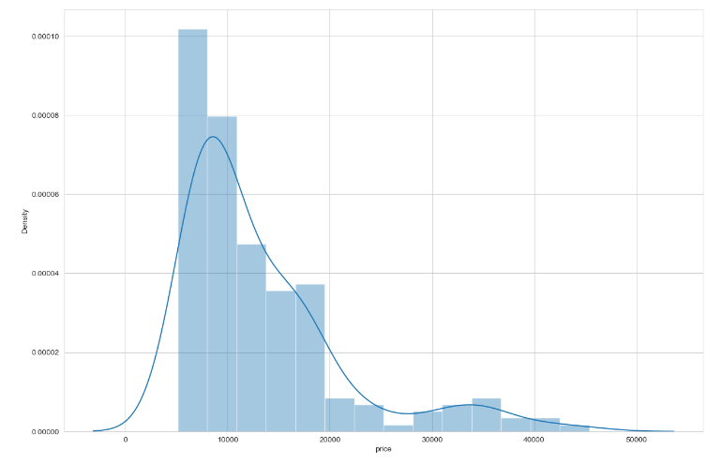

1. Now let’s have a look at the correlation among all the features of this dataset:

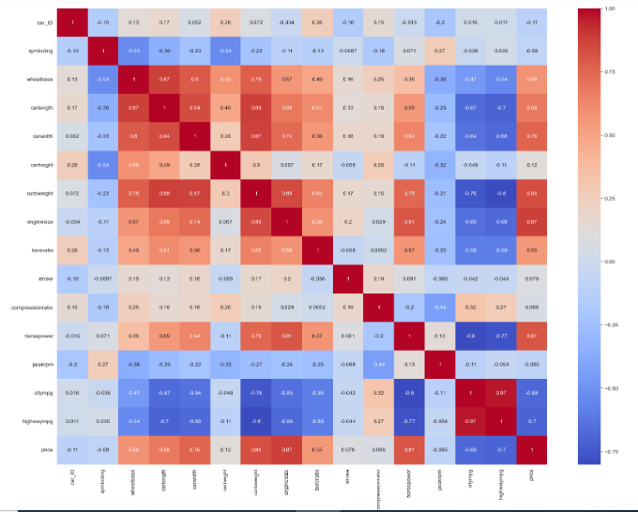

1. Training a Car Price Prediction Model
2. I will use the decision tree regression algorithm to train a car price prediction model. So let’s split the data into training and test sets and use the decision tree regression algorithm to train the model:

The model gives 100% accuracy on the test set, which is excellent.



Summary

So this is how you can train a machine learning model for the task of predicting car prices by using the Python programming language. It is a major research topic in machine learning because the price of a car depends on many factors. I hope you liked this project of training a model for predicting car prices with machine learning.