**High Level Design**

Online Clothing Store

High Level Design

ITI

Smart Village

Cairo, Egypt

**Table of Contents**

**1.** **Entity-Relationship Diagram (ERD)** 3

**2.** **Use case diagram** 4

**3.** **High level decomposition** 5

**4.** **Sequence Diagrams** 6

**Sequence Diagram ID:** OCS_Login_Sequence_01 6

# **Entity-Relationship Diagram (ERD)**

An Entity-Relationship Diagram (ERD) is like a picture that shows how a database is set up.

It helps us see how different things in the database are connected, like tables and what they contain.

ERDs are useful for people who work with databases because they help us understand how data is organized and how we can get it in and out of the database.

**ERD ID**: OCS_ERDDiagram_01

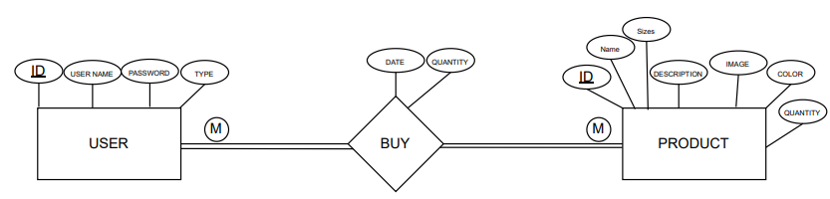

# **Use case diagram**

A use case diagram highlights the relationships between actors, use cases (system functionalities), and the system itself.

It provides an overview of how users (actors) engage with a system or software application, outlining the various functionalities available and the interactions between users and the system.

**Use Case ID:** OCS_Usecase_01

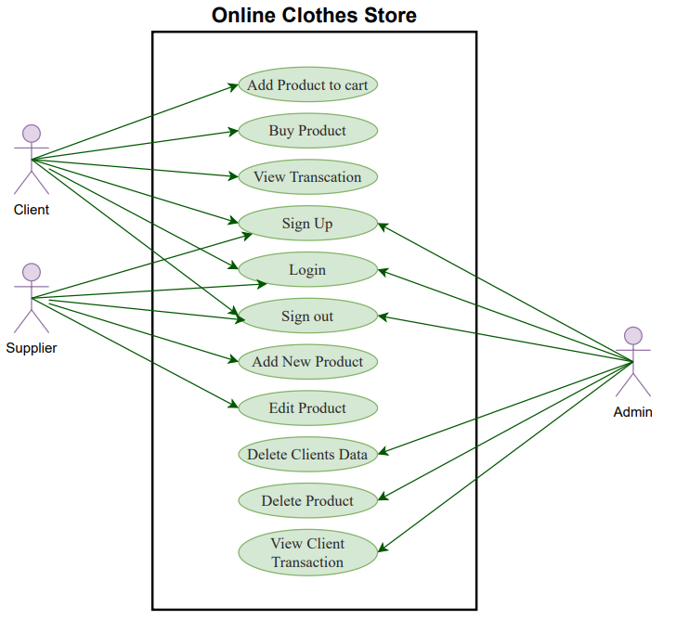

# **High level decomposition**

This decomposition diagram illustrates the primary modules of the system and their interconnections.

Each module represents a unique aspect of the Online Clothes Store project.

**Use Case ID:** OCS_HighLevelDesc_01

# **Sequence Diagrams**

A sequence diagram shows how different parts of a system talk to each other in a step-by-step way.

It's like drawing out a conversation between different pieces of a system to see how they work together.

## **Sequence Diagram ID:** OCS_Login_Sequence_01

