JOIN

A JOIN in SQL is used to combine rows from two or more tables based on a related column between them. Joins are a powerful feature of SQL that allow you to retrieve data from multiple tables as if they were a single table.
1). INNER JOIN
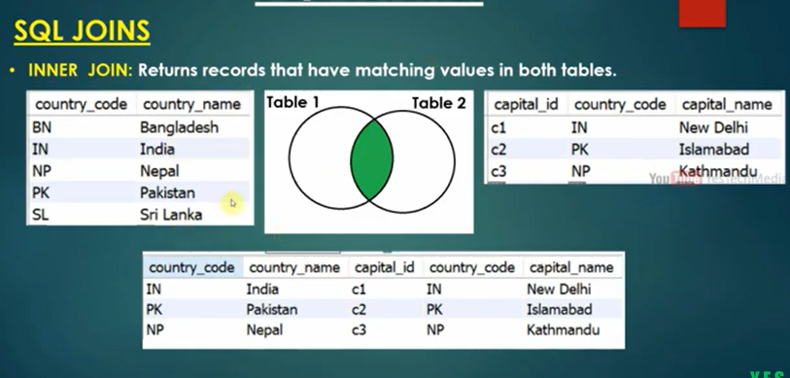

2). LEFT JOIN
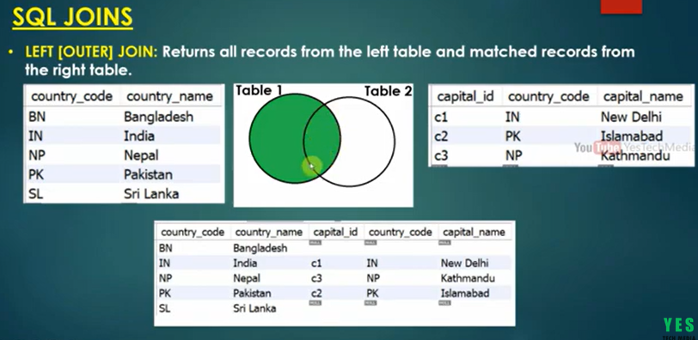
3). RIGHT JOIN
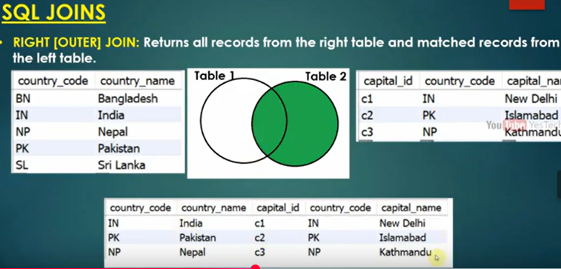
4) FULL JOIN
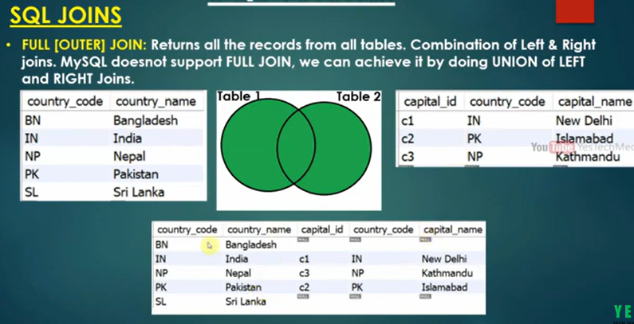

CROSS JOIN:
- Returns the Cartesian product of the two tables, i.e., every row in the first table is paired with every row in the second table.
SELF JOIN:
- A table is joined with itself

