**Name:** Mohamed Ashraf Hussain Hussain Elofy

**B.N/ 662**

**Date/** 9/6/2021

**Topic:** Programming Languages

**Application brief :**

This is an application about programming languages and their uses.

**Screenshots:**

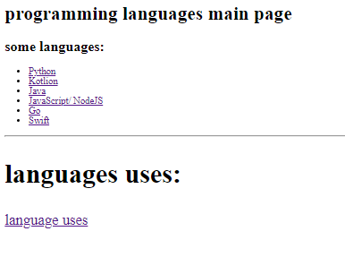

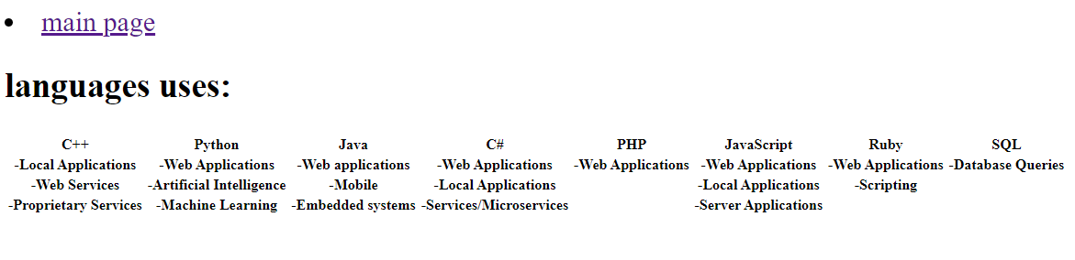

**Source code:**

