
PROJECT DOCUMENTATION
GitHub Projects
Data Analytics Pipeline
1. Collect  (GitHub API) | 2. Clean &  Prepare | 3. Store &  Analyze (SQL) | 4. Visualize  (Matplotlib) | 5. Git &  GitHub

Muhammad — DECI4-S-418111

1 Data Collection & Preparation

The pipeline starts by pulling live repository data directly from GitHub's public Search API, using a query for "machine learning" repositories sorted by star count. The JSON response is converted into a Pandas DataFrame, giving 100 raw repository records to work with.
Column Selection
Only the ten columns needed for analysis were kept: name, owner, language, stargazers_count, forks_count, watchers_count, open_issues_count, created_at, updated_at, and license.
Cleaning Steps Performed
● Extracted the owner's username from the nested "owner" object instead of storing the whole object.
● Extracted the license name from the nested "license" object.
● Converted created_at and updated_at into proper DateTime values.
● Removed duplicate repository records.
● Detected and dropped rows with missing (null) values.
● Renamed columns (e.g. stargazers_count → stargazers) for cleaner SQL use later.
● Standardized text fields (lowercase, trimmed whitespace) for name, owner, language, and license.
💡 Data quality fix
While exploring the language column, some repositories were labeled "Jupyter Notebook" instead of an actual programming language — because GitHub classifies a repo by its dominant file type, not the language inside the code. Since Jupyter is a coding environment, not a language, these values were corrected to "Python".

Result
After cleaning, the dataset was saved as github_projects.csv — verified by reloading it, checking its shape, and previewing the first rows. The final cleaned dataset contains 60 repositories ready for SQL analysis.

2 Store & Analyze the Data (SQLite + SQL)

The cleaned CSV was loaded into a SQLite database, into a table named Repositories (60 rows, 10 columns). SQL was then used to explore and summarize the data.
Filtering & Searching
SELECT * FROM Repositories WHERE stargazers > 10000;
SELECT * FROM Repositories WHERE name LIKE '%machine%';
Logical Operators — AND / OR / NOT
-- AND
WHERE stargazers > 10000 AND name LIKE '%machine%';

-- NOT IN
WHERE stargazers > 10000 AND language NOT IN ('JavaScript','C#');

-- OR
WHERE language = 'Python' OR language = 'C++';
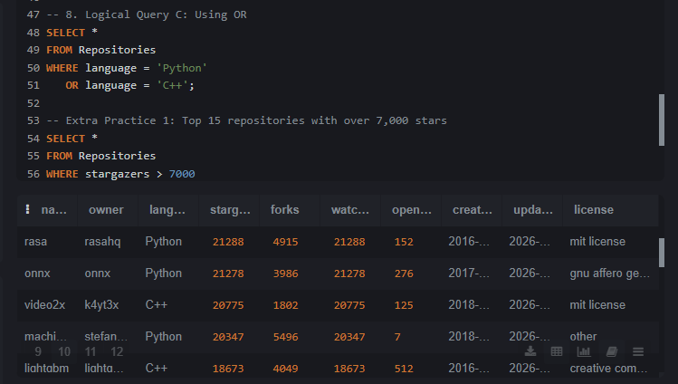
The OR query executed successfully, returning repositories written in Python or C++ (rasa, onnx, video2x, lightabm...).
Sorting, Limiting & Aggregates
SELECT * FROM Repositories ORDER BY stargazers DESC LIMIT 10;
SELECT COUNT(*) AS Rows_counts FROM Repositories;
SELECT AVG(stargazers) AS stargazers_c FROM Repositories;
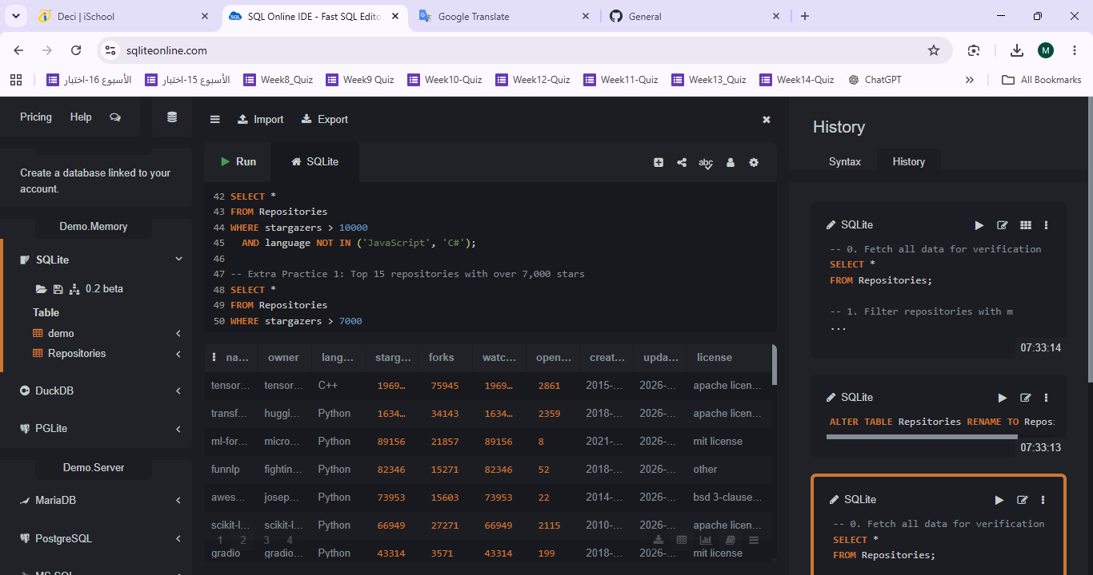
Row count result: 60 repositories in the cleaned dataset.
Grouping — GROUP BY / HAVING
SELECT language, COUNT(*) AS s
FROM Repositories
GROUP BY language
HAVING COUNT(*) > 5;
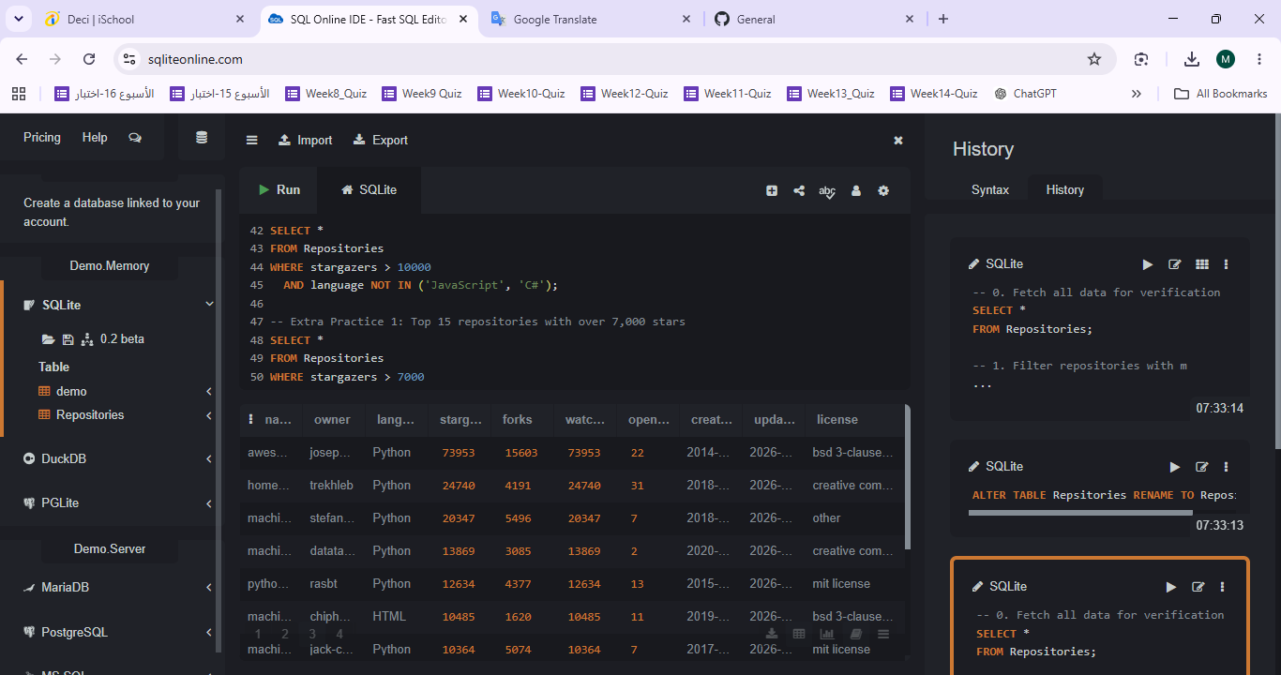
Languages with more than 5 repositories: Python (37) and C++ (11).
💡 SQL findings summary
The Top 10 repositories by stars are dominated by TensorFlow (~197K) and Hugging Face Transformers (~163K), each far ahead of the rest of the dataset. The average star count across all 60 repositories is about 26,284. Python is by far the most common language (37 of 60 repos), followed by C++ (11) — together these two languages account for the vast majority of machine-learning repositories collected.

3 Python Visualizations (Matplotlib)

Beyond the two required charts, additional visualizations were created to explore the dataset more deeply — stars, open issues, languages, and licenses.
Top & Bottom 10 Repositories by Stars
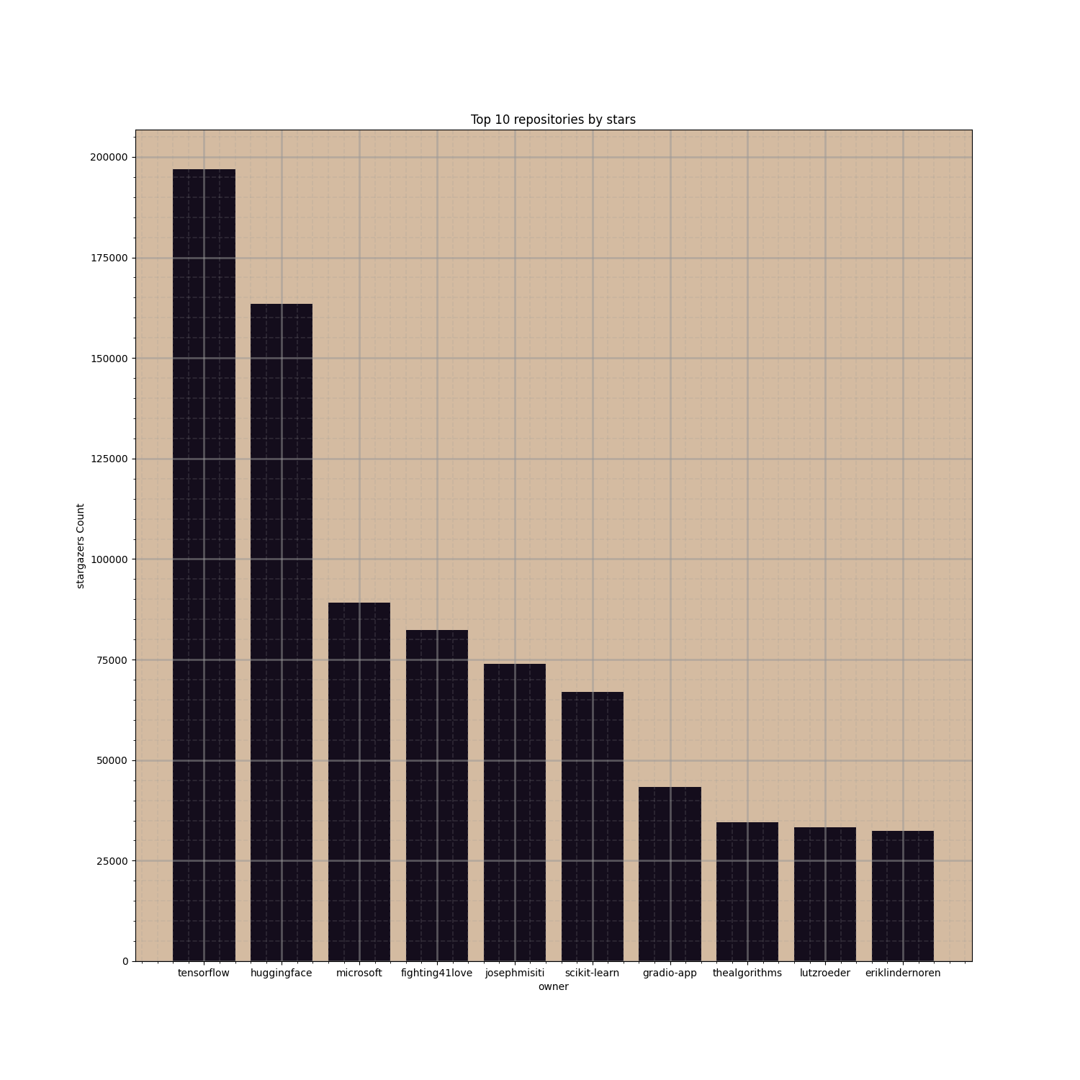
Top 10 repositories by star count — TensorFlow and Hugging Face lead by a wide margin.
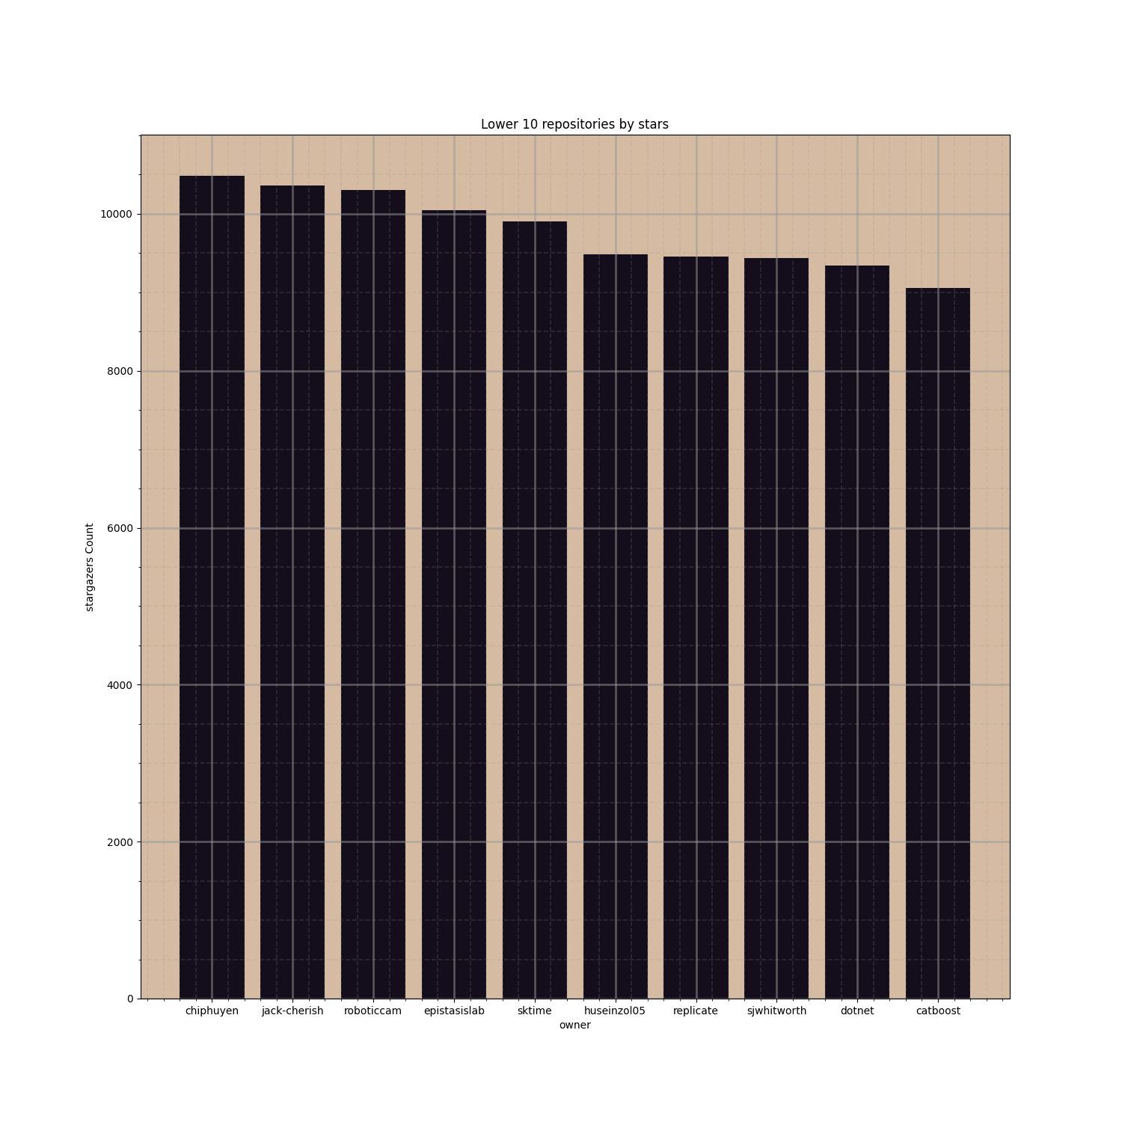
Lower 10 repositories by star count — values cluster tightly around 9,000–10,500 stars.
Open Issues — Top & Bottom 10
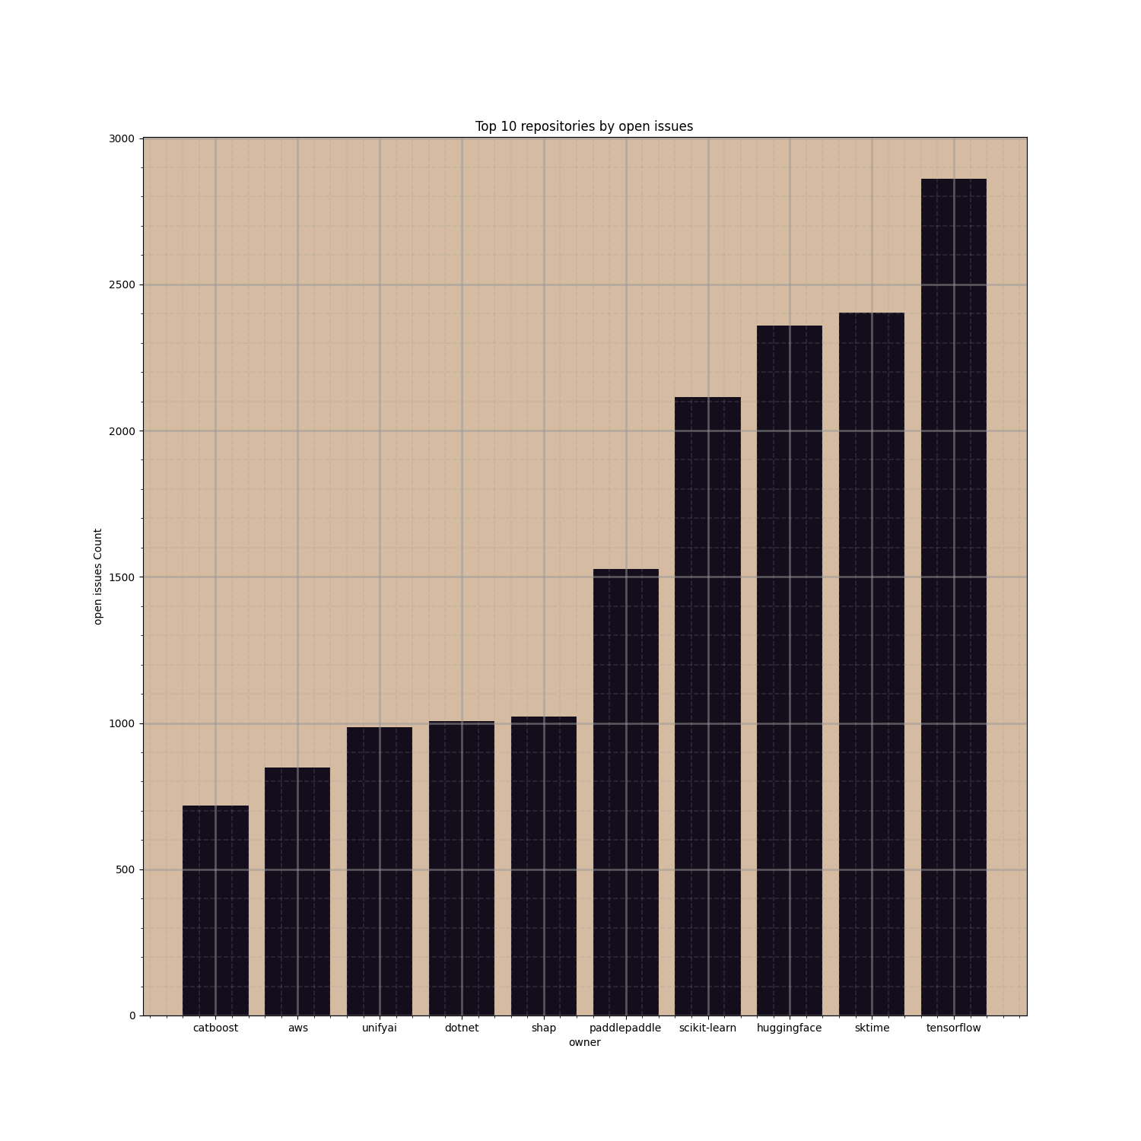
Repositories with the most open issues — TensorFlow again leads, with nearly 3,000 open issues.
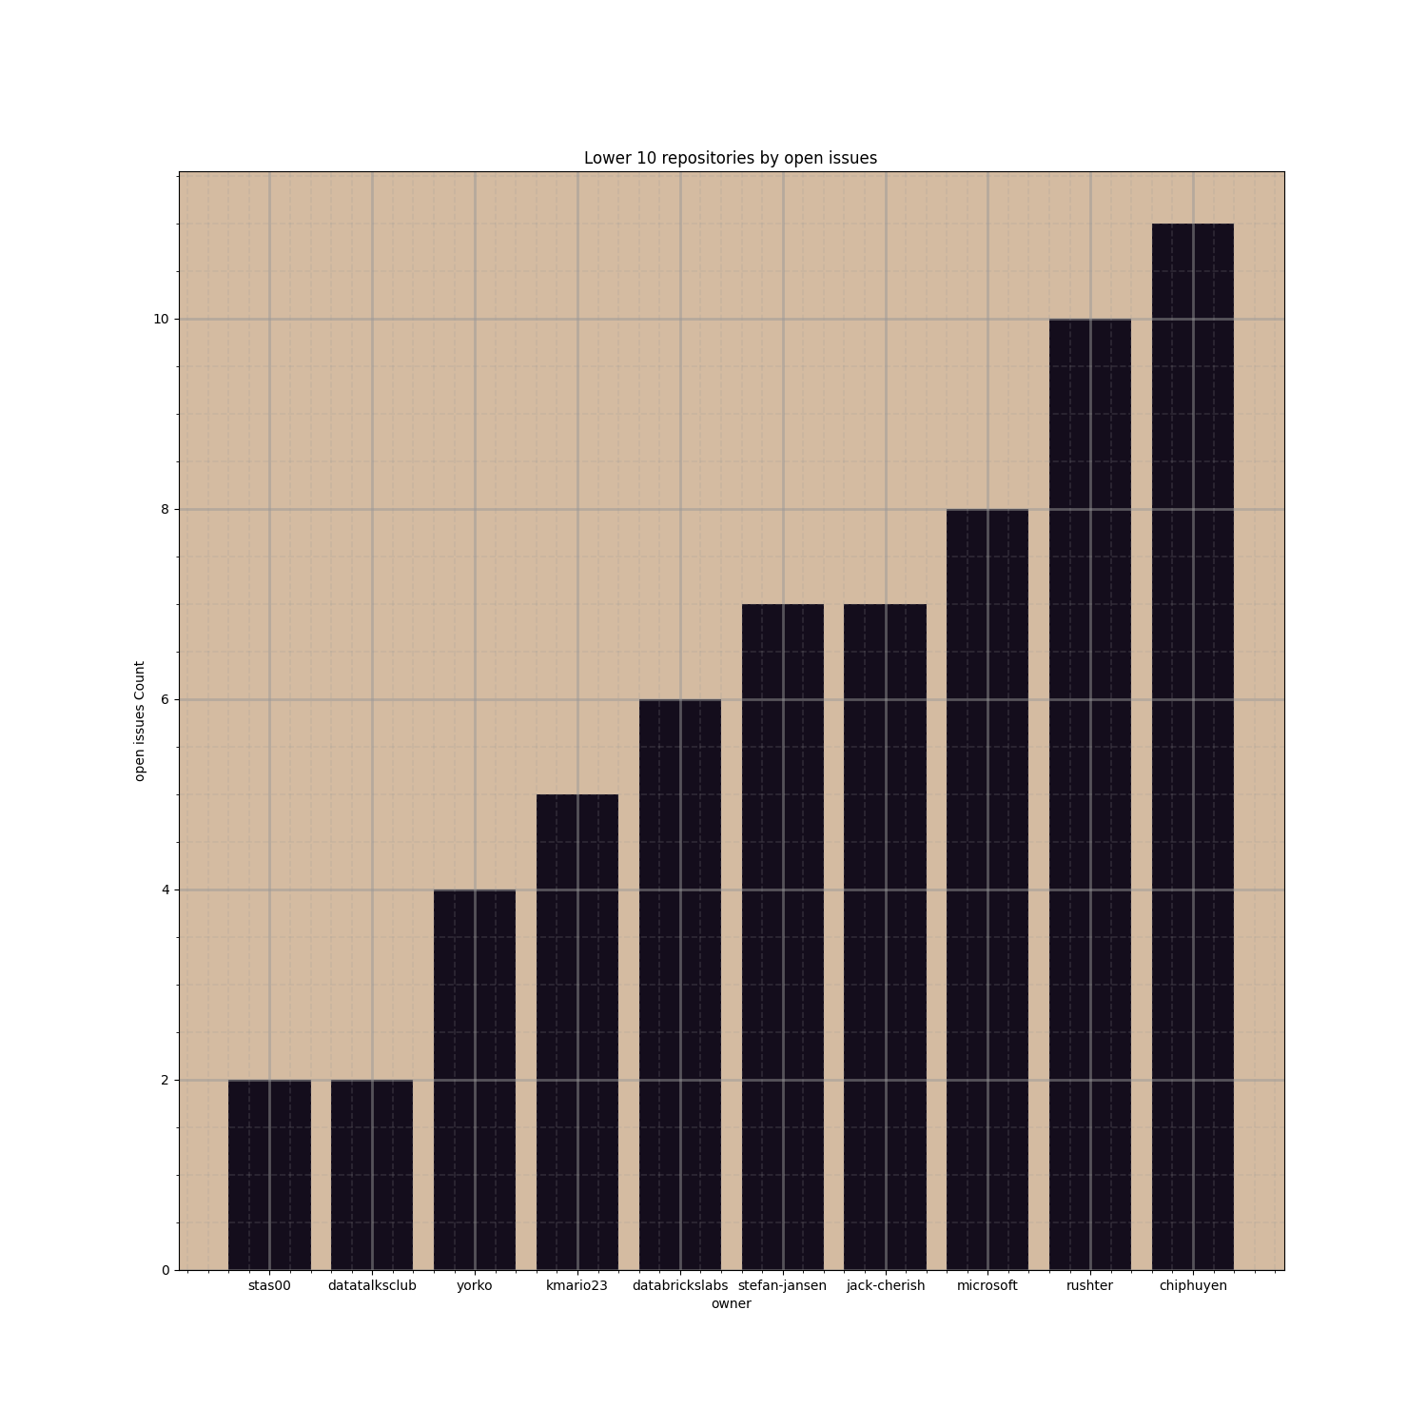
Repositories with the fewest open issues — well-maintained smaller projects.
Repository Creation Trend by Year
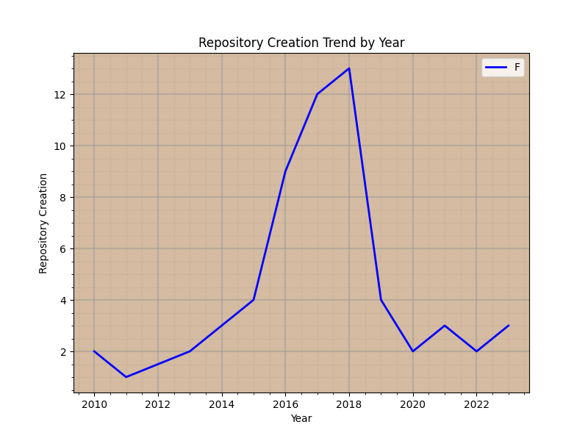
Repository creation peaked in 2018 (13 repos), following a steady rise from 2010.
Languages & Licenses Distribution
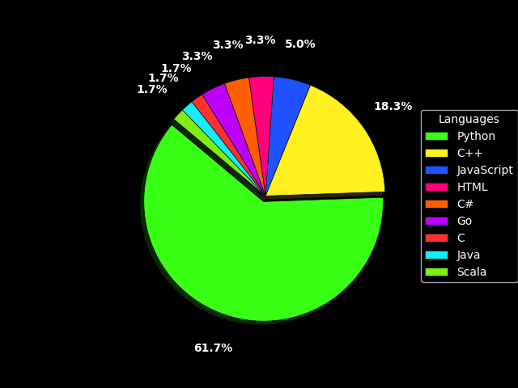  Languages across all 60 repositories — Python dominates (61.7%). | 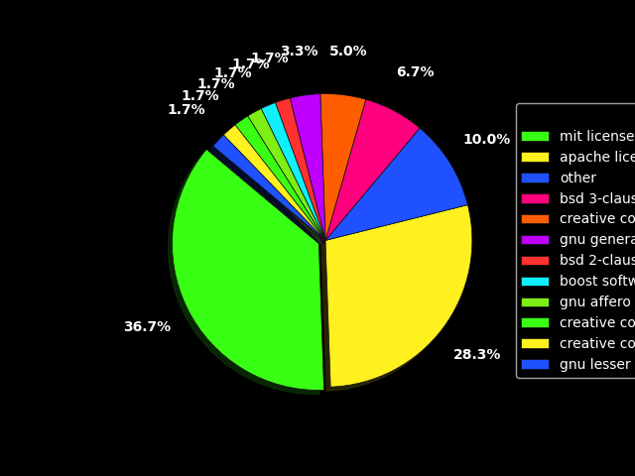  License types — MIT (36.7%) and Apache 2.0 (28.3%) are most common.
Owner Tier Breakdown (Best / Very Good / Bad / Worst)
Repositories were grouped into four tiers by comparing star count against open-issue count, to see whether language choice affects a repository's overall standing.
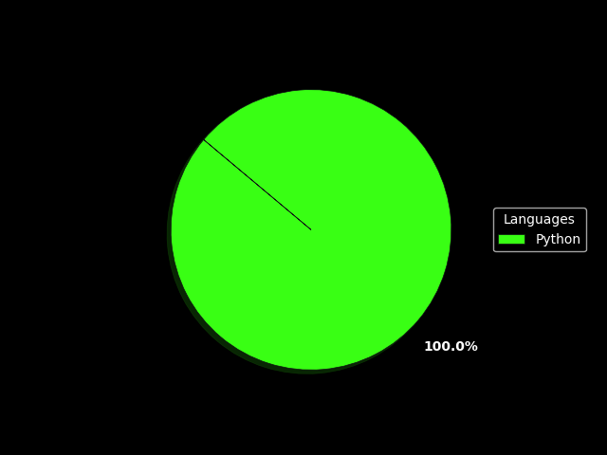  "Very Good" tier — Python leads (58.3%), followed by C++. | 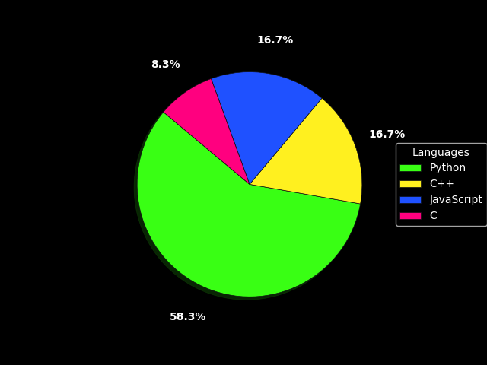  "Best" tier — a single owner (Microsoft), 100% Python.
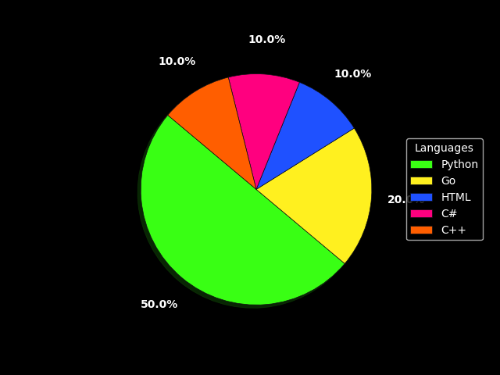  "Bad" tier — an even 33.3% split across Python, C#, and C++. | 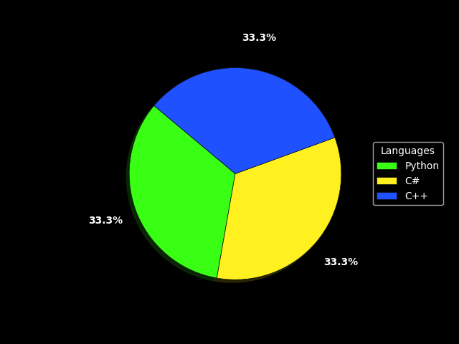  "Worst" tier — most language diversity, Python still leads at 50%.
💡 Interpretation
After comparing all four tiers, language does not appear to determine a repository's success or issue burden — the top-performing group (Microsoft) and the lowest-performing group both include Python as their leading language. Popularity and maintenance quality seem to depend more on project design and maintainer activity than on the programming language itself.

4 Version Control — Git & GitHub

The completed project (notebooks, dataset, SQL files, and screenshots) was tracked with Git and published to a public GitHub repository.
git init
git status
git add .
git commit -m "Initial project commit"
git remote add origin <repository-url>
git push -u origin MLI
● git init — created a local Git repository inside the project folder.
● git status — confirmed all project files were detected as untracked, ready to be staged.
● git add . — staged every file for the first commit.
● git commit -m "Initial project commit" — saved the first snapshot of the project history.
● git push — published the repository to GitHub under the branch "MLI".

The published repository organizes the project into four folders — Colab, Dataset, My Information Source, and SQL — and is publicly viewable on GitHub, including the commit history and all supporting files.

5 Ethics Reflection

💡 Q1 — Why verify data from public APIs?
Public APIs return data generated by many different users and systems, so it isn't guaranteed to be clean, complete, or accurate. Fields can be missing, mislabeled, or misleading (e.g. "Jupyter Notebook" appearing as a language). Verifying the data prevents silent errors downstream, protects the integrity of the analysis, and builds trust in the conclusions drawn from it.

💡 Q2 — Why document the data source?
Documenting the exact API endpoint, parameters, and collection date makes an analysis reproducible and checkable. Without it, no one — including the analyst — can confirm whether a result is still valid. It also gives context: a query like "machine+learning" sorted by stars is a specific, biased slice of GitHub, and documenting it prevents readers from over-generalizing the findings.

💡 Q3 — How do missing/inaccurate data affect analysis?
Missing or inaccurate values can distort the overall picture, not just create small gaps. Dropping incomplete rows is safe when the gaps are random, but can quietly bias results if certain kinds of repositories are removed more often than others. This skews statistics like averages and rankings, can lead to poor decisions, and damages trust once errors are discovered.

