

**Faculty of engineering - Shoubra**

**Benha University**

**Research Article / Research Project / Literature Review**

in fulfillment of the requirements of

|  |  |
| --- | --- |
| **Department** | **Engineering Mathematics and Physics** |
| **Division** | **-----------** |
| **Academic Year** | **2019 2020 Preparatory** |
| **Course name** | **Computer** |
| **Course code** | **ECE001** |

**Title: -**

**COVID-19**

By:

|  |  |  |  |
| --- | --- | --- | --- |
|  | Name | Edu mail | B.N |
| 1 | محمد أيمن جابر حسن | Muhammed195752@feng.bu.edu.eg | 25 |

**Approved by:**

|  |  |
| --- | --- |
| Examiners committee | Signature |
| Dr.Ahmed Bayoumi |  |
| Dr.Shady Elmashad |  |
| Dr. Abdelhamid Attaby |  |

**Literature Review**

## Covid-19:

Coronavirus disease 2019 (COVID-19) is an infectious disease caused by severe acute respiratory syndrome coronavirus 2 (SARS-CoV-2).It was first identified in December 2019 in Wuhan, China, and has resulted in an ongoing pandemic. The first case may be traced back to 17 November 2019. As of 5 June 2020, more than 6.63 million cases have been reported across 188 countries and territories, resulting in more than 391,000 deaths. More than 2.86 million people have recovered.

Common symptoms include fever, cough, fatigue, shortness of breath, and loss of smell and taste. While the majority of cases result in mild symptoms, some progress to acute respiratory distress syndrome (ARDS) likely precipitated by a cytokine storm,[citation needed] multi-organ failure, septic shock, and blood clots. The time from exposure to onset of symptoms is typically around five days, but may range from two to fourteen days.

The virus is primarily spread between people during close contact,[a] most often via small droplets produced by coughing,[b] sneezing, and talking. The droplets usually fall to the ground or onto surfaces rather than travelling through air over long distances. Less commonly, people may become infected by touching a contaminated surface and then touching their face. It is most contagious during the first three days after the onset of symptoms, although spread is possible before symptoms appear, and from people who do not show symptoms. The standard method of diagnosis is by real-time reverse transcription polymerase chain reaction

(rRT-PCR) from a nasopharyngeal swab .Chest CT imaging may also be helpful for diagnosis in individuals where there is a high suspicion of infection based on

symptoms and risk factors; however, guidelines do not recommend using CT imaging for routine screening.

Recommended measures to prevent infection include frequent hand washing, maintaining physical distance from others (especially from those with symptoms), quarantine (especially for those with symptoms), covering coughs, and keeping unwashed hands away from the face.The use of cloth face coverings such as a scarf or a bandana is recommended in public settings to minimise the risk of transmissions, with some authorities requiring their use.Medical grade facemasks such as N95 masks should only be used by healthcare workers, first responders and those who care for infected individuals.

According to the World Health Organization (WHO), there are no vaccines nor specific antiviral treatments for COVID-19. On 1 May 2020, the United States gave emergency use authorization to the antiviral remdesivir for people hospitalized with severe COVID‑19[citation needed] Management involves the treatment of symptoms, supportive care, isolation, and experimental measures.The World Health Organization (WHO) declared the COVID‑19 outbreak a public health emergency of international concern (PHEIC) on 30 January 2020 and a pandemic on 11 March 2020. Local transmission of the disease has occurred in most countries across all six WHO regions.

## Application Brief:

Notepad++ is a text and source code editor for use with Microsoft Windows. It supports tabbed editing, which allows working with multiple open files in a single window. The project's name comes from the C increment operator.

Notepad++ is distributed as free software. At first the project was hosted on SourceForge.net, from where it has been downloaded over 28 million times, and twice won the SourceForge Community Choice Award for Best Developer Tool.The project was hosted on TuxFamily [fr] from 2010 to 2015; since 2015 Notepad++ has been hosted on GitHub.[5] Notepad++ uses

## Screen shots:

## Page 1

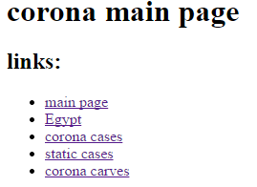

## Page2

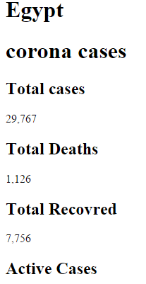

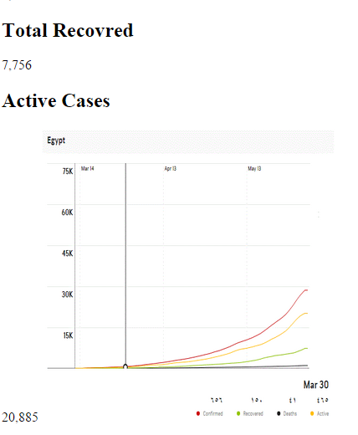

## Page3

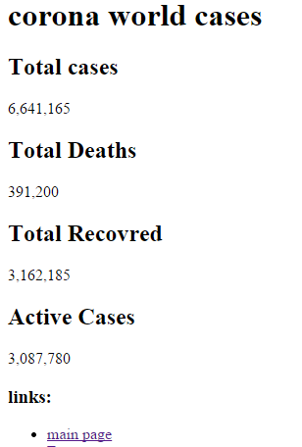

## Page4

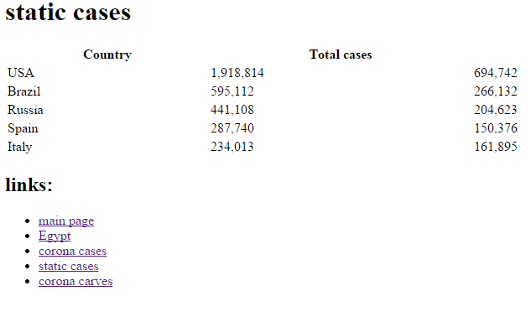

### Page5

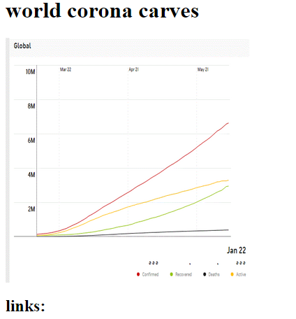

## Source code:

Of Home page

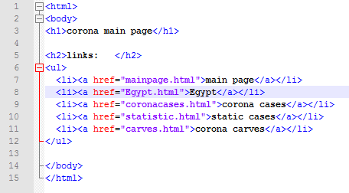

Of Egypt page

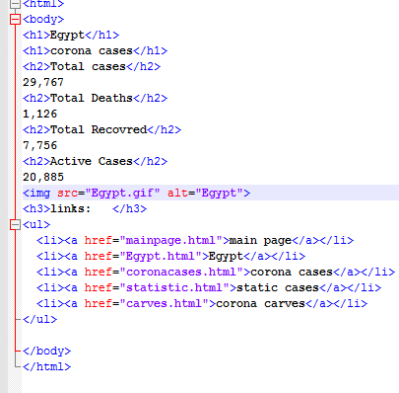

Of cases page

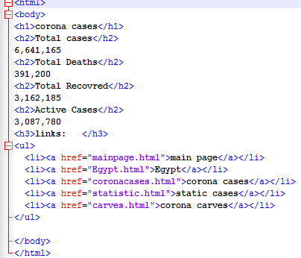

Of Static cases page

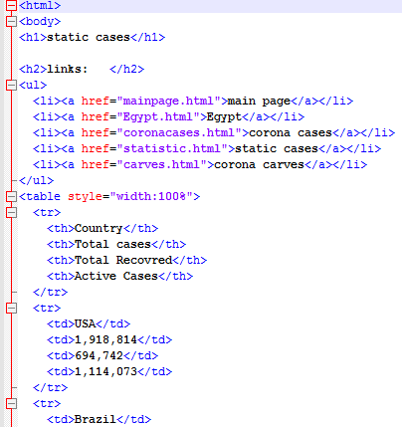

Of carves page

