1.1 ABOUT THE PROJECT
The Smart Travel Route Planner is a web-based client–server application designed to assist travelers in creating optimized, personalized, and well-organized travel routes. Users can enter their starting and ending locations, after which the system automatically generates an intelligent route and identifies major tourist attractions, scenic viewpoints, and important landmarks along the way. These suggested locations can be reviewed, selected, and added to a customized itinerary.
The system enables users to reorder destinations, add custom stops, calculate total travel distances and durations for efficient planning. Each completed travel plan can be saved, modified, or reused, allowing users to revisit past itineraries or fine-tune new ones with ease. Users can also explore detailed attraction information, visualize routes on an interactive map, and manage all planned trips in a structured manner.
By integrating route generation, attraction discovery, and itinerary management into a unified interface, the Smart Travel Route Planner offers a seamless and intelligent travel-planning experience that enhances decision-making and simplifies trip organization for user
The system supports two major user roles:
- Admin – Manages users, route data, traffic information, system settings, and generates reports and analytics.
- Users (Travelers) – Search and view optimized routes, compare route options, track travel details, and manage saved routes.

1.2 ABOUT THE ORGANIZATION
Rajagiri College of Management and Applied Sciences (RCMAS) is a premier institution of higher education located in Kakkanad, Kochi, Kerala. Established in 2005, the college operates under the esteemed Rajagiri Vidyapeetham and is managed by the Carmelites of Mary Immaculate (CMI) congregation, known for their dedication to quality education and social commitment. The college is affiliated with Mahatma Gandhi University, Kottayam, and offers a wide range of undergraduate and postgraduate programs in fields such as Commerce, Management, Computer Applications, English, and Graphic Design. RCMAS is committed to academic excellence, character formation, and the holistic development of students, guided by its motto "Learn, Serve, Excel."
The campus is situated in the picturesque Rajagiri Valley, an eco-friendly environment that supports both academic and personal growth. RCMAS fosters a vibrant learning community through well-qualified faculty, modern infrastructure, and numerous clubs and student organizations that promote creativity, leadership, and service. With a strong emphasis on innovation and ethical values, the college has earned a reputation for producing socially responsible professionals equipped to meet the demands of a dynamic global environment. Over the years, the institution has achieved significant academic success, including multiple university ranks and recognitions, reinforcing its position as a leading center for higher education in Kerala.

2.1 SYSTEM STUDY
The Smart Travel Route Planner is designed to simplify travel planning by providing an intelligent platform that generates optimized routes and recommends tourist attractions along the way. Traditional travel planning often requires users to rely on multiple sources such as maps, travel websites, and blogs, making the process time-consuming and less organized.
The system allows users to enter starting and ending locations, automatically generating routes and suggesting nearby tourist spots. Users can select recommended locations and create a structured itinerary, which can also be saved for future reference.
The application is developed using React for the frontend, FastAPI for the backend, and MongoDB for the database, ensuring a responsive interface and efficient data management. Overall, the system provides a convenient and organized solution that improves the travel planning experience for users.
2.1.1 Existing System
In the current scenario, travel route planning is mostly handled through traditional and fragmented methods. Travelers commonly rely on printed maps, basic navigation apps, verbal directions, travel blogs, or multiple unrelated websites to plan their journeys. These methods are often unstructured and lack integration, making it difficult for users to organize routes, attractions, and schedules efficiently.
Since there is no single centralized system that combines route optimization, attraction discovery, and itinerary management, users must manually search for routes, tourist spots, distances, and travel durations across different platforms. This disconnected approach leads to confusion, inefficient planning, and increased chances of missing important locations or choosing suboptimal routes. Most existing tools provide only basic navigation, focusing mainly on point-to-point directions. They do not support personalized itinerary creation, destination reordering, or the ability to save and reuse complete travel plans.

As a result, users often repeat the same planning process for every trip, wasting time and effort.

The lack of a structured digital travel-planning system leads to several challenges such as:

No integrated platform to combine routes, attractions, and travel plans

Manual selection of destinations without intelligent suggestions

Difficulty in calculating total travel distance and duration for multi-stop trips

No proper storage or management of past itineraries

Limited personalization based on user preferences

Inadequate visualization of routes and travel plans

Disadvantages of the Existing System

i. Travel planning requires switching between multiple applications and information sources.
ii. There is no centralized system for managing routes, destinations, and itineraries together.
iii. Manual route planning is time-consuming and prone to errors.
iv. Users cannot easily reorder destinations or add custom stops dynamically.
v. Lack of itinerary storage makes it difficult to reuse or modify past travel plans.
vi. Limited attraction discovery along routes reduces travel experience quality.
vii. Absence of structured travel data makes long-distance or multi-day trip planning inefficient.

The existing system is therefore disorganized, time-consuming, and insufficient for modern travelers who require intelligent, personalized, and well-organized travel route planning solutions.

2.1.2 Proposed System

The Smart Travel Route Planner aims to overcome the limitations of traditional travel planning methods by introducing a fully digital, centralized, and intelligent web-based platform that integrates route generation, attraction discovery, and itinerary management into a single unified system for users and administrators.

This proposed system allows users to enter their source and destination locations, after which the platform automatically generates optimized travel routes along with suggestions of major tourist attractions, scenic viewpoints, and important landmarks along the route. Users can review these suggestions, select preferred locations, add custom stops, and organize them into a personalized travel itinerary. The system supports destination reordering, multi-stop route planning, and automatic calculation of total distance and travel duration for efficient trip management.

Each travel plan can be saved, modified, reused, and managed through a structured user dashboard, enabling travelers to maintain a digital history of their journeys. Interactive maps provide visual route representation, attraction locations, and navigation flow, improving clarity and planning accuracy.

Administrators manage system users, route data, attraction information, system configurations, and analytical reports through a centralized admin panel. All system processes—including route generation, itinerary creation, data storage, and user management—are automated and synchronized through a centralized database, ensuring accuracy, reliability, and smooth system operation.

Advantages of the Proposed System
i. Intelligent and optimized route generation between multiple destinations.
ii. Integrated attraction discovery along travel routes.
iii. Personalized itinerary creation with reordering and custom stop options.
iv. Centralized storage and management of travel plans and user data.
v. Interactive map visualization improves route understanding.

vi. Easy saving, editing, and reuse of previous travel plans.
vii. Automated distance and travel time calculation for efficient scheduling.
viii. User-friendly interface for smooth travel planning experience.
ix. Centralized admin control for system management and reporting.
x. Reduces planning complexity, time consumption, and manual effort.

The proposed system modernizes travel planning by providing a smart, reliable, scalable, and user-centric solution that enhances trip organization, decision-making, and overall travel experience.

2.1.3 Feasibility Study

The feasibility study evaluates whether the Smart Travel Route Planner can be successfully designed, developed, deployed, and maintained. This study ensures that the proposed solution is technically reliable, economically affordable, and operationally practical for both administrators and users.

2.1.3.1 Technical Feasibility

The Smart Travel Route Planner is developed using modern, reliable, and widely adopted web technologies:

Frontend: HTML, CSS, JavaScript, React – used to design responsive, interactive, and user-friendly interfaces that work seamlessly across browsers and devices.

Backend: Python (Fast API) – used to handle route generation logic, itinerary management, user authentication, data processing, and system communication.

Database: MongoDB – used to store flexible, document-based data such as user profiles, saved travel plans, destinations, attraction details, routes, and activity logs in JSON-like documents, allowing scalable and dynamic data management.

Mapping & Location Services: Integration with map APIs (such as Google Maps or OpenStreetMap) for route visualization, distance calculation, and attraction discovery.

These technologies are:

Open-source, reducing licensing and development costs

Lightweight and efficient, ensuring fast system performance

Scalable, allowing future expansion and feature enhancement

Secure, supporting safe data handling and access control

Widely supported, ensuring long-term maintainability

The system follows an API-based architecture, enabling smooth integration with mapping services and potential future mobile applications. No specialized hardware is required; users can access the system using any internet-enabled device with a web browser.
Therefore, the project is technically feasible.

2.1.3.2 Economic Feasibility

The Smart Travel Route Planner is economically viable due to its efficient use of resources:

Use of open-source technologies (Python, fastapi, react , Mongodb) eliminates licensing expenses

Development costs are reasonable and within manageable limits

Maintenance costs are minimal due to simple server and infrastructure requirements

Digital travel planning reduces dependence on external paid tools or services

Centralized system reduces repetitive planning effort, saving time and operational resources

Since the system is designed for scalability, additional features can be added without major redevelopment costs. Overall, the benefits gained in efficiency and usability outweigh the development and operational expenses.
Hence, the system is economically feasible.

2.1.3.3 Operational Feasibility

The proposed system is designed to be easy to use, intuitive, and practical for all users:

Admin Panel: Enables administrators to manage users, route data, attractions, system configurations, and generate reports and analytics.

User Interface: Allows travelers to search routes, discover attractions, create and manage itineraries, view maps, and reuse saved travel plans effortlessly.

The system requires minimal training due to its clean interface and guided workflows. Users can plan trips, reorder destinations, and manage itineraries without technical expertise. Automated calculations for distance and travel time further simplify planning.

The architecture supports future enhancements such as real-time traffic integration, multi-day trip planning, recommendation engines, and mobile app extensions without redesigning the entire system.

Thus, the Smart Travel Route Planner is operationally feasible and suitable for long-term, real-world use.

2.2 USER CHARACTERISTICS
The Smart Travel Route Planner is designed to support multiple categories of users with different responsibilities, access privileges, and technical proficiency levels. To effectively manage these differences, the system employs a role-based access control (RBAC) mechanism that ensures each user can access only the features relevant to their assigned role. The user interface, navigation flow, and system functionalities are carefully structured to align with the skills, expectations, and operational needs of each user group, ensuring usability, security, and efficiency.
The following sections describe the detailed characteristics of each user role within the system.
2.2.1 System Administrator
The System Administrator plays a critical role in maintaining the overall functionality, reliability, and integrity of the Smart Travel Route Planner. Administrators are responsible for managing the system’s data, users, configurations, and performance. They act as the primary authority for resolving technical issues, enforcing system policies, and ensuring smooth operation across the platform.
Key Characteristics:
- Possesses advanced technical knowledge and administrative expertise
- Has full access to all system modules, including user management, route data, attraction databases, itinerary records, and analytics
- Thorough understanding of system architecture, workflows, and data dependencies
- Capable of configuring system settings, permissions, and access controls
- Skilled in identifying and resolving system errors, performance issues, and data inconsistencies
- Responsible for maintaining system security, backups, and data integrity

Main Responsibilities:
- Create, manage, modify, and deactivate user accounts
- Monitor and manage user activities to ensure policy compliance
- Maintain and update route information, attraction details, and system content
- Configure system parameters and manage access permissions
- Handle user complaints, feedback, and technical support requests
- Monitor system performance, availability, and usage trends
- Generate analytical reports for system evaluation and decision-making
- Ensure regular data backups, recovery procedures, and security enforcement
System Administrators function as the technical and operational backbone of the Smart Travel Route Planner, ensuring that the platform remains accurate, secure, and efficient for all users.
2.2.2 Users (Travelers)
Users, also referred to as Travelers, are the primary beneficiaries of the Smart Travel Route Planner. They interact directly with the system to plan trips, explore routes, discover attractions, and organize travel itineraries. The system is designed to accommodate users with varying levels of technical expertise, from casual travelers to frequent planners.
Key Characteristics:
- Requires basic to intermediate digital literacy
- Accesses the system through web browsers on smartphones, tablets, or desktop computers
- Expects a simple, intuitive, and visually guided interface
- Values accurate route optimization, time estimation, and attraction recommendations
- Seeks flexibility in modifying and personalizing travel plans

Main Responsibilities:
- Enter starting and ending locations for trip planning
- View optimized routes along with alternative route suggestions
- Explore tourist attractions, landmarks, and scenic locations along the route
- Select preferred attractions and add them to a personalized itinerary
- Reorder destinations and add custom stops based on travel preferences
- View total travel distance, estimated duration, and route summaries
- Save completed travel plans for future reference or reuse
- Modify or update existing itineraries as needed
- View past travel history and manage saved routes
Users rely on the system to reduce planning complexity, improve travel efficiency, and provide a structured approach to organizing trips.

2.3 SYSTEM SPECIFICATION
The system specification defines the hardware and software requirements necessary for the successful development, deployment, and smooth functioning of the Smart Travel Route Planner. Proper selection of hardware and software ensures reliability, scalability, performance, and ease of maintenance of the system.

2.3.1 Hardware Specification
The Smart Travel Route Planner is a web-based application and does not require specialized hardware. Standard computing devices are sufficient for both development and end-user access. The following hardware specifications are recommended to ensure smooth operation:
Processor | Intel Core i5-3220 (3.3 GHz) or above
RAM | 4 GB
Storage | 512 GB and above
Other Peripherals | Standard Keyboard and Mouse

2.3.2 Software Specification
Component | Specification
Operating System | Windows 7/8/10/11 or Linux-based systems
Front End | HTML, CSS, JavaScript,react
Back End | Python (Fast API)
Database | MongoDB
Web Browser | Google Chrome, Mozilla Firefox, Microsoft Edge

2.3.3 About the Software Tools and Platform
FRONTEND SPECIFICATION: React.js (HTML, CSS, JavaScript)
React.js
React.js forms the core of the frontend in the Smart Travel Route Planner. It is used to design and manage all user-facing pages such as login and registration screens, route input forms, itinerary dashboards, attraction listings, interactive maps, and admin panels. React organizes the user interface into reusable components, allowing smooth navigation and dynamic updates without full page reloads.
HTML
HTML is used within React components to define the structural layout of all pages. It organizes text, forms, buttons, input fields, tables, and map containers in a clear and accessible manner, enabling users to interact efficiently with the system.
CSS
CSS is used to style and enhance the visual appearance of the application. It controls layout structure, colors, fonts, spacing, and alignment to ensure a clean and professional interface. CSS also ensures responsiveness, allowing the system to function smoothly across desktops, tablets, and mobile devices.

BACKEND SPECIFICATION: Python (FastAPI)
Python (FastAPI Framework)
FastAPI handles all server-side operations and backend logic of the Smart Travel Route Planner. It manages user authentication, route generation logic, itinerary creation and modification, attraction data handling, and communication between the frontend and the database. FastAPI supports asynchronous processing, high performance, and built-in data validation, making the system fast, secure, and scalable.
FastAPI exposes RESTful APIs that allow seamless data exchange between the frontend and backend and enable easy integration with external mapping and location services.

DATABASE SPECIFICATION: MongoDB
MongoDB (NoSQL Database)
MongoDB stores all system data in a flexible, document-based structure. It manages data related to users, saved travel routes, itineraries, destinations, attraction details, preferences, and system logs. The NoSQL nature of MongoDB allows easy handling of complex and dynamic travel data.
MongoDB ensures high performance, scalability, and data reliability. All CRUD operations (Create, Read, Update, Delete) are performed securely through FastAPI, enabling efficient and reliable data management.

3.1 MODULES AND DESCRIPTION
The main modules of the Smart Travel Route Planner are:
1.User Registration
2.Profile Management
3. Location & Route Management
4. Tourist Spot Discovery Management
5. Itinerary Builder Management
6. Saved Trips Management

1. User Registration Management
This module manages all user account–related activities within the Smart Travel Route Planner. It allows new users to register into the system and provides functionality to view and update basic user details. The module ensures secure onboarding of users and maintains a centralized database of registered travelers. Administrators can access user records for monitoring and system management purposes. This module serves as the entry point to the system and ensures authenticated and controlled access to all platform features.

2. Profile Management
The Profile Management module allows users to create, maintain, and update their personal profile information. It helps personalize the travel planning experience by storing user preferences and essential details. Users can easily view or modify their profiles whenever required, ensuring accurate and up-to-date information. This module enhances user experience by enabling personalization and easy account management.

3. Location & Route Management
This module is responsible for generating and managing travel routes based on user-selected start and end locations. It allows users to add locations, view route details, and modify location data if required. The system processes location inputs to generate optimized routes and supports multi-stop travel planning.
4. Tourist Spot Discovery Management
This module identifies and manages tourist attractions, landmarks, and scenic spots along the generated travel routes. It allows the system to suggest relevant points of interest that users can explore during their journey. Users can view detailed information about each spot and include selected attractions in their itinerary. This module enhances the travel experience by combining route planning with attraction discovery.
5. Itinerary Builder Management
The Itinerary Builder Management module enables users to create, organize, and customize their travel plans. Users can add selected destinations and tourist spots into an itinerary, reorder stops, and modify travel sequences according to their preferences. It also calculates total distance and estimated travel duration. This module helps users structure their trips efficiently and supports better time and route management.
6. Saved Trips Management
This module stores and manages users’ completed or partially planned travel routes. It allows users to save itineraries for future use, edit existing plans, or reuse previous travel routes. The module maintains a history of trips, enabling easy access and efficient planning for repeat journeys.The Saved Trips Management module reduces repetitive planning effort and provides long-term value by preserving user travel data.

3.2 CONTEXT DIAGRAM

Level 0 Context Diagram
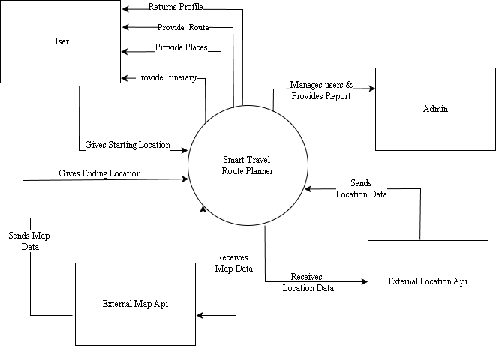

3.3 DATA FLOW DIAGRAM

A data flow diagram (DFD) is a graphical tool used to illustrate and analyze the movement of data within a system. It serves as a fundamental tool from which other components of the system are developed. DFDs describe the logical flow of data between various elements in a system, such as people, departments, and workstations, independently of the physical components. These diagrams, often referred to as "bubble charts," are crucial for understanding system requirements and identifying key data transformations that will be translated into programs during system design. DFDs consist of interconnected bubbles representing processes, data sources or destinations, data stores, and information or data lines.
The Three symbols used for drawing DFDs are:

Process or function


Data Store

Data flow

Rules for drawing data flow diagrams:
Rule 1: Define the context of the diagram by identifying all input and output data flows.
Rule 2: Choose a starting point for drawing the DFD.
Rule 3: Provide meaningful labels for all data flow lines.
Rule 4: Label processes with action verbs that relate to input and output data
flows.
Rule 5: Exclude insignificant functions usually handled during programming.
Rule 6: Avoid including control or flow of control information.
Rule 7: Avoid overcrowding the DFD with excessive information.
Rule 8: Be open to starting the diagram over if necessary.

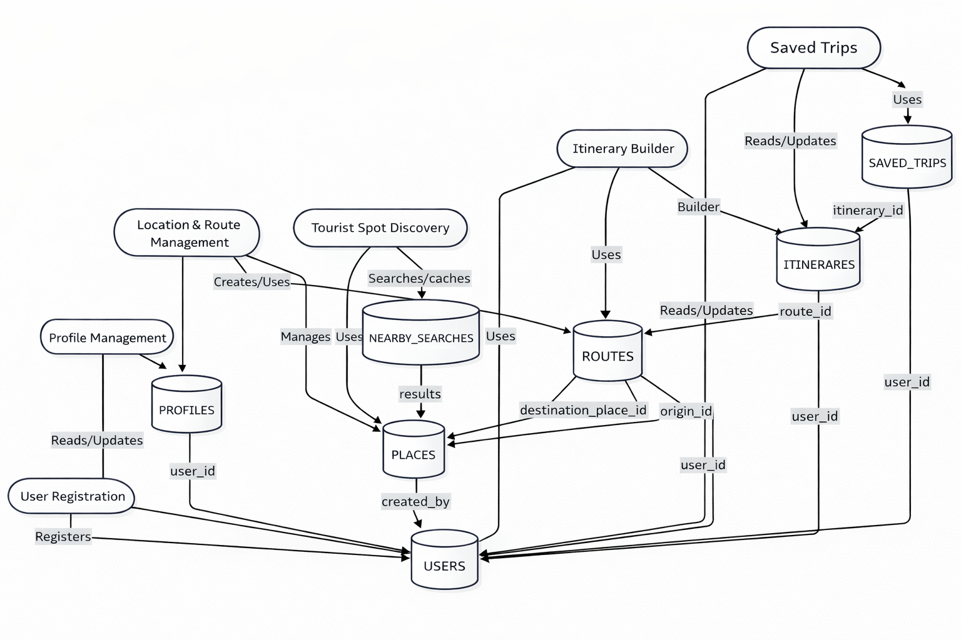
Data Flow Showing Smart Travel Route Planner

3.4 ENTITY RELATIONSHIP DIAGRAM
The ER model provides a conceptual way to perceive the real world, representing it as a collection of entities and the relationships between them. Central to this model is the Entity-Relationship diagram, a visual tool used to illustrate data components. ER modelling is extensively applied in the initial design phase of database applications, and its concepts are fundamental to various database design tools.

 Entity Type

 Weak Entity Type

 Relationship Type

 Attribute

 Key attribute

ER Diagram Showing Smart Travel Route Planner

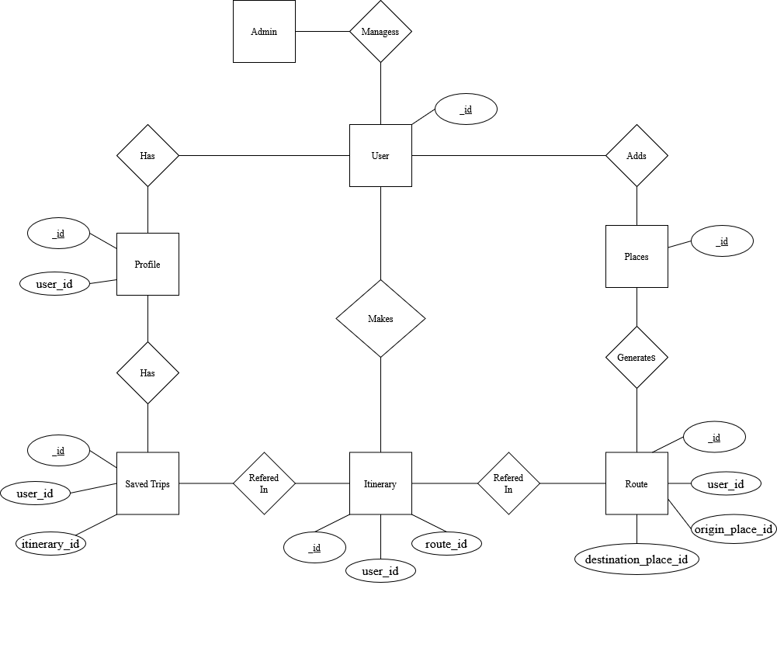

4.1 INPUT DESIGN
Input design is the process of converting a user-oriented description of the inputs to a computer-based system into a programmer-oriented specification. The quality of system input determines the quality of system output. Input specification describes the manner in which data enter the system for processing. Input design features can ensure the reliability of the system and produce result from accurate data or they can result in the production of errors. The input design also determines whether the user can interact efficiently with the system. Input design requires consideration of the needs of the data entry operator. Three data entry considerations are:
• The field length must be documented.
• The sequence of fields must match the sequence of the fields on the source document.
• The data format must be identified to the data entry operator.
In our system almost, all inputs are being taken from the databases. To provide adequate inputs we have to select necessary values from the databases and arrange it to the appropriate controls.
Inaccurate input data are the most common cause of errors in data processing. Errors entered by data entry can be controlled by input design. Input design is the process of converting user-oriented inputs to a computer-based format. There are three major approaches for entering data into the computer. They are menus, formatted forms and prompts. A menu is a selection list that simplifies computer data access or entry. Instead of remembering what to enter, the user choices from the list of option. A formatted form is a pre-printed form or a template that request the user to enter data inappropriate location. It is a fill-in-the-blank type form. The form is flashed on the screen as a unit. In prompt the system displays one enquiry at a time, asking the user for a response.

Login Page
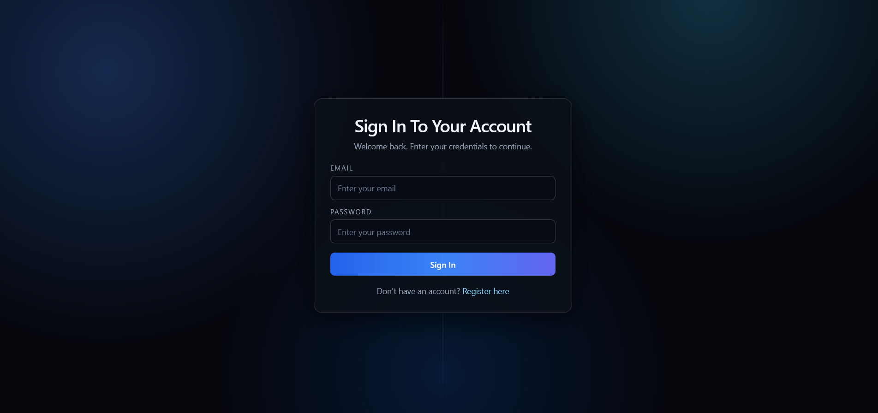
Description: This is the Login page for this website

Home Page
Description: This is the home page for this website
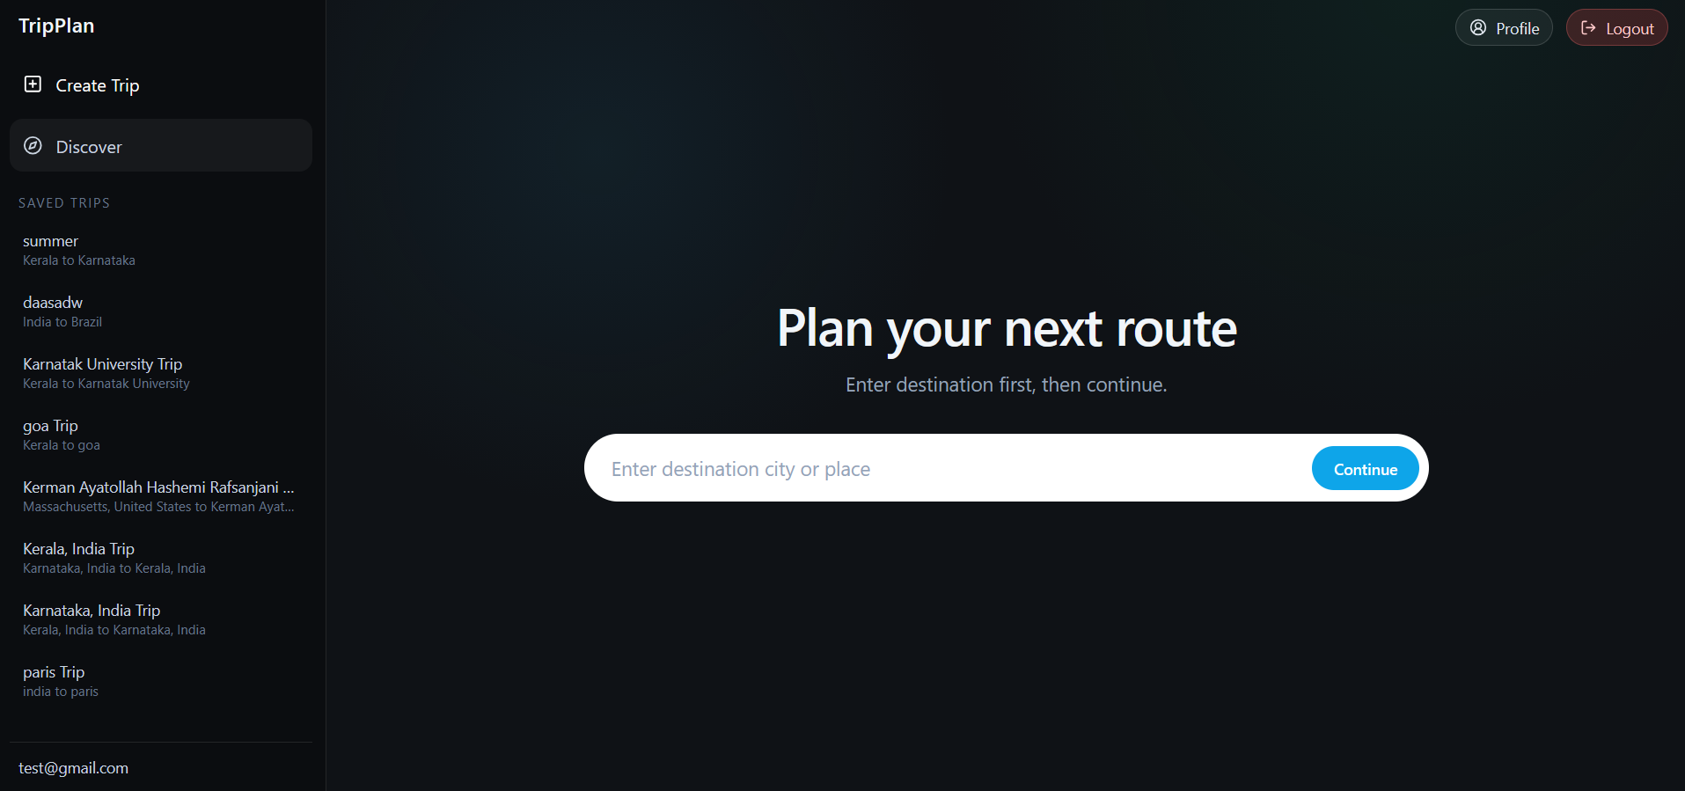

Trip Creation Page
Description: This is the Trip creation page for this website
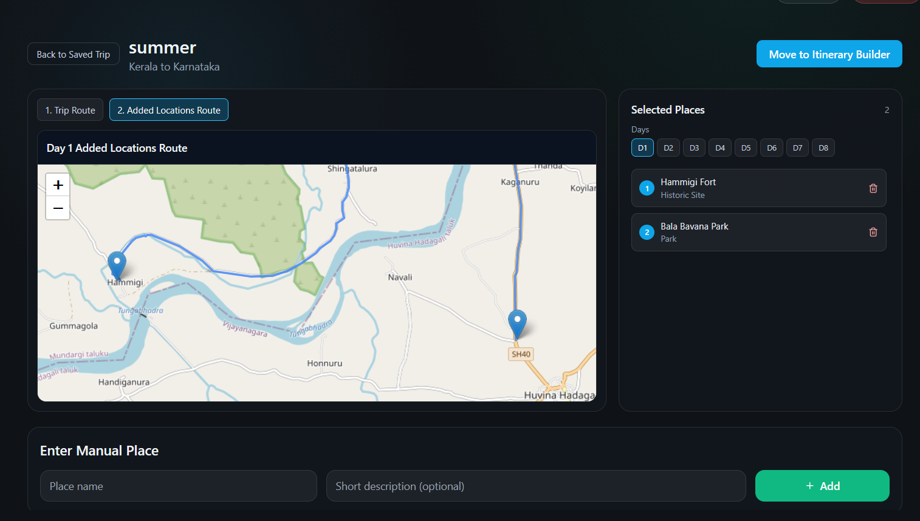

Admin Page
Description: This is the Admin page for this website
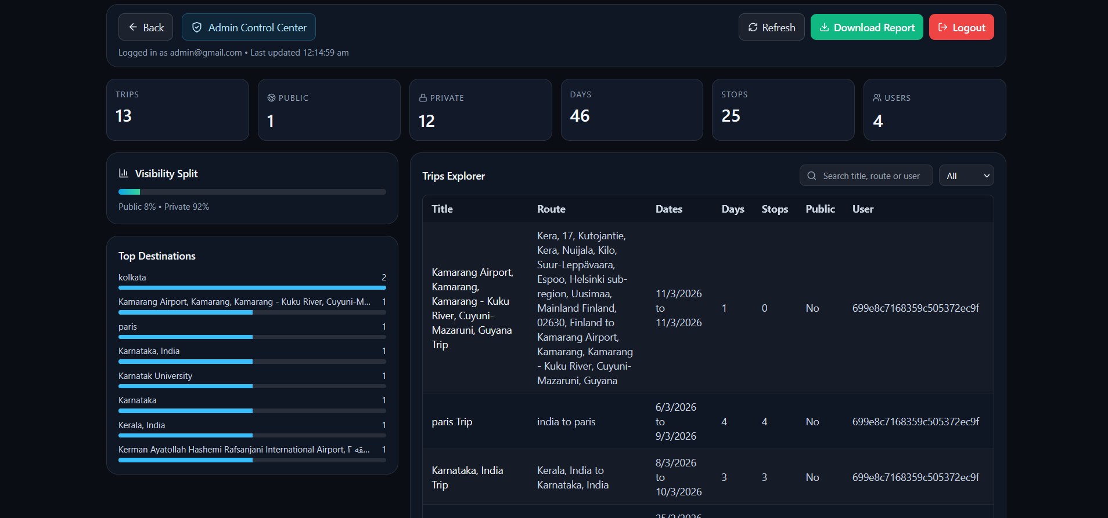

4.2 OUTPUT DESIGN
One of the most important components of an information system is the output it generates, as outputs directly reflect the usefulness and effectiveness of the system to its users. In the Smart Travel Route Planner, outputs are designed to present travel routes, recommended destinations, and itinerary details in a clear, structured, and interactive format for travelers planning their journeys.
The success of the system largely depends on its ability to transform user inputs—such as starting location, ending location, and selected tourist spots—into a well-organized and optimized travel plan. Therefore, output design was given significant importance during system development. The system generates multiple outputs including interactive route maps, recommended tourist spots, generated travel itineraries, total travel distance and duration summaries, and saved trip records.
During the analysis phase, the required outputs were identified based on common travel planning needs and user expectations. In the design phase, these outputs were structured using a clean and intuitive interface to ensure clarity and ease of understanding. The outputs are primarily displayed on-screen through an interactive map and dynamic content panels, allowing users to visualize routes, explore recommended locations, and modify travel plans in real time.
The system displays the route on an interactive map and suggests nearby tourist attractions. Users can select places to create a customized itinerary with estimated distance and travel time. All plans can be saved, viewed, edited, and reused, ensuring an organized and efficient travel planning experience.

Itinerary viewer Page
Description: This is the page for viewing Itinerary
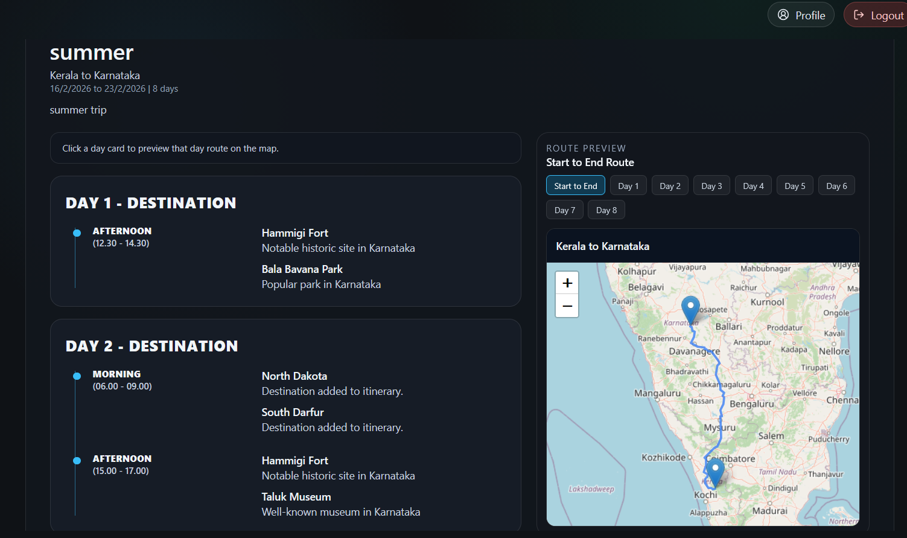

Discover Trip Page
Description: This is the page for viewing Trip Discovery
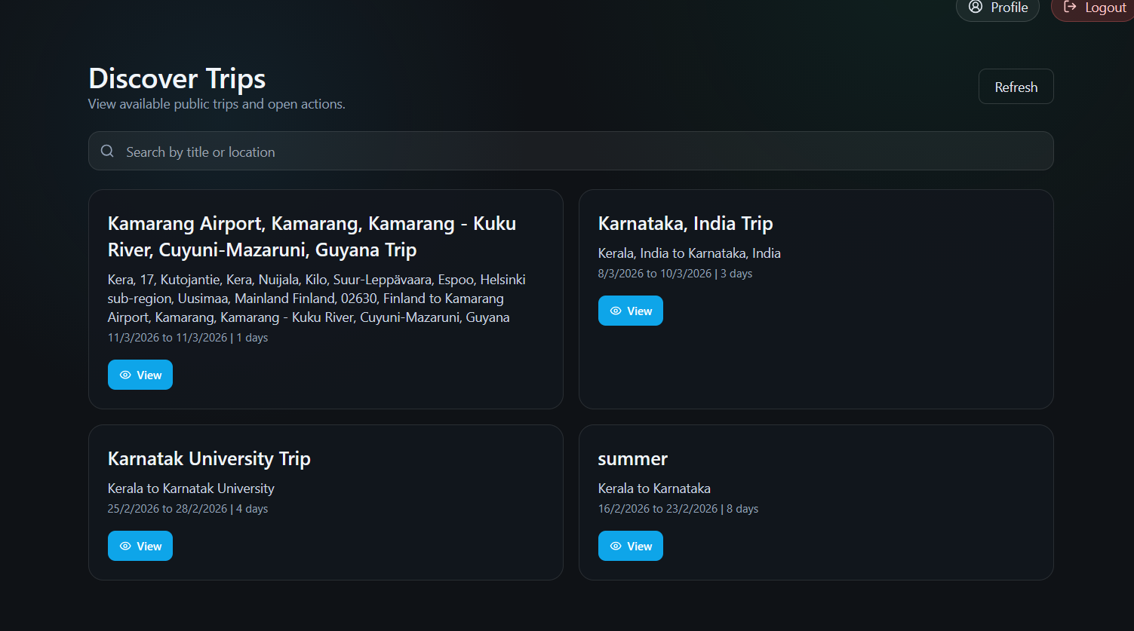

4.3 NOSQL DATABASE DESIGN
Users Collection
Description:
Stores all registered users’ essential account information, including login credentials, assigned roles (e.g., user or admin), and account status. This collection serves as the foundation for authentication, authorization, and linking user-specific data across the application.
{
_id: ObjectId("..."), // PK, auto-generated by MongoDB
username: "john_doe", // string, unique
email: "john@example.com", // string, unique
password_hash: "<hashed_pw>", // string
role: "user", // string: "user" | "admin"
is_active: true, // boolean, default: true
created_at: ISODate("2024-06-12T10:00:00Z"), // date
updated_at: ISODate("2024-06-12T11:00:00Z") // date
}
Profiles Collection
Description:
Contains extended personal and preference information for each user, such as full name, contact details, profile picture, travel preferences, and other personalization data. Each profile is linked to a specific user account and supports features that offer a tailored user experience.
{ _id: ObjectId("..."), // PK
user_id: ObjectId("..."), // FK, references USERS._id
full_name: "John Doe", // string

phone: "+1 555-1234", // string
date_of_birth: ISODate("1990-01-01T00:00:00Z"), // date
gender: "male", // string
profile_pic_url: "https://...", // string (URL)
profile_pic_uploaded_at: ISODate("2024-06-01T09:00:00Z"), // date
preferences_travel_type: ["adventure", "culture"], // array of string
preferences_budget_range: "mid", // string
created_at: ISODate("2024-06-12T10:00:00Z"), // date
updated_at: ISODate("2024-06-12T11:00:00Z") // date
}
Places Collection
Description:
Holds detailed information about destinations, landmarks, accommodations, restaurants, or custom locations within the system. Each place entry has geographic coordinates, categorization, external reference data, and is optionally linked to the user who added it. This collection powers discovery and trip planning features.
{
_id: ObjectId("..."), // PK
name: "Eiffel Tower", // string
place_type: "landmark", // string (enum)
coordinates_lng: 2.2945, // float
coordinates_lat: 48.8584, // float
address: "Champ de Mars, Paris", // string
external_provider: "osm", // string: "osm" | "manual"
external_place_id: "OSM12345", // string

categories: ["sightseeing"], // array of string
rating: 4.8, // float
is_api_generated: true, // boolean
created_by: ObjectId("..."), // FK, references USERS or null
created_at: ISODate("2024-06-12T10:00:00Z"), // date
updated_at: ISODate("2024-06-12T11:00:00Z") // date
}
Routes Collection
Description:
Represents travel routes generated or saved by users, including the start and end locations (linked to PLACES), route distance, duration, and the encoded travel path. Routes support the creation of itineraries and facilitate personalized travel planning.
{
_id: ObjectId("..."), // PK
user_id: ObjectId("..."), // FK, references USERS
origin_place_id: ObjectId("..."), // FK, references PLACES
destination_place_id: ObjectId("..."), // FK, references PLACES
distance_km: 10.5, // float
duration_minutes: 20, // int
polyline: "<encoded polyline>", // string
created_at: ISODate("2024-06-12T10:00:00Z") // date
}
Nearby_searches Collection
Description:
Caches the results of spatial searches for places around a specific geographic

location, defined by coordinates and radius. This collection improves search efficiency by storing results for reuse, minimizing redundant external API calls, and linking discovered places for quick lookup.
{
_id: ObjectId("..."), // PK
center_lng: 2.2945, // float
center_lat: 48.8584, // float
radius_meters: 500, // int
place_types: ["landmark", "restaurant"], // array of string
results: [ObjectId("..."), ...], // array of FK, references PLACES._id
cached_at: ISODate("2024-06-12T10:05:00Z"), // date
expires_at: ISODate("2024-06-12T12:05:00Z") // date }
Itineraries Collection
Description:
Manages users’ custom travel itineraries, tying together selected routes and planned daily activities. Each itinerary includes a title, breakdown by days (structured as JSON), and a reference to the associated route and user. This collection enables users to organize and visualize their trip plans.
{
_id: ObjectId("..."), // PK
user_id: ObjectId("..."), // FK, references USERS
route_id: ObjectId("..."), // FK, references ROUTES
title: "Paris City Tour", // string
days: {/* custom JSON structure */}, // object/JSON
total_days: 3, // int
created_at: ISODate("2024-06-12T10:00:00Z"), // date

updated_at: ISODate("2024-06-12T11:00:00Z") // date
}
Saved_trips Collection
Description:
Tracks trips that users have planned, are currently undertaking, or have completed. Each saved trip links back to an itinerary and user, stores custom trip names, statuses (planned, ongoing, completed), and travel dates. This collection allows users to manage their travel history and access previous or active plans.
Let me know if you'd like the descriptions in a table or with briefer/expanded text for your documentation!
{
_id: ObjectId("..."), // PK
user_id: ObjectId("..."), // FK, references USERS
itinerary_id: ObjectId("..."), // FK, references ITINERARIES
trip_name: "Summer 2024 Europe", // string
status: "planned", // string: "planned" | "ongoing" | "completed"
start_date: ISODate("2024-07-01T00:00:00Z"), // date
end_date: ISODate("2024-07-10T00:00:00Z"), // date
created_at: ISODate("2024-06-12T10:00:00Z"), // date
updated_at: ISODate("2024-06-12T11:00:00Z") // date
}

5.1 INTRODUCTION
Testing in the Smart Travel Route Planner is the process of evaluating the system to ensure that its actual functionality aligns with the requirements defined during the design phase. The primary objective of testing is to identify and correct errors before the system is deployed for real user interaction.
Although testing cannot guarantee that the system is completely error-free, it helps build confidence by verifying that all major functionalities operate correctly under expected conditions. For the Smart Travel Route Planner, testing focused on detecting issues that could affect route generation accuracy, tourist spot recommendations, itinerary creation, trip storage, user authentication, or overall system performance.
System testing formed a crucial stage prior to deployment. This phase ensured that all core modules—including user registration and login, route generation, map visualization, tourist spot recommendation, itinerary generation, saved trips management, and profile management—functioned accurately and integrated seamlessly. The testing process followed the principle that if each module performs correctly both independently and collectively, the overall system will operate reliably and meet user expectations.
Levels of Testing
5.1.1 Unit Testing
5.1.2 Integration Testing
5.1.3 Output Testing
5.1.4 Validation Testing
5.1.1 Unit Testing
Output testing ensured that all generated resume outputs, including AI-generated content, on-screen resume previews, and final ATS-friendly PDF documents, were accurate and properly formatted. User feedback was

considered to confirm clarity, consistency, and professional presentation of the generated resumes.
5.1.2 Integration Testing
Integration testing verified that different modules of the Smart Travel Route Planner worked together smoothly. The interaction between the React frontend, FastAPI backend, and MongoDB database was tested to ensure correct data flow and seamless system functionality.
5.1.3 Output Testing
Output testing ensured that all generated outputs of the Smart Travel Route Planner, including route maps, recommended tourist spots, and generated itineraries, were accurate and properly displayed. User feedback was considered to verify clarity, correctness of routes, and usefulness of the suggested locations for effective travel planning.
5.1.4 Validation Testing
Validation testing confirmed that the Smart Travel Route Planner met all specified requirements and fulfilled its purpose of simplifying travel planning. The system was tested to ensure that route generation, attraction recommendations, itinerary creation, and trip saving worked correctly before deployment.

5.2 TEST CASES
A test plan documents the strategy that will be used to verify and ensure that a product or system meets its design specification and other requirements. A test plan is usually prepared by or with significant input from Test Engineers.
5.2.1 Unit Testing
Form / Module | Procedure | Expected Result | Actual Result | Status
Landing Page | Open application URL | Landing page loads successfully | Page loaded successfully | Pass
Login Form | Enter valid email and password | User authenticated and redirected to dashboard | Login successful | Pass
User Registration | Register with valid user details | Confirmation message displayed | User registered successfully | Pass
Create Trip | Click "Create New Trip" button | Route input fields displayed | Fields displayed correctly | Pass
Route Input Form | Enter start and end locations | Route generated on map | Route displayed successfully | Pass
Map Display | Generate route | Interactive map displays travel path | Map displayed correctly | Pass
Tourist Spot Recommendation | Generate route | Recommended tourist spots displayed | Spots displayed correctly | Pass
Spot Selection | Select recommended tourist spots | Selected spots added to itinerary builder | Spots added successfully | Pass
Itinerary Generation | Generate itinerary from selected spots | Ordered itinerary generated | Itinerary created successfully | Pass
Save Trip | Save generated itinerary | Trip stored in database | Trip saved successfully | Pass
Saved Trips History | Click saved trip in sidebar | Stored itinerary displayed | Trip loaded successfully | Pass
Profile View | Open profile section | User profile information displayed | Profile displayed | Pass

5.2.2 Integration Testing
Module / Feature | Procedure | Expected Result | Status
Login and Dashboard | User logs in with valid credentials | Dashboard loads successfully | Pass
Trip Creation and Route Generation | Enter start and end locations | Route displayed on map | Pass
Map and Tourist Spot Integration | Generate route | Recommended tourist spots appear below map | Pass
Spot Selection and Itinerary Builder | Select tourist spots | Spots added to itinerary builder | Pass
Itinerary Generation | Generate itinerary | Complete itinerary displayed | Pass
Save Trip | Save itinerary | Trip stored in MongoDB database | Pass
Saved Trips History | Select saved trip | Previously generated itinerary displayed | Pass
Frontend–Backend Communication | React sends API request | FastAPI returns correct response | Pass
Backend–Database Integration | Store itinerary data | MongoDB stores trip successfully | Pass
Logout | Click logout button | User redirected to login page | Pass

5.2.3 Validation Testing
Form / Module | Procedure | Expected Result | Status
Login Form | Submit login with invalid credentials | Error message displayed | Pass
User Registration | Submit registration form with missing fields | Error message displayed | Pass
Route Input | Leave start or end location empty | Warning message displayed | Pass
Invalid Location Input | Enter incorrect location | Error message displayed | Pass
Itinerary Generation | Attempt to generate itinerary without selecting spots | Warning message displayed | Pass
Save Trip | Attempt to save itinerary without route | Error message displayed | Pass
Duplicate Account | Register with existing email | Error message displayed | Pass
Profile Update | Submit empty profile fields | Validation message displayed | Pass
Invalid Input Format | Enter incorrect data in input fields | Error message displayed | Pass

6.1 INTRODUCTION
In the Smart Travel Route Planner, the implementation phase represents the transformation of the approved system design into a fully functional web-based travel planning platform. This phase involved careful planning, analysis of user requirements, and evaluation of technical constraints to ensure smooth deployment. Key activities included system configuration, backend API development, frontend interface implementation, and database setup for managing users, routes, itineraries, and saved trips.
A structured implementation plan was followed, outlining development milestones, resource allocation, and deployment procedures. The system was deployed only after successful testing to verify functionality, route generation accuracy, tourist spot recommendations, itinerary creation, and proper interaction between the React frontend, FastAPI backend, and MongoDB database. Once implemented, the platform was made operational for real-time use, allowing users to generate routes, explore recommended destinations, build itineraries, and manage saved trips efficiently.
The implementation phase ensured system stability, improved usability, and built user confidence by delivering a reliable, scalable, and performance-oriented travel route planning solution.

6.2 INSTALLATION PROCEDURE
In the Smart Travel Route Planner, installation represents the final stage of deploying the system in a real-world environment to ensure stable operation and easy user accessibility. This phase mainly focused on preparing the required software environment, configuring the backend services, and establishing database connections to enable efficient storage and retrieval of system data.
The implementation involved deploying the React frontend, which provides an interactive interface for users to create trips, generate routes, and manage itineraries. The FastAPI backend server was configured to handle application logic, process user requests, and manage communication between the frontend and the database. The MongoDB database was set up to securely store user accounts, route information, itineraries, and saved trips.
Proper integration between the frontend, backend, and database ensured smooth communication and reliable system performance. Additional configurations such as API connections, server setup, and dependency installations were completed to ensure that the application runs efficiently in the deployment environment.
Careful planning and verification were carried out during installation to avoid technical issues and ensure system stability. The system was made operational only after successful testing of all core modules, including user registration, route generation, tourist spot recommendations, itinerary creation, and saved trip management.
The successful installation and implementation of the Smart Travel Route Planner ensured that the platform met user requirements and delivered a stable, scalable, and efficient solution for organizing and managing travel plans.

6.3 IMPLEMENTATION PLAN
The Implementation Plan for the Smart Travel Route Planner defines the structured process for deploying and transitioning the system into full operational use. It outlines key activities such as system setup, frontend and backend configuration, database deployment, map service integration, and user access management. These steps ensure that the application functions efficiently and meets all system requirements.
The system was developed using React for the frontend, which provides an interactive and responsive user interface for route planning and itinerary management. The FastAPI backend handles application logic, route generation requests, and communication between the frontend and the database. The MongoDB database stores user data, routes, itineraries, and saved trips securely, enabling efficient data management and retrieval.
Map services were integrated into the system to generate routes and display them through an interactive map interface. This allows users to visualize travel paths and explore recommended tourist spots based on their destination.
The implementation plan was initially prepared during the Design Phase, refined during the Development Phase, and finalized after Integration and System Testing. This structured approach helped coordinate development tasks, minimize deployment risks, and ensure a smooth transition from traditional travel planning methods to the intelligent route planning platform powered by React, FastAPI, and MongoDB.

7.1 FUTURE ENHANCEMENT
Although the Smart Travel Route Planner effectively fulfills current travel route planning and itinerary management requirements, there is significant scope for future enhancements to further improve functionality, intelligence, and user experience. Potential extensions include:
- Mobile Application Support: Development of dedicated Android and iOS applications to allow users to plan trips, generate routes, and manage itineraries directly from their smartphones.
- Real-Time Traffic Integration: Integration of live traffic data to provide more accurate route suggestions, travel time estimates, and alternative route recommendations.
- AI-Based Travel Recommendations: Implementation of AI algorithms to suggest tourist spots, restaurants, and activities based on user preferences, travel history, and popular trends.
- Multi-Day Trip Planning: Addition of advanced itinerary features that support planning trips across multiple days with optimized daily schedules.
- Weather Forecast Integration: Display of real-time weather information for selected destinations to help users plan trips more effectively.
- Budget Estimation Module: Introduction of a feature that estimates travel costs including transportation, accommodation, and attractions to help users plan within their budget.
- Social Sharing & Collaboration: Allow users to share itineraries with friends or collaborate on travel plans in real time.
These future enhancements would further improve the system’s capabilities, enhance user convenience, and transform the Smart Travel Route Planner into a more intelligent and comprehensive travel planning platform.

BIBLIOGRAPHY
The following websites were referred to during the development and documentation of the Smart Travel Route Planner project:
• React Official Documentation – https://react.dev/
• FastAPI Documentation – https://fastapi.tiangolo.com/
• MongoDB Documentation – https://www.mongodb.com/docs/
•JavaScript Documentation (MDN Web Docs) https://developer.mozilla.org/
•Google Maps Platform Documentation – https://developers.google.com/maps/documentation
• GitHub – https://github.com/
• Stack Overflow – https://stackoverflow.com/

APPENDICES
APPENDIX A
Sample Source Code/Pseudo Code
'use client';
import React, { useState, useEffect } from 'react';
import { tripsApi } from '@/lib/api';
import { TripCard } from '@/components/TripCard';
import { ProtectedRoute } from '@/components/ProtectedRoute';
import { Globe, Search } from 'lucide-react';

export default function DiscoverPage() {
const [trips, setTrips] = useState<any[]>([]);
const [isLoading, setIsLoading] = useState(true);
const [searchQuery, setSearchQuery] = useState('');

useEffect(() => {
loadPublicTrips();
}, []);

const loadPublicTrips = async () => {
try {
const response = await tripsApi.getPublicTrips(20, 0);
setTrips(response.data.trips);
} catch (error) {
console.error('Failed to load trips:', error);

} finally {
setIsLoading(false);
}
};

const filteredTrips = trips.filter((trip) =>
trip.title.toLowerCase().includes(searchQuery.toLowerCase()) ||
trip.start_location.toLowerCase().includes(searchQuery.toLowerCase()) ||
trip.end_location.toLowerCase().includes(searchQuery.toLowerCase())
);

return (
<ProtectedRoute>
<div className="min-h-screen bg-gray-50">
{/* Hero Section */}
<div className="bg-gradient-to-r from-indigo-600 to-purple-600 text-white py-12">
<div className="max-w-7xl mx-auto px-4">
<h1 className="text-4xl font-bold mb-4 flex items-center gap-2">
<Globe size={36} />
Discover Trips
</h1>
<p className="text-xl">Explore amazing journeys from travelers around the world</p>
</div>

</div>
{/* Main Content */}
<div className="max-w-7xl mx-auto px-4 py-12">
{/* Search Bar */}
<div className="mb-12">
<div className="relative">
<Search className="absolute left-4 top-3 text-gray-400" size={20} />
<input
type="text"
value={searchQuery}
onChange={(e) => setSearchQuery(e.target.value)}
placeholder="Search trips by location or title..."
className="w-full pl-12 pr-4 py-3 border border-gray-300 rounded-lg focus:outline-none focus:border-blue-500"
/>
</div>
</div>

{/* Trips Grid */}
{isLoading ? (
<div className="text-center py-12">
<p className="text-gray-600">Loading trips...</p>
</div>
) : filteredTrips.length > 0 ? (

<div className="grid grid-cols-1 md:grid-cols-2 lg:grid-cols-3 gap-6">
{filteredTrips.map((trip) => (
<TripCard key={trip._id} trip={trip} mode="discover" />
))}
</div>
) : (
<div className="bg-white rounded-lg p-12 text-center">
<Globe size={48} className="mx-auto text-gray-400 mb-4" />
<h3 className="text-xl font-bold text-gray-800 mb-2">No trips found</h3>
<p className="text-gray-600">Try adjusting your search</p>
</div>
)}
</div>
</div>
</ProtectedRoute>
);
}

APPENDIX B
Acronyms
ER- Entity relation
DFD-Data Flow Diagram
API – Application Programming Interface
NoSQL – Not Only Structured Query Language
JSON – JavaScript Object Notation

