Exp_1

SQL CODE:

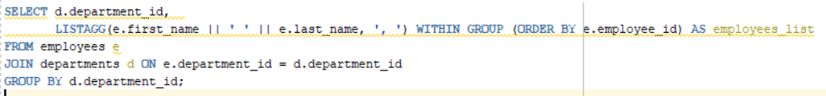

RESULT:

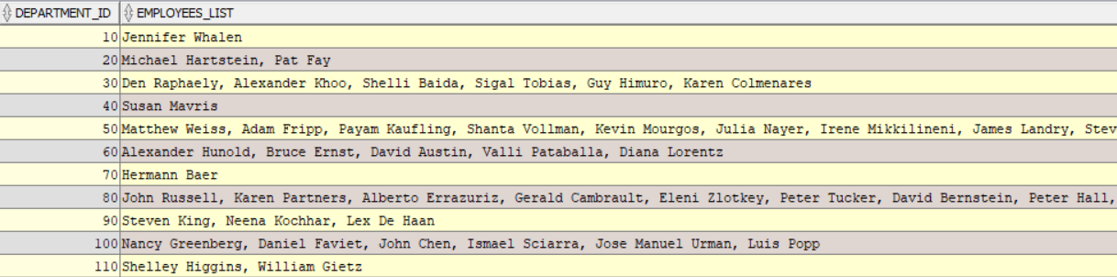

EXP_2

SQL CODE: SELECT EMPLOYEES.*, SUM(SALARY)

OVER (PARTITION BY JOB_ID ORDER BY EMPLOYEE_ID ROWS BETWEEN 1 PRECEDING AND 1 FOLLOWING) NUM

FROM EMPLOYEES;

RESULT:

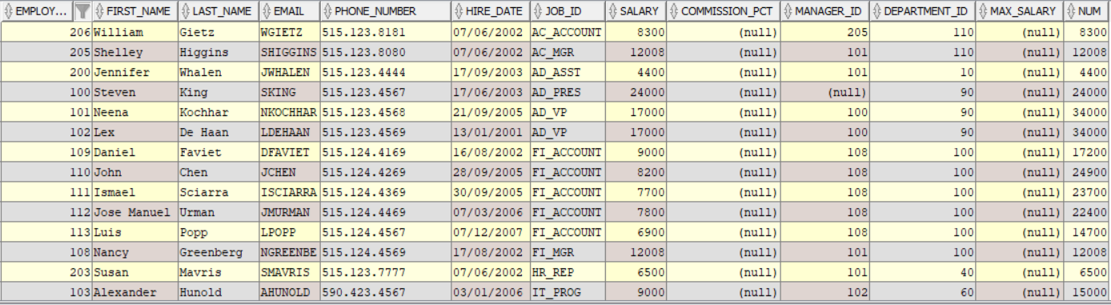

EXP_3

SQL CODE: SELECT EMPLOYEE_ID,PHONE_NUMBER,HIRE_DATE,DEPARTMENT_ID,LEAD(PHONE_NUMBER,1) OVER(PARTITION BY DEPARTMENT_ID ORDER BY HIRE_DATE) NEXT FROM EMPLOYEES;

RESULT:

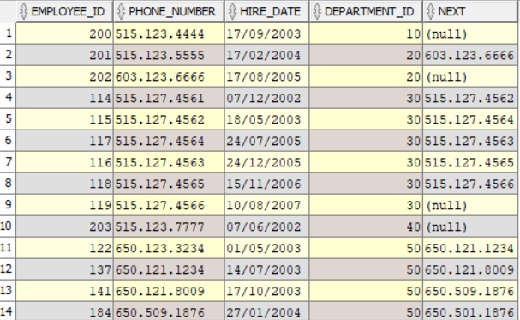

EXP_4

SQL CODE: SELECT EMPLOYEES.*,RANK() OVER(ORDER BY SALARY DESC,HIRE_DATE ASC) SALARY_RANK FROM EMPLOYEES ORDER BY SALARY_RANK;

RESULT:

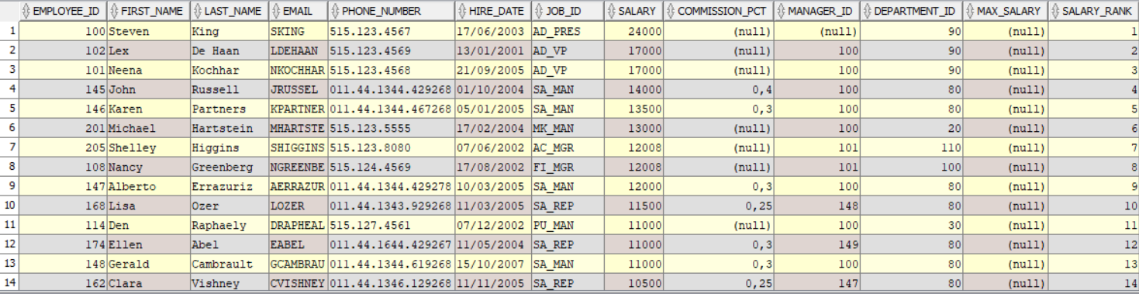

EXP_5

SQL CODE: SELECT EMPLOYEE_ID,NTILE(4) OVER (ORDER BY EMPLOYEE_ID) FROM EMPLOYEES;

RESULT:

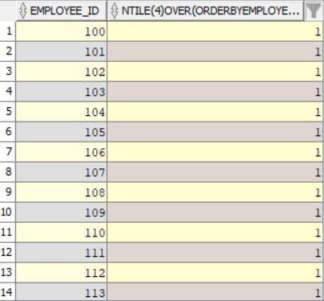

EXP_6

SQL CODE: SELECT EMPLOYEE_ID,SALARY,DEPARTMENT_ID,

CASE

WHEN SALARY<avg_salary_lower THEN 0

ELSE 1

END AS SALARY_LABEL FROM (SELECT EMPLOYEE_ID,SALARY,DEPARTMENT_ID,

AVG(SALARY) OVER (PARTITION BY DEPARTMENT_ID) AS avg_salary_lower FROM EMPLOYEES) ORDER BY 1,3;

RESULT:

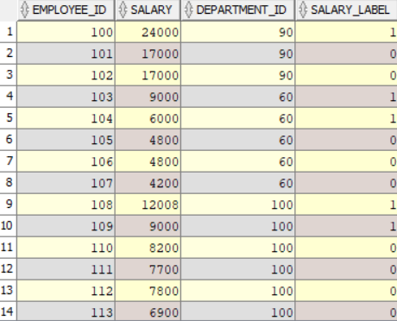

EXP_7

SQL CODE: SELECT E.EMPLOYEE_ID,E.HIRE_DATE,E.DEPARTMENT_ID FROM EMPLOYEES E JOIN(

SELECT EMPLOYEE_ID,HIRE_DATE FROM (SELECT EMPLOYEE_ID,HIRE_DATE,ROW_NUMBER() OVER (PARTITION BY EXTRACT(YEAR FROM HIRE_DATE) ORDER BY HIRE_DATE) AS rn FROM EMPLOYEES)

RANKED_EMPLOYEES WHERE rn=1 ) first_employee_per_year ON E.EMPLOYEE_ID=first_employee_per_year.employee_id and E.HIRE_DATE=first_employee_per_year.HIRE_DATE;

RESULT:

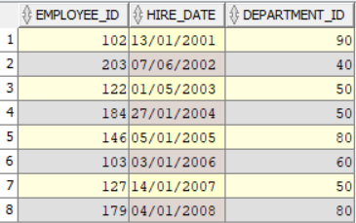

EXP_8

SQL CODE: SELECT * FROM EMPLOYEES WHERE EMPLOYEE_ID NOT IN (SELECT EMPLOYEE_ID FROM(SELECT EMPLOYEE_ID,DENSE_RANK() OVER (PARTITION BY DEPARTMENT_ID ORDER BY SALARY DESC) SALARY_RANK

FROM EMPLOYEES) RANKED WHERE SALARY_RANK=1);

RESULT:

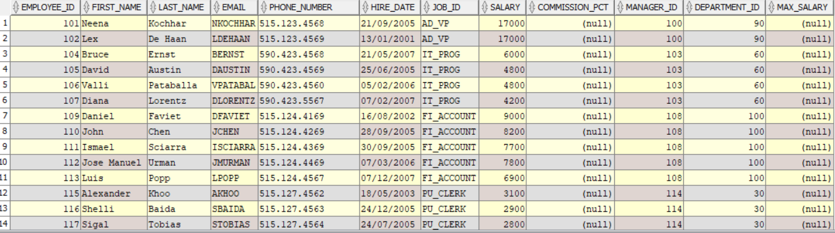

EXP_9

SQL CODE: SELECT * FROM EMPLOYEES

WHERE EMPLOYEE_ID

NOT IN

(SELECT EMPLOYEE_ID FROM (SELECT EMPLOYEE_ID,DENSE_RANK() OVER(PARTITION BY DEPARTMENT_ID ORDER BY SALARY DESC) SALARY_RANK FROM EMPLOYEES)

RANKED WHERE SALARY_RANK>2);

RESULT:

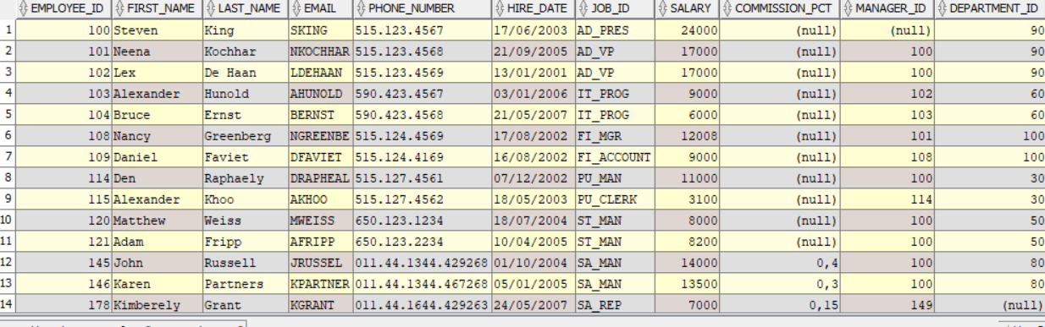

EXP_10

SQL CODE: SELECT E.FIRST_NAME ||' '|| E.LAST_NAME FULL_NAME,E.DEPARTMENT_ID,E.HIRE_DATE,DENSE_RANK() OVER (PARTITION BY DEPARTMENT_ID ORDER BY HIRE_DATE) AS RANK FROM EMPLOYEES E

ORDER BY DEPARTMENT_ID,HIRE_DATE;

RESULT:

