|  |  |
| --- | --- |
| **Topic** | Oracle SQL Language Fundamentals I |
| **Document Name** | SQL02-HW-ANSWER |
|  |  |

## Exercise SQL02-EX-01:

**Definiton :** Write an SQL query that selects employee’s id, employee’s first name, employee’s last name and employee’s **number of months** from hire_date to today for all employees. (Hint:MONTHS_BETWEEN)

**SQL:**

SELECT EMPLOYEE_ID,FIRST_NAME,LAST_NAME,

MONTHS_BETWEEN('23-JUL-2023',HIRE_DATE)

FROM HR.EMPLOYEES

**Screenshot:**

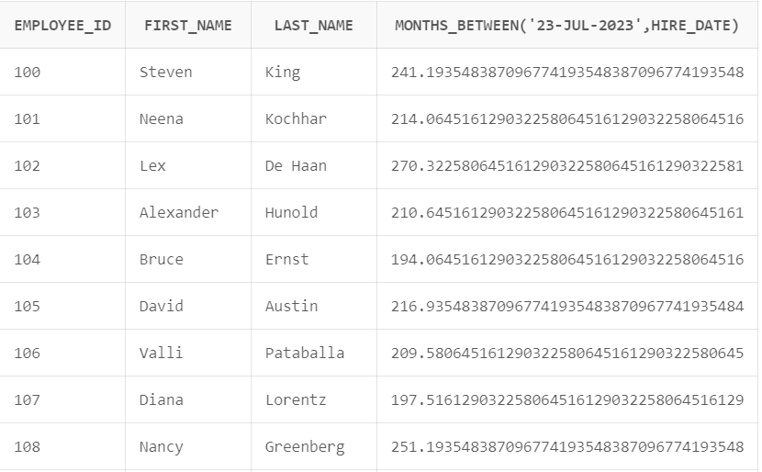

## Exercise SQL02-EX-02:

**Definiton :** Write a query that displays the grade of all employees based on the value of the column JOB_ID, using the following data: (Use DECODE)

|  |  |
| --- | --- |
| **Job** | **Grade** |
| AD_PRES | A |
| ST_MAN | B |
| IT_PROG | C |
| SA_REP | D |
| ST_CLERK | E |
| None of the above | 0 |

**SQL:**

SELECT JOB_ID AS Job , DECODE(JOB_ID,

'AD_PRES','A','ST_MAN','B','IT_PROG','C','SA_REP','D','ST_CLERK','E','0')

AS Grade FROM HR.EMPLOYEES ORDER BY Grade ;

**Screenshot:**

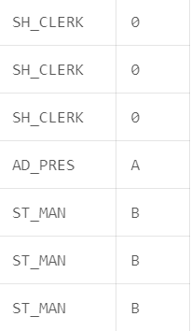

## Exercise SQL02-EX-03:

**Definiton :** Write a query for SQL02-EX-02(previous question) with using **CASE WHEN.**

**SQL:**

SELECT JOB_ID AS JOB,CASE JOB_ID

WHEN 'AD_PRES' THEN 'A'

WHEN 'ST_MAN' THEN 'B'

WHEN 'IT_PROG' THEN 'C'

WHEN 'SA_REP' THEN 'D'

WHEN 'ST_CLERK' THEN 'E'

ELSE '0'

END AS GRADE FROM HR.EMPLOYEES;

**Screenshot:**

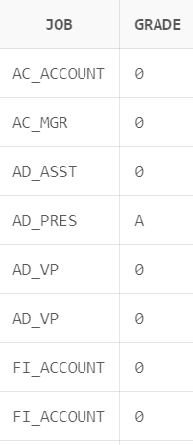

## Exercise SQL02-EX-04:

**Definiton :** Write a query that displays the employee number and last name of all employees who work in a department with any employee whose last name contains a “i”.

**SQL:**

SELECT P.EMPLOYEE_ID,P.LAST_NAME FROM HR.EMPLOYEES P

WHERE P.LAST_NAME LIKE '%i%' AND P.DEPARTMENT_ID IS NOT NULL

**Screenshot:**

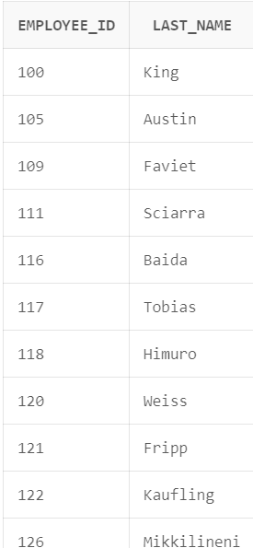

## Exercise SQL02-EX-05:

**Definiton :**

* Create a table for MY_EMP_TABLE with following columns
* Insert following rows,
* Update salary with 1.10 times of salary value
* Delete rows which first_name is David
* Truncate table.

|  |  |  |  |
| --- | --- | --- | --- |
| **ID** | **LAST_NAME** | **FIRST_NAME** | **SALARY** |
| 1 | Black | John | 1100 |
| 2 | White | Kent | 1300 |
| 3 | Orange | David | 1700 |
| 4 | Pink | Alissa | 1900 |

**SQL:**

CREATE TABLE MY_EMP_TABLE(ID NUMBER(1),

LAST_NAME VARCHAR2(20),

FIRST_NAME VARCHAR2(20),

SALARY NUMBER(5,2)

);

INSERT ALL

INTO MY_EMP_TABLE(ID,LAST_NAME,FIRST_NAME,SALARY) VALUES (1,'Black','Jhon',1100)

INTO MY_EMP_TABLE(ID,LAST_NAME,FIRST_NAME,SALARY) VALUES (2,'White','Kent',1300)

INTO MY_EMP_TABLE(ID,LAST_NAME,FIRST_NAME,SALARY) VALUES (3,'Orange','David',1700)

INTO MY_EMP_TABLE(ID,LAST_NAME,FIRST_NAME,SALARY) VALUES (4,'Pink','Alissa',1900)

SELECT * FROM MY_EMP_TABLE;

UPDATE SALARY SET SALARY=SALARY*1.1;

SELECT * FROM MY_EMP_TABLE;

DELETE FROM MY_EMP_TABLE WHERE FIRST_NAME='David';

SELECT * FROM MY_EMP_TABLE;

TRUNCATE TABLE MY_EMP_TABLE;

**Screenshot:**

