|  |  |
| --- | --- |
| **Topic** | Oracle SQL Language Fundamentals I |
| **Document Name** | SQL03-EX-01-05 |
|  |  |

## Exercise SQL03-EX-01:

**Definiton :** Write followig SQL queries:

* Add a colum to employees table named MAX_SALARY.
* Update MAX_SALARY with maximum salary amount with subquery.
* Delete employee who have minimum salary using subquery.

**SQL:**

ALTER TABLE EMPLOYEES ADD MAX_SALARY NUMBER(8,2);

UPDATE EMPLOYEES SET MAX_SALARY = (SELECT MAX(SALARY) FROM EMPLOYEES);

DELETE FROM EMPLOYEES WHERE SALARY =(SELECT MIN(SALARY) FROM EMPLOYEES);

SELECT * FROM EMPLOYEES;

**Screenshot:**



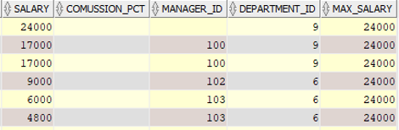



## Exercise SQL03-EX-02:

**Definiton :** Write followig SQL queries:

* Define index (named DPR_NAME_IDX) on DEPARTMENT_NAME column of DEPARTMENTS table.
* Define constraint (named CNSTR_SALARY) on employee salary. (Salary must be between 1000$ and 100.000$)
* Drop defined index.
* Enable, disable, drop defined constraint.

**SQL:**

**CREATE INDEX DPR_NAME_IDX ON DEPARTMENTS(DEPARTMENT_NAME);**

**ALTER TABLE EMPLOYEES ADD CONSTRAINT CNSTR_SALARY CHECK (SALARY>1000 AND SALARY<100000) ;**

**DROP INDEX DPR_NAME_IDX;**

**ALTER TABLE EMPLOYEES ENABLE CONSTRAINT CNSTR_SALARY;**

**ALTER TABLE EMPLOYEES DISABLE CONSTRAINT CNSRTR_SALARY;**

**ALTER TABLE EMPLOYEES DROP CONSTRAINT CNSRTR_SALARY;**

**Screenshot:**









## Exercise SQL03-EX-03:

**Definiton :** Create a table from EMPLOYEES with distinct department_id column. Add department_name to that table. With DEPARTMENTS table, update department_name for included department_ids and insert department_id and department_name values for not included rows. Use MERGE keyword.

**SQL:**

CREATE TABLE NEW_EMP AS SELECT DISTINCT DEPARTMENT_ID FROM EMPLOYEES;

ALTER TABLE NEW_EMP ADD DEPARTMENT_NAME VARCHAR2(20);

MERGE INTO NEW_EMP USING DEPARTMENTS ON (NEW_EMP.DEPARTMENT_ID = DEPARTMENTS.DEPARTMENT_ID) WHEN MATCHED THEN UPDATE SET NEW_EMP.DEPARTMENT_NAME=DEPARTMENTS.DEPARTMENT_NAME;

SELECT * FROM NEW_EMP;_NAME;

SELECT * FROM NEW_EMP;

**Screenshot:**

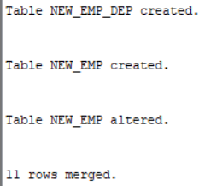

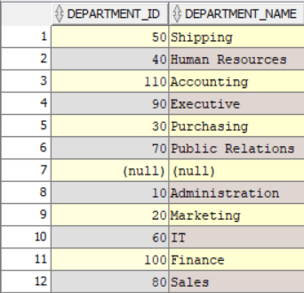

## Exercise SQL03-EX-04:

**Definiton :** Using **WITH** keyword, do following jobs:

* Firstly select first_name, last_name, job_id, department_id from employees table whoes job_id starts with ‘S’.
* Additionally select job_title and min-max salary amount.
* Add department_name to that query.
* Lastly concat first_name and last_name with space as full_name alias and list with other selected columns.

**SQL:**

WITH EMP_JOBS AS (SELECT FIRST_NAME,LAST_NAME,JOB_ID,DEPARTMENT_ID FROM EMPLOYEES WHERE FIRST_NAME LIKE 'S%'),

JOB_MAX_MIN AS ( SELECT JOB_ID,JOB_TITLE,MIN_SALARY,MAX_SALARY FROM JOBS),

DEP_DET AS ( SELECT DEPARTMENT_ID,DEPARTMENT_NAME FROM DEPARTMENTS)

SELECT E.FIRST_NAME,E.LAST_NAME,E.JOB_ID,

JM.JOB_TITLE,JM.MAX_SALARY,JM.MIN_SALARY,

D.DEPARTMENT_NAME,

CONCAT(E.FIRST_NAME,E.LAST_NAME) AS FULL_NAME FROM EMP_JOBS E

JOIN JOB_MAX_MIN JM ON E.JOB_ID = JM.JOB_ID

JOIN DEP_DET D ON E.DEPARTMENT_ID = D.DEPARTMENT_ID;

**Screenshot:**

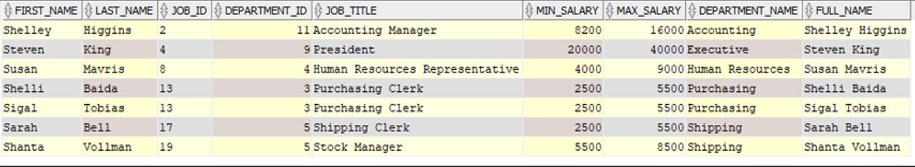

## Exercise SQL03-EX-05:

**Definiton :** Search for COMMIT and ROLLBACK keywords and explain them.

**SQL:**

**Commit is the command used to persist transactions in the database.**

**Rollback lets you undo your actions in a database**

**Screenshot:**