**Design**

**Implementation and User Guide**

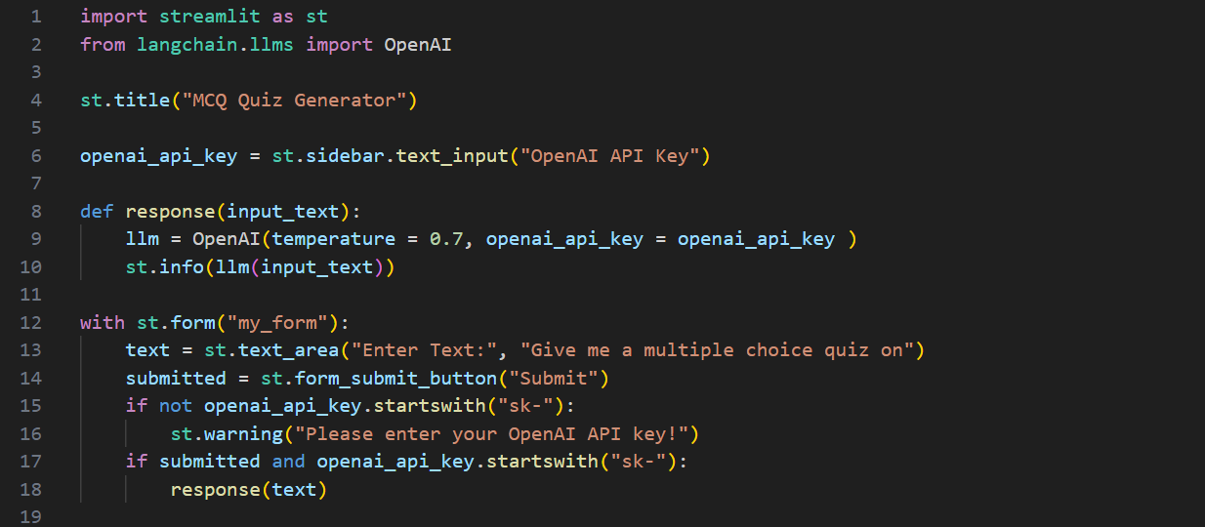

User Guide: -

1. The user prompted to enter an API key.
2. Once the key is entered the user can give a prompt such as “Give me an multiple choice quiz of 5 questions about football” and accordingly the generator makes the quiz.