BIM216 – Database Management Systems

Term Project – Final Report

Eco-Track: Supply Chain Carbon Management System

Project No: 7

Group No: 17

Group Members

Name Surname | Contribution
Muhammed Beşir | 50%
Muhammed Asım Çiçek | 50%
Submission Date: May 5, 2026

1. Requirement Analysis

1.1 Project Overview

Eco-Track is a Supply Chain Carbon Management System designed to help organizations monitor, analyze, and reduce their carbon emissions across the entire supply chain. Eco-Track provides an integrated platform for real-time emission tracking, supplier evaluation, carbon offset management, and regulatory compliance reporting.

1.2 Main Objectives

- Track and record carbon emissions from all supply chain activities including transportation, warehousing, manufacturing, and procurement.

- Enable companies to monitor supplier sustainability performance and carbon footprint contributions.

- Provide advanced analytics and reporting for regulatory compliance (GHG Protocol, ISO 14064, EU CSRD).

- Facilitate carbon offset and credit management to support net-zero targets.

- Support multi-user access with role-based permissions for different organizational levels.

1.3 User Types and Information Needs

User Type | Description | Information Needs
System Administrator | Manages users, system config, and data integrity | User management, system logs, database backups
Sustainability Manager | Oversees carbon strategy and reporting | Aggregate emission reports, trend analysis, compliance status
Supply Chain Analyst | Analyzes supplier and logistics data | Supplier emission scores, transportation data, benchmarks
Supplier (External) | Reports their own emission data | Emission submission forms, verification status
Executive / Viewer | Reviews high-level dashboards | KPI summaries, carbon reduction progress

1.4 Problems the System Aims to Solve

- Fragmented data: Carbon data is scattered across spreadsheets and ERP systems with no unified view.

- Lack of supplier visibility: Companies have limited insight into upstream Scope 3 emissions.

- Compliance risk: EU CSRD and SEC climate rules demand accurate, auditable GHG reporting.

- Inefficient offset tracking: Carbon credit purchases are difficult to reconcile with emission reductions.

- No predictive capability: Without historical analysis, companies cannot forecast emission trends.

1.5 Key Data Attributes and Relationships

- Companies and their organizational hierarchy (subsidiaries, divisions, facilities).

- Emission activities: type (Scope 1/2/3), source, quantity, emission factor, calculated CO2e.

- Suppliers: profile, sustainability rating, submitted emission data, verification status.

- Supply chain transactions: shipments, freight modes, distances, fuel consumption.

- Carbon offsets: project name, certification body, credits purchased, credits retired.

- Regulatory frameworks and compliance targets per period.

1.6 Advanced Database Queries

Query 1 – Monthly Emission Trend Analysis: Total CO2e per company per month with month-over-month % change.

Query 2 – Top Supplier Carbon Risk Ranking: Rank suppliers by Scope 3 contribution using RANK() window function.

Query 3 – Carbon Offset vs. Net Emission Balance: Quarterly gross emissions vs. retired credits showing net balance.

Query 4 – Regulatory Compliance Status Report: Target vs. actual CO2e per framework with over-target percentage.

Query 5 – Transport Mode Emission Comparison: CO2e per tonne-km across road, sea, air, rail, inland waterway.

Query 6 – Emission Intensity by Product Category: Carbon intensity (CO2e per unit) grouped by product category and supplier.

Query 7 – Supplier Emission Verification Lag: Suppliers who have not submitted emission data with days past deadline.

2. Entity-Relationship (E/R) Design

2.1 Identified Entities and Attributes

Entity | Key Attributes | Primary Key
Company | company_id, name, industry, country, tax_id, founded_year | company_id
Facility | facility_id, company_id, name, location, facility_type, size_sqm | facility_id
User | user_id, company_id, email, password_hash, role, full_name | user_id
Supplier | supplier_id, name, country, sustainability_rating, verified | supplier_id
EmissionActivity | activity_id, facility_id, supplier_id, scope, co2e_kg, activity_date | activity_id
Shipment | shipment_id, supplier_id, company_id, transport_mode, co2e_kg, shipment_date | shipment_id
CarbonOffset | offset_id, company_id, project_name, credits_purchased, credits_retired | offset_id
RegulatoryFramework | framework_id, name, jurisdiction, target_year | framework_id
ComplianceRecord | record_id, company_id, framework_id, reporting_period, status | record_id
AuditLog | log_id, user_id, action, table_name, timestamp | log_id

2.2 Relationships and Cardinalities

- Company HAS MANY Facilities (1:N) – A company operates one or more facilities.

- Company HAS MANY Users (1:N) – Users belong to one company.

- Company HAS MANY Suppliers (M:N via SupplierRelationship) – A company works with multiple suppliers.

- Facility RECORDS MANY EmissionActivities (1:N) – Emission events are tied to a facility.

- Supplier CONTRIBUTES TO EmissionActivities (1:N) – Scope 3 activities linked to a supplier.

- Company PURCHASES MANY CarbonOffsets (1:N) – Carbon credits are purchased by a company.

- Company HAS MANY ComplianceRecords (1:N) – Each company tracks compliance against frameworks.

- RegulatoryFramework GOVERNS MANY ComplianceRecords (1:N).

- Shipment involves SUPPLIER and COMPANY (M:N resolved as Shipment entity).

- User GENERATES AuditLog entries (1:N) – All user actions are logged.

2.3 E/R Diagram

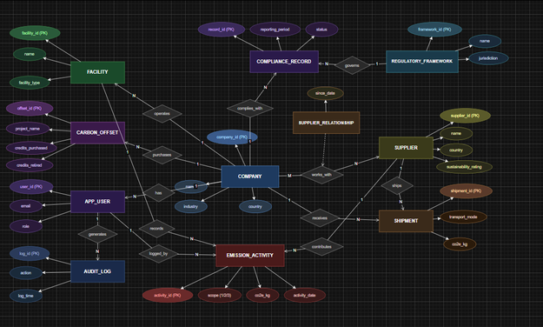

3. Relational Database Schema

3.1 Schema Overview

The E/R diagram was mapped to the following relational schema using the standard mapping rules covered in class. All M:N relationships are resolved into junction tables. Foreign key and NOT NULL constraints are applied where appropriate.

3.2 Relational Schema Diagram

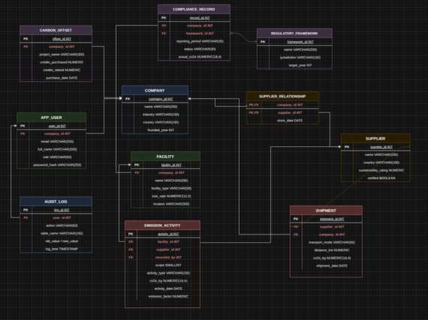

3.3 Schema Description

Table Name | References | Notes
company | – | Root entity; all other tables reference this
facility | company(company_id) | Physical locations of a company
app_user | company(company_id) | Named app_user to avoid SQL reserved word
supplier | – | Supplier profile
supplier_relationship | company + supplier | M:N junction table
emission_activity | facility + supplier + app_user | Core fact table; scope 1/2/3 entries
shipment | supplier + company | Logistics emission events
carbon_offset | company(company_id) | Carbon credit records
regulatory_framework | – | Reference data for regulations
compliance_record | company + regulatory_framework | Tracks target vs actual per period
audit_log | app_user(user_id) | Full audit trail of all changes

System Functionalities
The Eco-Track system is designed as a multi-tier database application that enables comprehensive carbon footprint management across a complex supply chain. The core functionalities are categorized as follows:
Core Database Operations (CRUD)
The application provides a robust Graphical User Interface (GUI) to perform essential Create, Read, Update, and Delete operations on the following entities, ensuring referential integrity at the database level:
- Company & Facility Management: Internal users can define organizational hierarchies and physical locations where emission events occur.
- Supplier Onboarding: Allows the system to register and maintain profiles for external partners, including their base sustainability ratings.
- Emission Activity Logging: The central fact table where Scope 1, 2, and 3 activities are recorded with precise timestamps and categorical data.
Advanced Analytical Reporting
Beyond basic data entry, the system leverages complex SQL queries to provide strategic insights for decision-makers:
- Time-Series Emission Tracking: Using window functions (e.g., LAG, SUM OVER), the system visualizes monthly and quarterly emission trends, allowing Sustainability Managers to monitor net-zero progress.
- Supplier Risk Assessment: Employs ranking algorithms to identify high-polluting suppliers, enabling Supply Chain Analysts to optimize the vendor pool based on carbon intensity.
- Regulatory Compliance Monitoring: Automatically compares actual emission data against predefined targets in the compliance_record table, generating "Status Reports" for frameworks like EU CSRD.
User Authentication and Role-Based Access Control (RBAC)
To ensure data security and accountability, the system implements a strict authorization layer:
- Role-Specific Dashboards: System Admins, Managers, Analysts, and Suppliers each access a tailored interface with permissions restricted to their functional scope.
- Data Validation & Integrity: Every data entry is validated against database constraints (e.g., CHECK for scope types, NOT NULL for critical IDs) to prevent corrupted data entry.
- Audit Logging: Every critical transaction is recorded in the audit_log table, providing a full history of "who changed what and when," which is essential for environmental auditing.

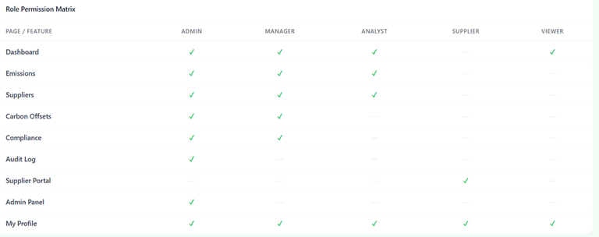

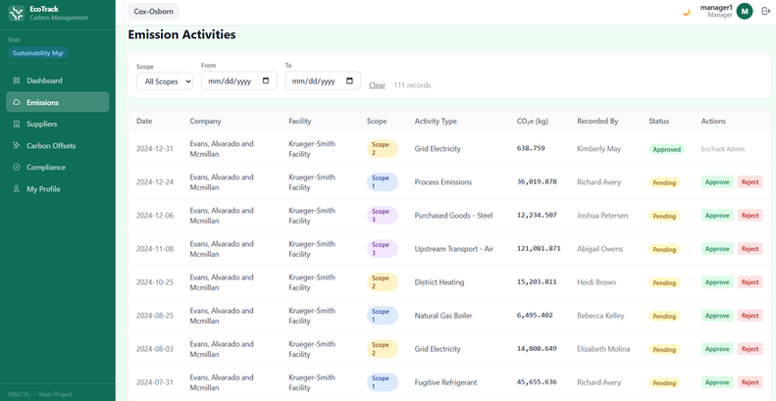

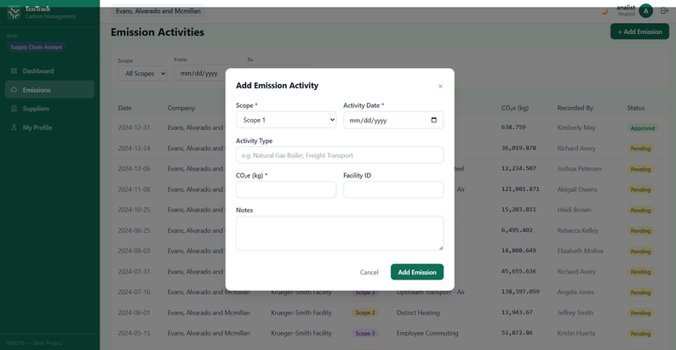

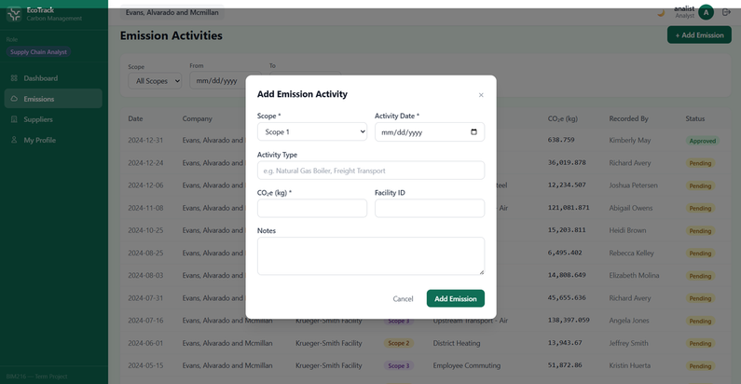

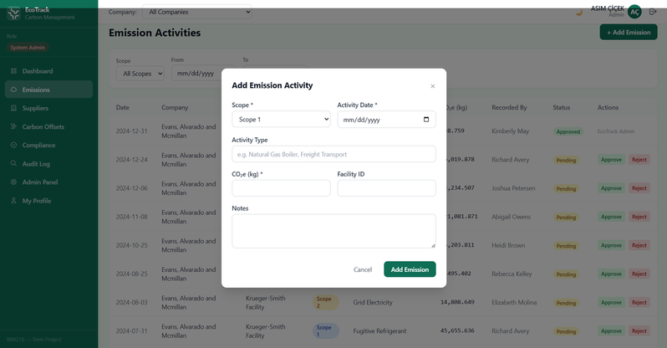

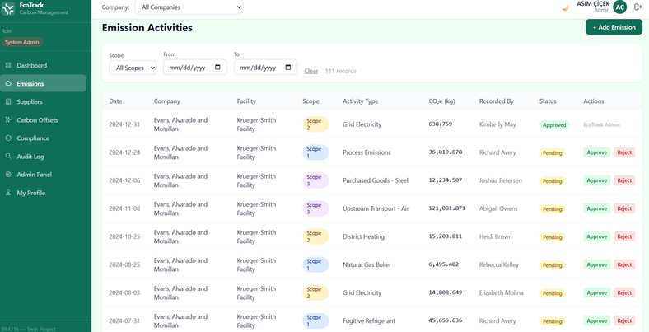

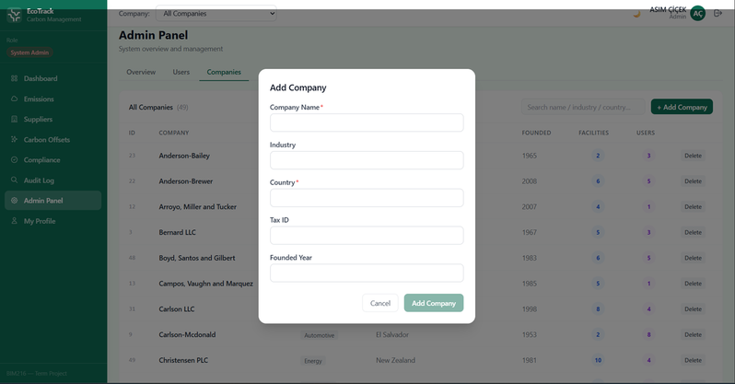

Challenges & Improvements

We addressed several key functional challenges to ensure system reliability and data integrity. One primary obstacle was managing data granularity, where we had to store high-fidelity daily records while dynamically aggregating them into quarterly reports using SQL window functions. Furthermore, establishing Scope 3 data integrity required designing a secure, restricted portal for external suppliers to ensure consistent data entry without compromising internal security. We also tackled the complexity of dynamic sustainability ratings, shifting from static storage to real-time calculations based on live emission activities. Finally, implementing a robust Role-Based Access Control was essential to manage complex approval workflows between Analysts and Sustainability Managers, ensuring every entry undergoes a "four-eyes" verification process before being reflected in official reports.

Conclusion

This project successfully demonstrated the design and implementation of a comprehensive, RDBMS-driven carbon management system capable of handling complex supply chain emission data. By mapping raw environmental activities into a structured relational schema and managing a dataset exceeding 5,000 records, we ensured both data integrity and high-performance retrieval. The implementation of advanced analytical queries proved that the system goes beyond simple data storage, providing actionable insights through monthly trend analysis and supplier risk rankings. Ultimately, Eco-Track serves as a robust prototype for real-world environmental monitoring, highlighting the critical role of database management in achieving global sustainability goals.
AI Use Statement
Tool(s) Used:
GitHub Copilot (powered by Claude Sonnet 4.6) — accessed via the VS Code editor extension.

What It Was Used For:
Brainstorming and refining the relational schema design (table relationships, FK constraints)
Generating boilerplate TypeScript/Express route handlers and React component structure
Debugging runtime errors (e.g., JWT token staleness, PostgreSQL FK cascade violations, route shadowing)
Drafting SQL queries (window functions, LAG, RANK) and reviewing their logic
Suggesting fixes for Docker Compose configuration and container networking
Key Prompts / Questions Asked (Summarized):

"How should I structure the supplier_relationship table to support many-to-many company-supplier links?"
"Why is my admin getting 403 on approve/reject even though the role is correct?" → led to the stale JWT discovery
"Generate a React modal component with a facility dropdown that fetches from /companies/:id"
"Why does my DELETE /companies/:id fail with FK violation?" → identified missing cascade on shipment, carbon_offset, compliance_record tables
What Was Changed / Verified Afterwards:
TypeScript code was reviewed for type correctness and adjusted to match the project's existing type definitions
Route logic was manually traced through the middleware chain to verify authentication and authorization behavior
SQL query results were verified against known seed data to confirm correctness

