BIM216 – Database Management Systems
Term Project – Progress Report
Eco-Track: Supply Chain Carbon Management System
Project No: 7
Group No: 17
Group Members
Name Surname | Contribution
Muhammed Beşir | 50%
Asım Çiçek | 50%
Submission Date: April 5, 2026

1. Requirement Analysis
1.1 Project Overview
Eco-Track is a Supply Chain Carbon Management System designed to help organizations monitor, analyze, and reduce their carbon emissions across the entire supply chain. Eco-Track provides an integrated platform for real-time emission tracking, supplier evaluation, carbon offset management, and regulatory compliance reporting.
1.2 Main Objectives
- Track and record carbon emissions from all supply chain activities including transportation, warehousing, manufacturing, and procurement.
- Enable companies to monitor supplier sustainability performance and carbon footprint contributions.
- Provide advanced analytics and reporting for regulatory compliance (GHG Protocol, ISO 14064, EU CSRD).
- Facilitate carbon offset and credit management to support net-zero targets.
- Support multi-user access with role-based permissions for different organizational levels.
1.3 User Types and Information Needs
User Type | Description | Information Needs
System Administrator | Manages users, system config, and data integrity | User management, system logs, database backups
Sustainability Manager | Oversees carbon strategy and reporting | Aggregate emission reports, trend analysis, compliance status
Supply Chain Analyst | Analyzes supplier and logistics data | Supplier emission scores, transportation data, benchmarks
Supplier (External) | Reports their own emission data | Emission submission forms, verification status
Executive / Viewer | Reviews high-level dashboards | KPI summaries, carbon reduction progress

1.4 Problems the System Aims to Solve
- Fragmented data: Carbon data is scattered across spreadsheets and ERP systems with no unified view.
- Lack of supplier visibility: Companies have limited insight into upstream Scope 3 emissions.
- Compliance risk: EU CSRD and SEC climate rules demand accurate, auditable GHG reporting.
- Inefficient offset tracking: Carbon credit purchases are difficult to reconcile with emission reductions.
- No predictive capability: Without historical analysis, companies cannot forecast emission trends.
1.5 Key Data Attributes and Relationships
- Companies and their organizational hierarchy (subsidiaries, divisions, facilities).
- Emission activities: type (Scope 1/2/3), source, quantity, emission factor, calculated CO2e.
- Suppliers: profile, sustainability rating, submitted emission data, verification status.
- Supply chain transactions: shipments, freight modes, distances, fuel consumption.
- Carbon offsets: project name, certification body, credits purchased, credits retired.
- Regulatory frameworks and compliance targets per period.
1.6 Advanced Database Queries
Query 1 – Monthly Emission Trend Analysis: Total CO2e per company per month with month-over-month % change.
Query 2 – Top Supplier Carbon Risk Ranking: Rank suppliers by Scope 3 contribution using RANK() window function.
Query 3 – Carbon Offset vs. Net Emission Balance: Quarterly gross emissions vs. retired credits showing net balance.
Query 4 – Regulatory Compliance Status Report: Target vs. actual CO2e per framework with over-target percentage.
Query 5 – Transport Mode Emission Comparison: CO2e per tonne-km across road, sea, air, rail, inland waterway.
Query 6 – Emission Intensity by Product Category: Carbon intensity (CO2e per unit) grouped by product category and supplier.
Query 7 – Supplier Emission Verification Lag: Suppliers who have not submitted emission data with days past deadline.
2. Entity-Relationship (E/R) Design
2.1 Identified Entities and Attributes

Entity | Key Attributes | Primary Key
Company | company_id, name, industry, country, tax_id, founded_year | company_id
Facility | facility_id, company_id, name, location, facility_type, size_sqm | facility_id
User | user_id, company_id, email, password_hash, role, full_name | user_id
Supplier | supplier_id, name, country, sustainability_rating, verified | supplier_id
EmissionActivity | activity_id, facility_id, supplier_id, scope, co2e_kg, activity_date | activity_id
Shipment | shipment_id, supplier_id, company_id, transport_mode, co2e_kg, shipment_date | shipment_id
CarbonOffset | offset_id, company_id, project_name, credits_purchased, credits_retired | offset_id
RegulatoryFramework | framework_id, name, jurisdiction, target_year | framework_id
ComplianceRecord | record_id, company_id, framework_id, reporting_period, status | record_id
AuditLog | log_id, user_id, action, table_name, timestamp | log_id

2.2 Relationships and Cardinalities
- Company HAS MANY Facilities (1:N) – A company operates one or more facilities.
- Company HAS MANY Users (1:N) – Users belong to one company.
- Company HAS MANY Suppliers (M:N via SupplierRelationship) – A company works with multiple suppliers.
- Facility RECORDS MANY EmissionActivities (1:N) – Emission events are tied to a facility.
- Supplier CONTRIBUTES TO EmissionActivities (1:N) – Scope 3 activities linked to a supplier.
- Company PURCHASES MANY CarbonOffsets (1:N) – Carbon credits are purchased by a company.
- Company HAS MANY ComplianceRecords (1:N) – Each company tracks compliance against frameworks.
- RegulatoryFramework GOVERNS MANY ComplianceRecords (1:N).
- Shipment involves SUPPLIER and COMPANY (M:N resolved as Shipment entity).
- User GENERATES AuditLog entries (1:N) – All user actions are logged.
2.3 E/R Diagram
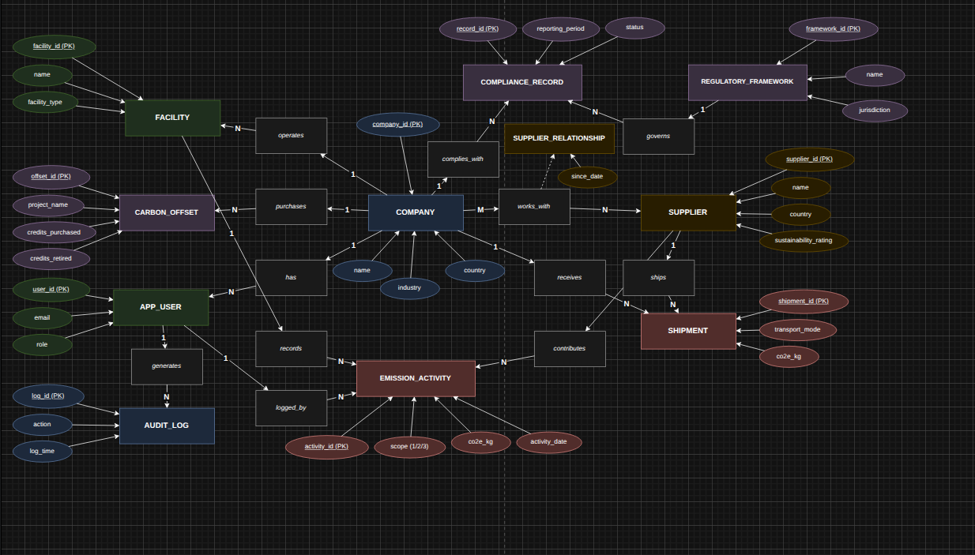

3. Relational Database Schema
3.1 Schema Overview
The E/R diagram was mapped to the following relational schema using the standard mapping rules covered in class. All M:N relationships are resolved into junction tables. Foreign key and NOT NULL constraints are applied where appropriate.
3.2 Relational Schema Diagram
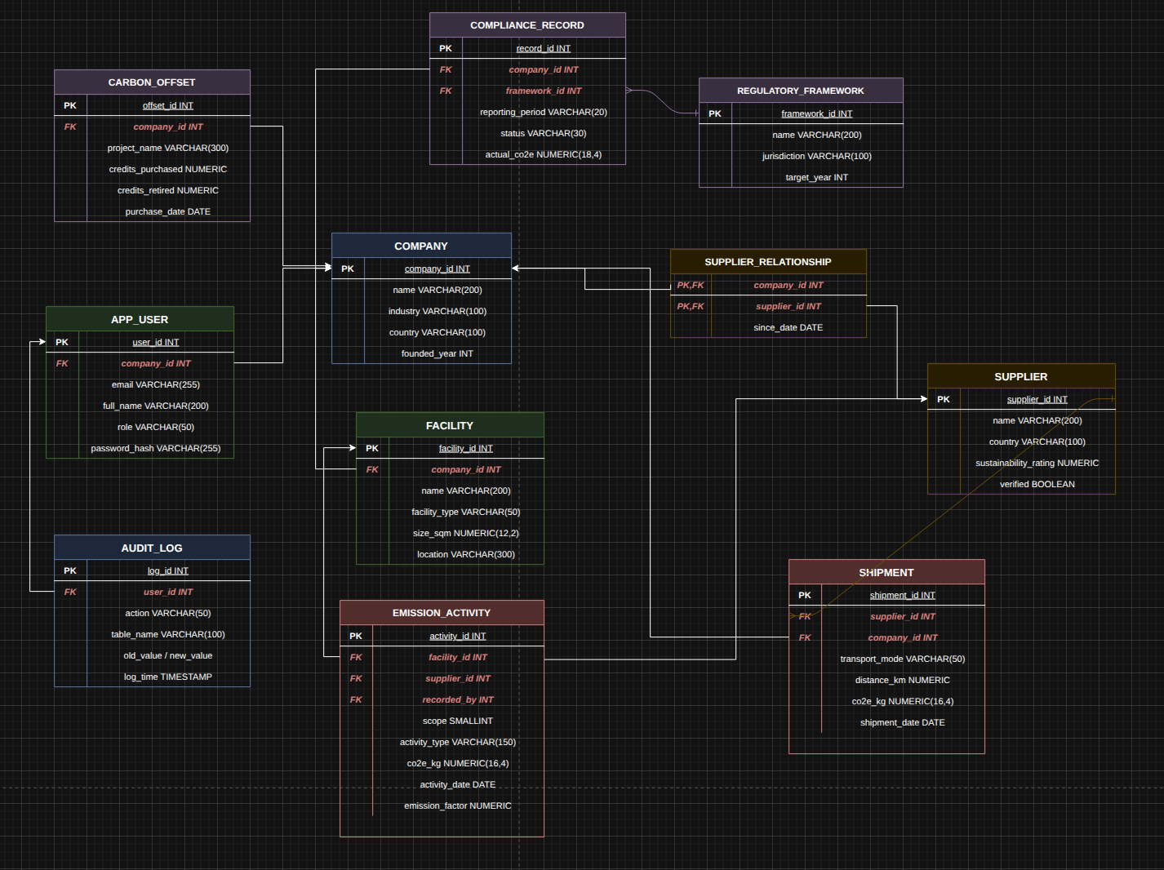

3.3 Schema Description

Table Name | References | Notes
company | – | Root entity; all other tables reference this
facility | company(company_id) | Physical locations of a company
app_user | company(company_id) | Named app_user to avoid SQL reserved word
supplier | – | Supplier profile
supplier_relationship | company + supplier | M:N junction table
emission_activity | facility + supplier + app_user | Core fact table; scope 1/2/3 entries
shipment | supplier + company | Logistics emission events
carbon_offset | company(company_id) | Carbon credit records
regulatory_framework | – | Reference data for regulations
compliance_record | company + regulatory_framework | Tracks target vs actual per period
audit_log | app_user(user_id) | Full audit trail of all changes

4. SQL Database Creation Commands
4.1 Database and Initial Setup
The database is implemented in PostgreSQL. The main CREATE TABLE statements with integrity constraints are shown below. Full SQL including INSERT statements for 5,000+ records is provided in the attached .sql files.

CREATE DATABASE ecotrack;
\c ecotrack;

CREATE TABLE company (
company_id SERIAL PRIMARY KEY,
name VARCHAR(200) NOT NULL,
industry VARCHAR(100),
country VARCHAR(100) NOT NULL,
tax_id VARCHAR(50) UNIQUE,
founded_year INT CHECK (founded_year > 1800)
);

CREATE TABLE facility (
facility_id SERIAL PRIMARY KEY,
company_id INT NOT NULL REFERENCES company(company_id) ON DELETE CASCADE,
name VARCHAR(200) NOT NULL,
facility_type VARCHAR(50) CHECK (facility_type IN ('warehouse','factory','office','port','farm')),
size_sqm NUMERIC(12,2)
);

CREATE TABLE supplier (
supplier_id SERIAL PRIMARY KEY,
name VARCHAR(200) NOT NULL,
country VARCHAR(100),
sustainability_rating NUMERIC(3,1) CHECK (sustainability_rating BETWEEN 0 AND 10),
verified BOOLEAN DEFAULT FALSE
);

CREATE TABLE emission_activity (
activity_id SERIAL PRIMARY KEY,
facility_id INT REFERENCES facility(facility_id),
supplier_id INT REFERENCES supplier(supplier_id),
scope SMALLINT NOT NULL CHECK (scope IN (1,2,3)),
co2e_kg NUMERIC(16,4),
activity_date DATE NOT NULL,
recorded_by INT REFERENCES app_user(user_id)
);

-- Full schema (app_user, shipment, carbon_offset,
-- regulatory_framework, compliance_record, audit_log)
-- provided in attached ecotrack_schema.sql

5. Advanced Database Queries
The following queries will be implemented as features within the final application.

Query 1 – Monthly Emission Trend Analysis
SELECT c.name, DATE_TRUNC('month', ea.activity_date) AS month, ea.scope,
SUM(ea.co2e_kg) AS total_co2e_kg,
LAG(SUM(ea.co2e_kg)) OVER (PARTITION BY c.company_id, ea.scope
ORDER BY DATE_TRUNC('month', ea.activity_date)) AS prev_month_co2e
FROM emission_activity ea
JOIN facility f ON ea.facility_id = f.facility_id
JOIN company c ON f.company_id = c.company_id
GROUP BY c.company_id, c.name, month, ea.scope
ORDER BY c.name, month;
Purpose: Monthly emission trends per scope with month-over-month comparison.

Query 2 – Top Supplier Carbon Risk Ranking
SELECT s.name, s.country, SUM(ea.co2e_kg) AS total_scope3_co2e,
RANK() OVER (ORDER BY SUM(ea.co2e_kg) DESC) AS carbon_risk_rank
FROM emission_activity ea
JOIN supplier s ON ea.supplier_id = s.supplier_id
WHERE ea.scope = 3
GROUP BY s.supplier_id, s.name, s.country
ORDER BY total_scope3_co2e DESC LIMIT 20;
Purpose: Identifies highest-risk suppliers by Scope 3 contribution.

Query 3 – Carbon Offset vs. Net Emission Balance
SELECT c.name, DATE_TRUNC('quarter', ea.activity_date) AS quarter,
SUM(ea.co2e_kg) AS gross_emissions_kg,
COALESCE(SUM(co.credits_retired), 0) * 1000 AS offsets_kg,
SUM(ea.co2e_kg) - COALESCE(SUM(co.credits_retired), 0) * 1000 AS net_emissions_kg
FROM emission_activity ea
JOIN facility f ON ea.facility_id = f.facility_id
JOIN company c ON f.company_id = c.company_id
LEFT JOIN carbon_offset co ON co.company_id = c.company_id
AND DATE_TRUNC('quarter', co.purchase_date) = DATE_TRUNC('quarter', ea.activity_date)
GROUP BY c.company_id, c.name, quarter ORDER BY c.name, quarter;
Purpose: Quarterly net emission balance after accounting for carbon offsets.

Query 4 – Regulatory Compliance Status Report
SELECT c.name, rf.name AS framework, cr.reporting_period,
cr.target_co2e, cr.actual_co2e, cr.status,
ROUND((cr.actual_co2e / NULLIF(cr.target_co2e,0) - 1)*100, 2) AS over_target_pct
FROM compliance_record cr
JOIN company c ON cr.company_id = c.company_id
JOIN regulatory_framework rf ON cr.framework_id = rf.framework_id
ORDER BY cr.reporting_period DESC, over_target_pct DESC;
Purpose: Full compliance status for all regulatory frameworks per company.

Query 5 – Transport Mode Emission Comparison
SELECT sh.transport_mode, COUNT(*) AS shipment_count,
SUM(sh.co2e_kg) AS total_co2e_kg,
ROUND(SUM(sh.co2e_kg) / NULLIF(SUM(sh.distance_km * sh.weight_kg / 1000),0), 4)
AS co2e_per_tonne_km
FROM shipment sh
GROUP BY sh.transport_mode
ORDER BY co2e_per_tonne_km DESC;
Purpose: Compares carbon intensity across transport modes (road, sea, air, rail).

Query 6 – Emission Intensity by Product Category
SELECT s.name AS supplier_name, ea.category AS product_category,
ea.activity_type, COUNT(*) AS activity_count,
SUM(ea.co2e_kg) AS total_co2e_kg,
ROUND(SUM(ea.co2e_kg) / NULLIF(COUNT(*), 0), 4) AS co2e_per_unit
FROM supplier s
JOIN emission_activity ea ON ea.supplier_id = s.supplier_id
GROUP BY s.supplier_id, s.name, ea.category, ea.activity_type
ORDER BY total_co2e_kg DESC;
Purpose: Carbon intensity (CO2e per unit) grouped by product category and supplier.

Query 7 – Supplier Emission Verification Lag
SELECT s.name AS supplier_name, s.country, s.verified,
s.last_submission_date,
CURRENT_DATE - s.last_submission_date AS days_since_submission,
CASE
WHEN s.last_submission_date IS NULL THEN 'Never submitted'
WHEN CURRENT_DATE - s.last_submission_date > 90 THEN 'Overdue (>90 days)'
WHEN CURRENT_DATE - s.last_submission_date > 30 THEN 'Late (>30 days)'
ELSE 'Recent'
END AS submission_status
FROM supplier s
WHERE s.verified = FALSE
OR s.last_submission_date IS NULL
OR (CURRENT_DATE - s.last_submission_date) > 30
ORDER BY days_since_submission DESC NULLS FIRST;
Purpose: Suppliers who have not submitted emission data recently, with days past deadline.

6. Data Population Strategy
To meet the requirement of at least 5,000 records, the following strategy will be used:

Table | Target Records | Method
company | 50 | Manual + Faker
facility | 300 | Faker (2–10 per company)
app_user | 200 | Faker with role distribution
supplier | 500 | Faker + real country data
supplier_relationship | 800 | Random M:N assignments
emission_activity | 10,000+ | Python + IPCC emission factors
shipment | 5,000+ | Faker + realistic trade lane data
carbon_offset | 300 | Faker + VCS/Gold Standard names
regulatory_framework | 20 | Manual (GHG Protocol, EU CSRD…)
compliance_record | 400 | Derived from emission data
audit_log | 2,000+ | Auto-generated with DML triggers

Real-world emission factors from the IPCC AR6 report and GHG Protocol calculation tools will be used. Python scripts using the Faker library and pandas will generate and export data as SQL INSERT statements.

