EVALUATION REPORT WITH WORK LOG AND SCREENSHOTS

Stack used for Backend:
Node.js, MySQL, Sequelize ORM
Stack used for Frontend:
React.js, Material-UI, chart.js

Work log:
- First of all, I carefully reviewed the task document to understand and analyze all functional and quality requirements.
- Then I studied the provided entities like customers, products, transactions etc and analyzed their existing attributes to gain clarity on their structure and relationships.
- Then I determined the primary key for each entity and began identifying inter-entity relationships for foreign keys.
- Then I downloaded and explored the csv to better understand the real data structure and how data is arranged and confirm relationships among entities.
- Clearly identified primary keys and foreign keys to confirm these.
- Moving on to the development, I created two folders, one for backend, the other one for frontend.
- I set up the project for backend and downloaded dependencies using npm install.
- Then I clarified the logic and structure for backend in detail to start by reading document several times.
- I defined folders and structure for backend including controller, route, services, middleware, models, seeders, migration etc.
- I created database techmart_db in mysql.
- I created an env file for my backend.
- I started working on migration (runMigration.js) and models code creating separate model file for each entity and database.js in config for connection between backend and database using sequelize ORM. I also added script “npm run migrate” to my package.json for running migration.
- After that I verified the creation of tables in mysql database.
- Then, I worked upon seeding the data from csv files to the database, for this purpose I created a file “runSeeders”.
- I added the script “npm run seed” to the package.json for running seeding code.
- I ran npm run seed and then verified mysql database for fields creation along with data.
- I also created another script called npm run clean for resetting and cleaning the database incase there is any problem or we need to re migrate and re seed the data
- After that I worked upon the services creation.
- For inventoryService.js, First, I read the task and understood that this file will handle product stock, inventory, and related operations in backend.
- I read the task and understood this file is for handling product stock and inventory logic. I used Product, Supplier, and Transaction models to work with data. I started by making a function to get products with low stock. It checks which products are below a threshold and also filters by category if needed. It includes supplier info and also calculates daily sales, days left before stockout, and urgency level. Then I made another function to update product stock quantity, where I can add or subtract quantity and make sure stock doesn’t go below zero. After that, I created a function to get total inventory value category-wise, using sum and count functions to calculate how much value each category has. Then I added a check stock availability function to see if a product has enough stock for a requested amount and tell if it can fulfill or not. At the end, I made a helper function to show urgency levels based on days until stock finishes. I also handled errors in all functions and tested the logic to make sure results come properly.
TransactionService.js:
- I started this file to handle all logic related to transactions. First, I made a function to create a new transaction. It checks if the customer and product exist, then confirms there is enough stock available. I calculated subtotal, tax, shipping cost, and total amount. I added limits for minimum and maximum allowed amount. After creating a transaction, I updated product stock and also updated the customer’s total spent and loyalty tier. I also triggered risk score functions for fraud detection without waiting for them to finish. Then I made a function to get a transaction by ID, which fetches product and customer details too. After that, I created a function to get all transactions with filters like date range, status, or amount range and added pagination for it. I added a function to update the status of a transaction safely with only valid statuses. Then I made two reporting functions, one for getting top customers by spending, and another for finding frequent buyers with the most transactions. Finally, I handled errors properly in all functions and tested the main flow for creating and fetching transactions.

- RecommendationService.js: I made this service to generate personalized product recommendations for customers. First, I checked cache and database to avoid recalculating. Then I used three methods : affinity (bought together), collaborative (similar customers), and segment-based (popular in same group). I combined all results with weighted scores to get final top products. I also added caching and batch generation for all customers to improve speed.

- Fraud Detection Service: I made this service to find suspicious transactions in system. It check many things like big amount, failed payments, and fast repeat buying. It also look for test payments under $1 and weird IP changes. Then I give each transaction a risk score out of 100. If too many risky things found, it marks that transaction as suspicious. It group them by risk level like low, medium, high, critical. I also made stats to show total flagged and top fraud reasons. At end, customer risk score also update from his past 30-day activity.
- Then I worked on controllers for defining endpoints,first of all inventory controller, I make this controller to manage all product stock in system. It can show which products have low stock using threshold. It also calculate total inventory value by each category. I add function to update stock when quantity change. Another part show all product categories from database. Then we can also get products by any category name. Each request give success message and proper JSON data when I tested on postman. It helps to keep stock balanced and know shortage quickly.
- Transaction Controller.js: I make this controller to handle all transaction work in system. It can create new transaction and save it in database. I added route to get any transaction by its ID. Also make function to fetch all transactions with date or status filters. Added logic to get top customers and frequent buyers using segment option. Another endpoint checks suspicious transactions for fraud risk. Each request returns proper message and data in JSON. It help to track, manage and detect risky sales easily. Below attached is a screenshot of testing.
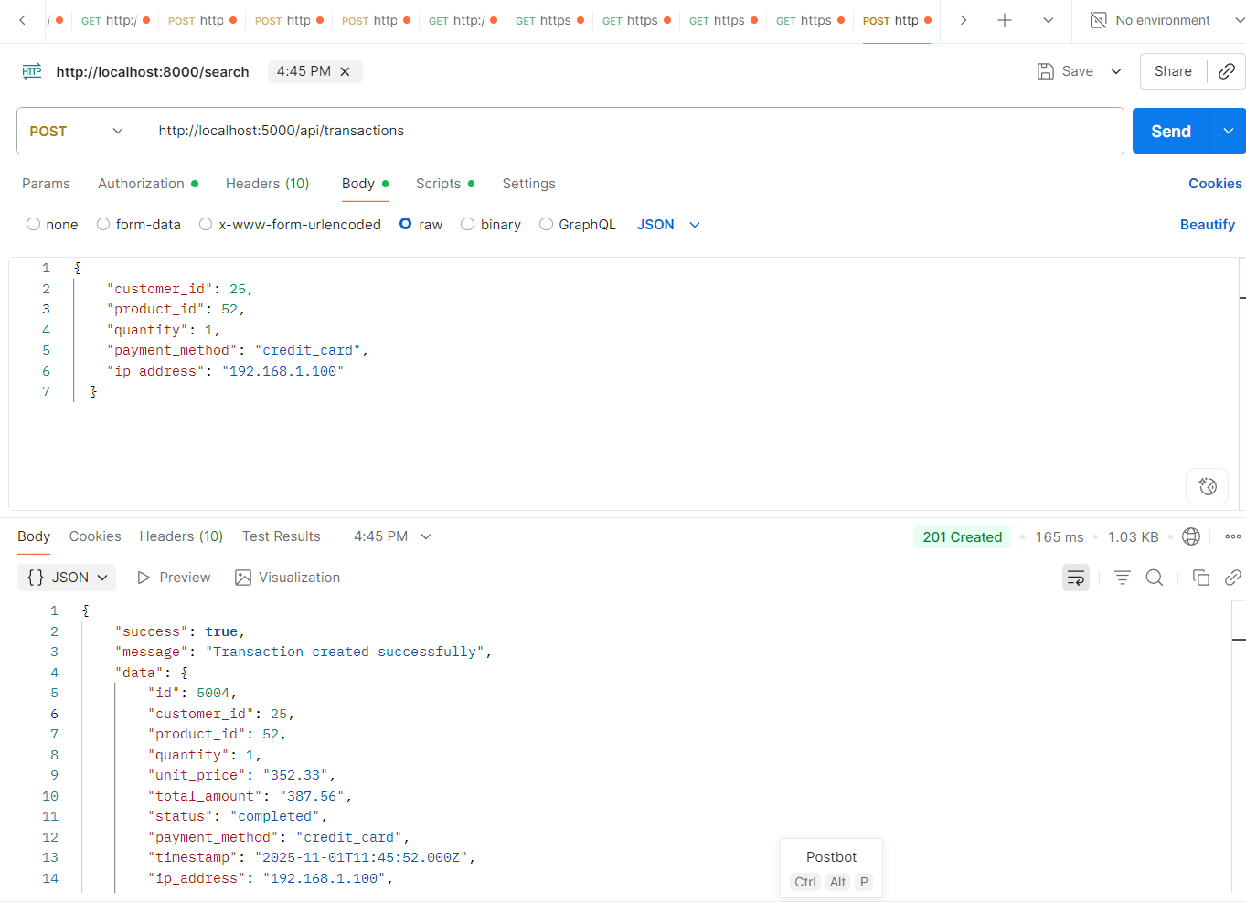
- Dashboardcontroller: I made this controller for showing dashboard stats in system. It handle request from frontend to show overview data. I added function to get records for last 24 hours or custom date. It take filters like start date, end date or hours from query. Then it calls analytics service to get data. After that it send response back with success and overview info. It help user to see quick summary of system performance. This make dashboard dynamic and data-driven.
- Analytic controller: I made this controller to handle analytics and reporting part of the system. It has two main APIs: one for hourly or interval-based sales and another for category-wise sales. I added support for optional filters like start and end dates, interval, and detailed flag. When detailed flag is true, it fetch all individual transactions instead of aggregated data. The other API gives breakdown of sales by product category. Both functions call analytics service to get data and send JSON response. This controller helps frontend to show dynamic charts and insights easily.
- Customer’s Controller: I made this controller to handle all customer-related operations in backend. It can fetch all customers, search by name or email, and filter by loyalty tier. I added pagination, sorting, and search filters for better control. One endpoint also returns full customer details along with analytics data if available. There is a separate API for quick search and another for autocomplete to help frontend dropdowns. Validation is added for loyalty tiers to avoid wrong inputs. In the end it helps frontend get customer info easily with flexible filters and search support.
- Middleware/errorhandler: Then I made this file to handle all app errors in one place. If any route not found, it give “Cannot GET /route” message. If code crash or throw error, this handler catch it and send clean JSON response. I add custom class AppError to make my own error message with status code. It also handle Sequelize errors like validation, duplicate entry, or database crash, and give easy message to user. In development, it log full stack for debugging. Also made async wrapper so no need to write try-catch everywhere. Whole file keep backend clean and safe from breaking.
- Middleware/validation: I make this file to check if user send correct data before it reach backend logic. I use express-validator to check inputs for body and query. If something wrong, it throw error using my AppError class.I add rules for different things , like creating transaction, checking date range, pagination, alerts, low stock, and suspicious activity. For example, if user not send customer_id or send wrong date, it give message right away. This stop bad or missing data from going into database.This file help keep API clean, safe, and easy to debug when wrong input comes from frontend or Postman.
- Routing : Then I created separate files for all routes, and linked them using index.js, linking it to app.js so that all routes can start working together
- Fraud detection test: This file is for testing fraud system. I made some transactions for check. One normal, one big amount, one round amount, one failed. Then I tested small small things, like if score is high, it say “critical”. If small, it says “low”. I also checked if payment type is right, if IP address looks real, and if numbers not go crazy. Every test sees if function works correct. At end, it says to run tests with npm test.
- After the I finalized the server.js and verify.js and started my application using npm start. Before moving on to frontend, I tested my backend routes using postman to see if everything was working correctly.
- Frontend: Moving onto frontend, I first created react app and then I put all folders like components and services in right place after defining the structure of frontend.
- I installed MUI for pretty buttons and cards.Also added emotion and icons so design look cool.
- I added react-router-dom for move between pages.Then made routes and small menu for navigation.
- I created api.js file and use axios.Then set backend link and handle errors inside.
- I made .env file for secrets.Put REACT_APP_API_URL and set proxy inside package.json.
- Dashboard component: I made main dashboard page and used MUI grid and hooks to manage data. This is a screenshot of dashboard
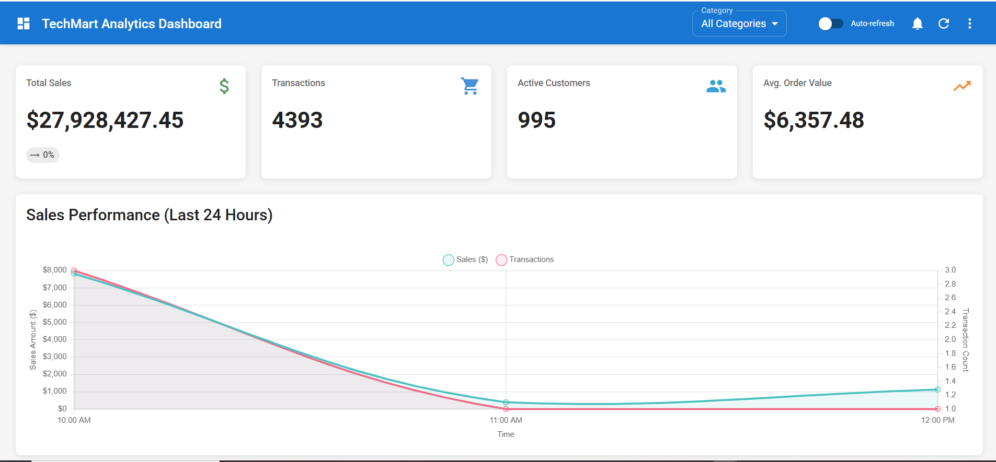
- salesChart component: I used Chart.js to make line chart which shows sales over time with tooltips for the last 24 hours. I uses showsales endpoint.
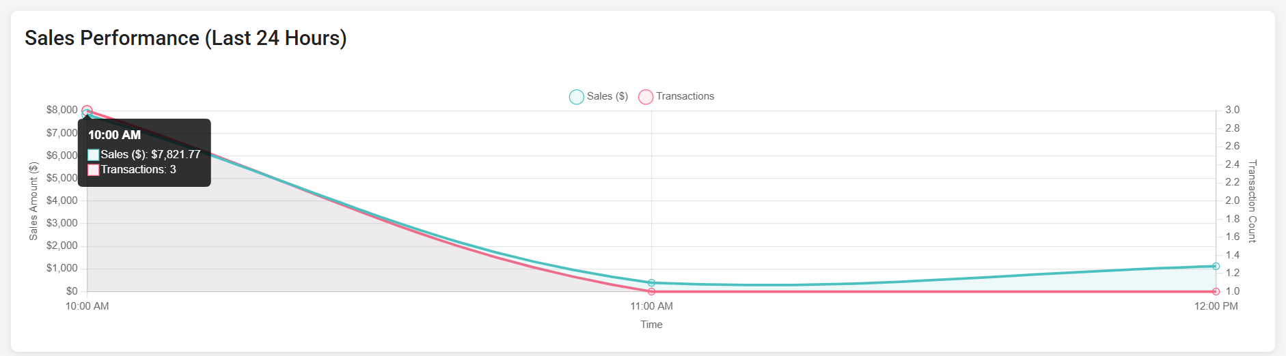
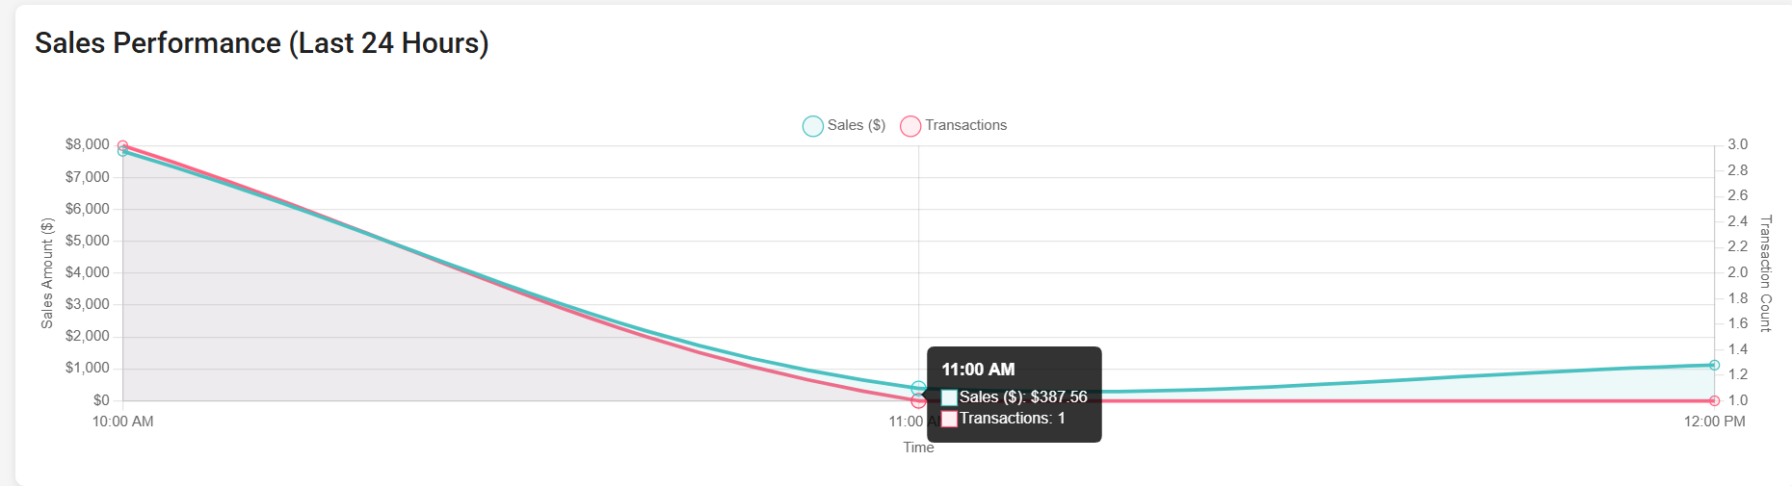
- TopProductsTable.js component
I made a table for best products.Below attached is its screenshot.
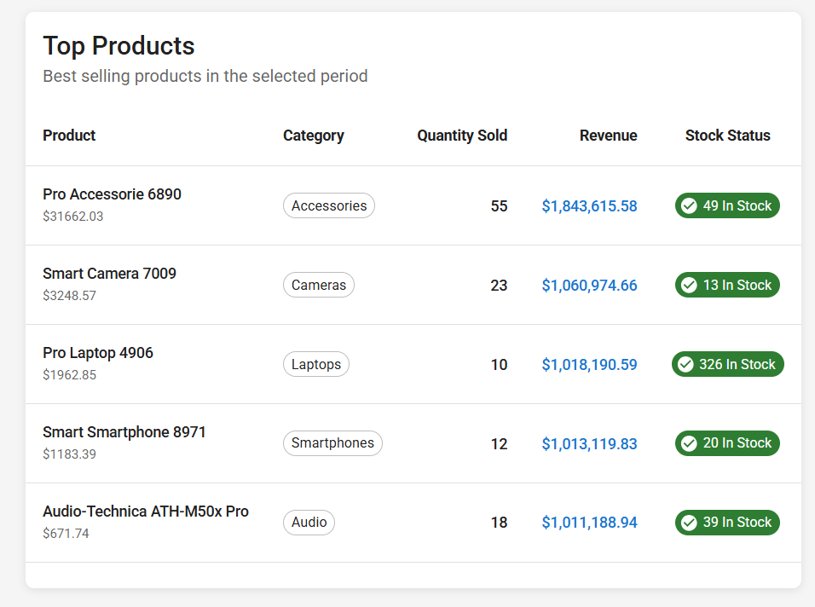
- RecentTransactions.js component
I made list for last purchases.It shows customer, amount, and status color. Uses get transactions endpoint with time period filter.
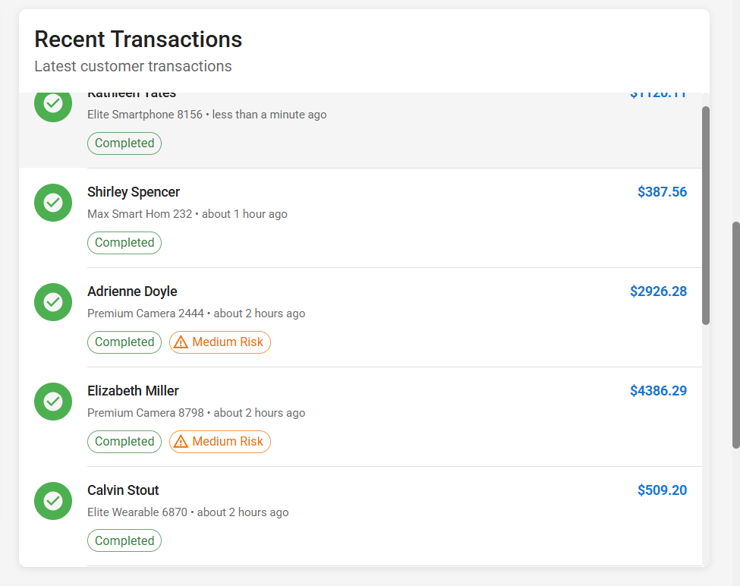

- LowStockAlerts.js component
For showing alerts when stock is low and uses red color for danger and warning.
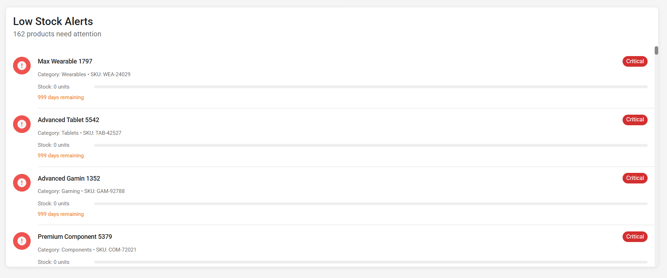
- TransactionsTable.js component
I make big table with all orders.Add pages and filters for easy use. Filters that I added have been showcased in screenshots.
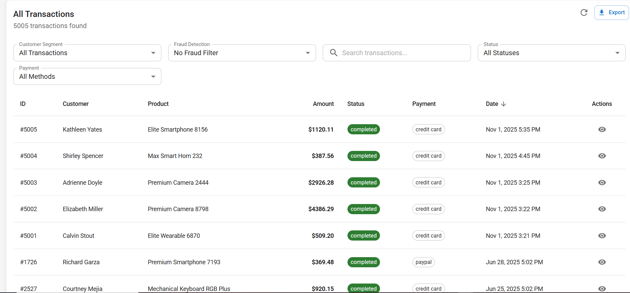

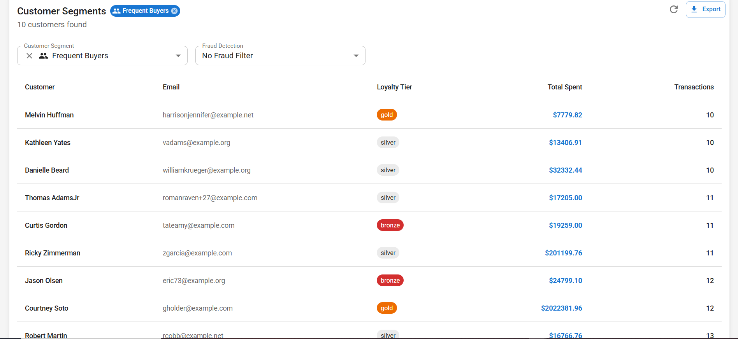
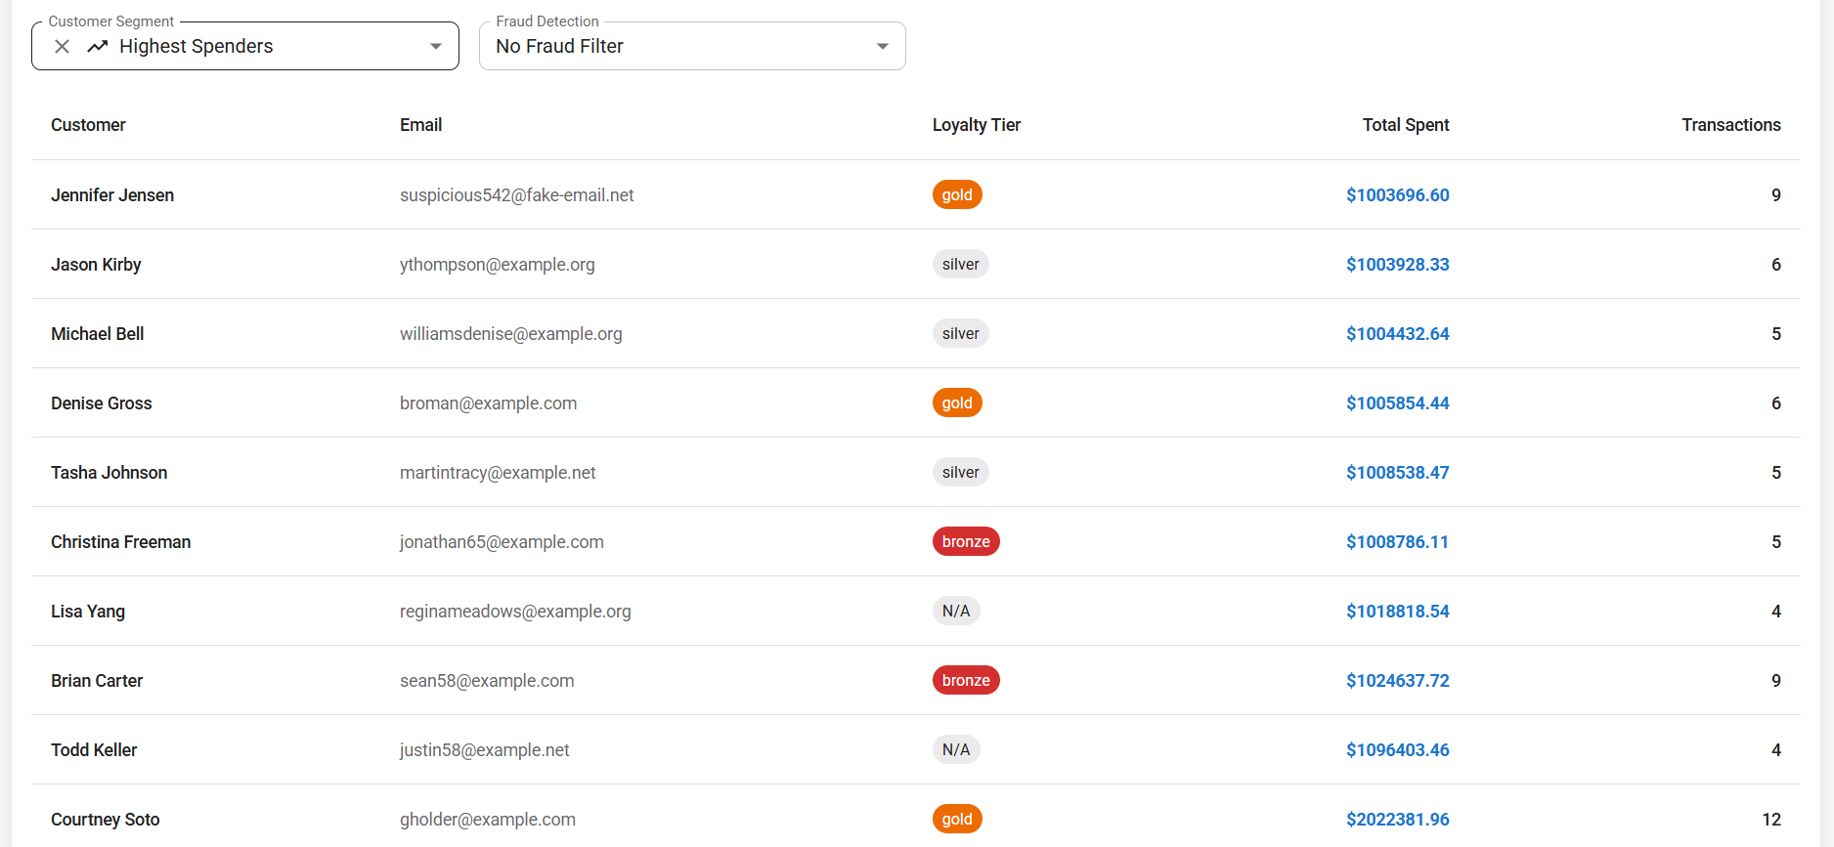
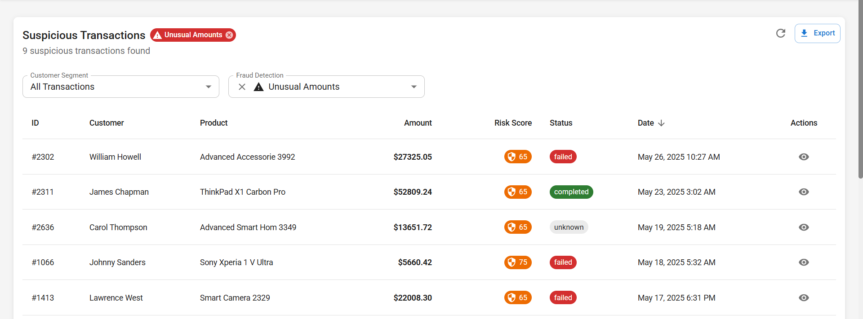
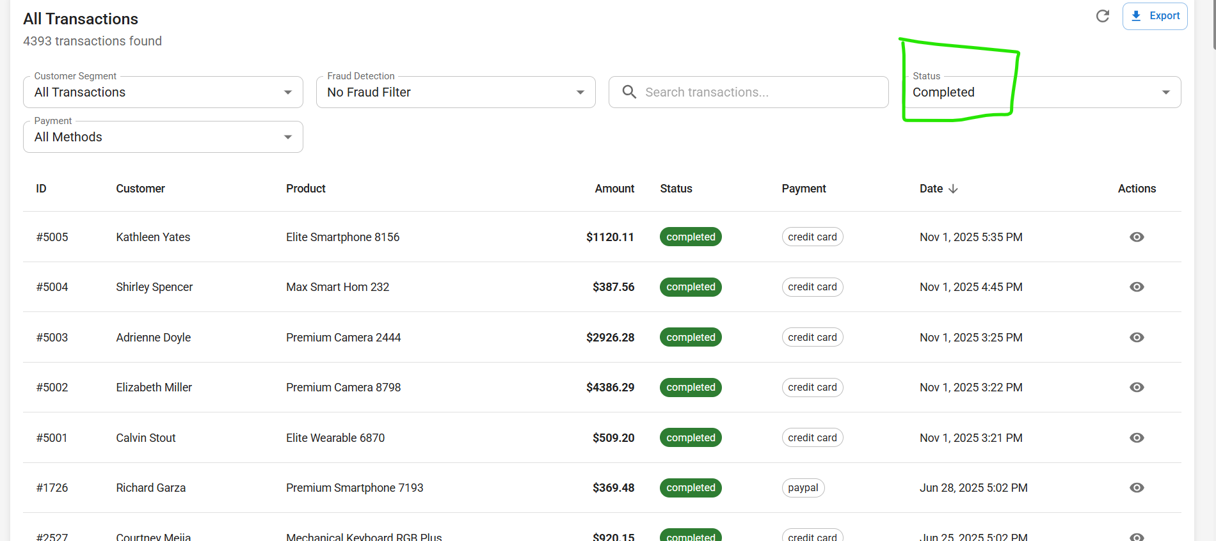
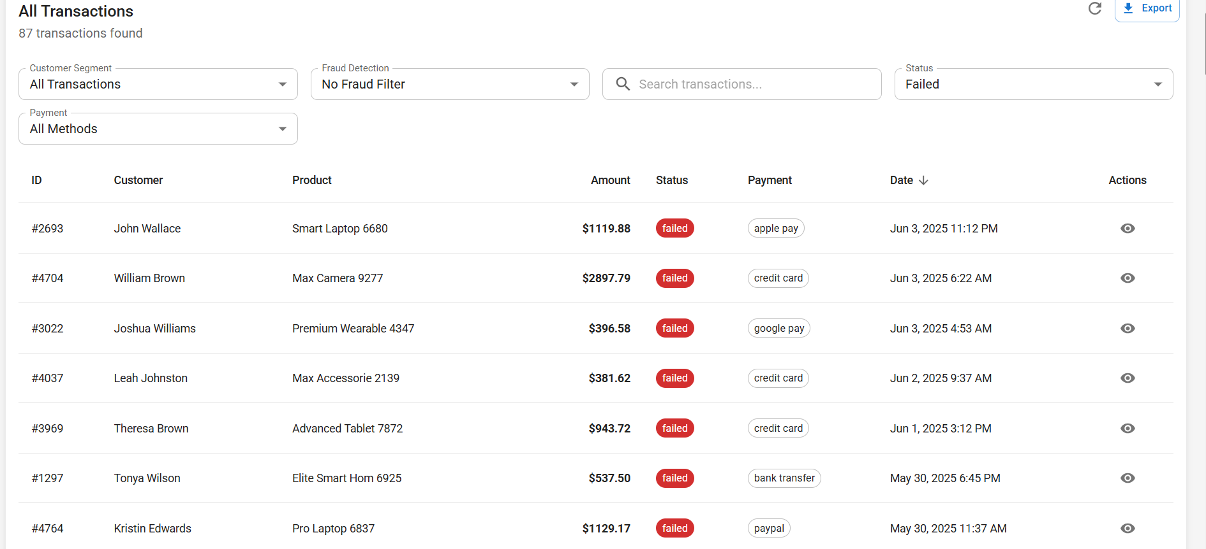

45. Navigation.js component
This component was created for navigating between pages. For dashboard pages which cover basic application, the route is /dashboard and for challenge analytics the routes have also been defined.
Data Visualization
49. Added multiple chart types
I made bar, pie, and line charts..
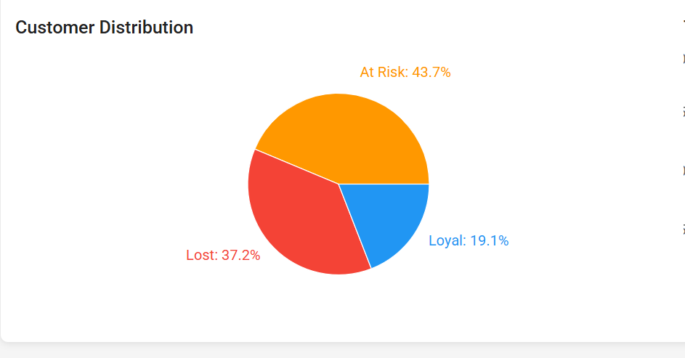
50. Chart customization
I added my own colors and fonts.Numbers and dates show clean now.
Advanced Features
53. Search functionality
I put search bar in transactions table for searching transactions.It finds customers fast.
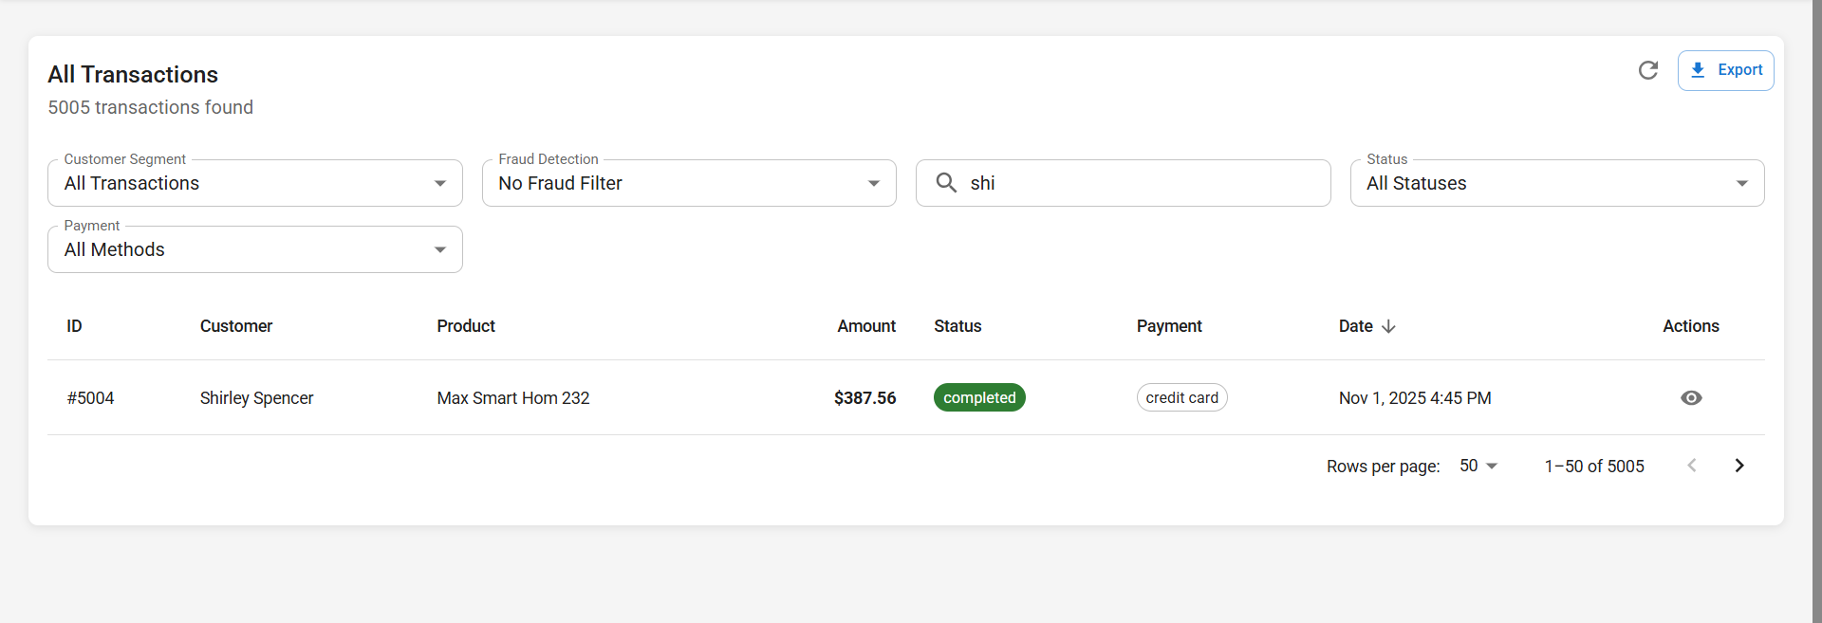
54. Filter components
I add date and status filters.User can pick what they want to see.Like for low stock alerts for products, I added a filter by product category.
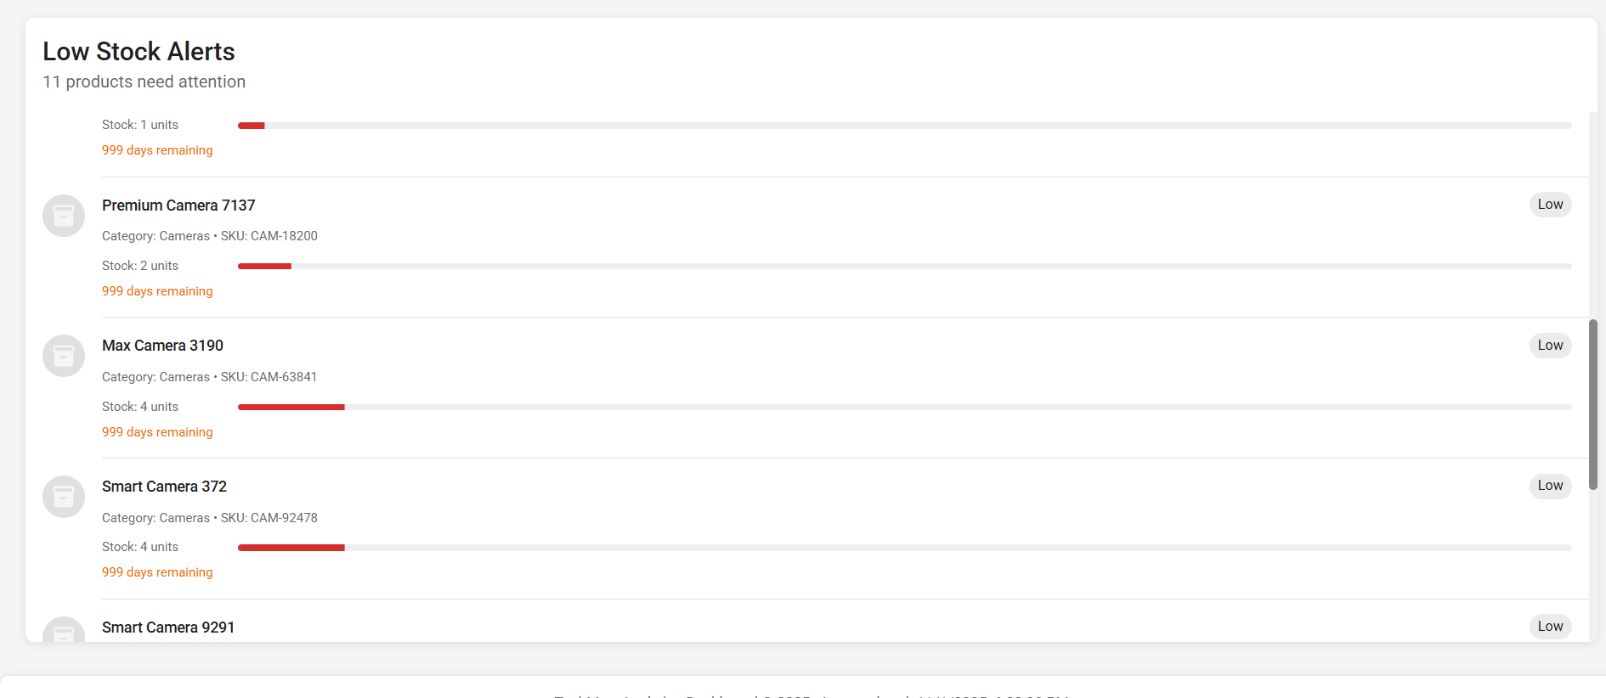
55. Export features
I added download for PDF and Excel for transactions.
User can get full report file downloaded.
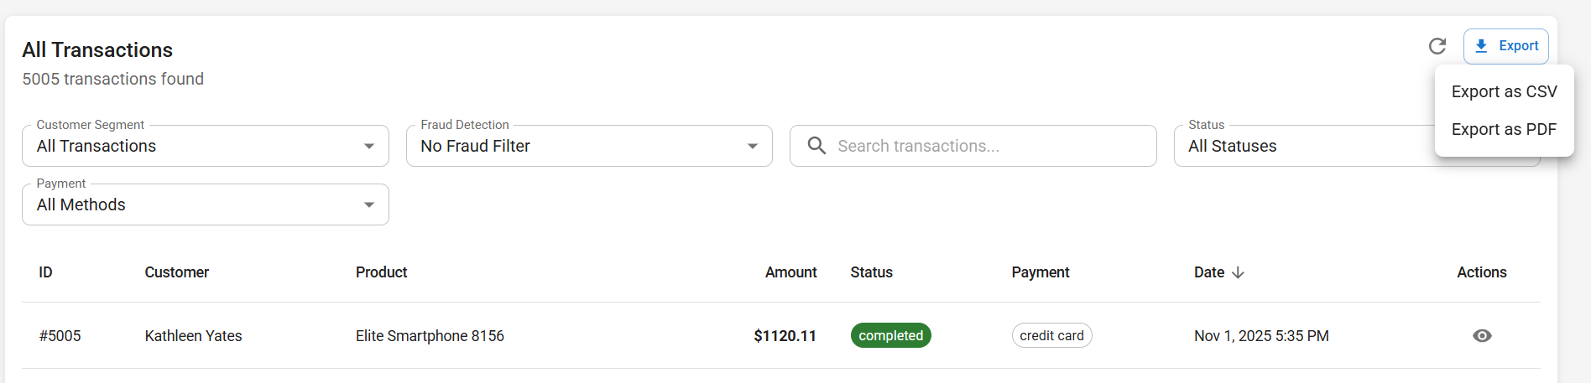
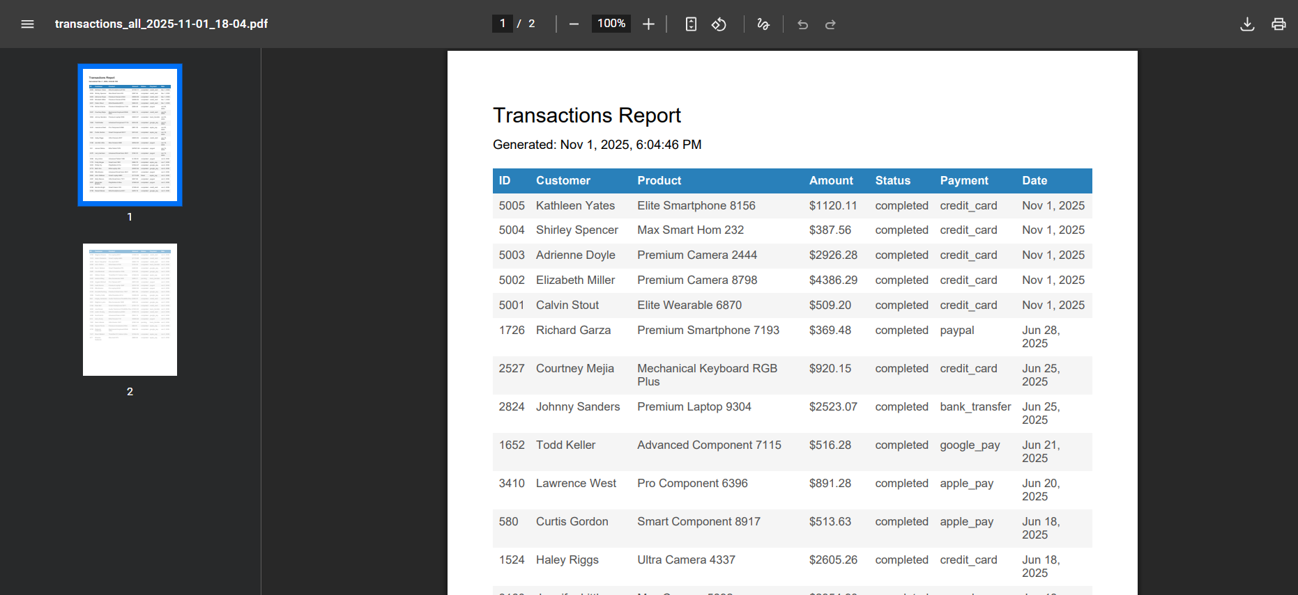
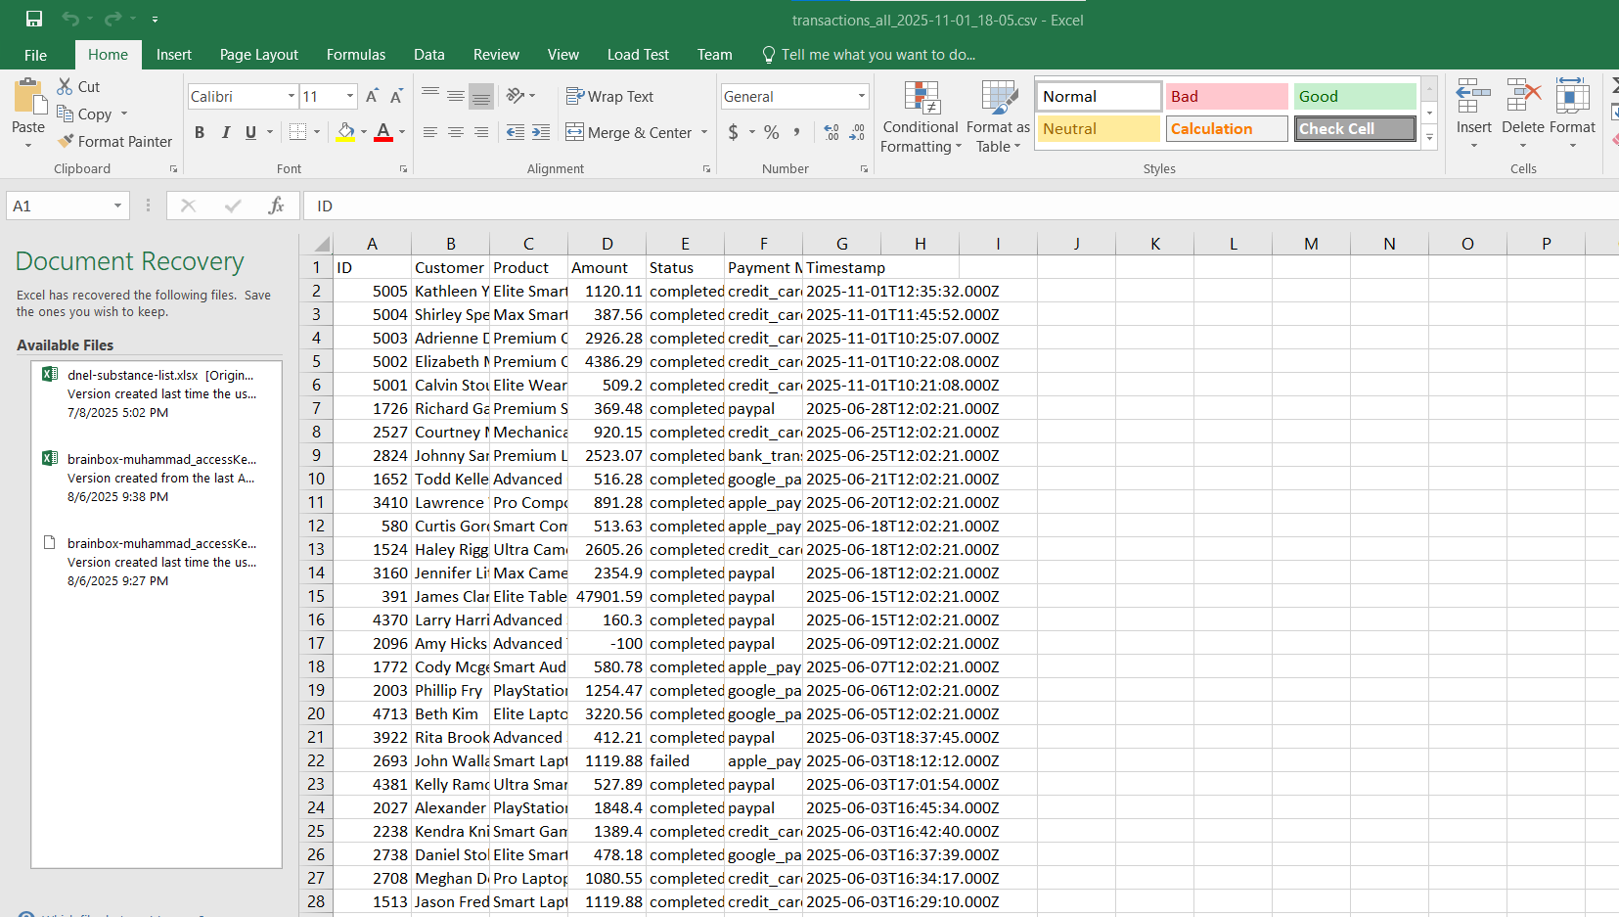

56. Error handling
I made error boundary so app does not crash.It shows simple message when something wrong.
57. Form validation
I check all input before submit and Show red text if something bad.
60. Mobile responsiveness and automatic updates
I made application responsive for mobile and also added auto refresh, the dashboard updates automatically.
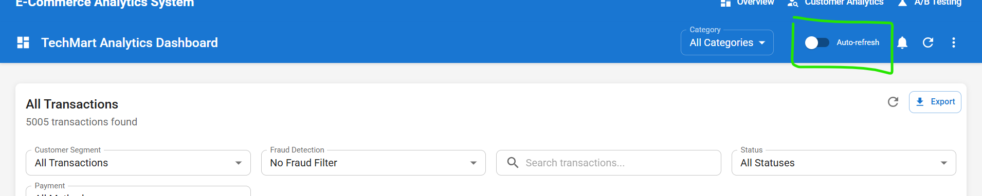
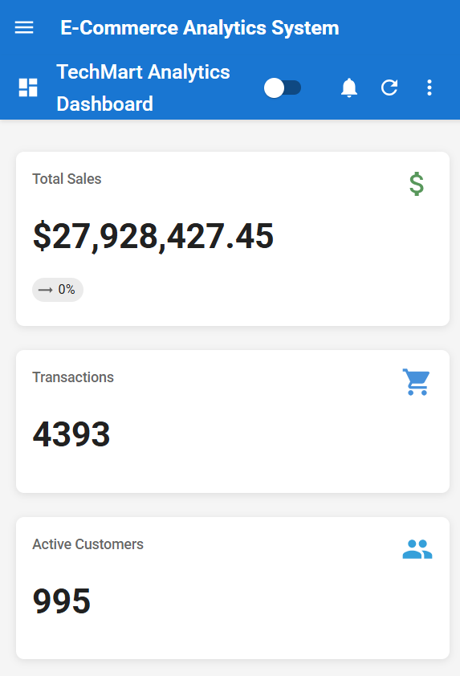

CHALLENGE C IMPLEMENTATION
Why I chose:
I selected Challenge C over the alternatives because it provides the optimal combination of technical depth and business value. Challenge A (fraud detection) was too infrastructure-focused and reactive in nature. Challenge B (inventory management) felt operational rather than strategic. Challenge D (performance optimization) was purely infrastructure engineering without intelligent features.
Challenge C stood out because it implements multiple revenue-driving ML algorithms - RFM segmentation, hybrid recommendations (collaborative + content-based + segment-based), CLV prediction, and churn detection. The technical complexity is substantial: complex SQL behavioral analysis, two-tier caching for 100x performance gains, A/B testing framework, and sophisticated frontend visualizations. Most importantly, customer analytics is universally applicable to any e-commerce business, making it highly portfolio-worthy while demonstrating both engineering excellence and business acumen. It's strategic (proactive personalization) rather than reactive (fraud) or operational (inventory), representing the core competitive advantage in modern e-commerce.

Database Models - The Foundation
61.First I make CustomerAnalytics model where I save rfm scores. I put customer id as foreign key and made fields for recency, frequency and money score. Also added rfm segment name and some extra fields like recency days and value.
62.In same model i put clv fields for lifetime value prediction. I make predicted_clv field and confidence score also. i think keep all analytics in one place is better.
63.Then I added churn fields for customer risk. I made churn_risk_score and churn level, plus churn indicators list to see why customer risky. I also keep last purchase days.
64. I make another model called ProductRecommendation. It connect customer id and product id, also have score and reason arrays. It store why system recommend that item.
65. Then I added expiry for recommendations. I put expires_at field so old data auto refresh after 12 hours.
66.After that i made AnalyticsCache model for any type of analytics data. It store cache key, value, type and expiry time. Helps keep things fast.
67.Then i made ABTest model for experiments. It store test name, type, variants and metrics. all customer assignments saved as json also.
68.I connect all models together in index.js. i make relations like CustomerAnalytics belongs to Customer and Recommendation belongs to Product too.
69. After that I updated migrations. I create tables in right order and add indexes. I tested run and all fine.
70. For seeding i only keep base data. Analytics data come from real calculations later.

RFM Analysis Service
71. I made rfmService.js for all logic. I planned how to calculate recency, frequency and money.
72.For recency I find last buy date and count days. I give score 1 to 5 depending how recent. less days = high score.
73.For frequency I count how many transactions customer have. more buys get more score. simple rule.
74.For money I check total spent and make percentile. top spenders get 5, low spenders get 1.
75.After that I mix three scores and give segment name like Champion, Loyal, Lost etc.
76. Then I made one function that calculate all customers at once. It loop all and save result.
77.Also count how many people in each segment and how much revenue they bring.
78.Then I save results in cache table for 24 hours so dashboard load fast.

CLV Prediction Service (Points 49-54)
79.I create clvService.js file for lifetime value. I use formula AOV x Frequency x Lifespan.
80.Then I add bonus if customer buy recently or very frequent. Loyalty levels also give extra percent.
81.I make confidence score system from 50 to 100 based on how active customer is.
82.After that I make function to calculate one customer and save value with confidence.
83.Then I make bulk function to do all customers fast without too many queries.
84.Finally I cache results for one week since this data change slow.

Churn Detection Service
85.I make churnService.js with 8 risk checks. Each one give points and total become 0 to 100.
86. If customer not buy for long time i add big points because it’s strong sign.
87. I check drop in frequency too, if buying goes down, risk goes up.
88.I add other factors like less spending, failed payments, support calls, and less activity.
89. Then i divide levels like Low, Medium, High, Critical based on total.
90. I make function that check all and save score, level and reasons.
91. Then i cache churn data for 48 hours and refresh when new transaction happen.

Recommendation Engine
92. I make recommendationService.js that mix 3 logics together ,collaborative, affinity and segment.
93. For collaborative, i find customers who buy similar things and suggest same products.
4. For affinity, i check items bought together and suggest combos.
95. For segment, i use popular items from same RFM group.
96. I mix all 3 scores using weights and sort by final score.
97. Then I make function that generate top 5 products and save them.
98. I cache them for 12 hours and show reasons why system picked them.
99. Then I make bulk generator that run at night for all customers automatically.

Two-Tier Caching System
100. I design caching with two layers, memory and database ,memory super fast, db little slower.
101.When system need data it check memory first, then db, then calculate fresh if both empty.
102.When saving cache, it write in both memory and db with different expiry times.
103.Different data types have different TTL like 1h, 24h or 7 days.
104. I also make invalidation that clear old cache by time or when data change.

A/B Testing Framework
105.I create abTestService.js for running experiments, it store test name, type, and duration.
106. Customers assigned by hash so same customer always get same version.
107.I track conversion, revenue and engagement from both sides.
108.Then i calculate which variant doing better by conversion and lift %.
109.System pick winner only if result strong and enough samples collected.

Scheduled Jobs
110. I setup cron job that run every night at 2 AM. It calculate all analytics like RFM, CLV, churn and recommendations.
111. Every hour cleanup job remove old cache entries.
112.Once a week system check A/B tests and close finished ones.
113.I also make manual trigger to run everything anytime if needed.

Backend Controllers and Routes
114.I add new endpoints for all analytics like RFM, CLV, churn and recommendations.
115.Then I make routes for getting segments, top CLV, and high-risk customers.
116. In customersController I add pagination, search, autocomplete, and filter by loyalty.
117.For A/B testing I add routes to create, get results and track conversions.
118.I also make cacheController for checking and clearing cache manually.
119. I put all these routes in separate files and link them in index.js.
120.I also make sure validators and error handlers work same for all routes.

Frontend Analytics Components
121. I make new dashboard page showing segments, top customers and high risk list with charts.
122. I create customer analytics page with search and full profile details.
123. Then I make small badge component for showing segment with color and icon.
124. I make RFM score card with progress bars and tooltips.
125. CLV widget show lifetime value with confidence circle and color meter.
126. Churn widget show gauge with score and risk levels plus reasons.
127.Recommendation panel shows product cards with match percent and why chosen.
128. Segment overview show pie and bar charts from API data.
129.I make two lists for top CLV and high-risk customers with scrolling and color labels.
130. Then I make a component for creating, editing, showing and running ab tests

Screenshots of challenge pages
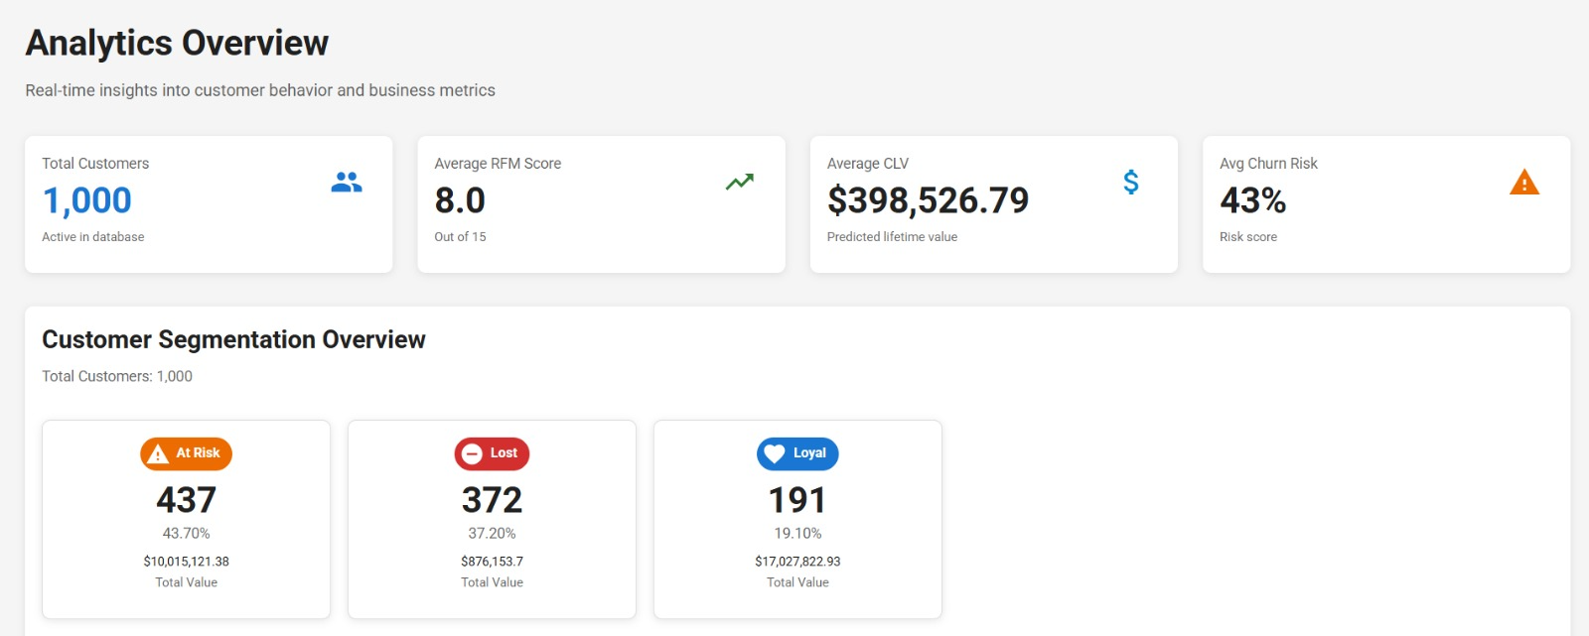
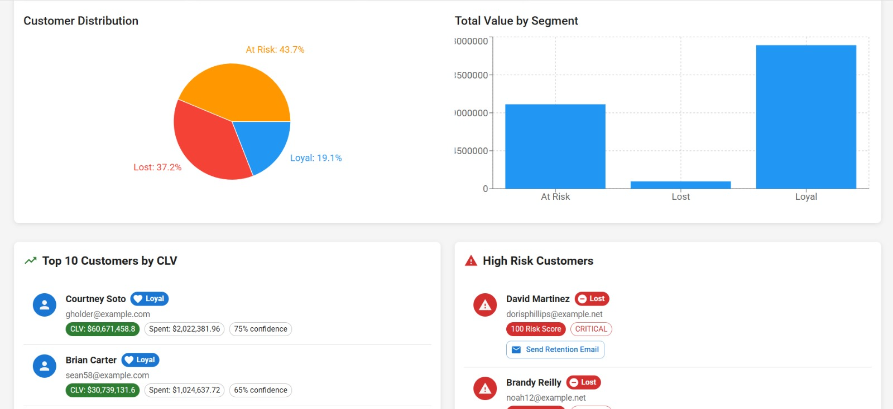
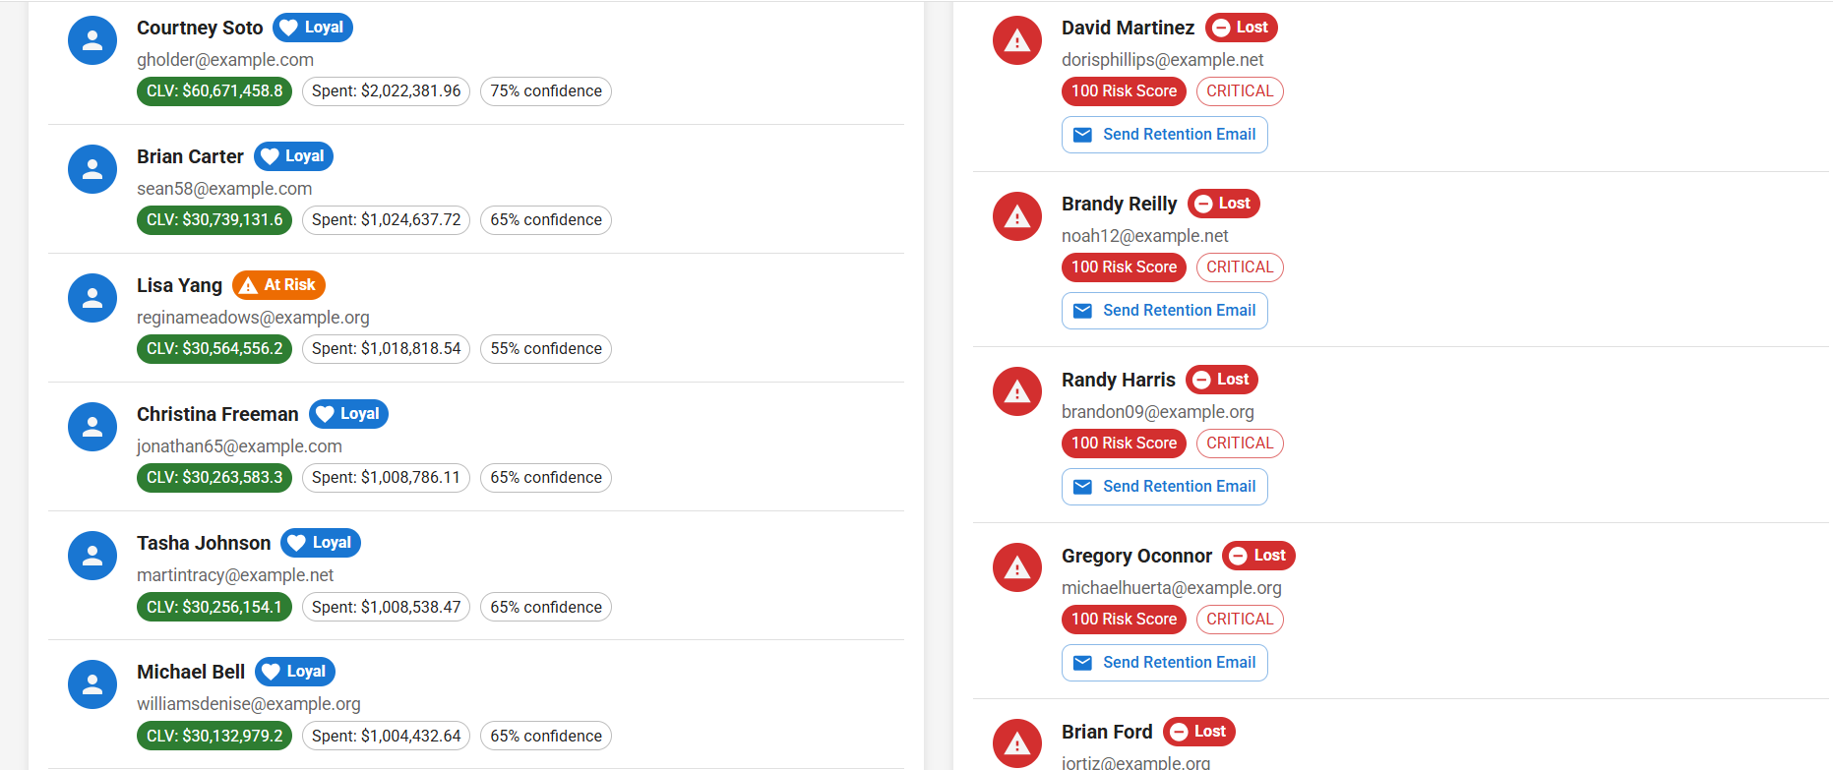
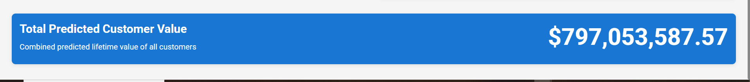

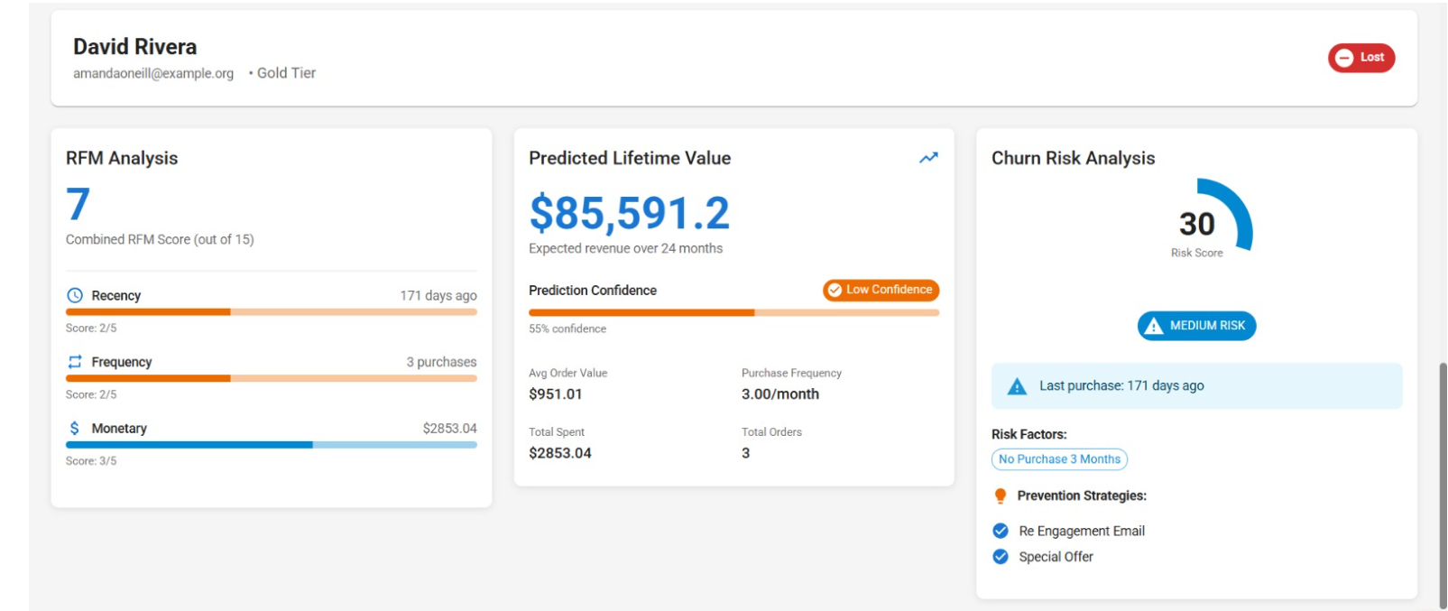
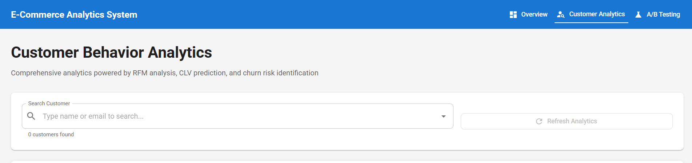
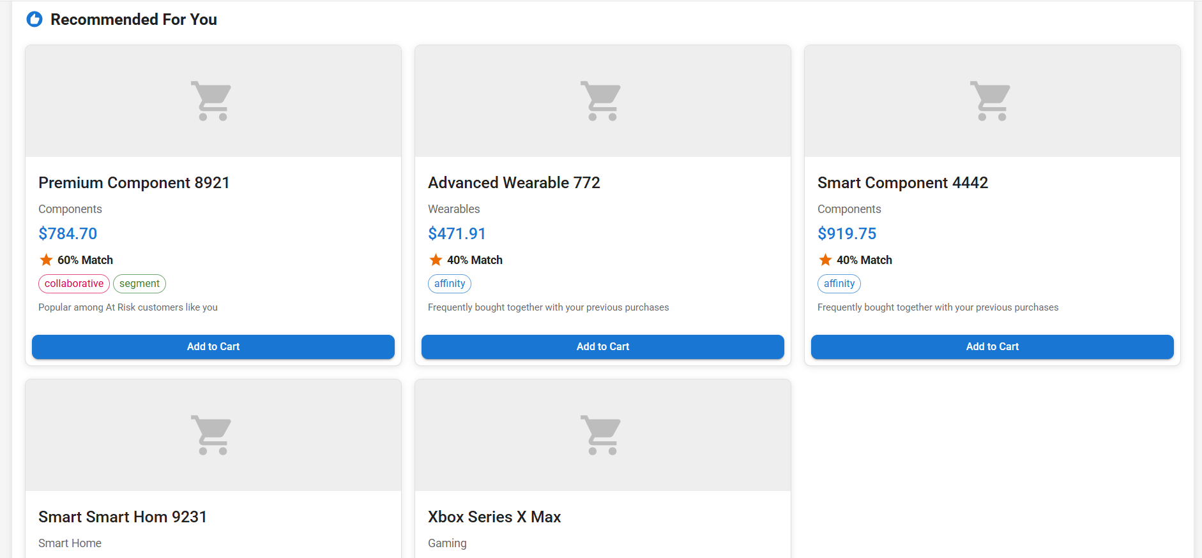
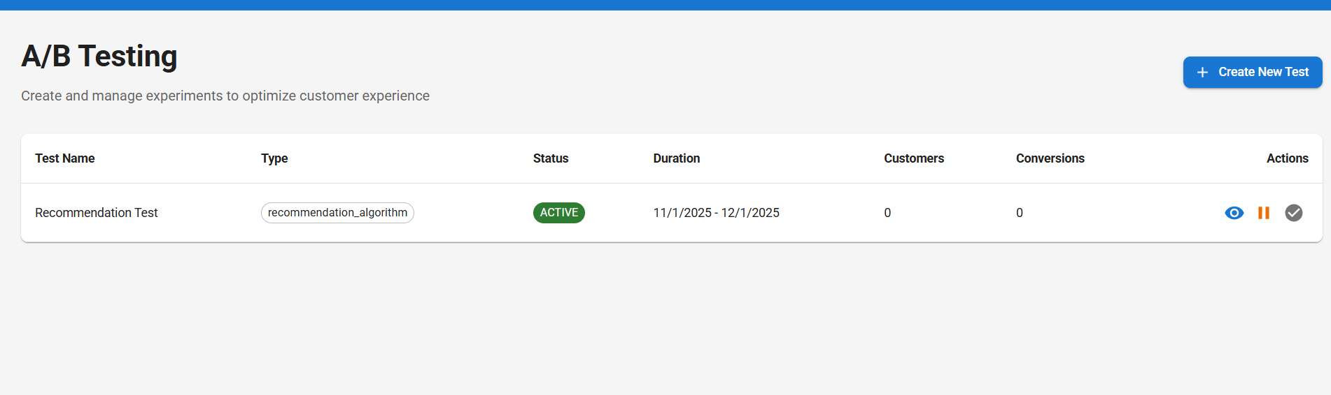
131. After that I created api documentation for all endpoints using swagger.

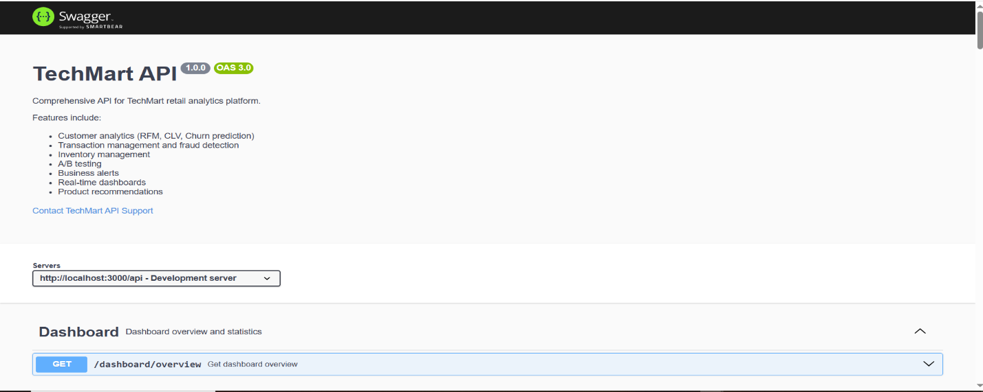
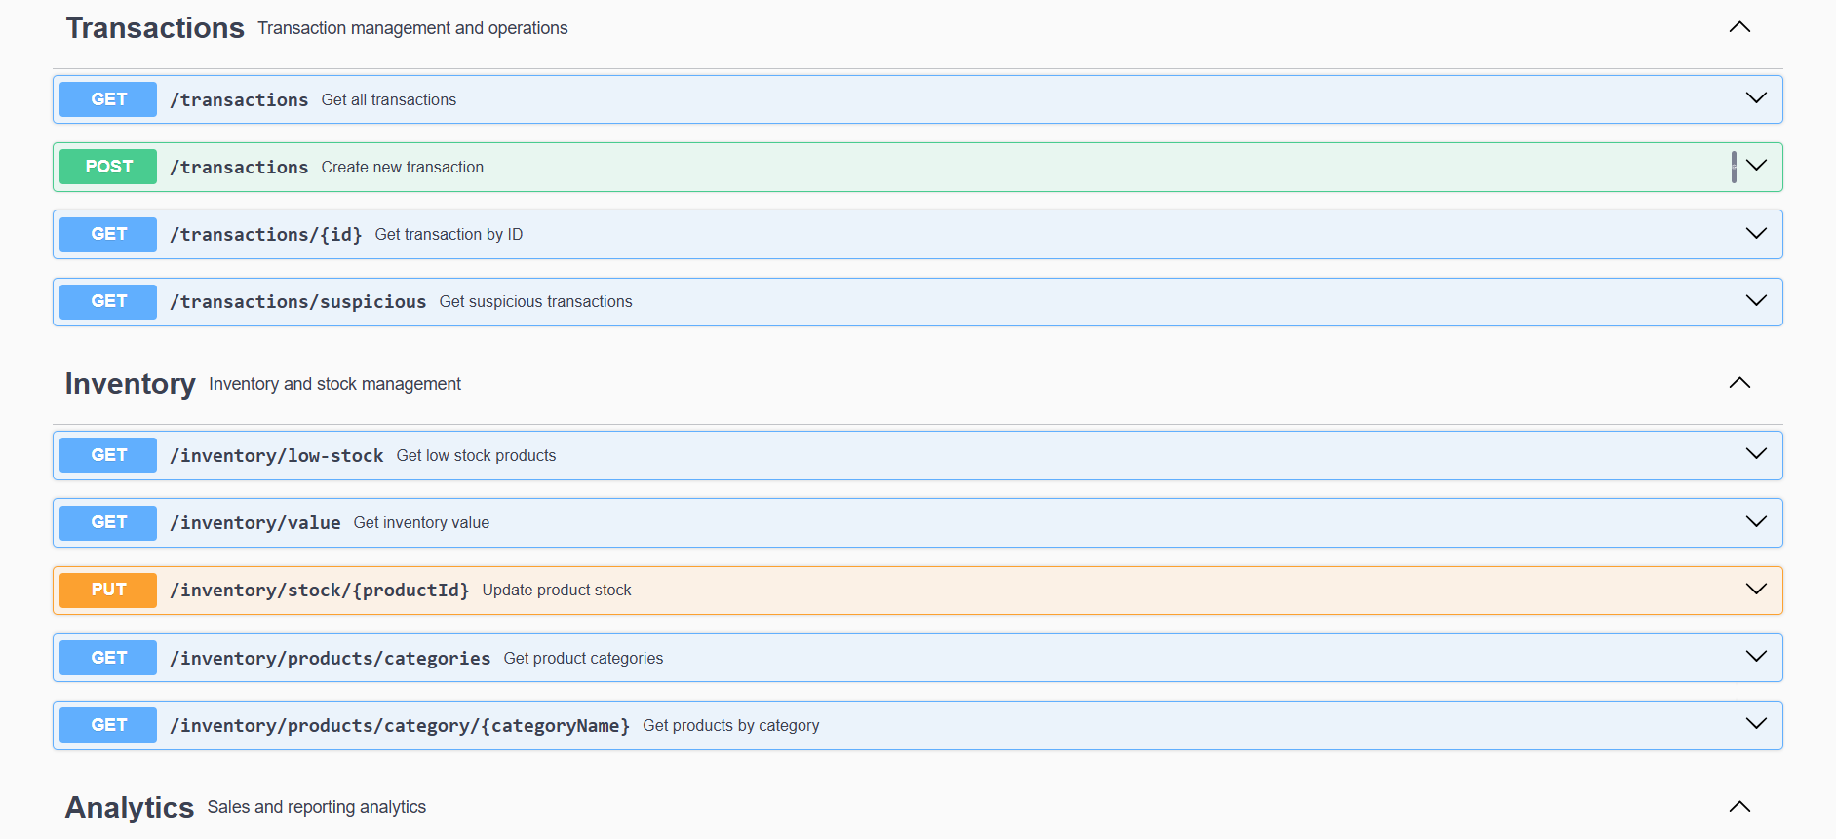
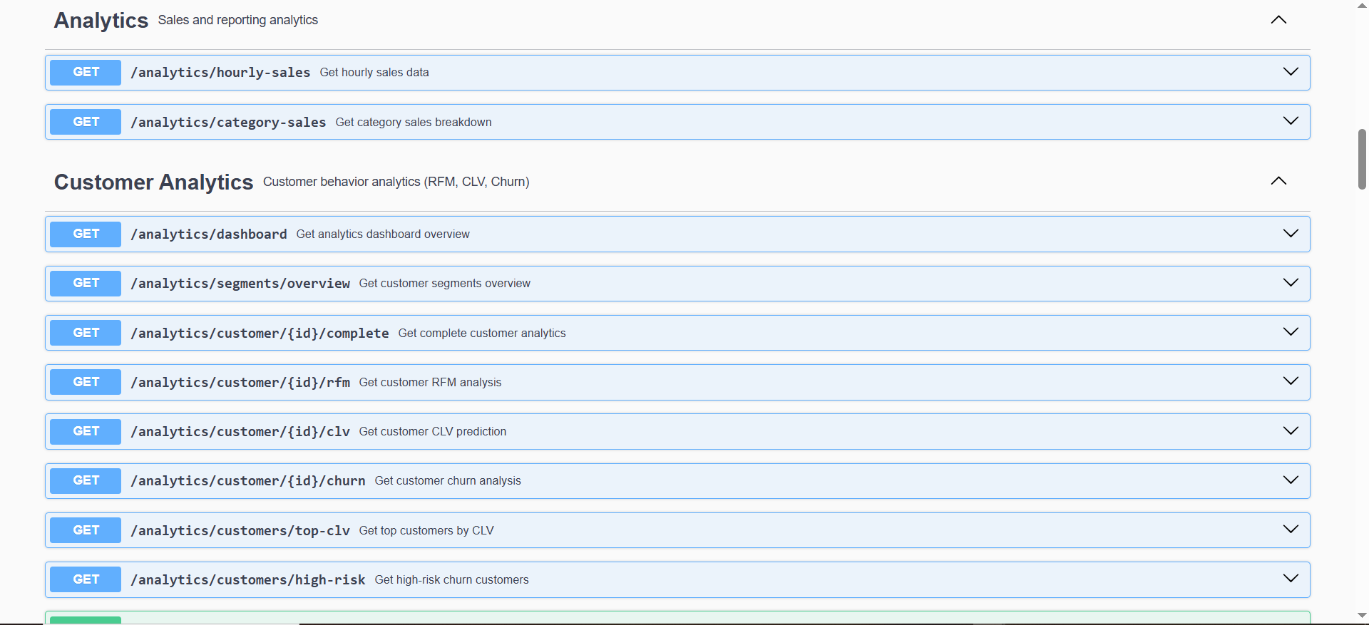
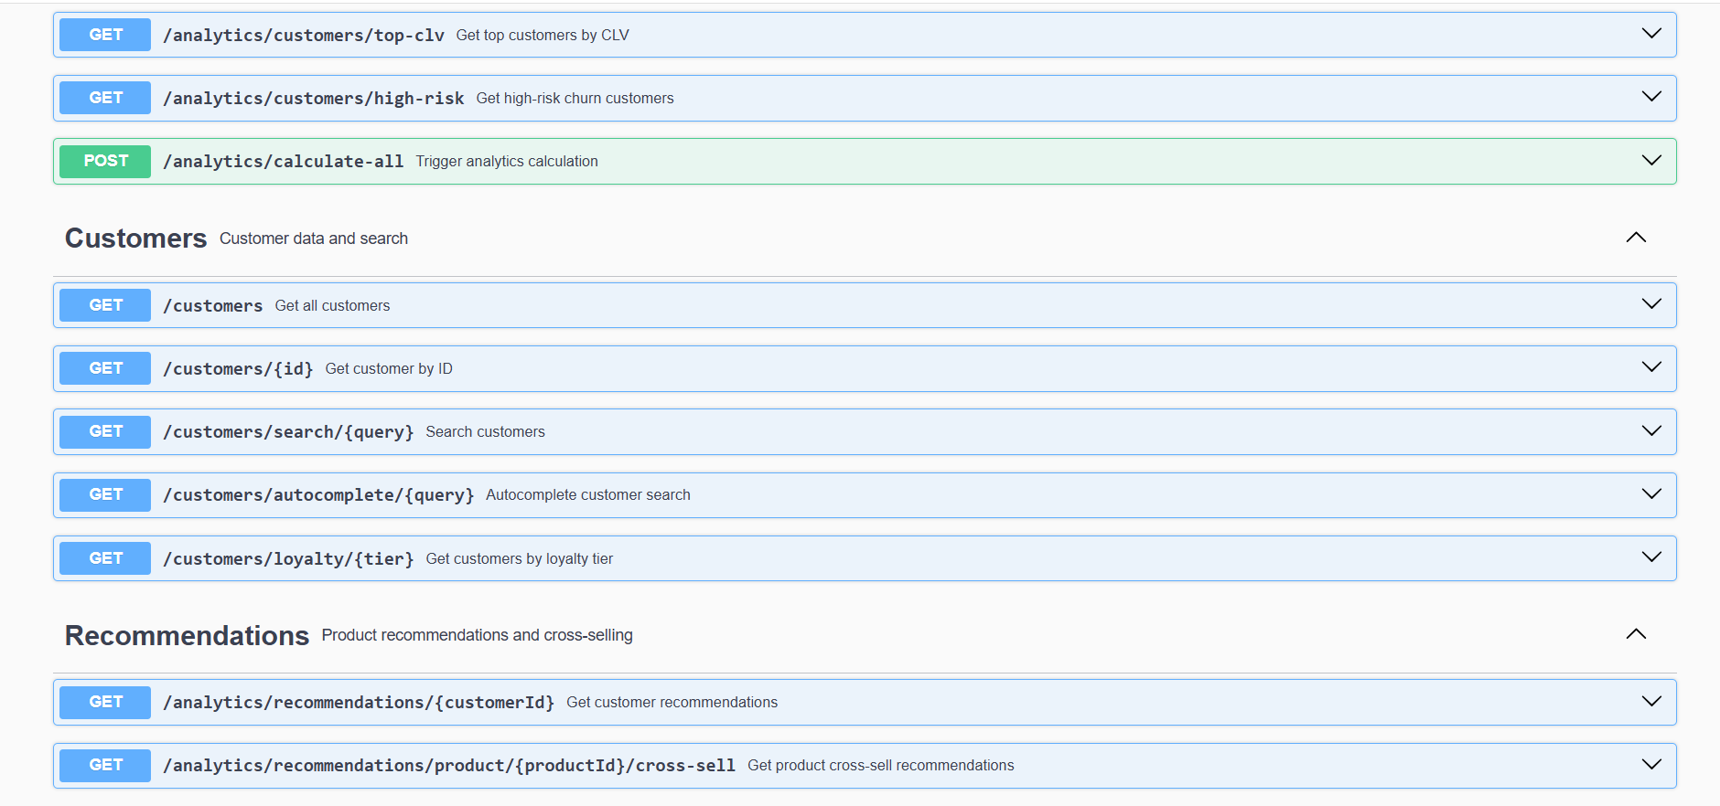
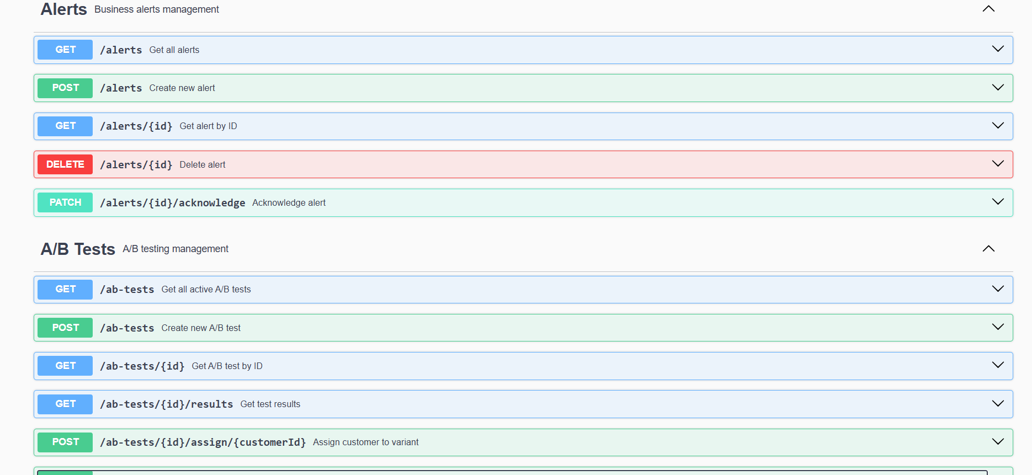
It is available at http://localhost:5000/api-docs

132. Then I deploy my frontend and backend both on docker as containers. Here are the screenshots of the process
The command I used was docker compose up which I ran in project’s root directory, I had two dockerfiles, both for frontend and backend.
