

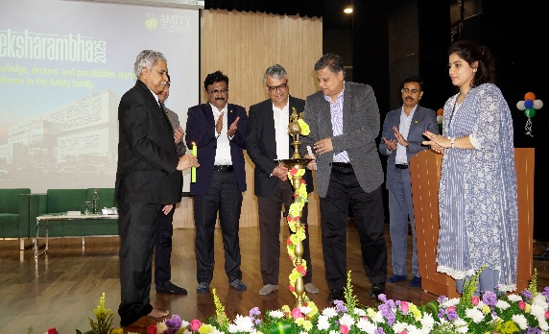
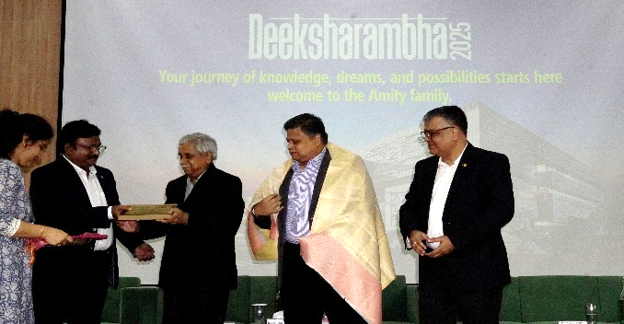
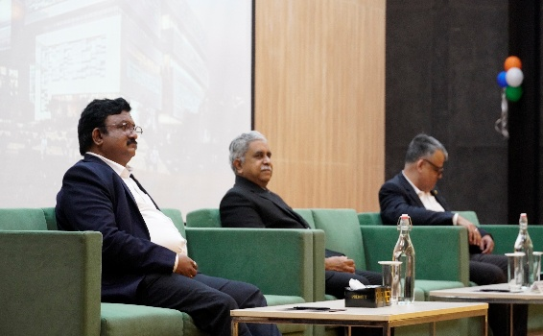
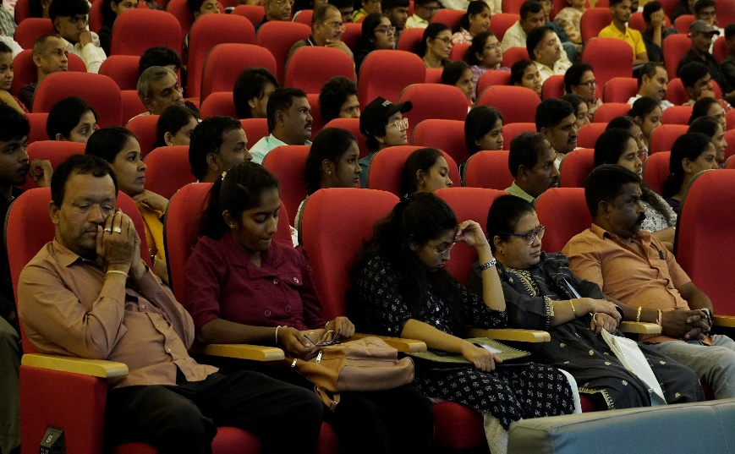
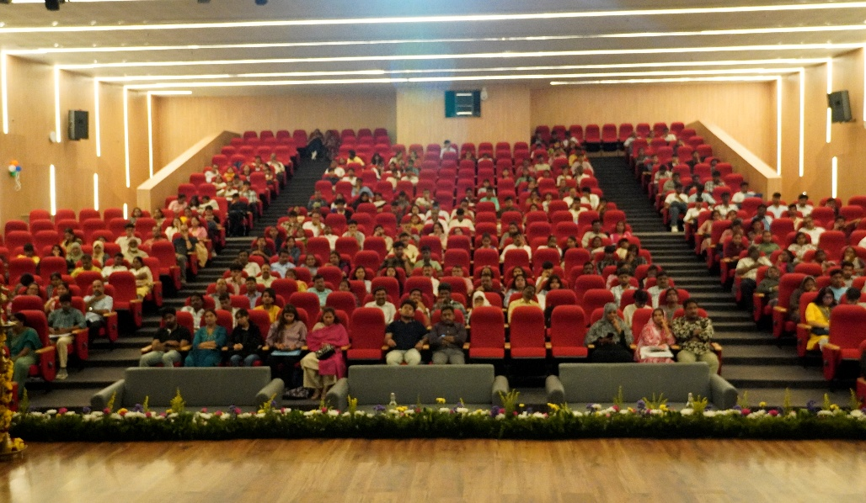
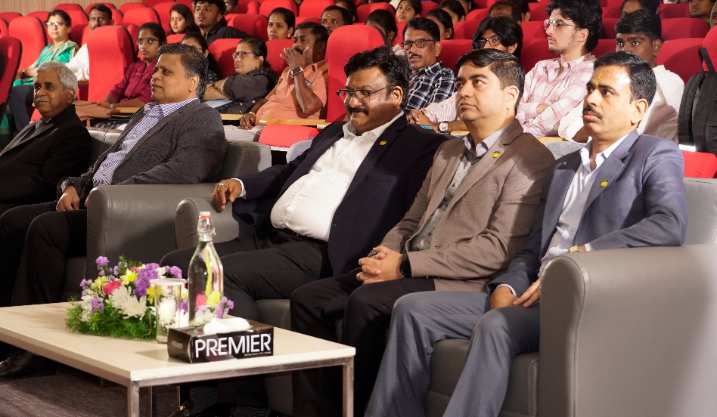
.
AFTER THE HAWAN CEREMONY, THE ORIENTATION CEREMONY STARTED AT 11:00 AM IN THE UNIVERSITY AUDITORIUM.
THE CHIEF GUEST VARADHARAJU JANARDHANAN,ALONG WITH THE VICE CHANCELLOR,THE PRO VICE CHANCELLOR ,THE VICE PRESIDENT OF AMITY UNIVERSITY BENGULURU,THE REGISTRAR,THE FACULTY MEMBERS,THE STAFF MEMBERS AND THE STUDENTS ATTENTED THE PROGRAMME THE CHIEF GUEST INAUGRATED THE CEREMONY BY LIGHTING THE LAMP.THE OFFICIALS ADDRESSED THE GATHERING.
.
.
.

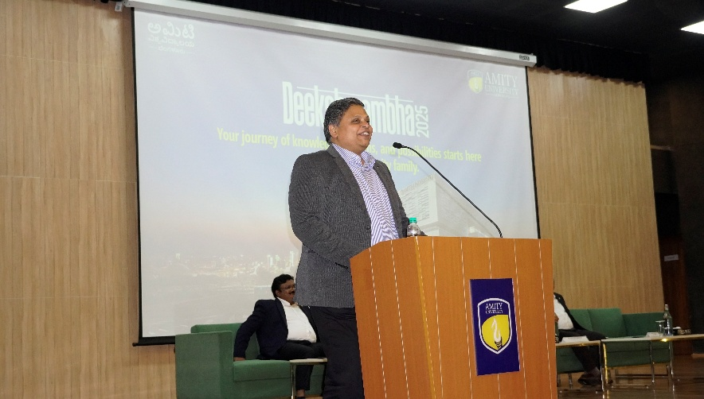
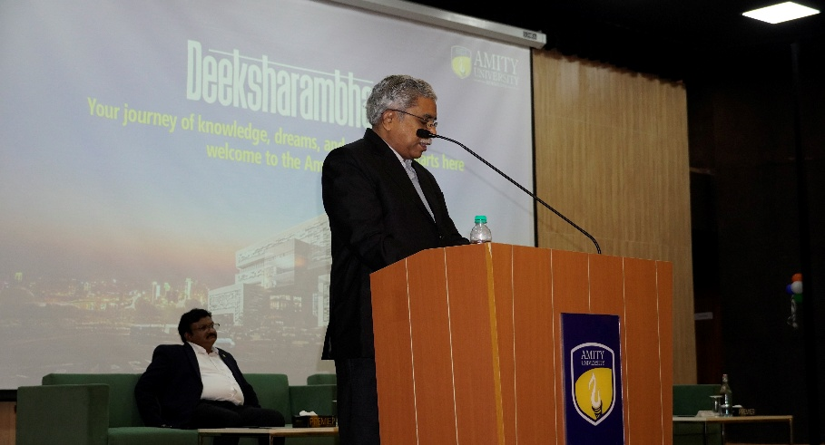
THE VICE CHANCELLOR
DR.D.SUBHAKAR
THE CHIEF GUEST
VARADHARAJU JANARDHANAN
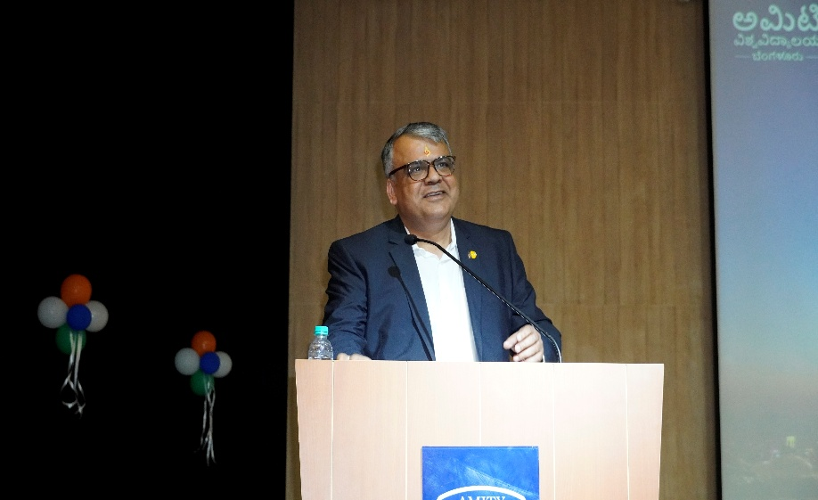
PRO VICE CHANCELLOR
DR.MONIT KAPOOR
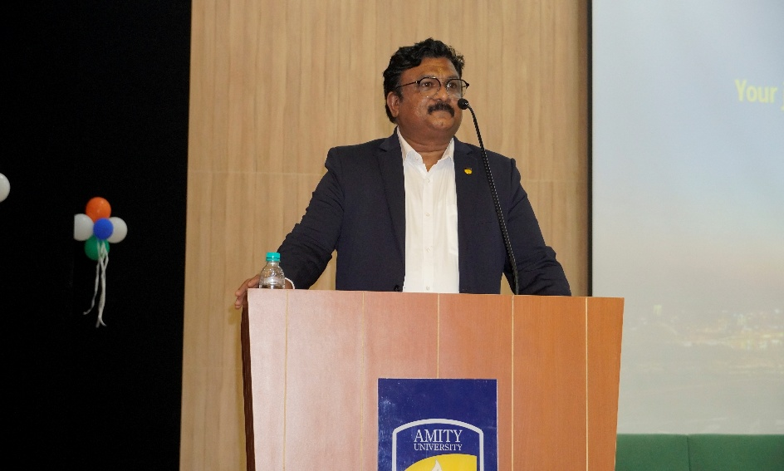
THE VICE PRESIDENT
P S SALLI

