Docker assignment
Muhammed Jamzeeth
November 7, 2025
Fortude

1. Verifying Kernel Sharing
docker run -it --rm ubuntu bash
uname -r
cat /proc/version
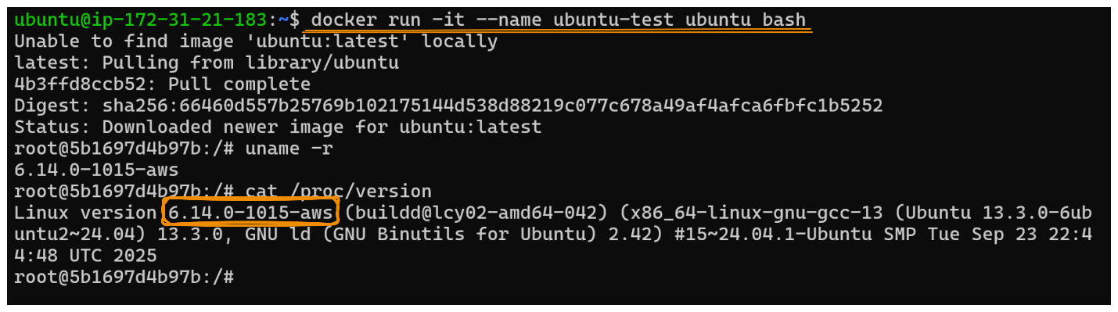
docker run -it --rm alpine sh
uname -r
cat /proc/version
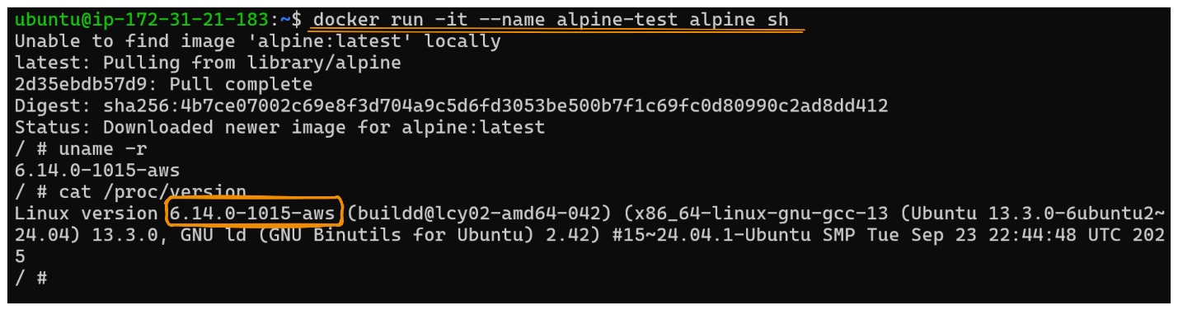
On host:
Uname -r
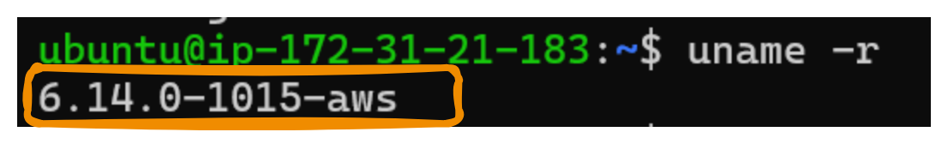
Observation:
- The kernel version is identical across host and containers. (6.14.0-1015-aws)
- This shows containers use the same kernel, not a virtualized one.
Conclusion:
Containers aren’t VMs. They are processes isolated via kernel features, not separate operating systems.
2. Process and PID Mapping
docker run -d --name testpid ubuntu sleep 300
docker exec -it testpid bash
echo $$
On host:
docker inspect -f '{{.State.Pid}}' testpid
ps -ef | grep 3532
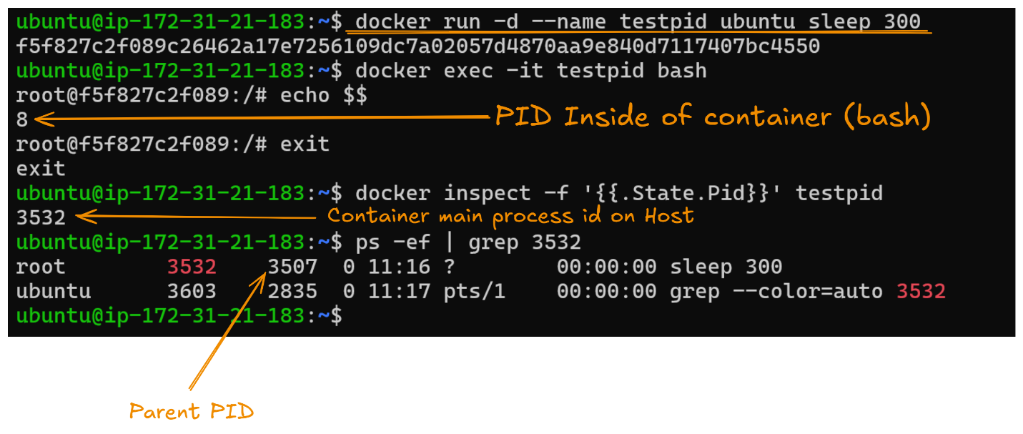
Observation:
- The container’s PID 8 inside maps to a different PID on the host.
- You’ll see it as a child of containerd-shim or runc.
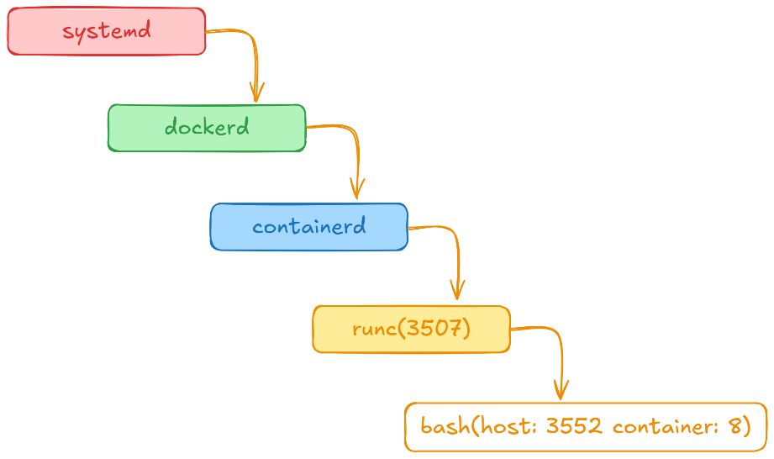
Process Tree:

3. Exploring Namespace Isolation
docker run -d --name ns-test1 ubuntu sleep 3600
docker run -d --name ns-test2 ubuntu sleep 3600
PID1=$(docker inspect -f '{{.State.Pid}}' test1)
PID2=$(docker inspect -f '{{.State.Pid}}' test2)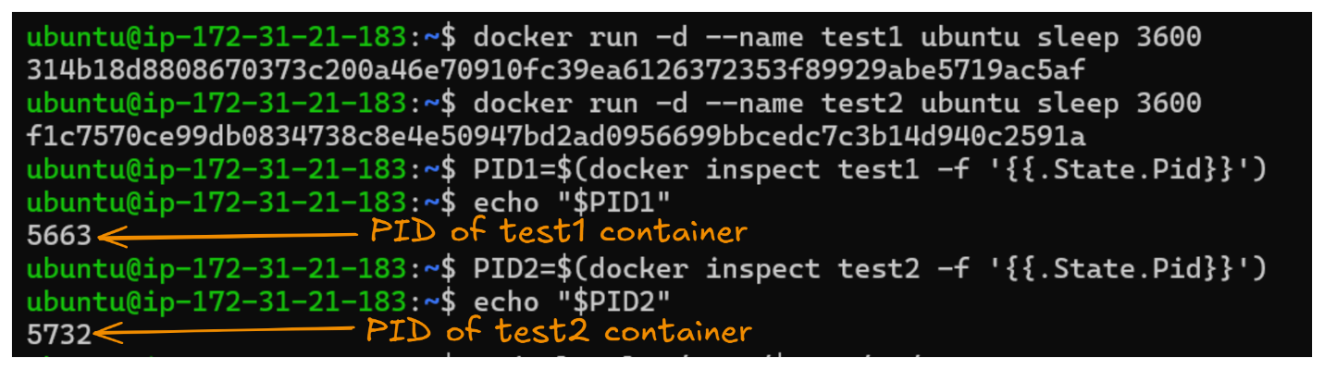
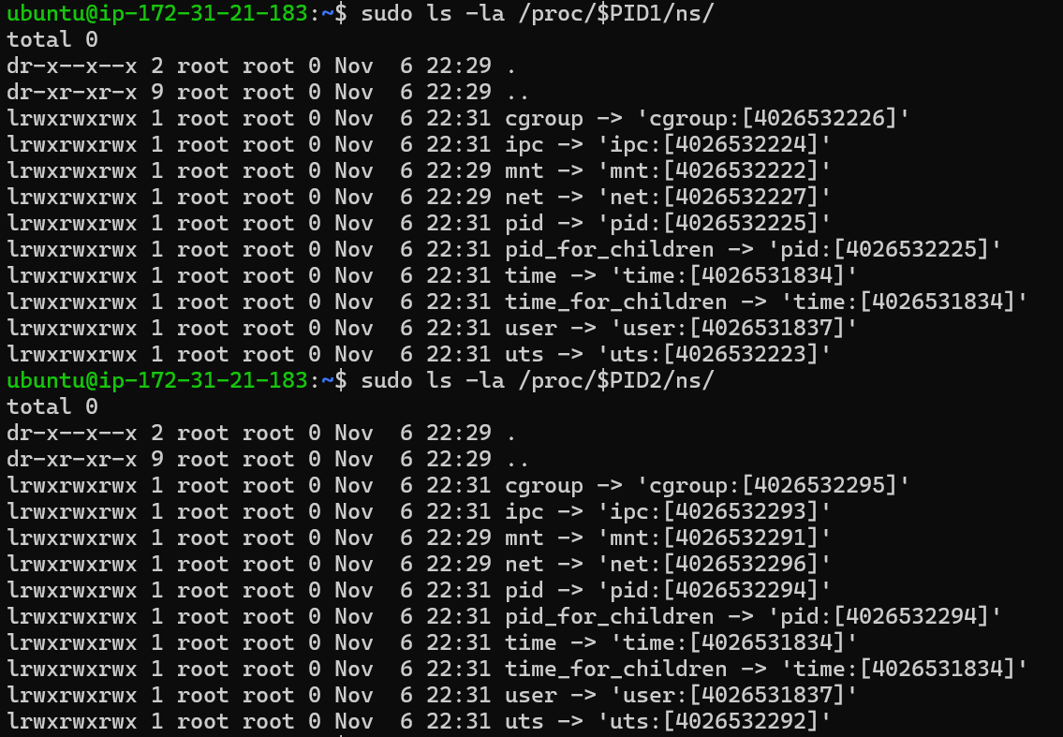

Observation
- The namespace IDs (numbers inside [ ]) differ between $PID1 and $PID2 for most types cgroup, ipc, mnt, net, pid, and uts.
- This indicates that each container has its own isolated namespace for processes, networking, mounts, etc.
- However, the user namespace ID is the same ([4026531837]), meaning both the host and container share the same user namespace typical in default Docker configurations.

4. Observing New Namespace Creation

# Monitor dockerd for clone() calls
sudo strace -f -e trace=clone,unshare -p $(pidof dockerd) 2>&1 | tee /tmp/docker-trace.log
// After run this command in new terminal start new container to monitor

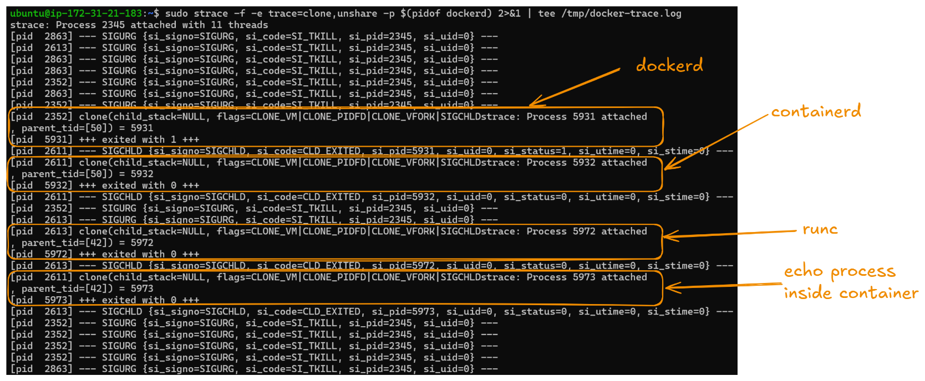
// When started go to the trace terminal
Extract clone flags from trace

Conclusion
This experiment demonstrates that when a container is created, Docker (through dockerd → containerd → runc) uses the Linux clone() system call with namespace flags to isolate processes, mounts, networks, and hostnames.
Each new container triggers these calls, effectively creating a new namespace context that makes containers appear as independent systems even though they share the same Linux kernel.
Note:

Observation Note:
- In the strace output, namespace creation flags (e.g., CLONE_NEWNS, CLONE_NEWPID, CLONE_NEWNET) were not visible.
- This is because the trace was attached to dockerd, which does not directly create namespaces.
- The actual namespace creation happens inside runc, a short-lived process that runs briefly to set up the container and then exits.
- Therefore, only normal clone() calls (process/thread spawns) were captured, not the namespace-related ones.

5. Investigating cgroup Assignments

docker run -d --name cgroup-test \ --cpus="0.5" \ --memory="256m" \ ubuntu sleep 3600
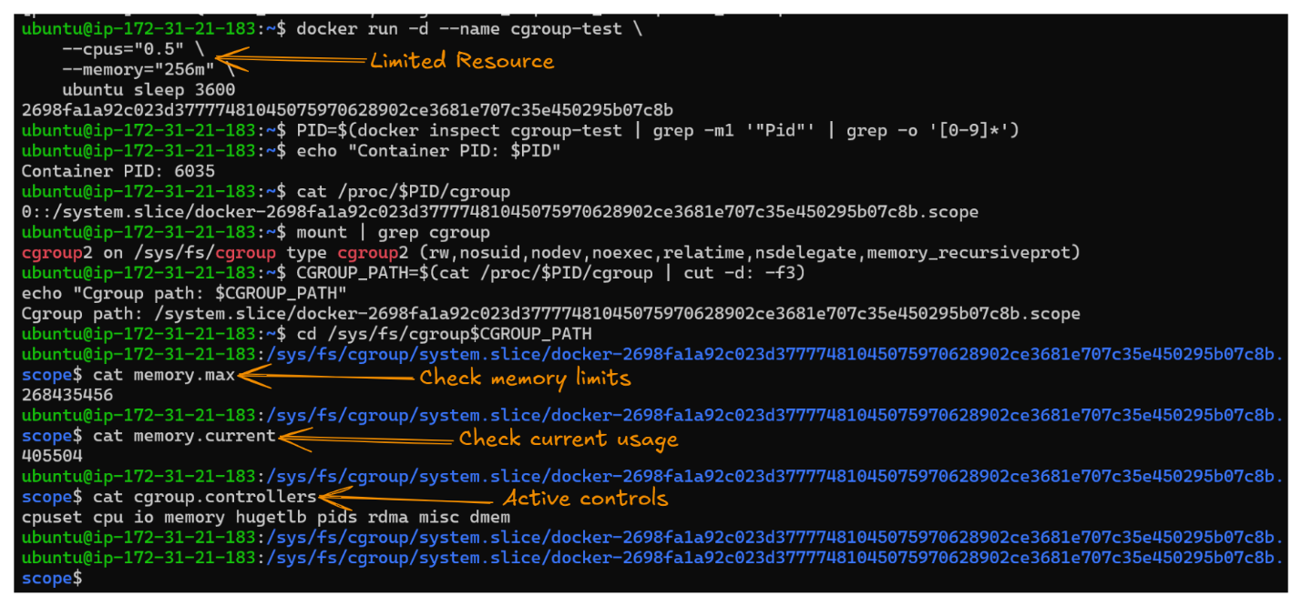

Monitor in real-time:
docker stats cgroup-test

6. Resource Behavior Under Load

Install stress tool:
apt-get update && apt-get install -y stress
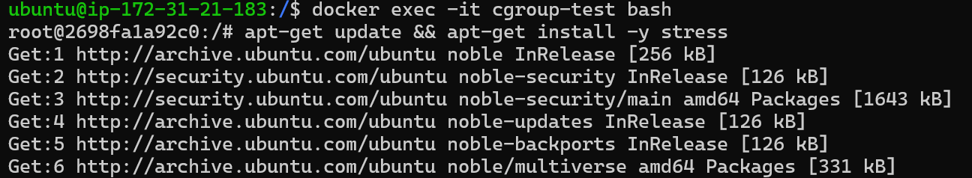

Install stress tool apt-get update && apt-get install -y stress:

Watch cgroup metrics :
watch -n 1 "cat /sys/fs/cgroup$CGROUP_PATH/cpu.stat"
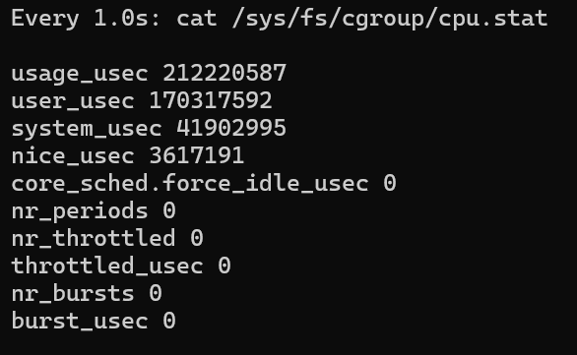

Observation:
- CPU usage capped at ~50% despite 4 stress workers
- Container can't exceed limits even under full load

Watch docker stats:
docker stats cgroup-test
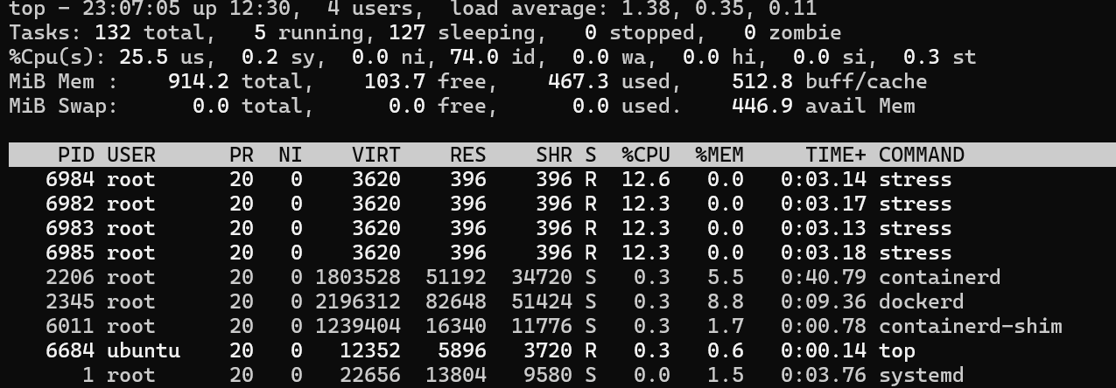

7. Filesystem Layer Analysis
Navigate to overlay2 directory:
sudo ls -la cd /var/lib/docker/overlay2/

# Find specific container's layers CONTAINER_ID=$(docker ps -qf name=cgroup-test) sudo docker inspect $CONTAINER_ID | grep -E "UpperDir|LowerDir|MergedDir"

# Get the paths UPPER=$(sudo docker inspect $CONTAINER_ID -f '{{.GraphDriver.Data.UpperDir}}')
echo "Upper (writable): $UPPER"

# Check what's in the writable layer
sudo ls -la $UPPER
# Create a file in container
docker exec cgroup-test bash -c "echo 'persistent data' > /testfile.txt"
# Check it appears in UpperDir sudo cat $UPPER/testfile.txt
# Stop container (layer persists)
docker stop cgroup-test
sudo ls $UPPER # Still exists!

# Start again
docker start cgroup-test
docker exec cgroup-test cat /testfile.txt # File still there!

# Remove container (layer deleted)
docker rm cgroup-test

# Check again
sudo cat $UPPER/testfile.txt # You cannot find the file

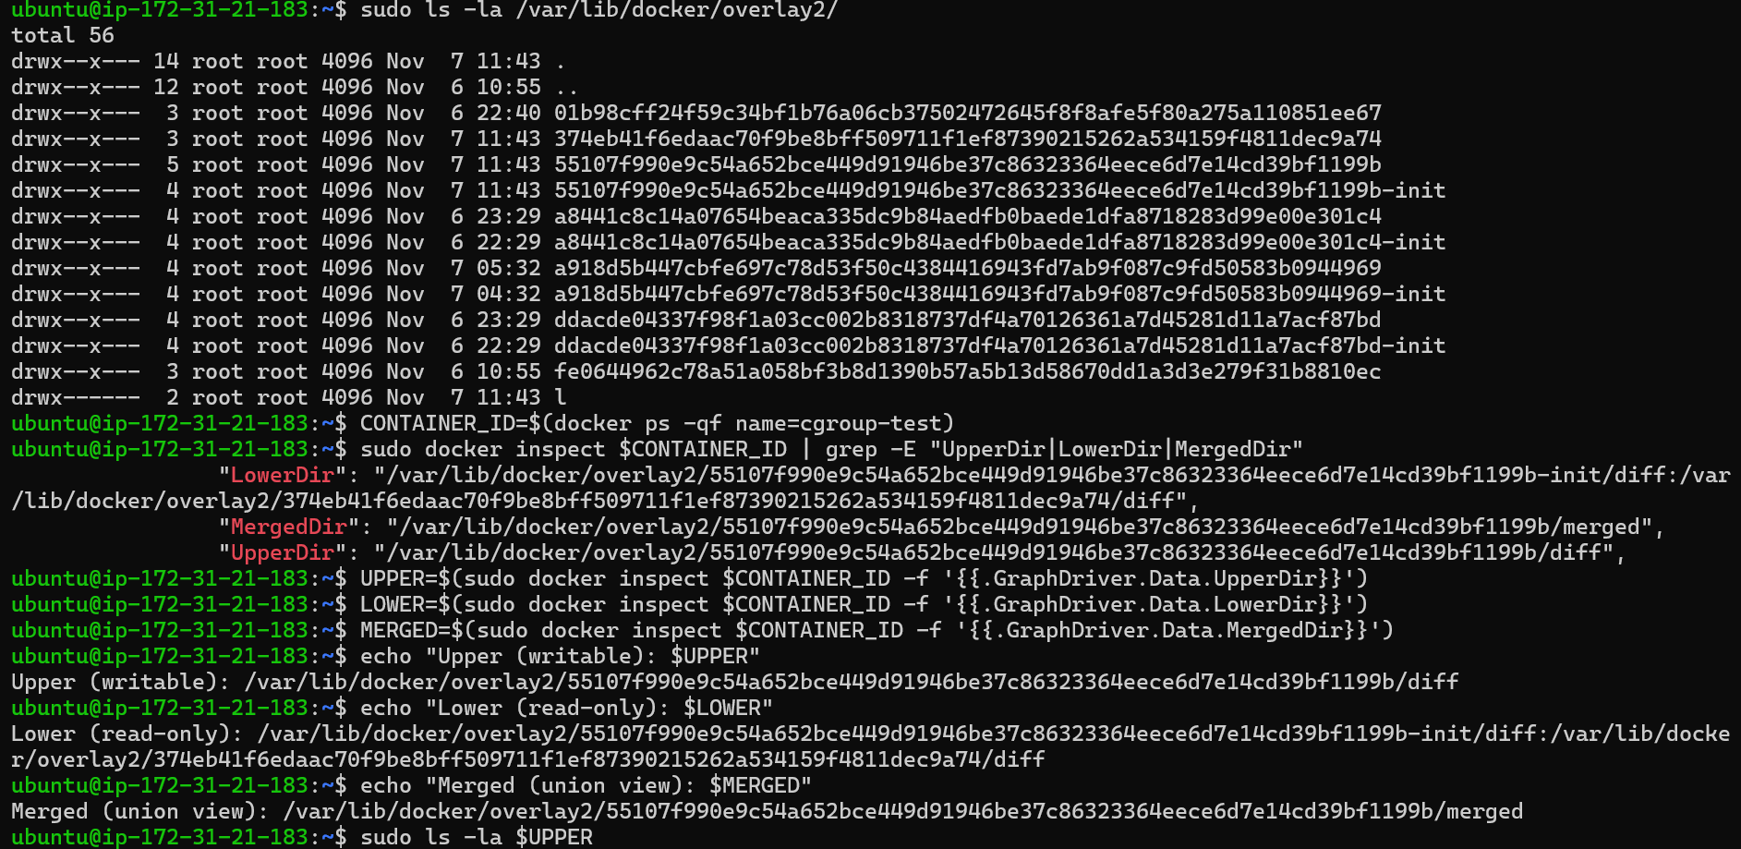
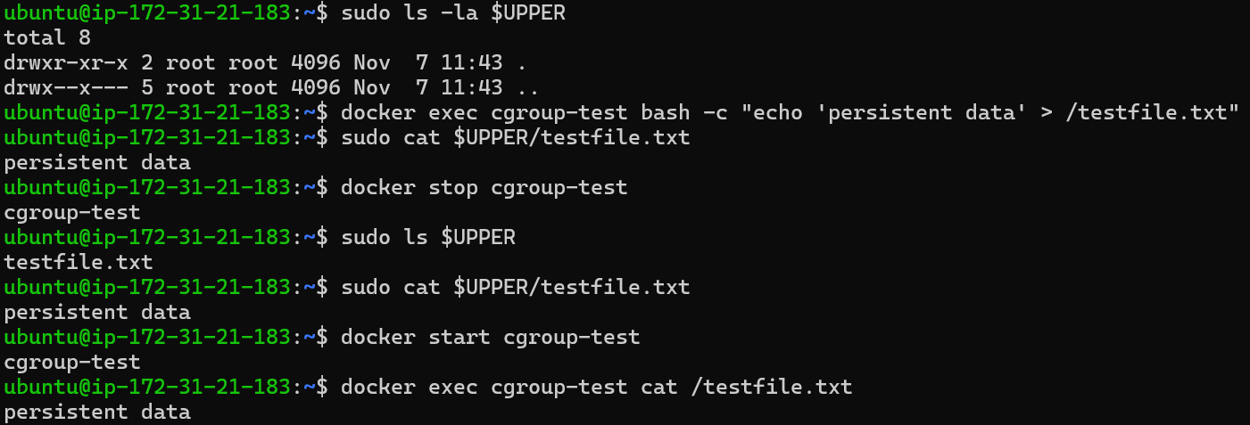
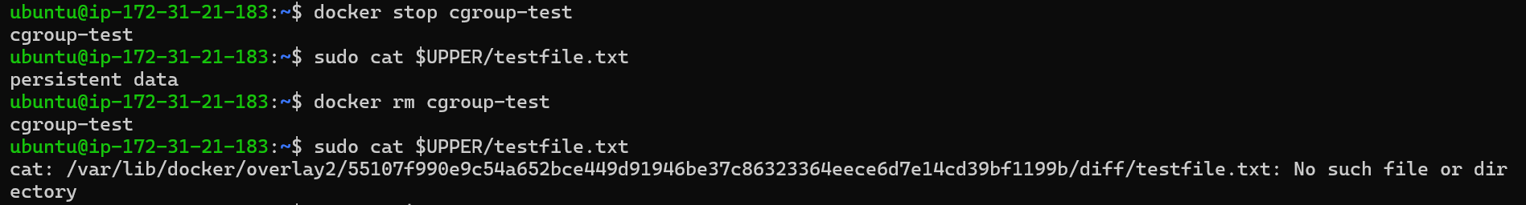
8. Process Creation Flow Examination
# Show complete Docker process hierarchy
pstree -p $(pidof dockerd) | head -50
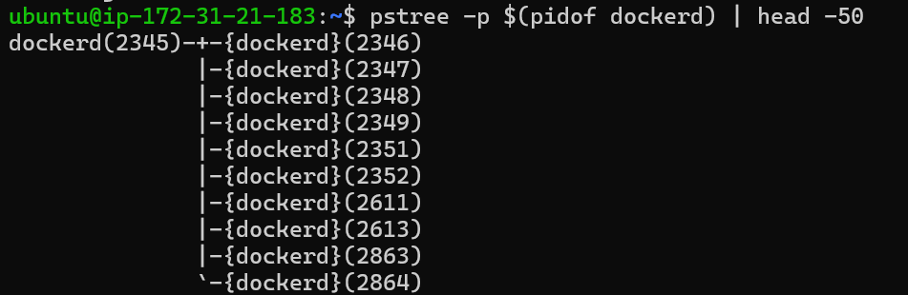

# Trace specific container
PID=$(docker inspect cgroup-test | grep -m1 '"Pid"' | grep -o '[0-9]*')
pstree -p -s $PID
1. systemd (PID 1): Ubuntu's init system
2. dockerd: Docker daemon (manages containers)
3. containerd: Container runtime (manages container lifecycle)
4. containerd-shim: Shim process (keeps STDIO open, reaps zombies)
5. runc init: Actually creates namespaces/cgroups (short-lived)
6. Container process : Your bash/application (PID 1 in container)
9. Comparative Namespace Experiment
# Run a fully isolated container
docker run -it --name isolated ubuntu bash
# Inside the container:
ps -ef
hostname
ip addr show
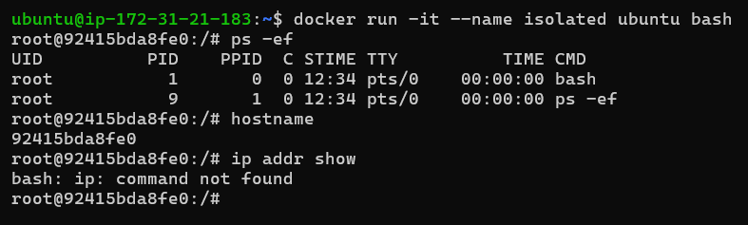
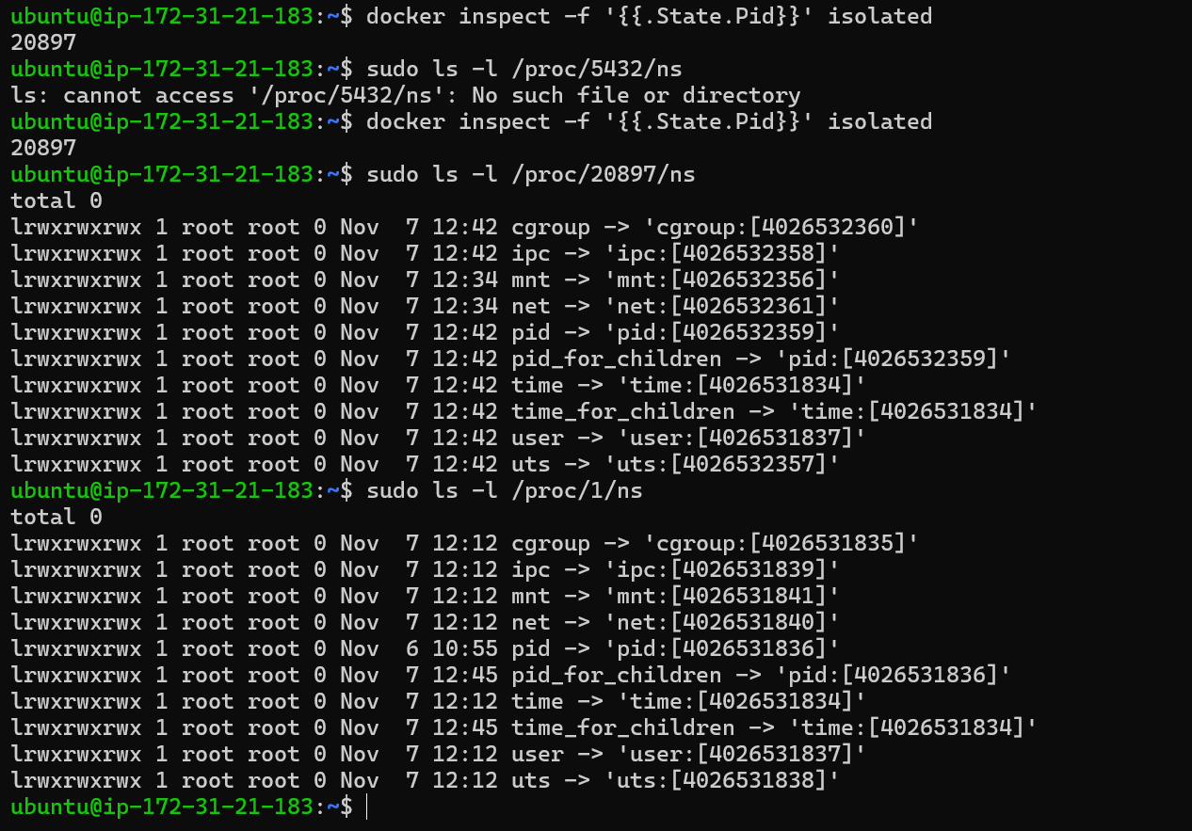
We can see different inode numbers for PID, NET, MNT, etc. compared to host processes — proving the container is isolated.

Run a Container Sharing the Host PID Namespace:
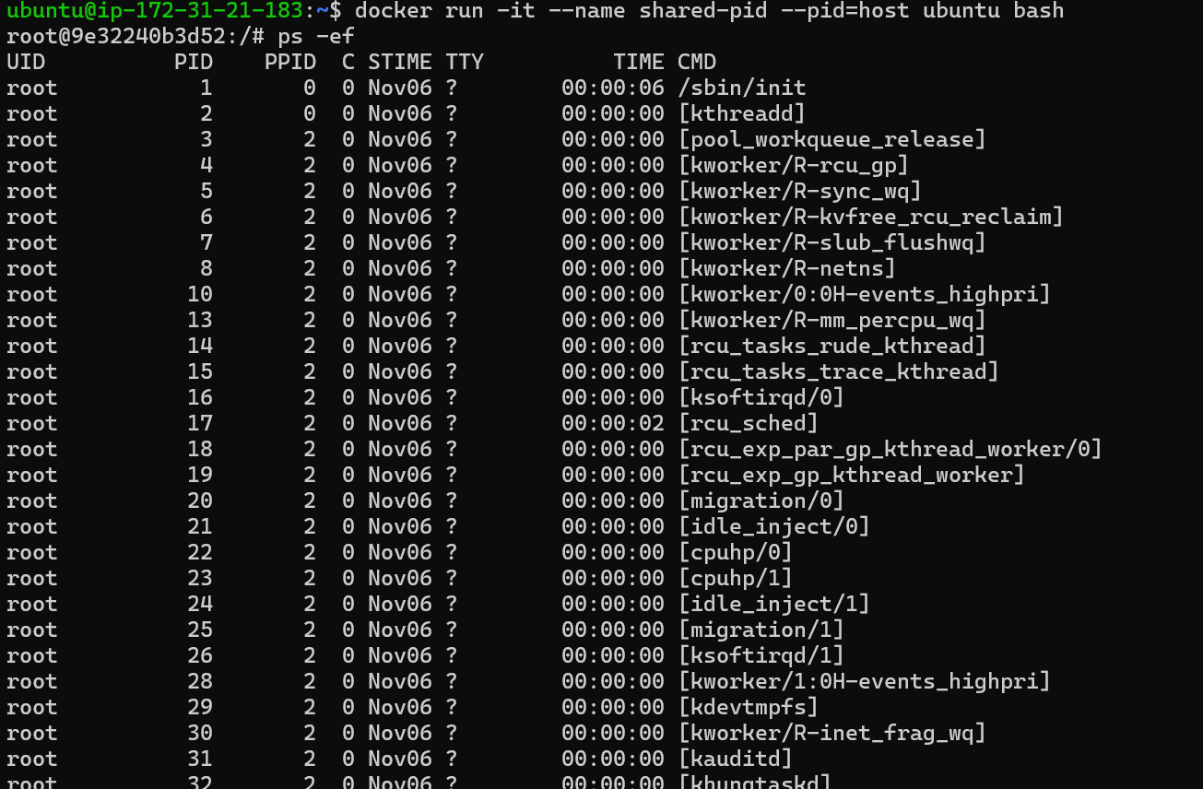
We can now see all host processes, not just the container ones because the container is using the host PID namespace.

On the host:
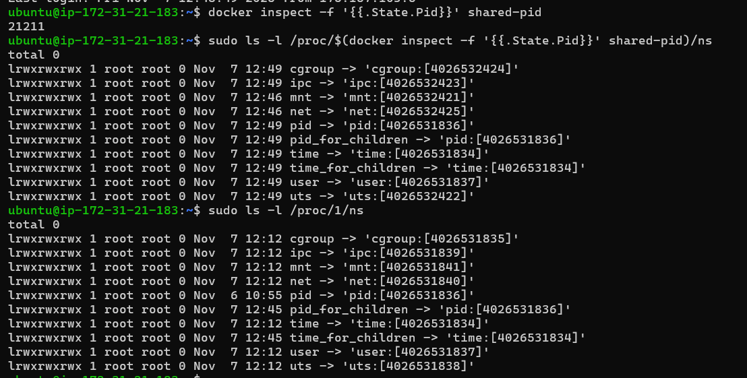

Compare namespace inode numbers with your host’s /proc/1/ns/pid.
We will see they are identical meaning the container shares the host’s PID namespace.

Run a Container Sharing the Host Network Namespace:
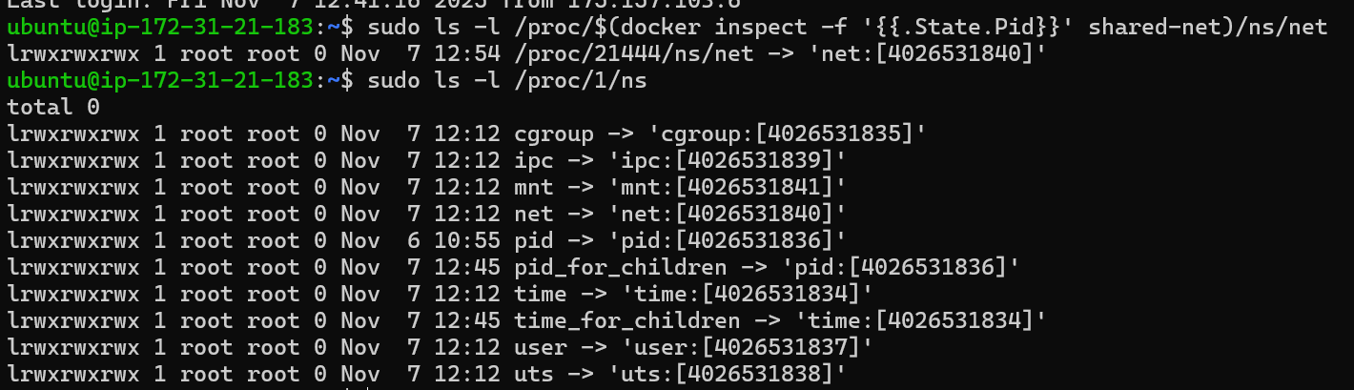
You can see here both host and shared-net using same net ID

Understanding setns():
When Docker runs a container with --pid=host or --network=host,
instead of creating new namespaces, it uses the setns() system call.
- clone(): creates a new namespace
- setns(): joins an existing namespace

