

**Senior Design Project Report II**

**COMP492**

Atakan Ermete, 041601023

Muhammed Rahmetullah Kartal, 041701008

Zeynep Ayyüce Çay, 041601021

Advisor: Tuna Çakar

2021

**ABSTRACT**

**Marbles**

Atakan Ermete

Muhammed Rahmetullah Kartal

Zeynep Ayyüce Çay

MEF UNIVERSITY

Faculty of Engineering

Department of Computer Engineering

Advisor: Tuna Çakar

APRIL 2021

Unlike the common 2D story-based games that are in today's game market, the aim is to bring a different perspective to the market by supporting the in-game quests with Artificial Intelligence (AI) and multiple decisions made by the player during the game to set in an imaginary world, this game is a story-driven 2D RPG, so to add a new viewpoint to the game industry by encouraging different algorithms of AI in in-game quests and story flow according to the player's decisions is the most important part, and applying that idea in a 2D story-driven game is the project’s must. In this imaginary world, the player is going to play the game as an American army soldier against Nazi Germany in Second World War and going to understand cruelty in world events.

**Keywords:** 2D, Story flow, AI, Role Play Game (RPG)

# TABLE OF CONTENTS

ABSTRACT 2

TABLE OF CONTENTS 3

LIST OF TABLES 5

LIST OF FIGURES 6

1. INTRODUCTION 7

1.1. Motivation 7

1.2. Content 7

1.3. Artificial Intelligence 7

1.4. Economic Aspects 8

1.5. Impact 8

1.5.1. Global Impact of the solution 8

1.5.2. Economic Impact of the solution 8

1.5.3. Societal Impacts of the solution 8

2. PROJECT DEFINITION AND PLANNING 9

2.1. Project Definition 9

2.2. Project Planning 9

2.2.1 Aim of the Project 9

2.2.2 Story 9

2.2.3 Quest Types 11

2.2.4 Project Time Planning 15

2.2.5 Success Criteria 18

2.2.6 Project Time and Resource Estimation 19

2.2.7 Risk Analysis 19

2.2.8 Tools Requirements 20

3. THEORETICAL BACKGROUND 20

3.1. Literature Survey 20

3.2. Solution Method 22

4. ANALYSIS AND MODELLING 23

4.1. System Factors 23

4.2. How System Works 23

4.3. Modelling and System Architecture 24

5. DESIGN, IMPLEMENTATION AND TESTING 27

5.1. Design 27

5.2. Implementation 27

5.3. Testing 27

6. RESULTS 27

7. CONCLUSION 28

7.1. Life-Long Learning 28

7.2. Professional and Ethical Responsibilities of Engineers 29

7.3. Contemporary Issues 29

7.4. Team Work 29

8. REFERENCES 30

9. Appendix 31

# LIST OF TABLES

Table 1. The event done by group members 15

# LIST OF FIGURES

Figure 1. First move of Isolation Game 12

Figure 2. Second move of Isolation Game 13

Figure 3. Four Connect In-game AI is Winner 14

Figure 4. Gantt Chart of the Project 17

Figure 5. Workflow Scheme 25

Figure 6. Isolation content flowchart 25

Figure 7. Minimax Flow-chart 26

Figure 8. Digging Scene 28

Figure 9. Dynamite 31

Figure 10. Bullet box 31

Figure 11. Gallon 32

Figure 12. Fire hydrant 32

Figure 13. Chest 33

Figure 14. Inside of box 33

Figure 15. AI background 34

Figure 16. Red coin 34

Figure 17. Grey coin 34

Figure 18. Circle 35

Figure 19. Circle 35

Figure 20. Circle 35

# INTRODUCTION

## Motivation

The main motivation to start this project is the group member's desire to create a game and a story due to their imaginations. Group members chose to different unique game to the game market because of they had an idea about the games available on the market. It is determined to design a 2D story-based game using artificial intelligence in mini quests and storyline. The biggest difference of the this game from game market is that it contains 2-dimensional and artificial intelligence tasks by story-based.

## Content

The content is designed to express the effects of war on human psychology and ideas. To make feel better these effects game and environments going to be designed in different parts, the first part takes the middle of the war, consequently the problems that it causes as the topic from the perspective of a soldier, in the continuation of the story the psychological effects and disappointments of the first episode is dealt with, at the end of the fiction with the concreted emotions which are decided by the player, the alternative endings came up. Decisions will impress the player as the whole fiction continues as a main story.

## Artificial Intelligence

The role of AI in the game is to give a challenge to players on the different side and main quests like the 3x3 isolation game. Almost all these quests are going to be compulsory to achieve full progress in the story, and the level of AI is going to change related to the player’s decisions and play style. There are some side quests in the main story. Since these quests will affect the flow of the storyline, it is the player's decision to do it or not. In the side mission called Connect-four, the user has to win the game against artificial intelligence. Otherwise, player can not able to see the possible consequences because of the chest quest not completed. In another task, the user has to finish the randomly determined maze with the luck factor(dices) before the artificial intelligence. The luck factor has been developed so that it is possible for the user to defeat artificial intelligence. In the last part of the game, the user have to play a 3x3 isolation game to finish and see alternative end scenes by completing story. He must complete the tasks within the specified time and make the necessary move for the isolation game. Otherwise, the user cannot defeat the artificial intelligence. The purpose of artificial intelligence is to enable the user to perform tasks in a difficult way and to restrict freedom of movement. The user will face this and similar artificial intelligence tasks many times.

## Economic Aspects

Due to the consensus of the group members the project doesn’t have an economic income expectation, the main idea is launching the game on different computer platforms and to be accessible by other players.

## Impact

* + 1. **Global Impact of the Solution**

The global impact of this project, we have done is that people play this game. Because as the number of people playing this game increases, the rate of people being talked about will increase and will begin to attract people's attention. Being popular in the market causes the number of such games to increase. Users mostly like to experience new games. The aim of this project is to provide users with new experiences.

* + 1. **Economic Impact of the Solution**

The project will allow players to get a new and different experience for free. Therefore, the project does not make any economic contribution. But even though it does not have an economic impact, it has innovative effects on the game market in many areas. Only by increasing the popularity of the game environments we have installed has contributed to those environments.

* + 1. **Societal Impact of the Solution**

An example of the societal impact of the project can be the negative factors such as the stress experienced by the individuals who play during the day by enjoying this game. Having fun while playing this game is among the main goals. Since the game is not online, there will be no social communication. However, the fact that people talk about alternative endings by verbally communicating and changing the flow of the game based on these can be an example of the social effect of the game.

# PROJECT DEFINITION AND PLANNING

## Project Definition

This game is a story-driven 2D RPG set in an imaginary universe. In the game, you play as a soldier of the American army against Nazi Germany in WW2 to complete quests in the story to reach multiple endgame scenarios. The decisions of the user are important because they affect the storyline and Artificial Intelligence in quests. These choices are very important as the game strategy of artificial intelligence will change according to the user's decisions.

## Project Planning

## Aim of the Project

The aim is serving a new perspective to gaming industry by implementing an AI supported, story-based 2D game. The role of AI in this aim is giving an extra challenge to player and force him/her to make correct decisions. Story-based 2D games are almost nonexistent in the game market. This project is created in order to bring a different area to the game market. At the same time, it is free also it aims for users to experience different experiences in a free and easy way.

## Story

The first scene starts with hope about the end of the war, soldiers are talking about that situation, but all hope ends with a sudden attack on the second facade of the American Army which is inside the Nazi Germany area, this facade doesn’t have concrete buildings. Before that attack soldiers are training in different zones of the facade, this scene is about basic quick tips about playstyle and conversations of our two main characters (old man [Gerard] and young one [Sam]), on these conversations Sam realizes that Gerard has some problems about remembering things, because of that he gives a photo of himself to Gerard in that day.

On the night of the day that attack happens by enemy planes, as soon as Sam wakes up, he runs out of the tent checks for Gerard’s tent, and realizes that he is missing, after that he tries to help other soldiers and sees the injured commander, takes command from him, and starts his first actual quest about ringing the alarm and communicating the third facade about the situation.

After finishing these quests and saving people, Sam still worries about Gerard and returns to the second facade which is officially under the invasion of the enemy, in some area that is close to that facade he finds Gerard. Gerard remembers him and talks about the plan he made for that they need to split up, this part has two different stories for each main character, and we are going to play them one by one, also they will have quests together.

In the middle of this plan, enemy soldiers notice our main characters and start shootings, one of the characters is going to be shot but the screen will be almost fully blurred, and we won’t be able to see who is shotted.

After a while we are going to play with Gerard while he is running away from the area without Sam, after some time he will be out of breath and going to faint in a secure place, then we will see that Sam got shot and the enemy soldiers around the body, they will leave him by thinking he is dead. When they are gone, he will wake up with an injured body and goes to a German city after changing his uniform. Besides all that he thinks that Gerard has left him and run away, but at the same time he thinks if he is on Gerard's foot, he will probably do the same thing.

The main story starts in the German city, Sam is going to try to get himself a new life, he is going to work in a casual job, with the time he will get the news about the end of the war and the victory of Germany, he is going to fall in love with a girl named Elizabeth in this period. With some of the side and main quests, he can be able to find gifts for Elizabeth or useful goods for himself, for example after a game against ai in the city tavern, if he can do enough success against ai he will get two tickets for a prom, on this prom scene we are going to see how their relationship is going to move on (player will decide that by his/her decisions).

In some of the parts, Sam will realize that he is not able to do some of the things that he can do before that injury, but he won’t mention this situation to anyone. After all these, it will come out that Elizabeth’s father is one of the commanders which saw Sam’s dead body, but he won’t understand that because time passed and changes on Sam.

One day Elizabeth mentions a man, which his father trying to catch, to Sam and shows the photo of him, after a little shock Sam realizes that the person in the photo is himself, then starts thinking about Gerard, he thinks Gerard is probably captured by the enemy and they took his photo from Gerard’s backpack.

Because of recent events Sam decides to avenge and does little sabotage operations while everything was on the rail. After a couple of successful sabotages Elizabeth’s father understands that Sam is responsible for all that, but he doesn’t reveal this situation. At the end of all these sabotages Sam decides that he did take revenge on Gerard, but it is too late for everything because Elizabeth’s father threatens Sam, with his own daughter’s life. This is the last decision of the game, the player can save Elizabeth but not Sam, can lose both or save both, it is all about understanding the trick in the story, because all the scenes, including Sam’s first injury, is a dream of Gerard, actually we are playing Gerard’s ideas in Sam’s body. There will be more signs to make the player realize that everything is a dream.

## Quest Types

### • Main Quests

These quests are mandatory to pass levels and will be in interaction with the main story. In the current situation we are going to talk with the commander, will take a quest about connecting the parts of broken bell and ringing the bell. While in this quest we need a shovel and dig the rubbles those are blocking our way. For this operation we need a save system between scenes and currently working on save system.

### • AI Oriented Quests

One of the most important part of the game is AI because they will be the actual challenges, as we mentioned in the introduction.

***Connect Four Game and Implementation:***

Connect four is a two-player connection-based board game. In this game players select a color and try to connect four of these same-colored discs vertically, horizontally or diagonally into a seven column, six row grids. The piece placement mechanic is like each piece fall straight and occupies the lowest place in the column. By the correct moves, starter player can always win [1].

As said before, we are fighting against Nazi Germany, they have an encryption machine named Enigma, the main idea in this machine is creating an encryption system to hide messages in the war [2], in our implementation instead of encryption there will be a lock in a box, to collect the loot of box we need to win against a four-connect AI. There are three possible levels in the AI, first one will be almost perfect, it always does the correct moves, if player loses first round box is going to be damaged and game will restart with a lower-level AI, if player loses again box is going to get another damage and game will restart with an AI that is programmed to lose, in this level box is going to be opened whether player loses or wins.

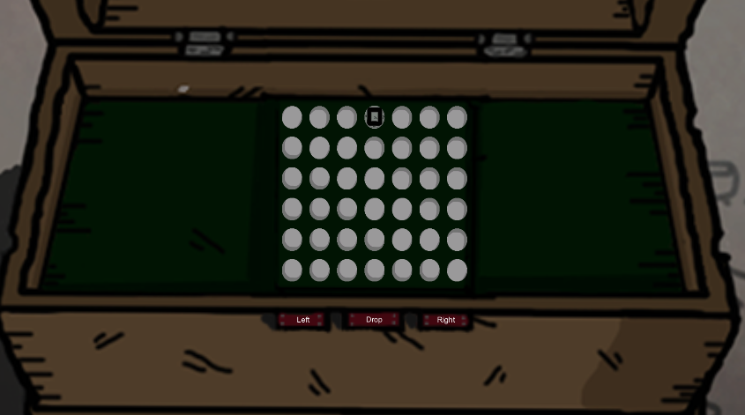

**Figure 1:** Connect Four In-Game

The coding part have two different aspects, first one is unity coding for one versus one gameplay, the 6x7 grid can be seen in Figure 1, with the help of Left, Right and Drop buttons we can place our pieces, AI is going to move after each move of us. The square piece in the center top of screen shows where we are going to play next.

For the piece placement there are two 1D arrays, one of them is to store rows, the other one is to store columns, in the beginning column array is filled with “5” s. The reason behind this “5” values assignment is simulating piece fall down effect. There is a 1D array which contains 42 different white circles as images, to put a piece in the board, we are changing the image sprite of corresponding place. To detect the corresponding place in the unity screen, coordinates are being used.

To implement artificial intelligence, alpha-beta pruning algorithm is used. It is a depth-first tree search algorithm which is an optimized version of minimax algorithm, the main idea is stopping the evaluation of current move if there is a possibility that proves move is worse than the previous one [3].

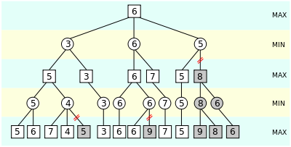

**Figure 2:** Alpha-Beta Pruning Illustration [3]

As we can see in Figure 2, gray subtrees are eliminated because there is no need to evaluate them again and again, like in the second left, it is obvious that algorithm will select “5” as second maximizing node, so in the second bottom left subtree after finding “4” next ones aren’t important.

The heuristic calculations are done with a different method, main idea of the method is gathering continuous vertical, horizontal and diagonal places as windows that are sized 4 and checking these window places like how many of them are corresponding to AI, player and empty pieces. For example, if AI can ensure all four of them are AI places, it will add 100 points to its score, or three of them are corresponding to opponent and last one is corresponding to an empty space, it will subtract 5 points from its score.

All the score calculations, winning conditions and algorithm implementations is done in a 2D, 6x7 array because unity gameObject sprite changes and controls take time, so in order to save time AI pieces numbered as “2”, player pieces numbered as “1” and empty places assumed “0”, instead of changing sprites of each image on each iteration, we can basically change the array elements in the minimax algorithm and at the end change the sprite of correct place.

As said before, alpha-beta pruning is an improved version of minimax, so main idea of minimax is maximizing AI move scores while minimizing the enemy scores. In the first condition algorithm checks is the current move a terminal, in other words finishing move, if it is a terminal and AI is winning, it returns a max score for AI, if player is winning it returns min score for AI, if there is a tie situation, returns zero.

Since minimax is a recursive algorithm, it will call itself until becoming a terminal node and in each recursion operation it creates a clone of current board and adds its move to that, by doing this it prevents doing wrong operations in main board.

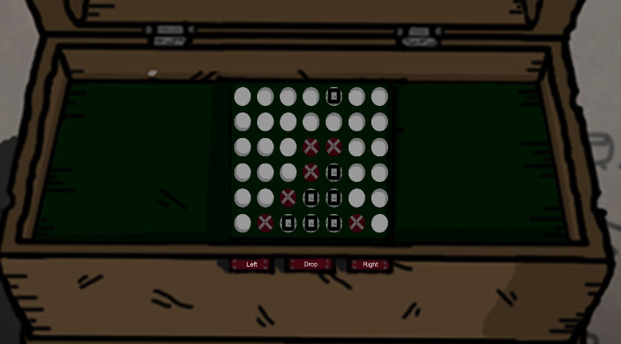

**Figure 3:** Four Connect In-game AI is Winner

We can see the winning situation in Figure 3, currently after first lose of player, buttons are becoming non-interactable.

***Labyrinth Game Idea:***

Currently team is working on a labyrinth game that player is going to play in a tavern. Player is going to sit next to someone in the tavern and the opponent will create a random labyrinth by putting wooden barricades in a squared zone. After preparing the area opponent will select start and end zones. In the beginning algorithm will use A* search to find the correct path, after finding the path it will store the coordinates.

Game is going to be one vs one, and each player is going to try to solve the maze. At the start of the game player will roll two dices and will have sum of dice values moves, for example if dices are 1 and 2, player will be able to play 3 squares, same situations are going to be applied to AI, besides those, player will have a limited time for each move for extra challenge.

Since A* is an informed search algorithm we need start and ending position, that is why enemy is selecting start and ending positions, algorithm works like checking the lowest cost while searching next values by checking heuristics.

***Isolation Game Idea:***

Main idea of the game is making the enemy unable to move in a 3x3 grid. For this operation alpha-beta pruning is going to be used as like the connect four game. To make a move, player must play a basic mini game like remembering a number sequence, these games won’t be based on AI. Each move of player will sabotage a part of a building, while player sabotaging zones AI is going to try to prevent him by doing its moves.

## Project Time Planning

**Table 1:** Project Tasks, Time Plan and Deliverables

|  |  |  |  |  |
| --- | --- | --- | --- | --- |
| **Task** | **Start & Due** **Dates** | **Deliverable** | **Evaluation Criteria** | **Objective** |
| Project Proposal | 28/02/2021  05/03/2021 | Proposal of specific objectives. | Readable and understandable | Defining our goals for the research project and our responsibilities for the semester. |
| The bell mission in  the first part of the  game | 01/03/2021  10/03/2021 | Completing the animations and codes required to collect and combine the bells in the bell mission. | The player completes the task successfully | Putting the bells in different areas. Later developing animations that allow the bells to be collected. Then have the bell parts assembled. |
| Animation transitions in the  first part of the  game | 03/03/2021  15/03/2021 | Combining the tasks and animations in the first episode and completing the episode | Completion of the first part completely | Completing all scene transitions, and the character animations in the first episode. Finishing the mission and animation codes. |
| AI mission after the  first episode of the  game | 15/03/2021  30/03/2021 | Designing AI missions that can interest the player | Smooth running of the AI mission | Designing AI mission, the player will try to decrypt a lockbox by playing a board game that is challenging. |
| Artwork in the  second part of the game | 15/03/2021  01/04/2021 | Drawing things that can be found in the environment in the  city part | Completing the drawings of the city part of the game | The things in the city part will be drawn. |
| Character drawings in the second part of the game | 15/03/2021  04/04/2021 | Drawing of characters in the city part | Completing the drawing of the characters who will be in the city part | Drawing the characters in the city part and then animating them. |
| AI task 1 in the  second part of the game | 01/04/2021  17/04/2021 | Designing and implementing AI tasks. | The player successfully plays the AI missions | Design and execute two AI tasks. These AI missions will be played in the tavern and will be in the form of board games. |
| Continuation of the artwork in the  second part of the game | 13/04/2021  01/05/2021 | Making drawings in  the city part successfully | Completing the drawings in the city part | Completing the drawings to be made inside and outside of the buildings in the city part. |
| AI task 2 in the  second part of the game | 26/04/2021  15/05/2021 | Designing and executing the AI task | Successful completion of the last AI mission | Performing an AI mission where the main character will try to sabotage the main building in order to revenge her friend, in this mission the AI will try to prevent the character trying to burn the building. |
| Mission in the  second part of the game | 15/05/2021  25/05/2021 | Design daily tasks for the player | Successful completion of the tasks | Doing daily tasks to support the story-flow. |
| Completing and  combining the game | 25/05/2021  31/05/2021 | Combining the scenes in the game | The ability to play the game without any problems | Completing all the stage transitions and creating the whole game by connecting the tasks to each other. |
| Final Report &  Presentation  Preparation | 22/05/2021  02/06/2021 | Report and presentation that have been meticulously planned | Full, readable, and properly formatted | Discussing the work and  preparing report, presentation. |

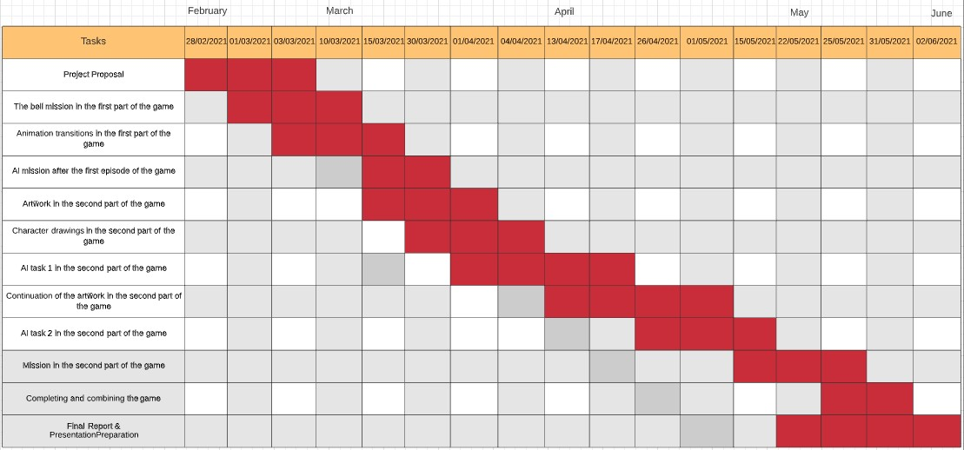

**Figure 4:** Gantt Chart of the Project

Table 1 and Figure 4 shows the things what we are planned to do at the start of the term, rest of the header contents shows what we did.

*(05.03.2021)* Before the first week all members of team made a serious decision about continuation of work, this was about decreasing the story’s importance in game and increasing AI quests weight. First decision was preparing a scene for first AI quest, the idea was implementing a connect four game to unlock a lockbox. Atakan is assigned to draw environment items, Muhammed is assigned to fix errors in unity about first semester’s work and connect scenes, Ayyüce is assigned to draw environment.

*(14.03.2021)* *First Checkpoint:*

In the first meeting Atakan draw dynamite, gallon, bullet box and a chest view for AI quest. Ayyüce draw the wooden background for chest scene, Muhammed did the ringing bell animation(cutscene). The new quests are assigned, Ayyüce supposed to write a code in C# for connect-four AI, Atakan is assigned to draw inside chest view and coin designs, Muhammed is assigned to scene connection like if player digged the rubble in background, unity must save it and when player pass to front scene, back scene must look digged. These assignment’s deadline was 1.5 week ()

*(25.03.2021) Second Checkpoint:*

In the second meeting Ayyüce wrote a code but had some errors about compiling in unity and AI decision was ambiguous, she is assigned to fix them. Atakan draw the chest and coin prototypes, Muhammed tried two different methods, first one was hard coding the system, created like 7 different scenes for it but it didn’t work, next method was DontDestroyOnLoad attribute of unity, but couldn’t make it. Atakan and Ayyüce is assigned to combine code with unity, Muhammed is assigned to finish scene management.

*(30.03.2021) Third Checkpoint:*

Workshare changed after one week, Ayyüce assigned to draw city map, Atakan is assigned to draw environment items for map and update chest view, Muhammed continued scane management.

*(03.04.2021)Fourth Checkpoint:*

Ayyüce draw half of city background and assigned to create the map of chest screen. Atakan redraw the outside view of chest and draw a fire hydrant, Muhammed rewrite the connect four and combined with unity.

*(08.04.2021)Fifth Checkpoint:*

Ayyüce created the map but need to fix basic errors in unity, Atakan redraw the inside chest related to Muhammed’s feedbacks, Muhammed changed the code related to drawings and combined them in unity. Atakan is assigned to draw a tavern scene, Ayyüce will continue city drawing, Muhammed is going to design the new Labyrinth AI in unity. An important decision which is drawing extra characters like a shadow is made, it will be supported with story like, main character won’t remember the faces.

## Success Criteria

In this project, the success criteria are that all the tasks we have planned for the game are formed without any additional. Then, the project we have done is compatible with the project as we started. Meeting these criteria means realizing the goals planned for the game.

Another success criterion is that the players who play the game enjoy this game and recommend this game in their environment. Thus, it is ensured that the game is spread quickly and easily among people.

## Project Time and Resource Estimation

This project is a project in which three people work together. It does not cost anything, but employees must devote a significant amount of time to this project. Therefore, there is no financial expense.

The estimated time required for the project is nine months. All the members working on this project during these nine months have shown a great amount of effort to complete this project. All the employees have shown their efforts for the project by doing the work they need to do on time. Several changes occurred during the project process. In the project, which was targeted as 3 people for 9 months, several changes took place in order to save time.

## Risk Analysis

One of the biggest risks that may occur in this project may be the tension that may arise between the members of the group and the interruption of the project due to this. But this event does not contain a high probability of occurrence. Any problems that may arise among the group members may cause the project to be disrupted. As in every project, this situation is possible in this project. Fortunately, thanks to the respect and cooperation within the group, teamwork proceeds well.

One of the other risks is that the drawings we make are recorded on a cloud. This is the deletion of records for any reason. As the project is done by three people, group members need to share these documents easily and quickly. For this reason, files are stored on various platforms. The probability of this problem is somewhat higher. The solution to this problem is to prevent the loss of data by keeping the drawings or anything made by each group member on their computer.

## Tool Requirements

Adobe Photoshop: For environment and character designs.

Unity: Animations, scene designs, and the main game.

C#: Coding Language

# THEORETICAL BACKGROUND

## Literature Survey

The levels of today's video games are very limited. Artificial intelligence can be used to eliminate this. It may therefore be possible to create cross-game AI by identifying and targeting conceptual problems rather than their game-specific instances[4]. Thus, a different perspective was brought to video games. In the game we made, we used artificial intelligence to make the tasks in the game various. In this way, the user will play the games with more difficulty in the game and thus, his interest will be more in the games.

It is a big problem that the natural behavior of the characters does not occur in games. To do this in the most natural way, we need more cognitive behavior. The use of special environmental characteristics can provide the illusion that characters are cooperating, while they merely all react to the same environmental cue.[5] With the use of these techniques in games, a greater improvement can be achieved. In this game, we thought of making this cognitive response thanks to the animations of the characters and their communication about the environment. Thus, we aimed to complete the story correctly based on real life.

Simulating human game-play in strategy games using a variety of AI techniques, including simulated annealing, decision tree learning, and case-based reasoning.[6] This AI, which is a learning-based game plan, is making a move in this way by constantly updating the data. In this way, it provides great success. One task we have done in the game is that we aimed to improve the AI we have done by keeping the data in this way. Thus, we made an artificial intelligence that holds more data and plays better.

Artificial intelligence used in computer games defends against players and slows down their progress in the game. The basic moving target search (BMTS) algorithm is a generalization of the learning real-time algorithm [7]. Since this algorithm is more comprehensive than other algorithms, it makes better decisions at the decision-making stage. We aimed to make the players enjoy the game more by improving the AI algorithms used in the game. We created this by designing the AI algorithm more comprehensively. In this way, the algorithm will reach a more effective result by looking at more data when deciding on a move.

AI is not aesthetically good for navigating video games. But the fractal model is pretty good at this. The data we report, according to the fractal model, suggests that stealthy paths are statistically significantly unique in relative aesthetic value when compared to control paths[8]. The last task in our game is a maze quest. In fact, we aimed to design this task with artificial intelligence. We'll do the algorithm part that way. But we aimed to give a different perspective to this maze game by using fractals as well. Thus, we will have a more aesthetic game than other artificial intelligence games.

AI needs to be fun and intelligent today for its users to enjoy the games they play against AI. Most AIs don't have this either. As a solution to this. Employs machine learning techniques to mimic the human’s ability in intuiting the opponent’s intentions after several game sessions and is hence particularly helpful with imperfect information games[9]. In the game we have made, artificial intelligence tasks are one of the cornerstones of our game. The more good artificial intelligence we can design, the more users we will be able to appeal. That's why we have written a more invincible and more successful artificial intelligence program by using machine learning techniques to increase the success of our artificial intelligence tasks and these tasks. Thus, the user has to think more while performing the task and gives his / her attention to the game.

There are story-driven games as a genre in computer games. The priority here is to tell a story: that is the primary goal of the project, with games chosen as the delivery mechanism for the story. It’s likely that the story concept was the inception of the project[10]. The first thing we did when creating the game we did is to outline the story. Because our game actually progresses in the form of a movie. In this way, the more robust the story we create, the more robust missions and characters suitable for these missions. For this reason, we have given our top priority to creating the story. From then on, it became easier and more understandable to design tasks, places and people by separating this story little by little.

Today, video games are mostly played by adolescents. During this period, the development of young people is very important. These games they played affect their psychology. Video games have potential for health promotion and may be especially promising when attempting to reach youth [11]. The game we have designed takes place in a war period. In fact, here we are giving the message of what a bad event the war has done by showing the damage done. In addition, we emphasize the importance of solidarity in the game. If we do not help the other character in one of our missions, we cannot complete the quest. By doing some of these tasks, we aim to push young people to the right behavior.

Story-driven games are games that are associated with a story and built on it. The stories in games are found textually in dialogue, speech, or prose, or within cinematic narratives called cutscenes[12]. In the game we have made, the dialogues of our main character with the other character are shown as examples of story-oriented games. Later, we aimed to connect the player to the story by showing the intermediate scenes in this game. In this way, the user who plays the game will be more dependent on the game by wondering what is happening in the story. In these cut scenes, we aimed to prevent users from skipping these scenes by giving little information about the game.

Today we are in the age of play. For this reason, many kinds of games come to the fore. But in this period, story-based games take the biggest rise. Not only would I argue that they can at times challenge film and television—and books—in terms of complexity and plot development, but the extent of the worldbuilding they demonstrate is truly immersive. It is therefore little surprise that they are revolutionizing the latest generation of video games, but also that they offer a genuine value to those who play them[13]. In our game, the story is very important and we think that it will attract more attention of the player as it is a livable story in the real world. In this way, the actors are both playing games and trying to finish a movie.

## Solution Method

To touch human feelings topic is chosen from the current world and history, and to produce that topic game type is set as RPG. Most importantly the usage of AI separates the game from others because in most of the story-driven games game’s hardness is related to damages of enemies, but in this game, there will be AI heuristics that are determined related to player’s playstyle, this idea is going to give a competitive perspective to the game.

# ANALYSIS AND MODELLING

Since the project will be played on a computer platform, other 2D story-based games in the game market were analyzed. In line with the analysis, the most important factors of the game were determined before the modeling. Elements such as being a story-based game, being a 2D game, containing mini-tasks, giving alternative ending scenes, and artificial intelligence tasks were determined. With these determined elements, the game will stand out differently from other games in the market. Users will want to try this new and unique gaming experience for free.

## System Factors

In this project, factors are affecting the development process of the project. These factors are the best example of current news in the game market. The game market is a platform that is renewed and developed every day. On the computer platform, it is important to follow this current news. As the group members are related to the gaming industry, they are kept up to date with the latest game news and up-to-date technology news. Since artificial intelligence has roles in-game, changes may happen in the tasks and planning within the project with new developments.

## How System Works

The story is first outlined in the game's creation. The group members decide the details required to build the story using their imaginations. Then, in this story, the tasks required to complete the story that will take place in the game begin to be considered. Plans are made about how the tasks should be. Tasks are planned to be created using both normal and artificial intelligence. After the tasks are decided, important game details such as surrounding objects, items and characters are drawn. These drawings are made with Photoshop. Then, it was planned to make animations over Unity and make the characters or objects drawn in the environment ready for use in the game. After these animations are completed, the parts that need to be coded, such as the movements in the game, changing the scene, are coded on the unit using C # language. After this coding is completed, the drawings, animations, and parts in the coding of the game are combined over Unity to create the necessary scenes for 25 games. Then the game is completed by eliminating the deficiencies of these stages.

The role of Artificial Intelligence is effective to complete alternative ending scenes in the game. There is a sabotage quest in the final part of the game. In this quest, Artificial Intelligence plays against the player. The player firstly chooses a room to sabotage. There is a mini-quest in the room player will choose. When the player starts the mini-quest, the artificial intelligence is activated. To make artificial intelligence to be active, the player must start the task. The player must complete the task within the allotted time. If the player cannot complete the mini-quest, the sabotage mission fails. Minimax algorithm evaluates every possibility and plays the option that causes the user to lose. The player loses the game and cannot leave the room. If the player does the mini-quest within the allotted time, he moves to another room to sabotage. The previous room is locked, and the player goes to the other room. The player does the mini-quest again in the other room. The logic of the game works in this way and the player must complete all mini-quests within the specified time to successfully pass the AI ​​mission. In the connect-four game main idea is connecting four same colored pieces, the piece placements can be done by using left, right and drop buttons which will be on the user interface. The labyrinth AI system works like both AI and player is going to try to solve a random generated maze, to give a chance to player both AI and player will determine its move count by rolling dices, and to add competition to this turn based game each player will have a limited time to decide its moves.

## Modeling and System Architecture

The design part includes all the design details such as the game's characters and the gaming area. All the visuals in the game are designed and prepared. The game, which stands out with its story-based nature, creates, and designs mini-missions to create side missions by adhering to the story. The most important part is artificial intelligence. Tasks and games for artificial intelligence started to be designed. The designed tasks are coded and developed. These tasks will be combined with the design to match the game and the story. The workflow scheme is given as in Figure 5, the isolation game example flowchart is given in Figure 6 and minimax flowchart can be seen in Figure 7.

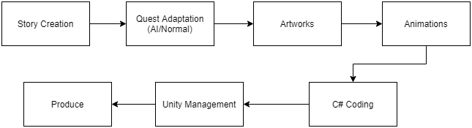 **Figure 5:** Workflow Scheme

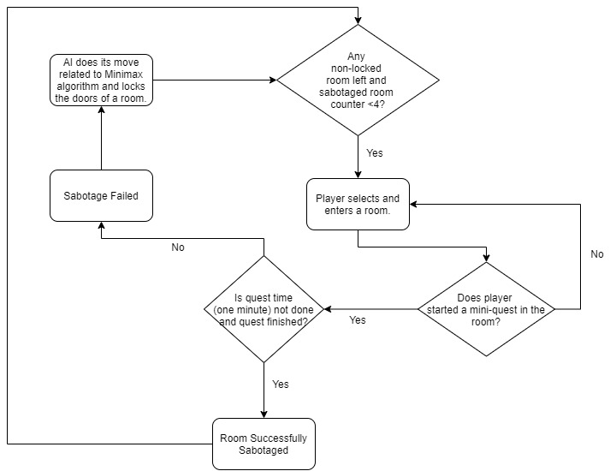 **Figure 6:** Isolation content flowchart

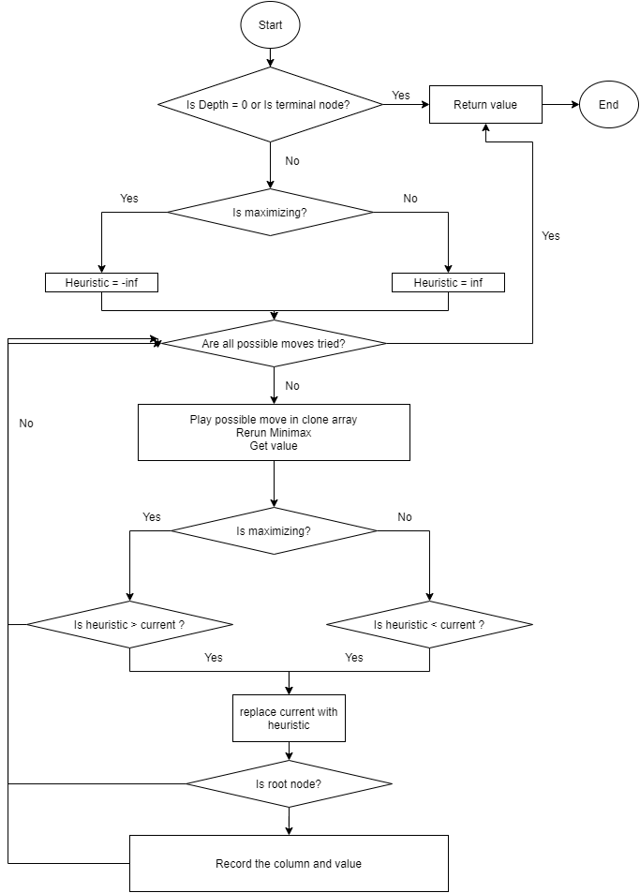

Figure 7: Minimax Flow-chart

# DESIGN, IMPLEMENTATION AND TESTING

## Design

There are three main aspects of the project, and these are artworks, story, and artificial intelligence, all the things are set to satisfy the storyline. The first stage of creating a story is written and agreed upon by team members, and then with several meetings, some quests are designed to support the story, after all, the creation of artworks is started.

The artworks have four different aspects, they are character design, environment design, object design, and in-game animations, after a while from the start job share is assigned to members.

Ideas about artificial intelligence are shared between team members and with these ideas, some quest types are designed too.

## Implementation

The implementation is about unity aspects, which are coding and scene management. The first thing about coding is almost every object on the screen needs a script, like the movement of players, running animations, noticing about collusions, or dialogue management. Besides scripts scene management is also important because there is a story that needs to flow, to satisfy this condition each object needs to be in a harmony, also if something changes in a part of the map, that change must be permanent.

## Testing

Lastly, after each script or scene design, its compatibility is tested by team members, and feedbacks are given to the designer. Feedbacks are the most important things in this part because for example artworks must be of the same quality, or the scenes should support each other.

# RESULTS

First part of the game is almost done, which is the facade scene. There are minor changes in the distribution of tasks after the COMP491 final presentation. The background design that ensures the integrity of the environmental design in Unity is given to Zeynep Ayyüce, the surrounding objects and environmental design to Atakan, and Muhammed is assigned to the coding and combining the elements of the project through Unity. This semester focus will be more on AI coding instead of artworks and story. The coding of some of the artificial intelligence missions finished and the environment drawings of these tasks are also prepared.With the completion of these tasks, the artworks of the second part which is city scene is started, new AI quest ideas are determined and members started to design them. Shortly, a connect-four AI is designed, a maze solver AI quest is determined with its environment, an autosave system is almost done, new environment elements and a cutscene prototype is done.

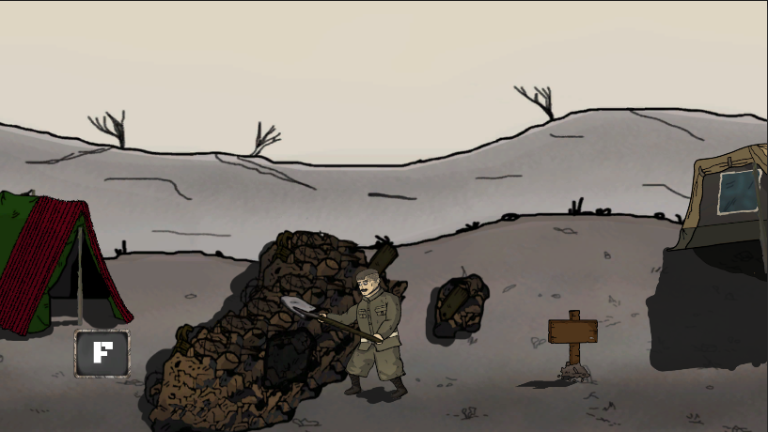

**Figure 8:** Digging Scene

# CONCLUSION

## Lifelong Learning

While working on this project, the biggest advantage of all employees is that we learned about the programs that we did not have experience with and learned about these issues. By learning these programs, ourselves, we saw the problems encountered while accessing information and had the opportunity to improve ourselves on this issue. Additionally, we are gradually gaining the experience required for the game industry. Thus, when this project is finished, we will have gained experience on behalf of the sector, and we will be able to use the information and programs we have learned in other projects.

## Professional and Ethical Responsibilities of Engineers

In this process, it is the principle of professional reliability in our project. Another important principle is honesty. For example, in this project we have done, we emphasize that we only progress our drawings without any external element. If we want to follow this sentence, we must continue exactly like this. Because the principle of reliability is very important to us. Another important element is respect. We can exemplify this as follows. First, the members in the group respect each other. Then, in this project, we continue the project within this framework, respecting the social and social events.

## Contemporary Issues

The aim of this project is for the players to enjoy playing this game, thus making bad thoughts less prominent. The technologies we used in this project were not used until the last ten years. In the upcoming period, we think that these technologies will progress in a big way. Because this sector we have entered is one of the most active and fastest-growing sectors in the world. For this reason, the technologies we are using now may not be used next year. For example, maybe we will design the players we have designed in such a way that the time spent on the design process will gradually decrease.

## Teamwork

Teamwork was the biggest influence on this project. Knowledge of accountability, which is one of the variables in the development of this teamwork, is very crucial. They will not face a major problem if the individuals in a team meet their obligations.

Another significant concern is that individuals value one another. Since the first presentation teamwork was changed, the background design is assigned to Zeynep Ayyüce, the surrounding objects and environment designs are assigned to Atakan, the animations, coding, unity aspects are assigned to Muhammed.

# REFERENCES

[1] En.wikipedia.org. n.d. *Connect Four - Wikipedia*. [online] Available at: <https://en.wikipedia.org/wiki/Connect_Four> [Accessed 10 April 2021].

[2] K. Moore, E. W and E. Dean, "Enigma Machine | Brilliant Math & Science Wiki", *Brilliant.org*. [Online]. Available: https://brilliant.org/wiki/enigma-machine/#:~:text=An%20Enigma%20machine%20is%20a,time%20the%20code%20seemed%20unbreakable. [Accessed: 10- Apr- 2021].

[3]"Alpha–beta pruning - Wikipedia", *En.wikipedia.org*. [Online]. Available: https://en.wikipedia.org/wiki/Alpha%E2%80%93beta_pruning. [Accessed: 10- Apr- 2021].

[4] Fonteneau R. and Ernst D. (2015).Artificial Intelligence in Video Games: Towards a Unified Framework. International Journal of Computer Games Technology

[5] Westra J., Van Doesburg W. and Harbers M. (2009). Games and Agents: Designing Intelligent Gameplay. International Journal of Computer Games Technology

[6] Colton S. and Morris M. (2009). Combining AI Methods for Learning Bots in a Real-Time Strategy Game. International Journal of Computer Games Technology

[7] Loh P. and Prakash E. (2008). Performance Simulations of Moving Target Search Algorithms. International Journal of Computer Games Technology

[8] Coleman R. (2009). Fractal Analysis of Stealthy Pathfinding Aesthetics. International Journal of Computer Games Technology

[9] Aiolli F. and Palazzi C. (2008). Enhancing Artificial Intelligence on a Real Mobile Game. International Journal of Computer Games Technology

[10] Jonas S. (2018). 3 approaches to storytelling in games. A Day of Faces and The Mechanical Crown(39-88)

[11] Baranowski T. and Thompson D. (2012). Story Immersion of Videogames for Youth Health Promotion: A Review of Literature. Games Health J.(199-204)

[12] Somerdin M. (2016). The Game Debate: Video Games as Innovative Storytelling. University of Missouri, St. Louis

[13] Endacott AB.(2018). The Rise of Narrative-Based Videogames. The Nerd Daily Culture

# Appendix

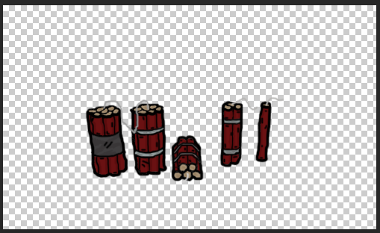

**Figure 9:** Dynamite

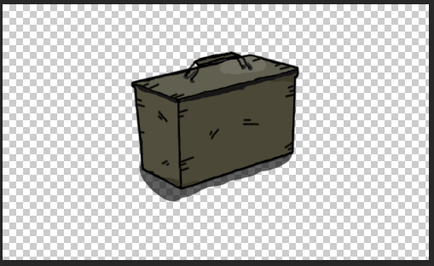

**Figure 10:** Bullet box

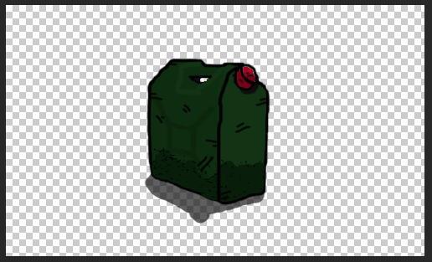

**Figure 11:** Gallon

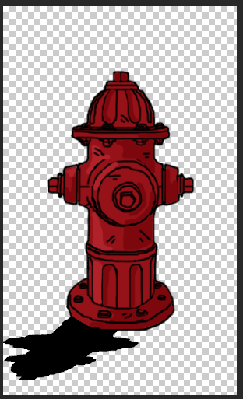

**Figure 12:** Fire hydrant

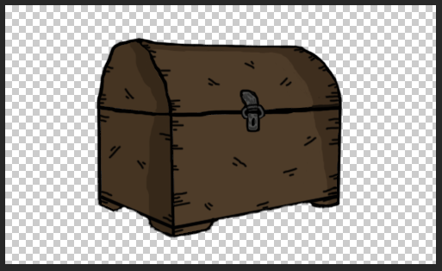

**Figure 13:** Chest

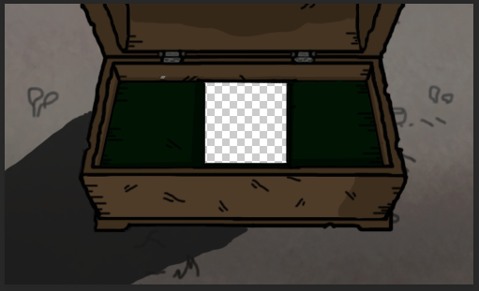

**Figure 14:** Inside of box

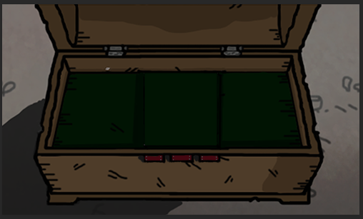

**Figure 15:** AI background



**Figure 16:** Red coin

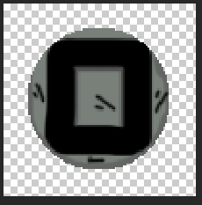

**Figure 17:** Grey coin



**Figure 18:** Circle



**Figure 19:** Circle

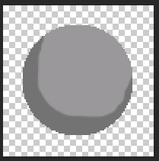

**Figure 20:** Circle