**CO1_Program 2**

s=int(input("enter strat year"))

e=int(input("enter end year"))

if(s<e):

print(" leap year are:",end=" ")

for i in range(s,e):

if i%4==0 and i%100!=0:

print(i,end=" ")

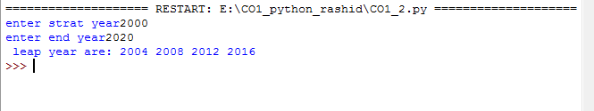

**CO1_Program 3**

list1=[-10,20,35,-67,70]

re=[num for num in list1 if num>=0]

print(re)

print("\n ................................. ")

n=int(input("enter limit:"))

squarelist=[i**2 for i in range(1,n+1)]

print("square of n numbers:",squarelist)

print("\n ................................. ")

word=str(input("enter the word"))

print("the original string is:"+word)

print(" the vowels are",end=" ")

for i in word:

if i in 'aeiouAEIOU':

print([i],end=" ")

print("\n ................................. ")

w=input("enter the word:")

print("ordinal value corresponding to each element is ")

for i in w:

print(i,end=":")

print(ord(i),end=" ")

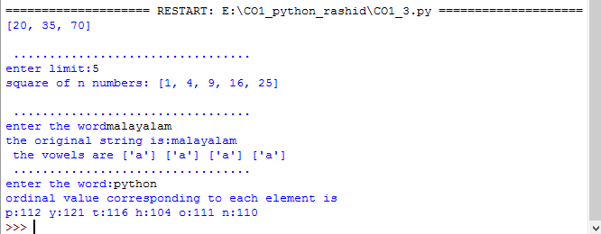

**CO1_Program 4**

str1=input("enter a string")

wordlist=str1.split()

count=[]

for w in wordlist:

count.append(wordlist.count(w))

print("count of the occurence:"+str(list(zip(wordlist,count))))

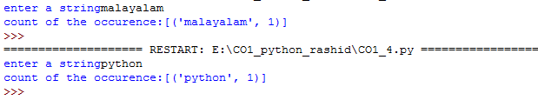

**CO1_Program 5**

n=[]

s=int(input(" enter a limit"))

print("enter {s} values")

for i in range(0,s):

n.append(int(input()))

print("\n the list after assinging: \n")

for i in range(0,len(n)):

if n[i]>=100:

print("over")

else:

print(n[i])

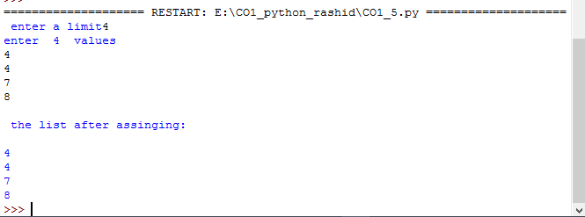

**CO1_Program 6**

a=["a","b","a"]

occ=a.count("a")

print("count of occurence of a:",occ)



**CO1_Program 7**

l=[1,3,5,7,9,11,34]

l1=[5,13,45,7,20,65,1]

s=int(0)

c=int(0)

if len(l)==len(l1):

print("list are of same length")

else:

print("list are of same length")

for i in range(0,len(l) and len(l1)):

s=s+l[i]

c=c+l1[i]

if(s==c):

print("equal sum")

else:

print("not equal sum")

print("elements that matched are:")

I=[]

for i in range(0,len(l)):

for j in range(0,len(l1)):

if l[i]==l1[j]:

I.append(l[i] and l1[j])

else:

continue

print(I)

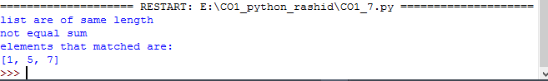

**CO1_Program 8**

str1="malayalam"

char=str1[0]

str1=str1.replace(char,'$')

str1=char+str1[1:]

print(str1)



**CO1_Program 9**

tr=input("enter a string:")

new_str=str[-1:]+str[1:-1]+str[:1]

print("New string: ",new_str)

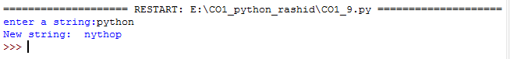

**CO1_Program 10**

pi=3.14

r=float(input("input the radius of the circle"))

result=3.14*r**2

print("the area of circle with radius is :",result)

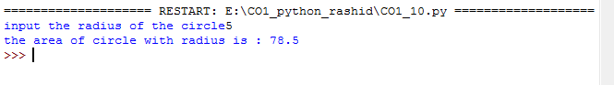

**CO1_Program 11**

x=int(input(" enter the 1st number"))

y=int(input(" enter the 2st number"))

z=int(input(" enter the 3st number"))

if (x>y) and (x>y):

lar=x

elif (y>z):

lar=y

else:

lar=z

print(lar)

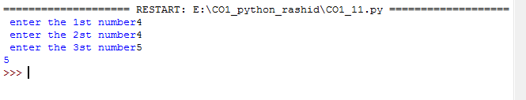

**CO1_Program 12**

file=input("enter the filename:")

f=file.split(".")

print("extension of file is:"+f[-1])

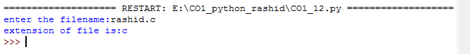

**CO1_Program 13**

a=[]

for i in range(3):

b=input("enter the color:")

a.append(b)

print(a)

print(a[0])

print(a[2])

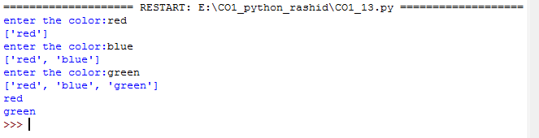

**CO1_Program 14**

n=int(input("enter a number:"))

x=int("%s"%n)

y=int("%s%s"%(n,n))

z=int("%s%s%s"%(n,n,n))

print("n+nn+nnn:",x+y+z)

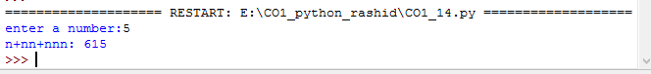

**CO1_Program 15**

color1=set(["white","pink","red","blue"])

color2=set(["red","green","pink"])

print(color1.difference(color2))



**CO1_Program 16**

a="python"

b="java"

p1=a[0]

p2=b[0]

c=b[0]+a[1:len(a)]+" "+a[0]+b[1:len(b)]

print(c)



**CO1_Program 17**

import operator

d={1:2,3:4,4:3,2:1,0:0}

print('original dictionary:',d)

sorted_d=sorted(d.items(),key=operator.itemgetter(1))

print('dictionary in ascending order by value',sorted_d)

sorted_d=dict(d.items(),key=operator.itemgetter(1),reverse=True)

print('dictionary in descending order by value:',sorted_d)

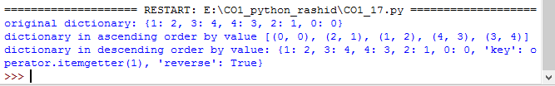

**CO1_Program 18**

d1={'a':100,'b':200}

d2={'x':300,'y':200}

print("Dictionary 1=:",d1)

print("Dictionary 2=:",d2)

d=d1.copy()

d.update(d2)

print(" merged Dictionary :",d)

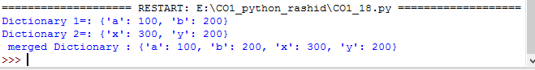

**CO1_Program 19**

x=int(input("enter the 1st number"))

y=int(input("enter the 2st number"))

i=1

while(i<=x and i<=y):

if(x%i==0 and y%i==0):

gcd=i

i=i+1

print("GCD:",gcd)

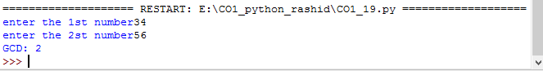

**CO1_Program 20**

num=[7,8,120,25,44,20,27]

print("Orginal list:",num)

num=[x for x in num if x%2!=0]

print("list after removing even number :",num)

