============================================================
JAVASCRIPT DOM - COMPLETE NOTES
============================================================

1. WHAT IS DOM?
---------------

DOM stands for Document Object Model.

- The DOM represents an HTML document as a tree of objects.
- JavaScript uses the DOM to access and manipulate HTML elements.
- We can change HTML content, styles, attributes, and structure.
- We can also respond to user actions such as clicks and typing.

Example HTML:

<html>
<body>
<h1 id="heading">Hello World</h1>
</body>
</html>

JavaScript:

document.getElementById("heading").innerHTML = "Welcome";

Output:
The heading changes from "Hello World" to "Welcome".

2. DOM TREE
-----------

The DOM represents HTML elements in a hierarchical structure.

Example:

<html>
|
+-- <body>
|
+-- <h1>
|
+-- <p>

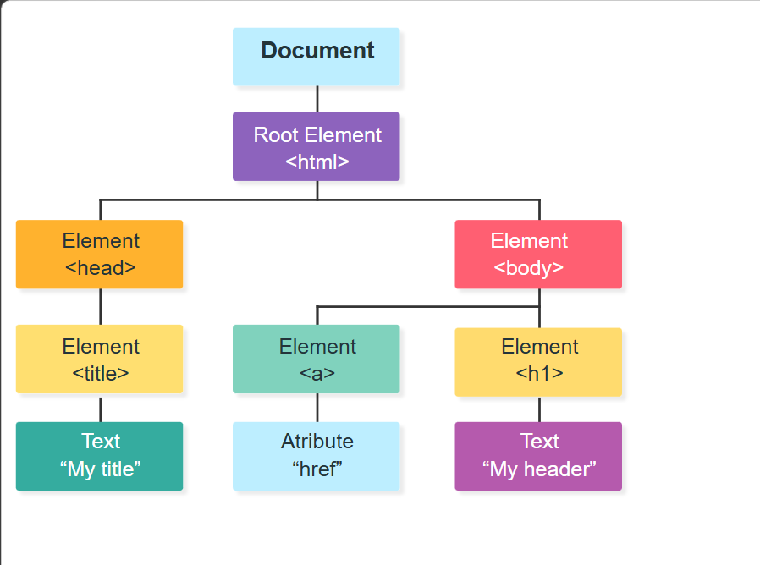
Important terms:

- Document: The entire HTML document.
- Element: An HTML tag such as <p>, <div>, or <h1>.
- Node: An item in the DOM tree.
- Parent: An element that contains another element.
- Child: An element contained inside another element.
- Sibling: Elements that share the same parent.

3. SELECTING HTML ELEMENTS
--------------------------

A) getElementById()

Selects an element using its ID.

Syntax:
document.getElementById("id");

Example:
let heading = document.getElementById("heading");

B) getElementsByClassName()

Selects all elements with the specified class.

Syntax:
document.getElementsByClassName("className");

Example:
let items = document.getElementsByClassName("item");

Returns:
HTMLCollection.

C) getElementsByTagName()

Selects all elements with the specified tag name.

Syntax:
document.getElementsByTagName("p");

Example:
let paragraphs = document.getElementsByTagName("p");

Returns:
HTMLCollection.

D) querySelector()

Selects the first element matching a CSS selector.

Syntax:
document.querySelector("CSS selector");

Examples:
document.querySelector("#heading"); // ID
document.querySelector(".box"); // Class
document.querySelector("p"); // Tag

Returns:
A single element or null.

E) querySelectorAll()

Selects all elements matching a CSS selector.

Syntax:
document.querySelectorAll("CSS selector");

Example:
let items = document.querySelectorAll(".item");

Returns:
NodeList.

You can use forEach() to iterate over the NodeList.

Example:
items.forEach(function(item) {
console.log(item);
});

important:refer to querySelectornotes in this folder

4. QUICK COMPARISON OF SELECTORS
--------------------------------

Feature | getElementById() | querySelector()
-------------------------|------------------------|---------------------
Selection | Element with an ID | First CSS match
Returns | Element or null | Element or null
CSS selectors supported? | No, accepts an ID | Yes

Feature | getElementsByClassName() | querySelectorAll()
-------------------------|--------------------------|--------------------
Selection | All matching classes | All CSS matches
Returns | HTMLCollection | NodeList
Updates automatically? | Yes, live collection | No, static collection
Supports forEach()? | Not directly in general | Yes

IMPORTANT:
- HTMLCollection is generally a live collection.
- NodeList from querySelectorAll() is static.
- Both querySelector() and querySelectorAll() support CSS selectors.

5. CHANGING HTML CONTENT
------------------------

A) innerHTML

Gets or sets the HTML content inside an element.

Example:
document.getElementById("demo").innerHTML = "<b>Hello</b>";

Result:
The word Hello appears in bold.

B) textContent

Gets or sets all text content inside an element.

Example:
document.getElementById("demo").textContent = "Hello World";

HTML tags included in the assigned string are treated as text.

C) innerText

Gets or sets the rendered text of an element.

Example:
document.getElementById("demo").innerText = "Welcome";

Comparison:

Property | Purpose
---------------|----------------------------------
innerHTML | Reads or writes HTML markup
textContent | Reads or writes text content
innerText | Reads or writes rendered text

NOTE:
Use textContent when you only need to insert plain text.
Avoid inserting untrusted input through innerHTML because it
can create cross-site scripting (XSS) vulnerabilities.

6. CHANGING CSS STYLES
----------------------

JavaScript can change CSS styles using the style property.

Example HTML:
<p id="demo">Hello World</p>

JavaScript:
let element = document.getElementById("demo");

element.style.color = "red";
element.style.backgroundColor = "yellow";
element.style.fontSize = "25px";
element.style.display = "none";

IMPORTANT:
- CSS properties written in kebab-case become camelCase in JS.
- background-color becomes backgroundColor.
- font-size becomes fontSize.
- Use strings for CSS values.

Example:
element.style.marginTop = "20px";

7. WORKING WITH ATTRIBUTES
--------------------------

A) getAttribute()

Reads an attribute value.

Example:
let link = document.querySelector("a");
console.log(link.getAttribute("href"));

B) setAttribute()

Sets or changes an attribute.

Example:
link.setAttribute("href", "https://example.com");

C) removeAttribute()

Removes an attribute.

Example:
link.removeAttribute("target");

D) hasAttribute()

Checks whether an attribute exists.

Example:
console.log(link.hasAttribute("href"));

E) Direct property access

Example:
let image = document.querySelector("img");

image.src = "photo.jpg";
image.alt = "A photo";

8. WORKING WITH CLASSES
------------------------

A) classList.add()

Adds a class.

element.classList.add("active");

B) classList.remove()

Removes a class.

element.classList.remove("active");

C) classList.toggle()

Adds the class if absent; removes it if present.

element.classList.toggle("active");

D) classList.contains()

Checks whether a class exists.

console.log(element.classList.contains("active"));

E) classList.replace()

Replaces one class with another.

element.classList.replace("old", "new");

9. CREATING AND REMOVING ELEMENTS
----------------------------------

A) createElement()

Creates a new HTML element.

let paragraph = document.createElement("p");

B) createTextNode()

Creates a text node.

let text = document.createTextNode("Hello World");

C) appendChild()

Adds a node as the last child.

paragraph.appendChild(text);

D) append()

Adds text or nodes at the end of an element.

document.body.append(paragraph);

E) prepend()

Adds content at the beginning.

document.body.prepend(paragraph);

F) remove()

Removes an element.

paragraph.remove();

G) removeChild()

Removes a child node from its parent.

parent.removeChild(child);

H) before() and after()

Insert content before or after an element.

element.before(paragraph);
element.after(paragraph);

Example: Create a new paragraph.

let paragraph = document.createElement("p");

paragraph.textContent = "This is a new paragraph.";

document.body.appendChild(paragraph);

10. DOM TRAVERSAL
------------------

DOM traversal means moving between related elements.

A) parentElement

Returns the parent element.

element.parentElement;

B) children

Returns the child elements.

element.children;

C) firstElementChild

Returns the first child element.

element.firstElementChild;

D) lastElementChild

Returns the last child element.

element.lastElementChild;

E) nextElementSibling

Returns the next sibling element.

element.nextElementSibling;

F) previousElementSibling

Returns the previous sibling element.

element.previousElementSibling;

G) parentNode

Returns the parent node, which may not always be an element.

H) childNodes

Returns all child nodes, including text nodes and comments.

IMPORTANT:
- children contains only element children.
- childNodes can contain whitespace text nodes.
- Prefer firstElementChild when you need an HTML element.

11. ADDING EVENT LISTENERS
---------------------------

An event is an action that happens in the browser.

Examples:
- Clicking a button
- Typing into an input
- Submitting a form
- Moving the mouse
- Loading a page

Syntax:

element.addEventListener("event", function() {
// Code to execute
});

Example HTML:
<button id="btn">Click Me</button>

JavaScript:

let button = document.getElementById("btn");

button.addEventListener("click", function() {
alert("Button clicked!");
});

IMPORTANT:
addEventListener() is preferred for attaching event handlers
because multiple listeners can be attached to the same event.

12. COMMON JAVASCRIPT EVENTS
-----------------------------

Event | Description
------------------|--------------------------------
click | Element is clicked
dblclick | Element is double-clicked
mouseover | Pointer moves onto an element
mouseout | Pointer leaves an element
mouseenter | Pointer enters an element
mouseleave | Pointer leaves an element
keydown | A keyboard key is pressed
keyup | A keyboard key is released
input | Input value changes during editing
change | A value change is committed
submit | A form is submitted
focus | Element receives focus
blur | Element loses focus
DOMContentLoaded | HTML document has been parsed

Example:

let input = document.querySelector("#username");

input.addEventListener("input", function() {
console.log(input.value);
});

13. THE EVENT OBJECT
---------------------

The event object contains information about an event.

Example:

button.addEventListener("click", function(event) {
console.log(event);
});

Important properties:

event.target
- The element that triggered the event.

event.currentTarget
- The element on which the listener is registered.

event.type
- The event type, such as "click".

Example:

button.addEventListener("click", function(event) {
console.log(event.target);
console.log(event.currentTarget);
console.log(event.type);
});

14. PREVENTING DEFAULT BEHAVIOUR
---------------------------------

preventDefault() stops the browser's default action.

Example: Prevent a form from reloading the page.

let form = document.querySelector("#myForm");

form.addEventListener("submit", function(event) {
event.preventDefault();

console.log("Form submitted");
});

Examples of default actions:
- A form submitting to a server
- A link navigating to another page

IMPORTANT:
preventDefault() does not stop event propagation.

15. EVENT PROPAGATION
----------------------

Event propagation describes how events travel through the DOM.

Phases:
1. Capturing phase
2. Target phase
3. Bubbling phase

Event bubbling:
The event travels from the target element up through its ancestors.

Example:

parent.addEventListener("click", function() {
console.log("Parent clicked");
});

child.addEventListener("click", function() {
console.log("Child clicked");
});

If the child is clicked, the child handler runs first, followed
by the parent handler during bubbling.

stopPropagation():

event.stopPropagation();

Stops the event from continuing to propagate.

IMPORTANT:
- preventDefault() prevents the default action.
- stopPropagation() stops event propagation.

16. EVENT DELEGATION
---------------------

Event delegation means attaching one event listener to a parent
instead of attaching separate listeners to many child elements.

Example:

document.querySelector("#list").addEventListener("click",
function(event) {
if (event.target.matches("li")) {
console.log(event.target.textContent);
}
}
);

Advantages:
- Fewer event listeners
- Works for matching child elements added later
- Useful for dynamic lists and tables

17. THE VALUE PROPERTY
-----------------------

The value property is used to get or set the value of form controls.

HTML:
<input type="text" id="username">

JavaScript:

let input = document.getElementById("username");

console.log(input.value);

Set a value:

input.value = "Rizwan";

IMPORTANT:
- Use value for input, select, and textarea elements.
- Use textContent or innerHTML for element content.

18. FORM VALIDATION
--------------------

Example HTML:

<form id="myForm">
<input type="text" id="username" required>
<button type="submit">Submit</button>
</form>

JavaScript:

let form = document.querySelector("#myForm");
let username = document.querySelector("#username");

form.addEventListener("submit", function(event) {
event.preventDefault();

if (username.value.trim() === "") {
alert("Please enter your name");
} else {
alert("Form submitted successfully");
}
});

trim() removes whitespace from the beginning and end of a string.

NOTE:
Client-side validation improves user experience but does not
replace server-side validation.

19. DOM DOCUMENT PROPERTIES
----------------------------

document.title
- Gets or sets the page title.

document.URL
- Returns the document URL.

document.body
- Returns the body element.

document.head
- Returns the head element.

document.documentElement
- Returns the root HTML element.

document.forms
- Returns the document's forms collection.

document.images
- Returns the document's images collection.

document.links
- Returns the document's links collection.

Example:

console.log(document.title);
console.log(document.body);
console.log(document.URL);

20. ELEMENT DIMENSIONS AND SCROLLING
-------------------------------------

element.clientWidth
- Inner width including padding but excluding borders and
vertical scrollbars.

element.clientHeight
- Inner height including padding but excluding borders and
horizontal scrollbars.

element.offsetWidth
- Width including padding and borders.

element.offsetHeight
- Height including padding and borders.

element.getBoundingClientRect()
- Returns the element's size and position relative to the
viewport.

element.scrollTop
- Vertical scroll position inside a scrollable element.

element.scrollLeft
- Horizontal scroll position inside a scrollable element.

21. TIMING AND DOM READY
-------------------------

DOMContentLoaded fires when the HTML document has been parsed
and the DOM is ready. Images and other resources may still load.

Example:

document.addEventListener("DOMContentLoaded", function() {
console.log("DOM is ready");
});

A script using defer also runs after HTML parsing and before
DOMContentLoaded.

Example HTML:

<script src="script.js" defer></script>

Using defer is a common way to load an external JavaScript file
without blocking HTML parsing.

22. COMMON DOM MISTAKES
------------------------

1. Using the wrong ID or class name.
2. Running JavaScript before the HTML element exists.
3. Using querySelectorAll() as though it returns one element.
4. Forgetting to use a loop when updating multiple elements.
5. Using innerHTML when textContent is sufficient.
6. Forgetting event.preventDefault() when needed for a form.
7. Confusing event.target with event.currentTarget.
8. Using className when classList methods are more suitable.
9. Forgetting that querySelectorAll() returns a static NodeList.
10. Trying to use innerHTML on an element that is null.

23. COMPLETE MINI PROJECT: CLICK COUNTER
-----------------------------------------

HTML:

<h2 id="count">0</h2>
<button id="increase">Increase</button>
<button id="decrease">Decrease</button>
<button id="reset">Reset</button>

JavaScript:

let count = 0;

let countDisplay = document.querySelector("#count");
let increaseBtn = document.querySelector("#increase");
let decreaseBtn = document.querySelector("#decrease");
let resetBtn = document.querySelector("#reset");

increaseBtn.addEventListener("click", function() {
count++;
countDisplay.textContent = count;
});

decreaseBtn.addEventListener("click", function() {
count--;
countDisplay.textContent = count;
});

resetBtn.addEventListener("click", function() {
count = 0;
countDisplay.textContent = count;
});

24. QUICK REVISION TABLE
-------------------------

Method / Property | Purpose
---------------------------|--------------------------------
getElementById() | Select element by ID
getElementsByClassName() | Select elements by class
getElementsByTagName() | Select elements by tag
querySelector() | Select first CSS match
querySelectorAll() | Select all CSS matches
innerHTML | Read or write HTML markup
textContent | Read or write text content
innerText | Read or write rendered text
style | Change inline CSS styles
classList.add() | Add a class
classList.remove() | Remove a class
classList.toggle() | Toggle a class
classList.contains() | Check for a class
getAttribute() | Read an attribute
setAttribute() | Set an attribute
removeAttribute() | Remove an attribute
createElement() | Create an element
appendChild() | Append a node
append() | Append text or nodes
remove() | Remove an element
parentElement | Access parent element
children | Access child elements
addEventListener() | Register an event handler
preventDefault() | Prevent the default action
stopPropagation() | Stop event propagation
matches() | Check whether an element matches
closest() | Find nearest matching ancestor
value | Read or set form control value
focus() | Give an element focus
blur() | Remove focus from an element

25. IMPORTANT INTERVIEW QUESTIONS
----------------------------------

1. What is the DOM?
The Document Object Model represents an HTML document as
objects that JavaScript can access and manipulate.

2. What is the difference between querySelector() and
querySelectorAll()?
querySelector() returns the first matching element.
querySelectorAll() returns a static NodeList of all matches.

3. What is the difference between HTMLCollection and NodeList?
HTMLCollection contains elements and is generally live.
NodeList can contain different node types, depending on how
it is obtained. querySelectorAll() returns a static NodeList.

4. What is the difference between innerHTML and textContent?
innerHTML works with HTML markup, while textContent works
with text content.

5. What is event bubbling?
An event propagates from the target element toward its
ancestors.

6. What is event delegation?
It is the technique of handling events on child elements
through a listener attached to a common parent.

7. What is preventDefault()?
It prevents the browser's default action for an event.

8. What is stopPropagation()?
It prevents an event from propagating further.

9. What is classList?
It provides methods to add, remove, toggle, and check CSS
classes on an element.

10. What is DOM traversal?
It means navigating between parent, child, and sibling
nodes or elements.

11. What is the difference between target and currentTarget?
target is the event's originating element; currentTarget
is the element whose listener is currently running.

12. What is the difference between live and static collections?
A live collection updates when the DOM changes; a static
collection represents the selection at the time it was made.

============================================================
END OF NOTES
============================================================

