**A**

**MINI PROJECT**

**Grocery Website**

**Under the guidance of**

**Aman**

***-*** *Submitted By*

**HCL Coders**

**Name: Muhammed Sinan**

**Reg No: 12218621**

**Roll No: A 13**

**Name: Harsh Chaudhari**

**Reg No: 12217727**

**Roll No: A 11**

**Section: KOC 30**

**Technologies used**

* **HTML**

HTML (Hyper Text Markup Language) is the standard markup language for web pages. HTML elements are used as the most basic building blocks of the webpage; it defines the meaning and the structure of the web content. The first version of HTML was written by Tim Berners-Lee in 1993.

* **CSS**

CSS (Cascading Style Sheets) is a style sheet language used to style an HTML document. CSS is used to control presentation, formatting, and layout. It also describes how HTML elements should be displayed. CSS was first proposed by Håkon Wium Lie on 10 October 1994.

* **JavaScript**

JavaScript, often abbreviated as JS, is the programming language of the Web. It is used to control the behaviour of different elements. It is an interpreted language and is a core technology used by several websites along with HTML and CSS. JavaScript was invented by Brendan Eich in 1995.

**About Project**

1. **Title**

Online Grocery Store

1. **Objective**

Aim of the project is to develop an online grocery store containing information about the different categories of the products available, the offers available on different products and the advantages of using the grocery website. It also contains the contact information. This website allows the user to have a glimpse of the grocery revolution too. This website allows users to order their preferred grocery from anywhere. It also discusses the challenges related to food resources and the possible solutions.

**3.Description**

**Header**

Header section consists of the navigation bar, the shopping cart and the login form.

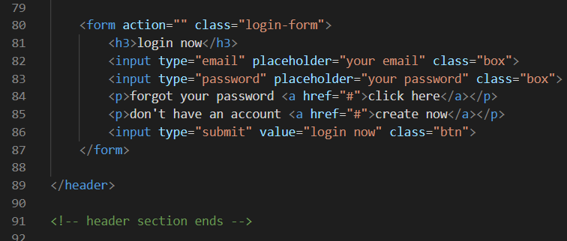

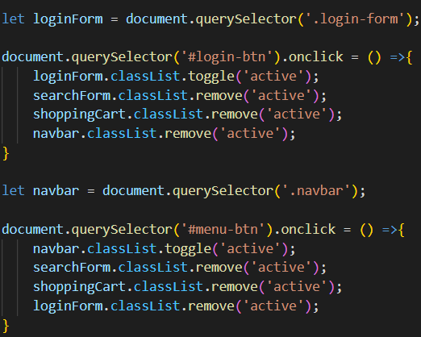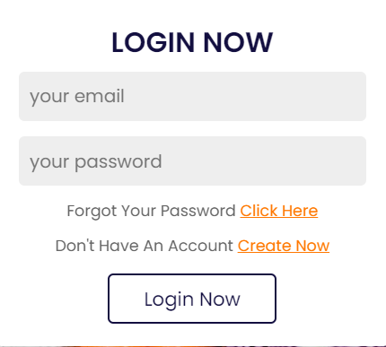

**Navigation Bar**

The navigation bar takes the user to different modules like advantages, products, categories, contact us and revolution.

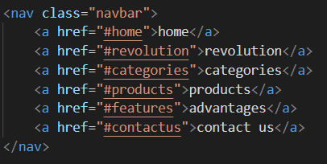 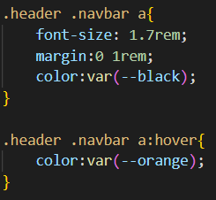 

**Footer**

The footer section contains a small description about the grocery store, the contact details, quick links and the newsletter subscription form.

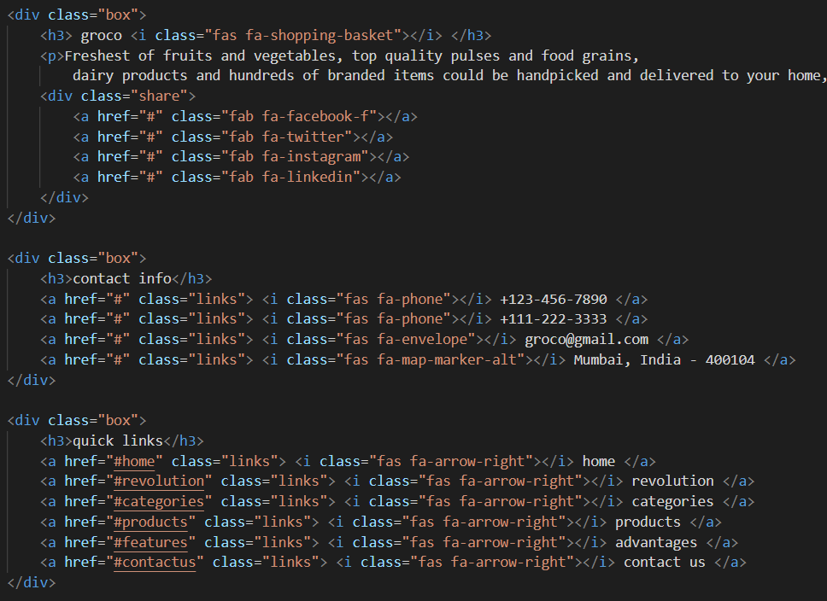 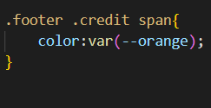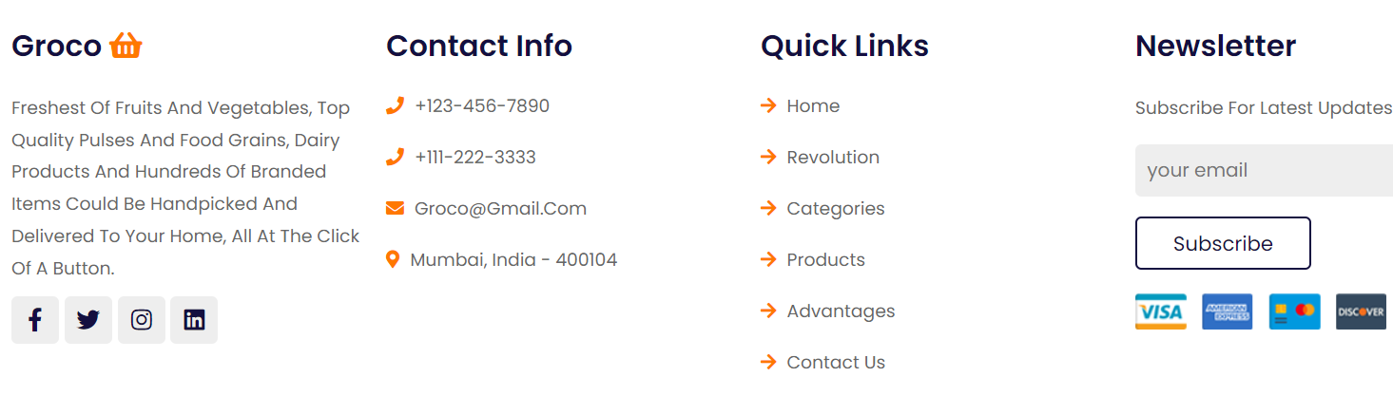

The different modules included are advatages, products, categories, contact us, and revolution.