**TABLE CODES AND TABLE POPULATION CODES**

CREATE TABLE Potential_Buyer

(BuyerNumber char(8) not null,

Buyer_Name char(20) not null,

Buyer_Address char(50) not null,

Min_Bedroom char,

Min_Bathroom char,

Min_reception char,

Family_Type varchar(12) not null,

GarageRequired char(10),

Max_price number,

constraint Potential_Buyer_BuyerNumber_pk primary key(BuyerNumber));

CREATE TABLE Seller

(SellerNo char(8) not null,

Property_Status char(20),

constraint Seller_SellerNo_pk primary key(SellerNo));

CREATE TABLE Sale_Property

(PropertyCode char(10) not null,

SellerNo char(8) not null,

Area char(20),

Address char(50) not null,

Bedroom_Number char,

Bathroom_Number char,

Reception_Number char,

Garage_status varchar(10),

Property_Type varchar(25) not null,

Price number,

Property_ownership char(20),

Market_Date date,

Property_Current_State char(15),

constraint Sale_Property_PropertyCode_pk primary key(PropertyCode),

constraint Sale_Property_SellerNo_fk Foreign key(SellerNo) references Seller(SellerNo));

CREATE TABLE Staff_Member

(StaffNo varchar(8) not null,

Staff_name char(20) not null,

Staff_address varchar(80),

constraint Staff_Member_StaffNo_pk primary key(StaffNo));

CREATE TABLE Viewing_Appointment

(AppointmentNo char(10) not null,

BuyerNumber char(8) not null,

PropertyCode char(10) not null,

StaffNo varchar(8) not null,

AppointmentDate date,

Appointmenttime char(7) not null,

constraint Viewing_Appointment_AppointmentNo_pk primary key(StaffNo,BuyerNumber,PropertyCode,AppointmentDate,Appointmenttime),

constraint Viewing_Appointment_BuyerNumber_fk foreign key(BuyerNumber) references Potential_Buyer(BuyerNumber),

constraint Viewing_Appointment_PropertyCode_fk foreign key(PropertyCode) references Sale_Property(PropertyCode),

constraint viewing_Appointment_StaffNo_fk foreign key(StaffNo) references Staff_Member(StaffNo));

INSERT INTO

Potential_Buyer(BuyerNumber,Buyer_Name,Buyer_Address,Min_Bedroom,Min_Bathroom,Min_reception,Family_Type,GarageRequired,Max_price)

VALUES('A11065', 'Adekunle Ayomide', '10 Stellamaris Bristol', '2', '1', '1', 'Children', 'yes', 700);

INSERT INTO

Potential_Buyer(BuyerNumber,Buyer_Name,Buyer_Address,Min_Bedroom,Min_Bathroom,Min_reception,Family_Type,GarageRequired,Max_price)

VALUES('A11075', 'Adebisi Muhammed', 'T43 Glamorgan Treforest', '4', '2', '2', 'Children', 'yes', 950);

INSERT INTO

Potential_Buyer(BuyerNumber,Buyer_Name,Buyer_Address,Min_Bedroom,Min_Bathroom,Min_reception,Family_Type,GarageRequired,Max_price)

VALUES('A11088', 'Folami Phola', '30 Wood Road Treforest', '3', '2', '1', 'no Children', 'yes', 800);

INSERT INTO

Potential_Buyer(BuyerNumber,Buyer_Name,Buyer_Address,Min_Bedroom,Min_Bathroom,Min_reception,Family_Type,GarageRequired,Max_price)

VALUES('A11092', 'Emmanuel Fintch', '40 Nepa Swansea', '5', '3', '2', 'Children', 'yes', 1050);

INSERT INTO

Potential_Buyer(BuyerNumber,Buyer_Name,Buyer_Address,Min_Bedroom,Min_Bathroom,Min_reception,Family_Type,GarageRequired,Max_price)

VALUES('A11096', 'Deji USman', 'N13 Glamorgan Treforest', '3', '1', '1', 'no Children', 'yes', 750);

INSERT INTO

Potential_Buyer(BuyerNumber,Buyer_Name,Buyer_Address,Min_Bedroom,Min_Bathroom,Min_reception,Family_Type,GarageRequired,Max_price)

VALUES('A11083', 'Sorewei Evelyn', 'P12 Glamorgan Pontypridd', '2', '1', '1', 'no Children', 'no', 600);

INSERT INTO

Seller(SellerNo,Property_Status)

VALUES ('SP1004','Null');

INSERT INTO

Seller(SellerNo,Property_Status)

VALUES('SP1006', 'Null');

INSERT INTO

Seller(SellerNo,Property_Status)

VALUES('SP1007', 'Null');

INSERT INTO

Seller(SellerNo,Property_Status)

VALUES('SP1008', 'sold');

INSERT INTO

Seller(SellerNo,Property_Status)

VALUES('SP1010', 'Null');

INSERT INTO

Seller(SellerNo,Property_Status)

VALUES('SP1012', 'Sold');

INSERT INTO

Staff_Member(StaffNo,Staff_name,Staff_address)

VALUES('M0012','Bill Clinton','T3 Simpson aberdare');

INSERT INTO

Staff_Member(StaffNo,Staff_name,Staff_address)

VALUES('M0010','Sean Jane','N0 10 Cornerstone Swansea');

INSERT INTO

Staff_Member(StaffNo,Staff_name,Staff_address)

VALUES('M0008','Nanu Osberg','3 Onward Carthys');

INSERT INTO

Staff_Member(StaffNo,Staff_name,Staff_address)

VALUES('M0007','Free Bossman','16 Treewood Avonmouth');

INSERT INTO

Staff_Member(StaffNo,Staff_name,Staff_address)

VALUES('M0014','Lisa Laura','4 Moonnight Pontypridd');

INSERT INTO

Staff_Member(StaffNo,Staff_name,Staff_address)

VALUES('M0016','Ben Bruce','15 Wood Road Cardiff');

INSERT INTO

Sale_Property(PropertyCode,SellerNo,Area,Address,Bedroom_Number,Bathroom_Number,Reception_Number,Garage_Status,Property_Type,Price,Property_Ownership,Market_Date,Property_Current_State)

VALUES('PC10063','SP1004','Pontypridd','M10 Wood Road','4','2','1','Yes','Detached',950,'freehold','03-JUN-2022','Unsold');

INSERT INTO

Sale_Property(PropertyCode,SellerNo,Area,Address,Bedroom_Number,Bathroom_Number,Reception_Number,Garage_Status,Property_Type,Price,Property_Ownership,Market_Date,Property_Current_State)

VALUES('PC10065','SP1010','Pontypridd','Y5 Bucketty','3','2','1','Yes','Terrace',800,'leasehold','15-MAY-2022','Unsold');

INSERT INTO

Sale_Property(PropertyCode,SellerNo,Area,Address,Bedroom_Number,Bathroom_Number,Reception_Number,Garage_Status,Property_Type,Price,Property_Ownership,Market_Date,Property_Current_State)

VALUES('PC10058','SP1006','Swansea','No15 Forest Groove','5','2','2','Yes','Semi-Detached',1100,'freehold','20-APR-2022','Unsold');

INSERT INTO

Sale_Property(PropertyCode,SellerNo,Area,Address,Bedroom_Number,Bathroom_Number,Reception_Number,Garage_Status,Property_Type,Price,Property_Ownership,Market_Date,Property_Current_State)

VALUES('PC10048','SP1012','Cardiff','T16 Morgan Base','3','1','1','Yes','Link',750,'freehold','15-JAN-2022','Sold');

INSERT INTO

Sale_Property(PropertyCode,SellerNo,Area,Address,Bedroom_Number,Bathroom_Number,Reception_Number,Garage_Status,Property_Type,Price,Property_Ownership,Market_Date,Property_Current_State)

VALUES('PC10043','SP1007','Newport','Memorial Road','2','1','1','No','Terrace',650,'freehold','03-MAR-2022','Unsold');

INSERT INTO

Sale_Property(PropertyCode,SellerNo,Area,Address,Bedroom_Number,Bathroom_Number,Reception_Number,Garage_Status,Property_Type,Price,Property_Ownership,Market_Date,Property_Current_State)

VALUES('PC10052','SP1008','Bridgend','Old Legacy Road','4','2','1','Yes','Semi-Detached',950,'leasehold','10-FEB-2022','Sold');

INSERT INTO

Viewing_Appointment(AppointmentNo,BuyerNumber,PropertyCode,StaffNo,AppointmentDate,Appointmenttime)

VALUES('NP1006','A11065','PC10063','M0012','06-JAN-2023','12:00');

INSERT INTO

Viewing_Appointment(AppointmentNo,BuyerNumber,PropertyCode,StaffNo,AppointmentDate,Appointmenttime)

VALUES('NP1008','A11075','PC10065','M0010','28-NOV-2022','14:00');

INSERT INTO

Viewing_Appointment(AppointmentNo,BuyerNumber,PropertyCode,StaffNo,AppointmentDate,Appointmenttime)

VALUES('NP1010','A11088','PC10058','M0008','04-DEC-2022','15:00');

INSERT INTO

Viewing_Appointment(AppointmentNo,BuyerNumber,PropertyCode,StaffNo,AppointmentDate,Appointmenttime)

VALUES('NP1012','A11092','PC10048','M0007','15-NOV-2022','12:00');

INSERT INTO

Viewing_Appointment(AppointmentNo,BuyerNumber,PropertyCode,StaffNo,AppointmentDate,Appointmenttime)

VALUES('NP1023','A11096','PC10043','M0014','20-DEC-2022','10:00');

INSERT INTO

Viewing_Appointment(AppointmentNo,BuyerNumber,PropertyCode,StaffNo,AppointmentDate,Appointmenttime)

VALUES('NP1014','A11083','PC10052','M0016','12-NOV-2022','09:30');

SELECT *

FROM Potential_Buyer;

SELECT *

FROM Seller;

SELECT *

FROM Staff_Member;

SELECT *

FROM Sale_Property;

SELECT *

FROM Viewing_Appointment;

**POPULATION TABLES**

* Potential_Buyer

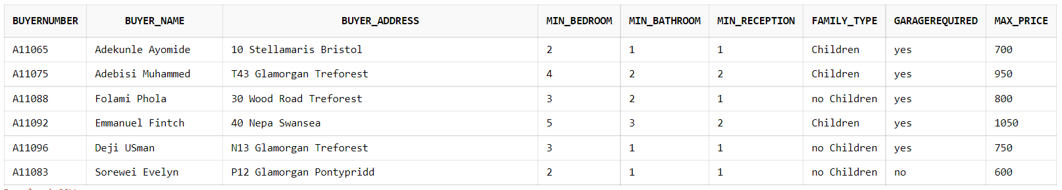

* Seller

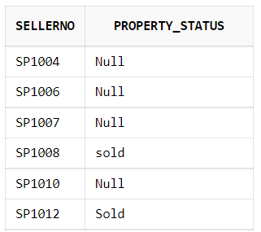

* Sales_Property

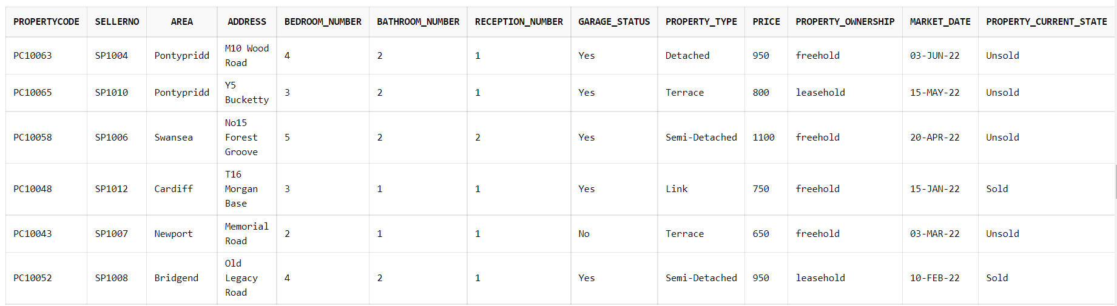

* Viewing_Appointment

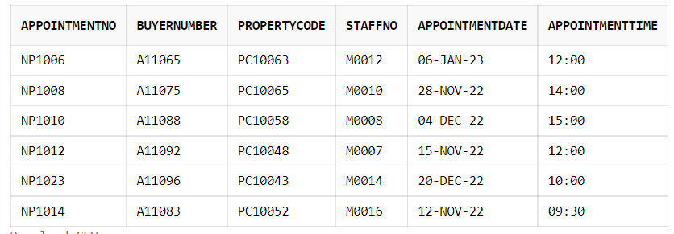

* Staff_Member

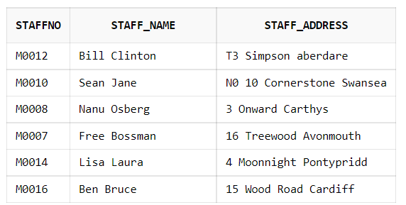

**ANSWERS TO THE QUESTIONS**

QUESTION ONE (1):

SELECT PropertyCode,SellerNo,Area,Address,Bedroom_Number,Bathroom_Number,Reception_Number,Garage_Status,Property_Type,Price,Property_Ownership,Market_Date,Property_Current_State

FROM Sale_Property

WHERE Area IN ('Pontypridd');



QUESTION TWO (2):

SELECT PropertyCode,SellerNo,Area,Address,Bedroom_Number,Bathroom_Number,Reception_Number,Garage_Status,Property_Type,Price,Property_Ownership,Market_Date,Property_Current_State

FROM Sale_Property

WHERE Property_Type IN ('Semi-Detached')

AND Property_Current_State IN ('Sold');



QUESTION THREE (3):

SELECT Property_Type AS Type,COUNT(Property_Current_State) AS Number_Sold

FROM Sale_Property

WHERE Property_Current_State IN ('Sold')

GROUP BY Property_Type,Property_Current_State;

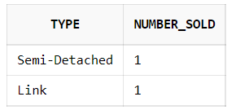

QUESTION FOUR (4):

SELECT *

FROM Sale_Property

WHERE Price IN (SELECT MAX(Price) FROM Sale_Property)

OR Price IN(SELECT MIN(Price) FROM Sale_Property);

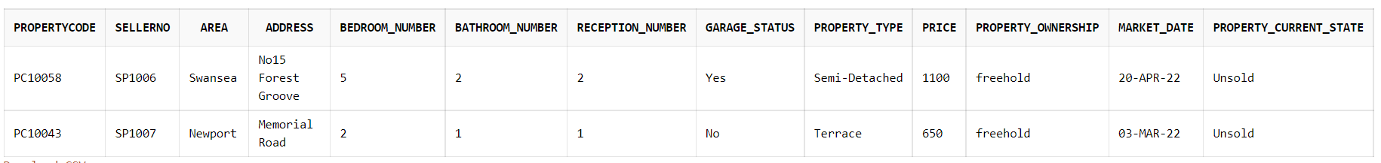

QUESTION FIVE (5):

SELECT PropertyCode,SellerNo,Area,Address,Bedroom_Number,Bathroom_Number,Reception_Number,Garage_Status,Property_Type,Price,Property_Ownership,Market_Date,Property_Current_State

FROM Sale_Property

WHERE Bedroom_Number >=3 AND Bathroom_Number >=1

AND Garage_Status IN ('Yes');

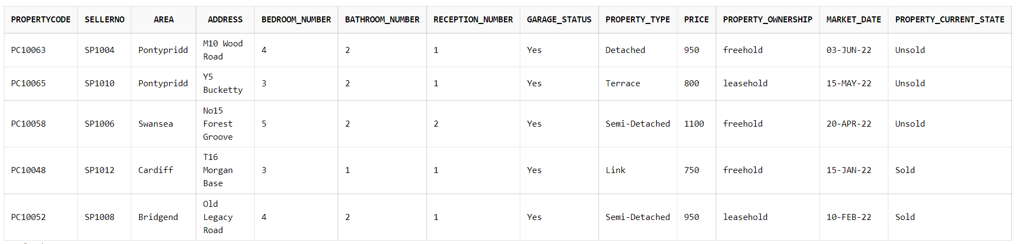

QUESTION SIX (6):

QUESTION EIGHT (8):

SELECT AppointmentNo,BuyerNumber,PropertyCode,AppointmentDate,Appointmenttime,'Supervised By','M0014','Lisa Laura'

FROM Viewing_Appointment;

