DOI: assigned by the journal upon publication
Mukhammed Zhumali
262937@astanait.edu.kz
BSc, Master’s student, School of Cybersecurity, Astana IT University, Astana, Kazakhstan. ORCID: 0009-0008-4052-0672
When Future Contacts Improve Satellite Key and Security Association Management
Abstract: Short satellite contacts must carry payload and the work needed to use valid traffic keys. The study asks when seeing more future contacts improves joint key and security association scheduling, and whether a bounded controller can realize that gain in time. Next and Multi share actions, safety rules, costs and five ordered service and resource criteria. Exact search applies to a finite event model; the practical controller compares seeds, retained plans and bounded search. In nine exact cases with prescribed preparation, Multi serves one extra contact in two cases, ties in five and leaves two unresolved. Larger budget checks find an autonomous service-improving plan under both tie rules, but only one rule completes the root proof. An offline full run under CONTINUE_WAIT serves three contacts with Multi and two with Next. The primary delay campaign comprises 88 attempts: four offline controls, four measured delay pilots and 80 main runs, with 20 Next/Multi pairs per tie rule. All main runs finish. When the measured decision pipeline consumes contact time, Multi has zero wins and 20 losses in served contacts under CONTINUE_WAIT; CANONICAL has zero wins, five ties and 15 losses. Useful time is lower for Multi in every pair; all 40 lexicographic comparisons favor Next, while modeled costs tie. Selected traces show decision delays consuming time needed for early key work. This tests one controller and host, without isolating the cost of each search component. In the 36-run offline disclosure series, recovery and confidential delivery depend on tie order. The contribution is a joint lifecycle model and controlled evidence separating feasible horizon gains from their timely execution, rather than a universal scheduling or security advantage.
Keywords: satellite security, key lifecycle, contact planning, computation, recovery

Introduction
Short spacecraft–ground contacts must accommodate both payload transmission and the management of traffic keys and security associations. A later contact may provide enough time to transmit its payload but insufficient time to establish the required security state. Earlier preparation can therefore matter, provided that validity, authorization, resource availability, and communication constraints permit it. Established space-security standards already define protection and management mechanisms [1] [2] [3]; the operational question is when to invoke their abstract counterparts.
Predictable connectivity also supports routing over planned contacts [4] [5]. However, a longer forecast does not itself establish a useful scheduling advantage. A feasible improvement may require a particular initial state, a suitable return contact, and enough computation to discover and execute the plan. Decision time can consume the communication opportunity that the plan seeks to preserve.
This study examines the incremental value of contact visibility for joint traffic-key and security-association lifecycle timing. Matched Next and Multi policies use the same actions, constraints, objective, costs, and tie-breaking rule, while observing different horizons. The analysis separates exact finite-model results from practical bounded execution, without assuming that additional visibility improves service.

Literature review and problem statement
Several established mechanisms already connect security management to intermittent or predicted connectivity. The expired Delay-Tolerant Key Administration proposal proactively distributes authenticated public keys using planned communications and effective times [6]. BERMUDA addresses unicast key management for delay-tolerant networks through public-key infrastructure, elliptic-curve key agreement, and certificate revocation [7]. These works concern the availability and administration of cryptographic material; they prevent treating advance preparation as a new mechanism.
Satellite handover research provides another precedent. Zhao transfers authentication context and session-key information before a predicted handover [8]. Kwon et al. separate initial authentication from lightweight handover operations in a satellite–terrestrial architecture [9]. Such designs establish that anticipating mobility and reducing repeated authentication costs are existing research directions.
Bernal et al. provide a particularly relevant contact-dependent identity architecture [10]. Ground-side identity operations support onboard authorization allowlists updated during satellite contacts. Their discussion also includes revocation delay, temporary local authorization withdrawal, and short-lived capability tokens. Thus, this work already couples authorization state to intermittent connectivity. The distinction considered here is the timing of directional traffic keys and security associations across an ordered contact sequence, rather than device identity or ledger-backed authorization.
Bundle Protocol Version 7 and BPSec establish a separate networking and security context [11] [12]. Most directly, Detke et al. translate temporally feasible Contact Graph Routing routes into protection-scheme-dependent key scopes and minimize the activated scopes needed for a target connectivity ratio [13]. Their model addresses route feasibility and provisioning footprint; scheduling keys over contact plans is identified as a further direction. The present study instead examines sequential lifecycle actions and their effects on admissible payload service under fixed constraints.
Receding-horizon optimization is itself established [14]. The narrower problem is whether changing only the visible contact horizon changes the selected lifecycle schedule, and whether a practical controller can realize that change within its computational budget. This operational comparison neither supplies a new authentication protocol nor substitutes for cryptographic analysis such as formal BPSec studies [15]. Consequently, any contribution must remain conditional on the modeled state, workload, constraints, and execution method.
Related work also addresses BPSec security models and policies [16]. Concrete contexts specify cryptographic processing and key-use rules [17]. The abstract operations are inspired by lifecycle requirements; the simulator implements neither those BPSec contexts nor a certified implementation of the space data-link standards. Its evidence concerns operation timing and modeled consequences, not protocol-level cryptographic strength.

Aim and objectives
The research question is: under identical lifecycle actions, security constraints, costs and plan tie-breaking, when does additional predicted contact visibility improve achievable spacecraft-ground service, and when can a bounded receding-horizon controller realize that improvement after its measured decision time is charged to contact opportunities?
The hypothesis is conditional: a longer horizon can expose a later contact whose service requires an earlier key or security-association operation, allowing a contact to be served that the shorter-horizon schedule misses. The effect can disappear when later time is sufficient, old material remains valid, search cannot discover the continuation, or computation consumes the useful opportunity.
The objectives are to isolate initialization from search, test timing and validity conditions, measure full-run quality under fixed computational budgets, and distinguish recovery milestones after key disclosure. The study formulates joint directional-key and security-association lifecycle scheduling and provides matched evidence identifying useful and ineffective regimes. The experiments separate the existence and discovery of a service-improving plan from its timely execution, and separate efficiency from disclosure consequences. Implementation checks support reproducibility; neither a new cryptographic protocol nor universal superiority of the longer horizon is claimed.

Materials and methods

State and admissible execution
A contact specifies a spacecraft, ground station, start, end, and offered payload in each direction. Each station context holds directional traffic-key material, installation acknowledgments, active generations, security associations, and counters. Key creation, installation, activation, and association opening are distinct events. PREPARE creates a pair; INSTALL confirms its availability at both ends; SWITCH activates it; OPEN or REUSE opens a context with admissible material. CONTINUE sends one complete frame; WAIT advances to an event without starting another frame. STOP and EXPIRE follow the executor rules automatically. One spare candidate and shared resources restrict the action space.
A material-age bound A is measured from creation c, and a cryptoperiod P from successful activation a. Previously committed deadlines cannot be extended by later opening or reuse. The use deadline d is bounded as in (1), with absent terms omitted before activation. Authorized context, directional binding, installation, acknowledgment, counters, and validity throughout a frame are checked in addition to this time bound.
$d = min(c + A, a + P, d_{committed})$ (1)
Management operations occupy elapsed time and, when applicable, the shared radio. The profile records spacecraft and ground CPU separately, radio occupancy, and uplink/downlink management bytes. Operations interrupted by a boundary charge only the executed phases; useful time includes complete delivered payload frames. The synthetic profile used in the new tests is summarized in Table 1. These are model parameters, not flight-hardware benchmarks. Search CPU and host elapsed time are measured separately.
Table 1. Synthetic operation profile; CPU is spacecraft plus ground, bytes are both directions.
Operation | Elapsed (s) | CPU (s) | Bytes
PREPARE | 2 | 0.20 | 0
INSTALL | 4 | 0.30 | 800
SWITCH | 1 | 0.15 | 200
OPEN / REUSE | 1 | 0.06 | 80
Revocation notice | 0.4 | 0.04 | 96

Objective and matched policies
A contact is served once its required uplink and downlink delivery thresholds are both met. A root evaluation includes the current contact’s already delivered progress and counts only incremental reward and costs, with no double counting of completed preparation. The five ordered criteria in (2) maximize served contacts S and useful payload time U, then minimize modeled operation CPU C, management bytes B, and newly created directional keys K. One extra served contact outranks any loss of useful time or increase in cost. Risk is not minimized by this objective.
${maximize}_{lex} J = (S, U, -C, -B, -K)$ (2)
Next uses H=1 and Multi H=2, where H counts future contacts beyond the current one. Inside C1, Next observes C1 and C2, while Multi also observes C3. Between contacts, H nearest contacts are available. Visible contacts, payload, and evaluationEnd remain fixed during a search; moving to another contact inside a branch reveals nothing new. The endpoint is the last visible contact’s end. Future attacks and failures are excluded from the observation.
Both horizons use the same finite start events, executor, constraints, resources, generation IDs and traversal. Only exact equality of all five criteria invokes the full-plan tie rule. Times retain nanosecond precision. The CANONICAL action tuple is (kind rank, start, station ID, context ID, uplink key ID, downlink key ID, until, contact ID), ascending. Kind order is PREPARE, INSTALL, SWITCH, OPEN, REUSE, CONTINUE, WAIT. Context compares spacecraft then station; strings use lexical order, and null precedes a value. Plans compare at their first unequal action; a proper prefix precedes its extension.
The exact solver explores the finite admissible continuations with validated pruning and state reuse. COMPLETE certifies this model’s root optimum, including tie order; a time or node stop is INCOMPLETE. The controller executes the first action and replans at events, except for an already proved continuation after a guarded nominal frame. Root optimality does not prove whole-mission optimality. The practical controller compares feasible seeds, retained continuations, and bounded-search results. FINISHED means that execution reached its endpoint, not that every decision was proved optimal.
CONTINUE_WAIT prepends (group, until) to the canonical tuple: group is CONTINUE=0, WAIT=1, all service operations=2. Thus until is compared before operation kind even within the service group. This complete order differs from tree visitation: SERVICE_FIRST visits CONTINUE, SWITCH, INSTALL, OPEN, REUSE, WAIT, PREPARE, with canonical secondary ordering. Seeds and retained plans are not injected as DFS incumbents.
Practical controller with measured decision time
1. Persist the checkpoint. Start the monotonic timer before constructing the permitted observation, wakeups and admissible candidates.
2. Check the saved proof against the observation and rules. If allowed, derive its continuation and select its first action.
3. Otherwise, construct a seed, validate/replay retained candidates, run bounded search and select by the five criteria and full-plan tie rule.
4. Prepare a certificate only for a matching unrestricted COMPLETE search; check original admissibility, finish the decision scope and construct its audit. Stop the timer.
5. Advance committed work and events by the measured interval, clipped at the scenario end.
6. Rebuild the observation and candidates; recheck the selected intent and WAIT wakeup. Discard stale or late choices; observed incident response takes precedence.
7. A shifted action receives no old optimality certificate. Retained original evidence must pass the full guard at the next decision.
8. Execute only the admitted first action and repeat. A seed or feasible bounded-search result alone carries no optimality proof.
Seeds and retained candidates use the same admissibility checks as search. Retention replays from the current root, preserving progress, costs, counters and issued IDs; it never reuses the old score. If no terminal candidate exists, an admissible local fallback is used. The Supplement gives the complete seed filters and source tie handling.

Experimental design
The primary latency test is the registered X01 campaign: four offline controls, four pilots and 80 main executions (Table 2). Pilots are excluded from main comparisons. Earlier offline experiments establish the mechanism, preparation effect and plan discovery; their histories are in the Supplement. The current fixed-budget series does not define a budget-quality curve.
Table 2. X01 attempts; the only unfinished run is the offline CANONICAL Multi control.
Phase | Planned | FINISHED | Unfinished
Offline controls | 4 | 3 | 1
Measured pilots | 4 | 4 | 0
Main executions | 80 | 80 | 0
Total | 88 | 87 | 1

The offline reference family uses exact search with a 2,000,000-node and 30-second limit; bounded comparisons also test a 5,000-node, one-second search. The subsequent autonomous root checks increase the search-time cap to 30 seconds. These are finite limits, not claims of full enumeration at every allowance. The Supplement separates all reference budgets from the current measured campaign.
The synthetic family uses C1 at A from 0 to 20 seconds, C2 at B from 30 to 50, and C3 at A from T to T+L. X01 has T=80, L=5, and P=150 seconds. Common preparation runs from −2 to 0 and its costs remain in the journal; autonomous runs start without a spare pair. Initial A material was created at −90 and activated at −80, and B at −40 and −30. Material age is 400 seconds and maximum reuse gap 200 seconds. Changing P rebuilds history through lifecycle transitions; expiry is never edited independently. Figure 1 illustrates the X01 timing mechanism.
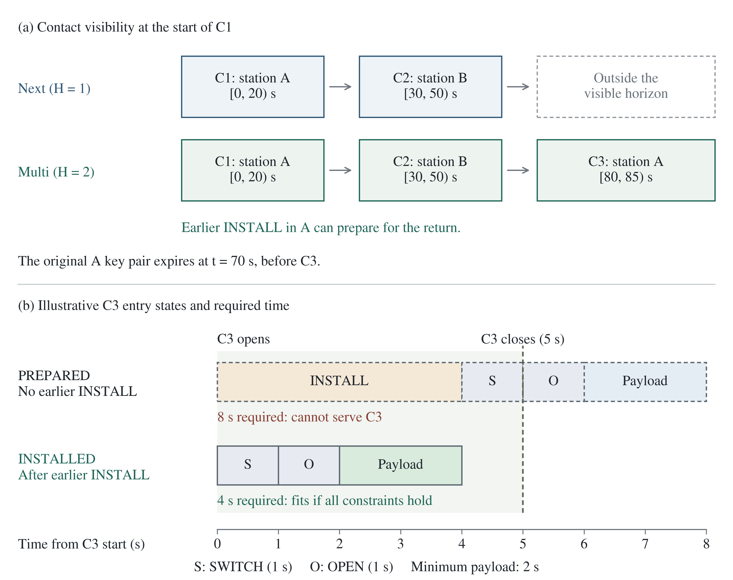
Fig. 1. X01 horizon mechanism: earlier installation can reduce the time needed to serve C3 from 8 s to 4 s if all lifecycle constraints hold. Illustrative timing requirements, not an execution trace.
The remaining family settings are shown in Fig. 2. X01 offers effectively unlimited payload in both directions in all three contacts (Long.MAX_VALUE, or 9,223,372,036,854,775,807 bytes per direction per contact). This offered demand is distinct from the service threshold of 400 bytes per direction. At 100 bytes per frame and 400 bytes per second, each frame lasts 0.25 seconds; the two directional thresholds of 400 bytes require eight frames, or two seconds. A pre-active installed pair therefore needs SWITCH+OPEN+payload, four seconds, while a prepared pair needs INSTALL+SWITCH+OPEN+payload, eight seconds. An already active pair needs REUSE+payload, three seconds. These are necessary timing totals for those chains, not universal sufficient conditions: resource use, whole frames, deadlines, and strict completion of management before contact loss are checked by execution.
Geometric contact inputs in the baseline were derived from archived CelesTrak general-perturbations data [18], SatNOGS station metadata [19] and Orekit propagation [20]. They represent visibility, not reserved ground-station service. The archived models identify dates, stations, payload assumptions and hashes. ISS controls reuse those windows, while X01 is synthetic; no new full-day propagation campaign is performed. Before the measured-delay campaign, the host was recorded as an AMD Ryzen 7 5800HS, 8 physical cores/16 logical processors, 16,541,487,104 bytes of OS-reported physical memory, Windows 11 build 26200 and Java 21.0.10. These desktop measurements are not onboard latency predictions.
Table 3. Common ISS long and late contact geometry; UTC on 12 October 2026. IDs have prefix orekit-25544-SATNOGS-.
ID suffix | Station ID | Start UTC | End UTC
3634-1 | 3634 | 00:08:37.296295166 | 00:14:59.990386963
2987-1 | 2987 | 00:25:53.554229736 | 00:30:27.284088135
3634-2 | 3634 | 01:47:18.202056885 | 01:49:19.758453369

Spacecraft NORAD-25544 uses stations SATNOGS-3634 and SATNOGS-2987. For all three ISS contacts, modeled payload throughput is 100 bytes/s and frames are 1,000 bytes (10 seconds). Offered UL/DL bytes are 39,000/39,000 in the first contact and 1,000/1,000 in each later contact; minimum UL/DL service is 1,000/1,000 in every contact. Window linkRateBps and expectedDataBytes are null; no measured physical link rate is inferred. Both station contexts start with no keys or prepared pairs, two UNKEYED SAs, zero counters and no open session. The scenario starts at 00:08:35.296295166 UTC and ends at the last listed contact end.
The ISS cryptoperiod is 5,400 seconds, material-age limit 172,800 seconds, and maximum reuse gap 86,400 seconds. Only the two listed station contexts are authorized; the blocked-key set and prescribed operation plan are empty. Phase reservations enforce exclusive spacecraft CPU, station-local CPU and shared UL/DL radio occupancy. The generator permits one spare pair per context by rejecting PREPARE while PRE_ACTIVE material or pending preparation exists; this is not a total storage-capacity parameter. Exact file paths, SHA256 hashes, complete initial states and the nine derived late-disclosure configurations are in Supplement and input-descriptors.json.
Autonomous root diagnostics restore the same t=0, H=2 observation for both tie rules and independently allow 100,000, 150,000 or 200,000 nodes with a 30-second search cap. The ordinary seed/retention/search portfolio receives no oracle plan or external incumbent. The smallest tested allowance whose replay-valid score improves on (2, 38, 0.12, 160, 0) is then used in an offline Next/Multi execution. Detailed limits and provenance are in the Supplement.

Measured decision-time protocol
The measured campaign starts autonomously at t=-2 seconds without a prepared spare pair; the earlier t=0 root diagnostics are a separate task. Physical costs, payload, key deadlines, actions, tie rules, traversal and objective are retained. Before registration, correction b2d04b8 included the existing certified-continuation checks and preparation in the measured controller cycle. It changes neither the offline solver nor the planning objective; implementation evidence is retained in the Supplement.
There are 20 Next/Multi pairs under each tie rule. Fresh Java 21 processes run serially with default JIT/GC, a 1,024 MiB heap and no explicit warmup; Next runs first in odd pairs and Multi in even pairs. Each search allows 150,000 nodes and 30 seconds. Whole-selection, controller and external-watchdog limits are 32, 180 and 210 seconds. These limits were registered before outcomes; there are no scientific retries or outcome-driven budget increases.
The charged monotonic interval begins before observation and candidate construction and ends after continuation-audit construction. It includes proof checking and preparation, seed/retention work, bounded search and final comparison. Committed work and physical events advance during that interval, followed by fresh intent admission. Checkpoint I/O, fresh admission, actual execution, JVM startup/deserialization and final export are outside the charged interval. Selection elapsed time, total controller elapsed time and modeled operation CPU are distinct quantities. The measurement is not a complete model of onboard computing overhead. Final service is reconstructed from delivered frames; unfinished executions have labeled prefix metrics and no final score.

Disclosure and recovery measurements
The separate 36-run offline disclosure series changes only attack timing in the fixed three-contact late-disclosure model. For the first contact’s end E=00:14:59.990386963 UTC on 12 October 2026, compromise occurs at E−40, E−20, or E−5 seconds, with detection delay 0, 2, or 20 seconds. Its 1,000-byte frames take ten seconds. All nine timing combinations run with both horizons and both tie rules: 36 attempts. The practical controller allows 5,000 nodes and 1 s per search, with a 2 s action-selection limit. Computation time is not charged to contact windows; these runs are separate from the measured-delay campaign. The common rule reveals the active directional traffic-key pair; a missing target would receive NO_TARGET rather than zero damage. The attack remains hidden from planning. Emergency response and independent replacement assumptions are unchanged.
From ground receipt of the detection notice, separate milestones measure confirmed spacecraft notice, agreed activation of a valid independent pair, opening of its security associations, and the first complete independent delivered frame. Independence means new directional material outside the disclosed-key set, under the model’s independent-generation assumption; both endpoints must agree and all lifecycle constraints remain satisfied. A milestone already satisfied at detection is labeled explicitly. Missing events are censored at observation end or unavailable for unfinished execution, never silently zero. Total compromise-to-delivery delay additionally includes actual ground-notification delay.
Readiness intervals end at expiration, revocation, replacement, or association closure. Waiting for material, notification, contact, and offered payload is represented by simultaneous condition flags; overlapping durations are not added as a causal decomposition. Confidential delivered bytes count full delivered payload protected by material never revealed in the modeled run. Decryptable emitted bytes include retrospectively recorded traffic and post-disclosure emission, including aborted prefixes; these are different denominators. The model assumes protected management and independent replacement material, and evaluates consequences of disclosure rather than its probability.

Results

Separating preparation from search
All paired initial execution snapshots and permitted observations match at fixed H, including journal costs and progress. After common preparation, exact and practical Multi both serve three contacts with 37 seconds of payload, 0.83 seconds of modeled CPU, 1,240 management bytes, and two new keys. Their Next counterparts serve two with 38 seconds, 0.32 seconds, 160 bytes, and two keys. Both tie rules give these outcomes. The additional served contact therefore costs one second of useful time and more management work, consistently with (2).
In the first revision, autonomous practical (5,000 nodes/one second) and exact Next runs under both tie rules give (2, 38, 0.12, 160, 0). Exact Multi under CONTINUE_WAIT finishes with (3, 37, 0.83, 1240, 2); CANONICAL stops with incomplete search. Thus a prepared exact run cannot alone establish a search advantage over an autonomous practical run. A matched autonomous comparison still exhibits a gap, but only one tie rule has a completed exact full execution in the registered budget.

When the horizon changes service
Fig. 2 reports nine exact-controller configurations with a common prescribed PREPARE, not nine autonomous practical comparisons. Seven have completed Next/Multi pairs under both tie rules: Multi serves one extra contact in X01 and X08, and five configurations tie. The two remaining settings have unfinished Multi searches and are unknown, not losses or estimated gains.
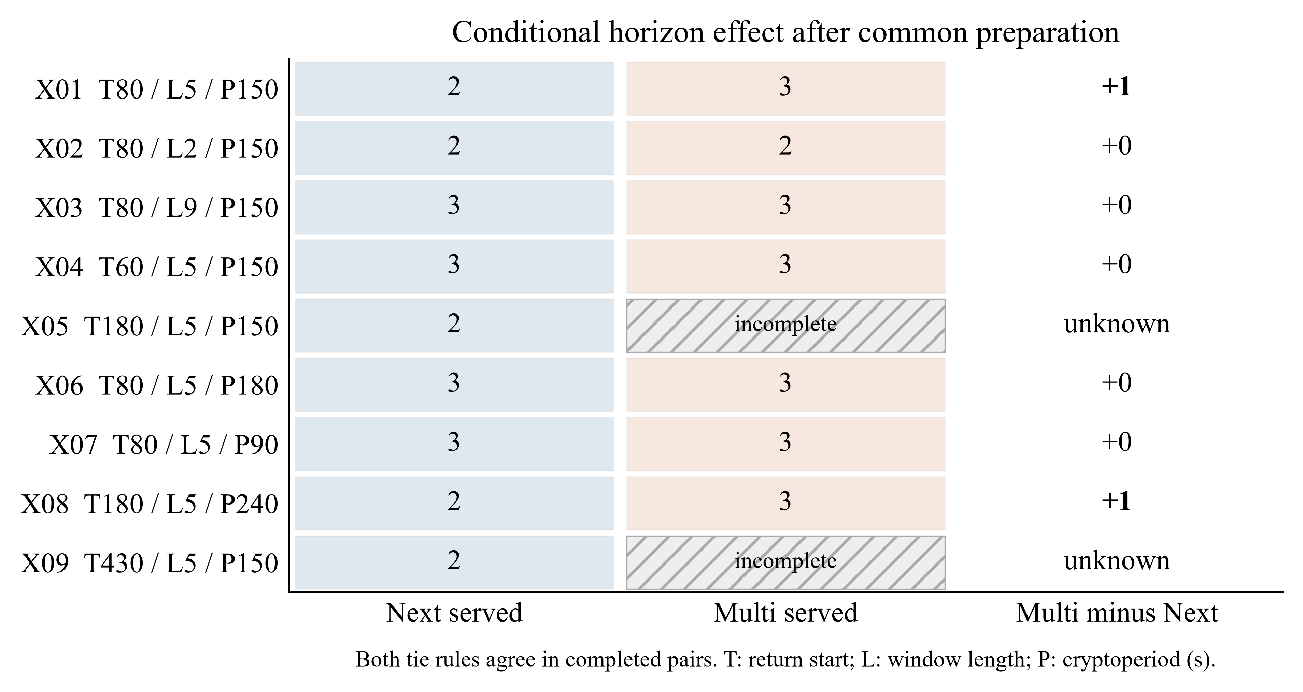
Fig. 2. Synthetic conditions after common preparation. T is return-contact start, L its length, and P cryptoperiod, all in seconds. Both tie rules agree in completed pairs. Hatched cells are incomplete exact executions, not zero service.
A two-second return window is insufficient for the considered entry chains. A nine-second window allows later installation and both horizons serve three contacts. Returning at 60 seconds or extending the cryptoperiod to 180 seconds preserves useful old material and removes the difference. With P=90, expiry inside C1 forces even Next to renew, also removing the difference. At T=180 and P=240, earlier installation again enables a third contact only for Multi. At T=430 all material created by C1’s end has exceeded its 400-second age limit before return, but the full policy comparison remains unknown because search is incomplete. The family establishes conditional examples, not a general interval threshold.

Discovering the offline improvement
The historical one-second offline budget control finds no horizon advantage at its tested allowances; Supplement Fig. S1 preserves that result without its older measured-delay points. In autonomous X, both horizons obtain (2, 38, 0.12, 160, 0) at every positive allowance; the long ISS control ties at (3, 410, 2.13, 3240, 6). This does not characterize larger search-time budgets. Table 4 therefore examines the same autonomous root with a 30-second search cap.
Table 4. New autonomous H2 root diagnostics; allowed/visited nodes. CAN=CANONICAL; CW=CONTINUE_WAIT. All selected plans pass common replay.
Rule | Allowed / visited | Search status | Selected S, U, C, B, K
CAN | 100000 /  100000 | INCOMPLETE | 2, 38, 0.12, 160, 0
CAN | 150000 /  150000 | INCOMPLETE | 3, 37, 0.83, 1240, 2
CAN | 200000 /  200000 | INCOMPLETE | 3, 37, 0.83, 1240, 2
CW | 100000 /  100000 | INCOMPLETE | 2, 38, 0.12, 160, 0
CW | 150000 /  134638 | COMPLETE | 3, 37, 0.83, 1240, 2
CW | 200000 /  134638 | COMPLETE | 3, 37, 0.83, 1240, 2

At 100,000 nodes both selected results remain (2, 38, 0.12, 160, 0). At 150,000 and 200,000 nodes both rules select (3, 37, 0.83, 1240, 2). CANONICAL stops at the node allowance without a certificate; CONTINUE_WAIT completes at 134,638 visited nodes and has a root certificate. All six start with OPEN and pass full-plan replay. No search reaches the new 30-second cap. This establishes discovery in these ordinary practical runs, not a universal threshold.
Both rules therefore select 150,000 as the smallest qualifying tested allowance for the four follow-up executions. Under CANONICAL, Next is FINISHED and Multi is CONTROLLER_TIME_LIMIT; their full-run comparison remains unresolved. Under CONTINUE_WAIT, the full Next and Multi runs finish with (2, 38, 0.12, 160, 0) and (3, 37, 0.83, 1240, 2), respectively. In this offline comparison, observed controller elapsed time was 2.537 s for Next and 32.426 s for Multi. These host measurements were not charged to contact time and do not establish onboard feasibility. The original autonomous initialization, preparation costs and subsequent decisions remain part of these runs; a good root score alone is not credited as delivered service.

Measured decision latency in X01
The four new offline controls reproduce the CONTINUE_WAIT scores (2, 38, 0.12, 160, 0) for Next and (3, 37, 0.83, 1240, 2) for Multi. CANONICAL Next finishes with the same Next score; CANONICAL Multi reaches the 180-second controller limit and has no final comparison score. All four pilots and all 80 main measured executions finish. Thus 87 of the 88 registered attempts are FINISHED, with the one incomplete offline control preserved separately.
Table 5. Main measured-delay series. CW=CONTINUE_WAIT; CAN=CANONICAL. Delta U is Multi minus Next; no main pair is incomplete.
Rule | Complete pairs | Multi S wins / ties / losses | Delta U (s), median [min; max]
CW | 20 / 20 | 0 / 0 / 20 | -15 [-15.75; -13]
CAN | 20 / 20 | 0 / 5 / 15 | -14.25 [-15.5; -11]
Table 5 reports every planned main pair. Next serves two contacts in all 40 main executions. CONTINUE_WAIT Multi serves one in all 20; CANONICAL Multi serves one in 15 and two in five. Useful time is lower for Multi in every pair. The five service ties therefore become losses at the second criterion, and Next wins all 40 full five-coordinate comparisons. Modeled GS+SC operation CPU, management bytes and new directional keys are respectively 0.12 seconds, 160 bytes and zero in every main execution; the differences arise in service and useful time, not these three resource coordinates.
Median useful times for Next/Multi are 32.75/17.75 seconds under CONTINUE_WAIT and 32.75/18.125 under CANONICAL. Median host controller elapsed times are 6.857/22.860 and 6.905/21.598 seconds, respectively. These are whole-controller host measurements, not modeled operation CPU or individual selection durations. Supplementary timing statistics retain that distinction. Fig. 3 shows actual execution in the representative pairs.
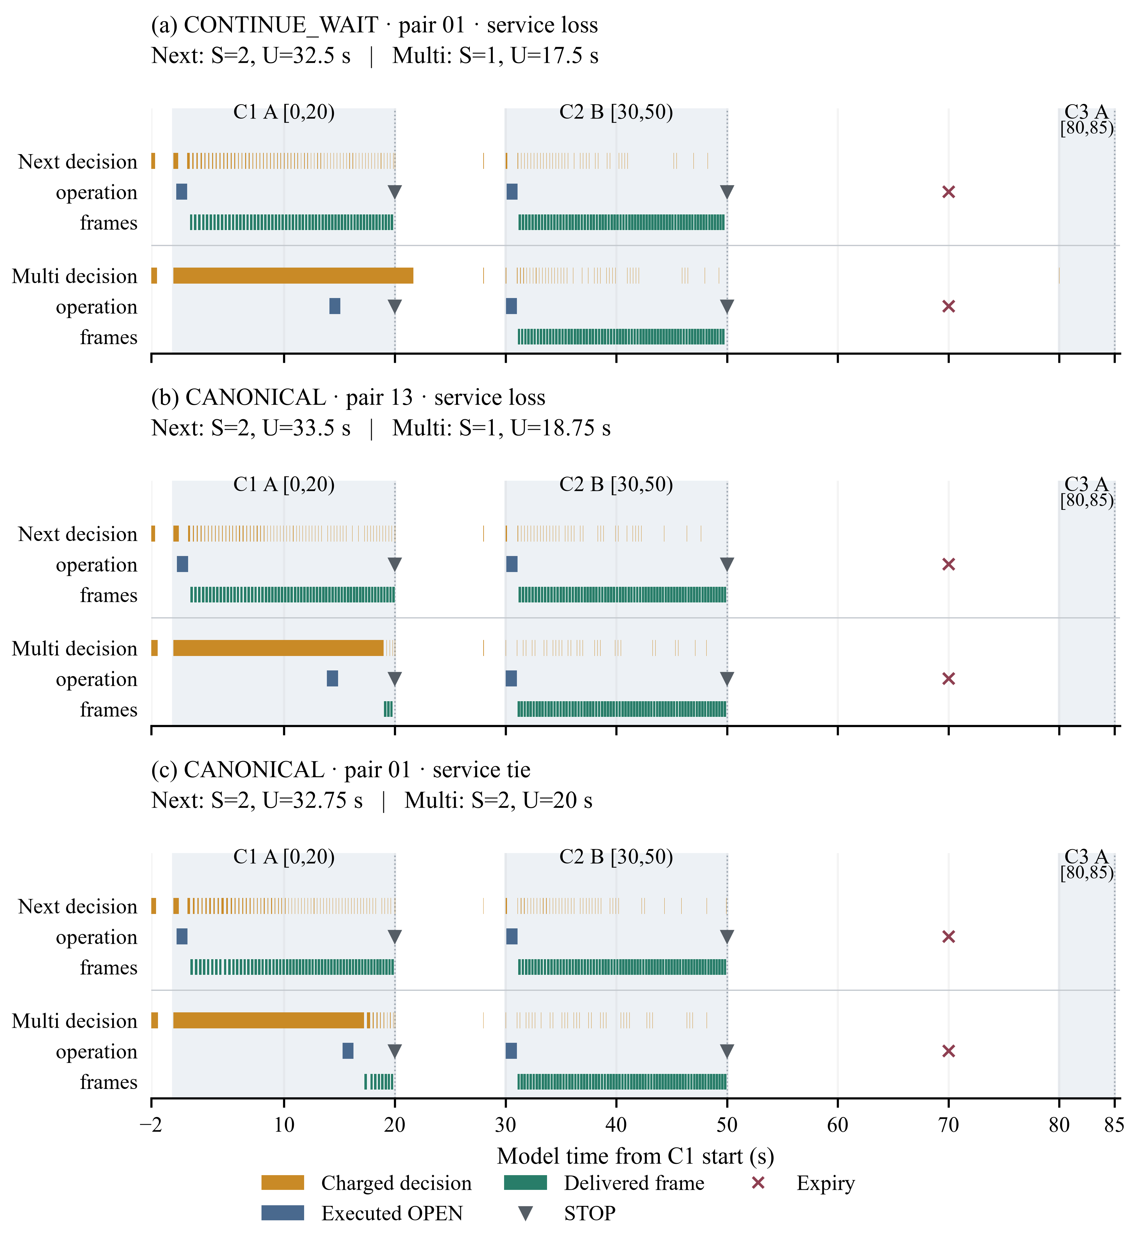
Fig. 3. Actual measured-delay executions in X01. Each pair is nearest to the median Delta U within its tie-rule/service-outcome group, with ties resolved by pair ID. Separate lanes show charged selections, executed lifecycle operations and delivered frames; shading marks contacts. S is served contacts and U is useful payload time. No PREPARE or INSTALL executes in these traces.
The representative traces expose missed preparation opportunities. In main-CONTINUE_WAIT-01, Multi first returns OPEN at t=14.0855122 s; the next selection ends at t=21.636010 s, after C1 closes. No new material or PREPARE/INSTALL is pending. Sequential PREPARE (2 s) and INSTALL (4 s) must start strictly before t=14 s because INSTALL must finish strictly before t=20 s; even that bound is only necessary if later decisions add delay. It is crossed at the first selection in main-CANONICAL-01 (t=15.2737277 s) and the second in main-CANONICAL-13 (t=18.9458863 s). The latter Multi run delivers 0.75 s in C1 without reaching both service thresholds; CANONICAL-01 delivers 2 s and serves C1. These selected witnesses support the timing mechanism without isolating the cost of DFS or proving it for every run.

Sensitivity to disclosure timing and tie order
All 36 attempts in the offline disclosure series finish, have a valid disclosed target, and eventually deliver an independent frame. There are no censored observations in this offline disclosure series. Fig. 4 compares matched horizons. CANONICAL gives earlier independent delivery for Multi in seven of nine timing pairs and 1,000 additional confidential bytes in five. CONTINUE_WAIT gives equal independent-delivery times and confidential bytes in all nine pairs. Neither pattern establishes robustness to untested tie orders.
The largest delay difference is about 5,554.5 seconds: under CANONICAL, fitting one independent frame before contact loss avoids waiting for the next return. This occurs at E−40 with a 20-second detection delay, and E−20 with zero or two seconds of delay. The effect combines horizon-dependent state and tie-dependent action timing. All runs serve three contacts by the original service definition, which must not be confused with confidentiality.
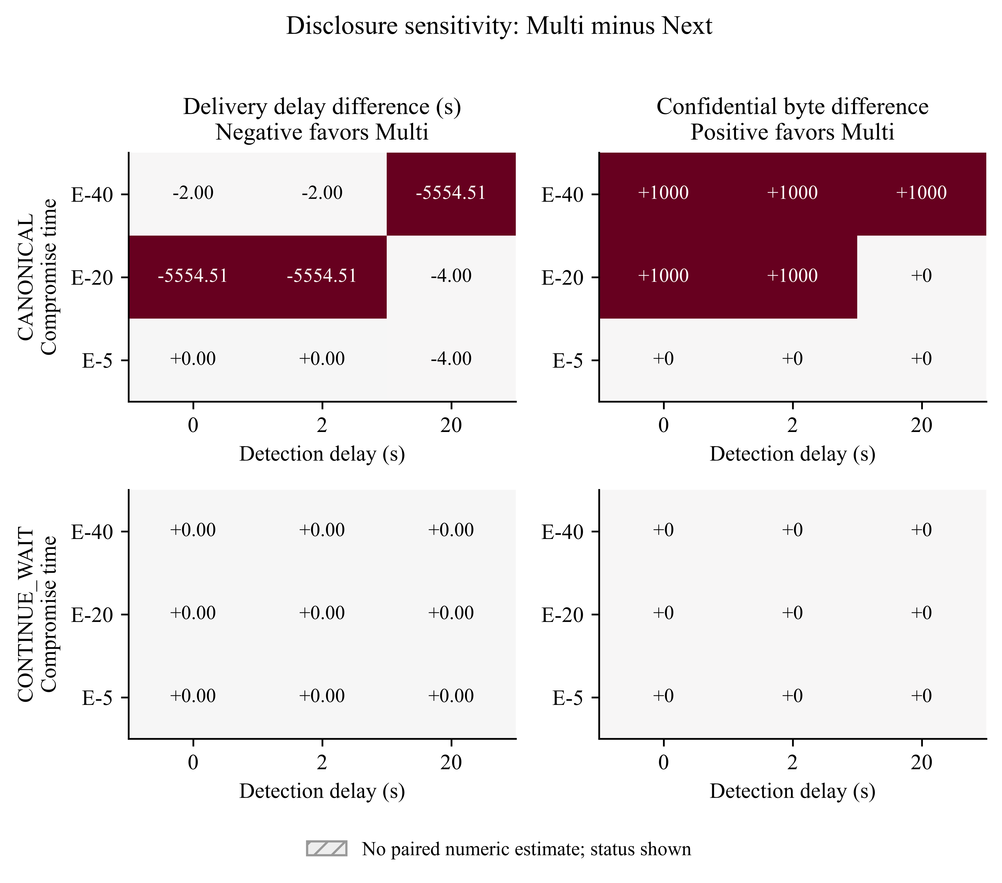
Fig. 4. Offline disclosure series: Multi minus Next for first independent delivery delay and confidential delivered bytes, separated by tie rule. E is contact end; rows are common compromise times and columns detection delays. All 36 runs finished and recovered. Signed values are per-pair differences, not means over selected successes.
Earlier activation need not improve delivery. For CANONICAL at E-5 with immediate detection, generation g2 activates after 1.4 s but expires before the return; g3 supplies the first independent frame after 5,559.212 s, when Next also delivers. With detection delays of either 0 or 2 s, Next obtains (3, 410, 2.17, 3336, 6), while Multi obtains (3, 400, 2.82, 4336, 8); both deliver 4,000 confidential bytes. Thus these cases incur additional lifecycle cost without earlier independent delivery. The Supplement retains the full milestones and readiness intervals.

Discussion
The experiments support the proposed timing mechanism in a restricted, explicit setting. Extra forecast information is useful when it exposes a later requirement early enough to change current lifecycle work, the resulting material survives until use, and the controller discovers and executes the necessary continuation. Holding only the action set constant is insufficient: initial preparation, complete plan tie order, and computational budget also change what the realized controller can achieve.
The new results distinguish a scheduling opportunity from its realization by a particular bounded controller. The unchanged offline control retains a three-versus-two-contact gain, while measured execution realizes no service gain in either tested tie order. Delays in the whole decision pipeline consume time needed for lifecycle work and can invalidate an intended continuation. This is evidence about this implementation and timing regime, not an impossibility result for multi-contact planning. Nor does it prove that replacing DFS alone would restore the gain: no component ablation, alternative solver or faster-platform comparison was performed. The contribution is controlled evidence linking horizon, validity, tie choice and computational timing to realized service, with recovery and confidentiality assessed separately.
The preserved ISS baseline also contains regimes without a horizon advantage: four completed nominal pairs tie on all five criteria, while five remain unresolved. Main-profile windows leave enough time for later security work, and many same-context return gaps exceed the 5,400-second cryptoperiod. With initially empty keys, positive service thresholds in both directions and no admissible reuse across served returns, each served contact needs two fresh directional keys, giving (3). This conditional count does not establish optimality for useful time, CPU, bytes or search cost.
$K_{new} ≥ 2S$ (3)
The lower bound applies only when the stated initial-state and reuse assumptions hold. Pre-existing suitable material, longer valid reuse, or different directional demand can invalidate it. In the baseline, longer-cryptoperiod sensitivity permits reuse for both horizons rather than creating an exclusive Multi benefit. Geometric-window results also remain specific to modeled payload, station access, and costs. The four complete nominal pairs cannot resolve the five unfinished comparisons or all orbital environments.
The 4-versus-8-second requirements in Fig. 1 identify a testable mechanism, not a general scheduling theorem: admissibility still depends on event boundaries, resources and key validity. Likewise, retaining a proved suffix is sound only under its guarded state and horizon conditions; it does not authorize skipping replanning after unforeseen changes.
The disclosure findings reinforce the separation between efficiency and security consequences. The objective rewards service and low overhead, not minimal exposure. A plan that renews earlier can waste key material before return, and additional useful time can include traffic later revealed. Reporting independent activation, delivery, and confidential bytes prevents a quick key replacement from being mistaken for faster end-to-end recovery. The selected late-disclosure grid tests one workload and active-pair threat model, not the probability of attack or resistance of a cryptographic protocol.
The study remains bounded by synthetic costs, discrete start opportunities, limited forecast horizons, nominal future operations and host-specific timing. Only completed certified searches establish finite-model root optima; practical results are feasible outcomes under registered limits. The nine configurations and 36 disclosure runs are not a statistical population sample. The new measured series adds repeated observations of one synthetic scenario on one desktop/JVM, with ordinary background activity neither disabled nor causally attributed. It does not compare alternative solvers or separate the costs of individual decision-pipeline components. Unresolved exact cells, timer-constrained searches and tie-dependent recovery benefits remain substantive limits.

Conclusion
Joint planning across predicted contacts can preserve an otherwise missed contact. The prescribed-preparation exact family establishes this in two configurations under both tested tie rules, with five ties and two unresolved settings. The new ordinary practical root checks also find the autonomous service-improving plan at 150,000 and 200,000 allowed nodes with a thirty-second search cap. CANONICAL supplies a feasible incumbent; CONTINUE_WAIT completes the finite root proof. These observations are specific to the preserved state and traversal.
The completed offline CONTINUE_WAIT execution serves three contacts with Multi and two with Next; the corresponding CANONICAL Multi offline comparison remains unresolved at the controller limit. The new measured-delay campaign tests whether that offline gain survives charging the decision pipeline. All 80 main executions finish. Across 20 pairs per rule, Multi has zero service wins: CONTINUE_WAIT gives 20 losses, while CANONICAL gives five ties and 15 losses. Useful time is lower for Multi in every pair, so all 40 full five-criterion comparisons favor Next. This bounds the tested implementation, host and X01 timing regime, without refuting the scheduling potential of additional visibility or establishing that a faster search would necessarily realize it. Disclosure outcomes also depend on tie order; early activation can expire before delivery. Neither lower compromise probability nor global mission optimality is established.

Acknowledgments and declarations
This research received no specific external funding. The author declares no competing interests. No human or animal participant study was conducted; this work uses simulation and archived orbital/station inputs.
Data and code availability: the X01 reproduction release contains all 88 attempts, registered inputs, frozen executables and SHA-256 manifests. Download its named reproduction ZIP; GitHub source-only archives omit raw journals and runtime artifacts. No repository DOI has been assigned.

References
[1] Consultative Committee for Space Data Systems. (2022). Space data link security protocol (CCSDS 355.0-B-2). https://ccsds.org/Pubs/355x0b2.pdf
[2] Consultative Committee for Space Data Systems. (2020). Space data link security protocol—Extended procedures (CCSDS 355.1-B-1). https://ccsds.org/Pubs/355x1b1.pdf
[3] Consultative Committee for Space Data Systems. (2023). Symmetric key management (CCSDS 354.0-M-1). https://ccsds.org/Pubs/354x0m1.pdf
[4] Consultative Committee for Space Data Systems. (2019). Schedule-aware bundle routing (CCSDS 734.3-B-1). https://ccsds.org/Pubs/734x3b1.pdf
[5] Fraire, J. A., De Jonckère, O., & Burleigh, S. C. (2021). Routing in the Space Internet: A contact graph routing tutorial. Journal of Network and Computer Applications, 174, Article 102884. https://doi.org/10.1016/j.jnca.2020.102884
[6] Burleigh, S., Horres, D., Viswanathan, K., Benson, M., & Templin, F. (2018). Architecture for delay-tolerant key administration (Internet-Draft draft-burleigh-dtnwg-dtka-02) [Expired draft]. Internet Engineering Task Force. https://datatracker.ietf.org/doc/html/draft-burleigh-dtnwg-dtka-02
[7] Fuchs, F., Walter, F., & Tschorsch, F. (2025). BERMUDA: A BPSec-compatible key management scheme for DTNs. In L. Nemec Zlatolas, K. Rannenberg, T. Welzer, & J. Garcia-Alfaro (Eds.), ICT systems security and privacy protection (IFIP Advances in Information and Communication Technology, Vol. 746, pp. 219–233). Springer. https://doi.org/10.1007/978-3-031-92886-4_15
[8] Zhao, H. (2020). A context-based secure handover mechanism for space-ground-integrated network. Research Briefs on Information and Communication Technology Evolution, 6, 52–61. https://doi.org/10.56801/rebicte.v6i.94
[9] Kwon, D. K., Son, S., Park, K., Das, A. K., & Park, Y. (2025). An efficient handover authentication scheme for 6G-enabled space-terrestrial integrated networks with mobile edge computing. IEEE Transactions on Information Forensics and Security, 20, 12157–12172. https://doi.org/10.1109/TIFS.2025.3628470
[10] Bernal, D., Ledesma, O., Lamo, P., & Bermejo, J. (2026). IOTA-based authentication for IoT devices in satellite networks. Computers, Materials & Continua, 86(1), 1–39. https://doi.org/10.32604/cmc.2025.069746
[11] Burleigh, S., Fall, K., & Birrane, E., III. (2022). Bundle protocol version 7 (RFC 9171). RFC Editor. https://doi.org/10.17487/RFC9171
[12] Birrane, E., III, & McKeever, K. (2022). Bundle protocol security (BPSec) (RFC 9172). RFC Editor. https://doi.org/10.17487/RFC9172
[13] Detke, R., Madoery, P. G., Cherini, R., Fraire, J. A., & Finochietto, J. M. (2026). Security-aware route selection in DTNs: Towards optimal key provisioning [Conference paper]. Space-Terrestrial Internetworking Workshop, IEEE WiSEE. https://stintworkshops.org/papers/stint2026-19-detke.pdf
[14] Mattingley, J., Wang, Y., & Boyd, S. (2010). Code generation for receding horizon control. In 2010 IEEE International Symposium on Computer-Aided Control System Design (pp. 985–992). IEEE. https://doi.org/10.1109/CACSD.2010.5612665
[15] Dowling, B., Hale, B., Tian, X., & Wimalasiri, B. (2025). Cryptography is rocket science: Analysis of BPSec. IACR Communications in Cryptology, 1(4). https://doi.org/10.62056/a39qudhdj
[16] Madoery, P. G., Cherini, R., Cammarano, A., Grosso, J., & Finochietto, J. M. (2024). Bundle protocol security models and policies for safeguarding space information networks. IEEE Journal of Radio Frequency Identification, 8, 547–558. https://doi.org/10.1109/JRFID.2024.3406890
[17] Birrane, E., III, White, A., & Heiner, S. (2022). Default security contexts for Bundle Protocol Security (BPSec) (RFC 9173). RFC Editor. https://doi.org/10.17487/RFC9173
[18] Kelso, T. S. (2026, June 23). A new way to obtain GP data (aka TLEs). CelesTrak. https://celestrak.org/NORAD/documentation/gp-data-formats.php
[19] Libre Space Foundation. (n.d.). API. SatNOGS Network documentation. Retrieved October 28, 2026, from https://docs.satnogs.org/projects/satnogs-network/en/stable/api.html
[20] Orekit. (n.d.). Orekit. Retrieved October 28, 2026, from https://www.orekit.org/

