Index
No | Program | Date | Page No | Sign
1
2
3
5
6
7
8
9
10
11
12
13
14
15

Program – 1

Algorithm

Step 1 : Start
Step 2 : Use extra 2 header file limits.h and float.h
Step 3 : Print size and range of data type
Step 4 : Stop
Program-1

Aim

Write program to print the size of any five data type and its range

Source Code

#include<stdio.h>
#include<limits.h>
#include<float.h>
int main()
{
printf("Size of int : %lu bytes \n", sizeof(int));
printf("Range of int : %d to %d \n", INT_MIN, INT_MAX);
printf("Size of char : %lu \n", sizeof(char));
printf("Range of char : %d to %d \n", CHAR_MIN, CHAR_MAX);
printf("Size of float : %lu bytes \n", sizeof(float));
printf("Range of float : %e to %e \n ", FLT_MIN, FLT_MAX);
printf("Size of double : %lu bytes \n", sizeof(double));
printf("Range of double : %e to %e \n", DBL_MIN, DBL_MAX);
printf("Size of short : %lu bytes \n", sizeof(short));
printf("Range of short: %d to %d \n", SHRT_MIN, SHRT_MAX);
}
Output
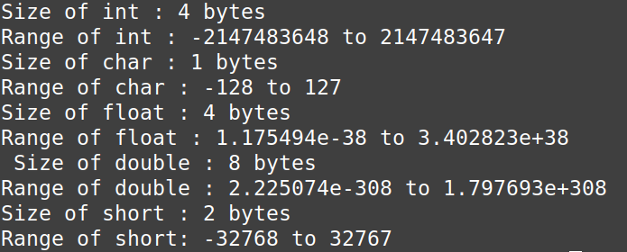
f
Program-2

Algorithm

Step 1 : Start
Step 2 : Declare fahrenhet and celsius
Step 3 : Input Fahrenhet
Step 4 : Applyformula for Convert to Fahrenhet
celsius = (fahrenhet – 32) * 5/9
Step 5 : Print celsius
Step 6 : Stop

Program-2

Aim

Write a program to convert fahrenhet to celsius.

Source Code

#include<stdio.h>
int main()
{
float fahrenhet, celsius;
printf("Enter Fahrenhet : ");
scanf("%f",&fahrenhet);
celsius = (fahrenhet - 32) * 5/9;
printf("\nCelsius = %f\n",celsius);
return 0;
}

Output

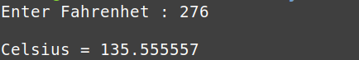
Program-3

Algorithm

Step 1 : Start
Step 2 :Declare variables num1, num2, num3, first,second.
Step 3 : Read three numbers num1, num2 and num3 from the user.
Step 4 : Compare num1 with num2 and num3 to find the largest of num1, num2, and num3 , then the largest number is store into first, compare remaning numbers using nested if find second largest , then the second largest number is store into second.
Step 5 : Print the largest number is (first).
Step 6 : Print the second largest number is (second).
Step 7 : Stop.
Program 3

Aim

3. Write a program to accept three numbers and find the largest and second largest (if stmt)

Source Code

#include<stdio.h>
int main()
{
int num1, num2, num3,first=0,second=0;
printf("Enter Three Numbers:");
scanf("%d%d%d", &num1,&num2,&num3);
if(num1>num2 && num1>num3)
{
first = num1;
if(num2>num3)
{
second = num2;
}
else
{
second = num3;
}
}else if (num2>num1 && num2>num3)
{
first = num2;
if(num1>num3)
{
second = num1;
}
else
{
second = num3;
}
}else
{
first = num3;
if(num1>num2)
{
second = num1;
} else
{
second = num2;
}
}
printf("\nThe Largest Number is %d\n", first);
printf("\nThe Second Largest Number is %d\n", second);

return 0;
}

OutPut

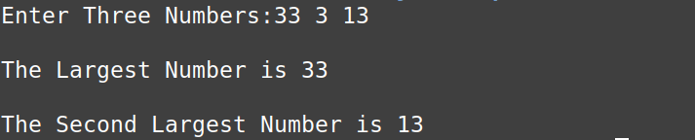
Program-4

Algorithm

Step 1 : Start
Step 2 : declare intiger variable a,b,c,d.
Step 3 : read a,b,c.
Step 4 : catculate d = (b * b - 4 * a * c)
Step 5 : check condition with nested if statement
Step 1 : if(d == 0) calculate x1 = -b / (2 * a) and intialise x1 = x2,
Print result x1 and x2
Step 2 : else if (d > 0) calculate x1 = (-b + sqrt(d)) / (2* a),
x2 = (-b - sqrt(d)) / (2 * a), Print result x1 and x2.
Step 3 : else or else if(d<0) Print No Solution.
Step 6 : Stop.
Program 4

Aim

Write a program to to find the roots of a quadratic equation (if stmt)
Source Code

#include <stdio.h>
#include <math.h>

int main() {
int a, b, c, d;
float x1, x2;
printf("Enter Coefficients a, b, and c: ");
scanf("%d%d%d", &a, &b, &c);
d = (b * b - 4 * a * c);
if (d == 0) {
x1 = -b / (2 * a);
x2 = x1;
printf("x = %.2f", x1);
printf("\n or \n");
printf("x = %.2f\n", x2);
} else if (d > 0) {
x1 = (-b + sqrt(d)) / (2* a);
x2 = (-b - sqrt(d)) / (2 * a);
printf("x = %.2f", x1);
printf("\n or \n");
printf("x = %.2f\n", x2);
} else {
printf("\nno solution");
}
return 0;
}
Output
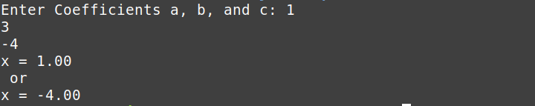
Program-5

Algorithm

Step 1 : Start
Step 2 : declare variables are lower_intervel, upper_intervel, flag, i, j.
Step 3 : read lower_intervel and upper_intervel.
Step 4 : use for loop
Step 1: intialise i = lower_intervel and set condion i<upper_intervel and update.
Step 2 : if condion i == 1 or i == 1 ,continue statement.
Step 3 : intialise flag =1.
Step 4 : using for loop , for( j=2; j<=i/2; j++)
Step 5 : condion check , if( i%j ==0) set flag=0 and break.
Step 5 : print prime numbers.
Step 6 : Stop.

Program 5

Aim
5. Write a program to print all prime numbers between any 2 given limits. (while/for
stmt
Source Code

#include<stdio.h>
int main()
{
int lower_intervel,upper_intervel, flag;
printf("Enter lower intervel: ");
scanf("%d",&lower_intervel);
printf("\nEnter Upper intervel: ");
scanf("%d",&upper_intervel);
printf("\nPrime Numbers are: ");
for(int i=lower_intervel; i<upper_intervel;i++)
{
if(i == 1 || i == 0)
{
continue;
}
flag = 1;
for(int j=2; j<=i/2; j++)
{
if( i%j ==0)
{
flag = 0;
break;
}
}
if(flag==1)
{
printf("%d, ",i);
}
} printf("\n");
return 0;
}
output

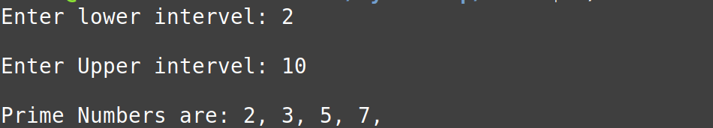
Problem-6

Algorithm

Step 1 : Start.
Step 2 : declare r (row),c (coloum), disc = 1 (flag),i , j.
Step 3 : read r and c from the user.
Step 4 : check condion if (r == c)
Step 1 : condion true.
Step 2 : declare matrix[r][c] and read matrix elements.
Step 3 : use for loop.
Step 4 : check if (matrix[i][j] != 0 && i != j), set dis=0 and break,
else if (matrix[i][j] != 1 && i == j), set dis=0 and break,
Step 5 : else part, dis =0.
Step 6 : using if check condion if (dis == 1) , Matrix is Identical.
else , Matrix is Not Identical.
Step 7 : Stop.

Program 6

Aim
Write a program to check whether a given matrix is an Identity matrix or not. (2D
array)

Source Code

#include <stdio.h>

int main() {
int r, c, dis = 1;
int i, j;
printf("Enter matrix order: ");
scanf("%d%d", &r, &c);
if (r == c) {
int matrix[r][c];
printf("Enter Matrix Elements: ");
for (i = 0; i < r; i++) {
for (j = 0; j < c; j++) {
scanf("%d", &matrix[i][j]);
}
}
for (i = 0; i < r; i++) {
for (j = 0; j < c; j++) {
if (matrix[i][j] != 0 && i != j) {
dis = 0;
break;
} else if (matrix[i][j] != 1 && i == j) {
dis = 0;
break;
}
}
}
} else {
dis = 0;
}
if (dis == 1) {
printf("\nMatrix is Identical.\n");
} else {
printf("\nMatrix is Not Identical.\n");
}
return 0;
}
Output
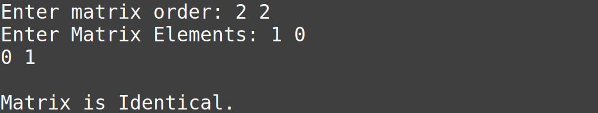
Problem-7

Algorithm

Program 7

Aim
Write a program matrix multiplication. (2D array).

Sorce Code

Output

Program-8

Algorithm

Program 8

Aim
8. Write a program to accept two numbers and perform various arithmetic operations (+,-,/,*) based on the symbol entered. (switch stmt)

Source Code

#include<stdio.h>
int main()
{
char symbol;
int num1,num2;
float result;
printf("\t Basic Arithmetic Operation\t");
printf("\nEnter :");

scanf("%d",&num1);
scanf("%c",&symbol);
switch(symbol)
{
case '+':
scanf("%d",&num2);
result= num1 + num2;
break;
case '-':
scanf("%d",&num2);
result= num1 - num2;
break;
case '*':
scanf("%d",&num2);
result= num1 * num2;
break;
case '/':
scanf("%d",&num2);
result= num1 / num2;
break;
default:
printf("Invalid operation symbol.");
}
printf("%.2f\n",result);
return 0;
}
output
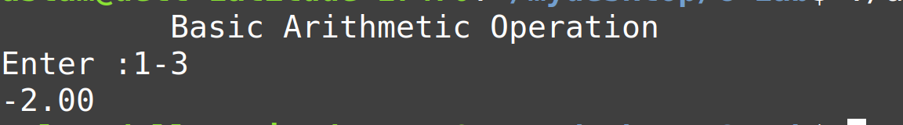
Program-9

Algorithm
Program 9

Aim

9. Write a recursive program to find the factorial of a number.(recursive function)

Source Code

#include<stdio.h>
long factorial(int n)
{
if(n==0)
return 1;
else
return (n*factorial(n-1));
}
int main()
{
int number;
int fact;
printf("Enter a number: ");
scanf("%d",&number);

fact = factorial(number);
printf("Factorial of %d is %d\n",number, fact);
return 0;

}

output
Program-10

Algorithm

Program 10

Aim

Source Code

