Program – 1

Algorithm

Step 1 : Start
Step 2 : Use extra 2 header file limits.h and float.h
Step 3 : Print size and range of data type
Step 4 : Stop
Program-1

Aim

Write program to print the size of any five data type and its range

Source Code

#include<stdio.h>
#include<limits.h>
#include<float.h>
int main()
{
printf("Size of int : %lu bytes \n", sizeof(int));
printf("Range of int : %d to %d \n", INT_MIN, INT_MAX);
printf("Size of char : %lu \n", sizeof(char));
printf("Range of char : %d to %d \n", CHAR_MIN, CHAR_MAX);
printf("Size of float : %lu bytes \n", sizeof(float));
printf("Range of float : %e to %e \n ", FLT_MIN, FLT_MAX);
printf("Size of double : %lu bytes \n", sizeof(double));
printf("Range of double : %e to %e \n", DBL_MIN, DBL_MAX);
printf("Size of short : %lu bytes \n", sizeof(short));
printf("Range of short: %d to %d \n", SHRT_MIN, SHRT_MAX);
}
Output
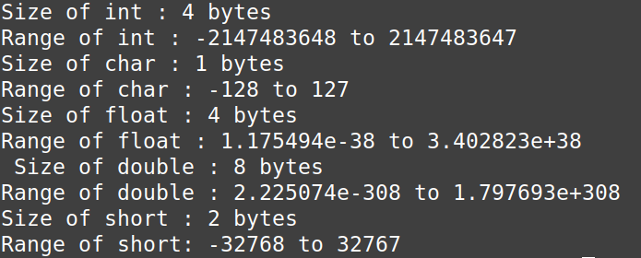
f
Program-2

Algorithm

Step 1 : Start
Step 2 : Declare fahrenhet and celsius
Step 3 : Input Fahrenhet
Step 4 : Applyformula for Convert to Fahrenhet
celsius = (fahrenhet – 32) * 5/9
Step 5 : Print celsius
Step 6 : Stop

Program-2

Aim

Write a program to convert fahrenhet to celsius.

Source Code

#include<stdio.h>
int main()
{
float fahrenhet, celsius;
printf("Enter Fahrenhet : ");
scanf("%f",&fahrenhet);
celsius = (fahrenhet - 32) * 5/9;
printf("\nCelsius = %f\n",celsius);
return 0;
}

Output

