CENG 479 — Parallel Computing | Gazi University | Spring 2026

Parallel Image Processing Engine
Final Implementation Report & Presentation

Java 17 Maven 3.6+ JMH ExecutorService ForkJoinPool
Filters Implemented
● Grayscale Point-wise — Low compute
● Gaussian Blur 5x5 Convolution — High compute (25 taps/pixel)
● Sobel 3x3 Gradient — Edge detection

Team Members
Muhammed Çakırgöz · Musa Bilal Yaz
Gazi University — Computer Engineering — Submission 2

GitHub Repository (Public)
https://github.com/Muhammedcakirgoz/parallel-image-processing
Source code, benchmarks, and all report assets are available at the link above

June 2026 — CENG 479 Parallel Computing

CENG 479 — Parallel Image Processing Engine
Implementation Report | Submission 2
1. Introduction
High-resolution image processing is computationally demanding. Sequential execution of kernel-based convolution filters creates significant bottlenecks at large image sizes (4K+). Because each output pixel depends solely on a fixed neighbourhood of the input image, the problem is embarrassingly parallel: the image can be divided across threads with zero inter-thread data dependencies during the compute phase.
This report presents a parallel engine built in Java using two concurrency strategies: ExecutorService with horizontal strip decomposition and ForkJoinPool with divide-and-conquer work-stealing. Three filters — Grayscale, Gaussian Blur 5x5, Sobel 3x3 — were benchmarked with JMH across image sizes 512x512, 1024x1024, 2048x2048.
Source code (public): https://github.com/Muhammedcakirgoz/parallel-image-processing
2. Sequential Baseline Implementation
SequentialProcessor iterates row-by-row applying the given filter. The Filter interface exposes a single apply(pixels[], width, height, x, y) method. Edge handling uses clamped coordinates, ensuring identical boundary behaviour across all implementations.

Filter | Type | Kernel | Cost per pixel
GrayscaleFilter | Point-wise | None (r=0) | Low — 3 reads, 1 write
GaussianBlurFilter | Convolution | 5x5 | High — 25 weighted taps
SobelFilter | Gradient | 3x3 Gx+Gy | Medium — 18 taps + sqrt

3. Parallel Implementation
3.1 ExecutorService — Horizontal Strip Decomposition
ExecutorParallelProcessor divides the image into N equal horizontal strips (one per thread). Each Callable task processes rows [start, end) and writes into a pre-allocated output array at its assigned offset. Strips are disjoint and the source array is read-only, so no locking is required. The thread pool is created once and reused via try-with-resources.
3.2 ForkJoinPool — Divide-and-Conquer
ForkJoinParallelProcessor uses a RecursiveAction that halves the row range until it falls below 64 rows (sequential threshold), then processes directly. The work-stealing scheduler rebalances load dynamically — advantageous for larger images where static strip imbalance would arise.
3.3 Correctness Verification
CorrectnessVerifier.firstDifference() performs a pixel-for-pixel comparison between parallel output and sequential baseline. All 6 combinations (3 filters x 2 strategies) on a 2048x2048 synthetic image produce bit-identical output:

Filter | ExecutorService (12 threads) | ForkJoinPool (12 threads)
Grayscale | PASS | PASS
GaussianBlur5x5 | PASS | PASS
Sobel3x3 | PASS | PASS

4. Performance Comparison
All benchmarks use JMH (10 warm-up + 10 measurement iterations, AverageTime mode, ms/op) on a 12-logical-core machine. Speedup = T_sequential / T_parallel.
4.1 GaussianBlur 5x5
Size | Threads | Seq (ms) | Executor (ms) | ForkJoin (ms) | Exec x | FJ x
512^2 | 1 | 11.16 | 11.502 | 12.209 | 0.97x | 0.91x
512^2 | 2 | 11.16 | 5.815 | 6.367 | 1.92x | 1.75x
512^2 | 4 | 11.16 | 3.081 | 3.132 | 3.62x | 3.56x
512^2 | 8 | 11.16 | 2.926 | 2.864 | 3.81x | 3.9x
1024^2 | 1 | 44.951 | 47.1 | 50.146 | 0.95x | 0.9x
1024^2 | 2 | 44.951 | 23.854 | 24.621 | 1.88x | 1.83x
1024^2 | 4 | 44.951 | 13.273 | 13.062 | 3.39x | 3.44x
1024^2 | 8 | 44.951 | 11.712 | 10.01 | 3.84x | 4.49x
2048^2 | 1 | 177.981 | 195.191 | 194.822 | 0.91x | 0.91x
2048^2 | 2 | 177.981 | 109.162 | 98.739 | 1.63x | 1.8x
2048^2 | 4 | 177.981 | 56.586 | 55.901 | 3.15x | 3.18x
2048^2 | 8 | 177.981 | 41.439 | 37.011 | 4.3x | 4.81x

4.2 Sobel 3x3
Size | Threads | Seq (ms) | Executor (ms) | ForkJoin (ms) | Exec x | FJ x
512^2 | 1 | 5.599 | 5.687 | 5.805 | 0.98x | 0.96x
512^2 | 2 | 5.599 | 2.852 | 2.99 | 1.96x | 1.87x
512^2 | 4 | 5.599 | 1.506 | 1.529 | 3.72x | 3.66x
512^2 | 8 | 5.599 | 1.321 | 1.354 | 4.24x | 4.14x
1024^2 | 1 | 23.156 | 22.783 | 23.59 | 1.02x | 0.98x
1024^2 | 2 | 23.156 | 11.334 | 11.912 | 2.04x | 1.94x
1024^2 | 4 | 23.156 | 5.927 | 5.906 | 3.91x | 3.92x
1024^2 | 8 | 23.156 | 5.236 | 4.652 | 4.42x | 4.98x
2048^2 | 1 | 90.82 | 88.598 | 89.27 | 1.03x | 1.02x
2048^2 | 2 | 90.82 | 46.149 | 46.798 | 1.97x | 1.94x
2048^2 | 4 | 90.82 | 24.923 | 23.628 | 3.64x | 3.84x
2048^2 | 8 | 90.82 | 20.205 | 17.809 | 4.49x | 5.1x

4.3 Grayscale
Size | Threads | Seq (ms) | Executor (ms) | ForkJoin (ms) | Exec x | FJ x
512^2 | 1 | 0.097 | 0.103 | 0.106 | 0.95x | 0.92x
512^2 | 2 | 0.097 | 0.075 | 0.084 | 1.29x | 1.16x
512^2 | 4 | 0.097 | 0.068 | 0.08 | 1.43x | 1.21x
512^2 | 8 | 0.097 | 0.067 | 0.085 | 1.44x | 1.15x
1024^2 | 1 | 0.33 | 0.363 | 0.357 | 0.91x | 0.92x
1024^2 | 2 | 0.33 | 0.246 | 0.237 | 1.34x | 1.39x
1024^2 | 4 | 0.33 | 0.227 | 0.233 | 1.45x | 1.42x
1024^2 | 8 | 0.33 | 0.225 | 0.236 | 1.47x | 1.39x
2048^2 | 1 | 1.329 | 1.305 | 1.386 | 1.02x | 0.96x
2048^2 | 2 | 1.329 | 0.869 | 0.881 | 1.53x | 1.51x
2048^2 | 4 | 1.329 | 0.856 | 0.855 | 1.55x | 1.55x
2048^2 | 8 | 1.329 | 0.855 | 0.861 | 1.55x | 1.54x

4.4 Speedup Charts

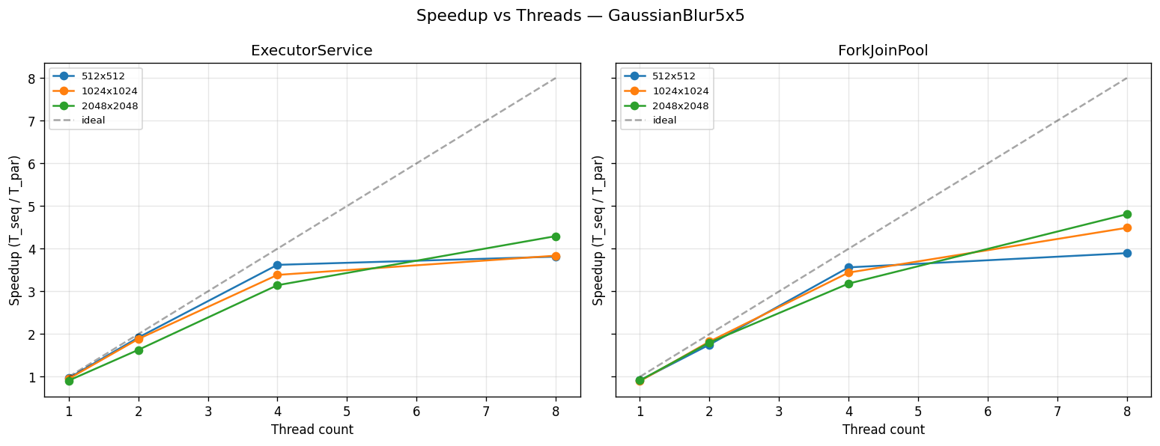
Figure 1 — GaussianBlur 5x5: ExecutorService (left) vs ForkJoinPool (right)
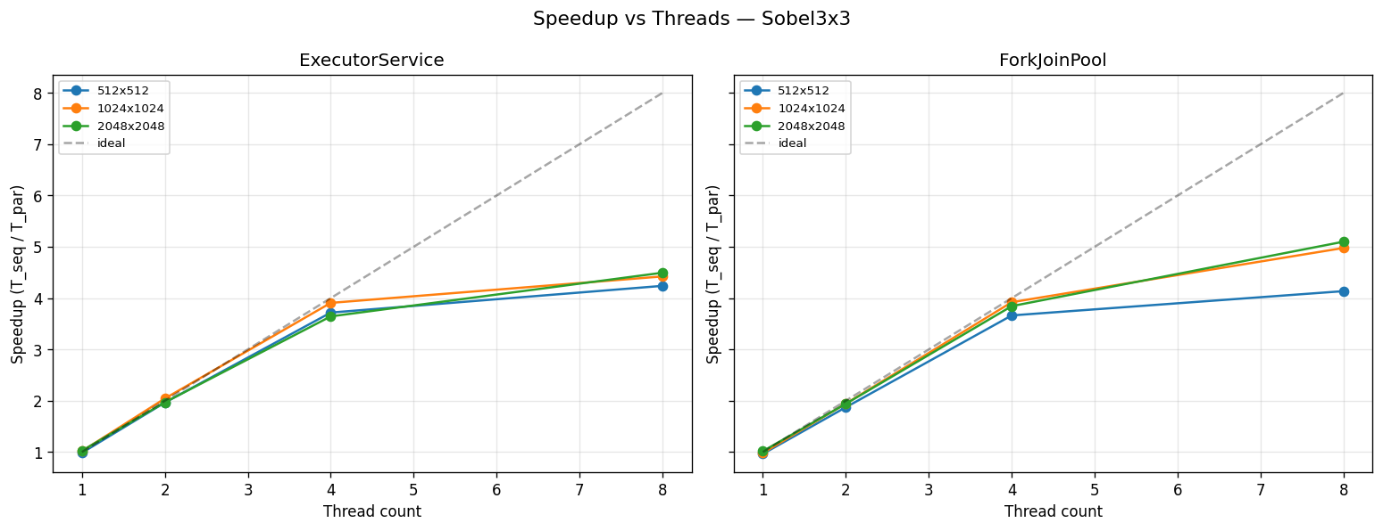
Figure 2 — Sobel 3x3: ExecutorService (left) vs ForkJoinPool (right)
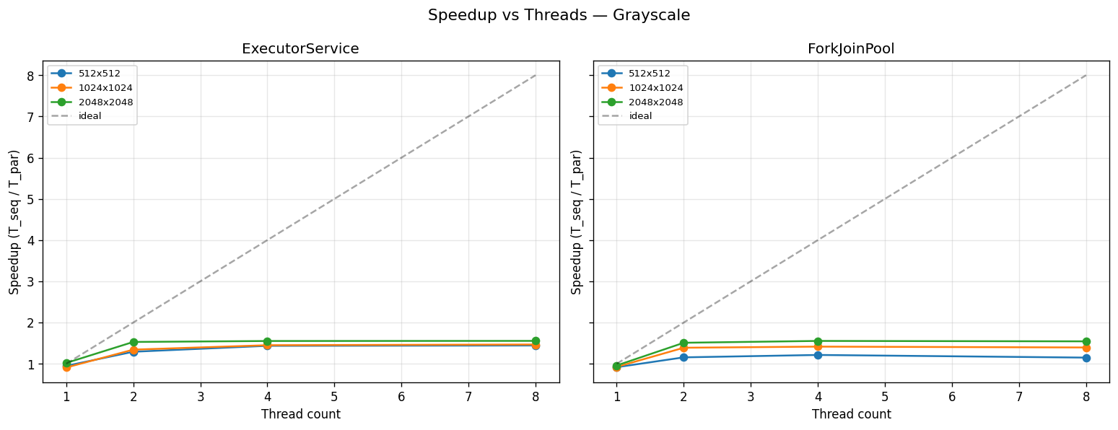
Figure 3 — Grayscale: memory-bound, speedup plateaus ~1.5x
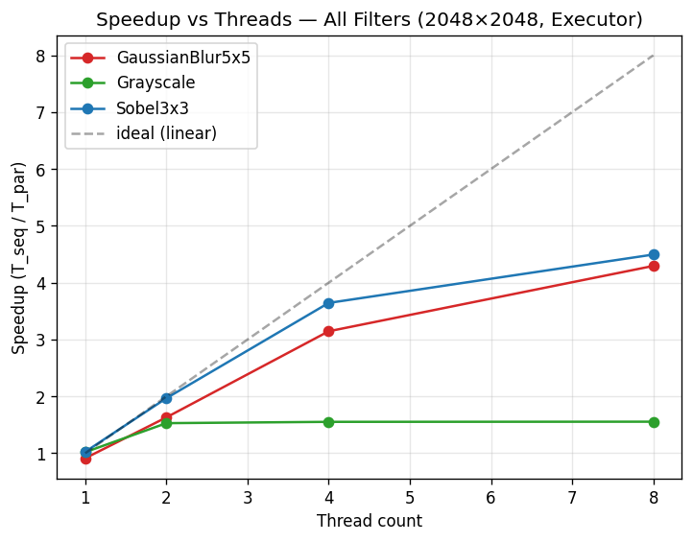
Figure 4 — All filters combined (2048x2048, Executor)
4.5 Analysis
Compute-bound filters (Gaussian Blur, Sobel) scale well, reaching 4.3x–5.1x at 8 threads. ForkJoinPool outperforms ExecutorService on larger images due to dynamic work-stealing load balancing.
Memory-bound filter (Grayscale) plateaus at ~1.5x regardless of thread count. The single-channel lookup saturates memory bandwidth before CPU utilisation can increase — consistent with the Roofline Model: low arithmetic intensity = bandwidth-limited.
Amdahl's Law: the empirical ceiling for Gaussian Blur aligns with p ~ 0.95 parallel fraction; sequential overhead (array allocation, thread setup) limits the theoretical max.
5. Academic Background
Seinstra et al. (2002) showed convolution filters exhibit near-linear speedup when partitioning minimises inter-thread communication — consistent with our strip-decomposition results for compute-intensive kernels.
Amdahl (1967): S = 1/(1-p). For Gaussian Blur, p ~ 0.95 gives theoretical max ~20x; our 4-5x at 8 threads is expected given practical overhead.
Williams et al. (2009) — Roofline Model — explains divergent scalability via arithmetic intensity: memory-bound kernels saturate bandwidth before compute capacity. Lea (2000) provides the theoretical basis for ForkJoinPool's work-stealing scheduler.
6. Challenges and Solutions
• JVM JIT Warm-up and GC Noise: System.nanoTime() measurements were skewed by JIT and GC. Solution: Adopted JMH with warm-up iterations and fork-per-config.
• Bit-Identical Correctness: Strip boundaries required careful handling. Solution: CorrectnessVerifier with pixel-for-pixel scan; clamped-coordinate edge handling ensures identical border treatment.
• Varying Scalability Between Filters: Grayscale achieved only ~1.5x with 8 threads. Solution: Profiling confirmed memory bandwidth saturation (Roofline Model) as root cause — not thread management inefficiency.
• ForkJoin Recursive Overhead on Small Images: For 512x512, ForkJoin recursion overhead slightly exceeded Executor. Solution: Tuned SEQUENTIAL_THRESHOLD to 64 rows.
7. Conclusion and Future Improvements
This project successfully demonstrated parallelisation of image convolution algorithms using Java concurrency. JMH benchmarks confirmed significant speedups for compute-bound operations: Gaussian Blur reached ~4.30x (Executor) and ~4.81x (ForkJoin) at 8 threads on 2048x2048; Sobel reached ~4.49x and ~5.10x. Grayscale was confirmed memory-bound at ~1.55x. ForkJoinPool's work-stealing advantage grew with image size.
- GPU/CUDA — exploit thousands of CUDA cores for pixel-independent kernels
- SIMD vectorisation (AVX2/AVX-512) — intra-core throughput gains
- 4K and 8K benchmarks — evaluate boundary overhead at ultra-high resolution
- Adaptive thread pool — dynamic tuning based on image size and hardware profile
- Cache-blocking and prefetching — optimise memory-bound filters like Grayscale
8. References
[1] Amdahl, G. M. (1967). Validity of the single processor approach to achieving large scale computing capabilities. Proc. Spring Joint Computer Conf., 483-485. https://doi.org/10.1145/1465482.1465560
[2] Seinstra, F. J., Koelma, D., & Bagdanov, A. D. (2002). Finite state machine-based optimization of data parallel regular domain problems applied to low-level image processing. IEEE Trans. Parallel Distrib. Syst., 15(10), 865-877. https://doi.org/10.1109/TPDS.2004.45
[3] Williams, S., Waterman, A., & Patterson, D. (2009). Roofline: An insightful visual performance model for multicore architectures. Commun. ACM, 52(4), 65-76. https://doi.org/10.1145/1498765.1498785
[4] Lea, D. (2000). A Java fork/join framework. Proc. ACM Java Grande Conf., 36-43. https://doi.org/10.1145/337449.337465

PRESENTATION SLIDES (10 Slides)

1 Parallel Image Processing Engine

CENG 479 — Parallel Computing | Gazi University | Spring 2026
Muhammed Cakiagoz · Musa Bilal Yaz

https://github.com/Muhammedcakirgoz/parallel-image-processing
Java Threads | ExecutorService | ForkJoinPool | JMH Benchmark
2 Problem & Motivation
• High-resolution image filtering (4K+) is slow on a single thread
• Convolution cost: O(W x H x K^2) per filter — bottleneck at scale
• Each output pixel is INDEPENDENT — embarrassingly parallel
• Goal: multi-threaded speedup with zero correctness compromise

Amdahl's Law: S = 1/(1-p) — p ~ 0.95 for Gaussian Blur
Theoretical max speedup ~20x at p=0.95
3 Architecture Overview
Filters:
• Grayscale (point-wise), Gaussian Blur 5x5, Sobel 3x3
Implementations:
• SequentialProcessor — single-thread baseline
• ExecutorParallelProcessor — fixed pool + horizontal strips
• ForkJoinParallelProcessor — RecursiveAction + work-stealing
Tools:
• CorrectnessVerifier + JMH Benchmark
All source code publicly available on GitHub
4 ExecutorService Design
• Image split into N equal horizontal strips (N = thread count)
• Each Callable processes rows [start, end) with no locking
• Source array is READ-ONLY — zero synchronisation overhead
• Thread pool created once, reused via try-with-resources

Strip[i] covers rows: i*(H/N) to (i+1)*(H/N)
Static decomposition — optimal for uniform workloads
5 ForkJoinPool Design
• RecursiveAction splits row range in half recursively
• Base case: range <= 64 rows — process sequentially
• Work-stealing: idle threads steal tasks from busy queues
• Better dynamic load balance than static strips for large images

• ForkJoin outperforms Executor on 2048x2048 (Gaussian: 4.81x vs 4.30x)
Dynamic decomposition — adapts to runtime load imbalance
6 Correctness Verification
CorrectnessVerifier.firstDifference() — pixel-by-pixel scan

Tested on 2048x2048 synthetic image — ALL 6 combinations PASS

• Grayscale: Executor PASS | ForkJoin PASS
• GaussianBlur5x5: Executor PASS | ForkJoin PASS
• Sobel3x3: Executor PASS | ForkJoin PASS
Bit-identical output to sequential baseline in all cases
7 Performance Results (8 threads, 2048x2048)
Compute-bound (scales well):
• Gaussian Blur: Executor 4.30x | ForkJoin 4.81x
• Sobel 3x3: Executor 4.49x | ForkJoin 5.10x

Memory-bound (bandwidth limited):
• Grayscale: Executor 1.55x | ForkJoin 1.54x
JMH | 10 warm-up + 10 measurement iterations | AverageTime ms/op
8 Speedup Charts

GaussianBlur5x5 & Sobel — near-linear scaling up to 4-5x at 8 threads
Grayscale — memory bandwidth saturation caps speedup at ~1.5x
ForkJoin advantage grows with image size (work-stealing benefit)

[See Figures 1-4 in the report section for full charts]
Roofline Model: compute-bound = scales | memory-bound = does not
9 Challenges & Key Findings
• JIT warm-up noise — solved with JMH (fork-per-config, 10 warm-up iters)
• Correctness — clamped edges + pixel-for-pixel CorrectnessVerifier
• Grayscale bottleneck — memory bandwidth saturated (Roofline Model)
• ForkJoin overhead on small images — tuned threshold to 64 rows

Key insight: speedup is FILTER-DEPENDENT — arithmetic intensity determines scalability
Benchmark: 12 logical cores, JDK 17, Maven 3.6
10 Conclusion & Future Work
• Parallelised 3 convolution filters with 2 Java concurrency strategies
• Up to 5.10x speedup (Sobel, ForkJoin, 8 threads, 2048x2048)
• Memory-bound filters need different strategy (not thread-level parallelism)
Future Work:
• GPU/CUDA — thousands of concurrent cores for pixel-independent kernels
• SIMD vectorisation (AVX2/AVX-512) for intra-core throughput
• Adaptive thread pool — dynamic tuning per image size and hardware
https://github.com/Muhammedcakirgoz/parallel-image-processing

