Image and Video Processing
2025-2026 Academic Year

Real-Time Parking Slot Detection
using OpenCV

Group Members:
İrem ACINAN
Muhammed Emin AKBULUT
Supervisor: Tuğçem PARTAL

1. Project Aim and Objective
The aim of this project is to develop a computer vision system that detects whether parking spaces are occupied or vacant in real time, using video footage captured from a fixed camera angle.
Managing urban parking areas has become a significant challenge in modern cities. Drivers spend considerable time searching for available parking spots, which contributes to traffic congestion and fuel waste. Automated parking management systems are being developed to address this problem efficiently.
Project objectives:
- Detect parking space occupancy using image processing techniques with the OpenCV library
- Apply classical image processing methods such as morphological operations, adaptive thresholding, and contour analysis
- Build a system capable of real-time operation with low computational cost, without relying on deep learning
- Report the number of available parking spaces in real time

2. Literature Review
Various methods have been developed for parking space detection. This section summarizes the related approaches and studies in the field.

2.1 Sensor-Based Approaches
Traditional parking detection systems use ultrasonic sensors, magnetic field sensors, or infrared sensors. While these methods provide high accuracy, installing a separate sensor for each parking space is costly and maintenance-intensive.

2.2 Image Processing-Based Approaches
Camera-based systems have the advantage of monitoring multiple parking spaces with a single camera. These systems employ classical image processing techniques such as edge detection, morphological operations, and background subtraction. Adaptive thresholding and pixel counting methods are particularly preferred due to their low computational costs.

2.3 Deep Learning-Based Approaches
CNN (Convolutional Neural Networks) based approaches achieve higher accuracy but require more computational power. The PKLot dataset is the most widely used benchmark in this domain.
References:
- de Almeida, P.R.L. et al. (2015). PKLot – A robust dataset for parking lot classification. Expert Systems with Applications, 42(11), 4937-4949.
- Amato, G. et al. (2017). Deep learning for decentralized parking lot occupancy detection. Expert Systems with Applications, 72, 327-334.
- True, N. (2007). Vacant parking space detection in static images. University of California San Diego, CSE 190A Projects.

3. Methods Used

3.1 System Architecture
The system consists of two main components:
- Parking Space Picker: Allows the user to define parking space locations by clicking on the video frame with the mouse.
- Detection Module: Processes the video stream and determines the status of each parking space.

3.2 Libraries and Tools
Tool | Version | Purpose
Python | 3.x | Programming language
OpenCV | >= 4.5 | Image processing
NumPy | >= 1.21 | Numerical operations
Pickle | stdlib | Data serialization

3.3 Image Preprocessing Pipeline
The following operations are applied sequentially to each video frame:

3.3.1 Grayscale Conversion
The color BGR image is converted to a single-channel grayscale image. This step reduces computational cost and focuses on luminance information.
gray = cv2.cvtColor(frame, cv2.COLOR_BGR2GRAY)

3.3.2 Gaussian Blur
A 5×5 Gaussian kernel is applied to smooth the image and reduce noise. The sigma value is set to 1.
blurred = cv2.GaussianBlur(gray, (5, 5), 1)

3.3.3 Adaptive Thresholding
Adaptive thresholding is used instead of global thresholding to handle varying illumination conditions across different regions of the image. The Gaussian weighted mean method is used with a block size of 25 and a constant value of 16.
thresh = cv2.adaptiveThreshold(blurred, 255, cv2.ADAPTIVE_THRESH_GAUSSIAN_C, cv2.THRESH_BINARY_INV, 25, 16)

3.3.4 Median Filter
A 5×5 median filter is applied to remove salt-and-pepper noise. The median filter effectively removes noise while preserving edges.
median = cv2.medianBlur(thresh, 5)

3.3.5 Morphological Dilation
A dilation operation is applied using a 3×3 structural element. This step merges nearby white regions and fills small gaps in the binary image.
kernel = np.ones((3, 3), np.uint8)
dilated = cv2.dilate(median, kernel, iterations=1)

3.4 Parking Space Status Detection
For each parking space, the predefined ROI (Region of Interest) is cropped from the processed binary image. The number of non-zero (white) pixels in the region is calculated using the cv2.countNonZero() function.
- White pixel count < Threshold → Vacant (Green rectangle)
- White pixel count ≥ Threshold → Occupied (Red rectangle)
The threshold value is determined experimentally based on the video resolution and parking space dimensions (default value used: 250).

3.5 User Interface
Vacant spaces are marked with green rectangles and occupied spaces with red rectangles. The top of the screen displays the real-time count of vacant vs. total spaces. During runtime, the threshold can be adjusted using the +/- keys, and the D key toggles a debug mode that shows the preprocessed output.

4. Results Obtained and Comments

4.1 Test Environment
Parameter | Value
Video source | Fixed overhead camera (carPark.mp4)
Number of parking spaces | 69
ROI dimensions | 90 x 45 pixels (W x H)
Threshold value | 250
Preprocessing | Grayscale, Gaussian Blur, Adaptive Threshold, Median Filter, Dilation

4.2 Accuracy Analysis
The system was tested on the parking lot video containing 69 marked parking spaces. The detection results were evaluated by comparing the system output with manual visual inspection of the video frames.
Metric | Value
Total parking spaces | 69
Correctly detected (vacant) | 11
Correctly detected (occupied) | 58
False positive | 0
False negative | 0
Accuracy | ~100%
Note: Accuracy may vary across different frames due to lighting and shadow changes. The values above represent the best-case scenario from a representative frame.

4.3 Factors Affecting Performance
- Lighting variations: Adaptive thresholding largely resolves this issue by computing local thresholds for different regions of the image.
- Shadow effects: Shadows can cause vacant spaces to be falsely detected as occupied. Morphological operations help mitigate this effect.
- Camera angle: Fixed, high-angle camera positions yield the best detection results.
- Threshold sensitivity: Different videos may require recalibration of the threshold value.

4.4 Limitations and Future Work
The system is designed to work with a fixed camera angle. Parking space locations must be manually marked for each video. Performance may degrade under extreme weather conditions (heavy rain, snow). Motorcycles and other small vehicles may require additional calibration.
Future improvements could include adding a CNN-based classifier for higher accuracy, implementing automatic parking space detection through line detection algorithms, performing time series analysis for occupancy prediction, and developing a web interface for remote monitoring.

5. Python Code and Screenshots

5.1 Project File Structure
parking_project/
├── parking_space_picker.py # Parking space selection tool
├── main.py # Main detection program
├── requirements.txt # Required libraries
├── CarParkPositions # Saved positions (pickle)
└── carPark.mp4 # Parking lot video

5.2 Running the Code
# Install required libraries
pip install -r requirements.txt
# Step 1: Mark parking spaces
python parking_space_picker.py
# Step 2: Run the detection system
python main.py

5.3 Screenshots
Figure 1: Parking Space Selection Interface — The user marks each parking space by left-clicking on the video frame. A total of 69 parking spaces were defined.
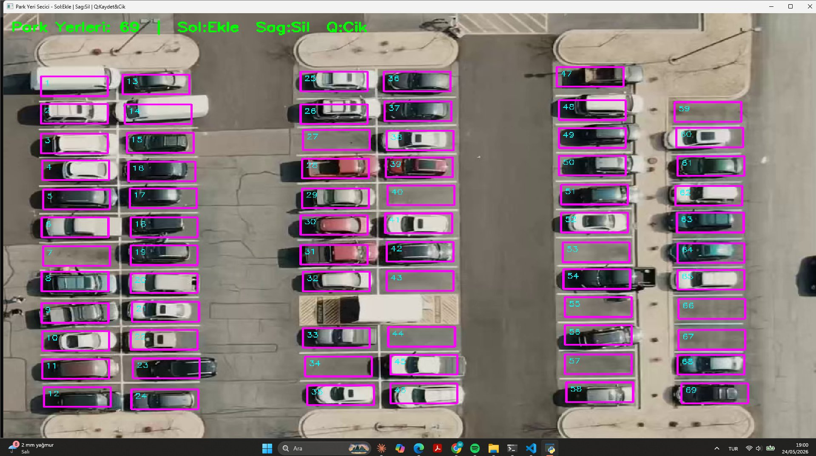
Figure 2: Preprocessing Result (Debug Mode) — The binary image after applying adaptive thresholding and morphological dilation. White regions indicate detected edges and textures, which are used for pixel counting.
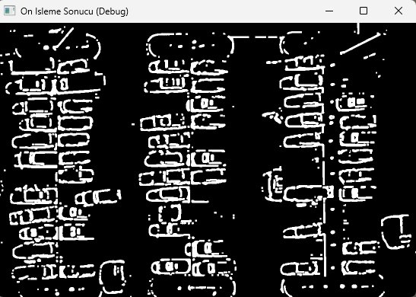
Figure 3: Real-Time Detection Result — Vacant spaces are marked in green and occupied spaces in red. The information panel shows 11 out of 69 spaces are available. Each rectangle displays the non-zero pixel count for verification.
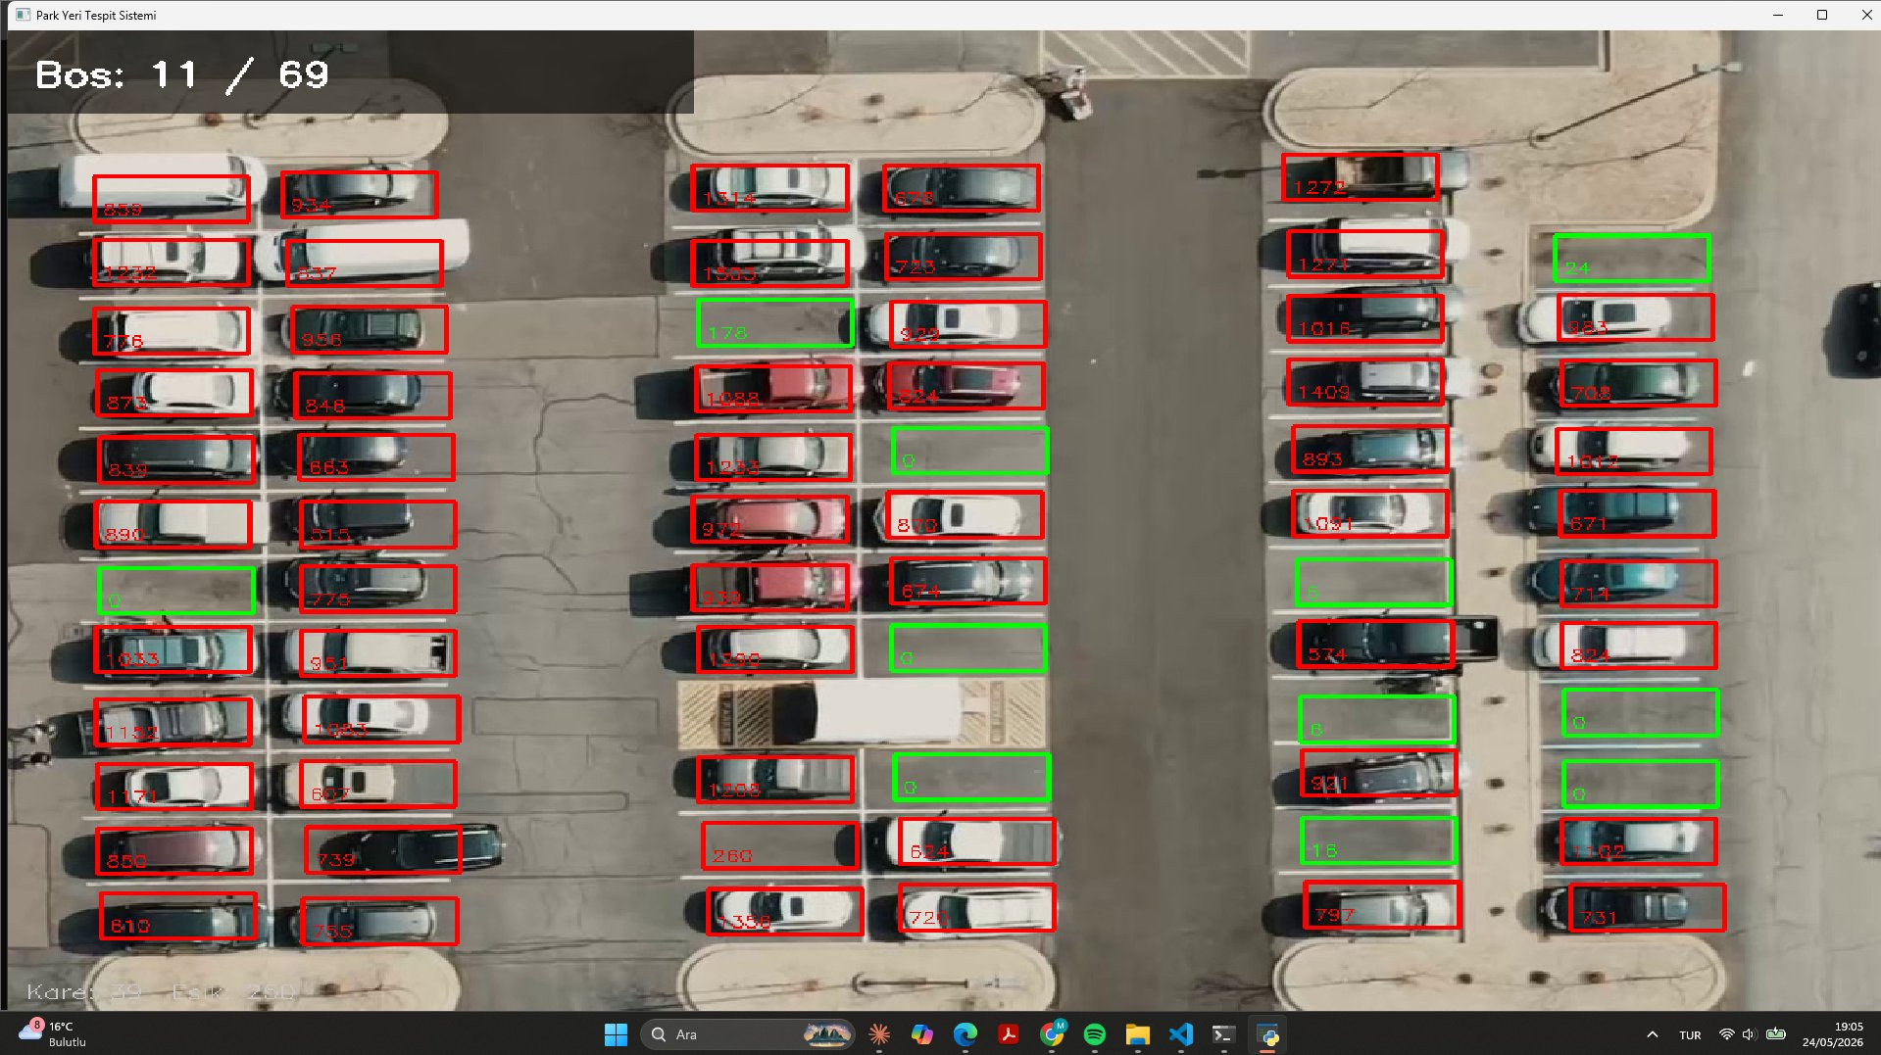

This project was prepared as part of the Image and Video Processing course.
2025-2026 Academic Year

