RDS (Relational Database Service)  
  
1) Create mariadb on ec2.  
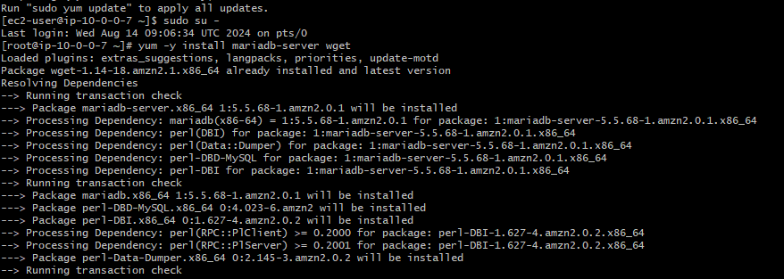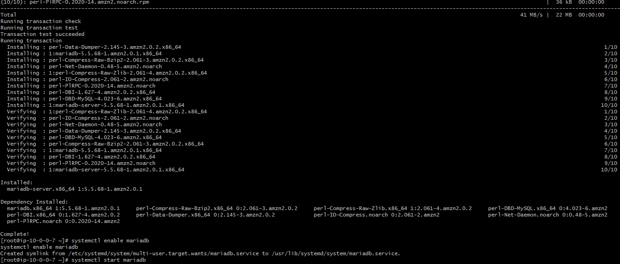2) Insert some dummy data.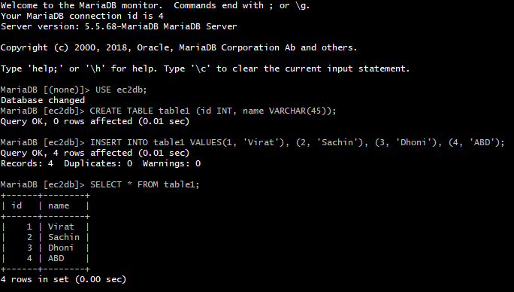

3) Take the backup of dummy data on ec2