# Terraform-02.

1) Watch the terraform-02 video.

2) Execute all the templates shown in video.

* If you have multiple providers

1. Local Provider 2) Random Provider

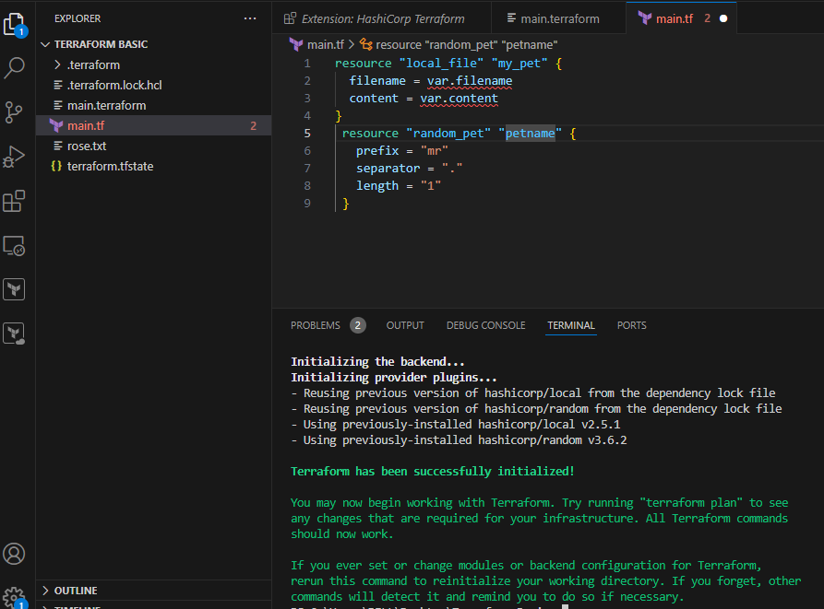

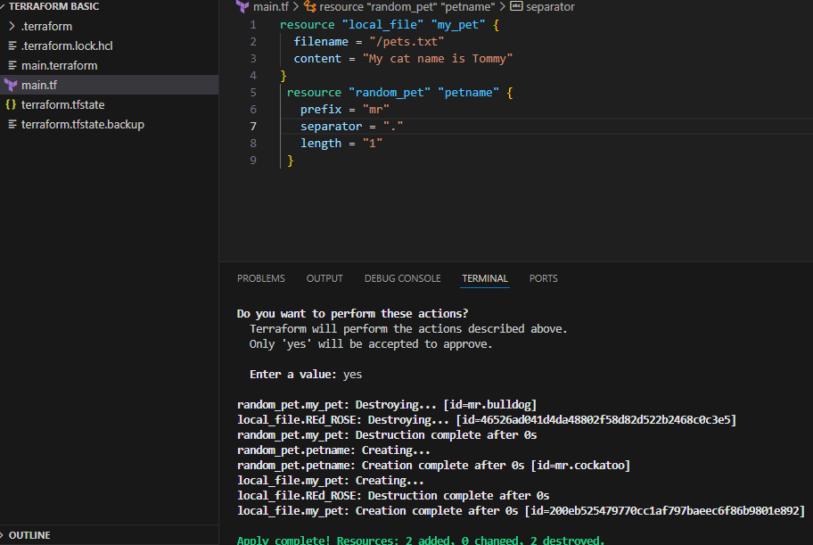

* Template: Using Lifecycle command Create_before_destroy = true (condition)

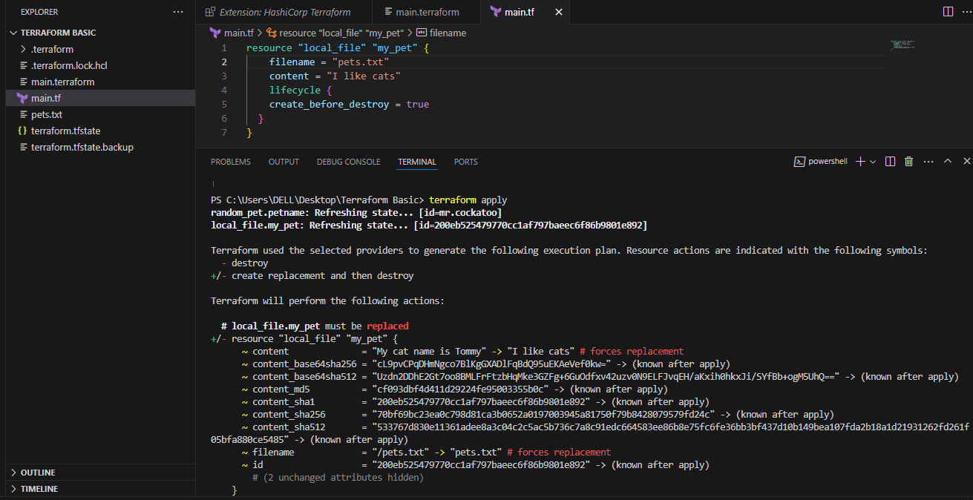

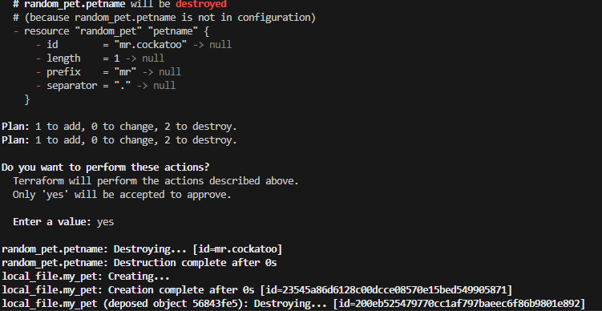

* When we made some changes in existing file terraform will detroy that file and create new file with updated changes so, to prevent this we can use prevent_destroy=true command

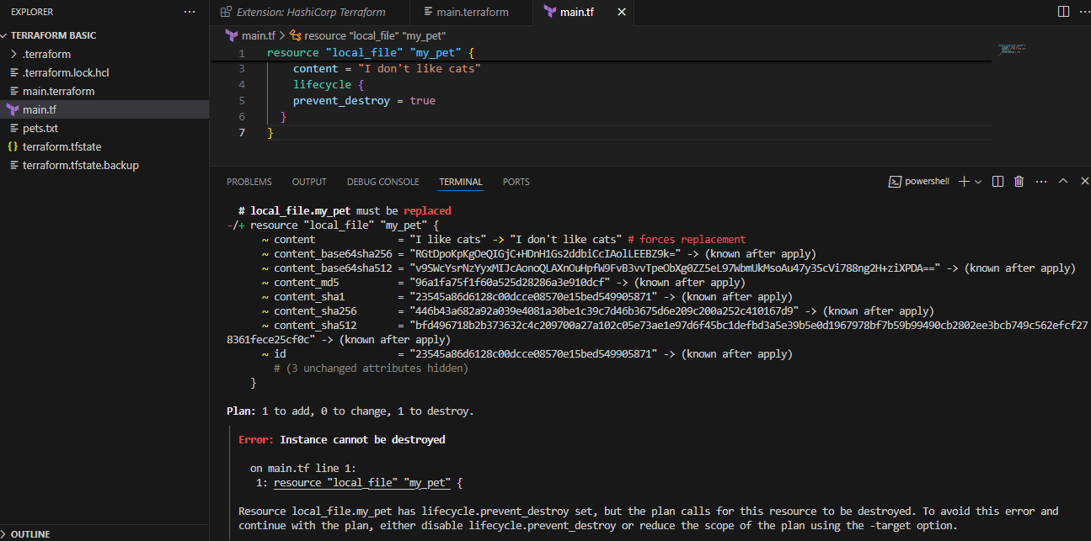

* To prevent any types of changes that we did in the existing file we can use Life_cycle.(ignore changes)

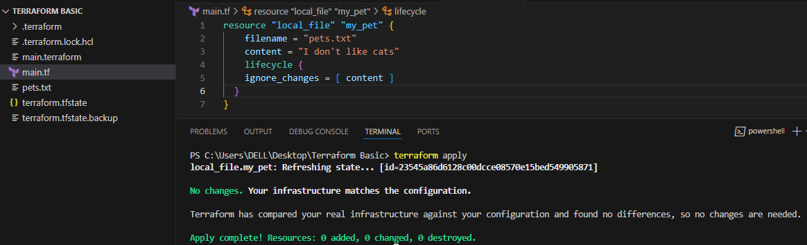

* Create a file variable.tf and use pets.txt as source file and we can do some changes in the variable of pets.txt file.

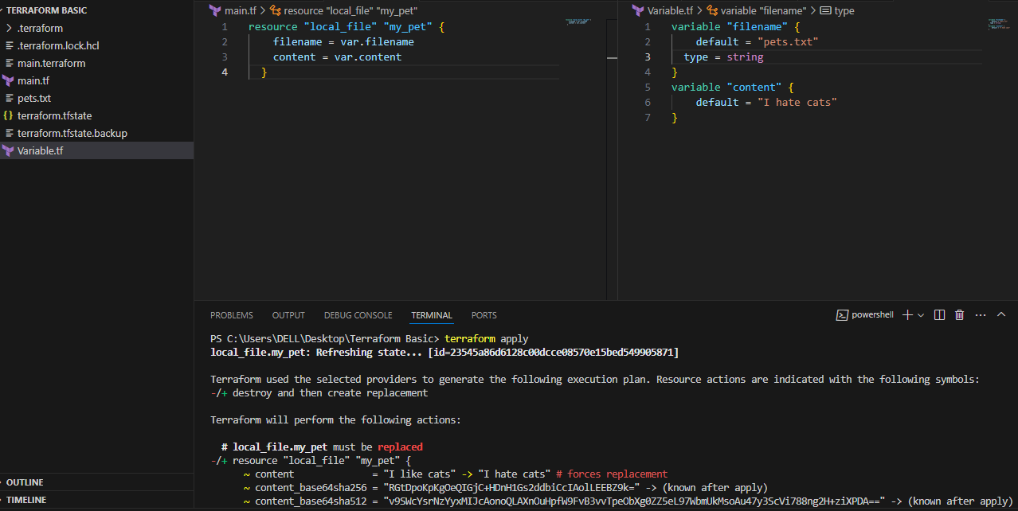

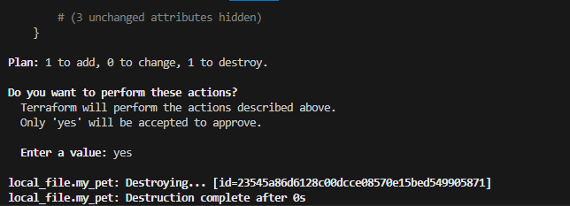

Can 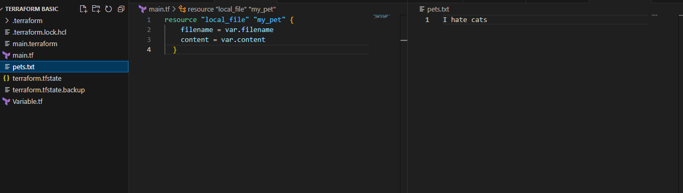

* String Templates

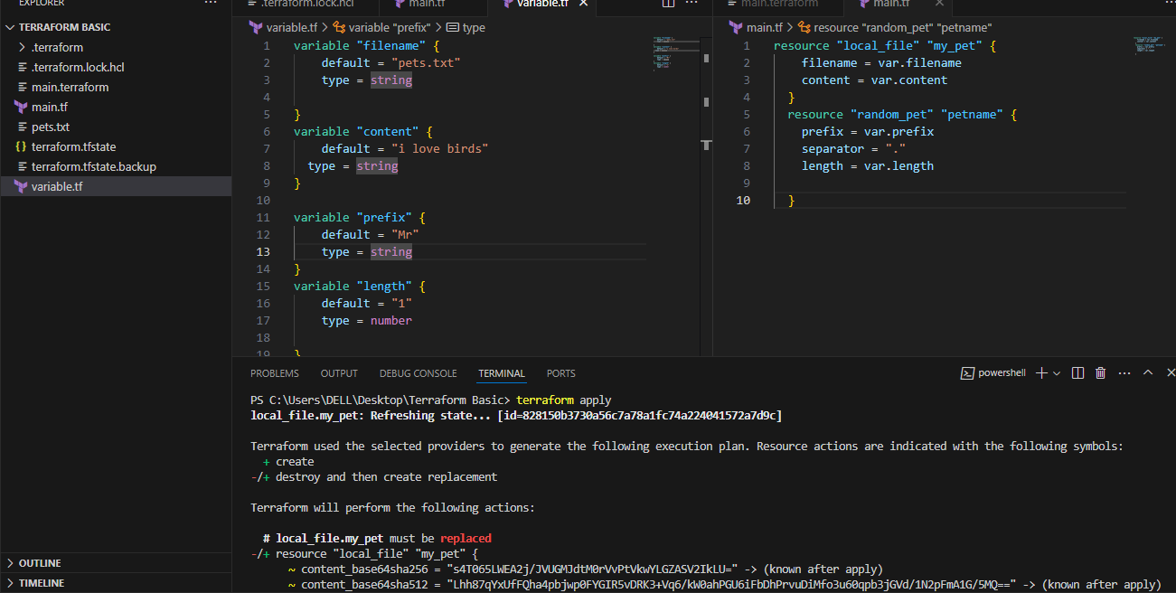

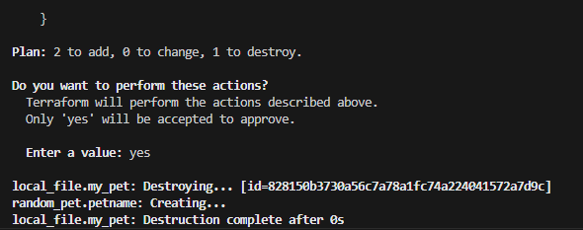

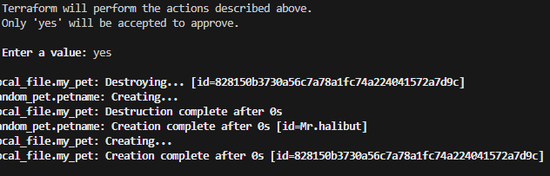

* If there is no variable data in variable file then by using a single command we can filename.

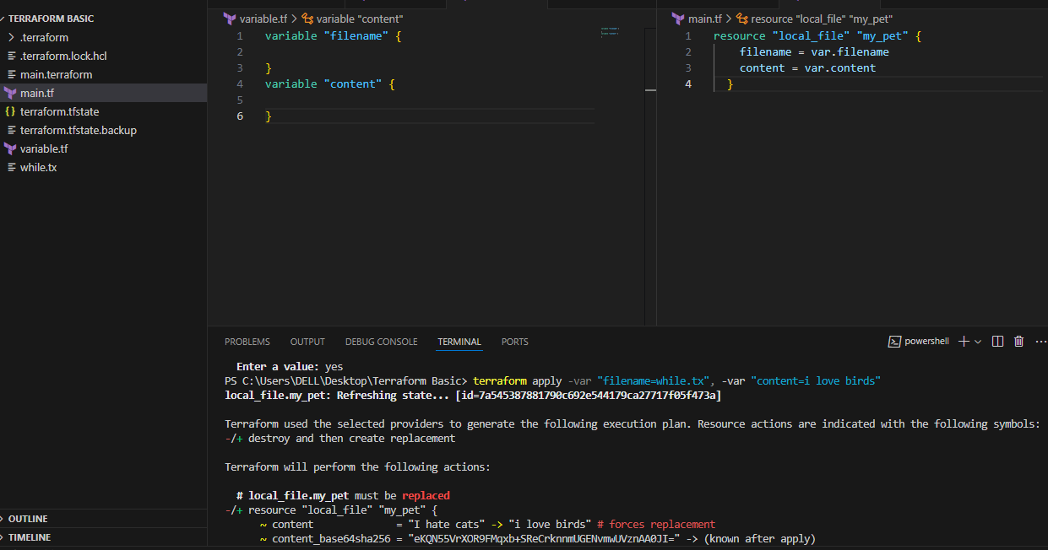

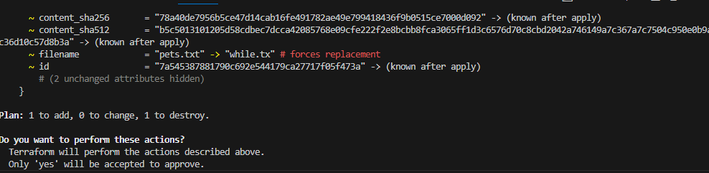

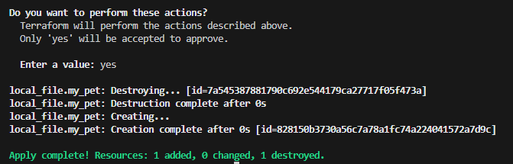

3) Integrate terraform in Jenkins using Terraform plugin.

