Cairo University Computer Department

Faculty of Engineering

Second year

**TASK 1**

**Submitted to**

Dr. Khaled M. Soradi

**Submitted by**

Muhammad Alaa Abd-Elkhalek

**Task 1**

You have 21 leds and four switches. It is required to get four bits binary number input from the user using the four switches. The input digit should be displayed on an one-digit display [ like seven segments display] using the 21 leds

For example:

If the user input is 0011 = 3

The leds should display one of the following (or any other suitable arrangement)

|  |  |  |
| --- | --- | --- |
|  |  |  |
|  |  |  |
|  |  |  |
|  |  |  |
|  |  |  |
|  |  |  |
|  |  |  |

|  |  |  |  |  |
| --- | --- | --- | --- | --- |
|  |  |  |  |  |
|  |  | | |  |
|  |  |
|  |  |
|  |  |  |  |  |
|  |  | | |  |
|  |  |
|  |  |
|  |  |  |  |  |

If the user input is 1010 = A

The leds should display one of the following (or any other suitable arrangement)

|  |  |  |
| --- | --- | --- |
|  |  |  |
|  |  |  |
|  |  |  |
|  |  |  |
|  |  |  |
|  |  |  |
|  |  |  |

|  |  |  |  |  |
| --- | --- | --- | --- | --- |
|  |  |  |  |  |
|  |  | | |  |
|  |  |
|  |  |
|  |  |  |  |  |
|  |  | | |  |
|  |  |
|  |  |
|  |  |  |  |  |

It is required to deliver one zip file named yourcode-Yourname.zip

for example:

121212-khaled_soradi.zip

containing two files

1. task1.simu
2. task1.ino

**Due date 30/3/2020**

# **Solution**

## Hardware:

* Arduino Uno
* 21 LED
* 4 switches
* Resistor:

1. 12 resistors 100 ohm.
2. 8 resistors 50 ohm.
3. 4 resistors 25 ohm

## 

* Arduino Uno
* 21 LED
* 4 switches
* Resistor:

1. 25 resistors 100 ohm.

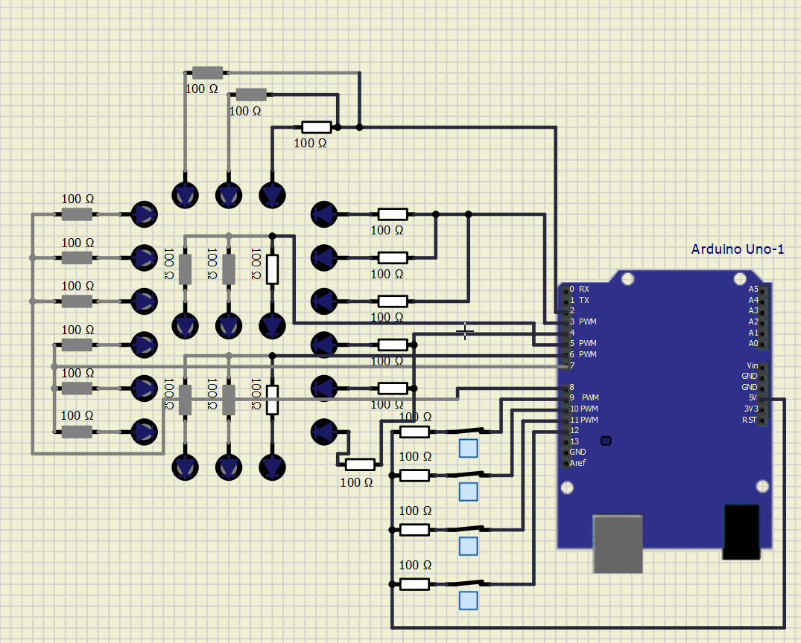

## Arduino Code:

### First Arrangement:

# byte A, B, C, D;

# void setup() {

# for ( byte i = 3; i <= 13; i++)

# pinMode(i, i < 7 ? INPUT : OUTPUT);

# pinMode(A0, OUTPUT), pinMode(A1, OUTPUT), pinMode(A2, OUTPUT), pinMode(A3, OUTPUT), pinMode(A4, OUTPUT), pinMode(A5, OUTPUT);

# }

# void loop() {

# A = digitalRead(3), B = digitalRead(4), C = digitalRead(5), D = digitalRead(6);

# digitalWrite(7, (A || B || C || !D)), digitalWrite(8, (A || !(B ^ D) || C));

# digitalWrite(10, (A || (!B && !D) || (!B && C) || (C && !D) || (B && !C && D)));

# digitalWrite(11, ((A && !C) || (!A && !B && !D) || (D && (B ^ C)) || (B && C && !D)));

# digitalWrite(12, (!A || !B || !D)), digitalWrite(A0, !(D ^ A) || (B ^ C) || (C && !D));

# digitalWrite(13, (A || (!C && !D) || (B && !C) || (B && !D))), digitalWrite(9, (!A || !B || !D || C));

# digitalWrite(A1, (!B && !D) || (C && !D) || (A && C) || (A && B)), digitalWrite(A2, (!B && C) || (C && !D) || (A && !B) || (A && C) || (!A && B && !C));

# digitalWrite(A3, !B || (!A && !(C ^ D)) || (A && !C && D)), digitalWrite(A4, !A || D || C), digitalWrite(A5, (!A && !C) || (!A && D) || (!C && D) || (A ^ B));

# }

### Second Arrangement:

### byte A, B, C, D;

### void setup() {

### for ( byte i = 2; i <= 12; i++)

### pinMode(i, i < 9 ? OUTPUT : INPUT);

### }

### void loop() {

### A = digitalRead(9), B = digitalRead(10), C = digitalRead(11), D = digitalRead(12);

### digitalWrite(2, (!B && !D) || (B && C) || (!A && C) || (A && !D) || (!A && B && D) || (A && !B && !C));

### digitalWrite(3, ((!A && !B) || (!B && !C) ) || (!B && !D) || (!A && !C && !D) || (!A && C && D) || (A &&(C ^ D)));

### digitalWrite(4, ((!A && !C) || (A && !B) || (!A && D) || (!C && D) || (!A && B)));

### digitalWrite(5, ((!B && C) || (!A && B && !C) || (C && !D) || (A && D) || (A && !B)));

### digitalWrite(6, (B && !C && D) || (!B && !D) || (!B && C) || (C && !D) || (A && !C));

### digitalWrite(7, (!B && !D) || (A && B) || (C && !D) || (A && C));

### digitalWrite(8, ((!C && !D) || (B && !D) || (A && C && D) || (!A && B && !C) || (A && !B && !C)));

### }

### 

# Symbols:

### First Arrangement:

|  |  |  |
| --- | --- | --- |
|  |  |  |
|  |  |  |
|  |  |  |
|  |  |  |
|  |  |  |
|  |  |  |
|  |  |  |

|  |  |  |
| --- | --- | --- |
|  |  |  |
|  |  |  |
|  |  |  |
|  |  |  |
|  |  |  |
|  |  |  |
|  |  |  |

# 

0 1

|  |  |  |
| --- | --- | --- |
|  |  |  |
|  |  |  |
|  |  |  |
|  |  |  |
|  |  |  |
|  |  |  |
|  |  |  |

|  |  |  |
| --- | --- | --- |
|  |  |  |
|  |  |  |
|  |  |  |
|  |  |  |
|  |  |  |
|  |  |  |
|  |  |  |

# 

2 3

|  |  |  |
| --- | --- | --- |
|  |  |  |
|  |  |  |
|  |  |  |
|  |  |  |
|  |  |  |
|  |  |  |
|  |  |  |

|  |  |  |
| --- | --- | --- |
|  |  |  |
|  |  |  |
|  |  |  |
|  |  |  |
|  |  |  |
|  |  |  |
|  |  |  |

# 

4 5

|  |  |  |
| --- | --- | --- |
|  |  |  |
|  |  |  |
|  |  |  |
|  |  |  |
|  |  |  |
|  |  |  |
|  |  |  |

|  |  |  |
| --- | --- | --- |
|  |  |  |
|  |  |  |
|  |  |  |
|  |  |  |
|  |  |  |
|  |  |  |
|  |  |  |

# 

6 7

|  |  |  |
| --- | --- | --- |
|  |  |  |
|  |  |  |
|  |  |  |
|  |  |  |
|  |  |  |
|  |  |  |
|  |  |  |

|  |  |  |
| --- | --- | --- |
|  |  |  |
|  |  |  |
|  |  |  |
|  |  |  |
|  |  |  |
|  |  |  |
|  |  |  |

# 

8 9

|  |  |  |
| --- | --- | --- |
|  |  |  |
|  |  |  |
|  |  |  |
|  |  |  |
|  |  |  |
|  |  |  |
|  |  |  |

|  |  |  |
| --- | --- | --- |
|  |  |  |
|  |  |  |
|  |  |  |
|  |  |  |
|  |  |  |
|  |  |  |
|  |  |  |

# 

A B

|  |  |  |
| --- | --- | --- |
|  |  |  |
|  |  |  |
|  |  |  |
|  |  |  |
|  |  |  |
|  |  |  |
|  |  |  |

|  |  |  |
| --- | --- | --- |
|  |  |  |
|  |  |  |
|  |  |  |
|  |  |  |
|  |  |  |
|  |  |  |
|  |  |  |

# 

C D

|  |  |  |
| --- | --- | --- |
|  |  |  |
|  |  |  |
|  |  |  |
|  |  |  |
|  |  |  |
|  |  |  |
|  |  |  |

|  |  |  |
| --- | --- | --- |
|  |  |  |
|  |  |  |
|  |  |  |
|  |  |  |
|  |  |  |
|  |  |  |
|  |  |  |

# 

### Second Arrangement:

|  |  |  |  |  |
| --- | --- | --- | --- | --- |
|  |  |  |  |  |
|  |  | | |  |
|  |  |
|  |  |
|  |  |  |  |  |
|  |  | | |  |
|  |  |
|  |  |
|  |  |  |  |  |

|  |  |  |  |  |
| --- | --- | --- | --- | --- |
|  |  |  |  |  |
|  |  | | |  |
|  |  |
|  |  |
|  |  |  |  |  |
|  |  | | |  |
|  |  |
|  |  |
|  |  |  |  |  |

0 1

|  |  |  |  |  |
| --- | --- | --- | --- | --- |
|  |  |  |  |  |
|  |  | | |  |
|  |  |
|  |  |
|  |  |  |  |  |
|  |  | | |  |
|  |  |
|  |  |
|  |  |  |  |  |

|  |  |  |  |  |
| --- | --- | --- | --- | --- |
|  |  |  |  |  |
|  |  | | |  |
|  |  |
|  |  |
|  |  |  |  |  |
|  |  | | |  |
|  |  |
|  |  |
|  |  |  |  |  |

2 3

|  |  |  |  |  |
| --- | --- | --- | --- | --- |
|  |  |  |  |  |
|  |  | | |  |
|  |  |
|  |  |
|  |  |  |  |  |
|  |  | | |  |
|  |  |
|  |  |
|  |  |  |  |  |

|  |  |  |  |  |
| --- | --- | --- | --- | --- |
|  |  |  |  |  |
|  |  | | |  |
|  |  |
|  |  |
|  |  |  |  |  |
|  |  | | |  |
|  |  |
|  |  |
|  |  |  |  |  |

4 5

|  |  |  |  |  |
| --- | --- | --- | --- | --- |
|  |  |  |  |  |
|  |  | | |  |
|  |  |
|  |  |
|  |  |  |  |  |
|  |  | | |  |
|  |  |
|  |  |
|  |  |  |  |  |

|  |  |  |  |  |
| --- | --- | --- | --- | --- |
|  |  |  |  |  |
|  |  | | |  |
|  |  |
|  |  |
|  |  |  |  |  |
|  |  | | |  |
|  |  |
|  |  |
|  |  |  |  |  |

6 7

|  |  |  |  |  |
| --- | --- | --- | --- | --- |
|  |  |  |  |  |
|  |  | | |  |
|  |  |
|  |  |
|  |  |  |  |  |
|  |  | | |  |
|  |  |
|  |  |
|  |  |  |  |  |

|  |  |  |  |  |
| --- | --- | --- | --- | --- |
|  |  |  |  |  |
|  |  | | |  |
|  |  |
|  |  |
|  |  |  |  |  |
|  |  | | |  |
|  |  |
|  |  |
|  |  |  |  |  |

8 9

|  |  |  |  |  |
| --- | --- | --- | --- | --- |
|  |  |  |  |  |
|  |  | | |  |
|  |  |
|  |  |
|  |  |  |  |  |
|  |  | | |  |
|  |  |
|  |  |
|  |  |  |  |  |

|  |  |  |  |  |
| --- | --- | --- | --- | --- |
|  |  |  |  |  |
|  |  | | |  |
|  |  |
|  |  |
|  |  |  |  |  |
|  |  | | |  |
|  |  |
|  |  |
|  |  |  |  |  |

a b

|  |  |  |  |  |
| --- | --- | --- | --- | --- |
|  |  |  |  |  |
|  |  | | |  |
|  |  |
|  |  |
|  |  |  |  |  |
|  |  | | |  |
|  |  |
|  |  |
|  |  |  |  |  |

|  |  |  |  |  |
| --- | --- | --- | --- | --- |
|  |  |  |  |  |
|  |  | | |  |
|  |  |
|  |  |
|  |  |  |  |  |
|  |  | | |  |
|  |  |
|  |  |
|  |  |  |  |  |

c d

|  |  |  |  |  |
| --- | --- | --- | --- | --- |
|  |  |  |  |  |
|  |  | | |  |
|  |  |
|  |  |
|  |  |  |  |  |
|  |  | | |  |
|  |  |
|  |  |
|  |  |  |  |  |

|  |  |  |  |  |
| --- | --- | --- | --- | --- |
|  |  |  |  |  |
|  |  | | |  |
|  |  |
|  |  |
|  |  |  |  |  |
|  |  | | |  |
|  |  |
|  |  |
|  |  |  |  |  |

e f