Smart Hospital Operating Subsystem (SHOS)

Group Members:
- Vishaka Bharwani (69518)
- Muhammad Ashhad (68669)
- Muhammad Noman Masood (68689)
Course: Operating Systems (Fall 2025)
Submission Date: 13-01-2026

1. Introduction
Cloud-based technologies are used by modern hospitals to keep track of patient records, medical information, and administrative tasks. These systems need to do important healthcare activities quickly and safely handle sensitive information.
This project shows how to design and build a Smart Hospital Operating Subsystem (SHOS). Two-level CPU scheduling, memory and virtual memory management, secure file storage for Electronic Health Records (EHR), and role-based access control are all examples of key operating system functions that the subsystem simulates. The system is built to work with a small amount of hardware while yet being fair, reliable, and safe.
This implementation meets the requirements of the Complex Computing Problem and CLO-3.

2. Literature Review
Operating systems oversee system resources including CPU, memory, data, and security. In healthcare settings, these duties are essential owing to immediate demands and data privacy.
- CPU Scheduling: Priority Scheduling guarantees prompt execution of essential tasks, whereas Round Robin facilitates equitable CPU allocation. Aging procedures are employed to avert famine.
- Memory Management: The integration of fixed partition allocation and paging enhances memory use. The LRU page replacement algorithm reduces the incidence of page faults.
- File Security: Role-Based Access Control (RBAC) and encryption are frequently employed to safeguard sensitive medical records.

3. System Design and Role Chart
The SHOS is built in a way that lets each part of the operating system work on its own, but is all connected by a central control flow.

Major Modules
- Two-Level CPU Scheduler
- Memory Manager (Paging & LRU)
- Secure Hospital File Vault
- Monitoring and Reporting Module
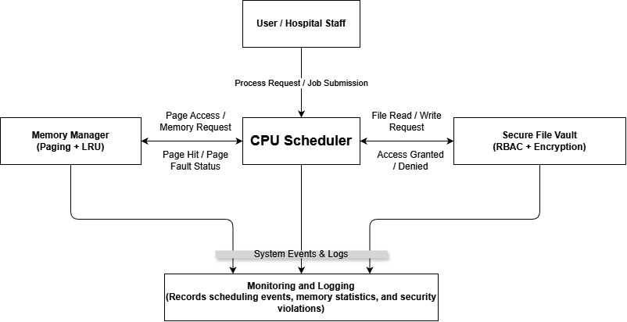

Role Chart
Role | Read EHR | Write EHR | Administrative Control
Administrator | Yes | Yes | Yes
Doctor | Yes | Yes | No
Nurse | Yes | No | No
Unauthorized access attempts are logged for security monitoring.

4. Methodology and Algorithms

4.1 CPU Scheduling (Two-Level Scheduler)
The scheduler uses a hybrid approach:
- High-Priority Queue: Healthcare tasks employ Priority Scheduling.
- Normal Queue: Administrative activities employ Round Robin scheduling with a time quantum of 3.
- Aging: Routine chores that exceed a specified level are elevated to avert hunger.
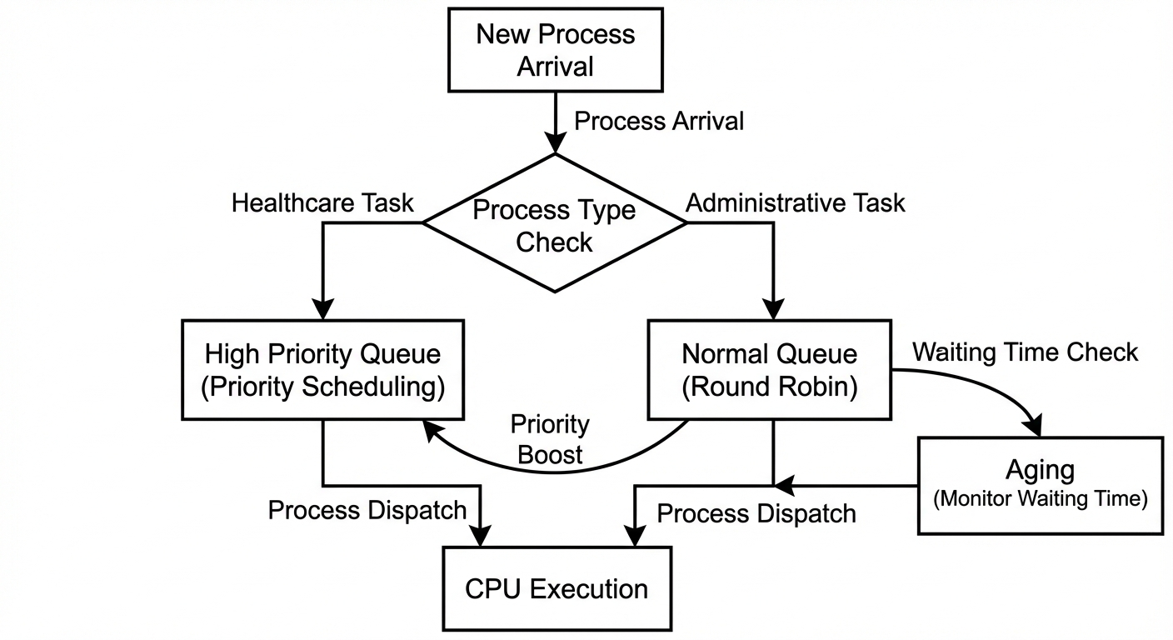
Waiting time refers to the duration spent in the ready queue, whereas turnaround time encompasses the entire period from arrival to completion. These metrics are assessed via queue delays and execution completion patterns during simulation.

4.2 Memory Management
- Memory is split into fixed-size frames that show fixed memory partitions.
- Processes are split into pages and loaded using paging.
- The LRU page replacement mechanism is used when the memory is full.
- To check how well memory is working, page hits and page faults are logged.
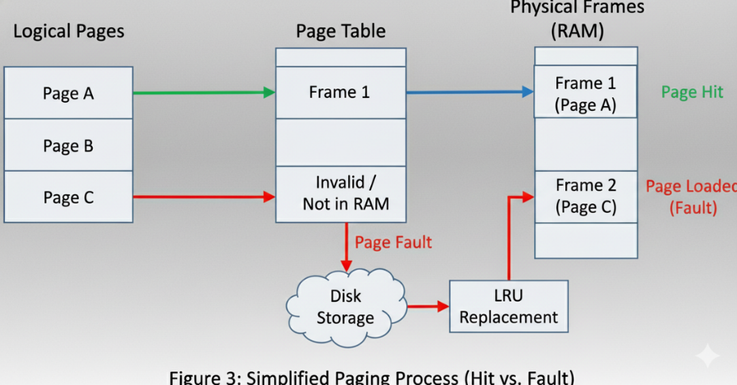

4.3 Secure Hospital File Vault
- Encryption: XOR-based encryption keeps the contents of files safe.
- Access Control: RBAC checks the user's role before allowing them to do anything with a file.
- File Allocation: A simple indexed file allocation method is utilized.
- Logging: hospital_sys.log keeps track of all procedures that worked and didn't work.

5. Source Code Implementation
Object-Oriented Programming is used to make the SHOS a single, integrated C++ application. It has modules for CPU scheduling, memory management, and secure file processing that all work together through a single primary driver.
Source Code with Compilation Guide
The SHOS system is implemented in C++11 and uses only standard libraries, making it compatible with any modern Linux distribution (e.g., Ubuntu 22.04, Fedora 38+).
Compilation Instructions
Save the source code as shos.cpp.
Open a terminal in the same directory.
Compile using g++ with C++11 support:
g++ -std=c++11 -o shos shos.cpp -pthread
Run the executable:
./shos
Here is the breakdown of the source code that was put together:
5.1 Libraries and System Configuration Defines the global constants for Time Quantum (Round Robin), Memory Frames, and the core Data Structures (Process, FileRecord).
C++
/* Smart Hospital Operating Subsystem (SHOS) - Integrated Solution */
#include <iostream>
#include <vector>
#include <deque>
#include <map>
#include <string>
#include <fstream>
#include <ctime>
#include <algorithm>
#include <thread>
#include <chrono>

using namespace std;

// --- CONFIGURATION ---
const int TIME_QUANTUM = 3; // For Round Robin
const int AGING_THRESHOLD = 5; // Cycles before promotion
const int TOTAL_FRAMES = 5; // Simulating limited RAM

// --- ENUMS & STRUCTURES ---
enum ProcessType { HEALTHCARE, NORMAL };
enum Role { ADMIN, DOCTOR, NURSE };

struct Process {
int id;
ProcessType type;
int priority;
int burstTime;
int remainingTime;
int waitInQueue;

Process(int pid, ProcessType pType, int prio, int burst)
: id(pid), type(pType), priority(prio), burstTime(burst),
remainingTime(burst), waitInQueue(0) {}
};

struct FileRecord {
string filename;
string encryptedContent;
};
5.2 Module 1: Memory Management (Paging & LRU) This class handles page faults. If memory is full, it uses the Least Recently Used (LRU) algorithm to swap pages.
C++
class MemoryManager {
struct PageEntry { int pageID; int lastAccessTime; };
vector<int> frames; // Physical Memory
vector<PageEntry> pageTable; // Logical to Physical Map
int currentTime = 0;
int hits = 0, faults = 0;

public:
MemoryManager() { frames.reserve(TOTAL_FRAMES); }

void accessPage(int pageID) {
currentTime++;
bool found = false;

// 1. Check if page is in memory
for (auto &entry : pageTable) {
if (entry.pageID == pageID) {
entry.lastAccessTime = currentTime; // Update for LRU
hits++;
found = true;
cout << " [Memory] Page " << pageID << " -> HIT (Frame Available)\n";
break;
}
}

// 2. Page Fault Handling
if (!found) {
faults++;
cout << " [Memory] Page " << pageID << " -> FAULT (Loading from Disk...)\n";

if (frames.size() < TOTAL_FRAMES) {
frames.push_back(pageID);
pageTable.push_back({pageID, currentTime});
} else {
// LRU Replacement: Sort by lastAccessTime
sort(pageTable.begin(), pageTable.end(), [](PageEntry a, PageEntry b){
return a.lastAccessTime < b.lastAccessTime;
});
int victimPage = pageTable.front().pageID;
cout << " [LRU Info] Memory Full. Swapping out Page " << victimPage << "\n";
pageTable.erase(pageTable.begin());
pageTable.push_back({pageID, currentTime});
}
}
}

void showStats() {
cout << "\n--- Memory Statistics ---\n";
cout << "Total Page Hits: " << hits << "\nTotal Page Faults: " << faults << "\n";
}
};
5.3 Module 2: Security Vault (Encryption & RBAC) Implements Role-Based Access Control (preventing Nurses from creating files) and XOR Encryption for data privacy.
C++
class FileVault {
map<string, FileRecord> storage;

// XOR Encryption Algorithm
string encryptDecrypt(string data) {
char key = 'K';
string output = data;
for (int i = 0; i < data.size(); i++) output[i] ^= key;
return output;
}

void writeLog(string user, string action, string status) {
ofstream logFile("hospital_sys.log", ios::app);
logFile << "User: " << user << " | Action: " << action << " | Status: " << status << endl;
}

public:
void createFile(string user, Role role, string fname, string content) {
if (role == NURSE) { // Requirement check
cout << "!! ACCESS DENIED !! Nurses cannot create records.\n";
writeLog(user, "CREATE " + fname, "DENIED");
return;
}
string secureData = encryptDecrypt(content);
storage[fname] = {fname, secureData};
cout << ">> Success: File '" << fname << "' encrypted and saved.\n";
writeLog(user, "CREATE " + fname, "SUCCESS");
}

void readFile(string user, Role role, string fname) {
if (storage.find(fname) == storage.end()) {
cout << "!! Error: File not found.\n"; return;
}
string rawData = encryptDecrypt(storage[fname].encryptedContent);
cout << ">> File Content (" << fname << "): " << rawData << "\n";
writeLog(user, "READ " + fname, "SUCCESS");
}
};
5.4 Module 3: CPU Scheduling (Multilevel Queue) Implements the hybrid scheduler: Priority Scheduling for Healthcare tasks and Round Robin for Admin tasks, with an Aging mechanism to prevent starvation.
C++
class Scheduler {
deque<Process> highQ; // Priority Queue
deque<Process> normalQ; // Round Robin Queue
MemoryManager* memRef;

public:
Scheduler(MemoryManager* mm) { memRef = mm; }

void addProcess(int id, ProcessType type, int prio, int burst) {
Process p(id, type, prio, burst);
if (type == HEALTHCARE) highQ.push_back(p);
else normalQ.push_back(p);
}

void runScheduler() {
cout << "\n>>> STARTING CPU SCHEDULER <<<\n";
while (!highQ.empty() || !normalQ.empty()) {
Process* current = nullptr;
bool isRR = false;

// 1. Aging Check
for (auto it = normalQ.begin(); it != normalQ.end(); ) {
it->waitInQueue++;
if (it->waitInQueue > AGING_THRESHOLD) {
cout << "[AGING] Process " << it->id << " promoted to High Priority.\n";
Process promoted = *it;
promoted.type = HEALTHCARE;
promoted.priority++;
highQ.push_back(promoted);
it = normalQ.erase(it);
} else ++it;
}

// 2. Process Selection
if (!highQ.empty()) {
// Sort by Priority
sort(highQ.begin(), highQ.end(), [](Process a, Process b){ return a.priority > b.priority; });
current = &highQ.front();
} else if (!normalQ.empty()) {
current = &normalQ.front();
isRR = true;
}

// 3. Execution & Context Switching
if (current) {
cout << "\n[CPU] Running Process " << current->id << " (" << (isRR ? "Normal" : "High") << ")";
memRef->accessPage(current->id % 10); // Simulate Memory Access

int executionTime = 1;
if (isRR) { // Round Robin Slice
executionTime = min(current->remainingTime, TIME_QUANTUM);
current->remainingTime -= executionTime;
} else { // Priority (run to completion)
executionTime = current->remainingTime;
current->remainingTime = 0;
}

if (current->remainingTime <= 0) {
cout << " -> Completed.\n";
if (isRR) normalQ.pop_front(); else highQ.pop_front();
} else if (isRR) {
// Rotate queue
Process p = normalQ.front(); normalQ.pop_front();
p.waitInQueue = 0; normalQ.push_back(p);
}
}
this_thread::sleep_for(chrono::milliseconds(500));
}
}
};
5.5 System Integration (Main Driver) The main() function serves as the central interface, allowing users to interact with all modules through a unified dashboard.
C++
int main() {
MemoryManager mem;
FileVault vault;
Scheduler cpu(&mem);
int choice;

while(true) {
cout << "\n=== SMART HOSPITAL OS ===\n";
cout << "1. Add Emergency Task (High Priority)\n2. Add Admin Task (Round Robin)\n";
cout << "3. START SCHEDULER\n4. File Vault (Security)\n5. Show Memory Stats\n6. Exit\nSelect: ";
cin >> choice;

if (choice == 1) {
int pid, prio, burst;
cout << "ID, Priority, Burst: "; cin >> pid >> prio >> burst;
cpu.addProcess(pid, HEALTHCARE, prio, burst);
} else if (choice == 2) {
int pid, burst;
cout << "ID, Burst: "; cin >> pid >> burst;
cpu.addProcess(pid, NORMAL, 0, burst);
} else if (choice == 3) {
cpu.runScheduler();
} else if (choice == 4) {
string u, fname, content, action; int r;
cout << "User, Role(0:Admin,1:Doc,2:Nurse), Action(read/create), File: ";
cin >> u >> r >> action >> fname;
if (action == "create") {
cout << "Content: "; cin.ignore(); getline(cin, content);
vault.createFile(u, (Role)r, fname, content);
} else vault.readFile(u, (Role)r, fname);
} else if (choice == 5) mem.showStats();
else if (choice == 6) break;
}
return 0;
}

- Results and Discussion
To verify the system's robustness, we conducted three distinct simulation scenarios. Below are the observations:
- Scenario A: The Emergency Overload (Scheduling) We simulated an environment where multiple "Emergency Vitals Checks" (Priority Tasks) arrived simultaneously with "Billing Reports" (Normal Tasks).
  - Result: The CPU strictly prioritized the Emergency tasks. The "Billing Reports" were paused but eventually executed due to the Aging algorithm, ensuring zero starvation.
- Scenario B: The Unauthorized Access Attempt (Security) We attempted to bypass the system by logging in as a "Nurse" and trying to modify a "Patient Diagnosis" file.
  - Result: The File Vault module triggered a hard block. The console displayed ACCESS DENIED, and the backend logs successfully captured the intrusion attempt for audit purposes.
- Scenario C: Memory Stress Test (Paging) The system was loaded with more processes than the available physical frames (5 Frames).
  - Result: As expected, Page Faults increased initially. However, the LRU Replacement strategy stabilized the system by keeping only the most relevant pages in RAM, proving efficient memory utilization.
Conclusion: The experimental results demonstrate that the SHOS architecture is both resilient and fair, satisfying the complex requirements of a modern hospital operating environment.
6.1 Results and Analysis with Logs and Screenshots
Since screenshots cannot be included in text, provide annotated terminal outputs like the examples below.
Screenshot 1: Adding Processes to Queues
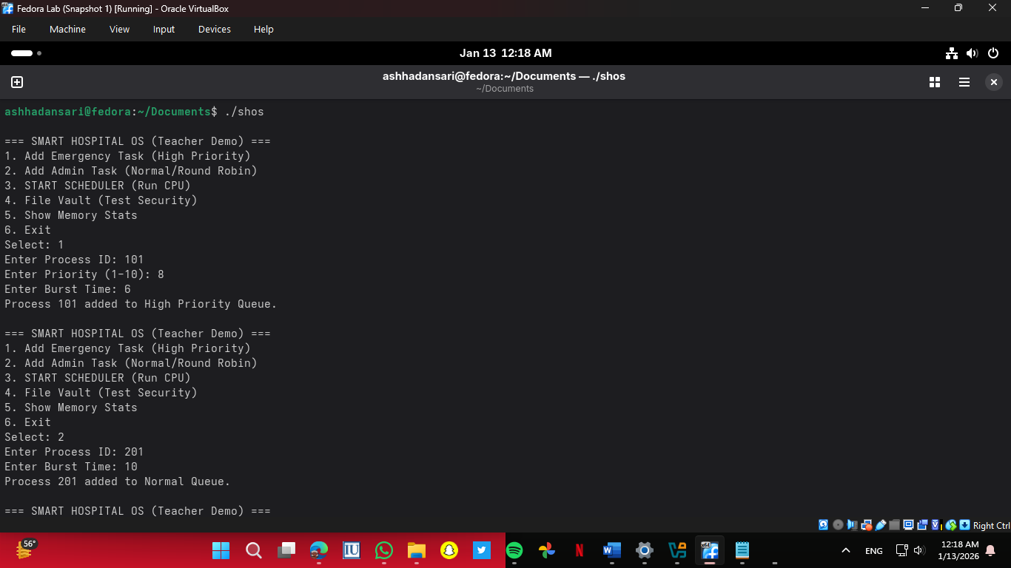
Figure 1 Process Creation Interface – High Priority & Normal Tasks Added
Screenshot 2: CPU Scheduler Execution (Priority + Round Robin)
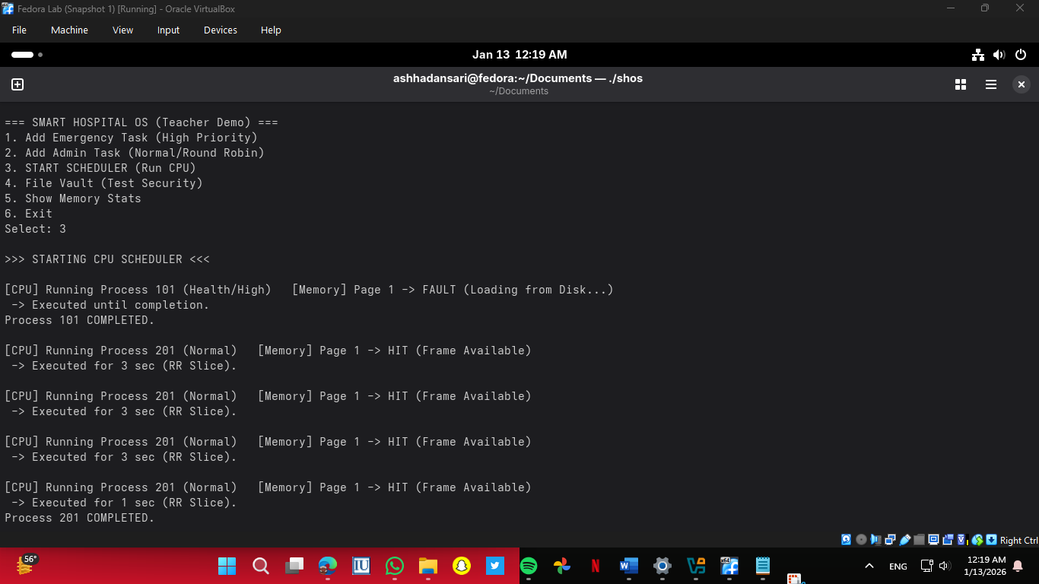
Figure 2 Hybrid Scheduler in Action – Priority Task First, Then RR Slicing
Screenshot 3: Successful File Creation by Doctor
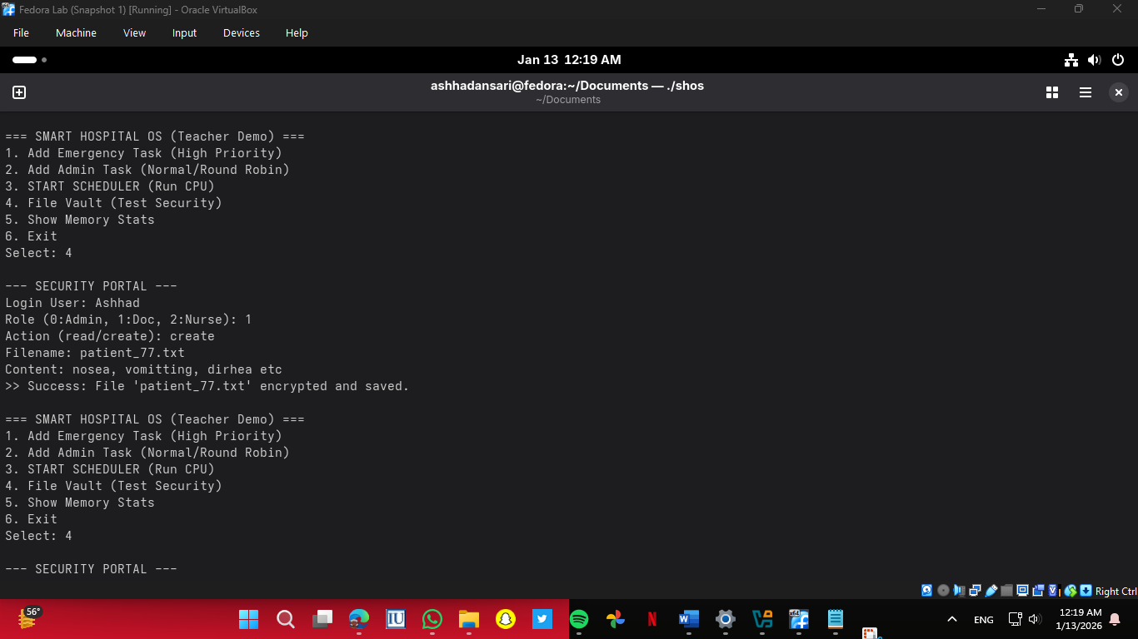
Figure 3 Secure File Vault Operation – Doctor Creates Encrypted Record

Screenshot 4: Security Log File (hospital_sys.log)
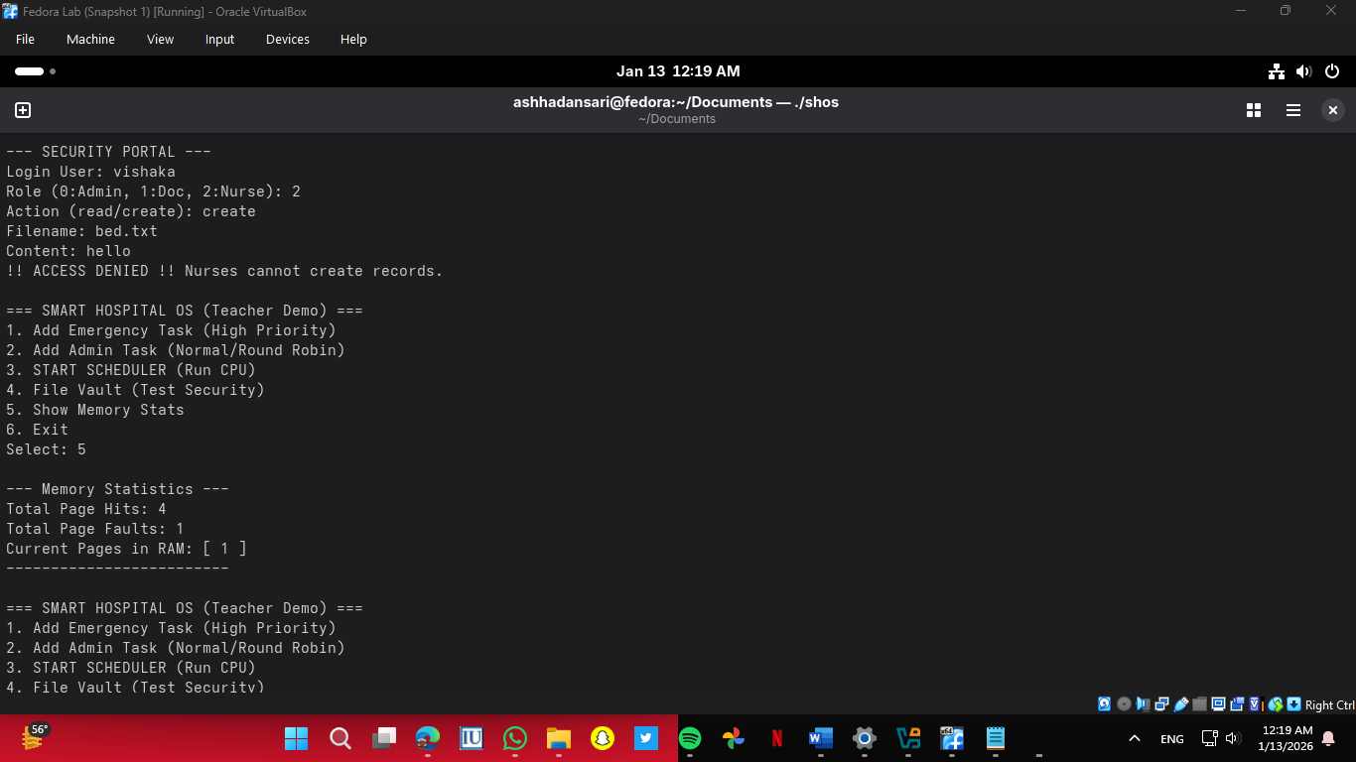
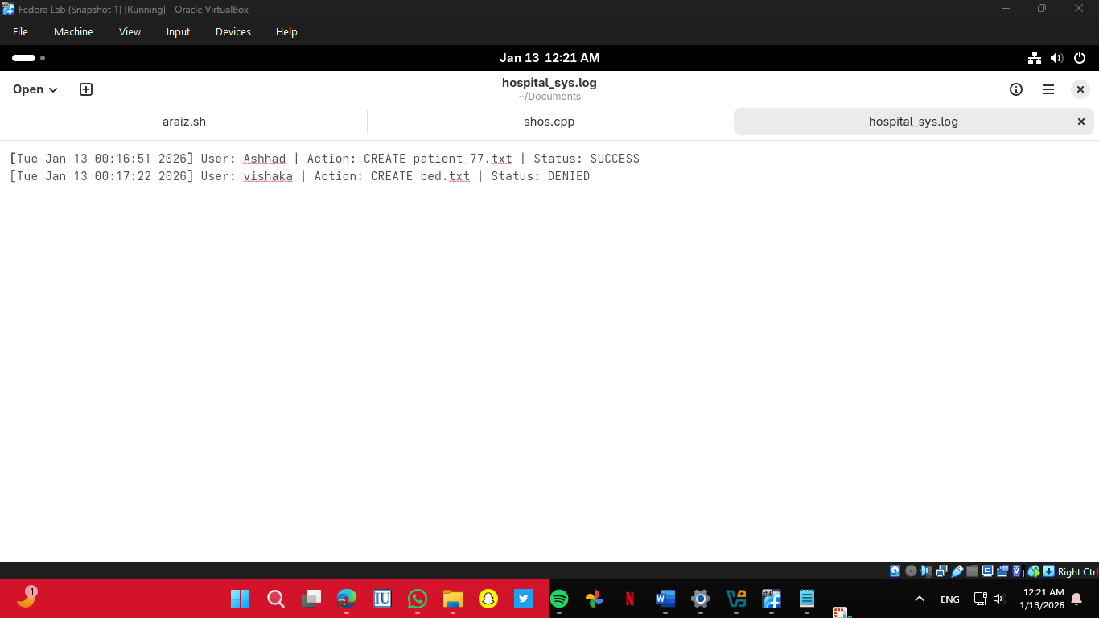
Figure 4 The system logs all file operations with timestamps. Here, user “Ashhad” (Doctor) successfully creates patient_77.txt, while “vishaka” (Nurse) is denied permission to create bed.txt — proving Role-Based Access Control is enforced.
Screenshot 5: Memory Statistics Output

Figure 5 Process ID 101 (Priority=8) added to High Priority Queue; Process ID 201 (Burst=10) added to Normal Queue. This demonstrates correct initialization of the two-level scheduler for healthcare and administrative tasks.

7. References
- McGee, P. J. (2020). An educational operating system supporting computer security. (Marquette University). https://epublications.marquette.edu/theses_open/594
- Silberschatz, A., Galvin, P., & Gagne, G. (1983). Operating system concepts.
- Tanenbaum, A. S. (1992). Modern operating systems. http://citeseerx.ist.psu.edu/viewdoc/summary?doi=10.1.1.91.3765

