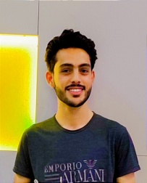

Summary

My name is Muhammad Hassan biggner in Web App and development. I have over 9th month experience within the industry. I have working Knowledge about **REACT, NODE.JS, EXPRESS, MONGOOSE, HTML, CSS, JS, BOOTSTRAP, RESTAPI,** and also project,

Skil

* Exceptional eye for and attention to detail.
* Ability to take direction and work independently.
* Working knowledge of**,HTML, CSS, JS, BOOTSTRAP, RESTAPI,**
* **REACT, NODE.JS, EXPRESS, MONGOOSE**

Experience

* 9th month of self learning and research about web app development

Education

**ISLAMIA COLLEGE UNIVERSITY PESH**, SOFTWARE ENG

1ST SMESTER

O313-2402444/03352402444

Add: Abdarra Canal Road Peshawar

MUHAMMAD HASSAN