Real-time control case:
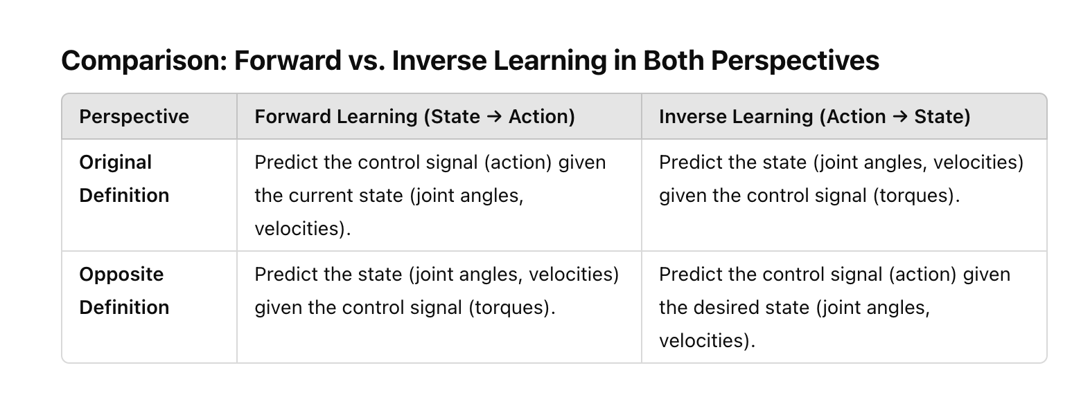
Let’s set up a detailed experiment for validating DipDNN in the opposite way (state → action for inverse learning) in the context of a real-time control system using the Reacher-v2 environment from Gymnasium. The goal is to evaluate DipDNN’s inverse performance in predicting control actions from desired states and compare its real-time control optimization against other approaches like i-ResNet.
Experiment Setup:
1. Datasets Used
- Environment: Reacher-v2 from Gymnasium/MuJoCo.
- Generated Dataset: We’ll generate state-action pairs by interacting with the environment and collecting observations (states) and actions (control signals, e.g., torques).
- Input (State):
  - Joint angles (2D)
  - Joint velocities (2D)
  - Angular accelerations (2D)
- Output (Action):
  - Torques (control signals) applied to the joints (2D)
  - Optionally, we can include torque derivatives (2D) to match the dimensionality.
2. Tasks
- Forward Learning Task:
  - Learn to predict the system state (joint angles, velocities) given the control signals (torques).
  - This will help understand how the system evolves based on the applied torques.
- Inverse Learning Task (Main Task):
  - Learn to predict the control signals (torques) that will result in the desired state (joint angles, velocities, accelerations).
  - This will showcase how DipDNN can use its analytical inverse mapping to calculate control actions for reaching target states efficiently.
3. Metrics to Evaluate the Performance
Forward Learning Metrics:
- Mean Squared Error (MSE):
  - MSE between the predicted state (from control signals) and the actual state.
  - This measures how accurately the model predicts how the system evolves under given control signals.
Inverse Learning Metrics (Key for DipDNN):
- Inverse Mapping Accuracy (MSE):
  - MSE between the predicted control signals (from desired states) and the actual control signals.
  - This evaluates how well DipDNN predicts the required torques to achieve a desired state.
Real-Time Control Optimization Metrics:
- Cumulative Reward:
  - The total reward over time in a control task (e.g., how quickly and accurately the robot reaches a target).
  - Higher rewards indicate better control performance.
- Real-Time Inference Speed:
  - Measure how fast DipDNN computes the inverse mapping (state → action) compared to an iterative method like i-ResNet.
  - Faster inference speed is crucial for real-time control systems.

Experiment Flow:
- Generate Data:
  - Interact with the Reacher-v2 environment and collect state-action pairs.
  - The collected data will be used to train both the forward and inverse models.
- Train Forward Model:
  - Learn the system dynamics by predicting the state from the control signal (forward task).
- Train Inverse Model (Main Task):
  - Train DipDNN to predict control actions (torques) from desired states (joint angles, velocities).
- Evaluate Forward and Inverse Models:
  - Use MSE to evaluate both forward and inverse mappings on test data.
- Test Real-Time Control:
  - Use DipDNN’s inverse mapping to compute control actions in real-time for the Reacher-v2 environment.
  - Compare its cumulative reward and inference speed to other models, such as i-ResNet, to demonstrate the benefits of DipDNN’s fast, analytical inverse

1. Separation of Evaluation into Two Stages
- Stage 1: This stage evaluates the forward and inverse models separately by calculating the MSE on test data. This helps to clearly show the performance of DipDNN in both forward (state → action) and inverse (action → state) mappings.
- Stage 2: This stage focuses on testing real-time control using DipDNN’s inverse mapping. It computes control actions from the desired states and applies them in the environment. The script tracks two key metrics:
  - Cumulative Reward: The total reward obtained during the control task (higher is better).
  - Inference Time: The time taken to compute the inverse mapping (lower is better), highlighting DipDNN’s strength in real-time applications.
2. Three Approaches to Matching Dimensions for Invertible Models
- Approach 1: We include torque derivatives to the action vector to match the input-output dimensions.
- Approach 2: We add dummy/virtual variables (zeros) to artificially increase the action dimensions to match the input dimensions.
- Approach 3: We introduce an extra non-invertible layer after the invertible layers to map to the same dimension. This allows us to maintain invertibility during training while ensuring the final output matches the desired dimension.
You can select between these approaches by adjusting the approach parameter in the preprocess_data function.

How DipDNN Benefits Real-Time Control
By clearly separating the evaluation of forward and inverse models, we can see how DipDNN performs in both tasks:
- Stage 1 shows how well DipDNN learns the mappings, especially focusing on the inverse task (state → action), which is critical for control.
- Stage 2 demonstrates the practical advantage of DipDNN’s analytical inverse in real-time control, as it allows for faster action computation compared to iterative methods like i-ResNet, improving both cumulative reward and inference speed.
This experiment setup is optimized for validating the advantages of DipDNN in real-time control systems.

这个问题引用的是hybrid, 不是switch, 换成switch获得新的信息.
为了说明switch重要就要说明两边优点要兼具的example, 才需要在training过程中进行转换.
i-resnet好DipDNN不好, 以及i-resnet不好DipDNN好各自有四点, 我现在需要能综合起来的, 非常specific的example.
举个例子, 我们自己对MNIST和CIFAR-10的探索过程是一种switch:
image需要convolution --》 DipDNN不具备 --〉pretrain resnet --》 转换为DipDNN
但是这个image案例还差的内容: 没有办法实例化 DipDNN > ResNet的几个点: 需要analytical inverse, strict one-to-one, no information loss.
可能符合但需要确定和specific design的: multiple image features map to the same target --》 ill-conditioned
我再多说一句, 我自己正在做的筛选data找的是 DipDNN > ResNet, 而switch对应的是要综合两边的, 比如computer vision 需要(convolution). 所以不一样, 都需要.

