ERD

FlowChart

1. Login

1. Registrasi Mahasiswa

1. Import Data Mahasiswa

1. Mata Kuliah

1. Absensi

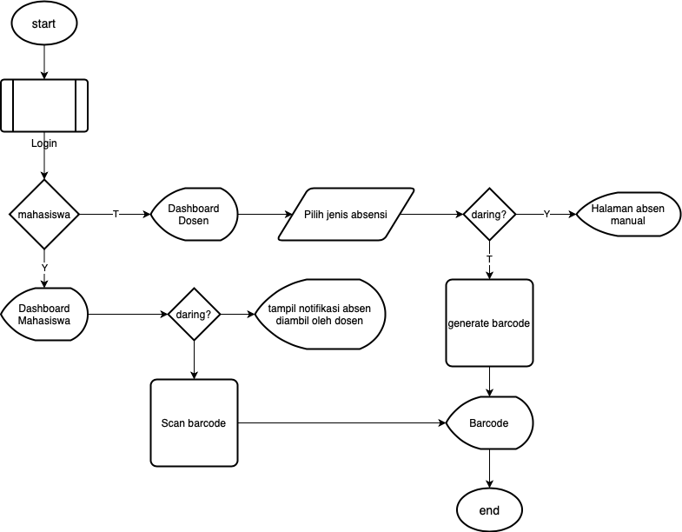

1. Materi Perkuliahan

